CONSULTING REPORT - 2
Logical Design and Physical Design
of the Data Warehouse Schema
Design and Implementation of a Data Warehouse
for a Retail Store with Store-level Data
ISTM 637 - Data Warehousing
Texas A&M University
Spring 2026
Team 1:
Nisarg Sonar
Bhavik Dalal
Yifei Wang
Date: March 18, 2026

Table of Contents
1. Introduction
1.1 Hybrid Data Pipeline Overview
2. Overview of Kimball's Methodology
3. Data Warehouse Logical Design (Star Schema Design)
3.1 Applying Kimball's Methodology to DFF
3.2 Star Schema Table Definitions
3.3 Star Schema ERD
3.4 Schema Justification for Each Business Question
3.5 Independent Data Marts Supported by Schema
4. Develop Two Mapping Tables
4.1 Mapping Table #1: Source Files to Staging Tables
4.2 Mapping Table #2: Staging Tables to Data Mart Tables
5. Physical Design

1. Introduction
This report presents the logical design and physical design of the data warehouse for Dominick's Fine Foods (DFF). It builds on the requirements analysis, business questions, and preliminary schema proposed in Report 1.
Report 1 identified 10 business questions grounded in the DFF dataset and retail domain research, proposed a star schema, and confirmed that the schema can answer all 10 questions. In this report, we focus on the 5 business questions selected by the professor for implementation: BQ2, BQ3, BQ4, BQ8, and BQ9. These span four product categories (Soft Drinks, Canned Soup, Toothpaste, and Crackers) and exercise key OLAP operations such as roll-up, dice, NTILE, RANK, and LAG.
Design Specifications (from Report 1):
- Implementation Architecture: Hybrid Data Pipeline
- Warehouse Architecture: Independent Data Marts
- Modeling Scheme: Dimensional Modeling (Star Schema)
- OLAP Style: HOLAP (Hybrid Online Analytical Processing)
- Target Infrastructure: SQL Server 2016

1.1 Hybrid Data Pipeline Overview
Our warehouse follows a Hybrid Data Pipeline architecture combining batch ETL processing with a structured staging layer. The pipeline has three main stages:
Stage 1 - Data Extraction: Raw CSV files (Movement files, UPC files, DEMO.csv, CCOUNT.csv) are extracted from the DFF source system. These flat files serve as the operational data sources.
Stage 2 - Staging Area: Extracted data is loaded into relational staging tables (stg_Movement, stg_Product, stg_Store). During this stage, data cleansing is performed: null values are handled, invalid records (OK=0, PRICE=0) are filtered out, and transformations like category code derivation from filenames are applied. The staging area acts as a buffer between source and target.
Stage 3 - Presentation Server (Data Mart): Cleaned and transformed data is loaded from staging into the star schema data mart tables (FactWeeklySales, DimProduct, DimStore, DimTime, DimCategory, DimPromotion). Surrogate keys are generated, foreign key lookups are performed, and derived facts (revenue, unit_price, profit_margin_pct) are computed during this load. The data mart serves as the presentation server for OLAP queries.
The two mapping tables in Section 4 document the transformations at each stage: Mapping Table #1 covers Stage 1 to Stage 2, and Mapping Table #2 covers Stage 2 to Stage 3.
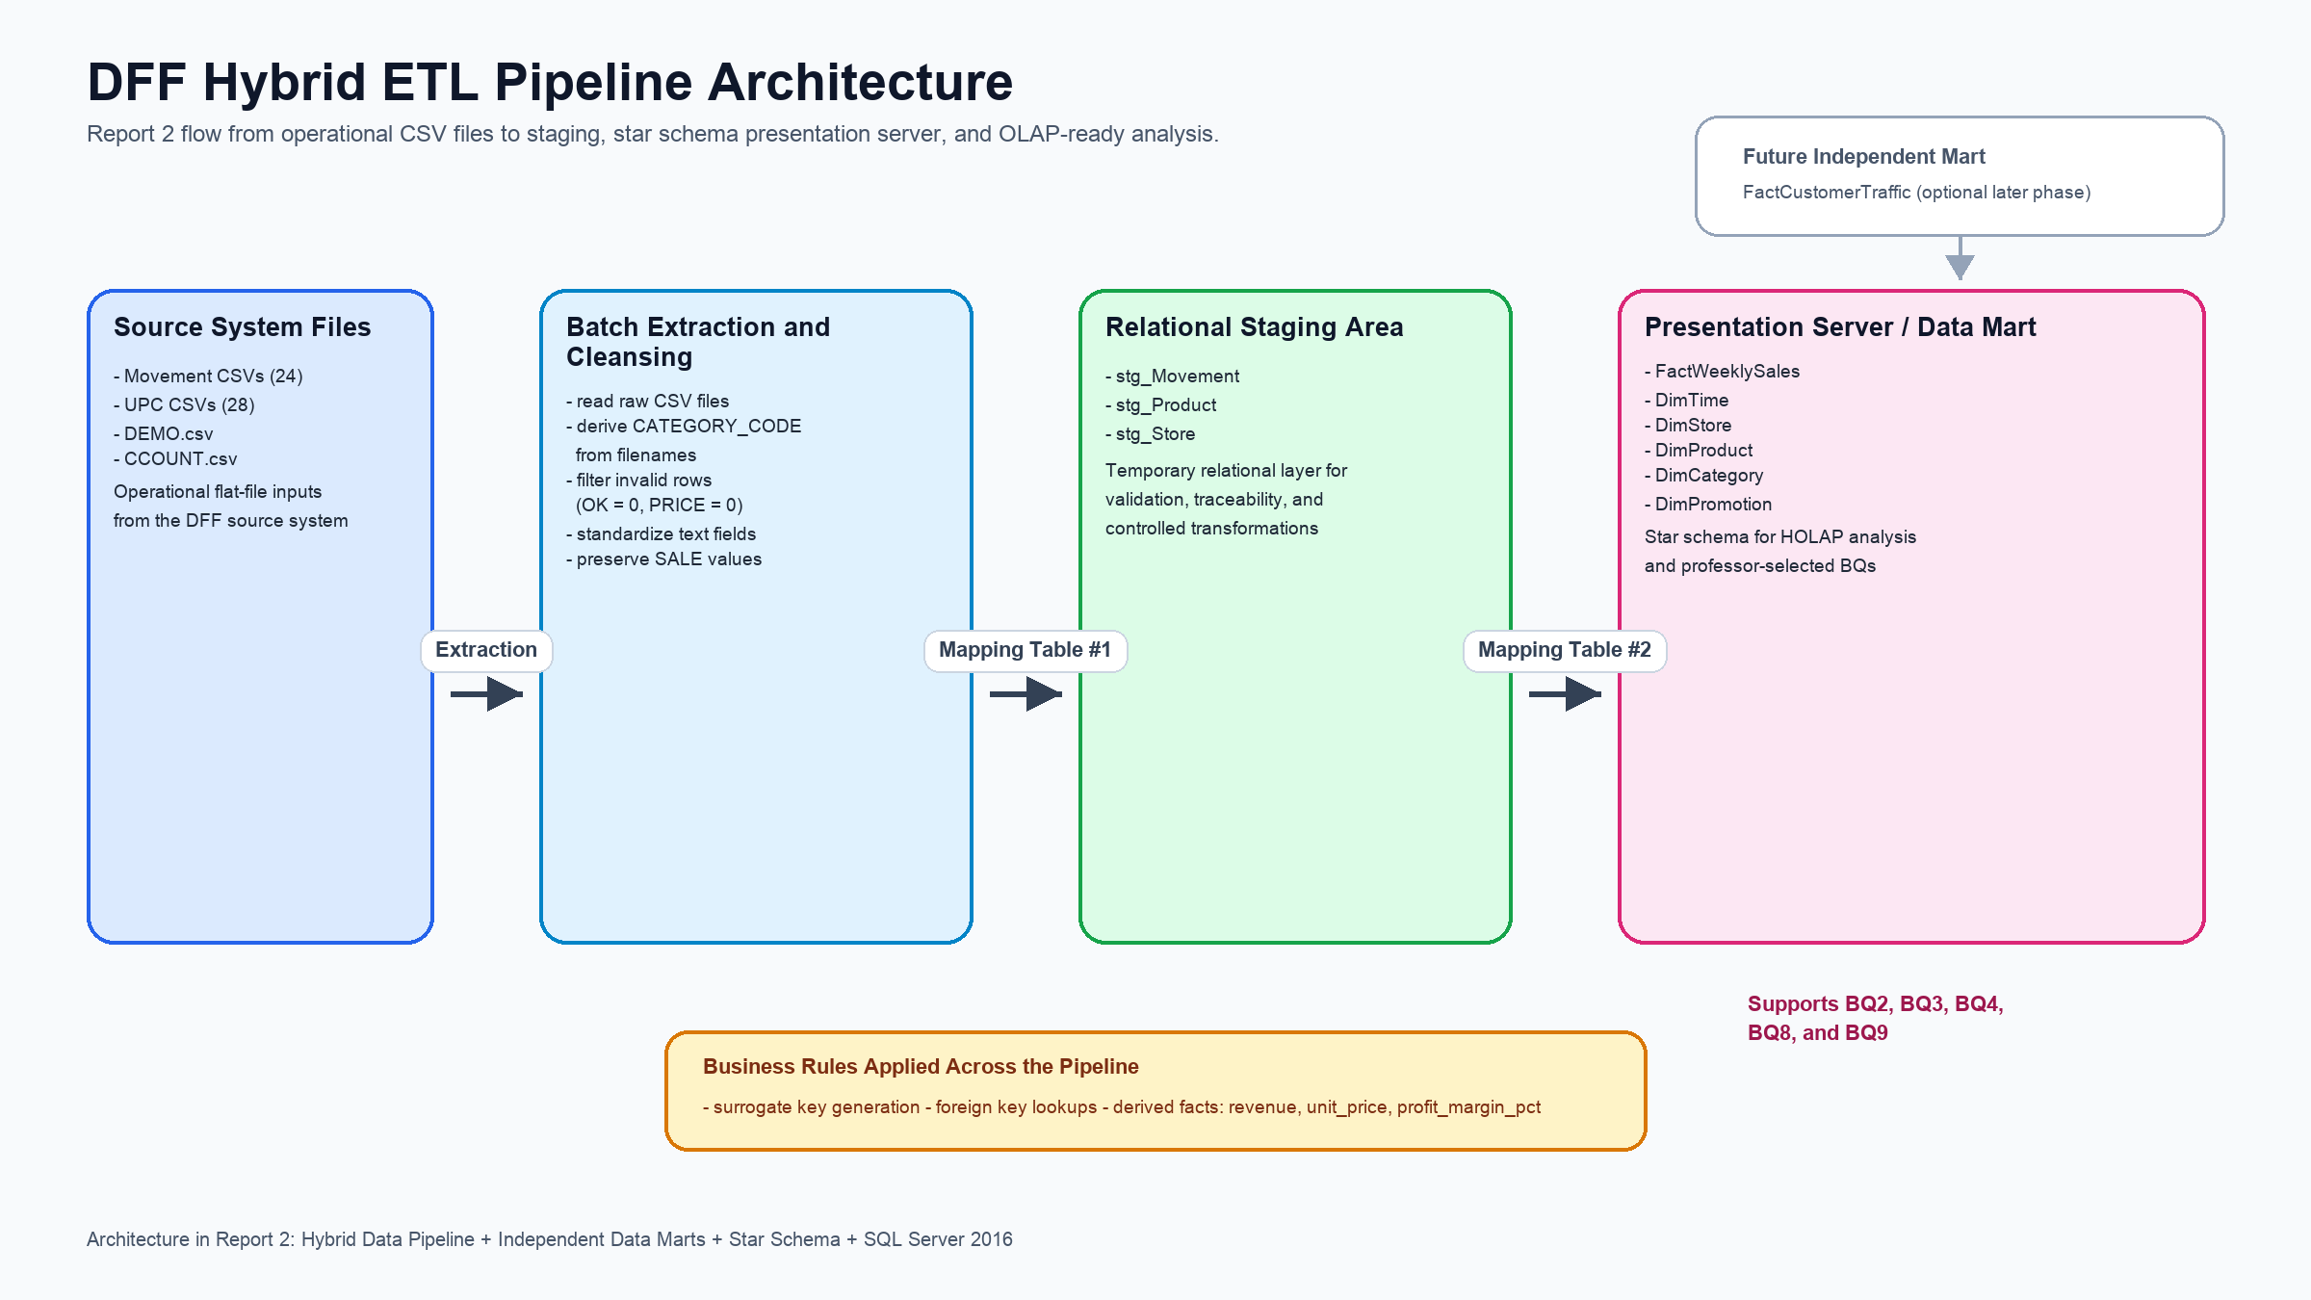

Figure 1. Hybrid ETL Pipeline Architecture for DFF

2. Overview of Kimball's Methodology
The data warehouse logical design follows Kimball's bottom-up methodology for building independent, conformable data marts. Dimensional modeling is a logical design technique that presents data in a standard format that is intuitive and allows for high-performance access. The fundamental idea is that every type of business data can be represented as a cube or hypercube. This approach is well suited for building independent data marts that can later be integrated through conformed dimensions.
Kimball's methodology consists of six steps. Each step builds on the previous one to progressively shape the data warehouse from business needs through logical design to physical implementation.
Step 1 - Requirements Analysis: The first step is to understand what the business needs from the data warehouse. This involves three activities: gathering business questions from stakeholders, looking for business objectives and issues that the warehouse should address, and collecting analysis requirements such as the types of reports, filters, and comparisons users need. Requirements analysis sets the foundation for all subsequent design decisions because the schema must be shaped by what users actually need to know, not by how data happens to be stored in the source system.
Step 2 - Build the Matrix: The matrix (also called the data mart/dimension matrix) is a grid that lists data marts along one axis and dimensions along the other, with intersections marked to show which dimensions each data mart uses. This step has three sub-steps: (2.1) list the data marts, starting with single-source data marts because they are simpler to implement and can deliver value to end users quickly; (2.2) list all the dimensions needed for filtering, grouping, and drilling into fact data; and (2.3) mark the intersections to identify conformed dimensions that are shared across multiple data marts. On average, each data mart uses about 10 dimensions, though this varies based on the complexity of the business domain.
Step 3 - Design Fact Tables: The fact table is the central table that stores the quantitative measurements (facts) of a business process. Designing it involves six sub-steps: (3A) choose the data mart to focus on, (3B) declare the grain, which means defining exactly what one row in the fact table represents, (3C) choose the facts and classify them as additive (can be summed across all dimensions), semi-additive (can be summed across some but not all dimensions), or non-additive (cannot be summed at all, such as ratios and percentages), (3D) include derived facts at design time rather than making end users calculate them, (3E) document all base and derived facts with clear definitions and formulas, and (3F) create a fact table diagram showing the fact table surrounded by its dimensions. A well-designed fact table should be deep (many rows) and narrow (few columns), containing mostly numeric measures and foreign keys.
Step 4 - Design Dimension Tables: Dimension tables store the descriptive, textual context that gives meaning to the numeric facts. Dimensions answer the "who, what, where, when, why, and how" of business questions. Each dimension should document its explicit grain (what one row represents), approximate cardinality (how many rows it will have), and hierarchical relationships between attributes (for example, week rolls up to month, which rolls up to quarter, which rolls up to year). Surrogate keys, which are meaningless sequential integers, are used as primary keys instead of production keys or smart keys. Dimensions should be denormalized into flat, wide tables. Snowflaking (normalizing dimension attributes into separate tables) is not recommended because it slows browsing among attributes, confuses business users, increases the number of joins required, and raises administration cost.
Step 5 - Feedback for the Design: Before finalizing the schema, the design is validated through three rounds of feedback. Step 5A involves review by the IS (Information Systems) technical team to check whether any important source attributes are missing from the model. Step 5B involves core business users who verify that the schema supports the reporting, navigation, and drill-down operations they need (such as drill-down from year to quarter to month, slicing by a single dimension value, and dicing across multiple dimensions). Step 5C is a broader presentation to business users to validate the model against the full set of business questions and confirm that every question can be answered.
Step 6 - Data Sourcing: The final step identifies all data sources and plans how data will flow from source systems into the warehouse. Data sources are classified as formal (maintained by database staff in structured formats) or informal (personal databases, spreadsheets, or new data). For each source, a data source definition is created that includes the source name, platform, location, and description of contents. Data sourcing also establishes two types of mapping: Type 1 mapping defines how source data is extracted and loaded into staging tables, and Type 2 mapping defines how staging data is transformed and loaded into the presentation server (data mart) tables.
Why is this methodology important for independent data marts?
Kimball's methodology ensures that each data mart is driven by actual business needs rather than simply copying the structure of source systems. By using conformed dimensions (dimensions that are shared across data marts with consistent definitions), independent data marts can be queried together and integrated across the enterprise without building a monolithic enterprise data warehouse upfront. This means organizations can start small, deliver value quickly with a focused data mart, and then expand incrementally by adding new data marts that share the same conformed dimensions. The emphasis on denormalized star schemas guarantees fast query performance and produces a structure that business users can understand without technical training, since each dimension corresponds to a familiar business concept.

3. Data Warehouse Logical Design (Star Schema Design)
This section presents the star schema design for DFF, created by following Kimball's six-step methodology in its entirety. We first walk through how each step was applied to arrive at our design, then present the resulting table definitions, ERD, and business question justifications.

3.1 Applying Kimball's Methodology to DFF

Step 1: Requirements Analysis for DFF
In Report 1, we studied the DFF dataset and identified 10 business questions from stakeholder analysis and retail domain research. The business objectives for DFF are: (1) understand weekly sales trends across product categories, (2) measure the effectiveness of different promotion types on sales volume, (3) compare store performance tiers using revenue and demographic data, and (4) track top-selling products and their week-over-week changes.
The analysis requirements include weekly sales trend tracking, promotional effectiveness measurement, store-level demographic segmentation, and product-level ranking with temporal comparisons. From the 10 questions, the professor selected the following 5 for this report:
BQ ID | Business Question | Category | OLAP Operation
BQ2 | What were the total weekly unit sales of Soft Drinks across all stores for each week? | Soft Drinks (SDR) | Roll-up
BQ3 | How do promotion weeks compare to non-promotion weeks in terms of sales volume? | Soft Drinks (SDR) | Dice
BQ4 | Which promotion type (B=Bonus Buy, C=Coupon, S=Sale) generated the highest incremental unit sales lift in Canned Soup? | Canned Soup (CSO) | Dice
BQ8 | Which stores fall into the top 25%, middle 50%, and bottom 25% of total revenue for Toothpaste, and how do their demographics differ? | Toothpaste (TPA) | NTILE
BQ9 | For each week, rank the top 10 products (UPCs) in Crackers by unit sales and show their week-over-week sales change. | Crackers (CRA) | RANK+LAG

Step 2: Building the Data Mart / Dimension Matrix
Step 2.1 - List the Data Marts: Following the principle of starting with single-source data marts, we identified FactWeeklySales as our primary data mart. It is sourced from the 24 Movement CSV files and captures weekly item-level sales across all DFF stores. This single data mart answers all 5 selected business questions, making it the core of our design.
Step 2.2 - List the Dimensions: Based on the filtering, grouping, and drilling requirements of the 5 BQs, we identified five dimensions:
- DimTime - provides week-level time hierarchy (week, month, quarter, year) for BQ2 weekly trending and BQ9 week-over-week comparisons
- DimStore - provides store attributes and demographics (income, education, poverty, urban status) for BQ8 store segmentation
- DimProduct - provides product attributes (UPC, description, size) for BQ9 product-level ranking
- DimCategory - provides product category filtering (SDR, CSO, TPA, CRA) needed by all 5 BQs to isolate specific categories
- DimPromotion - provides promotion type classification (No Promotion, Bonus Buy, Coupon, Sale) for BQ3 and BQ4
Step 2.3 - Mark the Intersections: Our design uses 5 dimensions for FactWeeklySales. While a typical enterprise has about 10 dimensions per data mart, the DFF dataset covers a single grocery retailer with a focused set of CSV files, not a multi-division corporation. The 5 dimensions are sufficient to support all the filtering, grouping, and drill operations needed by our 5 BQs.
Data Mart | DimTime | DimStore | DimProduct | DimCategory | DimPromotion | BQs Supported
FactWeeklySales | X | X | X | X | X | BQ2, BQ3, BQ4, BQ8, BQ9

All five dimensions are conformed, meaning they can be reused if additional data marts (for example, a customer traffic data mart built from CCOUNT.csv) are added in the future without any structural changes to the existing schema.

Step 3: Designing the Fact Table
Step 3A - Choose the Data Mart: FactWeeklySales is our primary data mart. It captures weekly item-level sales, which is the core business process for DFF and the process that all 5 BQs analyze.
Step 3B - Declare the Grain: Each individual fact record represents the weekly sales of one product (UPC) at one store. This is the finest grain available in the DFF Movement files. This grain supports all required aggregations: rolling up to weekly totals for BQ2, grouping by promotion for BQ3 and BQ4, summing revenue by store for BQ8, and ranking products within a week for BQ9.
Step 3C - Choose the Facts: Facts are classified by their additive properties:
- Additive (can be summed across all dimensions): units_sold (from MOVE), revenue (derived), gross_profit (from PROFIT)
- Non-additive (cannot be summed): unit_price (derived ratio), profit_margin_pct (derived ratio)
- Semi-additive (additive across some dimensions but not time): shelf_price (from PRICE), price_qty (from QTY)
The fact table has 13 columns (6 foreign keys + 7 measures), keeping it deep and narrow as recommended.
Step 3D - Include Derived Facts: Derived facts are included at design time rather than deferring them to end-user applications. Our derived measures and their calculations:
Derived Measure | Formula | Additivity | Purpose
revenue | units_sold x (shelf_price / price_qty) | Additive | BQ8 uses total revenue per store for quartile ranking
unit_price | shelf_price / price_qty | Non-additive | Per-unit price for pricing analysis
profit_margin_pct | (gross_profit / revenue) x 100 | Non-additive | Measures profitability as a percentage

Revenue is additive because it is a dollar amount per transaction that can be summed across products, stores, and time. Unit_price and profit_margin_pct are ratios, and summing ratios produces meaningless results, which is why they are non-additive.
Step 3E - Document Base and Derived Facts: All base facts (units_sold, shelf_price, price_qty, gross_profit) and derived facts (revenue, unit_price, profit_margin_pct) are documented in the table definition in Section 3.2 and cross-referenced with the 5 BQs in Section 3.4.
Step 3F - Create Fact Table Diagram: A logical diagram of the fact table with all its dimensions is presented as the Star Schema ERD in Section 3.3. This diagram shows the context of FactWeeklySales and can be used for communication with end users, data access tool selection, and training.

Step 4: Designing the Dimension Tables
Each dimension table uses a surrogate key (a meaningless 4-byte integer) as its primary key. We avoid using smart keys or production keys. The original natural keys (STORE number, UPC code, WEEK number) are kept as regular attributes for traceability back to source data.
All dimensions are fully denormalized into flat, wide tables with no snowflaking. Snowflaking would slow browsing, cause user confusion, increase the number of joins needed for queries, and raise administration cost. For example, DimStore contains all 18 demographic attributes directly (income, education, poverty, urban status, etc.) rather than normalizing demographics into a separate table. This allows BQ8 to compare store demographics across revenue tiers with a single join.
The explicit grain and approximate cardinality of each dimension:
Dimension | Grain | Approx Rows | Key Attributes for BQs
DimTime | One row per unique week | ~400 | week_id, month, quarter, year
DimStore | One row per store | ~107 | store_id, avg_income, education_pct, poverty_pct, is_urban
DimProduct | One row per unique UPC | ~14,000 | upc, description, size
DimCategory | One row per product category | 28 | category_code (SDR, CSO, TPA, CRA)
DimPromotion | One row per promotion type | 4 | deal_code (NULL, B, C, S), is_promoted

Step 5: Feedback for the Design
Step 5A (IS Team): We verified that no important attributes are missing from either the fact table or the dimensions. All 10 original BQs from Report 1 are answerable with the current dimensional model. The fact table grain supports all required aggregations.
Step 5B (Core Business Users): The schema supports standard OLAP navigation: drill-down (expanding from year to quarter to month to week), drill-up (summarizing by collapsing hierarchies), slice (fixing one dimension value such as a specific category), dice (filtering across multiple dimensions), ranking (RANK and NTILE window functions), and windowed operations (LAG for week-over-week comparisons).
Step 5C (Business Users): All 5 selected BQs were tested against the schema. Each BQ is fully supported by the current fact table and dimension combination. Detailed justifications with data evidence are provided in Section 3.4.

Step 6: Data Sourcing
Our data sources are all formal, maintained as structured CSV files from the DFF dataset published by the Kilts Center at the University of Chicago Booth School of Business.
Source | Platform | Location | Description
Movement Files (24) | CSV | DFF data/Movement/ | Weekly item-level sales: STORE, UPC, WEEK, MOVE, QTY, PRICE, SALE, PROFIT, OK
UPC Files (28) | CSV | DFF data/UPC/ | Product master: COM_CODE, UPC, DESCRIP, SIZE, CASE, NITEM
DEMO.csv | CSV | DFF data/Demographics/ | Store demographics: 107 stores, 18 demographic attributes per store
CCOUNT.csv | CSV | DFF data/Ccount/ | Customer traffic counts by department per store (potential future data mart)

Data mapping follows two stages as prescribed by the methodology: Source to Staging (Type 1) and Staging to Presentation Server (Type 2). Both are documented in Section 4.

3.2 Star Schema Table Definitions
The following table definitions are the result of applying Kimball's six-step process. All tables use surrogate keys as primary keys.

FactWeeklySales (Fact Table)
Grain: One row per UPC x Store x Week. Source: 24 Movement CSV files. Estimated ~134.9M rows.
Column | Data Type | Description | Source | Additivity
sales_fact_id (PK) | INT | Surrogate key | Generated | -
product_key (FK) | INT | FK to DimProduct | UPC | -
store_key (FK) | INT | FK to DimStore | STORE | -
time_key (FK) | INT | FK to DimTime | WEEK | -
category_key (FK) | INT | FK to DimCategory | filename | -
promotion_key (FK) | INT | FK to DimPromotion | SALE | -
units_sold | INT | Units moved/sold | MOVE | Additive
unit_price | DECIMAL(8,2) | shelf_price / price_qty | Derived | Non-additive
shelf_price | DECIMAL(8,2) | Listed shelf price | PRICE | Semi-additive
price_qty | INT | Qty for listed price | QTY | Semi-additive
revenue | DECIMAL(12,2) | units_sold x unit_price | Derived | Additive
gross_profit | DECIMAL(10,2) | Gross profit | PROFIT | Additive
profit_margin_pct | DECIMAL(5,2) | (gross_profit/revenue) x 100 | Derived | Non-additive

DimProduct
One row per unique UPC. ~14,000 rows. Source: 28 UPC CSV files.
Column | Data Type | Description | Source
product_key (PK) | INT | Surrogate key | Generated
upc (Unique) | BIGINT | Universal Product Code | UPC
description | VARCHAR(100) | Product description | DESCRIP
size | VARCHAR(20) | Package size | SIZE
case_pack | INT | Case pack quantity | CASE
commodity_code | INT | Manufacturer code | COM_CODE
item_number | BIGINT | Internal item number | NITEM

DimStore
One row per store. ~107 rows. Source: DEMO.csv. Fully denormalized.
Column | Data Type | Description | Source
store_key (PK) | INT | Surrogate key | Generated
store_id (Unique) | INT | Original store number | STORE
store_name | VARCHAR(50) | Store name | NAME
city | VARCHAR(40) | City | CITY
zip_code | VARCHAR(10) | ZIP code | ZIP
zone | INT | Pricing zone | ZONE
is_urban | BIT | Urban flag | URBAN
weekly_volume | INT | Avg weekly volume | WEEKVOL
avg_income | DECIMAL(10,2) | Avg area income | INCOME
education_pct | DECIMAL(5,2) | Pct higher education | EDUC
poverty_pct | DECIMAL(5,2) | Pct below poverty | POVERTY
avg_household_size | DECIMAL(4,2) | Avg household size | HSIZEAVG
ethnic_diversity | DECIMAL(5,2) | Ethnic diversity | ETHNIC
population_density | DECIMAL(10,2) | Population density | DENSITY
price_tier | VARCHAR(10) | Low/Medium/High | Derived: PRICLOW, PRICMED, PRICHIGH
age_under_9_pct | DECIMAL(5,2) | Pct under 9 | AGE9
age_over_60_pct | DECIMAL(5,2) | Pct over 60 | AGE60
working_women_pct | DECIMAL(5,2) | Pct working women | WORKWOM

DimTime
One row per unique week. ~400 rows. Derived from WEEK values (Week 1 = Sep 14, 1989).
Column | Data Type | Description | Source
time_key (PK) | INT | Surrogate key | Generated
week_id | INT | DFF week number | WEEK
week_start_date | DATE | Start date of the week | 1989-09-14 + (week_id-1) x 7
week_end_date | DATE | End date of the week | week_start_date + 6
month | INT | Month (1 to 12) | Derived
month_name | VARCHAR(10) | Month name | Derived
quarter | INT | Quarter (1 to 4) | Derived
year | INT | Calendar year | Derived
fiscal_year | INT | DFF fiscal year | Derived
is_holiday_week | BIT | Holiday week flag | Engineered

DimCategory
One row per product category. 28 rows. Derived from source filenames.
Column | Data Type | Description | Source
category_key (PK) | INT | Surrogate key | Generated
category_code (Unique) | CHAR(3) | 3-letter category code | filename
category_name | VARCHAR(30) | Full category name | Codebook
department | VARCHAR(20) | Department grouping | Engineered

Report 2 categories: SDR (Soft Drinks), CSO (Canned Soup), TPA (Toothpaste), CRA (Crackers).

DimPromotion
One row per promotion type. 4 rows. Derived from the SALE column in Movement files.
Column | Data Type | Description | Source
promotion_key (PK) | INT | Surrogate key | Generated
deal_code | CHAR(1) | Deal flag value | SALE
deal_type | VARCHAR(20) | Descriptive promotion name | Mapped from deal_code
is_promoted | BIT | Promoted yes/no flag | Derived

deal_code | deal_type | is_promoted
NULL or blank | No Promotion | 0
B | Bonus Buy | 1
C | Coupon | 1
S | Sale/Discount | 1

During ETL (Mapping Table #2), any Movement record where SALE is NULL or blank is mapped to the "No Promotion" row (promotion_key = 1, deal_code = NULL, is_promoted = 0). Records with SALE = B, C, or S are mapped to the corresponding promotion row.

3.3 Star Schema ERD
The Star Schema ERD below represents the logical design of our data warehouse. It shows FactWeeklySales at the center surrounded by the five conformed dimension tables. This diagram follows the fact table diagram approach from Step 3F, showing the context of the fact table with respect to all its dimensions.
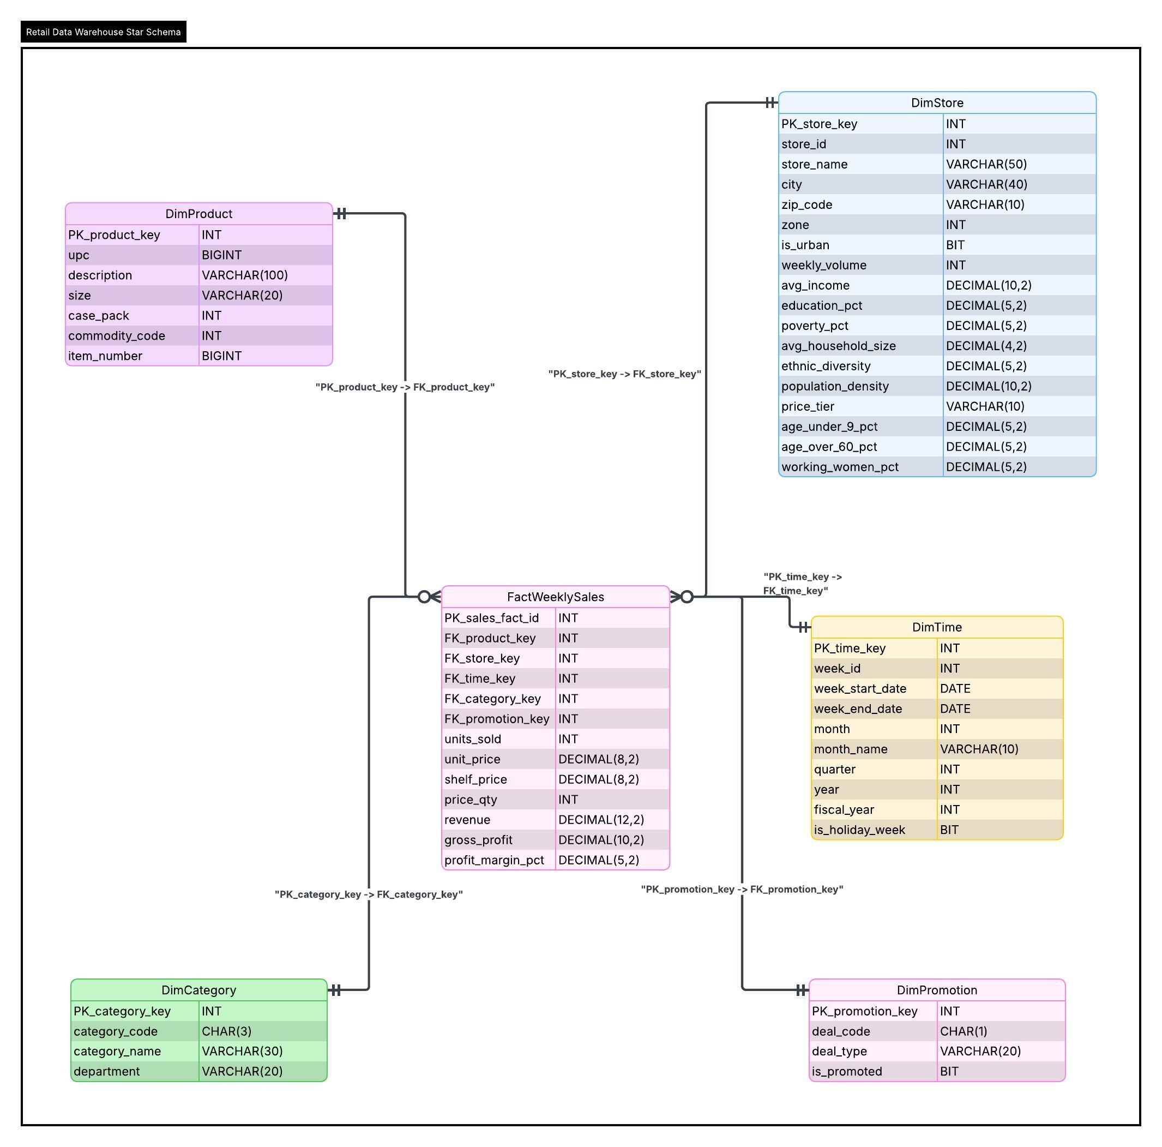
Figure 2. Star Schema ERD for DFF Data Warehouse
The ERD uses crow's foot notation to show 1:N relationships from each dimension to the fact table. FactWeeklySales holds five foreign keys (product_key, store_key, time_key, category_key, promotion_key), each pointing to its corresponding dimension. This is a pure star schema with no inter-dimension foreign keys.

3.4 Schema Justification for Each Business Question
Each business question is justified below with the tables and columns required, the OLAP operation involved, and data evidence from Report 1 showing that the schema produces meaningful results.

BQ2: Total weekly unit sales of Soft Drinks across all stores
Tables Required: FactWeeklySales, DimTime, DimCategory
OLAP Operation: Roll-up (aggregate individual product-store-week records up to weekly totals)
The units_sold measure is fully additive. By filtering on DimCategory.category_code = 'SDR' and grouping by DimTime.week_id, the schema aggregates individual product-store records into total weekly unit sales across all stores. This is a classic roll-up operation.
Data Evidence (Report 1): Soft Drinks had the highest total unit volume with 29,222 units in a 1,000-row sample. Weekly trends showed baseline demand between 100,000 and 200,000 units with promotional spikes above 400,000 units.

BQ3: Promotion weeks vs non-promotion weeks in sales volume
Tables Required: FactWeeklySales, DimPromotion, DimCategory
OLAP Operation: Dice (filter by category and group by promotion status simultaneously)
By joining FactWeeklySales with DimPromotion on promotion_key, users can group units_sold by is_promoted (0 or 1) or by deal_type for further drill-down. DimPromotion cleanly separates promoted from non-promoted records. This is a dice operation because we filter on two dimensions at once (category and promotion).
Data Evidence (Report 1): Promoted Soft Drink items averaged 56.61 units compared to 20.27 for non-promoted, a 2.8x lift. Sale generated 102.97 avg units (about 7.2x lift), Bonus Buy 94.50 (about 6.6x), Coupon 60.51 (about 4.2x).

BQ4: Highest incremental unit sales lift by promotion type in Canned Soup
Tables Required: FactWeeklySales, DimPromotion, DimCategory
OLAP Operation: Dice (filter category + promotion type, compare to baseline)
The schema captures each record's promotion type through promotion_key pointing to DimPromotion.deal_code. The incremental lift is calculated by comparing the average units_sold during promoted periods (B, C, or S) against the average during non-promoted periods. Grouping by deal_code reveals which promotion type delivers the highest lift for Canned Soup.
Data Evidence (Report 1): In Canned Soup, the non-promotional baseline was 10.17 units. Bonus Buy added +10.86 units, Sale added +74.30 units. Sale was clearly the strongest promotion type for this category.

BQ8: Store quartile tiers by Toothpaste revenue with demographics
Tables Required: FactWeeklySales, DimStore, DimCategory
OLAP Operation: NTILE (ranking into quartiles) + Drill-down (demographics)
The revenue derived measure is summed by store_key while filtering DimCategory.category_code = 'TPA'. NTILE(4) then divides stores into four quartiles. Because DimStore is fully denormalized with all demographic attributes (income, education, poverty, urban status, household size, ethnic diversity, population density), the quartile results can be directly compared by demographics without any additional joins or snowflake lookups.
Data Evidence (Report 1): Using percentile thresholds (Q1=$39,020.77, Q3=$72,517.15), Top 25% stores averaged weekly customer volume of 565.04 compared to 347.06 for Bottom 25%. Among Top 25% stores, 73.9% were urban, indicating a strong demographic correlation with revenue.

BQ9: Weekly top 10 Cracker products with week-over-week change
Tables Required: FactWeeklySales, DimProduct, DimTime, DimCategory
OLAP Operation: RANK (ranking within each week) + LAG (comparing to previous week)
FactWeeklySales stores units_sold at the UPC x Store x Week grain. By aggregating by product_key and time_key while filtering DimCategory.category_code = 'CRA', we get weekly totals per product. RANK() OVER(PARTITION BY week_id) identifies the top 10 products per week, and LAG() computes the week-over-week change by comparing each product's current week units to its previous week units.
Data Evidence (Report 1): The WEEK, UPC, and MOVE fields directly support this query. Top 10 filtering and difference-from-previous calculations were demonstrated using PivotTables in Report 1.

3.5 Independent Data Marts Supported by Schema
This report implements one independent data mart: FactWeeklySales, which focuses on the weekly retail sales process and answers all 5 selected business questions. The schema is designed following the independent data marts architecture specified in the project requirements, where each data mart is a self-contained star schema built around a single business process.
Key characteristics of this architecture as applied to DFF:
- FactWeeklySales is our first and currently only data mart. It is fully self-contained, with its own fact table and five conformed dimensions.
- All five dimensions (DimTime, DimStore, DimProduct, DimCategory, DimPromotion) are conformed, meaning they use consistent keys and definitions. If a second data mart is added in the future, it can reuse these same dimensions without any changes.
- The DFF dataset provides a clear candidate for a second data mart: a FactCustomerTraffic mart built from CCOUNT.csv, sharing DimStore and DimTime with the existing FactWeeklySales mart.
- No centralized enterprise data warehouse is built upfront. Instead, we start with the most critical business process (weekly sales) and can expand incrementally as new analytical needs arise.
The star schema design ensures efficient querying through simple joins between the fact table and its dimensions. Business users can understand the structure naturally because each dimension represents a familiar business concept: time, store, product, category, and promotion.

4. Develop Two Mapping Tables
Mapping tables are a critical part of the ETL process. They document exactly how data flows from source systems through the staging area and into the final data mart tables. Without mapping tables:
- Developers would not know which source columns feed which target columns
- Data transformations (cleansing, derivation, type conversion) would be undocumented
- Future maintenance and troubleshooting would be difficult because the data lineage is lost
- Auditing and data governance would be impossible since there is no traceability
There are two types of mapping in Kimball's methodology: Source to Staging (Type 1) and Staging to Presentation Server (Type 2). These correspond to the two stages of our Hybrid Data Pipeline described in Section 1.1.

4.1 Mapping Table #1: Source Files to Staging Tables
This mapping defines how raw source data is extracted from CSV files and loaded into relational staging tables. The staging tables serve as a buffer where data cleansing and initial transformations are performed before loading into the data mart.
Movement Files to stg_Movement:
Source File Name | Source File Attribute | Mapping | Staging Table Type | Staging Table Name | Staging Table Attribute
wsdr.csv | STORE | Copy | Relation | stg_Movement | STORE
wsdr.csv | UPC | Copy | Relation | stg_Movement | UPC
wsdr.csv | WEEK | Copy | Relation | stg_Movement | WEEK
wsdr.csv | MOVE | Copy | Relation | stg_Movement | MOVE
wsdr.csv | QTY | Copy | Relation | stg_Movement | QTY
wsdr.csv | PRICE | Copy | Relation | stg_Movement | PRICE
wsdr.csv | SALE | Copy (keep NULL as-is) | Relation | stg_Movement | SALE
wsdr.csv | PROFIT | Copy | Relation | stg_Movement | PROFIT
wsdr.csv | OK | Copy | Relation | stg_Movement | OK
wsdr.csv | (filename) | Extract 'SDR' | Relation | stg_Movement | CATEGORY_CODE
WCSO-Done.csv | (all cols) | Same as above | Relation | stg_Movement | (same)
WCSO-Done.csv | (filename) | Extract 'CSO' | Relation | stg_Movement | CATEGORY_CODE
WTPA_done.csv | (all cols) | Same as above | Relation | stg_Movement | (same)
WTPA_done.csv | (filename) | Extract 'TPA' | Relation | stg_Movement | CATEGORY_CODE
Done-WCRA.csv | (all cols) | Same as above | Relation | stg_Movement | (same)
Done-WCRA.csv | (filename) | Extract 'CRA' | Relation | stg_Movement | CATEGORY_CODE

Note: All 24 Movement files follow this same pattern. Only the 4 categories relevant to the selected BQs are shown. During staging, rows with OK = 0 or PRICE = 0 are filtered out as invalid records.
UPC Files to stg_Product:
Source File Name | Source File Attribute | Mapping | Staging Table Type | Staging Table Name | Staging Table Attribute
UPCSDR.csv | COM_CODE | Copy | Relation | stg_Product | COM_CODE
UPCSDR.csv | UPC | Copy | Relation | stg_Product | UPC
UPCSDR.csv | DESCRIP | Transform: Strip #/~ | Relation | stg_Product | DESCRIP
UPCSDR.csv | SIZE | Transform: Standardize | Relation | stg_Product | SIZE
UPCSDR.csv | CASE | Copy | Relation | stg_Product | CASE_PACK
UPCSDR.csv | NITEM | Copy | Relation | stg_Product | NITEM
UPCSDR.csv | (filename) | Derive 'SDR' | Relation | stg_Product | CATEGORY_CODE
UPCCSO.csv | (all cols) | Same; CODE='CSO' | Relation | stg_Product | (same)
UPCTPA.csv | (all cols) | Same; CODE='TPA' | Relation | stg_Product | (same)
UPCCRA.csv | (all cols) | Same; CODE='CRA' | Relation | stg_Product | (same)

Demographics (DEMO.csv) to stg_Store:
Source File Name | Source File Attribute | Mapping | Staging Table Type | Staging Table Name | Staging Table Attribute
DEMO.csv | STORE | Copy | Relation | stg_Store | STORE
DEMO.csv | NAME | Copy (NULL to UNKNOWN) | Relation | stg_Store | NAME
DEMO.csv | CITY | Copy (NULL to UNKNOWN) | Relation | stg_Store | CITY
DEMO.csv | ZIP | Copy | Relation | stg_Store | ZIP
DEMO.csv | ZONE | Copy | Relation | stg_Store | ZONE
DEMO.csv | URBAN | Copy | Relation | stg_Store | URBAN
DEMO.csv | WEEKVOL | Copy | Relation | stg_Store | WEEKVOL
DEMO.csv | INCOME | Copy | Relation | stg_Store | INCOME
DEMO.csv | EDUC | Copy | Relation | stg_Store | EDUC
DEMO.csv | POVERTY | Copy | Relation | stg_Store | POVERTY
DEMO.csv | HSIZEAVG | Copy | Relation | stg_Store | HSIZEAVG
DEMO.csv | ETHNIC | Copy | Relation | stg_Store | ETHNIC
DEMO.csv | DENSITY | Copy | Relation | stg_Store | DENSITY
DEMO.csv | AGE9 | Copy | Relation | stg_Store | AGE9
DEMO.csv | AGE60 | Copy | Relation | stg_Store | AGE60
DEMO.csv | WORKWOM | Copy | Relation | stg_Store | WORKWOM
DEMO.csv | PRICLOW,PRICMED,PRICHIGH | Derive: flag=1 to Low/Med/High | Relation | stg_Store | PRICE_TIER

4.2 Mapping Table #2: Staging Tables to Data Mart Tables
This mapping defines how staging data is transformed and loaded into the data mart (presentation server) tables. This is the second stage of the Hybrid Data Pipeline where surrogate keys are generated, foreign key lookups are performed, and derived facts are computed.
Staging Table | Staging Attribute | Mapping | DM Table Type | DM Table Name | DM Table Attribute
stg_Store | (auto) | Generate surrogate key | Dimension | DimStore | store_key (PK)
stg_Store | STORE | Copy | Dimension | DimStore | store_id
stg_Store | NAME | Copy | Dimension | DimStore | store_name
stg_Store | CITY | Copy | Dimension | DimStore | city
stg_Store | ZIP | Copy | Dimension | DimStore | zip_code
stg_Store | ZONE | Copy | Dimension | DimStore | zone
stg_Store | URBAN | Copy | Dimension | DimStore | is_urban
stg_Store | WEEKVOL | Copy | Dimension | DimStore | weekly_volume
stg_Store | INCOME | Copy | Dimension | DimStore | avg_income
stg_Store | EDUC | Copy | Dimension | DimStore | education_pct
stg_Store | POVERTY | Copy | Dimension | DimStore | poverty_pct
stg_Store | HSIZEAVG | Copy | Dimension | DimStore | avg_household_size
stg_Store | ETHNIC | Copy | Dimension | DimStore | ethnic_diversity
stg_Store | DENSITY | Copy | Dimension | DimStore | population_density
stg_Store | PRICE_TIER | Copy | Dimension | DimStore | price_tier
stg_Store | AGE9 | Copy | Dimension | DimStore | age_under_9_pct
stg_Store | AGE60 | Copy | Dimension | DimStore | age_over_60_pct
stg_Store | WORKWOM | Copy | Dimension | DimStore | working_women_pct
stg_Product | (auto) | Generate surrogate key | Dimension | DimProduct | product_key (PK)
stg_Product | UPC | Copy | Dimension | DimProduct | upc
stg_Product | DESCRIP | Copy | Dimension | DimProduct | description
stg_Product | SIZE | Copy | Dimension | DimProduct | size
stg_Product | CASE_PACK | Copy | Dimension | DimProduct | case_pack
stg_Product | COM_CODE | Copy | Dimension | DimProduct | commodity_code
stg_Product | NITEM | Copy | Dimension | DimProduct | item_number
(Generated) | WEEK values | Calculate dates from base | Dimension | DimTime | time_key, week_id, etc.
(Derived) | CATEGORY_CODE | Map codes to full names | Dimension | DimCategory | category_key, code, name
(Derived) | SALE values | Map: NULL to No Promotion; B/C/S to type | Dimension | DimPromotion | promotion_key, deal_code
stg_Movement | (auto) | Generate surrogate key | Fact | FactWeeklySales | sales_fact_id (PK)
stg_Movement | UPC | Lookup product_key | Fact | FactWeeklySales | product_key (FK)
stg_Movement | STORE | Lookup store_key | Fact | FactWeeklySales | store_key (FK)
stg_Movement | WEEK | Lookup time_key | Fact | FactWeeklySales | time_key (FK)
stg_Movement | CATEGORY_CODE | Lookup category_key | Fact | FactWeeklySales | category_key (FK)
stg_Movement | SALE | Lookup promotion_key | Fact | FactWeeklySales | promotion_key (FK)
stg_Movement | MOVE | Copy | Fact | FactWeeklySales | units_sold
stg_Movement | PRICE,QTY | Transform: PRICE/QTY | Fact | FactWeeklySales | unit_price
stg_Movement | PRICE | Copy | Fact | FactWeeklySales | shelf_price
stg_Movement | QTY | Copy | Fact | FactWeeklySales | price_qty
stg_Movement | MOVE,PRICE,QTY | MOVE x (PRICE/QTY) | Fact | FactWeeklySales | revenue
stg_Movement | PROFIT | Copy | Fact | FactWeeklySales | gross_profit
stg_Movement | PROFIT,revenue | (PROFIT/rev) x 100 | Fact | FactWeeklySales | profit_margin_pct

5. Physical Design
Data Aggregate Plan and Indexing Plan
The physical design transforms the logical star schema into a deployable structure on SQL Server 2016. Since DFF's data marts will grow as new product categories, stores, or time periods are added, each area is planned for scalability. With FactWeeklySales containing approximately 134.9 million rows at the UPC x Store x Week grain, pre-computed aggregate (summary) tables will improve query performance for frequently asked questions. Three aggregate tables are planned: agg_Weekly_Category_Sales (aggregating units_sold and revenue by week and category, speeding up BQ2-type queries), agg_Store_Category_Revenue (total revenue by store and category, speeding up BQ8 quartile analysis), and agg_Weekly_Product_Sales (units_sold by week and product per category, speeding up BQ9 rankings). For indexing, the fact table will use a clustered index on the composite key (time_key, store_key, product_key), with non-clustered indexes on promotion_key and category_key for filtered queries like BQ3 and BQ4. Dimension tables will use unique non-clustered indexes on surrogate primary keys. For columns with low cardinality such as DimPromotion.deal_code (4 values), DimStore.is_urban (2 values), and DimStore.price_tier (3 values), filtered non-clustered indexes will be created for each distinct value to speed up common query patterns on SQL Server 2016. A non-clustered columnstore index on FactWeeklySales will further accelerate analytical aggregations. During bulk ETL loads, indexes will be dropped before loading and recreated afterward to avoid slowing down the load process.
Data Standardization Plan and Storage Plan
Naming standards ensure consistency across the warehouse: dimension tables are prefixed "Dim," fact tables "Fact," staging tables "stg_," and aggregate tables "agg_." All surrogate keys are 4-byte INT, monetary values use DECIMAL(8,2) or DECIMAL(12,2), descriptive text uses VARCHAR(n), and flags use BIT. Null handling rules are enforced during ETL: SALE values that are NULL or blank are mapped to the "No Promotion" row in DimPromotion (promotion_key = 1), DEMO.csv NAME/CITY nulls become "UNKNOWN," and Movement rows with OK = 0 or PRICE = 0 are excluded during staging. For storage, FactWeeklySales will be horizontally partitioned by time_key using yearly partitions (about 52 weeks each), ensuring queries only scan relevant partitions, new data loads do not lock historical data, and backup and recovery operates at the partition level. Estimated total storage: FactWeeklySales about 4 to 5 GB, dimension tables under 10 MB, aggregates under 50 MB, indexes about 30 to 50 percent of base table size, staging area about 2 GB temporary. The independent data mart architecture allows new data marts to be added without modifying the existing FactWeeklySales schema or its conformed dimensions.

