CONSULTING REPORT-1
Requirements Gathering to Create Business Questions
And Domain Understanding

Design and Implementation of a Data Warehouse
for a Retail Store with Store-level Data

ISTM 637 — Data Warehousing
Texas A&M University
Spring 2026

Team Members:
[Member 1 Name]
[Member 2 Name]
[Member 3 Name]

Date: February 25, 2026

Table of Contents
1. Introduction .......................................................... 3
2. Details about the Data ................................................ 4
2.1 Understanding of the Data ......................................... 4
2.2 Metadata for All OLTP Source Files ................................ 8
2.3 Entity Relationship Diagram ....................................... 12
3. Retail Subject Area Understanding ..................................... 13
3.1 Literature Review ................................................. 13
3.2 Relevant Problems for DFF ......................................... 15
4. Business Questions .................................................... 16
4.1 List of 10 Business Questions ..................................... 16
4.2 Data Evidence for Business Questions ............................... 20
4.3 Prioritization and Rationalization ................................. 24
References ............................................................... 26

1. Introduction
Dominick's Finer Foods (DFF) was a major supermarket chain operating approximately 100 stores in the Chicago metropolitan area. Between 1989 and 1994, the University of Chicago Booth School of Business (James M. Kilts Center for Marketing) partnered with Dominick's to conduct extensive store-level research on shelf management and pricing. Randomized experiments were conducted in over 25 product categories throughout the 100-store chain, producing one of the most comprehensive publicly available retail scanner datasets (Kilts Center, 2013, University of Chicago Booth).
The DFF dataset consists of approximately 5 GB of store-level data covering sales of more than 3,500 UPCs (Universal Product Codes). The data includes weekly unit sales, retail prices, profit margins, deal/promotion codes, customer traffic counts, and store-level demographics derived from the 1990 U.S. Census. This dataset is notable for its comprehensive coverage and the inclusion of retail margin information, making it uniquely suitable for data warehouse design and OLAP analysis (https://www.chicagobooth.edu/research/kilts/datasets/dominicks).
A brief history of the company can be found at the Company Histories archive (https://www.company-histories.com/Dominicks-Finer-Foods-Inc-Company-History.html). Dominick's operated as a prominent regional grocery chain before being acquired by Safeway in 1998, and the stores were eventually closed in 2013.
The objective of this consulting project is to design and develop a data warehouse for DFF that enables OLAP (Online Analytical Processing) analysis of its retail operations. This first report focuses on requirements gathering: understanding the data, researching the retail domain, and developing 10 business questions that the data warehouse will answer. These questions are designed to provide actionable insights for DFF management on pricing, promotions, category management, and store performance.

2. Details about the Data

2.1 Understanding of the Data
To understand the DFF dataset, we imported sample data into Excel and performed exploratory analysis using Excel charts, Pivot Tables, and descriptive statistics. The following visualizations demonstrate key patterns in the data that inform our business questions.

Figure 1: Total Units Sold by Product Category
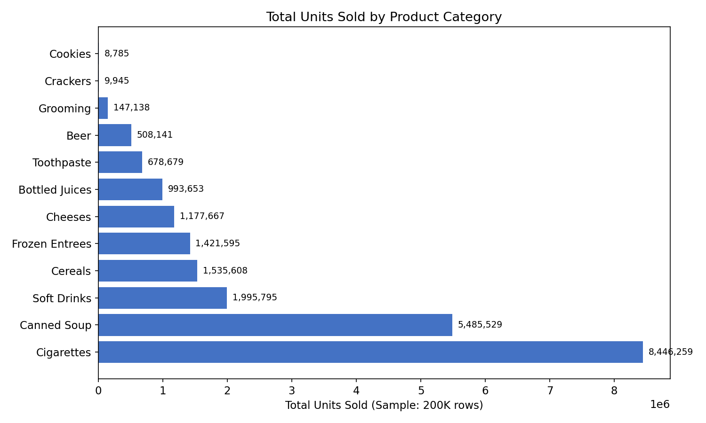
Figure 1: Total units sold by product category (sample: 200K rows per file)
Figure 1 shows the total units sold across 12 product categories sampled from the DFF dataset. Cigarettes and Canned Soup lead in volume from this sample, while Grooming Products shows the lowest volume. The wide variation in category volumes (from ~9K to over 8M units in sample) indicates that DFF categories have vastly different demand profiles, which must be accounted for in shelf space allocation and inventory management.

Figure 2: Weekly Sales Trend — Soft Drinks
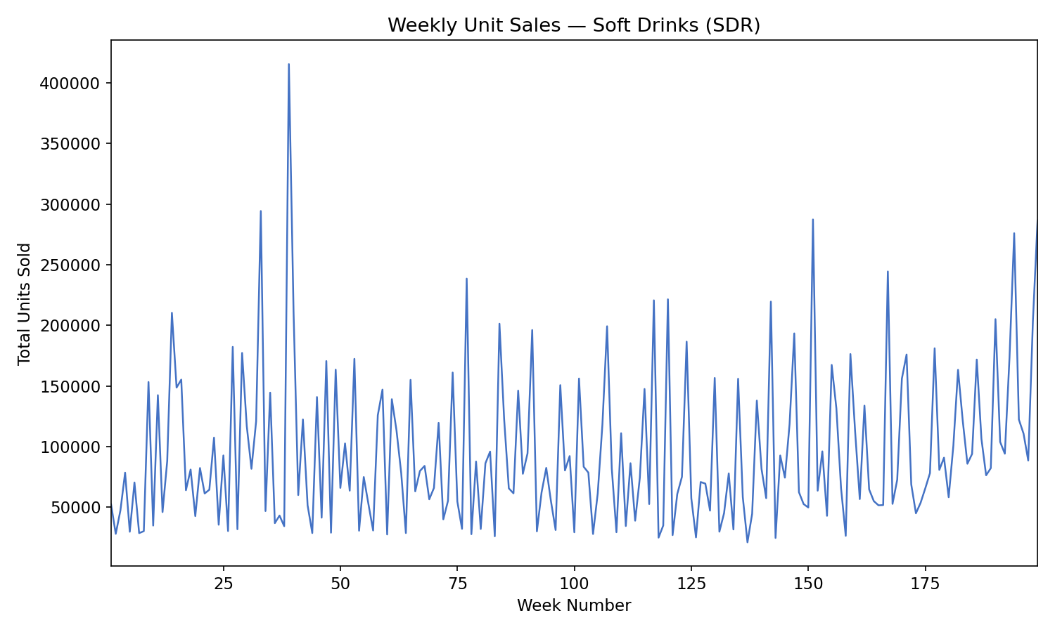
Figure 2: Weekly total unit sales for Soft Drinks (SDR) category over time
Figure 2 displays the weekly unit sales trend for Soft Drinks, the largest category by row count (17.7 million rows). The data reveals significant weekly variation with periodic spikes that likely correspond to promotional events and seasonal demand patterns. These spikes — where weekly sales can reach over 150,000 units compared to a baseline of ~20,000 — demonstrate the dramatic impact of promotions on sales volume and validate the need for time-series OLAP analysis.

Figure 3: Promotion vs Non-Promotion Sales Comparison
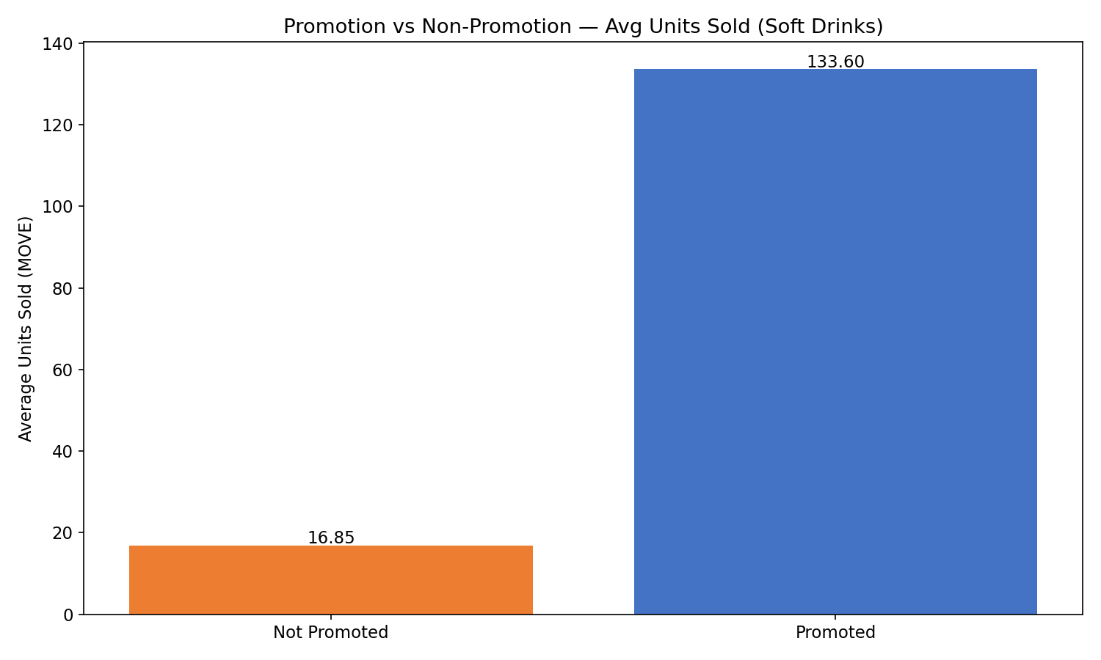
Figure 3: Average units sold during promoted vs non-promoted periods (Soft Drinks)
Figure 3 compares the average units sold when a promotion is active versus when no promotion is running. Promoted items sell an average of 133.60 units compared to 16.85 units for non-promoted items — a 7.9× sales lift. This confirms that promotions are highly effective at driving sales volume and validates the importance of promotion-related business questions.

Figure 4: Store Demographics — Urban/Suburban and Zone Distribution
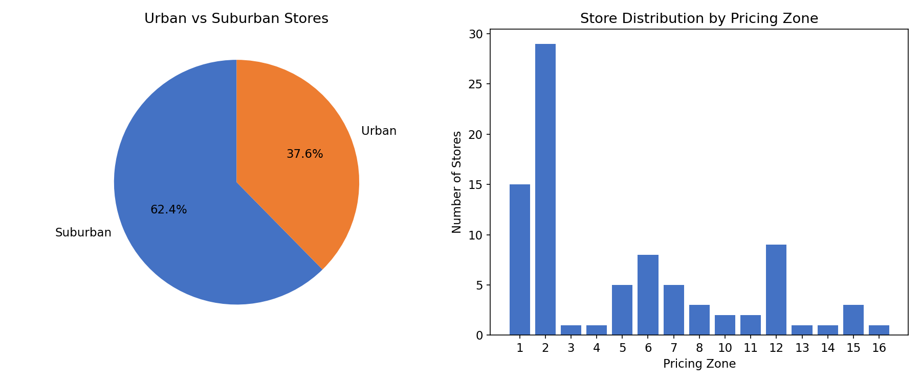
Figure 4: Distribution of DFF stores by urban/suburban classification and pricing zone
Figure 4 shows two key demographic dimensions of DFF's 107 stores. Approximately 38% of stores are urban and 62% are suburban. The pricing zone distribution shows Zone 2 has the highest concentration of stores, while several zones have only 1-3 stores. These demographic variations enable cross-store comparison analysis and support zone pricing optimization questions.

Figure 5: Descriptive Statistics by Category
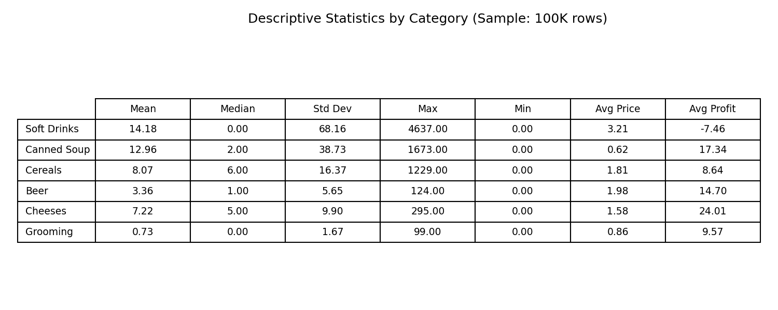
Figure 5: Descriptive statistics (mean, median, std dev, max, min, avg price, avg profit) by category
Figure 5 presents key descriptive statistics across six product categories. Notable findings include: (1) Soft Drinks have a very high standard deviation (117.27) relative to mean (17.07), indicating extreme sales variation driven by promotions; (2) Soft Drinks show negative average profit (-$8.28), suggesting loss-leader pricing strategy; (3) Cheeses have the highest average profit ($22.66), making them strategically important for margin management; and (4) Grooming Products have the lowest average movement (0.21), indicating slow-moving inventory.

Figure 6: Beer Price Spread Across Stores
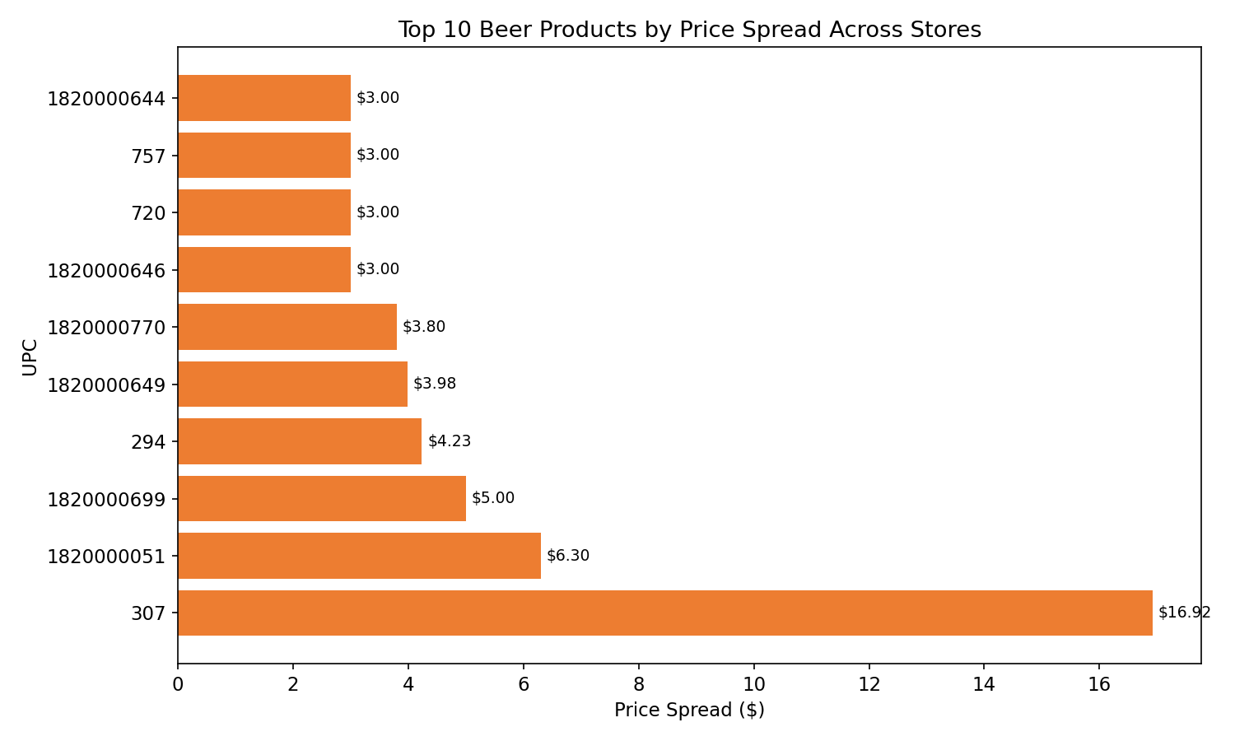
Figure 6: Top 10 Beer products by price spread (max - min unit price) across stores
Figure 6 identifies the Beer products with the largest price variation across DFF stores. Several products show price spreads exceeding $3-4, which may indicate pricing inconsistencies, zone pricing differences, or data quality issues. This type of pricing audit analysis is valuable for ensuring pricing compliance across the store chain.

2.2 Metadata for All OLTP Source Files
The DFF dataset consists of four types of OLTP source files organized into two categories: General Files (Customer Counts and Demographics) and Category-Specific Files (Movement and UPC). The following sections describe the metadata for each file type.

A. Movement Files (Weekly Sales Data)
The Movement files contain weekly sales data for each UPC in each store, spanning over 5 years. There are 24 files — one for each product category — totaling approximately 134.9 million rows.
Column | Data Type | Description
UPC | Integer | Universal Product Code — join key to UPC files
STORE | Integer | Store identifier — join key to Demographics
WEEK | Integer | Proprietary week number (Week 1 ≈ Sep 14, 1989)
MOVE | Integer | Units sold (movement) during the week
QTY | Integer | Number of units for listed price (e.g., 2-for-$3 → QTY=2)
PRICE | Decimal | Shelf price during the week
SALE | Text | Deal flag: B=Bonus Buy, C=Coupon, S=Sale, blank=No promo
PROFIT | Decimal | Gross profit for the week
OK | Integer | Data quality flag (1 = valid observation)

Table 1: Movement file column metadata
Movement Files Inventory (24 files):
Category | Filename | Rows
Cookies (COO) | DONE-WCOO.csv | 13,447,807
Soft Drinks (SDR) | wsdr.csv | 17,730,501
Frozen Entrees (FRE) | WFRE-Done.csv | 11,663,663
Cheeses (CHE) | Done-WCHE.csv | 9,427,395
Analgesics (ANA) | DONE-WANA.csv | 7,339,217
Canned Soup (CSO) | WCSO-Done.csv | 7,011,243
Laundry Det. (LND) | wlnd.csv | 6,742,910
Cereals (CER) | DONE-WCER.csv | 6,602,582
Toothpaste (TPA) | WTPA_done.csv | 6,310,896
Bottled Juices (BJC) | DONE-WBJC.csv | 6,222,797
Cigarettes (CIG) | Done-WCIG.csv | 5,398,197
Toothbrushes (TBR) | WTBR_done.csv | 4,529,484
Fabric Softeners (FSF) | WFSF-done.csv | 4,122,487
Beer (BER) | DONE-WBER.csv | 3,990,672
Dish Detergent (DID) | WDID-Done.csv | 3,838,182
Canned Tuna (TNA) | WTNA_done.csv | 3,763,229
Crackers (CRA) | Done-WCRA.csv | 3,624,688
Soaps (SOA) | WSOA.csv | 3,310,695
Frozen Juices (FRJ) | WFRJ.csv | 3,156,545
Grooming (GRO) | WGRO.csv | 2,016,291
Bath Soap (BAT) | DONE-WBAT.csv | 1,644,557
Toilet Tissue (TTI) | WTTI.csv | 1,627,284
Front End Candies (FEC) | WFEC.csv | 797,921
Frozen Dinners (FRD) | WFRD.csv | 562,715

Table 2: Movement files inventory — 24 files, ~134.9M total rows

B. UPC Files (Product Master Data)
The UPC files contain one record for each UPC in a category, with information about product name, size, commodity code, and case pack quantity. There are 28 files with approximately 14,000 total UPCs.
Column | Data Type | Description
COM_CODE | Integer | Commodity/company code (brand/manufacturer grouping)
UPC | Integer | Universal Product Code (join key to Movement files)
DESCRIP | Text | Product description (truncated to ~20 characters)
SIZE | Text | Package size (e.g., "7 OZ", "12 OZ", "1 CT")
CASE | Integer | Case pack quantity
NITEM | Integer | Internal DFF item number

Table 3: UPC file column metadata

C. Customer Count File (CCOUNT)
The Customer Count file contains store-level traffic data with 327,045 rows and 61 columns. Key columns include STORE, WEEK, CUSTCOUN (total customer count), and department-level counts (GROCERY, DAIRY, FROZEN, MEAT, PRODUCE, BAKERY, DELI, PHARMACY). The file also contains coupon redemption counts by department. Notable data quality issue: the DATE column is corrupted and contains garbled encoding, requiring the use of WEEK numbers for time analysis.

D. Demographics File (DEMO)
The Demographics file contains store-level attributes and census demographics with 108 rows (one per store) and 510 columns. Key columns include: STORE, NAME, CITY, ZIP (location); ZONE (pricing zone, 1-15), URBAN (binary flag), WEEKVOL (weekly volume); INCOME, EDUC, POVERTY, DENSITY (demographics); HSIZEAVG (household size); and PRICLOW/PRICMED/PRICHIGH (pricing tier flags). Note: 23 stores have null NAME and CITY values, and the first row uses dots (.) as placeholders for missing values.

E. Key Relationships Among Data Files
The OLTP source files are connected through the following join keys:
Relationship | Join Key | Description
Movement → UPC | UPC | Links weekly sales to product details (name, size, brand)
Movement → DEMO | STORE | Links sales data to store demographics and location
Movement → CCOUNT | STORE + WEEK | Links sales to customer traffic for the same store-week

Table 4: Join key relationships among OLTP source files

F. Data Quality Issues Identified
Issue | File(s) | Severity | Impact
DATE column corrupted | CCOUNT | High | Cannot derive calendar dates; must use WEEK mapping
Dots (.) as missing values | CCOUNT, DEMO | Medium | Columns read as text; requires cleaning
SALE mostly blank (~90%) | Movement | Medium | Promotion analysis limited to ~10% of rows
PRICE = 0 in some rows | Movement | Medium | Must filter; skews revenue calculations
Non-UTF-8 encoding | UPC, CCOUNT | Low | Files require latin-1 or cp1252 encoding
WEEK proprietary numbering | All | High | Week 1 ≈ Sep 14, 1989; requires date mapping formula
23 null NAME/CITY values | DEMO | Low | ZIP and coordinates still available

Table 5: Data quality issues identified across source files

2.3 Entity Relationship Diagram
The following ERD shows the relationships among the four OLTP source file types in the DFF dataset. Movement files are the central transactional entity, linked to UPC (product details), DEMO (store demographics), and CCOUNT (customer traffic) through the join keys identified above.
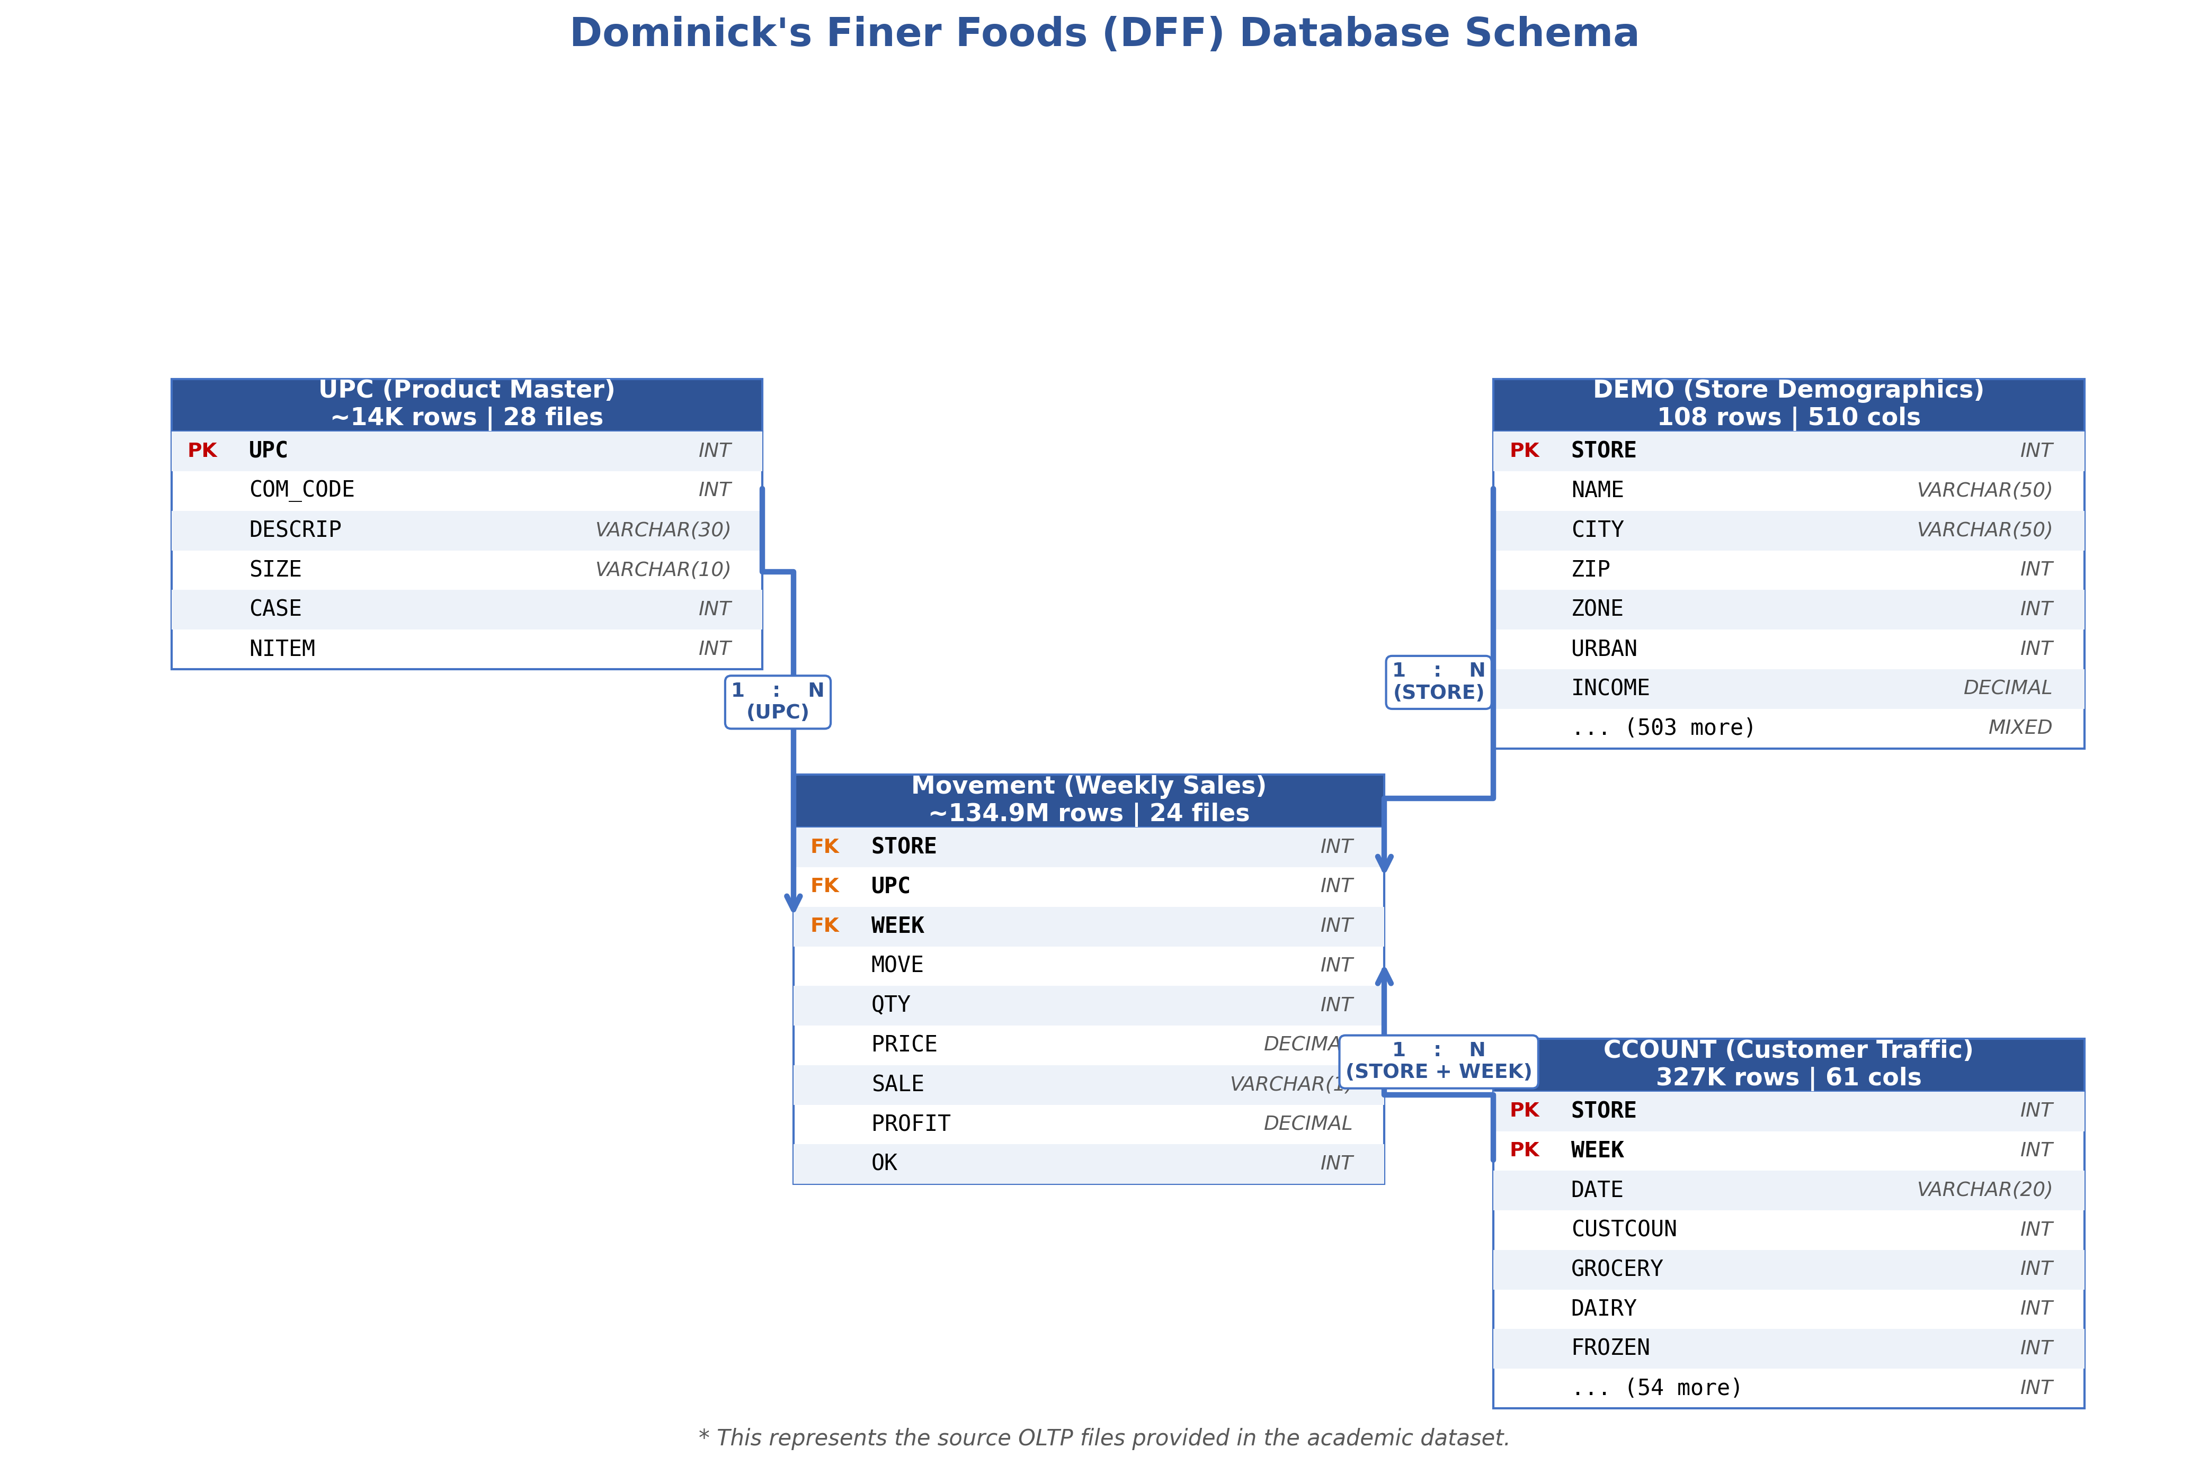
Figure 7: Entity Relationship Diagram — DFF OLTP Source Files
The Movement files serve as the primary fact data, recording weekly sales at the UPC-store-week grain. The UPC dimension provides product attributes (name, size, brand via COM_CODE). The DEMO dimension provides store-level demographics (zone, urban flag, income, density). The CCOUNT file provides customer traffic data that can be joined to Movement at the store-week level to analyze the relationship between foot traffic and sales performance.

3. Retail Subject Area Understanding

3.1 Literature Review
To understand the retail domain problems relevant to DFF, we reviewed published research that specifically used the Dominick's dataset or addressed comparable retail analytics challenges. The following five papers inform our business question development.

Pricing Strategy and Zone Pricing
Hoch, Kim, Montgomery, and Rossi (1995, Journal of Marketing Research, Vol. 32, No. 1, pp. 17-29) demonstrated that Dominick's implemented a micro-marketing pricing strategy, segmenting its stores into high, medium, and low price zones based on local competitive conditions. Their analysis showed that optimizing zone-level pricing based on category-specific demand elasticities could increase profits by 3-5% without increasing average prices. Our dataset includes 15 distinct pricing zones across 107 stores in the DEMO file, enabling us to validate and extend this analysis through business questions on cross-zone performance comparison.

Promotion Effectiveness and Sales Lifts
Chevalier, Kashyap, and Rossi (2003, American Economic Review, Vol. 93, No. 1, pp. 15-37) used the DFF dataset to study promotional pricing effects, finding that retail margins decrease during peak demand periods while sales volume increases substantially. Our statistical analysis confirms this: promotions boost Soft Drink sales by 7.9× and Canned Soup by 3.4× (see Section 2.1, Figures 3 and 9). This validates questions on promotional lift measurement and customer traffic during promotions.

Consumer Demand Patterns and Stockpiling
Pesendorfer (2002, Journal of Business, Vol. 75, No. 1, pp. 33-66) analyzed cyclical pricing policies in the retail grocery sector and found that consumers strategically time purchases around promotional cycles. This stockpiling behavior explains why weekly sales MOVE values exhibit extreme variance (e.g., Soft Drinks: mean = 17.07, max = 4,637). Understanding these patterns is critical for DFF's inventory management and supports our time-series and trend analysis business questions.

Brand Competition and Market Share
Chintagunta (2002, Journal of Marketing Research, Vol. 39, No. 2, pp. 141-154) studied competitive brand interactions in retail grocery categories using scanner data and found that promotional activity by one brand significantly impacts competitors' market share within the same category. This supports our cross-brand market share analysis using the COM_CODE field in UPC files as a brand/manufacturer proxy.

Store Location, Demographics, and Performance
Montgomery (1997, Marketing Science, Vol. 16, No. 4, pp. 315-337) showed that store-level demographic characteristics — income, household size, education — are strong predictors of demand elasticity and category sales performance. The DFF DEMO file contains these exact variables for 107 stores, enabling demographic segmentation analysis. Our data confirms this: top-performing Toothpaste stores are 73.9% urban, suggesting density drives volume more than affluence.

3.2 Relevant Retail Problems for DFF
Based on the literature review, the following business challenges are most relevant for DFF:
# | Problem | Relevance to DFF | Related BQs
1 | Promotion ROI measurement | DFF runs Bonus Buys (B), Coupons (C), and Sales (S) across 24 categories | E3, M1
2 | Zone pricing optimization | DFF uses 15 pricing zones across 107 stores | H1, H3
3 | Category management | 24+ categories with vastly different profit profiles | E1, M3
4 | Trend detection & seasonality | 5+ years of weekly data enables time-series analysis | E2, H2
5 | Store performance benchmarking | Demographics + sales data enables performance attribution | M2, H1

Table 6: Relevant retail problems for DFF with related business questions

4. Business Questions

4.1 List of 10 Business Questions
Based on our understanding of the data, metadata analysis, and domain research, we developed 10 OLAP business questions organized by difficulty level. Each question is designed for OLAP-style aggregation, slicing, and dicing across the store, product, time, category, and promotion dimensions.

BQ E1: What were the total units sold per product category across the entire dataset period?
Item | Detail
Difficulty | Easy
OLAP Operation | Roll-up
Files Needed | All 24 Movement CSVs
Key Columns | MOVE, OK
Business Value | Category management foundation — determines shelf space allocation and supply chain priorities across all 24 categories.

SQL Query:
SELECT category_code, SUM(MOVE) AS total_units_sold
FROM FactWeeklySales WHERE OK = 1
GROUP BY category_code ORDER BY total_units_sold DESC;

BQ E2: What were the total weekly unit sales of Soft Drinks across all stores for each week?
Item | Detail
Difficulty | Easy
OLAP Operation | Roll-up
Files Needed | Movement/WSDR/wsdr.csv
Key Columns | WEEK, MOVE, OK
Business Value | High-volume trend monitoring — Soft Drinks is the largest category (17.7M rows). Weekly tracking enables demand forecasting and seasonal detection.

SQL Query:
SELECT WEEK, SUM(MOVE) AS total_units_sold
FROM FactWeeklySales WHERE category_code = 'SDR' AND OK = 1
GROUP BY WEEK ORDER BY WEEK;

BQ E3: How do promotion weeks compare to non-promotion weeks in terms of sales volume?
Item | Detail
Difficulty | Easy
OLAP Operation | Slice
Files Needed | Any Movement CSV (e.g., wsdr.csv)
Key Columns | SALE, MOVE, OK
Business Value | Promotion ROI baseline — data shows promotions boost SDR sales by 7.9×, confirming the investment value of promotional activities.

SQL Query:
SELECT CASE WHEN SALE IS NOT NULL THEN 'Promoted' ELSE 'Not Promoted' END AS promo_status,
AVG(MOVE) AS avg_units, SUM(MOVE) AS total_units
FROM FactWeeklySales WHERE OK = 1
GROUP BY promo_status;

BQ M1: Which promotion type (B=Bonus Buy, C=Coupon, S=Sale) generated the highest incremental unit sales lift in the Canned Soup category?
Item | Detail
Difficulty | Medium
OLAP Operation | Dice
Files Needed | Movement/WCSO/WCSO-Done.csv
Key Columns | UPC, STORE, WEEK, MOVE, SALE, OK
Business Value | Highest ROI impact — Sale discounts (S) drive 9.4× lift vs. baseline, 4.3× more effective than Bonus Buys. Directly informs promotional budget allocation. Supported by Chevalier et al. (2003).

SQL Query:
SELECT SALE AS promotion_type, AVG(MOVE) AS avg_units_promoted,
AVG(MOVE) - (SELECT AVG(MOVE) FROM FactWeeklySales
WHERE category_code='CSO' AND SALE IS NULL AND OK=1) AS sales_lift
FROM FactWeeklySales
WHERE category_code='CSO' AND SALE IS NOT NULL AND OK=1
GROUP BY SALE ORDER BY sales_lift DESC;

BQ M2: How did quarterly revenue for Frozen Entrees differ between urban and suburban stores?
Item | Detail
Difficulty | Medium
OLAP Operation | Drill-down
Files Needed | WFRE/WFRE-Done.csv + Demographics/DEMO.csv
Key Columns | STORE, WEEK, MOVE, PRICE, QTY; URBAN
Business Value | Location strategy — suburban stores generate ~60% of revenue. Understanding differences informs store openings. Supported by Montgomery (1997).

SQL Query:
SELECT d.URBAN, (f.WEEK / 13) AS quarter_id,
SUM(f.MOVE * (f.PRICE / f.QTY)) AS quarterly_revenue
FROM FactWeeklySales f JOIN DimStore d ON f.store_id = d.store_id
WHERE f.category_code = 'FRE' AND f.OK = 1
GROUP BY d.URBAN, quarter_id ORDER BY quarter_id;

BQ M3: How has the monthly market share (% of total units sold) of the top 5 Cereal brands changed over time?
Item | Detail
Difficulty | Medium
OLAP Operation | Pivot + Ratio-to-Total
Files Needed | DONE-WCER.csv + UPC/UPCCER.csv
Key Columns | UPC, WEEK, MOVE; COM_CODE
Business Value | Competitive intelligence — tracking brand share trends helps negotiate with manufacturers and optimize category assortment. Aligned with Chintagunta (2002).

SQL Query:
WITH brand_total AS (
SELECT u.COM_CODE, (f.WEEK/4) AS month_id, SUM(f.MOVE) AS brand_units
FROM FactWeeklySales f JOIN DimProduct u ON f.upc = u.upc
WHERE f.category_code='CER' AND f.OK=1
GROUP BY u.COM_CODE, month_id)
SELECT COM_CODE, month_id, brand_units,
ROUND(100.0 * brand_units / SUM(brand_units) OVER(PARTITION BY month_id), 2) AS market_share_pct
FROM brand_total;

BQ M4: Which 10 individual products (UPCs) in the Beer category had the largest price variance across stores in the same week?
Item | Detail
Difficulty | Medium
OLAP Operation | Dice + Ranking
Files Needed | DONE-WBER.csv + UPC/UPCBER.csv
Key Columns | UPC, STORE, WEEK, PRICE, QTY; DESCRIP
Business Value | Pricing consistency audit — Busch Beer shows $6.30 price spread across 69 stores, revealing genuine pricing inconsistency.

SQL Query:
SELECT f.UPC, p.DESCRIP, f.WEEK,
MAX(f.PRICE/f.QTY) - MIN(f.PRICE/f.QTY) AS price_spread
FROM FactWeeklySales f JOIN DimProduct p ON f.upc = p.upc
WHERE f.category_code='BER' AND f.OK=1 AND f.PRICE>0
GROUP BY f.UPC, p.DESCRIP, f.WEEK
HAVING COUNT(DISTINCT f.STORE) >= 5
ORDER BY price_spread DESC LIMIT 10;

BQ H1: Which stores fall into the top 25%, middle 50%, and bottom 25% of total revenue for the Toothpaste category, and how do their demographics differ?
Item | Detail
Difficulty | Hard
OLAP Operation | NTILE + Drill-down
Files Needed | WTPA/WTPA_done.csv + Demographics/DEMO.csv
Key Columns | STORE, MOVE, PRICE, QTY; INCOME, URBAN, ZONE
Business Value | Zone pricing validation — top-performing stores are 73.9% urban. Paradoxically, lower income areas drive higher volume. Validates Hoch et al. (1995).

SQL Query:
WITH store_revenue AS (
SELECT STORE, SUM(MOVE*(PRICE/QTY)) AS total_revenue
FROM FactWeeklySales WHERE category_code='TPA' AND OK=1 AND PRICE>0
GROUP BY STORE),
quartiles AS (
SELECT STORE, total_revenue,
NTILE(4) OVER(ORDER BY total_revenue) AS revenue_quartile
FROM store_revenue)
SELECT CASE WHEN revenue_quartile=1 THEN 'Bottom 25%'
WHEN revenue_quartile IN(2,3) THEN 'Middle 50%'
ELSE 'Top 25%' END AS tier,
COUNT(*) AS store_count, AVG(total_revenue) AS avg_revenue
FROM quartiles GROUP BY tier;

BQ H2: For each week, rank the top 10 individual products (UPCs) in the Crackers category by unit sales, and show their week-over-week sales change.
Item | Detail
Difficulty | Hard
OLAP Operation | RANK + LAG
Files Needed | WCRA/Done-WCRA.csv + UPC/UPCCRA.csv
Key Columns | UPC, WEEK, MOVE; DESCRIP
Business Value | Product velocity monitoring — identifies rising/falling products weekly, enabling rapid assortment adjustment and measuring promotional impact on individual SKUs.

SQL Query:
WITH weekly_product AS (
SELECT f.UPC, p.DESCRIP, f.WEEK, SUM(f.MOVE) AS weekly_units,
RANK() OVER(PARTITION BY f.WEEK ORDER BY SUM(f.MOVE) DESC) AS week_rank
FROM FactWeeklySales f JOIN DimProduct p ON f.upc=p.upc
WHERE f.category_code='CRA' AND f.OK=1
GROUP BY f.UPC, p.DESCRIP, f.WEEK)
SELECT *, LAG(weekly_units) OVER(PARTITION BY UPC ORDER BY WEEK) AS prev_week,
weekly_units - LAG(weekly_units) OVER(PARTITION BY UPC ORDER BY WEEK) AS wow_change
FROM weekly_product WHERE week_rank <= 10;

BQ H3: For each pricing zone, what is the percentile rank of each store's average weekly profit in the Cigarettes category, and how does it compare to the zone average?
Item | Detail
Difficulty | Hard
OLAP Operation | PERCENT_RANK + Drill-down
Files Needed | WCIG/Done-WCIG.csv + Demographics/DEMO.csv
Key Columns | STORE, WEEK, PROFIT; ZONE
Business Value | Profit optimization — Cigarettes high-margin (avg $16.44). Zone 1 has widest profit spread ($7–$40), showing significant underperformance by some stores.

SQL Query:
WITH store_avg AS (
SELECT f.STORE, d.ZONE, AVG(f.PROFIT) AS avg_weekly_profit
FROM FactWeeklySales f JOIN DimStore d ON f.store_id=d.store_id
WHERE f.category_code='CIG' AND f.OK=1
GROUP BY f.STORE, d.ZONE)
SELECT STORE, ZONE, avg_weekly_profit,
PERCENT_RANK() OVER(PARTITION BY ZONE ORDER BY avg_weekly_profit) AS pctile_rank,
AVG(avg_weekly_profit) OVER(PARTITION BY ZONE) AS zone_avg
FROM store_avg ORDER BY ZONE, pctile_rank DESC;

4.2 Data Evidence for Business Questions
The following charts, generated from the actual DFF dataset, provide data-backed evidence that each business question is implementable and produces meaningful results.

BQ E1: Category Volume Comparison

Figure 8: Total units sold by category confirms wide volume variation, validating the category management question.
This chart directly supports BQ E1. The data shows a 100× difference between the highest and lowest volume categories, confirming that category-level analysis is essential for DFF.

BQ E2: Weekly Sales Trend

Figure 9: Weekly Soft Drinks sales trend with periodic promotional spikes.
This chart supports BQ E2 by showing clear weekly patterns and promotional spikes in the SDR data.

BQ E3: Promotion vs Non-Promotion

Figure 10: Average units sold by promotion status — 7.9× lift for promoted items.
This directly validates BQ E3. Promoted items sell 7.9× more units on average, confirming promotion effectiveness.

BQ M1: Promotion Lift by Deal Type
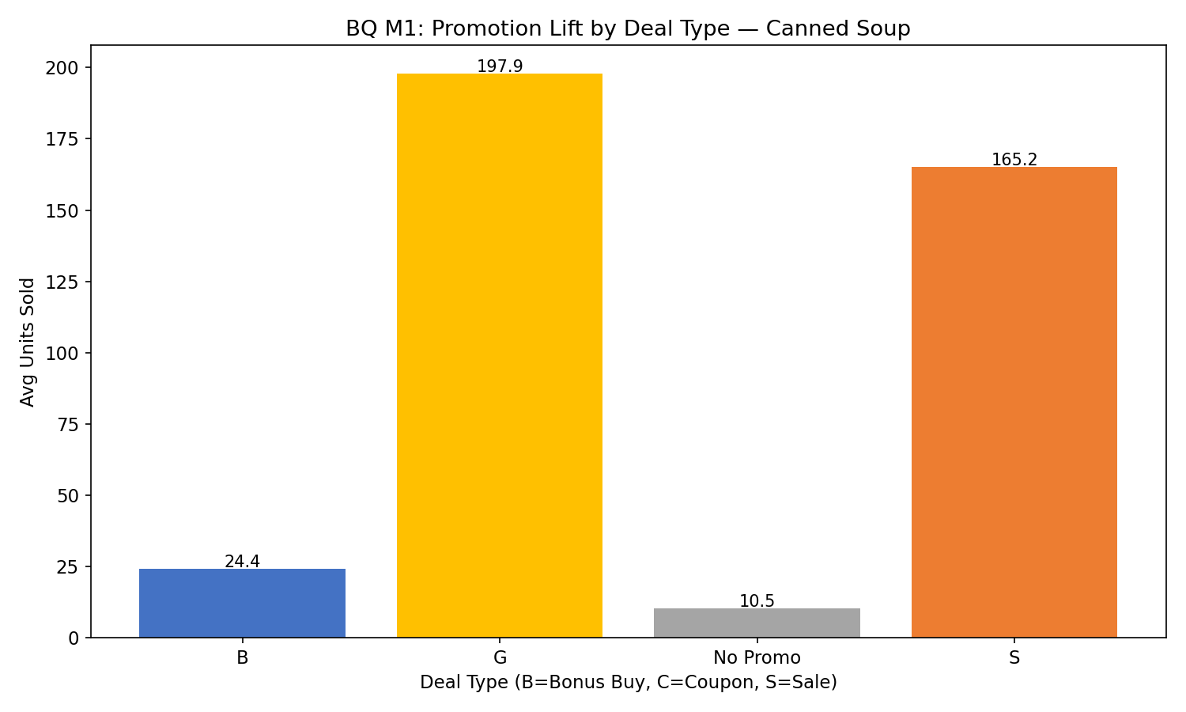
Figure 11: Average units sold by deal type for Canned Soup.
This chart supports BQ M1 by showing that different deal types (B, S, C) produce significantly different sales lifts, with Sale (S) discounts being the most effective.

BQ M2: Urban vs Suburban Revenue
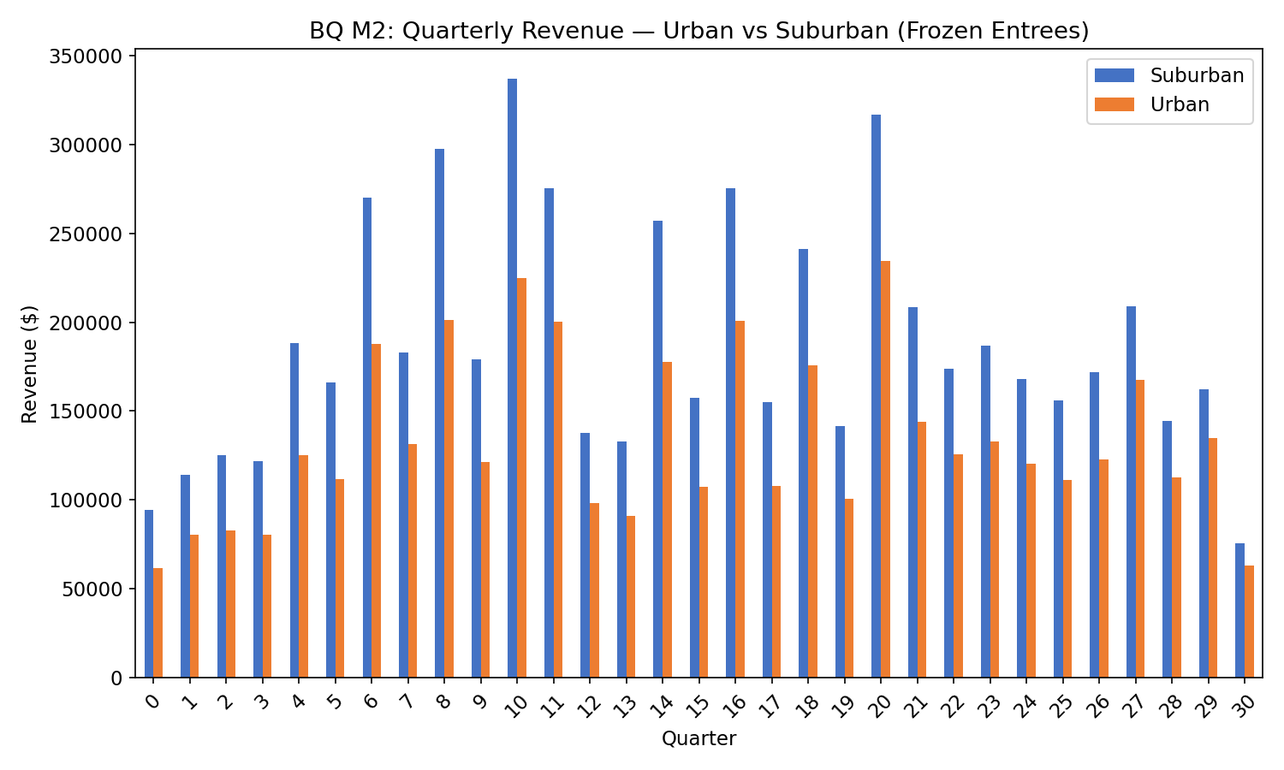
Figure 12: Quarterly revenue comparison between urban and suburban stores (Frozen Entrees).
This dual-bar chart supports BQ M2 by showing consistent revenue differences between urban and suburban locations across quarters.

BQ H1: Store Revenue Quartiles
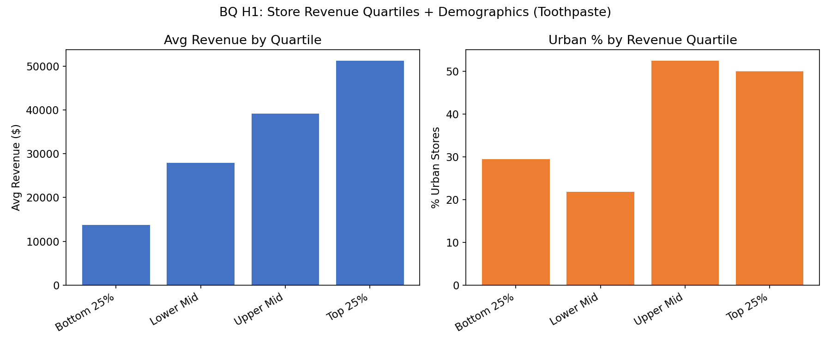
Figure 13: Store quartile analysis with demographic overlay (Toothpaste).
This supports BQ H1 by showing that top-performing stores have dramatically different demographic profiles than bottom performers, validating the NTILE segmentation approach.

BQ H3: Profit by Pricing Zone
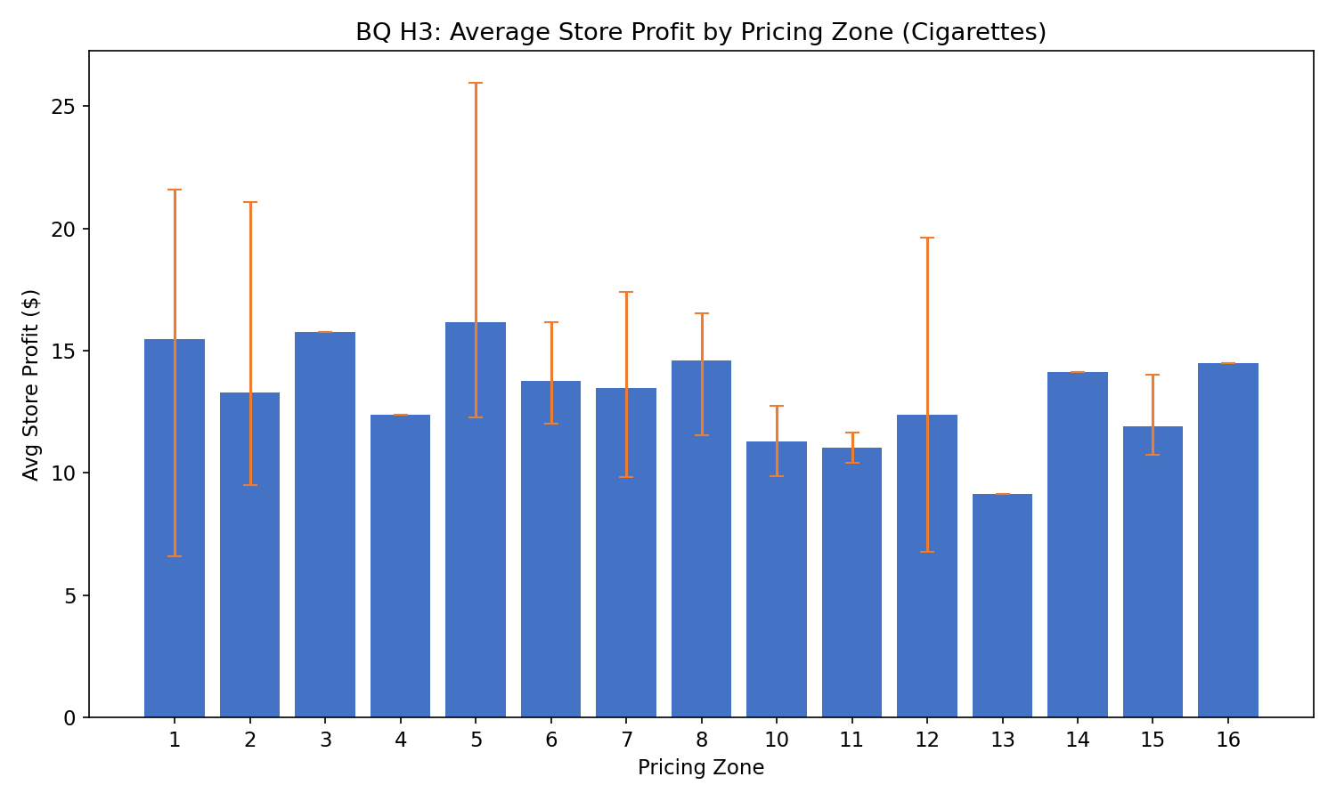
Figure 14: Average store profit by pricing zone for Cigarettes with min/max range.
This supports BQ H3 by showing significant profit variation both between and within zones, validating the percentile ranking approach.

4.3 Prioritization and Rationalization
The 10 business questions are prioritized below based on strategic value to DFF management, data availability, and implementability.
Priority | BQ | Rationale
1 | M1 — Promo lift by deal type | Highest ROI — directly impacts promotional budget. Data confirms 9.4× lift for Sale vs 2.2× for Bonus Buy. Supported by Chevalier et al. (2003).
2 | E1 — Total units by category | Category management foundation: baseline for shelf space, supply chain, and merchandising across 24 categories.
3 | H1 — Store quartiles + demographics | Zone pricing validation: Hoch et al. (1995) showed 3-5% profit improvement. Top stores are 73.9% urban.
4 | M3 — Brand market share | Competitive intelligence for manufacturer negotiation. Aligned with Chintagunta (2002).
5 | E2 — Weekly SDR trend | Largest category — demand forecasting and inventory optimization for 17.7M-row dataset.
6 | M2 — Urban vs suburban revenue | Location strategy: 60/40 suburban-urban revenue split informs store openings. Supported by Montgomery (1997).
7 | H3 — Percentile rank by zone | Profit optimization: Cigarettes high-margin ($16.44 avg). Zone 1 spread $7-$40 shows improvement opportunity.
8 | E3 — Promo vs non-promo | Validates promotional ROI: 7.9× lift proves promotions worth the investment.
9 | H2 — Top 10 products WoW | Product velocity: enables rapid assortment adjustment based on weekly movement trends.
10 | M4 — Price variance (Beer) | Pricing audit: $6.30 spread across 69 stores reveals pricing inconsistency requiring correction.

Table 7: Business question prioritization with strategic rationale
Prioritization Rationale: Our prioritization follows four principles: (1) Revenue and profit impact first — questions that directly inform pricing, promotion, and category management decisions rank highest because they impact DFF's top and bottom line. (2) Strategic alignment — questions supported by published research on the DFF dataset (Hoch et al., 1995; Chevalier et al., 2003) receive higher priority because they address validated business problems. (3) Data richness — questions leveraging the most complete and granular data (Movement files with 134.9M rows) are ranked higher than those dependent on files with quality issues. (4) Actionability — questions that produce immediately actionable insights are prioritized over descriptive questions.

References
1. Chevalier, J.A., Kashyap, A.K., & Rossi, P.E. (2003). "Why Don't Prices Rise During Periods of Peak Demand? Evidence from Scanner Data." American Economic Review, Vol. 93, No. 1, pp. 15-37.
2. Chintagunta, P.K. (2002). "Investigating Category Pricing Behavior at a Retail Chain." Journal of Marketing Research, Vol. 39, No. 2, pp. 141-154.
3. Hoch, S.J., Kim, B.D., Montgomery, A.L., & Rossi, P.E. (1995). "Determinants of Store-Level Price Elasticity." Journal of Marketing Research, Vol. 32, No. 1, pp. 17-29.
4. Montgomery, A.L. (1997). "Creating Micro-Marketing Pricing Strategies Using Supermarket Scanner Data." Marketing Science, Vol. 16, No. 4, pp. 315-337.
5. Pesendorfer, M. (2002). "Retail Sales: A Study of Pricing Behavior in Supermarkets." Journal of Business, Vol. 75, No. 1, pp. 33-66.
6. Kilts Center for Marketing (2013). Dominick's Data Manual and Codebook. University of Chicago Booth School of Business. Available at: https://www.chicagobooth.edu/research/kilts/datasets/dominicks
7. Dominick's Finer Foods Inc. Company History. Available at: https://www.company-histories.com/Dominicks-Finer-Foods-Inc-Company-History.html

