Diego Alba Burbano
Quantitative Methods in Biology: Extra Credit

t-Stochastic Neighbor Embedding (t-SNE)

- What is SNE?

Stochastic Neighbor Embedding is an algorithm for data visualization. SNE attempts to represent high-dimensional data in lower dimensions so the structure of the data can be better analyzed by humans (we’re not very good at interpreting high-dimensional data). In order to do this, SNE follows these steps:

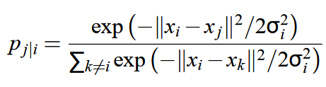
Conditional probabilities, which represent similarities, are defined by measuring the distance between datapoints. In other words, the closer two datapoints are to each other, the more likely they are to belong to the same neighborhood (the more similar they are). Hence, the conditional probability p_{j|i} is given by the equation below, where σ_{i} is the variance of the Gaussian distribution centered at x_{i}.

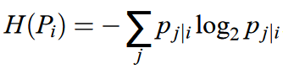
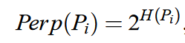
Because the density of the data is probably not constant throughout, a variance for each datapoint must be defined. To do so, a chosen perplexity (a measurement of how well a probability distribution predicts a sample) is fixed, and the variance that satisfies it is calculated:

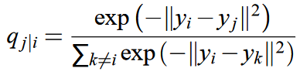
Likewise, conditional probabilities for the low-dimensional representation of the data can also be defined:

If the low-dimensional model is accurate, then p_{j|i} and q_{j|i} should be equal. The divergence of p_{j|i} and q_{j|i} can be quantified by their relative entropy (Kullback–Leibler divergence). Therefore, is this measure is minimized for all datapoints, a proper representation of the high-dimensional data is achieved. In order to minimize the divergence, represented by the const function C below, a gradient descend method is used.

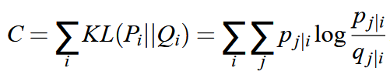
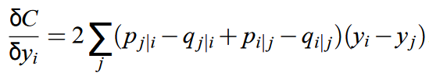
- Differences and Advantages

The two differences between SNE and t-SNE are:
- Symmetrized version of the cost function with simpler gradients.
- Similarities in the low-dimensional representation are computed with a Student t-distribution (instead of Gaussian).
These two changes were implemented to overcome some of the original drawbacks of SNE: a difficult to optimize cost function, and small distances in the low-dimensional space that lead to crowding of datapoints.
The advantage of using a symmetric cost function is the simpler form of its gradient, which is faster to compute, and therefore easier to optimize. Moreover, using a t- distribution allows for grater spacing between points in the lower-dimensional representation that are close together in the high-dimensional space, avoiding overcrowding.
- Optimizing t-SNE

The authors describe two techniques to optimize the t-SNE algorithm: early compression, and early exaggeration. In the former, the first points at the start of the optimization are forced to be close to each other. This makes it easier to explore all of the possibilities to organize the data, since clusters can easily move through one another. In the later, the probabilities in the high-dimensional space are multiplied by a factor (the paper gives 4 as an example), which makes the clusters spread away in the low-dimensional representation. With greater relative empty space, the clusters can easily move around in order to find a good global structure.

- Weaknesses

The three main weaknesses discussed by the authors are the following:
- Performance on general dimensionality reduction problems
- Curse of intrinsic dimensionality
- Not guaranteed to converge to a global optimum of its cost function.
The paper only discusses using t-SNE for data visualization purposes, so it is unclear how will the algorithm perform if the data is reduced to dimensions greater than two or three. Moreover, neighbor embedding might not accurately represent the structure of intrinsically high-dimensional data (the structure of such data could be too complex). Lastly, because the cost function is non-convex, several parameters must be fixed in order to do the optimization, and so the low-dimensional solution depends on these parameters.

