**수치해석 Final Report**

21700242 문선빈

1. Simulink Simulation

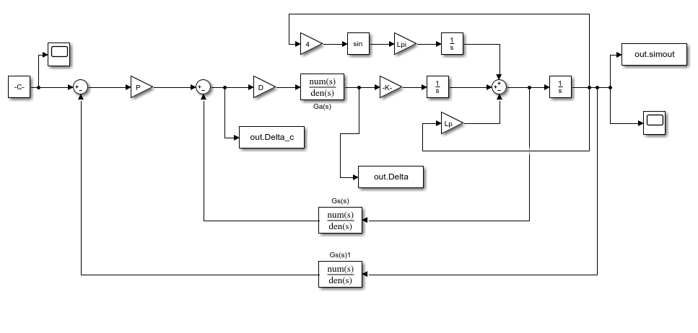

Figure 1. Simulation 1

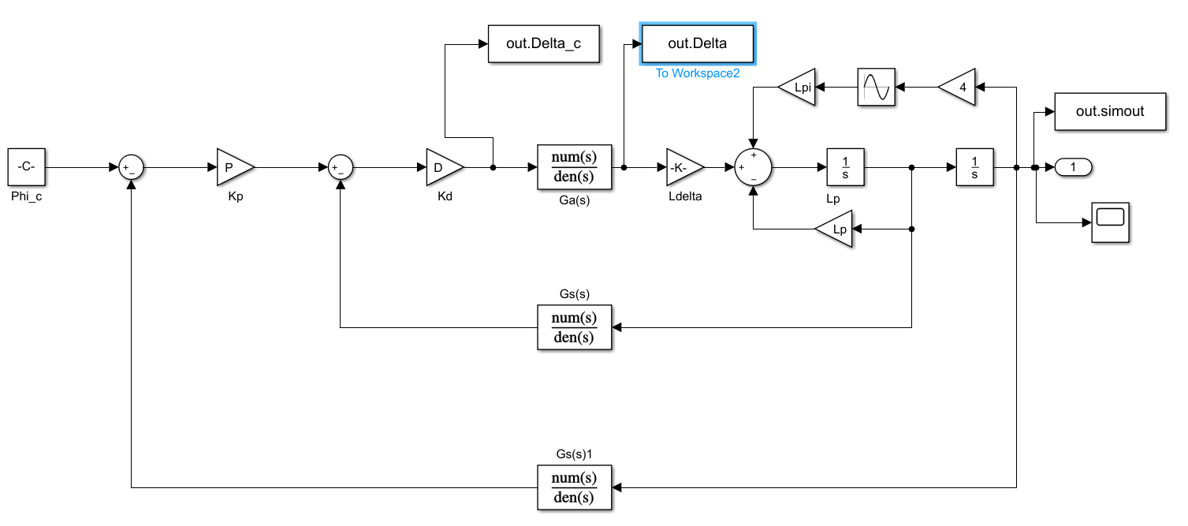

Figure 2. Simulation 2

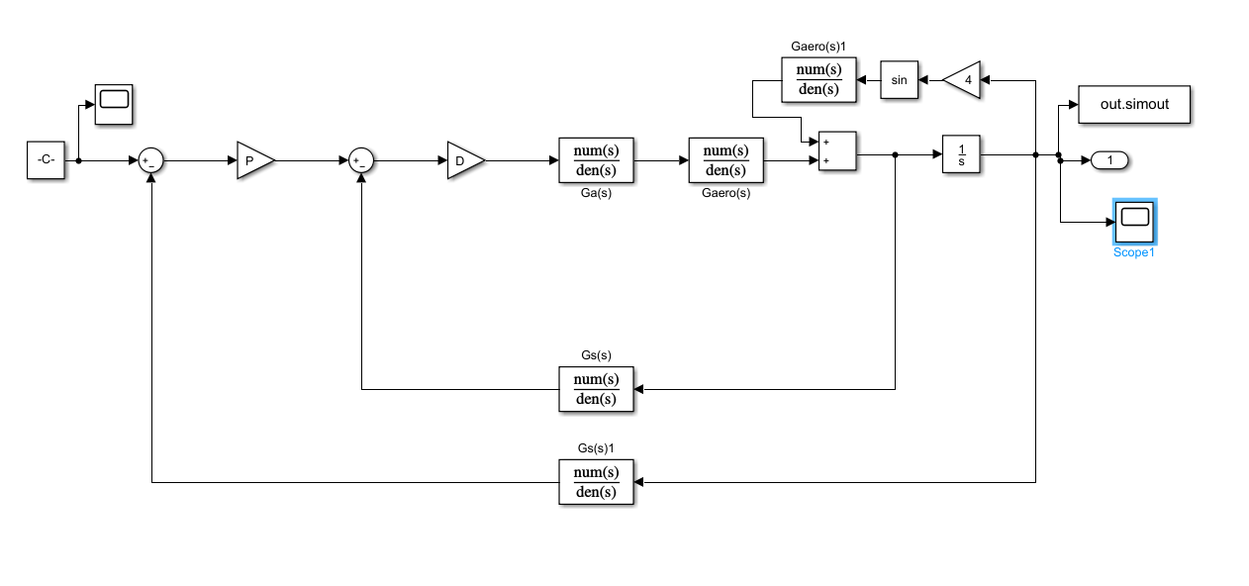

Figure 3. Simulation 3

|  |  |  |
| --- | --- | --- |
|  |  |  |
|  | | |

|  |  |  |
| --- | --- | --- |
|  |  |  |
|  | | |

|  |  |  |
| --- | --- | --- |
|  |  |  |
|  | | |

|  |  |  |
| --- | --- | --- |
|  |  |  |
|  | | |

|  |  |  |
| --- | --- | --- |
|  |  |  |
|  | | |

|  |  |  |
| --- | --- | --- |
|  |  |  |
|  | | |

|  |  |  |
| --- | --- | --- |
|  |  |  |
|  | | |

|  |  |  |
| --- | --- | --- |
|  |  |  |
|  | | |

|  |  |  |
| --- | --- | --- |
|  |  |  |
|  | | |

1. Code

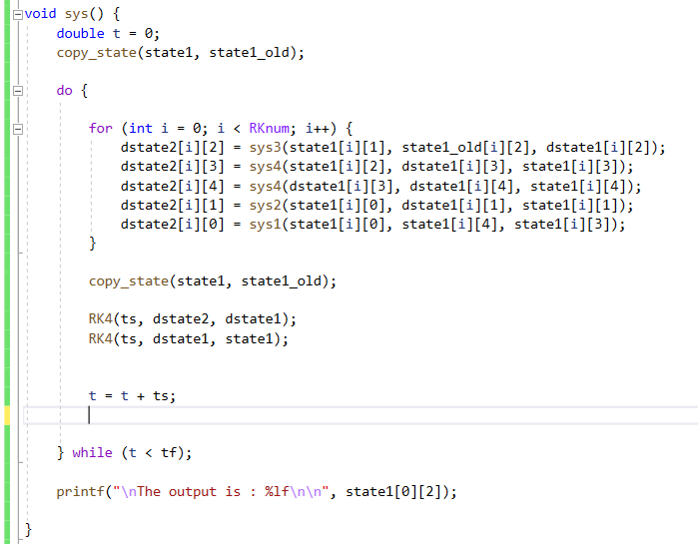

Figure. Overall System Code

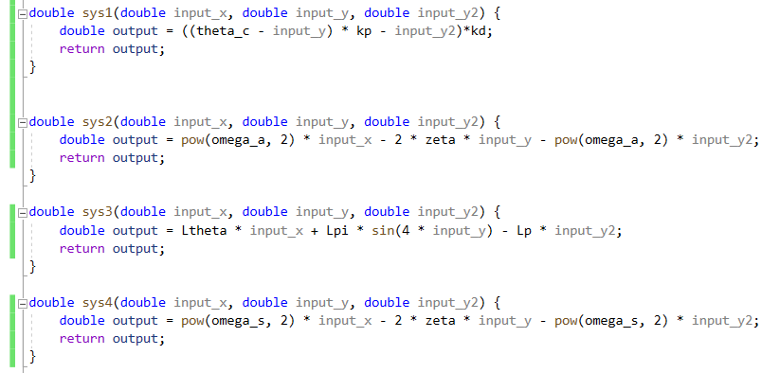

Figure. each system Transfer Function

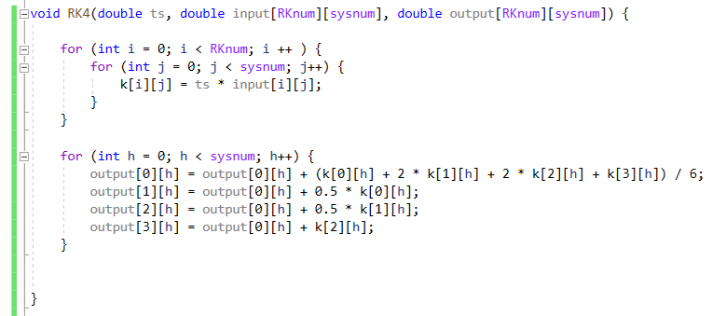

Figure. Runge Kutta 4

1. output

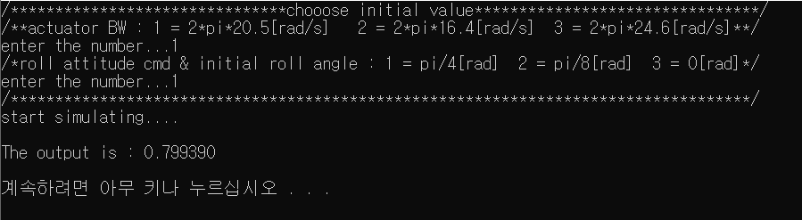

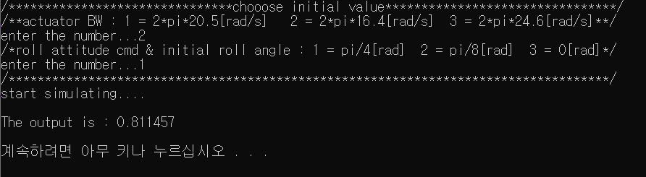

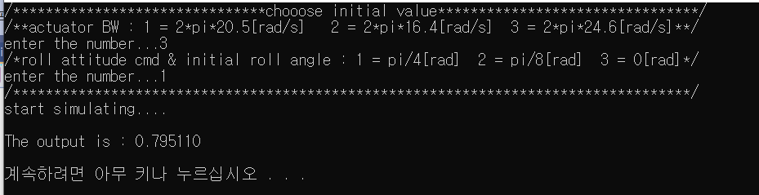

Figure. Output

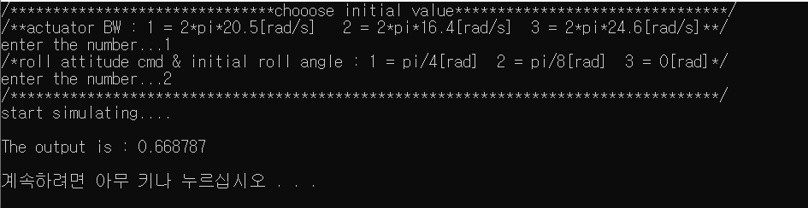

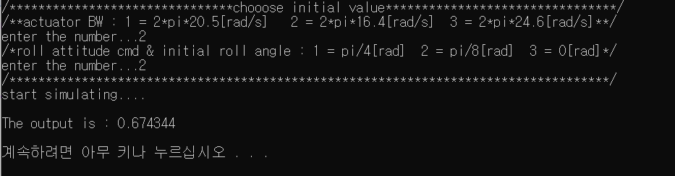

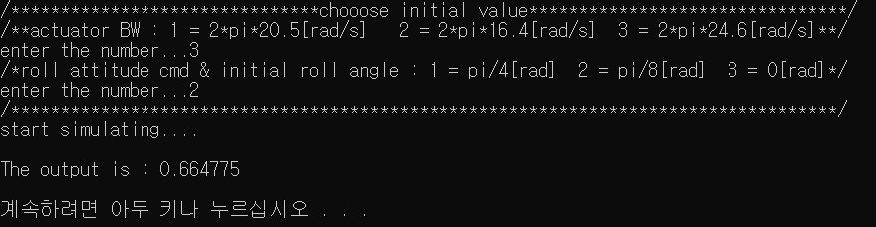

Figure. Output