# Cooling Tower Lab

Ryan Dalby

February 4, 2021

**Figure 1a.** Water temperature and wet bulb temperature of the air as a function of height along the cooling tower for the case of an inlet water flow rate of 30.0 gm/s. The Range and Approach are denoted by the vertical lines labeled “R” and “A”, respectively.

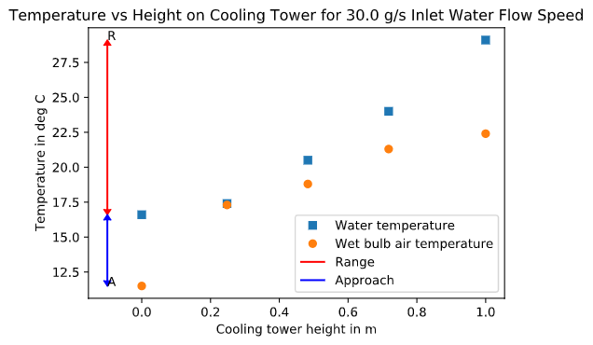

**Figure 1b.** Cooling tower efficiency as a function of water inlet flow rate.

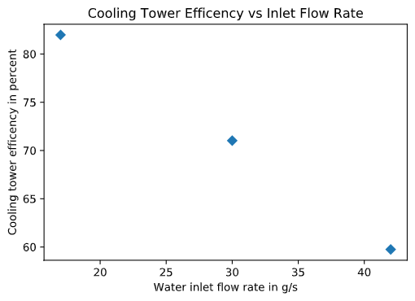

**Figure 1c.** Specific humidity as a function of height along the cooling tower. The results for three different water inlet flow rates are shown.

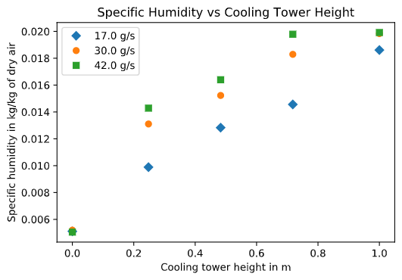

**Figure 1d.** Dry bulb temperature as a function of height along the cooling tower. The results for three different water inlet flow rates are shown.

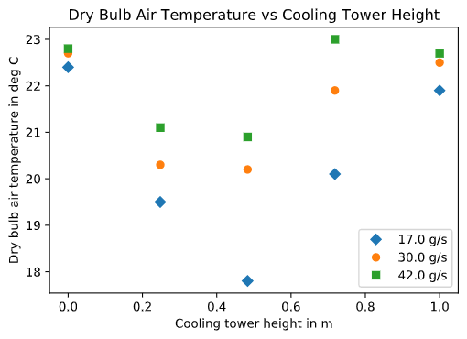

**Figure 1f.** Heat transfer rate to the dry air and the surroundings as a function of water inlet temperature.

**NOTE:** Q_dot_amb values are low (should be closer to 0.3 kW) and Q_dot_a was high (should be closer to 1 kW).

These discrepancies are likely the result of:

* Measuring error (the T3 and T4 values were essentially equal meaning that dry and wet bulb temperatures were equal at the outlet)
* Unaccounted for energy into the system (the heater and pump may have put more energy into the system than the given power values)

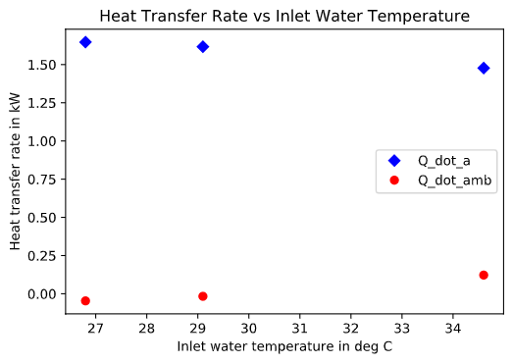

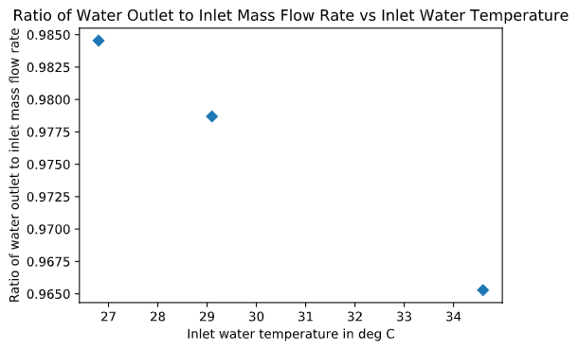

**Figure 1e.** Ratio of water outlet mass flow rate over water inlet mass flow rate as a function of water inlet temperature.

**2a.**

The dry bulb temperature of the air-vapor mixture initially decreases until around 0.5m up the cooling tower then begins to increase again as seen in Figure 1d, as flow rate increases we get less of an initial dip in temperature. The specific humidity increases as the air-vapor mixture moves up the cooling tower as seen in Figure 1c, as the flow rate increases the specific humidity does as well.

These observtions can be explained by first considering the state of the air entering the cooling tower at the bottom, this air is dry as shown by the specific humidity at 0m. At the bottom of the tower the evaporation rate is the highest since the dry and wet bulb temperatures are the furthest apart which means that the wet bulb temperature is having a lot of heat taken in the form of evaporation. Thus initially the evaporation process takes in so much heat it actually decreases the dry bulb temperature of the air-vapor mixture. As we move higher up the tower the water content in the air-vapor mixture continues to increase and take on more heat and as the evaporation rate is not as large and thus more of the heat increases the temperature of the air-vapor mixture.

**2b.**

Approximately 2.5% of the inlet water ends up evaporated out of the system. This is found by looking at Figure 1e which relates the mass flow rates of the water outlet to the water inlet. The mass flow rate ratio of the outlet to the inlet would be 1 if there was no mass loss (we are assuming we are in steady state). In this case the ratio is on average .975 so .025 of the water is lost to evaporation.

As the inlet water temperature increase we also see that more water is lost since the outlet to inlet ratio decreases as temperature increases. This makes sense since the state of the water is more favorable for evaporation of the water since the temperature is higher (given all other thermodynamic properties are constant).

**2c.**

A calculated makeup water flow rate on average of approximately 0.63 g/s is needed for this cooling tower from calculation. The observed, rough estimate water flow rate, found by measuring the decrease in volume of the makeup tank, was found to be approximately 0.1 g/s. The average calculated value is 6.3 times bigger, or 630% more than the rough estimate measured in lab. Although this seems like a big difference this is reasonable since both of these values are on the same magnitude scale and the water volume measured was a very rough estimate. Specifics can be seen in the code for the determination of these values.

**2d.**

The maximum efficiency achieved was approximately 82% at a mass flow rate of 17.0 g/s. Looking at Figure 1b we see a trend of decreasing efficiency as the water mass flow rate increases, this trend also appears to be linear for this small sample size.