# Spark Ignition Engine Lab

Ryan Dalby

February 11, 2021

**Figure 1a.** Measuredtorque versus crankshaft speed for the spark ignition engine at fully open throttle.

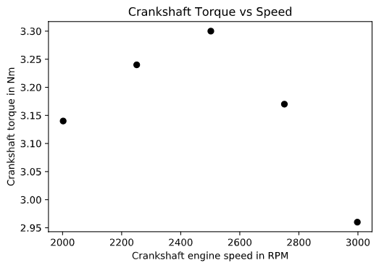

**Figure 1b.** Brake power and total power versus crankshaft speed for the spark ignition engine at full throttle. The markers indicate the experimental measurements. The black line represents the total theoretical power available, based on the Otto cycle using the air-standard model at the same conditions as those measured in the experiment.

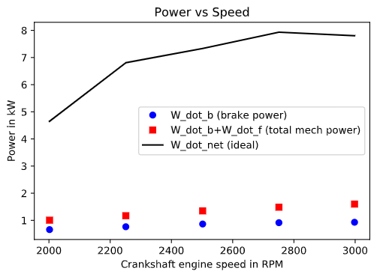

**Figure 1c.** Thermal efficiency versus crankshaft speed, comparing the measurements and theory. The theory is based on the Otto cycle using the air-standard model at the same conditions as those measured in the experiment.

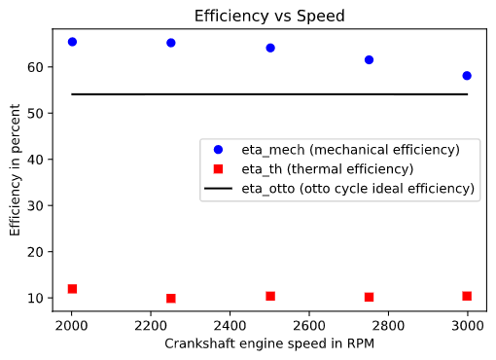

**Figure 1d.** Work rate terms in the energy balance of the engine versus crankshaft speed, as based on the experimental measurements.

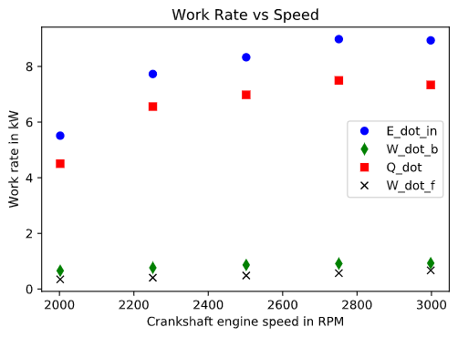

**Figure 1e.** Mean effective pressure acting on the piston head versus crankshaft speed, as based on the experimental measurements.

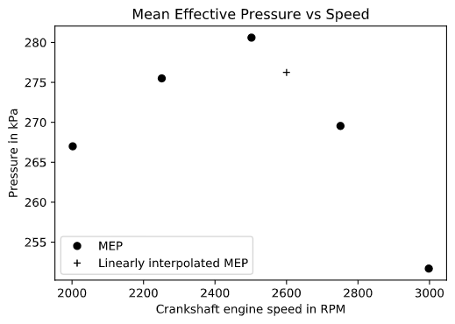

**2a.**

Average W_dot_b/E_dot_in = 10.56%; average W_dot_f/E_dot_in = 6.25%; average Q_dot/E_dot_in = 83.20%

The frictional and inertial losses are shown by W_dot_f/E_dot_in at 6.25%, this is much lower than the miscellaneous heat lost to the surrounds of Q_dot/E_dot_in at 83.20%. Clearly the heat lost to the surroundings is where a majority of the energy into the system ends up. At the same time when W_dot_b and Q_dot increase the thermal efficiency of the engine decreases (W_dot_b/E_dot_in) since less of the energy into the system is going to be used as brake power (W_dot_b). In the end minimizing W_dot_b and Q_dot are important to increase the thermal efficiency of the engine.

**2b.**

* The average mechanical efficiency of the engine is 0.63, or 63%. This is lower than the minimum nominal efficiency of a 1-4 hp electric motor of 78.8% (“Electric Motor Efficiency,”).
* The thermal efficiency was 10.56% on average for this motor. The Otto cycle efficiency for this motor was calculated to be 54.1%. The discrepancy between the thermal efficiency and the Otto cycle efficiency was on average 80.48%
* During our analysis we assumed the fluid inside of the engine was ideal air (reversible and an ideal gas), not a non-ideal air-gas mixture. We assumed the combustion process is a simple heat addition process. We assumed the exhast process is a simple heat rejection process. Each of these things could have contributed to the 80.48% discrepancy between the thermal and Otto cycle efficiency.

**2c.**

The estimated MEP at 2600 RPM is 276.25kPa, this corresponds to an average force of 3678.02N or 826.85lb.

**2d.**

Electrification/hybridization of combustion engines by introducing an electric motor can reduce CO2 emissions by around 50% (Ishii et al.). Some of the specific things that can be utilized to reduce CO2 emissions through electrification is regenerative braking which can be used to charge the battery. The electric system also allows for more efficient idling and stop and go engine efficiencies. In the end having a battery for instant power (and storing power) can be very effective at saving energy that would be lost to inertia or heat.

The primary challenges with hybridization of combustion engines is the new complexity that is introduced with the electrical drivetrain (Weber). The electrical systems on hybrid cars is much more complicated. This complexity means that manufacturing is more complicated, control systems needs to be more intelligent, and the system design must be more efficient in terms of weight because of the extra components.

**References**

1. “Electric Motor Efficiency,” Engineering ToolBox. [Online]. Available: https://www.engineeringtoolbox.com/electrical-motor-efficiency-d_655.html. [Accessed: 08-Feb-2021].
2. J. Ishii, M. Osuga, T. Okada, H. Miyazaki, M. Koseki, and K. Tanikoshi, “[PDF] Reduction of CO 2 Emissions for Automotive Systems: Semantic Scholar,” *[PDF] Reduction of CO 2 Emissions for Automotive Systems | Semantic Scholar*, 01-Jan-1970. [Online]. Available: https://www.semanticscholar.org/paper/Reduction-of-CO-2-Emissions-for-Automotive-Systems-Ishii-Osuga/bb04a0866899f79a3b14d133b3503aba73e8b0e9. [Accessed: 08-Feb-2021].
3. A. Weber, “The Hybrid Challenge,” ASSEMBLY RSS, 04-May-2012. [Online]. Available: https://www.assemblymag.com/articles/84379-the-hybrid-challenge. [Accessed: 08-Feb-2021].