# Circular Cylinder Lab

Ryan Dalby

March 4, 2021

**Figure 1a.** Normalized mean horizontal velocity as a function of vertical distance in the wake of the circular cylinder at x/D=7 and ReD=1x104. The error bars represent a 95% confidence interval in the mean at each y-location. Measurements were obtained using a Pitot-static tube, and time-averaged for 15 s at each y-location.

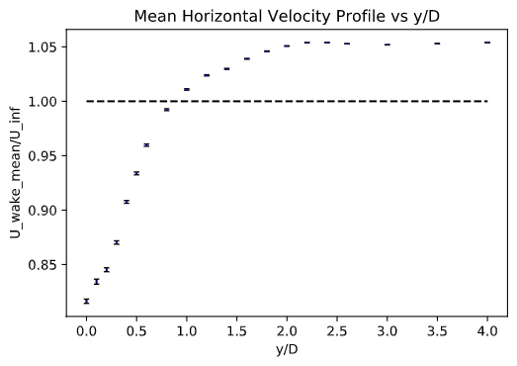

**Figure 1b.** Normalized turbulence intensity as a function of vertical distance in the wake of a circular cylinder under the same conditions as those in Figure 1a.

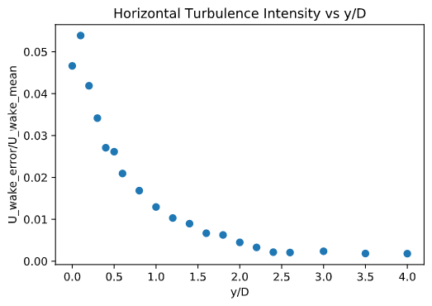

**Figure 1c.** Coefficient of pressure as a function of angular position around the surface of a circular cylinder at ReD=1x104. The error bars represent a 95% confidence interval in the mean at each angular position. Measurements were obtained using a surface tap on the cylinder, and time-averaged for 15 s at each angular position.

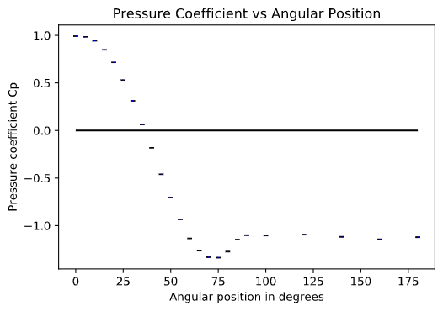

**Figure 1d.** Drag coefficient versus Reynolds number for a circular cylinder, comparing the values obtained from the present measurements using two different methods: (i) integrating the static pressure distribution around the cylinder, and (ii) applying conservation of x-momentum to a control volume around the cylinder. The published data are from Schlichting, Boundary-Layer Theory (1979).

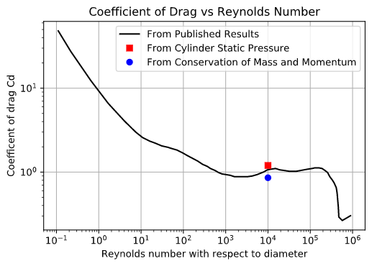

**2a.**

The wake thickness behind the cylinder was found to be 2.25D, based on Pitot-static probe measurements taken at a downstream distance of x/D=7.00 and Reynolds number of ReD=10000.00. The wake thickness was determined as the y-location in the wake profile where the wake velocity u reached a plateau, i.e., became independent of y.

**2b.**

The maximum uncertainty for u_wake_mean was 10.77% at y/D = 0.10. The maximum uncertainty for Cp was 49.36% at theta = 35.00 degrees. As can be seen in Figure 1a the error bars on u/U∞ are not uniform with respect to y/D, this is likely due to how u_wake_mean/u_inf is changing the fastest as a function of y/D at the region of maximum uncertainty. This implies that u_wake_mean/u_inf is changing rapidly at positions near that position and thus over a 15 second sample its value is more susceptible to error in this region with higher velocity gradients. As can be seen in Figure 1c the error bars on Cp are not uniform with respect to θ, this is also is likely due to how Cp is changing the fastet with respect to θ, thus implying that the region has large differences in Cp for small θ differences. At regions where Cp is not changing rapidly with respect to θ, error is the lowest. This makes sense since regional differences in these areas are less pronounced and more “steady”.

**2c.**

The y/D range for which u_wake_mean/u_inf is greater than or equal to 1 is from approximately y/D = 1.0 to y/D = 4.0 (the biggest y/D value measured). This wake profile was measured by a Pitot-static probe where measurements were taken at a downstream distance of x/D=7.00 and Reynolds number of ReD=10000.00. There are regions of the flow in the wake where u_wake_mean is greater than u_inf, this is reasonable because of the momentum deficit that the cylinder causes for the flow directly behind the cylinder downstream. As a result of the conservation of momentum, since momentum decreases for the flow behind the cylinder the momentum of the rest of the flow must increase, assuming no other momentum losses. Thus the velocity of some of the flow downstream is greater than the freestream velocity upstream.

**2d.**

At a cylinder Reynolds number of ReD=10000.00, the percent difference in Cd between the published results and the present data based on conservation of mass/momentum from the wake profile measurements is 19.73%. At the same Reynolds number, the percent difference in Cd between the published results and the present data based on the static pressure measurements around the cylinder is 12.48%.

From this, it is clear that the static pressure measurements around the cylinder method yields a more accurate measure of the drag coefficient.