# Vapor-Compression Refrigeration Lab

Ryan Dalby

March 11, 2021

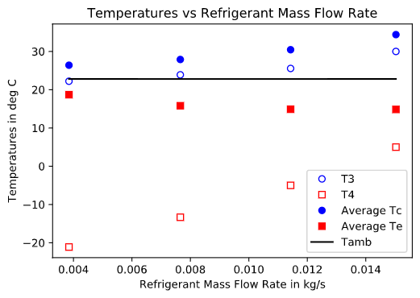

**Figure 1b.** Various specific energy terms in kJ/kg as a function of refrigerant mass flow rate in kg/s. These specific energy terms include the specific energy transferred to the refrigerant in the evaporator (q_L), the specific energy rejected from the refrigerant in the condenser (q_H), the specific energy lost to the surroundings by the compressor (q_loss), and the specific work to done to the refrigerant (w_in).

**Figure 1a.** Recorded temperatures in °C at various locations along the path Refrigerant HFC-134a takes as a function of mass flow rate in kg/s. These locations are at the condenser outlet & expansion valve inlet (T3), at the expansion valve outlet & evaporator inlet (T4), at the exit of the condenser (Te, an averaged temperature), and at the exit of the evaporator (Tc, an averaged temperature). The ambient air temperature (Tamb) is also superimposed for reference.

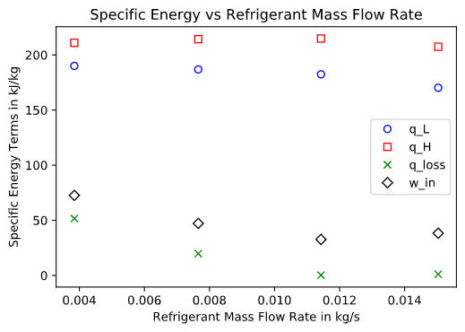

**Figure 1c.** The coefficient of performance for the refrigerator analyzed in this lab as a function of mass flow rate in kg/s.

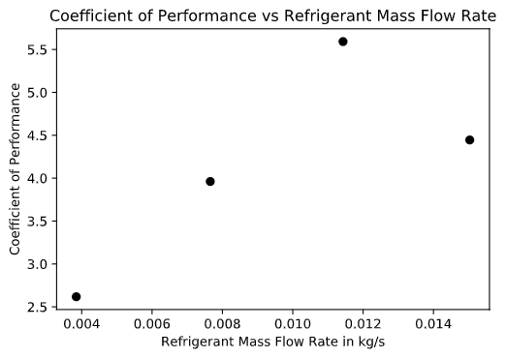

**Figure 1d.** The isentropic efficiency of the compressor (eta_c) in percent and the total electrical power supplied to the system (W_dot_total) in W both as a function of refrigerant mass flow rate in kg/s. The isentropic efficiency of the compressor appears as the left y-axis while the total electrical power appears as the right y-axis in the plot above.

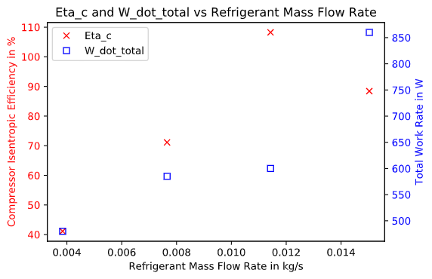

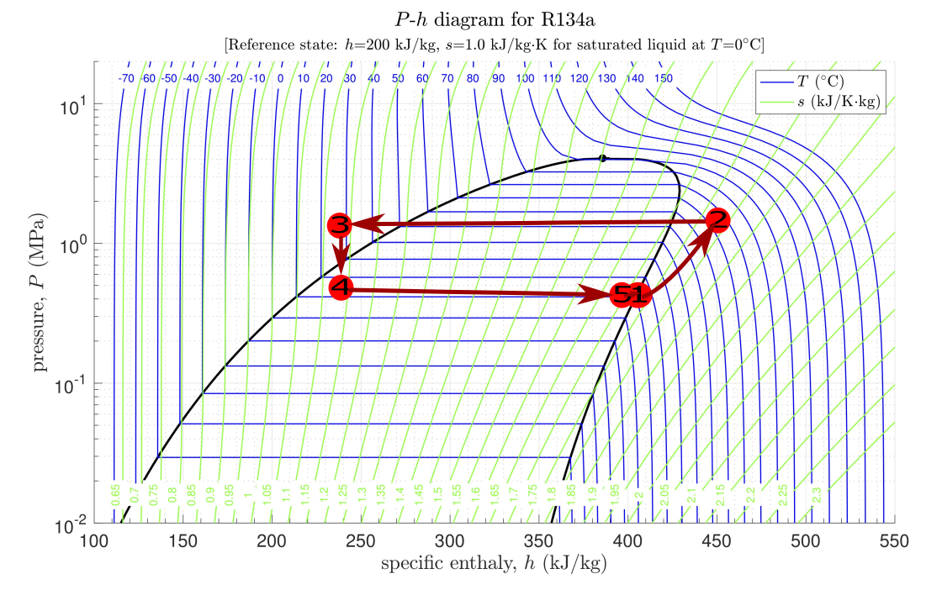

**Figure 1e.** A P-h diagram containing labeled states of the refrigeration cycle analyzed in this lab. State 1 is at 0.34MPa and 411.93kJ/kg. State 2 is at 1.36MPa and 449.15kJ/kg. State 3 is at 1.35MPa and 241.71 kJ/kg. State 4 is at 0.38MPa and 241.71kJ/kg. State 5 is at 0.36MPa and 410.44kJ/kg. The reference state for the P-h diagram is h=200 kJ/kg and s=1.0 kJ/kg·K for saturated liquid at T=0°C.

**2a.**

Comparing the *P-h* diagram in Figure 1e to an ideal *P-h* diagram there are a few differences. The most noticeable difference is at state 3 where the HFC-134a fluid is in a sub-cooled liquid state rather than right on the saturated liquid line like in the ideal *P-h* diagram. Another key difference is the existence of state 5 at the evaporator exit which means that the evaporator exit is at a slightly different state than the compressor exit (state 1). The path from state 1 to 2 also does not follow the line of constant entropy as in the ideal case. Lastly, there are consistent pressure drops when going from states 2 to 3 and 4 to 5 even when the ideal cycle has no pressure drop between these states. This can be explained by the mechanical losses in the pipes that manifest as a pressure drop in the pipes.

**2b.**

Based on the attached figures a mass flow rate around 0.012 kg/s would be an optimal HFC-134a fluid mass flow rate to get optimal performance out of the refrigerator. This is because looking at Figure 1c the highest coefficient of performance is obtained at a mass flow rate of 0.012 kg/s. At this mass flow rate, we also have the lowest specific energy lost to the surrounding by the compressor as seen in Figure 1b. The specific energy transferred to the refrigerant and the specific energy rejected to the surrounding at a mass flow rate of 0.012 kg/s is virtually the same as the other mass flow rates. In the end, this indicates that this mass flow rate is the best tradeoff between efficient and yet capable refrigeration cycle.

**2c.**

An effective way to increase the COPR is to reduce compressor losses. One effective method of reducing these losses is to match compressor capacity with cooling load so the compressor will not have to stop and start at much for partial loads (this is an inefficiency). This can be done by utilizing multiple compressors and having them operate in sequence to better match the load at a given time (Saxena, 2015). By reducing compressor losses qloss is decreased, thus more energy can be transferred to the refrigerant rather than being lost during the compression process. This means less specific work done to the refrigerant (win)will be needed for the same fluid state which transfers the same specific energy to refrigerant in the evaporator (qL). Then using equation 10 in the handout this implies that the COPR would increase since win decreases for the same qL.

**References**

* S. Saxena, “INCREASING THE EFFICIENCY OF REFRIGERATOR BY REDUCES THE LOSSES IN EVAPORATOR, COMPRESSOR AND CONDENSER ,” *International Journal of Scientific & Engineering Research*, vol. 6, no. 5, May 2015.