# Airfoil Lab

Ryan Dalby

March 25, 2021

**Figure 1a.** Lift coefficient versus angle of attack for a NACA 0012 airfoil at various cord Reynolds number values. Experimental values are shown with 95% confidence interval error bars and connected by dashed line. Published data is shown in grayscale.

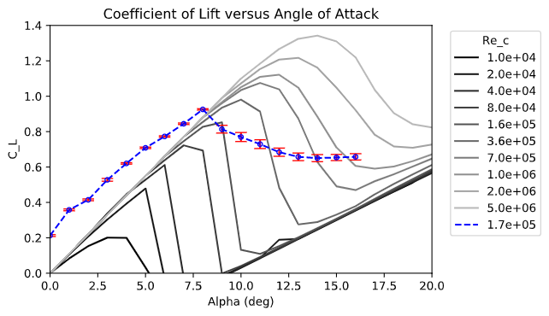

**Figure 1b.** Drag coefficient versus angle of attack for a NACA 0012 airfoil at various cord Reynolds number values. Experimental values are shown with 95% confidence interval error bars and connected by dashed line. Published data is shown in grayscale.

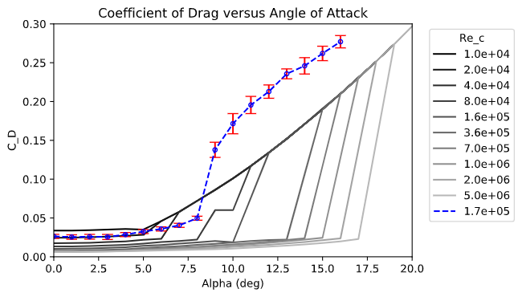

**Figure 1c.** Pressure coefficient versus distance along the cord is show at angle of attacks of 5°(left) and 12°(right). These angle of attacks are before stall and after stall respectively for a NACA 0012 airfoil. The pressure coefficient is shown for both the top and bottom surfaces and are represented by different markers. The cord Reynolds number for the experiment is 1.7*105. Note that as shown in Figure 1a and Figure 1b, stall occurs at approximately 8°.

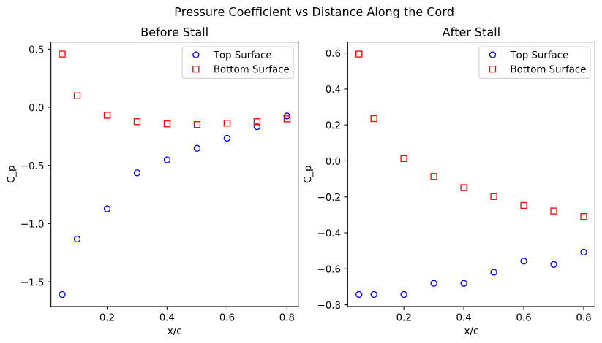

**2a**.

Based on the present lift and drag measurements at Rec = 1.7*105, stall is observed to occur at an angle of attack of about αstall = 8°. Starting at an angle of attack of α = 0°, the coefficient lift measurements increase linearly with angle of attack until the stall angle where the coefficient of lift decreases toward a constant coefficient of lift value. Starting at an angle of attack of α = 0°, the coefficient drag measurements stay relatively constant until the stall angle where the coefficient of drag increases rapidly then it increases linearly after the sudden increase.

**2b.**

The average percent uncertainty in CL is 1.98%. The average percent uncertainty in CD is 7.08%. As the angle of attack increases for both the coefficient of lift and the coefficient of drag the uncertainty in the experimental measures increases.

**2c.**

* One way the CL and CD values differ from the published results for a similar cord Reynolds number is that at an angle of attack of 0° both CL and CD do not have values of 0 like they do in the published results. This bias is likely due to the placement of the pivot support which is at the center of mass rather than the center of pressure.

A second way that the CL and CD values differ from the published results is right after the stall angle of 8°, here the published results have a more drastic change in CL (for published the drop is from 0.8 to 0.1 while the drop for the experiment is 0.9 to 0.7) and a similar change occurs in CD (for published results the increase is from 0.01 to 0.12 while for the experiment the increase is from 0.04 to 0.17).

* For the previously published results, starting at an angle of attack of α = 0° the CL value increases linearly until the stall angle where it decreases rapidly down to near 0, then it increases linearly again yet never reaching the same peak CL value.

For the previously published results, starting at an angle of attack of α = 0° the CD value stays relatively constant until the stall angle where it increases rapidly then the CD value continues to increase linearly.

**2d.**

If the UAV was flying at 17.24m/s the results from the experiment would be applicable.

The maximum lift coefficent for this experiment was 0.93 which corresponds to a lift force of 30.76N thus the UAV could support a maximum of 3.14kg.