# 2D Conduction Lab

Ryan Dalby

April 4, 2021

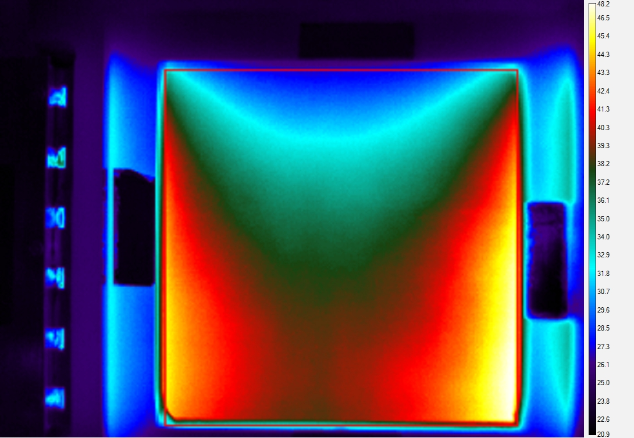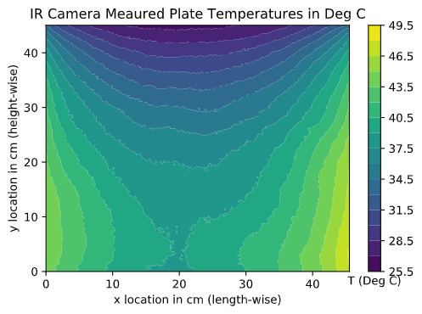

**Figure 1a.** Thermal image displayed by IR camera (left) and filled-color contour plot of measured temperatures from IR camera (right) side-by-side. The thermal image shows a red bounding box representing the boundary edge temperatures which were utilized for this lab. The contour plot uses 20 isotherms and x=0cm and y=0cm represents the bottom left of the plate as shown in the thermal image. The colorbars show temperatures in degrees Celsius.

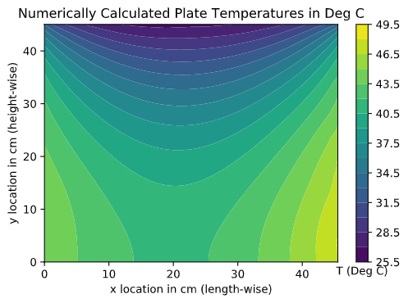

**Figure 1b.** Filled-color contour plot of numerically computed temperatures. These temperatures were found using numerical simulation (second-order central difference) of the two-dimensional heat diffusion equation with measured boundary temperatures for the left, right and top edges. The bottom edge was taken to be an insulated boundary condition. The contour plot uses 20 isotherms and x=0cm and y=0cm represents the bottom left of the plate. The colorbar shows temperatures in degrees Celsius.

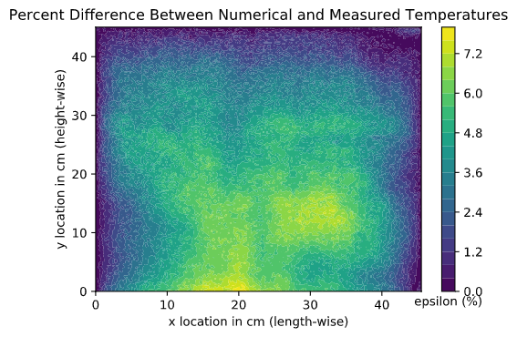

**Figure 1c.** Filled-color contour plot of the percent difference between the measured and computed temperature fields. The contour plot uses 20 isotherms and x=0cm and y=0cm represents the bottom left of the plate. The colorbar shows percent difference between the measured and computed temperature fields.

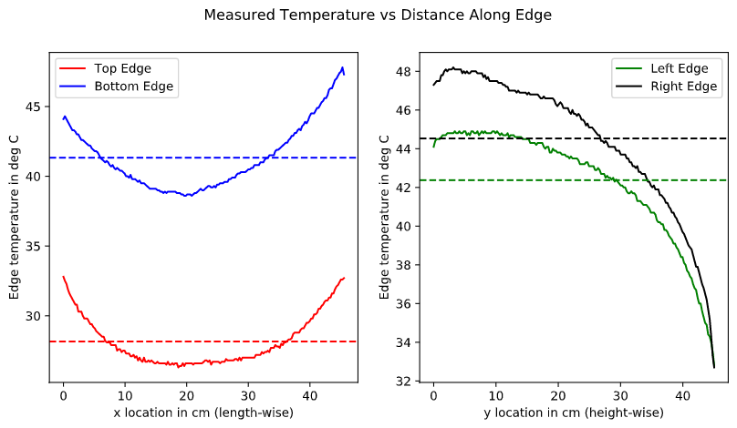

**Figure 1d.** Plot of IR camera measured temperatures versus distance along length-wise x-direction (left) and IR camera measured temperatures versus distance along height-wise y-direction (right). The average temperatures of the edges are represented by dashed horizontal lines in colors corresponding to the edge represented.

**Table 1e.** The magnitude of the net heat transfer rate (q) in Watts and the measured power supplied to the TECs (P_E) in Watts for each edge of the plate. The net heat transfer rate was calculated by first determining the heat flux using second-order finite differencing methods for 3 pixels from the corresponding edge. The heat flux was then integrated to get the net heat transfer rate using trapezoidal method integration for each edge. Note that only measured power readings for the heated edges were available.

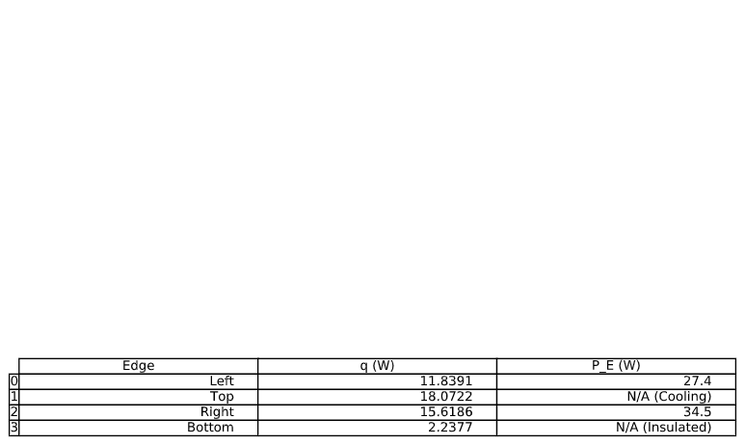

**2a.**

The average percent difference between the measured and computed temperature fields was 3.74%. The max percent difference between the measured and computed temperature fields was 7.98% at x = 20.82cm and y = 0.00cm. The middle-bottom of the plate had the largest discrepancy between the measured and computed temperature values. This makes sense since known temperatures were used for all edges but the bottom edge and the further from these known values the greater percent difference. This numerical simulation does seem to be accurate since it has average error under 4%. The accuracy of this simulation could be improved if temperature readings of the bottom edge were utilized as a boundary condition.

**2b.**

The 95% error of the left edge measured temperature was 13.60%, the 95% error of the top edge measured temperature was 12.57%, the 95% error of the right edge measured temperature was 15.66%, the 95% error of the bottom edge measured temperature was 11.27%. It does seem appropriate to assume that the left, top, and right edges are uniform temperature distributions since between these three sides, on average most temperatures fall within 14% of the mean corresponding edge temperature. The bottom edge also seems appropriate since this side has the most compact distribution of temperatures thus local length-wise temperature gradients are small, so it is likely that local height-wise temperature gradients are small as well.

**2c.**

It is estimated that to heat the left edge 12.46W of power was used. The actual measured power was 27.4W. It is estimated that to cool the top edge 120.48W of power was used. The actual measured power was not measured. It is estimated that to heat the right edge 16.44W of power was used. The actual measured power was 34.5W. The heating values were a fair amount away form the actual measured power values (approximately 50%). This may still be reasonable since the calculation just assumed that all loss is accounted for by the efficiency, which may not be true since that would assume that the heat produced by the TECs is perfectly transferred to the defined plate edge via conduction. It is likely that heat was lost in the distance between the TECs and defined edges due to radiation and convection to the surroundings.