# Flat Plate Convection Lab

Ryan Dalby

April 13, 2021

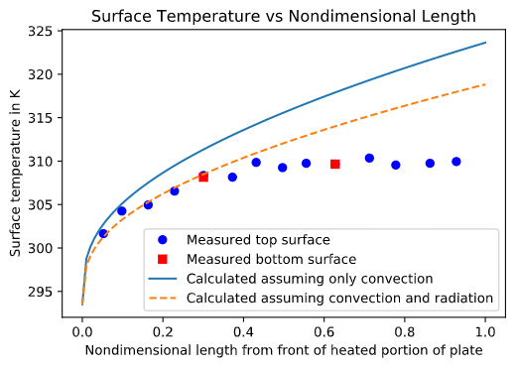

**Figure 1a.** Surface temperature in kelvin of a flat plate versus nondimensional length beginning from the front of the heated portion of the flat plate. Surface temperature values on the top and bottom of the plate were measured using thermocouples. The theoretical values were calculated using correlations assuming iso-flux boundary conditions.

**Figure 1b.** Local heat transfer coefficient in watts/(meters^2 * kelvin) versus nondimensional length beginning from the front of the heated portion of the flat plate. The experimental values assume 100% efficient transfer of electrical power to heat via resistive heating. The theoretical values were calculated using correlations assuming iso-flux boundary conditions with fluid properties evaluated at the average film temperature for the heated section of the plate.

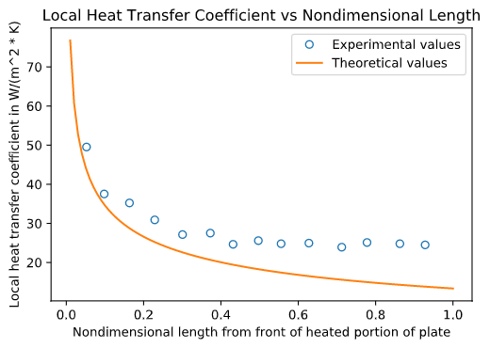

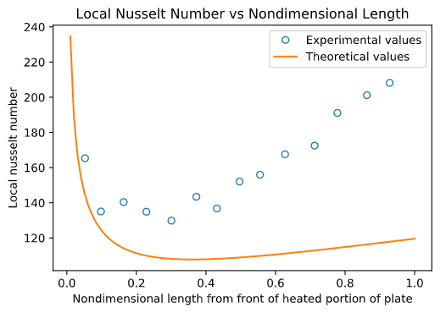

**Figure 1c.** Local Nusselt number versus nondimensional length beginning from the front of the heated portion of the flat plate. The experimental values assume 100% efficient transfer of electrical power to heat via resistive heating. The theoretical values were calculated using correlations assuming iso-flux boundary conditions with fluid properties evaluated at the average film temperature for the heated section of the plate.

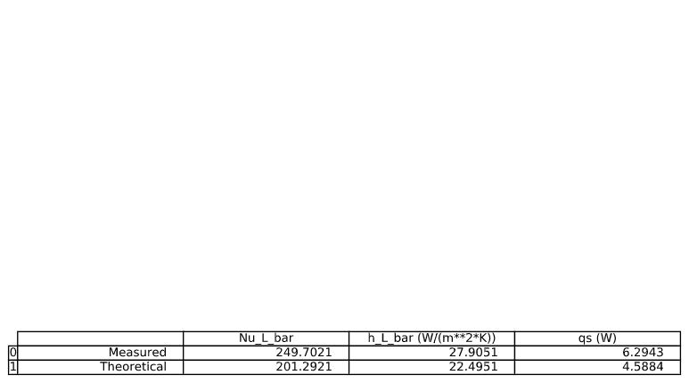

**Table 1d.** Comparison of measured and theoretical average Nusselt number (Nu_L_bar), the average heat transfer coefficient (h_L_bar) in watts/(meters^2 * kelvin), and the net heat transfer rate(qs) in watts. The experimental values assume 100% efficient transfer of electrical power to heat via resistive heating. The theoretical values were calculated using correlations assuming iso-flux boundary conditions.

**2a.**

The local Nusselt number had a min percent difference between theoretical and experimental values of 8.96% and a max of 76.60%. The local heat transfer coefficient had a min percent difference between theoretical and experimental values of 8.91% and a max of 77.24%. The surface temperature of the top of the plate had a min percent difference between theoretical and experimental values of 0.54% and a max of 17.92%. The percent difference between theoretical and experimental values follow a similar trend of increasing as the nondimensional length increases for all three quantities mentioned above. This is likely because the assumptions of the experiment become to be less reasonable as the flow moves further along the flat plate. A specific assumption that may become less reasonable as the nondimensional distance increases would be the one-dimensional convection assumption.

**2b.**

The average heat transfer coefficient had a percent difference between theoretical and experimental values of 24.05%. The average Nusselt number had a percent difference between theoretical and experimental values of 24.05%. Both values are relatively high, just like 2a. There are some possible explanations for this discrepancy which are related to the experimental assumptions. First, the one dimensional convection assumption may not be a good assumption for this plate. Second, the iso-flux boundary condition assumption may not be exactly true. An experimental modification to improve the results would likely deal with expanding the experiment to a two-dimensional convection problem and adding thermocouples in the “y” direction.

**2c.**

The percentage of heat flux lost to the surroundings via radiation compared to net heat flux to the top surface by resistive heaters was 15.98%. This value is high and does partially explain the discrepancy between the experimental and theoretical data, although not completely. This is because the percentage of heat flux lost via radiation is still not the ~25% error of the average heat transfer coefficient. Also, even when considering radiation, the measured and theoretical values still differ as seen in Figure 1a.

**2d.**

The Reynolds number based on L for this experiment was: 57933.37. This is much less than the critical Reynolds number for a flat plate of 500000.00 so the flow is expected to be laminar over the whole plate. Experimentally the flow could be verified to be laminar by measuring the dynamic pressure and determining the freestream velocity as done in this lab. For some fluids, this verification could also be done visually using flow visualization techniques to see how the flow is separating and mixing.