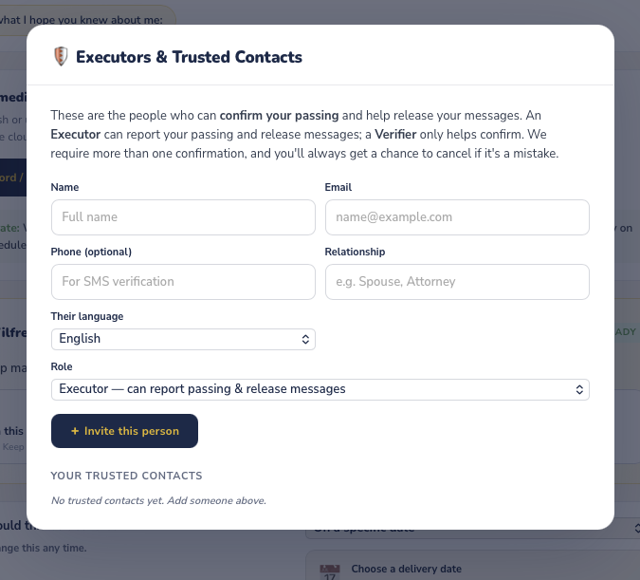
No button to close this window if they don’t want to complete it right now -user can click off the screen and it goes away but should be button to close this window for all pop ups on this page or an X top right corner is easy to understand .
