Quick Start.

Connect a USB/UART adapter to PMOD1. Baud= 115200,8,n,1 This is the Debug terminal.

Import the projects

Build the **x1RA6_boot** project (Debug configuration)

Build the **RA6_primary_L** project (Debug configuration) then debug. You should see 3 LEDs blinking and the debug terminal displays:

Build the RA6_update_L project (Debug configuration) and debug it. You should see 2 LEDs blinking and the terminal will display

Right-click on the RA6_primary_L project and change the Build Configuration to Bootable.

Build the Bootable configuration. Repeat this for the RA6_update_L project.

Note the Console output. srec_cat issues a warning, but everything works. The python scripts should run without error.

Build both RA6_primary_L and RA6_update_L projects.

Open the tools folder in Explorer (not in e2studio). These 2 batch files are used.

erase_qspi_quick erases just the used sections of QSPI. The erase_qspi_all erases the entire chip, but takes a while to do so. The upload_update loads the update into QSPI.

Erase the QSPI by double-clicking the erase_qspi_quick.bat. You should see this:

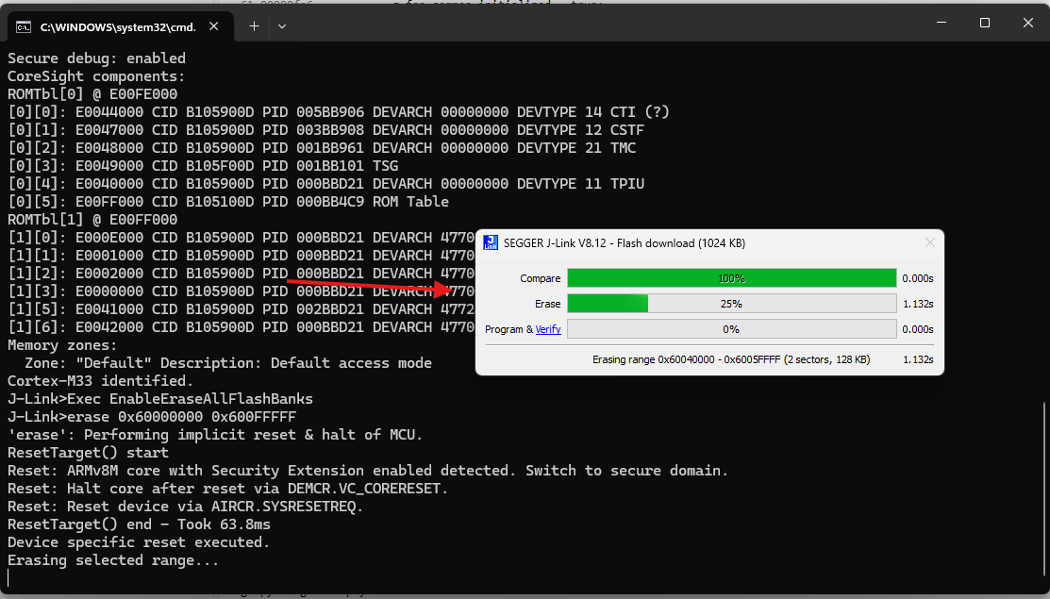

Once it’s done, press any key

Open the Debug configuration for the x1RA6_boot bootloader project.

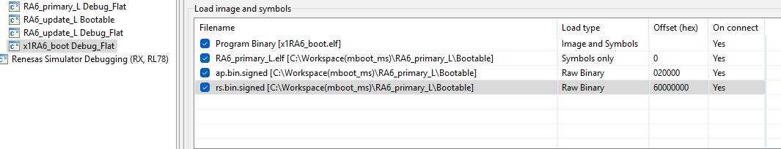

Note in the startup tab that we load the signed application and the signed resources to their appropriate places in memory: ap to flash and rs to QSPI space. Since we erased the QSPI, there will be no update available.

Debug the x1RA6_boot project. Resume and you’ll see this on the Debug terminal:

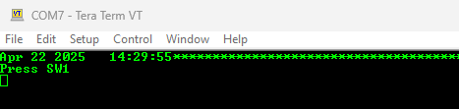

Press SW1 on the board.

There will be a flurry of activity… then this at the end:

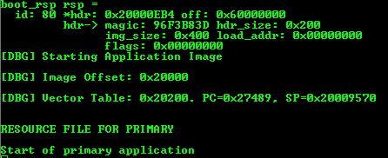

Run the upload_update.bat file:

This causes MCU to reset. Press SW1. Another flurry of activity and both the application and the resources are updated and booted.

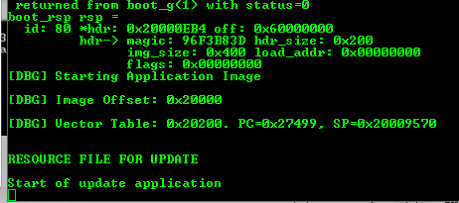

Press reset. Then press SW1. It will revert.