Quick Start.

Connect a USB/UART adapter to PMOD1. Baud= 115200,8,n,1 This is the Debug terminal.

Import the projects from the e2_projects folder: EW_encrypted_demo_1_A and *_B (The LVGL demos are HUGE and I had to split them up into two archives)

You should have all of the following projects.



Right Click on the EW_primary project and select. Build Configurations->Build Selected…



Check the configurations to build. For EW_primary you must build the Signed configuration for this demo.



Repeat this for the EW_update project.

Build the **x2RA6_boot** project (Debug configuration).

Open the debug perspectives and select the x2RA6_boot Debug_flat configuration.



Make sure these are selected in the startup tab, (note, I’m testing in a workspace at C:\Y) You will see different paths.



Next open a DOS CMD prompt and navigate to the tools folder in your workspace.

Type Jlink and the cmd prompt. If you get a command not found then add jlink.exe to your path. Jlink.exe is in whatever folder you downloaded the Jlink tools.

Type Python and verify Python runs. Python has to be setup for doing the encryption stuff. Consult the MCUboot application note if you’re not setup.

With the board connected, in the cmd prompt in the tools folder type

erase_everything

IN e2studio

Build the **RA6_primary_L** project (Debug configuration) then debug. You should see 3 LEDs blinking and the debug terminal displays:

Build the RA6_update_L project (Debug configuration) and debug it. You should see 2 LEDs blinking and the terminal will display

Right-click on the RA6_primary_L project and change the Build Configuration to Bootable.

Build the Bootable configuration. Repeat this for the RA6_update_L project.

Note the Console output. srec_cat issues a warning, but everything works. The python scripts should run without error.

Build both RA6_primary_L and RA6_update_L projects.

Open the tools folder in Explorer (not in e2studio). These 2 batch files are used.

erase_qspi_quick erases just the used sections of QSPI. The erase_qspi_all erases the entire chip, but takes a while to do so. The upload_update loads the update into QSPI.

Erase the QSPI by double-clicking the erase_qspi_quick.bat. You should see this:

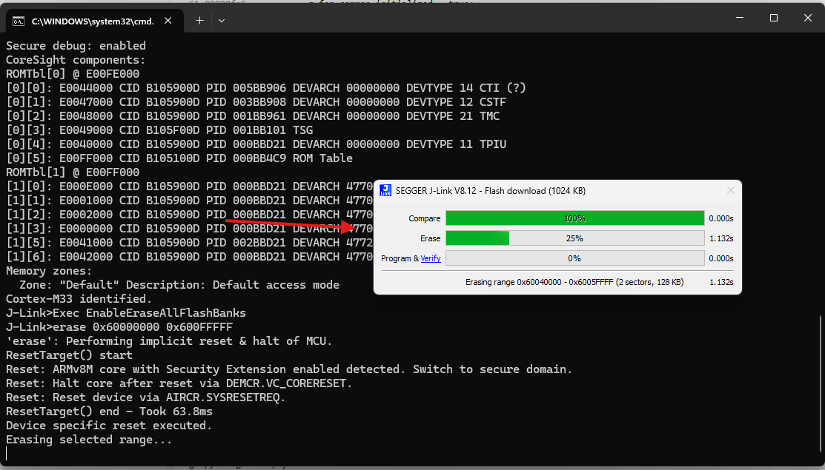

Once it’s done, press any key

Open the Debug configuration for the x1RA6_boot bootloader project.

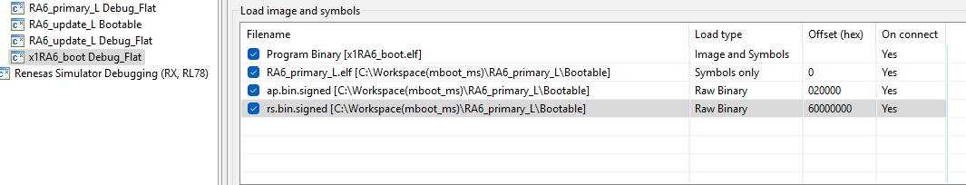

Note in the startup tab that we load the signed application and the signed resources to their appropriate places in memory: ap to flash and rs to QSPI space. Since we erased the QSPI, there will be no update available.

Debug the x1RA6_boot project. Resume and you’ll see this on the Debug terminal:

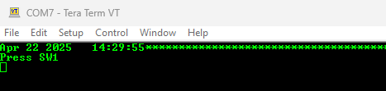

Press SW1 on the board.

There will be a flurry of activity… then this at the end:

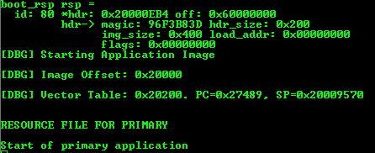

Run the upload_update.bat file:

This causes MCU to reset. Press SW1. Another flurry of activity and both the application and the resources are updated and booted.

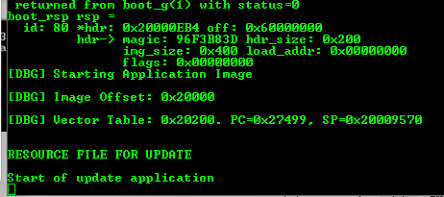

Press reset. Then press SW1. It will revert.