ERRORS FOUND IN MONICET PLATFORM

- ABSENCE OF THE DATE IN THE PHOTOS THAT ARE BEING COMPARED
In the identification process, sometimes it is needed to check the dates of the two pictures in order to compare them more easily. This can be done by putting the mouse over that photo, but in some cases this tool doesn’t work. We have always detected this problem in the photos that are being compared (the ones on the right). In the original ones, the tool always works well.
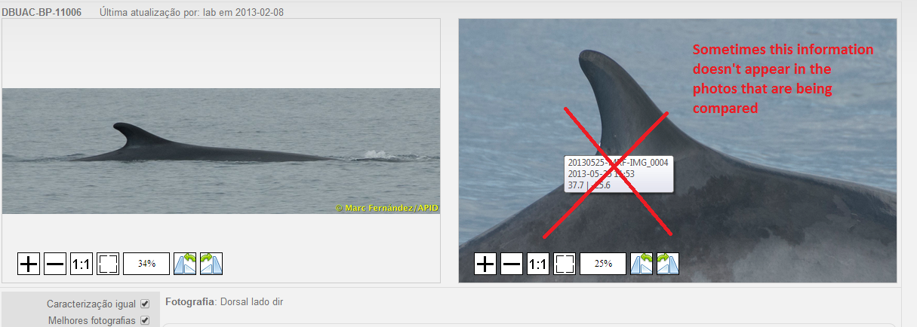

Update from Alex:
Fixed
- DEFORMATIONS IN THE PHOTOS TO ASSOCIATE
When comparing the photos in the identification process, we have found that, depending on the size and shape of the original photo, the photos of the catalogue can appear deformed.
The program should keep the original size and shape of all the photos, because this problem makes more difficult the comparison between them.
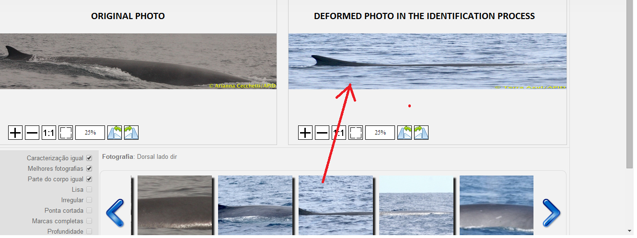
http://www.monicet.net/admin.php/observation-photo/3372/identify

Update from Alex:
Fixed ... with one minor issue: the amount shown in the zoom box (eg above 25%) is not accurate (issue related to the embedded plugin from an external source). Everything else seems to be all right.

- LATITUDE AND LONGITUDE INFORMATION IN THE “PROCESS” STEP
When processing the photos, some information is automatically filled in by the program, when one photo is associated to one sighting. Behavior information is now automatically filled in, but also Latitude and Longitude coordinates should automatically be filled in with the GPS coordinates of that sighting.

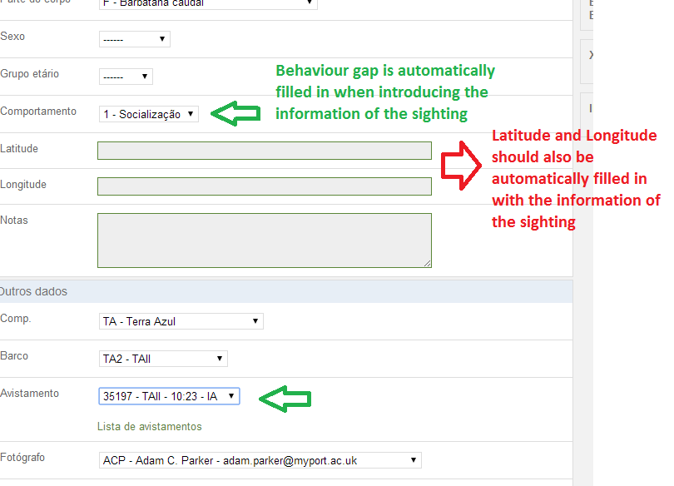
Update from Alex:
Fixed (For I and F - nothing happens, as animals shouldn’t be seen then)
Plus, I changed the code of the maps for company users: the sign isn’t inverted automatically by the software. Data is treated as is (sign or no sign), but the coordinates inputted are validated as follows: the latitude and longitude values are compared to the company base coordinates and they are valid only if within 100km from the point of reference (company base).
In the case of the “procesar foto” step (see above screenshot), if a company is selected from the drop down, only then the coordinates are validated in relation to the base of that company.
In order to receive correct coordinates from companies when inputting their base coordinates, a point-and-click map was added to the registration form.
Added on the 7th of October: Some of the pages working with coordinates now have embedded coordinates converters (from degrees-minutes-seconds format to decimals). All the forms, except “Add registos to saida”, which accepts DMS format, as well will only accept coordinates in the decimals format. I also added a ‘sign helper’. If the latitude is smaller than -4 (degrees), meaning it’s not near the Ecuator, in saida (aka general info), when you add a registo, the line comes pre-filled with a minus sign in the latitude field. If the latitude is bigger than -60 and smaller than 60 and the longitude is smaller than -10 (degrees), meaning it’s not near the Prime Meridian (and not too far up North, where the degrees of longitude are only a few km long), the registo (record) line comes pre-filled with a minus sign in the longitude field.

- ERRORS OF THE WHALE WATCHING COMPANIES IN SAIDAS DA EMPRESA
Currently, the whale watching enterprises can upload sightings with errors that are not supposed to appear in the interface. For instance, this sighting starts with an Inicio associated to a dolphin.
http://www.monicet.net/admin.php/general_info/sheet/action?giid=3562
Update from Alex:
Fixed - for new Saidas (also companies, can no longer change the date of old saidas in order to use them as new saidas)
Other changes done to the code in relation to the “saida” errors:
- no longer possible to remove the first record (registo) line inside the form of a saida
- code was saving only valid records, which was causing the main error... it was changed: it either saves all the records (if they are valid, of course) or none
- when you have a new (and, by default empty) saida and you leave the page without having added any valid records to it - the saida will be deleted (this doesn’t work on some versions of some browsers - due to unrelated web development general issues). In case it is not deleted, there is a backup plan: every new saida is marked as empty and if nothing is saved in it, it doesn’t get displayed in the saida list, so you can’t see it (Note for future developers: Never delete the empty saida as it might just be a saida which was just created and which the user is currently filling in). A better alternative to the marker would be to create a new column (is_empty) in the general_info (=saida) table. Therefore, you might encounter empty (with no records connected to them) saidas in the database. This shouldn’t cause any issues, as nothing is tied to an empty saida, it’s not being printed anywhere and the site will not crash if it is empty.

- ERASED PHOTOS
Some photos have been associated to a photo that was erased later. Therefore, the program detects an error, and these photos cannot be validated (because the associated photo doesn’t exist anymore).
In this case, when the associated photo is erased, the program should automatically re-start the process of identification of the original photo (in order to review the catalogue again, to see whether another photo can be associated to that one or not).
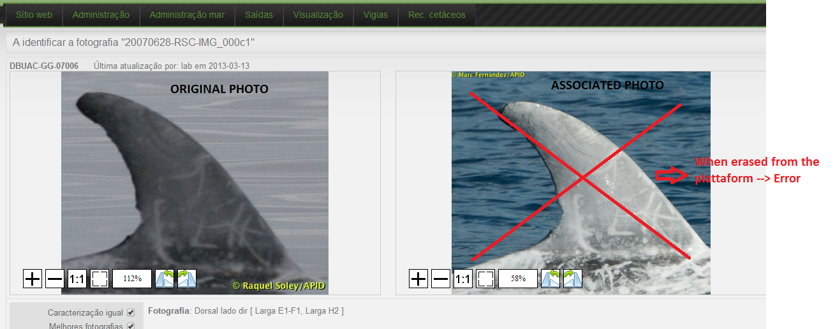
We have found this problem in these three photos:
http://www.monicet.net/admin.php/observation-photo/2492/identify
http://www.monicet.net/admin.php/observation-photo/2017/identify
http://www.monicet.net/admin.php/observation-photo/1953/identify
Update from Alex:
Fixed

- DOLPHIN WITH NO NAME
For some reason we don’t know, there is a dolphin that has no name, and therefore it should be erased from the platform. The same photo is already associated to an individual that has already a name: DBUAC-TT-11017.

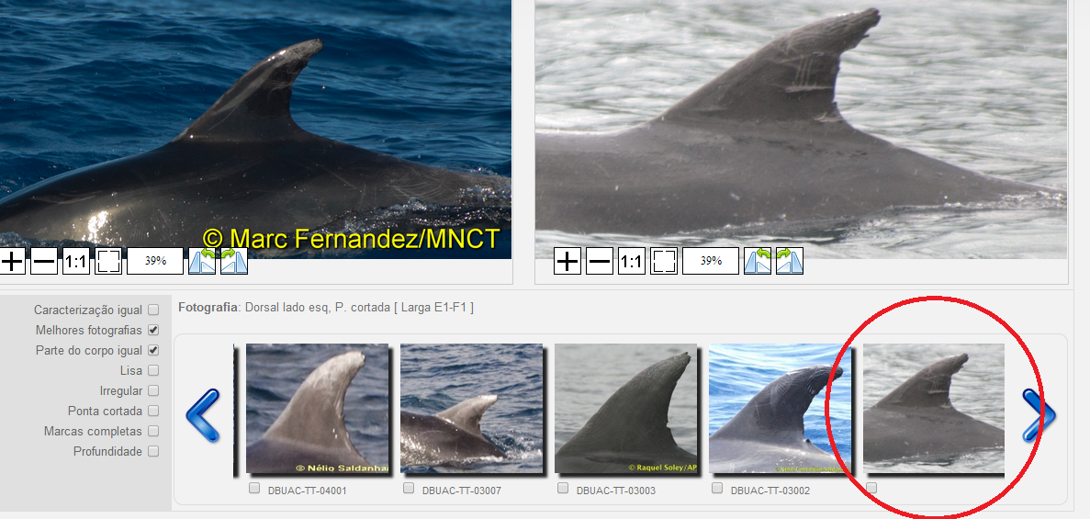

Update from Alex:
Fixed
Issue: photo http://monicet.net/uploads/pr_repo_final/20110413-CRC-IMG_0004c1.jpg was no longer assigned to an individual, but had the “validated” status

- WRONG FUNCTIONING OF THE FILTERS
FILTER OF DATE
Once this filter is used, it is impossible to re-start it until the next day. It is not possible to reset that information.
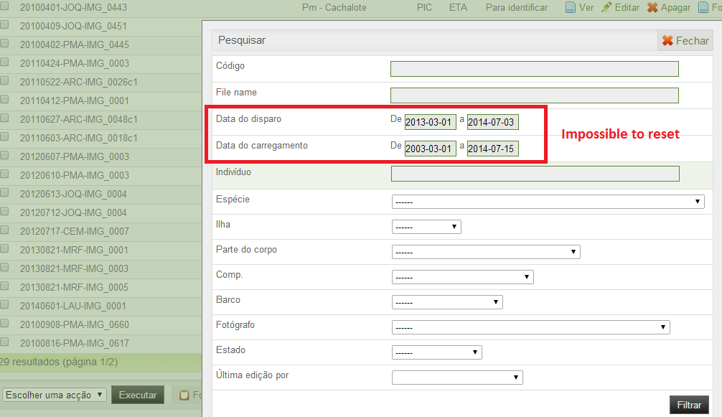
Update from Alex:
Fixed (also fixed bigger problem concerning the filter - it was remembering its previous search values…) - must also fix all the other filters from the whole website
JUST ONE PHOTO OF THE INDIVIDUAL IN THE SIGHTING OF EACH DAY
In the sightings, we just should take into account one photo per individual per day. Normally, each individual has just one photo per day, and this photo can be associated to the sighting. But sometimes, the individual can have more than one photo of the same day, because they are from different body parts.
When the photos are associated to the sightings, the program automatically associates each photo of the individual to one sighting, even if they are from the same day, so this is introducing an error (more sightings than the reality for each day) in the system.
When this happens (two or more photos of the same individual on the same day), the program should automatically select the best of this photos and associate it to one sighting, instead of associating all the photos of the individual as if they were different sightings.
For example, this individual (DBUAC-GG-07006) has two photos for the sighting of 2010-06-11, and in the map they appear as if they were two different sightings. The reality is that there is just one sighting with two associated photos, so the program should automatically show just one point in the map, and two photos associated to this point.

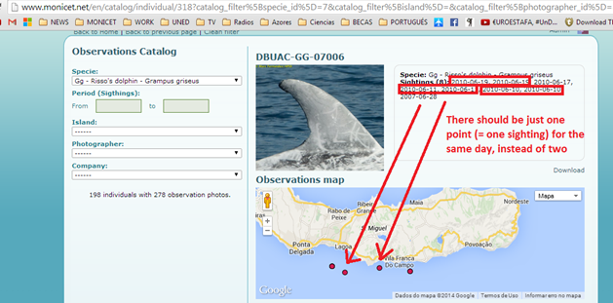

http://www.monicet.net/en/catalog/individual/318?catalog_filter%5Bspecie_id%5D=7&catalog_filter%5Bisland%5D=&catalog_filter%5Bphotographer_id%5D=&catalog_filter%5Bcompany_id%5D=&catalog_filter%5Bphoto_date%5D=Array&catalog_filter%5Bphoto_date%5D%5Bfrom%5D=&catalog_filter%5Bphoto_date%5D%5Bto%5D=
AUTOMATIC DETECTION OF TWO PHOTOS ASSOCIATED TO THE SAME DATE
Normally, we just should take into account one photo per individual per day. Normally, each individual has just one photo per day, but sometimes the individual can have more than one photo of the same day, because they are from different body parts.
The program could automatically detect when two photos (of the same body part) are being associated to one individual in the same day.
If this happens, the program could open a window asking if you really want to validate two photos of the same individual in the same day.
Update from Alex:
Both fixed (if two or more photos from 2 different dates have the same coordinates - then the map only shows one red dot from only one photo)

ERROR IN SELECTING THE LAST PHOTO OF THE CATALOGUE IN THE PUBLIC INTERFACE
The tool for selecting the last page of the catalogue in the photo ID of the public interface doesn’t always work.
http://www.monicet.net/en/catalog?page=49&catalog_filter%5Bspecie_id%5D=8&catalog_filter%5Bisland%5D=&catalog_filter%5Bphotographer_id%5D=&catalog_filter%5Bcompany_id%5D=
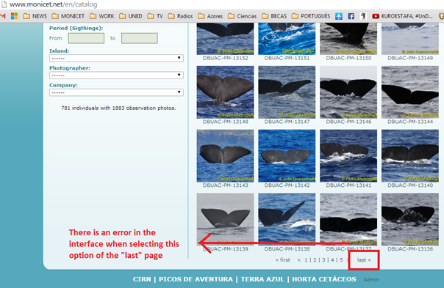
Update from Alex: unable to duplicate the error - waiting on feedback from users (was probably caused by BestObservationPhoto bug)

Error when exporting the photo catalogue
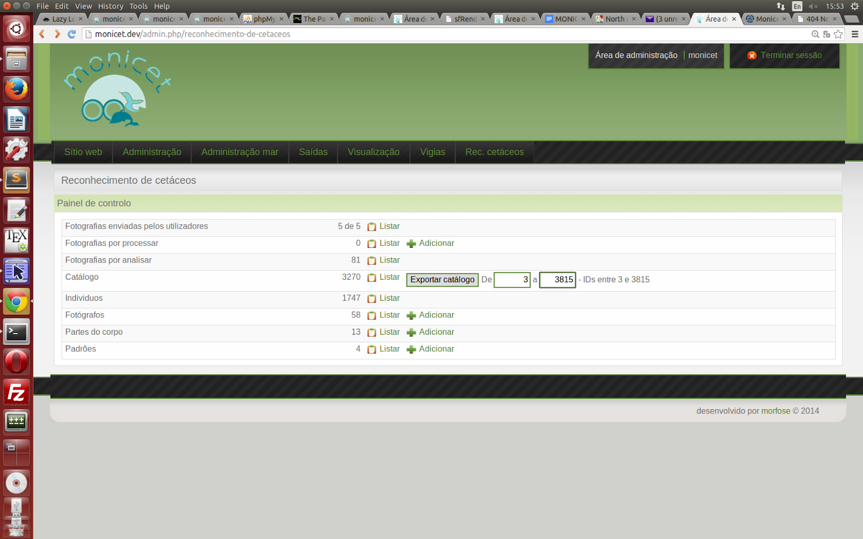
Update from Alex: Fixed (up to 2000 ids) - November 2014 update, due to the change of servers, it should be possible to export all ids at the same time (although it’s still recommended to do it in batches)

PHOTOS IN SMALL SIZE IN THE ROW OF PHOTOS
When identifying an individual, we can see a row of photos with all the pictures to compare in small size. Sometimes, in these tiny photos we just see a small part of the original photo (ex. photos in red), instead of seeing the whole photo in small size (ex. photo in green).
We would identify the individual faster, if we could see the whole picture in a small size. Like this, it won’t be necessary to click in each individual to see it in a big size, because some of them can already be identified by looking at the small photos.
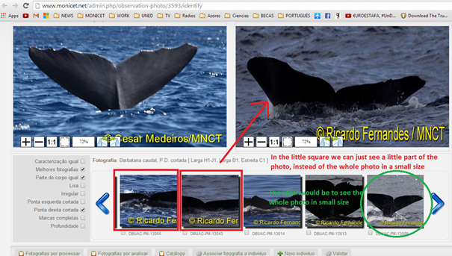
Update from Alex:
Fixed - but only for the new photos

VISUALIZING THE MAP IN THE “PROCESSING” STEP AND IN THE “IDENTIFICATION” STEP
When processing a photo, the GPS coordinates always have to be introduced. It would be very useful to have a direct access to the map, in order to automatically see where the animal is located in the map, and detect the possible GPS errors more easily.
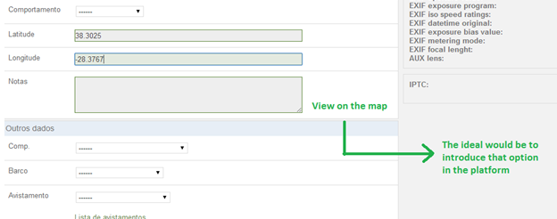
It would be also interesting to have the same option in the end of the identification process, in order to see the animal in the map once it is identified.
Update from Alex:
Done - the button is in the footer of the page

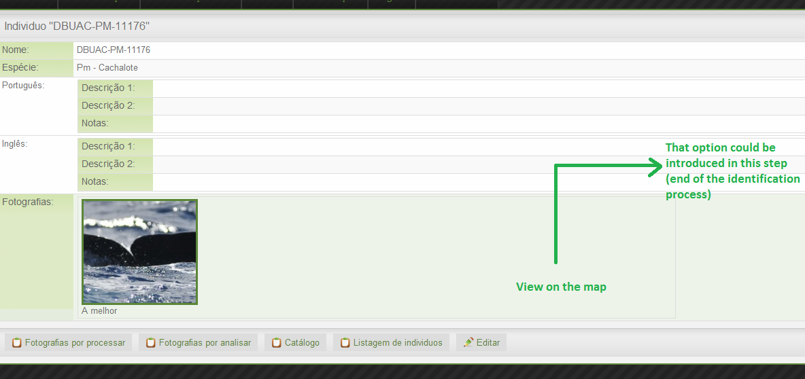
Alex:
Done - the button is in the footer of the page

ALERT TO ERRORS IN THE SIGHTINGS OF THE WHALE WATHCING COMPANIES
When the whale watching companies introduce the data of the sightings in the platform, they can also introduce some errors that are detected later in the validation process. When these sightings are not validated because they are wrong, anything appears in the “Valid” option, so the companies don’t realize that there is an error in that sighting data.
The ideal would be to put a symbol in red, so as the companies could better detect these sightings that have errors inside, in order to correct them easier.
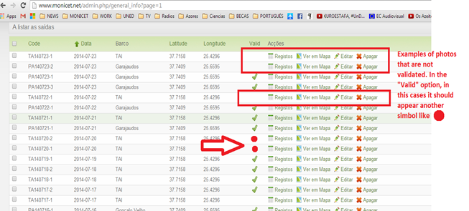
Update from Alex:
A new field - comments was added which displays the comments of the saida. Also, the red sign shows if a saida is invalid. That column (Valid) corresponds to the ‘valid’ column of the general_info (saida) table and can only show if it’s valid or not (or not show anything at all).

TOOL TO UPLOAD SEVERAL PHOTOS AT THE SAME TIME
With the current Monicet upload tool, it is just possible to upload photo by photo. It would be easier if we could upload several photos at the same time, by modifying this tool.
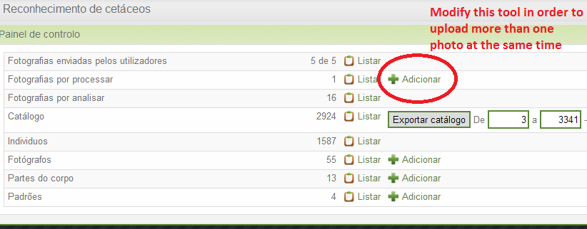
Update from Alex: This already exists (you can upload an archive - several files compressed into one)
Additional tasks
- Delete validated photos
Would it make more sense to allow the admins (of course, not the staff of companies) to delete any photo, including validated ones? I see that no one can delete validated photos now.
Answer from client: I'll allow admins to delete validated photos.
Status: Done
- Delete empty individuals
What about when you have an individual with only one photo and you delete that photo or you link it to a different individual...?
Shouldn't that individual be deleted from the database? What's the use of an individual without photos?
Answer from client: Individual is deleted when his only photo is deleted or is associated to a different individual (or to a new individual)
Status: Done
- Choose a new best photo for an individual when its original best photo was deleted or assigned to a different individual
There are 4 parts of the website using this function, getBestObservationPhoto(). The problem is that it’s sometimes returning NULL (when the individual doesn't have any photos which has is_best=1). That is causing an error on each page.
Ways to fix it:
...
3) leave the function as it is now and make sure an individual always has a best photo. When an individual is created from a photo, that photo becomes its best. The best photo of an individual can be assigned to a different individual or can be deleted. That leaves the initial individual best-photoless. This solution implies changing two functions (when you delete a photo and when you assign a photo) and is messier.

Answer from uni:
Regarding the photos that already have the problem, we will fix it with the solution 3.
Status: Done. When you delete or re-assign a best photo, if its previous individual...
- no longer has photos: the empty individual is deleted and you are redirected to ‘catalogue’ (when deleting) or to the page of the newly chosen individual (when identifying=assigning)
- is left with only one photo, this photo will be chosen as its best and you are redirected to ‘catalogue’ (when deleting) or to the page of the newly chosen individual (when identifying)
- is left with two or more photos, one photo belonging to the previous individual (from the ones which were left, of course) will randomly be chosen as its best (this to make sure that, in the case that when you are redirected to the old individual’s page for choosing a new best photo you decide to leave the page without choosing a new best photo, the previous individual is not left bestphoto-less). You will be redirected to the page of the previous individual, in order to have the option to choose a different best photo.

The identifying results from the carousel (strip of photos at the bottom of the identify page) no longer contains a photo of the individual to which the photo being assigned/identified already belongs (in case, of course it was already identified). This way, when you re-identify a photo, you won’t have the possibility to connect it to the individual to which it is already connected.
Status: Done
When editing a photo, if any attribute except body part and specie is changed, the photo will keep its original status (para caracterizar, para identificar, para validar, validated). However, when changing the specie and/or the body part, these are the new outcomes (according to answers from client):
- If at least the specie was changed and, in case the photo was linked to an individual, the photo is no longer linked to any individuals. If the specie was not changed, but the body part was changed, keep the individual, but change status of photo (see point 3) so that the user must re-characterize the photo (if it’s characterizable).
- If only the specie (the body part being kept unchanged) was changed from a specie with a characterizable body part to a different specie whose body part is characterizable too (in the case of this database, this means changing from a Roaz/Baleia Piloto de Barbatana Curta/Golfinho de Riso/Falsa Orca with a Lado esquerdo da barbatana dorsal or a Lado direito da barbatana dorsal body part to a different Roaz/Baleia Piloto de Barbatana Curta/Golfinho de Riso/Falsa Orca with the same Lado esquerdo da barbatana dorsal or a Lado direito da barbatana dorsal body part), then keep the marks linked to that photo, with a small side note to remember: the status of the photo will change to “para caracterizar”, forcing the user to go through the “characterize” process again. The user can remove the old mark, add a new one or just save without any changes. In all other cases, if there were marks linked to the photo, those marks will be deleted.
- Again, we are in the case where only the specie and/or the body part was changed. Irrelevant to the previous status of the photo, the status of the edited photo will be updated to “para caracterizar”, if the edited photo falls in the “characterizable” category (Roaz/Baleia Piloto de Barbatana Curta/Golfinho de Riso/Falsa Orca specie with a Lado esquerdo da barbatana dorsal/Lado direito da barbatana dorsal body part or Cachalote specie with a Barbatana caudal body part) or to “para identificar” (in all other cases).
Status: Done
About Larga A1 with Larga A1, isn't it possible for a body part to have two marks in the A section, like two Larga A1's? The A section, for example is quite big, so it could have two marks...? “No, our method says that only one mark per letter (section), like this, we can already filter out a lot of individuals.”
Status: Done - only one mark per letter possible from now on
- Regarding the adding of marks, on the characterize page, when you click on "Adicionar marca" the new mark is added and saved. The "Gravar" button is related to the Lisa/Irregular/Ponta Cortada fields. That's how it always was. Isn't that the way it was intended to be? “I think is better to change it to use gravar always. If not this double marking issue can occur easily. There is a lot of new people working with the database each year, so it's better to use the "Gravar" button to avoid misunderstoods.”
Status: Done
Note 1: Adicionar marca was replaced by Gravar e adicionar (Save and add), having the same behaviour, saving straight to the database. It changes the status of the photo (downgrading it) only if it was initially validated.
Note 2: Clicking on ‘Apagar and gravar’ removes the mark and updates the database (there’s no need to also click on ‘Gravar e adicionar’). It also changes the status of the photo (downgrading it) only if it was initially validated.
Note 3: If you change Lisa/Irregular/Ponta Cortada the status of the photo will become ‘para validar’, in case it was initially validated.
Note to future developer: statusUpdate() function needs refactoring, together with all the parts of code which update the status (plus set the last_edited_by - all must be followed by ->save()) in various places. It’s too chaotic now. Clear all other instances and only call statusUpdate(‘edit’,’change_marks’/etc). Also, statusUpdate() needs its switch run in relation to the action (‘edit’/’change_marks’/etc) and not the status (as it is now).

MODIFY THE INTERFACE AFTER THE SECOND VALIDATION TO CHOOSE THE BEST PHOTO
All the photos have to be identified once, and validated once again. Currently, in the first identification process it is possible to select the best photo of the individual, but not in the validation process, and this should be in the opposite way.
In order to do the comparison between individuals, the program automatically chooses the best photo of the individual. If the most recent photo is chosen as the best in the identification process, then in the validation process we cannot see the other photo that was associated to that individual, and it looks like if that individual only had one photo. Thus, the ideal would be that the option of choosing the best photo appeared only in the last validation process, just before storing the photo in the catalogue.
1) Currently, after the first identification process, the interface that appears in the screen is the one with all the photos of the individual, and there is an option in order to select the best photo. This be interface should be changed to the one that shows the characterization of the individual.
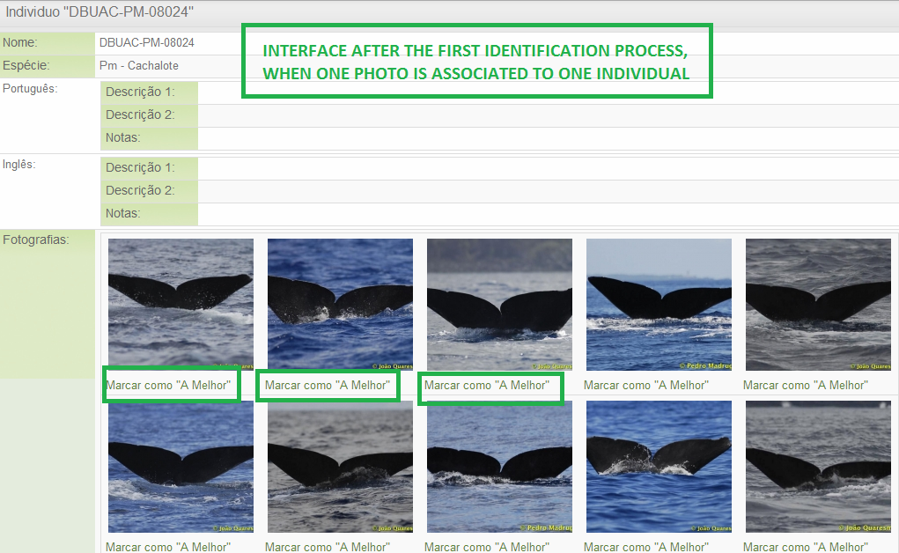
- Currently, after the second validation, the interface that appears in the screen is the one with the characterization of the individual, and there is not an option in order to select the best photo. This interface should be changed to the one showed before, with all the photos of the individual and the possibility to select the best one.
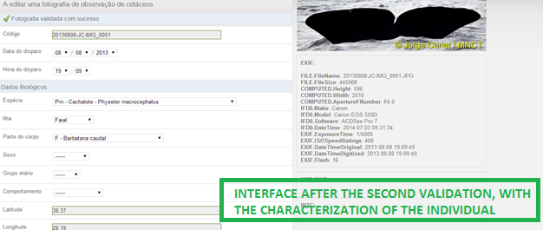

The ideal would be to inverse these two pages: 2) should appear at the end of the first identification process, and 1) should appear at the end of the last validation process.
Status: You are redirected to 1) after validating a photo
FILTER OF “SAME CHARACTERIZATION” + “BETTER PHOTOS”
When these both filters are selected together, most of the time the filter doesn’t work, and it just selects all the photos, instead of applying the selected criteria.
FILTERS OF “COMPLETE MARKS” AND “DEPTH”
These filters can’t be applied either, because they don’t work properly.
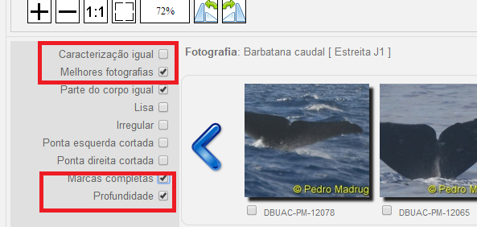
FILTER “TO CHARACTERIZE”
Some photos don’t need to be characterized, but when the filter “To characterize” is selected, these photos also appear in the page, even if they don’t have the option to be characterized.
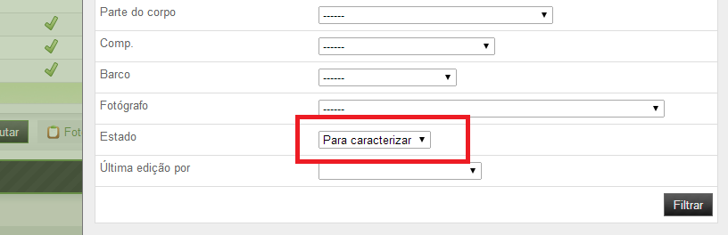
Update from Alex:
Issues with the main identify filter:
- Missing “I” from photo and from pattern_cell_tail table - the code was not mirroring this fact, so I changed it (this caused the page to stop working whenever a photo had a mark with “I” in it)
- When selecting sets of multiple marks in an alphabetically inverse order (eg Larga D1-B2, Estreita C2-A1) - the code did not work, so I changed it and it now works with inverse orders, as well
- Due to the fact that the names of the marks (eg A1, B1 etc) in the pattern_cell_dorsal_left/right tables are repeated 4 times (once for each Roaz/Baleia Piloto de Barbatana Curta/Golfinho de Riso/Falsa Orca specie), when clicking on a mark in the filter (with everything else unclicked) - the code was not looking for the specie of the photo and did not work perfectly (it now works)
- “Caracterizacao igual” never worked for photos with more than one mark (LOGICAL_AND from the last query->combine(...) was doing an “AND” on all conditions at the same time)
- “Caracterizacao igual” and the others always returned results belonging to the same body part. Now they return results from both body parts (for Dorsal Right and Left in the case of the Roaz/Baleia Piloto de Barbatana Curta/Golfinho de Riso/Falsa Orca species)
- The old algorithm which processed the chosen marks was returning these results:
1) if you only clicked on a (Larga - this is irrelevant) A1 mark: all the pictures which have a mark beginning with A1 (A1-H1, for example)
2) if you only clicked on an A2 mark: all the pictures which have a mark beginning with A2
3) if you clicked on A1-B1 (same results are returned if you click on A1-B2 or A2-B1 or A2-B2):
a) all the pictures which have a mark beginning with A1
PLUS b) all the pictures which have a mark beginning with A2
PLUS c) all the pictures which have a mark beginning with B1
PLUS d) all the pictures which have a mark beginning with B2
PLUS e) all the pictures which have any of these pairs of marks: A2-B2, A2-B1, A1-B2, A1-B1
4) if you clicked on A1-C1:
a) all the pictures which have a mark beginning with A1
PLUS b) all the pictures which have a mark beginning with B1
PLUS c) all the pictures which have a mark beginning with B2
PLUS d) all the pictures which have a mark beginning with C1
PLUS e) all the pictures which have any of these pairs of marks: A1-B2, A1-B1, B2-C1, B1-C1, A1-C1
5) if you clicked on A1-D1 (if you want to extrapolate for A2-D1, for example, just replace the A1 with A2):
a) all the pictures which have a mark beginning with A1
PLUS b) all the pictures which have a mark beginning with B1
PLUS c) all the pictures which have a mark beginning with B2
PLUS d) all the pictures which have a mark beginning with C1
PLUS e) all the pictures which have a mark beginning with C2
PLUS f) all the pictures which have a mark beginning with D1
PLUS g) all the pictures which have any of these pairs of marks:
A1-B1, A1-B2, A1-C1, A1-C2, A1-D1, B1-C1, B1-C2, B1-D1, B2-C1, B2-C2, B2-D1, C1-D1, C2-D1
The new algorithm has two versions:
Strict version (which only applies when “Estrito” is checked and only in the case of the vertical user marks = the ones on the left side):
- If you only select A from the vertical user marks, it will return all the photos which have an A1 or A2 mark and nothing else (it will not return A1-B2 for example)
- If you select A-C from the vertical user marks, you will get back all the photos which have an A1-C1 or A1-C2 or A2-C1 or A2-C2 mark
Loose version:
- If you choose (Larga) B1 (the same rule applies to B2) or just B (in the case of the user marks), it will return all the photos which have a B1 or B2 in their mark, like A1-B1, A2-B2, B1, B2, B1-C1, B2-D2 etc
- If you click on a B1-C1 (the same rule applies to B1-C2 or B2-C1 or B2-C2) or if you select B-C from the user marks, you will get back all the photos which have: i) B1 or a B2 in their mark, like A1-B2, B1, B2, B2-H1, B1-C1 PLUS ii) C1 or a C2 in their mark, like A2-C2, C2-D2, C1, C2, etc
Fixed
Plus:
1) I need to remove AJAX functionality (please use the big black button for everything. You can select things from both forms, vertical and horizontal at the same time and then press the button) and
2) add a button on the form filter , also
3) remove Marcas completas and Profundidade (from combination code, as well), add excluding button to Lisa/Irregular/Ponta e/d cortada and, move Caracterizacao igual to 3rd place - Status: 1), 2), 3) Done (waiting for upload)
4) add queries to the marks (just above the small photos in the carousel plugin) in order to add to the results the photos with the neighbouring marks (eg B2 takes B1, then A1, A2, C1 and C2) - As an alternative, two sets of user marks were added (they don’t do anything now, still waiting on new algorithm requirements):
- one on the left (called "vertical" inside the code, because it's in a vertical form)
- one on the right (upper right hand corner, next to the marks, just after + Escolha Marcas, called "horizontal")
You can use both sets of user marks separately or together.
I added two sets, in those two locations, because it gives you the possibility (if you select something from them, of course) to choose two custom sets of marks which a photo must have at the same time (so, not one or the other, but both simultaneously). So, you choose A - ---- (you can choose A and nothing or you can choose A - B or A - E, for example) on the vertical one and D on the horizontal one. You'll get results with photos which have Larga B1 and Estreita D1, for example.
It uses the same combinations algorithm as the one used when you click on marks (the ones which become bold when you click on them). On how this new algorithm actually works, see page and 20.
This is how the forms work (here I will split, for the sake of clearly explaining the functionality the “identify form”, which, in code is singular, in two ‘visually separate’ forms, ‘vertical’ and ’horizontal’):
The vertical form on the left (the one with all the options) is processed first. What it does is it filters out all the photos which have all the properties selected by you at the same time (in code terms connected with an AND). Let's say you choose same body part, irregular and user mark B. It will give you the photos which have the same body part as the photo you are identifying and which are irregular and have a marca B1 (Larga or Estreita), at the same time.
Next comes the horizontal strip (the one with marcas and horizontal user marks on top of the small photos). This works with the results returned by the form above. If you click on a Larga B1 (and it becomes bold + remember that you have to press the black button now), all the photos returned by the vertical form will be filtered and only the ones which also have B1 (or B1 - any letter) will be displayed. Now comes the difference to the vertical form. If you, in addition to having chosen Larga B1 from the horizontal form you choose Larga D1 and select F from the horizontal user marks), what you will receive (in code terms connected with an OR) is:
1) the photos returned by the horizontal form which also have a B1 (or B1 - any letter) mark
PLUS 2) the photos returned by the horizontal form that also have a D1 (or D1 - any letter) mark
PLUS 3) the photos returned by the horizontal form that also have a F1 (or F1 - any letter) mark
X) must also fix all the other filters from the whole website - see bug 7
Note for future developers: pages do not reset themselves after a search using the filter during the same session. Clicking on a page will only show the page containing the results obtained from a previous search. If you do a new search with nothing in the filters, you will obtain all the data. However, this is not the way it should work.
XI) avistamentos (similar to General_Info=Saida) - will cause same issues (saving only valid watch_sightings etc) + not deleting siblings as in the case of general_info
Note for future developers: this isn’t to be fixed before a new plan is developed for ‘avistamentos’, as they haven’t been user for more than 2 years.

FILTERS “IRREGULAR” AND SPECIES WITH 2 DIFFERENTS BODY PARTS
When we want to use the filter irregular for a specie which have 2 differents body parts in the catalogue, the filter shows us only the irregular individual with the same body part, even if the filter “parte do corpo igual” is unclicked. We would like to see all the irregular individual of this specie.
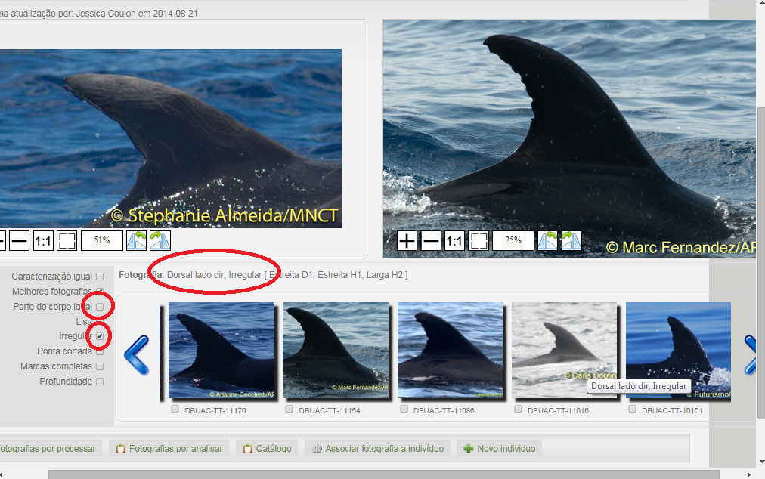
Status: Done
ERROR IN THE CAROUSSELLE WHEN USING FILTERS
When we use filters, some picture in the carouselle appears several time in the row (2 to 4).
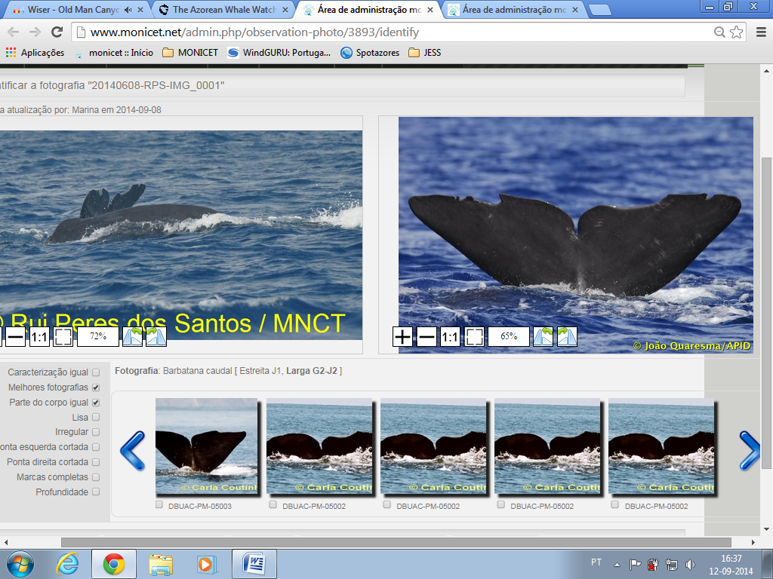
Status: Done
SHOWING AN “IN PROCESS” GIF, WHILE THE IDENTIFY FILTER IS SEARCHING FOR RESULTS
Status: Done
OPTION TO SELECT DIRECTLY THE NEXT PHOTO TO PHOTO-ID
Right now, after finishing the identification of one photo, the only options that can be selected are “Photos to process”, “Photos to analyze”, “Catalogue”, “List of individuals” and “Edit”.
In order to select the next photo to identify, the only current option is to click again in “Photos to identify” and choose the next one. Thus, it would be useful to create an option inside this menu that would allow selecting directly the next photo to identify, instead of having to return each time to the main menu.
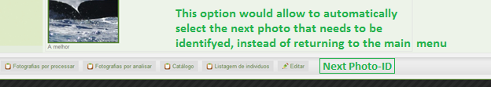
Status: Done. Note: the button is on the left hand side (and not on the right, like in the picture above).
NUMBER OF PHOTOS TO COMPARE IN THE PHOTO ID
It would be useful to have the information of how many photos do we have to compare when we are doing the photo identification. Depending on the filters we apply, the total number of these photos may vary, and this information would be useful in order to better memorize the location of the individuals in the row of photos.
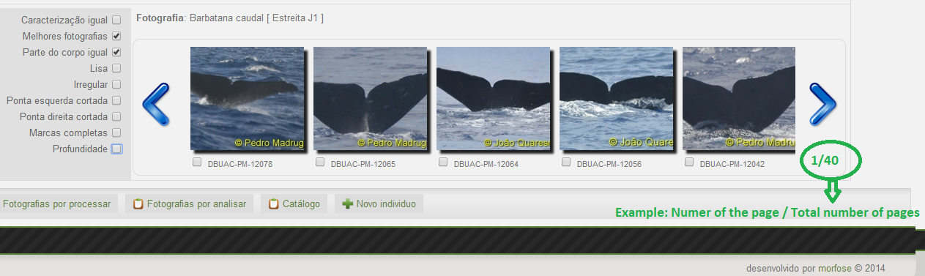
Status: Done
USING THE KEYBOARD TO SELECT THE PHOTOS IN THE PHOTO ID
Right now, in the Photo ID tool, it is just possible to pass from one photo to another selecting them with the mouse. It would be faster if we could select the photos by using the keyboard.
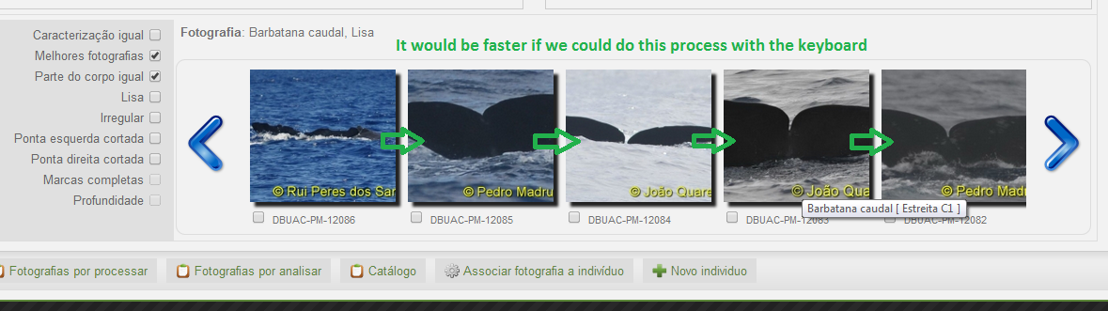
Status: Done. Note: If you click on the Tab key on the keyboard you will arrive (eventually) in the strip of photos. If you click again, you will go to the next photo. The Number of the page/Total nuber of pages indicator will not work correctly when using the Tab key.

NEW TAG FOR THE PHOTOS IN WHICH WE HAVE DOUBTS
There are some photos in which the Photo ID is not certain, and in which we have some doubts when validating them. Thus, it would be useful to tag these photos with a special label in order to identify them, and solve the possible doubts in the future.
Status: Done. This is how it works:
- on the identify page, there is a new button on the far right hand side… click it if you have doubts about the photo. This will add to the notes of the photo a marker, _doubt. If you don’t like using the button, you can also go to the edit page of the photo and add _doubt manually at the beginning (it’s important to have it at the beginning and not in the middle or at the end) of Notas (you can then write whatever you want after _doubt).
- now, when you go to the catalog page (Fotografias por analisar or Catalogo) you will see a new column on the upper right hand side (Notas). If you click on it, you will re-order the photos, the criterion being that the photos with _doubt at the beginning of their notes will be first in the re-ordered list.
- if you change your mind and you want to “un-doubt” a photo, when you try to identify the photo you’ll see a button on the far right hand side. Just click on it. An alternative way of “un-doubting” the photo is to go to its edit page and delete the _doubt from its notes.

SELECTION OF TWO BEST PHOTOS WHEN THE BODY PARTS ARE DIFFERENT
For every individual, we always have to select a best picture. When these photos are from different body parts, it should be compulsory to select one best picture for each body part.

Initial set-up:
The page of the individual was changed. The photos are grouped by body part. Each body part has a BEST photo now. One of the body parts is DOMINANT = the BEST photo of that body part is the “overall” BEST photo (used on the website, when it’s required to show only one photo per individual). A random BEST photo was selected for each body part. Before this, each individual already had one (and only one) BEST photo. This photo remained BEST for its body part and its body part was made the DOMINANT body part (therefore becoming the 'overall' BEST photo) for that particular individual (even if that body part was not the default DOMINANT body part).

Changing the DOMINANT body part:
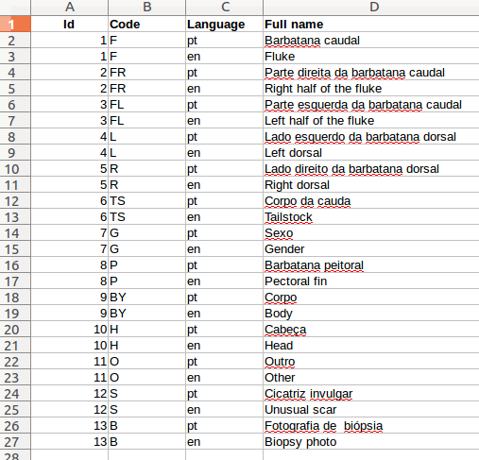
When the website wants the ‘overall’ BEST photo, it searches for the BEST photo with the DOMINANT body part.
It first looks in the newly created field (belonging to the ‘individual’ table), called dominant_body_part_code. The user has the possibility, by clicking on the radio button (on the page of the individual), below the body part names to set the DOMINANT body part. You’ll receive a message when it was successfully changed in the database. The body part code is also visible on the ‘edit’ page of the individual, where it can also be changed (never remove it, even if it’s a default body part). However, I strongly recommend to only change the DOMINANT body part by clicking on the relevant body part radio button on the page of the individual. The body part which has a checked (with a dot in the middle) radio button is the DOMINANT one for that individual.
Note for future developers: changing the DOMINANT body part from a non-default body part to a default body part doesn’t add anything to the dominant_body_part_code field (there’s no need, being that the new DOMINANT body part is the default one, plus I’d like to keep the field more as a user-set only type of marker). It only clears (sets it to NULL) the old body part code from the field. You will, however always see a body part code in the dominant body part section of the form present on the ‘edit’ page of each individual, because the form is calling the overriden getDominantBodyPartCode() function of the Individual class. This must be used with care, as there is no user input validation done here. To do: sfWidgetFormPropelChoice() in the BaseIndividualForm class for dominant_body_part_code using the model of the ObservationPhotoForm class (for body parts).
Secondly, if there is nothing in the dominant_body_part_code field, it looks for photos of that individual which have the default body part.
Normally, the default body part for species: Roaz/Baleia Piloto de Barbatana Curta/Golfinho de Riso/Falsa Orca is Lado esquerdo da barbatana dorsal. If there are no photos with Lado esquerdo da barbatana dorsal, it looks for photos with Lado direito da barbatana dorsal. If there are no photos with Lado direito da barbatana dorsal, it looks for photos with Barbatana Caudal. If there are no photos with Barbatana Caudal, it will return the first BEST photo it finds (to be more precise, it returns the BEST photo with the body part which has the photo with the oldest date - date of the actual file...this is how I noticed the random selection works, this was not set by me).The body part of this ‘first BEST photo’ has the radio button clicked when visiting the page of the individual.
For all other species, the default body part is Barbatana Caudal. If there are no photos with Barbatana Caudal, it will return the first BEST photo it finds (see ‘random’ rule from the end of the previous paragraph).
It is important to note that the programme makes it that way and always expects that an individual always has at least one photo and each body part present in those individual's photos has a BEST photo.

Deleting/re-associating a photo:
When you delete/re-associate (to an already existing individual) a photo you’ll be redirected to the previous individual only if it’s left with more than one photo with the same body part as the deleted/re-associated photo (if it’s left with exactly one photo, then there’s no choice, the last photo with that body part has to be BEST and you won’t be redirected to the previous individual’s page). You’ll receive a message informing you of this (containing the body part code of the deleted/re-associated photo, so that you know which body part of the previous individual was affected by the change).
Remember: a BEST photo for that body part, belonging to the previous individual was already chosen at random.
When you re-associate to a newly created individual (when you click on ‘novo individuo’), even if the photo was BEST you’ll be redirected to the page of the individual's (in the message you'll receive, there will be the name and code of the previous individual), because, at the moment of the message I don't have the name and code of the newly created individual (so, if I redirect you to the previous individual, I won't be able to redirect you to the new one afterwards). In general, when you re-associate to an already existing individual, you can see the code of the individual below the small photo from the carousel on the identify page (plus you always have the name of the photo on the upper left part of the page).
When you delete/re-associate a photo which also happened to be the ‘overall’ BEST photo, you will not receive a message concerning the DOMINANT body part of the previous individual. It will be displayed on the individual’s page (and chosen for other parts of the website) according to the rules described above (in the Changing the DOMINANT body part section). For example, if the photo was the second to last photo with its DOMINANT body part, the last remaining photo with that body part, belonging to the previous individual will become the ‘overall’ BEST photo and the DOMINANT body part will remain unchanged. However, it the photo being deleted/re-associated is the ‘overall’ BEST and the last photo with its body part, then (in the case where the previous individual doesn’t have photos with default body parts), the rules from the previous section will be applied. So, if you want to make sure it has the DOMINANT body part you want, just visit the page of the individual and set it manually, by clicking on the radio button. If a body part is dominant but no longer has any photos, it will no longer be DOMINANT. Only body parts with existing photos can be DOMINANT.
The general rules about deleting/re-associating a photo from point C on page 14 (Choose a new best photo for an individual when its original best photo was deleted or assigned to a different individual) still apply.
Notes:
On the page of an individual, if a photo is not validated, its background colour will be light red.
Status: Done

ATTACK CSRF
It happens sometimes
...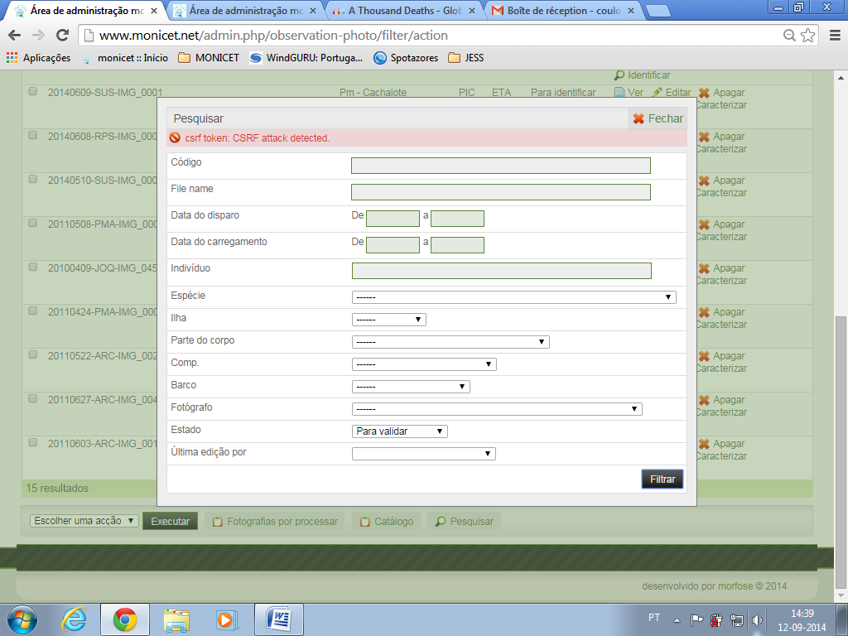

Status: could not replicate the error...to be continued (Note for future developers: this is a reccuring issue which must be dealt with)

NEW TOOL IN ORDER TO UPLOAD PHOTOS AND PHOTO-IDENTIFY THEM IN THE PLATFORM
This new tool would appear in the public interface. With it, people would be able to upload their own photos, and compare them with the whole Monicet catalogue, in order to photo identify them themselves. This tool would be similar to the Photo-ID Monicet tool, but more simplified.
The idea is to create this tool in order to make the characterization and photo identification process easier and to apply it first in the private interface and later in the public web site.

-add a photo to the database (when uploading make sure name has the correct format) - short procesar done in the upload window (body part & specie, if none, default Pm with Barbatana Caudal, island, default SMA or XXX - date, hour and code automatic with when it was uploaded) - save (if leave page - delete page or back-up leave uploaded marker in the notes - this goes for all actions) plus a button START OVER - which will delete the photo and ask for a re-upload - according to specie and body part - caracterizar will be active - simple caracterizar? - save or START OVER (same as above) - status will be para identificar - then re-direction to identify page (no duvidas or new individual, no messages) - only identify (this will delete the photo and redirect you to http://monicet.dev/en/catalog) or START OVER (same as above)
-when you upload a file (do nothing if no file) - ..according to specie/b_p go to frontend version of caracterizar (Voltar will mean what START OVER means). This frontend version needs to be a dumbed-down copy of the backend one (the same goes for the identify page)
-go to frontend identify afterwards, only have 2 buttons: filtrar, associate (the same as the save above) = Voltar or START OVER (do the same, delete photo, go to http://monicet.dev/en/catalog)
-would be nice to be able to click on the right hand side iviewer photo and be re-directed to the page of the individual http://monicet.dev/en/catalog *when in the frontend and for admins redirect to backend ind page
-2MB issue
-delete 'uploaded' if older than 1 hour from created_at when someone uploads a new photo
-don't link it to an individual, don't make it 'validated' and don't show it in the backend catalogue (or the frontend catalogue) - use the marker
-when body_part id is not 1,4,5 it's not displayed on the identify page - fix

