Project Site: 43 Keegan Drive | Massey| 003500089601 |  |  |  |  |  |  | Site Contacts
 |  |  |  |  |  |  | Site Engineer: |  | TBC
Objective: Excavate down and repair faulty 100mm lateral connection from cesspit |  |  | Drawing(s): Sketch as below |  |  |  | Foreman: |  | Dale Hogg
Permits/ Consents Required: Yes | Site prestart - Yes | Heavy machinery prestart - Yes |  | Team pre-con / induction - Yes |  | Safe-Dig Permit - Yes |  | BUD Plans – Yes | WorkSafe Notification Yes | 036
Critical Risks and Controls  Record details & owner on Crew’s Hazard Control Plan /JobSTART  - Pedestrian and vehicle management  - Site perimeter established with workers making sure pedestrians don’t enter the work zone  - Nearby vehicles managed by STMS and TMOs  - Loud machinery: Hydro excavator, upright rammer, grinder, electrical tools  - Ear protection to be worn while machinery is being used or when in the vicinity of the hydro excavator truck running.  - Excavations  - Zone of influence to be barricaded  - Shoring for trench required.  - BUD Notification.  - WorkSafe Notification  - Spotter in place for ground cracking and trench wall densities  - Working around services  - Close approach permits to be valid for the specific days planned  - Pre-excavation identification via service locate contractors and BUDs  - Identification during excavations strictly via hydro excavating only  - Heavy vehicles moving  - Spotters to be in place for safe reversing.  - High profile customer, sensitivity of customer and customers assets being affected  - Customer spoken to from start to finish through every milestone of the job process explaining every step of the job  - Controls put in place (track matts, water-diversion measures, immediate cleaning of customer assets affected due to the work) to alleviate any possible complaints  - Photos taken of the work zone prior to entering  - Considerations taken for start times around customers house  - Noise concerns to be communicated to the customer  - Customers vehicles to be moved if needed  - Length of job to be communicated to the customer  - Customer services being affected to be notified to the customer if they are affected  - Mitigation / contingency plan  - Email sent / written to customers prior to any work stating that all reinstatements will be done to same or better standard as it was found  - Before-hand photos taken prior to any work within any area of the workspace  - Customer’s briefed on the exact work that needs to happen  - Customers briefed if work would take longer than expected due to unforeseen circumstances (deeper and expected, contractor availability issues etc)  - Operations of electric tools and machinery  - Only competent and trained operators to use high-risk tools and machinery  - Ground gradients  - Considerations taken for orientation of vehicles  - Wheel chocks to be placed behind wheels of every vehicle  - Authorised Permit and Authority Issuers and receivers (Dg-ZHFM021-NZ Authorised Permit Issuers and receivers Register or equivalent)  - ATW’s approved by GM (with document control and consistent numbering format)  - Issued Permits (use DG-ZH-FM025-NZ Site Authority to Work Register or Equivalent). |  | Site Layout  Excavate down and repair faulty 100mm lateral connection from cesspit  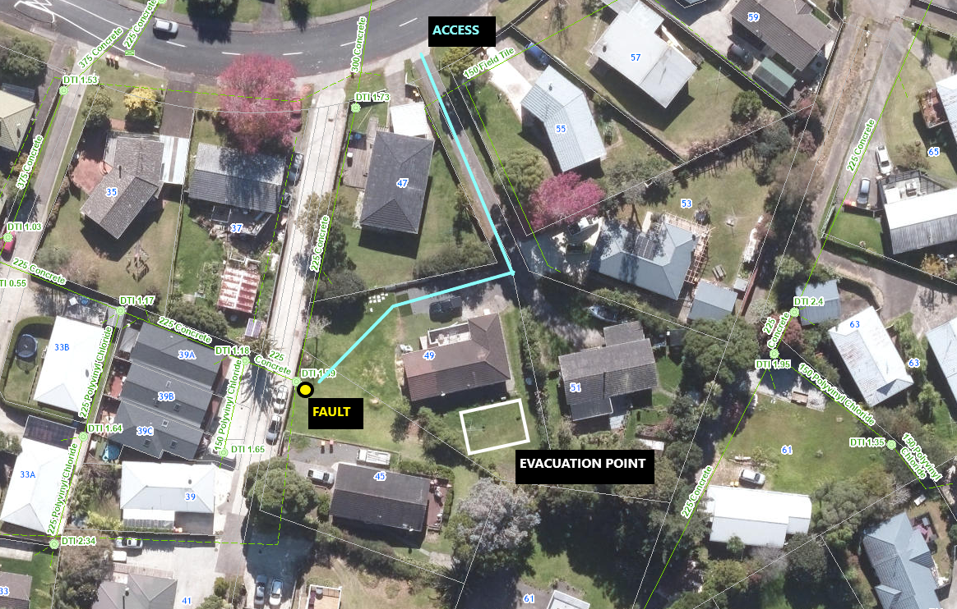  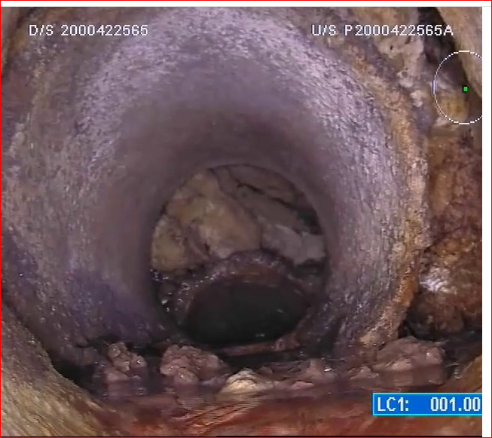 |  |  |  |  |  |  | Key Construction Tasks/Methodology  - Acquisition of relevant permits  - Team briefing & job-starts  - Customer briefing and notification of possibility of removing plants / trees and assurance that reinstatements will be done to satisfactory standards  - Take before photos  - Establish work zone(s)  - Establish shoulder and footpath closure  - Digger to move into the TMP closure  - Conduct top-down approach when placing the gripshore shields while excavating  - Downer arborist to give assistance in removing small plants / trees if too many roots are exposed.  - Faulty pipework exposed with S/L 2527561  - Trench shields checked for security  - Ladder lowered into the trench  - Drainlayer enters trench, cuts and conducts repair  - Haunches new repair, securing it in place  - Drainlayer exits trench  - Trench shield removal in stages as backfilling commences  - Backfill with aggregates up to 50-75mm below surrounding ground level.  - Compacted every 300mm to follow adequate compaction standards.  - Reinstate the work via topsoil and grass seed.  - Downer arborist to give assistance in replacing small plant(s) / tree(s)  - Wash down affected areas  - Pack up and clean work area  - TMP pack down  - Photos taken  - Customer debriefing
Key Quality Tasks
Site establishment
Exclusion zones
Before / after photos
Site area tidy up and make neat
Adequate compaction
Customer satisfaction

Safety Plan
Evacuation point in front of 49 Keegan Drive
First aid and Fire extinguisher in all downer vehicles
Nearest Medical centre: Massey Medical Centre

Site Engineer |  |  |  |  | Site Foreman
Print: TBC |  | Sign: |  |  | Print: Dale Hogg |  |  |  | Sign: D.L.HOGG

 | Crew’s Risk Control Plan |  |  |  |  |  |  |  |  | Site TMP requirements: Shoulder closure, L1  TMP Number: N/A  STMS for site: N/A
 |  | - What can harm me?  - What can harm others?  - What can harm the environment? | Potential Consequ-ences  1 – 6  (see next page) |  | Likelihood Of Event  Certain  Likely  Possible  Unlikely  Rare |  |  | Risk Rating Before Controls  A, B, C, D (see next page) | RISK CONTROLS  (How can we reduce the risk of personal and/ or environmental harm here?) |  | Residual Risk Rating  A, B, C, D (see next page) | PERSON or TEAM RESPONSIBLE | COMPLETED  BY
 |  |  |  |  |  |  |  |  | Eliminate the hazard, or Minimise the risk |  | Residual Risk Rating  A, B, C, D (see next page) | PERSON or TEAM RESPONSIBLE | Initials | Date
If there is a change on site that may create a new hazard, or increased residual risk rating, this form must be reviewed, then updated if required.
Any new hazards must be communicated and signed off by the work team. Examples of change include changes in plant/equipment, work methods, scope and site conditions.
Public, pedestrian and vehicle management |  |  |  | 3 |  | L | B |  | Site perimeter and exclusion zone establishment via cones and barrier arms. |  | D | Each worker | D.H. | 31/07/2025
Reversing vehicles |  |  |  | 3 |  | L | B |  | Every reversing vehicle will be assigned a spotter before any reversing is started. |  | D | Each worker | D.H. | 31/07/2025
Excavation |  |  |  | 3 |  | L | B |  | 2m perimeter minimum exclusion zone around deep excavations |  | D | Each worker | D.H. | 31/07/2025
Operating heavy equipment / machinery |  |  |  | 3 |  | P | B |  | Competent digger operator with current WTR endorsement. Confident and trained serviceman to use heavy equipment (trench rammer, compactors etc) |  | D | Team leader | D.H. | 31/07/2025
Slips, trips, falls |  |  |  | 3 |  | P | C |  | Pay attention to footing. Correct PPE. Housekeeping |  | D | Each worker | D.H. | 31/07/2025
Loud machinery |  |  |  | 4 |  | P | B |  | Wear appropriate PPE (earmuths) to be worn. Noise cancellation methods taken if available (noise control barriers) |  | D | Each worker | D.H. | 31/07/2025
Manual handling |  |  |  | 3 |  | P | C |  | Lift objects with recommended lifting technique. Wear appropriate gloves for the work required. Use right techniques for hand-digging. |  | D | Each worker | D.H. | 31/07/2025
Contaminated ground materials |  |  |  | 3 |  | P | C |  | Contaminated material sucked out and removed from site. Depending on liquid content of material, permits required for dumping. |  | D | Team leader / hydro contractors | D.H. | 31/07/2025
Deep excavation / trench wall density. |  |  |  | 4 |  | P | B |  | Compliant trench shields to be placed and secured within the trench to prevent and trench walls collapsing. Specifications of shields to be changed based on trench densities. If shallow trench, spotter to observe trench wall density. |  | D | Each worker | D.H. | 31/07/2025
Battery powered / corded power tools |  |  |  | 3 |  | U | C |  | Power leads to be signed off as safe to use. Leads and batteries to be checked for faults prior to using. Power tools to be checked for faults prior to using. Strict considerations to be taken when using power tools in the rain / around bodies of water. |  | D | Each worker | D.H. | 31/07/2025
Flying debris |  |  |  | 4 |  | L | B |  | Eye protection to be worn at all times around hydro excavating, concrete breaking, concrete cutting or any relevant demolition work |  | C | Each worker | D.H. | 31/07/2025
Airborne contaminants |  |  |  | 5 |  | P | B |  | Respirator with a P3 filter to be worn when handling any asbestos. Keep asbestos wet at all times when handling. To be bagged and disposed of appropriately. Any concrete cutting / demolition work to be evaluated prior to starting to find a water source and making sure all silica dust is contained |  | C | Each worker | D.H. | 31/07/2025
Steep gradients / low density parking spots |  |  |  | 4 |  | P | B |  | Wheel chocks to be put being every vehicle. Photos and considerations taken before parking any vehicle on a driveway or berm where damages may be caused. Strong considerations of the diggers orientation taken before taking an excavator on a steep / slippery gradient. |  | D | Each worker | D.H. | 31/07/2025
Working around services |  |  |  | 5 |  | P | B |  | Close approach permits to be valid for the specific days planned. Pre-excavation identification via service locate contractors or hand dig where service locators aren’t feasible. Identification during excavations strictly via hydro excavating or careful hand-digging. |  | C | Each worker | D.H. | 31/07/2025
Spills / leaks / cutting residue (slurries) |  |  |  | 5 |  | L | A |  | Spill kits to be checked for stock levels during pre-starts. Where overland and underland flow-paths lead to stormwater systems, spill kits to be used to prevent pollutions. Staining items to be used in areas which won’t leave a stain or can be cleaned (i.e. glues over driveways). Any leaks to be cleaned immediately. |  | C | Each worker | D.H. | 31/07/2025
Handling poisons and potential burners |  |  |  | 4 |  | P | B |  | Appropriate PPE (Gloves and masks) to be worn |  | C | Each worker | D.H. | 31/07/2025
Working at heights |  |  |  | 5 |  | P | B |  | Trench edges to be barricaded with trench edges cleaned. All workers where relevant to be training in Working At Heights. Harnesses to be worn where relevant |  | C | Each worker | D.H. | 31/07/2025
Lack of visibility |  |  |  | 3 |  | P | C |  | High visibility clothing to be worn at all times to meet Downer SWMS standards |  | C | Each worker | D.H. | 31/07/2025
Tree felling / heavy trimming / transplanting / plant removal and replacement |  |  |  | 4 |  | P | B |  | Tree felling, large trimming and transplanting to be done strictly by trained arborist. Escalation to made by arborist if tree requires third party contractors to remove. Customer approval and photos must be taken before any transplanting, removal or replacement of trees / plants is done |  | C | Each worker | D.H. | 03/07/2025
Spotters |  |  |  | 3 |  | P | C |  | Spotters to be trained on appropriate hand-signals and what is expected of them. |  | C | Each worker | D.H. | 31/07/2025
Structural movements |  |  |  | 5 |  | P | B |  | ACH advise put in place during the planning process and followed strictly. Top-down approaches to be in place during excavations. Pre-excavation surveys to be done to monitor ground movements and structural building movements. Dilapidation survey to be done prior to any work on the site. Scaffolders to be arranged prior to any work being complete onsite |  | C | Each worker | D.H. | 31/07/2025
Confined Space |  |  |  | 5 |  | P | B |  | Only trained CSE workers to be given a CSE job. Permits to be valid for the actual working dates and conditions of the permit followed strictly. Dispatch to contacted at the start and end of the job, notifying how long the individual entry will take. All PPE and health and safety equipment to be valid within the expiry date, relevant, safe to use, not damaged and adhere to NZ safety standards |  | C | Each worker | D.H. | 31/07/2025
Hot works |  |  |  | 5 |  | P | B |  | Hot works permit to be valid for the days worked and followed strictly. All relevant PPE to follow NZ standards. Only trained and competent workers to handle relevant hot materials or equipment |  | C | Each worker | D.H. | 31/07/2025
Risk Rating Chart

Residual Risk Level | Action Required
A | Immediately cease the activity  Take action to reduce residual risk to C or below
B | Take action to reduce residual risk to C or below  Introduce controls to reduce likelihood and/ or consequence of incident
C | Take action to reduce risk further if practicable  Closely supervise and monitor the effectiveness of existing risk controls
D | Monitor the effectiveness of risk controls.  Reduce the risk further if practicable.
Likelihood |  |  |  |  | Risk Assessment Matrix
Rare  Less than 1% chance | Unlikely  Greater than 1% chance | Possible  Greater than 10% chance | Likely  Greater than 50% chance | Almost certain  Over 90% chance | Risk Assessment Matrix
 |  |  |  |  | Consequences
B | B | A | A | A | 6 – Catastrophic Examples: Multiple fatalities  Significant irreversible effects to 10’s of people  Very serious long term environmental impact
C | B | B | A | A | 5 – Extreme Examples: Single fatality  Severe irreversible effects to one or more persons  Serious medium-term environmental impact
C | C | B | B | A | 4 – Severe Examples: Moderate irreversible disability to one or more persons  Moderate short term environmental impact
D | C | C | B | B | 3 – High Examples: Hospitalisation required  Medium term impairment to one or more persons  Minor effects on environment
D | D | C | C | B | 2 – Medium Examples: Reversible disability requiring medical treatment  Limited environmental damage to a minimal area
D | D | D | C | C | 1 – Low Examples: No treatment or minor first aid only  Small environmental impact

Prepared By: | Dale Hogg | Approved By: |  | Date: 21/07/2025
Signed by Workers and Visitors on site:
Ask your Supervisor or Manager for appropriate control methods or Hazard Control plans. Controls are to be reviewed and amended at least daily and if the scope of work changes. Attach other sheets if necessary.
During course of work, add any new work group member, subcontractor or visitor to site. Ensure they are briefed and inducted on this hazard information

Additional JobSTARTs attached (as required): | Monday | Tuesday | Wednesday | Thursday | Friday | Saturday | Sunday

