1. **GEE overview**

<https://code.earthengine.google.com/>

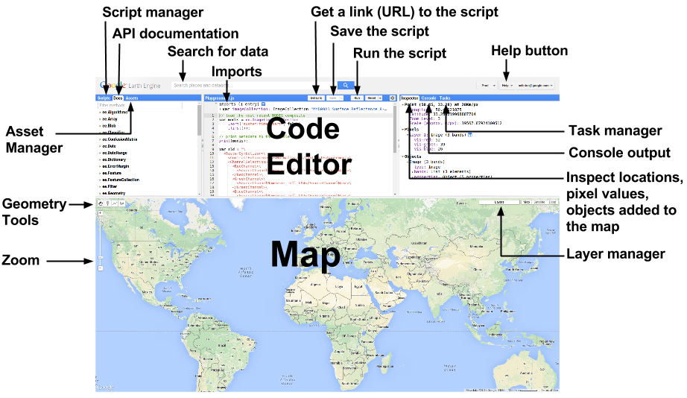

1. **Search for data: (surface albedo)**

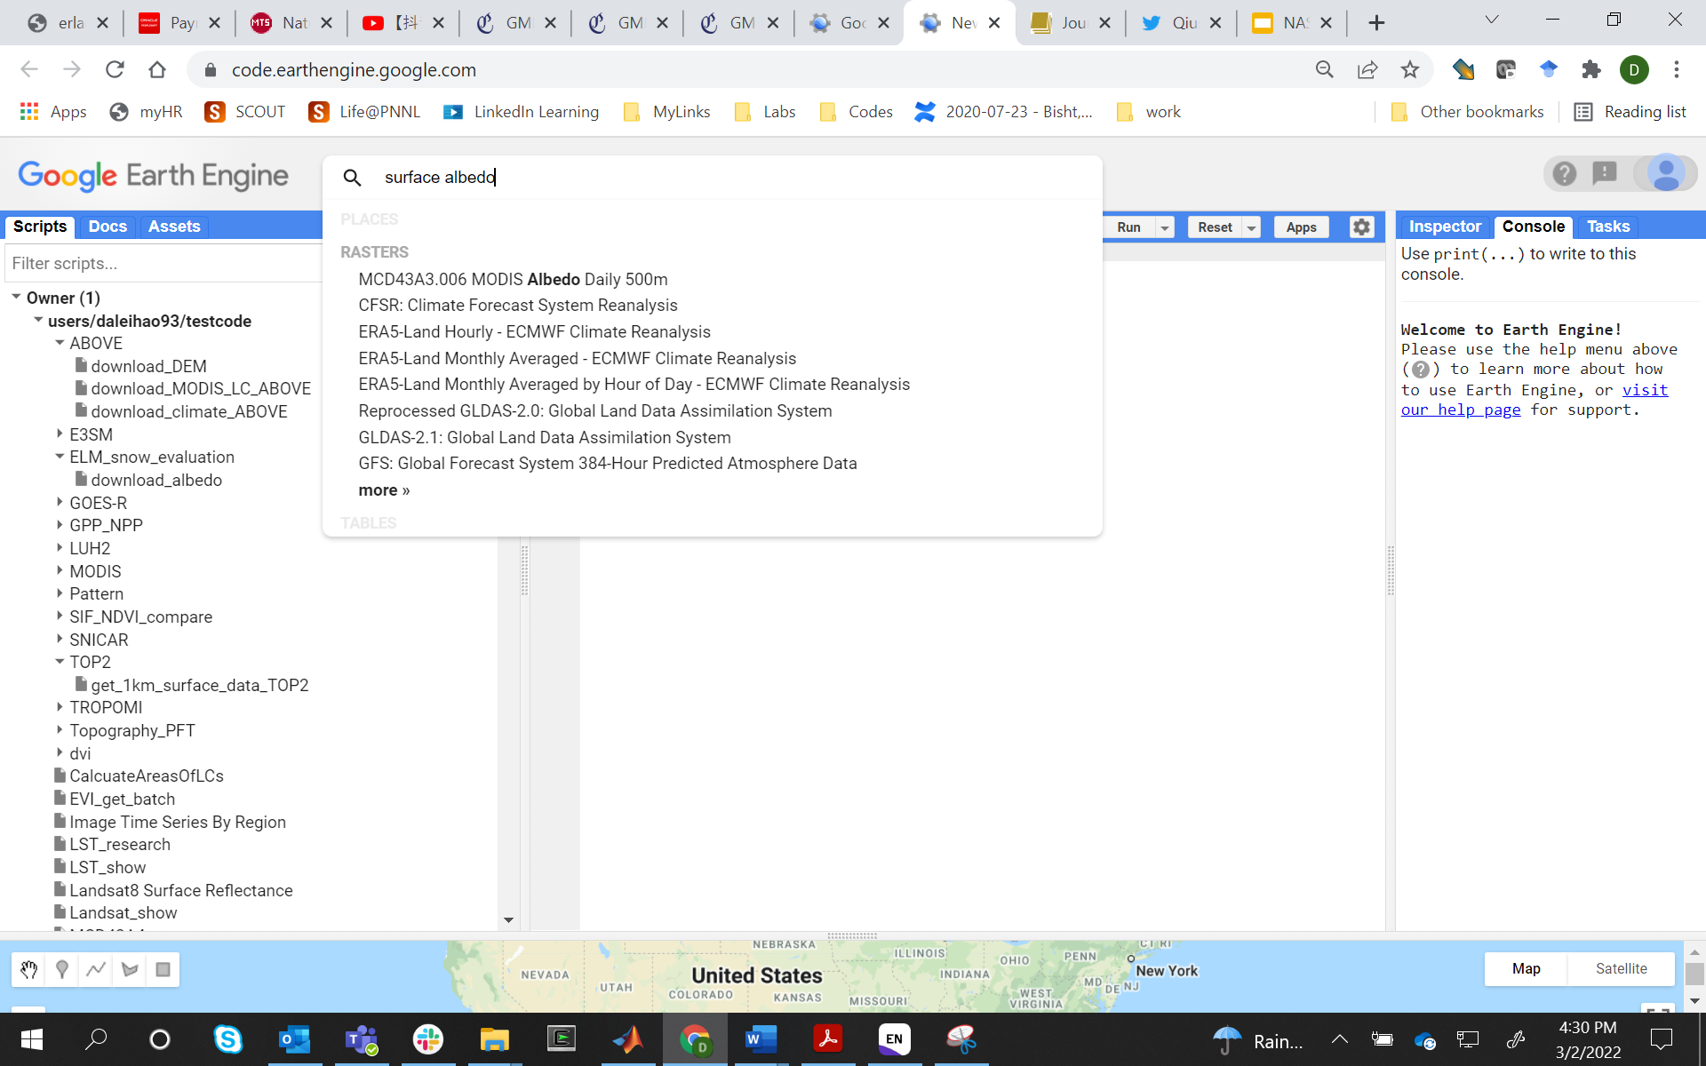

1. Get the data link (**ee.ImageCollection("MODIS/006/MCD43A3")**) and band info (Albedo_BSA_shortwave)

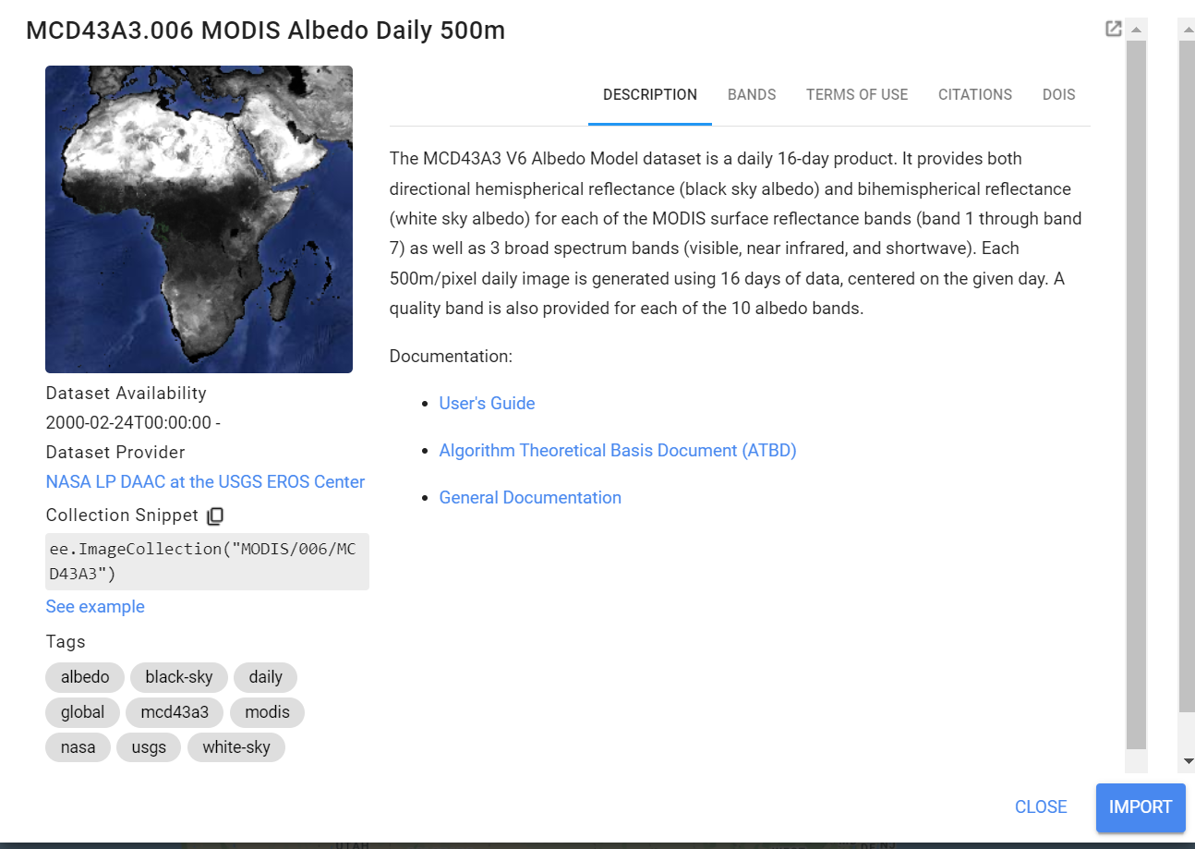

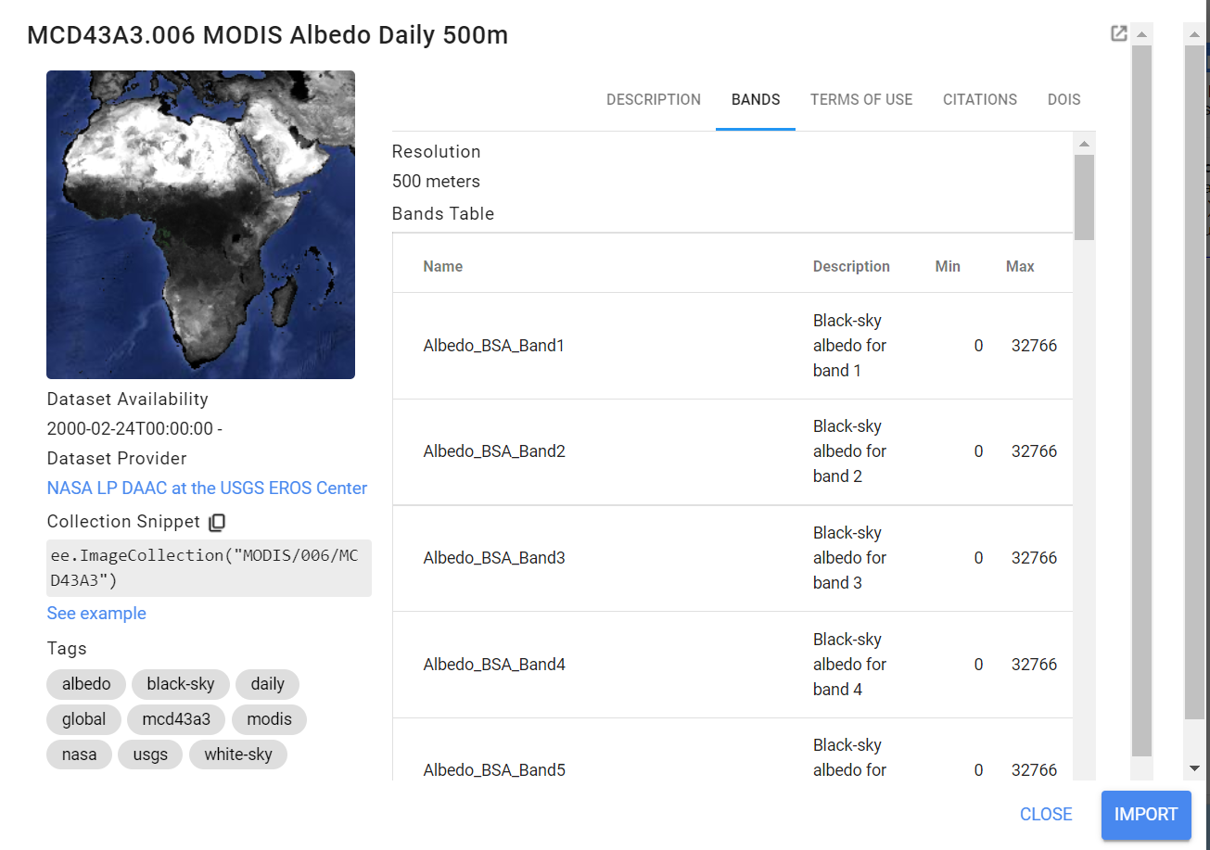

1. **Write javascript code to download the data (to google drive) by specifying the ROI and data info**

Please see here for codes:

<https://code.earthengine.google.com/8cbec972877aff40b8e6b6cea7401e81>

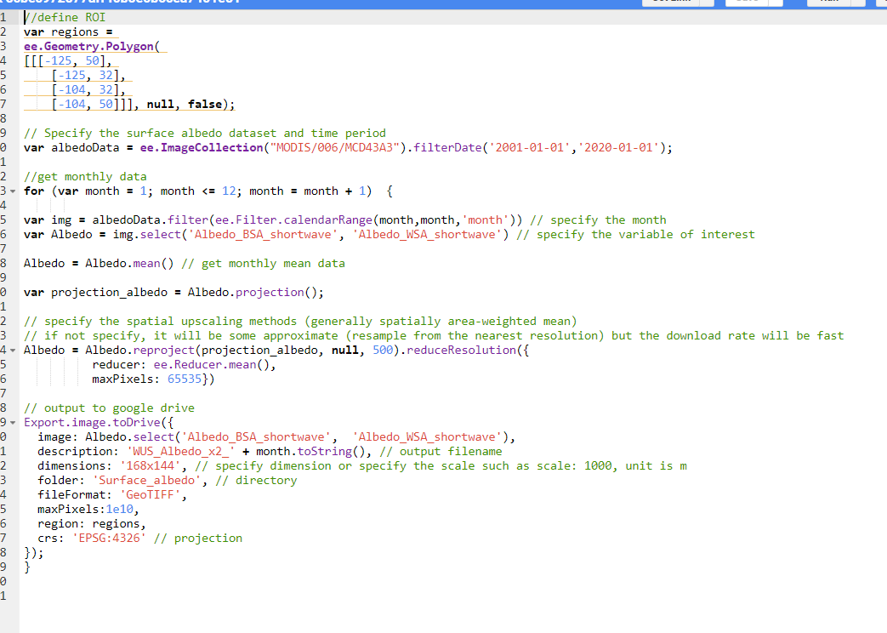

1. **Run script to download data**

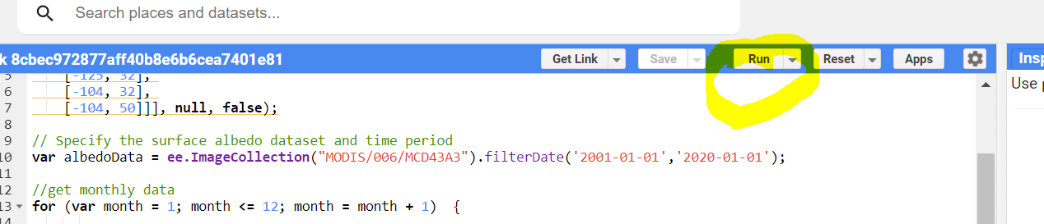

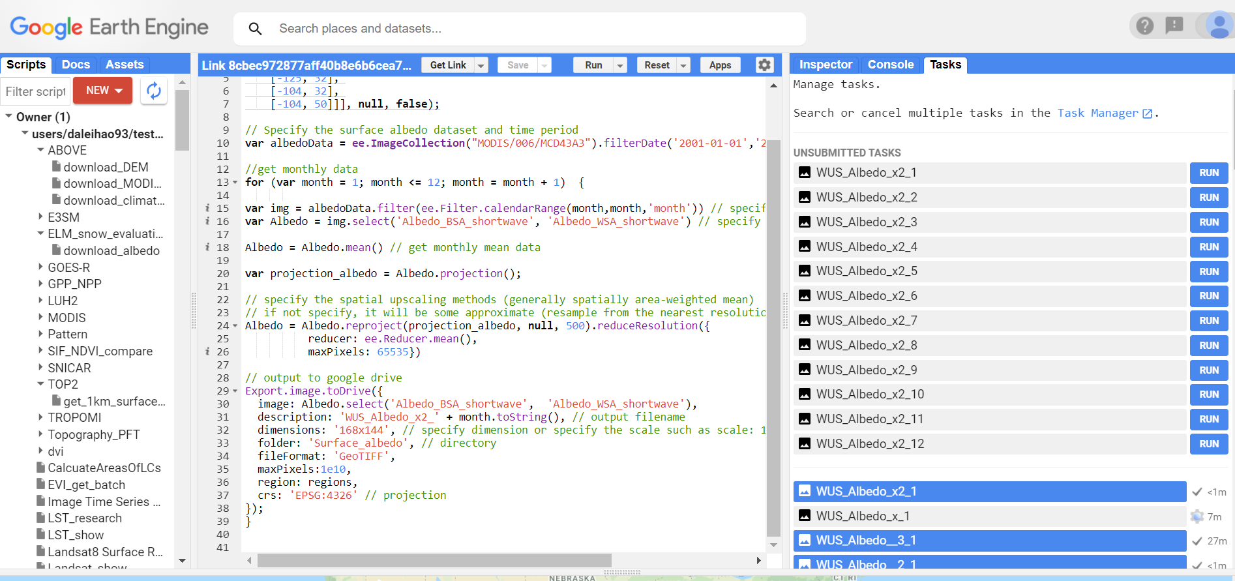

1. **Click run button to run tasks**

Batch export Google Earth Engine (GEE) tasks (no need to click the buttons manually): <https://github.com/gee-hydro/gee_monkey>

