Swedish

Reading comprehension the circus girl

9/23

Retest on 16/12, reaching an acceptable level of knowledge.

Billie book examination

20/26

The invisible girl

19/28



How is NP result?

EN

V48 NP English Part A - Oral

V41 glossary 14/16

V40 listening comprehension 12/25

V40 glossary 42/51



Physics

V49 Power and movement 15/19

V41 Exam physics -Universe 22/26



History

V49 the great power era 22/31



IdH/ PE

Dance: In the dance form inspired by West African dance, you have shown very good technical ability. Good, on the way to very good, musical ability and very good expressiveness. Write me a chat if you want further feedback

V47 preventing risks

Partial test 1:7/10

Module 2: You have demonstrated basic knowledge of how to prevent risks associated with various physical activities

V43 dance

In the dance form jazz dance, you have shown good, on the way to very good, technical ability as well as good musical ability and expressive ability. Write me a chat if you want further feedback.

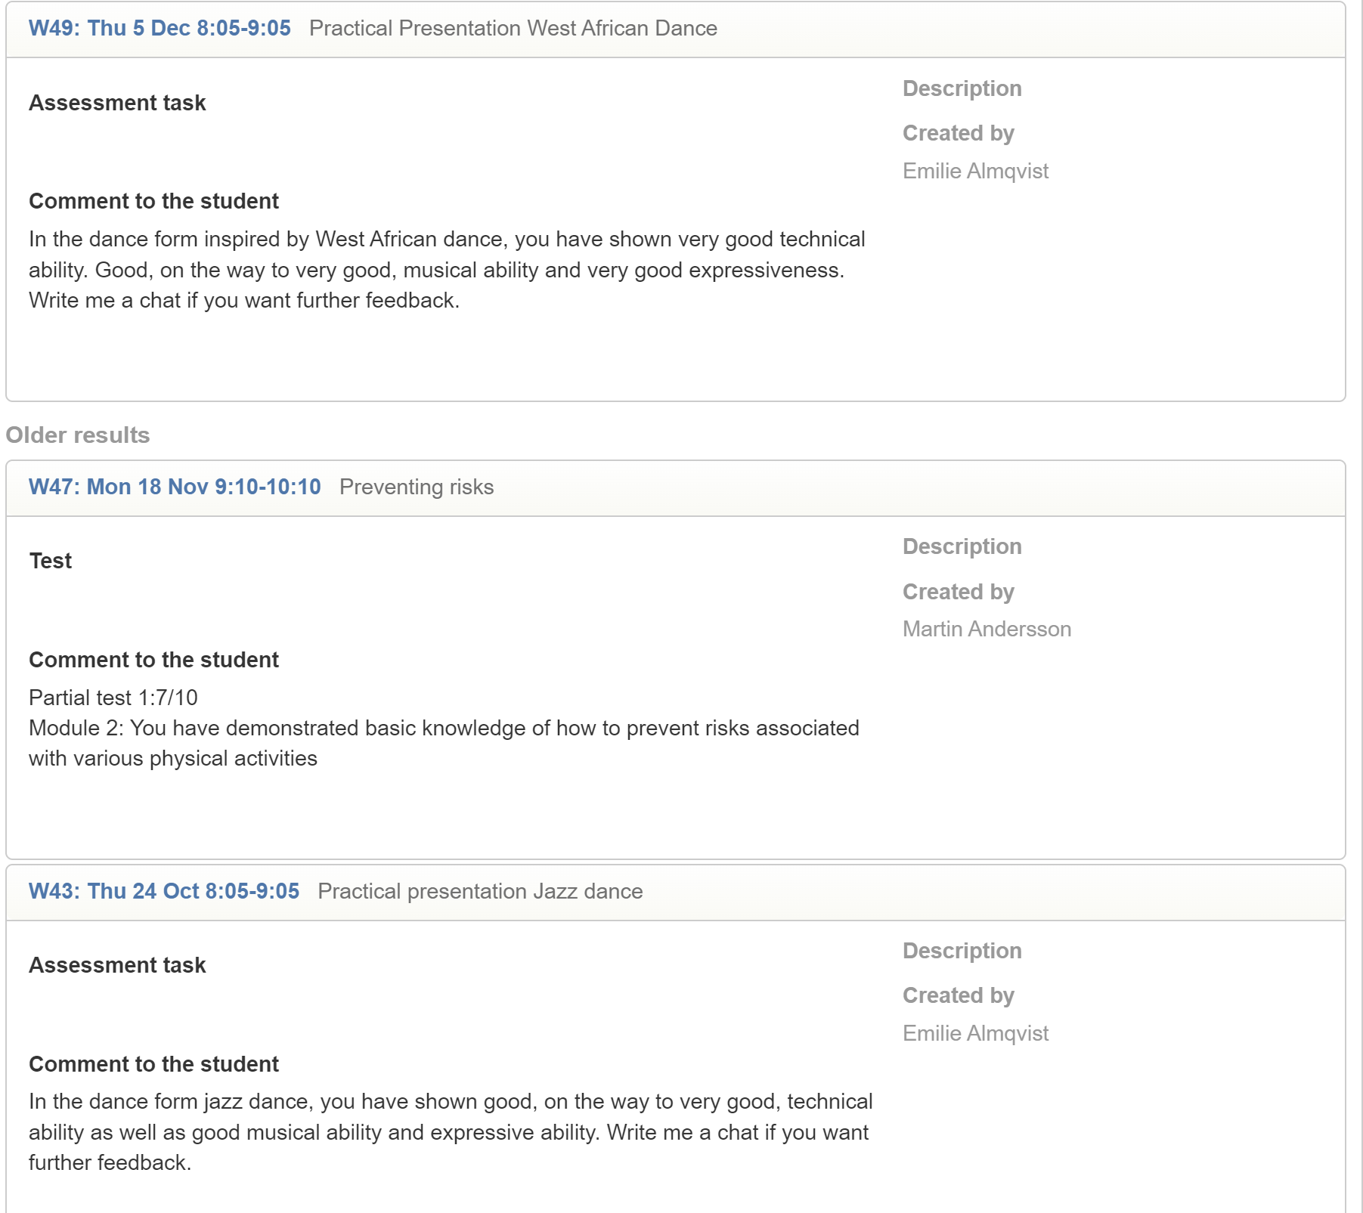

Math

V47 sample chapter 2 12/16, 18/18

V43 homework questioning quarrel 19.5/22

V40 sample chapter 1 49/54

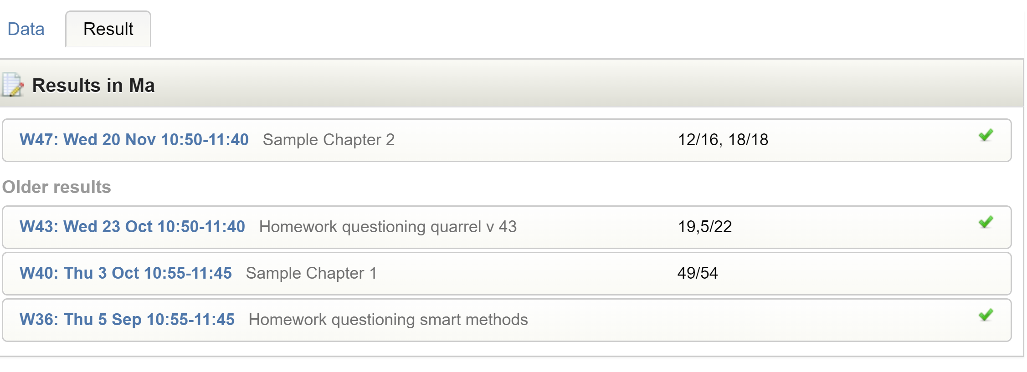

German

