

Swift Construction Company

USERS MANUAL
PN 5000001 Revision 0
Aircraft Wireless
2013-01-01

SCC Aircraft Wireless
The SCC Aircraft Wireless is a modern crystal radio receiver. The place we live on earth is filled with electric magnetic waves, which are produced by humans. Radio station transmit all the usable information at high frequency, through the antenna we receive these signals, then after some processing it is possible to obtain the original information. AM broadcast is using high frequency carrier with low frequency signal. It transmits the original signal by amplitude modulation of the high frequency carrier wave. To receive the signal from the air, we need an antenna. Antenna for AM channel is not very strict, usually larger areas and less obstruction will have better reception.

Circuit Theory
Signal received by the antenna is very weak and covers a wide band, so we need to separate the AM frequency we want by and filter out the other frequency bands. LC resonance is a good filtering circuit. We get maximum impedance when the frequency is equal to the formula. Using an inductor and one variable capacitor we can product different frequencies base on different LC values. We can select different radio channels in this way. However, the channel received is still in high frequency signal range and can't be heard by human ear, we need to remove the high frequency carrier wave. Diode conducts in positive direction only so used with RC filter we can demodulate the original signal. With a sensitive earphone you can receive clear AM channel. No electricity is needed!

Refer to Illustration 1: Aircraft Wireless Circuit Schematic. Electric wave received by antenna pass through the coupling capacitor C1 to LC circuit (consists of inductor L1 and variable capacitor VC1).

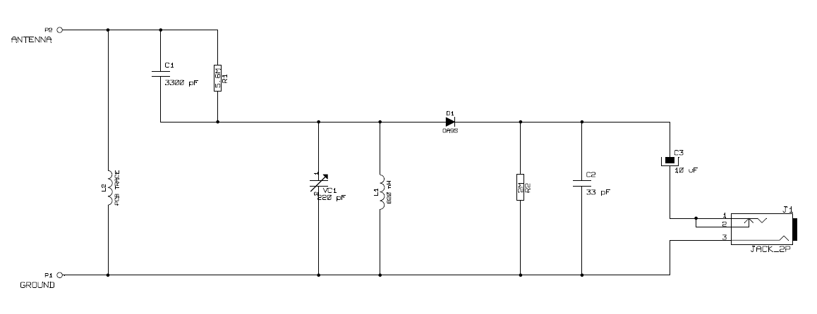Illustration 1: Aircraft Wireless Circuit Schematic

Use an adjusting stick to slowly adjust capacitor VC1 to the required frequency (Illustration 2: Amplitude Modulation is AM amplitude modulated wave). The frequency signal selected pass through the diode D1, then through the filtering circuit R2 and C2. Finally the sound signal is send to the earphone through the coupling capacitor C3.

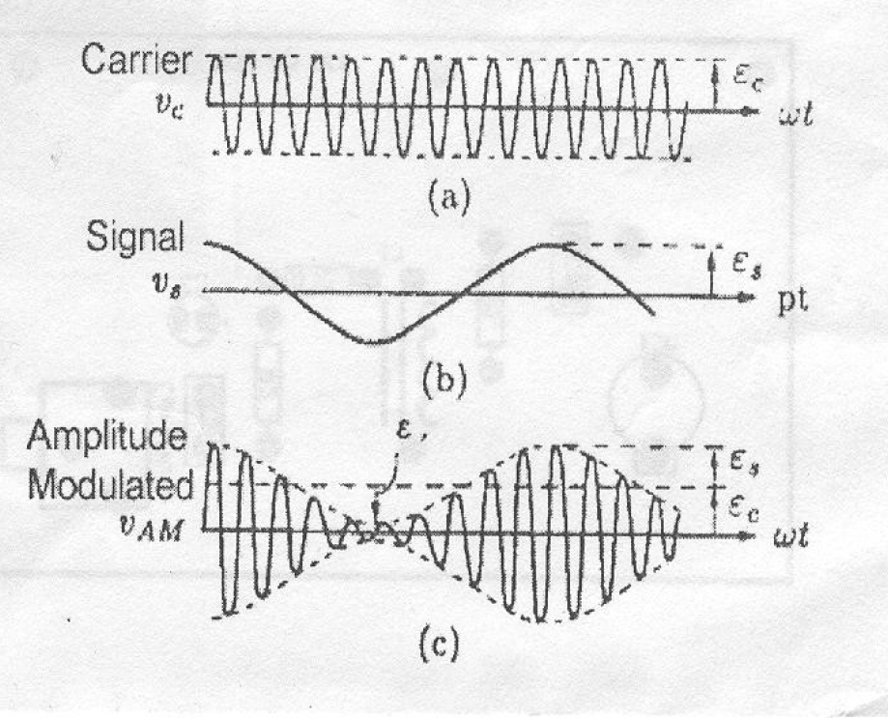Illustration 2: Amplitude Modulation

Use
If living in city area, place the antenna stick near window, then close the window and put the earphone on, rotate the variable capacitor to receive radio channels. Adjust the antenna and it's direction can improve reception, if still not satisfy, get an outdoor antenna. Caution, never connect to ground, equal potential and phase will cancel out the signal received.

Tips
- The antenna need to be straighten up.
- If sound signal is very weak, point the antenna to a direction with less obstruction.
- Make close contact to large metal plate to increase the receiving sensitivity.
- The earphone must be tight with ear without any gap.

