Aircraft Wireless Users Manual
PN 50000001 Revision 01



Illustration 1 is based on a public domain artwork. Website: FunDraw.com. Biplane – Line Drawing. http://www.fundraw.com/clipart/clip-art/3150/Biplane---Line-Drawing/ (accessed 2010-10-19).

Illustration 3 is a public domain artwork in the United States. Website: Wikipedia. File:Amplitude modulation detection.png. http://commons.wikimedia.org/wiki/File:Amplitude_modulation_detection.png (accessed 2011-02-28).
Table of Contents
Introduction 1
Installation 3
Operation 5
Circuit Theory 7
Troubleshooting 9
Replacement Parts 11
Notes 13

Introduction
The SCC Aircraft Wireless is a modern crystal radio receiver that receives Amplitude Modulated (AM) radio signals in the Medium Frequency (0.300 MHz to 3 MHz) radio spectrum.
The place we live on earth is filled with electric magnetic waves, which are produced by humans. Radio station transmit all the usable information at high frequency, through the antenna we receive these signals, then after some processing it is possible to obtain the original information. AM broadcast is using high frequency carrier with low frequency signal. It transmits the original signal by amplitude modulation of the high frequency carrier wave. To receive the signal from the air, we need an antenna. Antenna for AM channel is not very strict, usually larger areas and less obstruction will have better reception.
The Aircraft Wireless can be used to receive both Morse code and voice transmissions sent from transmitters located on the ground, on-board ships, or even in other aircraft.
The Aircraft Wireless is a perfect complement for a typical spark-gap type transmitter, creating a complete transmitting and receiving station.

Installation
Locate the Aircraft Wireless unit in a clean dry location. A common location is on the operator's lap or hung by a strap around their neck. It is important that water not come in contact with the Aircraft Wireless as it can diminish the units performance or even prevent it from operating entirely.

Antenna
Connect the antenna to the Yellow antenna terminal.
For non-directional reception, the antenna should be from 100 to 400 feet long with a lead weight on the end so that the antenna hangs approximately vertical in flight.
For directional reception, the antenna should be fastened to the aircraft airframe. If the antenna is mounted along the axis of the fuselage (see Illustration 1) the received signal will have maximum strength when the transmitter is to one side of the aircraft or the other. If the antenna is mounted along the axis of the wings, the received signal will have maximum strength the transmitter is located in front or behind the aircraft.

Illustration 1: Directional antenna mounting

Ground Connection
On the ground, an adequate ground connection is relatively easy to obtain using a ground stake or attachment to a cold water pipe. Unfortunately this is not possible in the air. To create a ground for the aircraft, connect the engine, fuel-supply tanks and piping together using copper braid, then connect the Green ground terminal on the Aircraft Wireless to a convenient point on the aircraft ground.
If the case of an aircraft with a metal framework, it is important to also ground the framework to the engine or fuel-supply tank.

Earphone
Insert the provided earphone into the earphone jack.
For improved reception, dual-style high-impedance headphones can be used, preferably covered with a tight-fitting soft leather helmet to reduce external noise interference. Headphones are not provided due to the highly individual choice of radio operators.

Operation
With an antenna and ground connected, and the earphone plugged into the earphone jack, carefully insert the earphone into your ear. Adjust the Tuning control slowly until the desired signal is received. It may be necessary to slowly sweep the Tuning control back and forth in the vicinity of the desired signal until reception is optimal.

Circuit Theory
Signal received by the antenna is very weak and covers a wide band, so we need to separate the AM frequency we want by and filter out the other frequency bands. LC resonance is a good filtering circuit. We get maximum impedance when the frequency is equal to the formula . Using an inductor and one variable capacitor we can product different frequencies base on different LC values. We can select different radio channels in this way. However, the channel received is still in high frequency signal range and can't be heard by human ear, we need to remove the high frequency carrier wave. Diode conducts in positive direction only so used with RC filter we can demodulate the original signal. With a sensitive earphone you can receive clear AM channel. No electricity is needed!
Refer to Illustration 2 for the Aircraft Wireless electronic circuit diagram. Electric wave received by antenna pass through the coupling capacitor C1 to LC circuit (consists of inductor L1 and variable capacitor VC1).

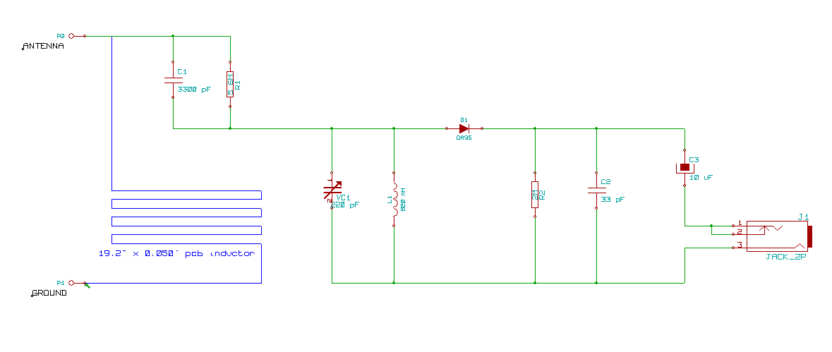Illustration 2: Circuit Schematic
Use an adjusting stick to slowly adjust capacitor VC1 to the required frequency of the AM amplitude modulated wave. ). The frequency signal selected pass through the diode D1, then through the filtering circuit R2 and C2. Finally the sound signal is send to the earphone through the coupling capacitor C3. Refer to the theory
of AM demodulation shown in Illustration 3.

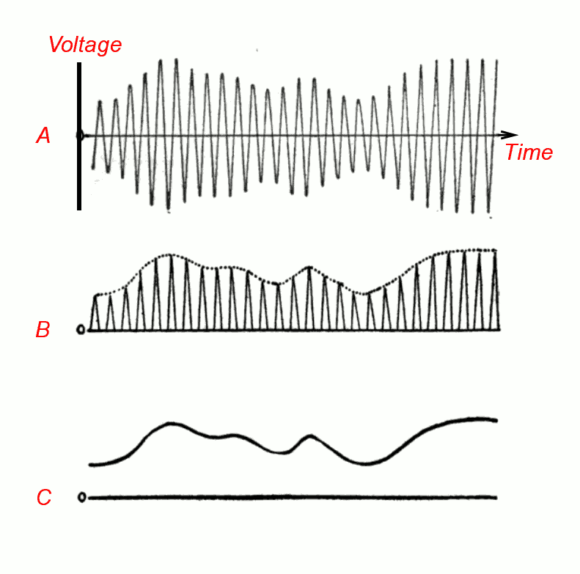Illustration 3: AM Demodulation

Troubleshooting
Should the Aircraft Wireless not perform as expected, please refer to the following troubleshooting tips:
- If the radio signal is blanketed by noises and clicks (“static” created by the engine's ignition system), first check that all connections to the aircraft ground system are in good condition. To further reduce engine static, surround all parts and wiring of the ignition system with metallic shields, grounded at frequent intervals to the engine structure.
- Check that the antenna has not come into contact with any component or structure which is part of the aircraft grounding system
- Check for good antenna and ground connections. Remove the antenna and ground leads and scrape their ends until shiny, then reattach them (if the terminals are not shiny, sand-paper can be applied until they are).
- Check the circuit board for any broken wiring or components. Although the SCC Aircraft Wireless is made to the highest quality, continuous engine vibration and hard landings can cause damage over time. If necessary, a replacement circuit board may be ordered (see Page 11).
- The earphone must be tight with ear without any gap. If using the provided earphone, it may be helpful to plug the other ear. A dual-style headphone set may also be purchased to replace the provided earphone.

Replacement Parts
The following replacement parts are available. Contact your dealer or the
Swift Construction Company for prices and information on ordering.
Part Number | Description
10000002 | ENCL,AIRCRAFT WIRELESS
20000003 | PCA,AIRCRAFT WIRELESS
50000001 | DOC,USER,AIRCRAFT WIRELESS
90000012 | EARPH,MONO,HI-Z,3.5MM
90000014 | CONN,BINDING POST BANANA,INSUL,GRN
90000015 | CONN,BINDING POST BANANA,INSUL,YEL

Notes

