Wideband and polarization-independent silicon waveguide to plasmonic waveguide mode converter based on optimization algorithms
Tian Zhang,¹ Zunwei Liu,¹ Yihang Dan,¹ Shuai Yu,¹ Jian Dai,¹ Xu Han,² and Kun Xu^{1,*}
¹State Key Laboratory of Information Photonics and Optical Communications, Beijing University of Posts and Telecommunications, Beijing 100876, China
²Huawei Technologies Co., Ltd, Shenzhen 518129, Guangdong, China
*Corresponding author: xukun@bupt.edu.cn
Received XX XXXXXX 2019; revised XX XXXXXX 2019; accepted XX XXXXXX 2019; published XX XXXXXX 2019
In this article, we propose a novel approach to achieve spectrum prediction, parameter fitting, inverse design and performance optimization for the plasmonic waveguide coupled with cavities structure (PWCCS) based on artificial neural networks (ANNs). The Fano resonance and plasmon induced transparency effect originated from the PWCCS have been selected as illustrations to verify the effectiveness of ANNs. Once ANNs are trained by using a small sampling of the data generated by Monte Carlo method, the transmission spectrums predicted by the ANNs are quite approximate to the simulated results. The physical mechanisms behind the phenomena are discussed theoretically, and the uncertain parameters in the theoretical models are fitted by utilizing the trained ANNs. More importantly, our results demonstrate that this model-driven method not only realizes the inverse design of the PWCCS with high precision but also optimizes some critical performance metrics for transmission spectrum. Compared with previous works, we construct a novel model-driven analysis method for the PWCCS which are expected to have significant applications in the device design, performance optimization, variability analysis, defect detection, theoretical modeling, optical interconnects and so on.

- INTRODUCTION
Surface plasmon polaritons (SPPs) is a special electromagnetic wave which can transmit on the interface between metal and dielectric [1-3]. Owing to breaking the diffraction limit, SPPs have applied in many photonic devices with compact dimension, such as plasmonic filters [4], beam splitters [5], reflectors [6], switches [7-8], modulators [9], absorbers [10], sensors [11-12], logic gates [13] and so on. In order to construct plamonic circuits, integrated plasmonic mode converter (PMC), which can convert the TE/TM mode in a silicon waveguide to the SPPs mode in a plasmonic waveguide, has attracted widespread attention because it’s a fundamental device in the optical interconnection system [14-20]. In recent years, many plasmonic waveguide structures, such as metallic slot waveguide and metal-dielectric-metal (MDM) waveguide, have been used to design various PMCs to adapt different integrated environment [14-20]. For these PMCs, conversion efficiency and bandwidth are two important performance metrics. It has been demonstrated that the conversion efficiency and 1 dB bandwidth of an early converter reach to 85% and 30-50 nm, respectively [14]. And a directional PMC has been designed to achieve polarization-invariant coupling with relatively high conversion efficiency [16]. In order to increase the conversion efficiency, the traditional straight waveguide in the PMC is replaced by a slot-taper structure to gradually squeeze the mode in the silicon waveguide into the plasmonic waveguide [20]. In addition to the adjustment of device structure, some traditional optimization algorithms, such as genetic algorithm (GA), have been used to search for the appropriate structure parameters of the taper [21]. Here, it should be noted the optimization abilities are limited because it only optimizes for a specific taper structure rather than a relatively complete space. Until now, there are few polarization- invariant PMCs simultaneously have high conversion efficiency and wide bandwidth. It is expect to further improve the conversion efficiency and bandwidth by designing reasonable device structure and selecting effective optimization algorithms.
In general, inverse design and performance optimization of the photonic devices could be solved by three traditional algorithms, namely gradient based methods, model based methods and gradient free methods [21-22]. As a representative method of gradient based methods, although adjoint variable method (AVM) could not only design linear optical devices but also optimize for the nonlinear devices in the frequency domain, it required physical background to derive the gradient of objective function [23]. Apart from gradient-based methods, model based methods, for example artificial neural networks, support vector machines and random forest, also could be applied in the inverse design of photonic devices [24-25]. However, in order to train the machine learning model, it required a significant amount of time to generate the training instances and test instances [26]. Compared with the gradient based methods and model based methods, gradient free methods which were usually based on the search strategy and evolutionary strategy had attracted widespread attention because of its simplicity and effectiveness [27]. Genetic algorithms (GA) and particle swarm optimization (PSO) were two kinds of typical evolutionary algorithms which had been

Apart from gradient-based methods (such as the AVM), for example, also can be applied in the inverse design of photonic devices.

For the complex PWCCSs, computing the electromagnetic responses for all structure parameters via numerical simulation methods usually requires tremendous computation time. If the electromagnetic responses for all structure parameters can be predicted by using a small sampling of simulation results, the efficiency of design and analysis for the complex PWCCSs will be improved. However, a simple and quick solution to predict and evaluate the spectrum responses for all structure parameters based on the partial simulation results is still lacking. In addition, although inverse design and performance optimization have been used to assist the design of mode multiplexer , wavelength multiplexer , polarization beam splitter , polarization rotator , power splitter and so on, few studies have been focused on the PWCCSs. Generally speaking, inverse design and performance optimization problems are solved by using several optimization algorithms, including gradient based methods and gradient free methods. For the gradient based methods, the topology optimization solved by adjoint method has been mostly applied in designing linear optical devices . Recently, T.W. Hughes et al. has extended the traditional adjoint method to model nonlinear devices in the frequency domain . For the gradient free methods, evolution algorithms (genetic and particle swarm ) and search algorithms (nonlinear search method ) are representative methods to design and optimize the photonic devices.

In this article, we propose a novel method using ANNs to achieve spectrum prediction, inverse design and performance optimization for the PWCCSs. To verify the effectiveness of ANNs, the Fano resonance (FR), especially for the plasmon induced transparency (PIT) effect, originated from the mode coupling in the PWCCSs are taken into consideration. We use the GA to design the network architectures and select the suitable hyper-parameters for ANNs. It is important to note that the transmission spectrum predicted by ANNs are approximate to the finite-difference time-domain (FDTD) simulated results with high precision. In addition, the physical mechanisms behind the FR and PIT effects are discussed based on the CMT and TMM, and the uncertain parameters in the theoretical models are fitted by using the trained ANNs effectively. Moreover, the ANNs have been successfully employed in solving the inverse design and performance optimization problems for the PWCCSs.
- DeVICE design AND SIMULATION RESULTS
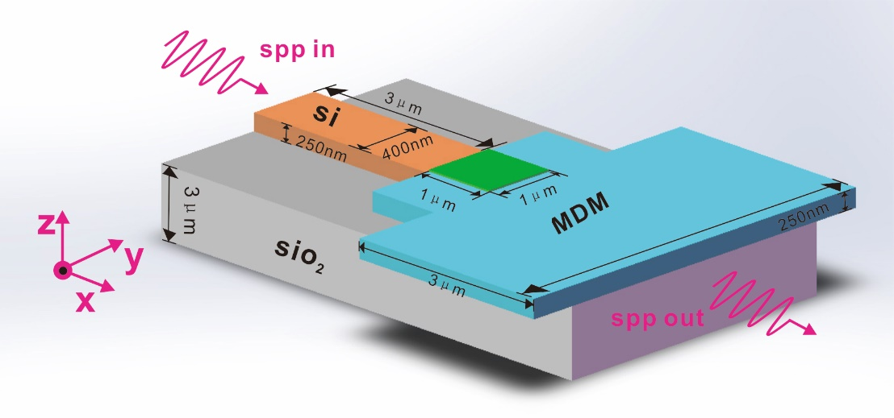
Fig. 1. Structure schematic of the proposed GMG structure.
We designed a high-efficiency polarization-independent wideband mode converter, and the bandwidth of the device ranges from 1450nm to 1650nm. As shown in Figure 1, the mode converter is a square two-dimensional code structure with a footprint of only 1*1um²(green), which is composed of 40*40 pixels, each pixel representing one point with a total of 1600 points. The Si waveguide (orange) on the left side is an input waveguide having a length of 3μm, a width of 400nm, and a height of 250nm; the right MDM waveguide(blue) is an output waveguide having a length of 3μm, a width of 3μm, and a height of 250 nm; the thickness silica substrate (grey) is 3um. The coupling efficiency of the dielectric-plasma slot waveguide mode converter is studied and optimized by the 2.5-dimensional finite-difference time-domain simulation MODE method. The coupling efficiency of the mode converter is defined as the ratio of the power coupled to the plasma waveguide mode to the input power in the silicon waveguide. The transmission loss of the plasmonic waveguide is calculated by placing several monitors on the Si waveguide and the MDM waveguide and then fitting these transmissions.
As shown in Fig. 3(a), there are the initial transmission curves of the transmission spectra for different wavelengths before the optimization of GA (red), PSO (green), and SA (blue) algorithms. Figure 3(b) shows the attenuation of the transmission spectrum obtained after each iteration of every algorithm. Fig. 3(c) is a plot of the transmission spectrum of the final structure obtained after five iterations, and Fig. 3(d) is the final transmission spectrum value obtained by five iterations by changing the different parameters using GA
We also used particle swarm optimization (PSO), genetic algorithm (GA) and simulated annealing (SA) algorithm to design the 40*40 pixel code structure. We use particle swarm algorithm firstly. The population size we set is 50, and the maximum genetic algebra is 200 generations, which means that it takes 200 iterations in one traverse. Similar to the DBS algorithm, we set 100 detection points at the waveguide structure, and the ideal value of each point is 1. Calculate the absolute value of the difference between the transmission spectrum of each particle and the target transmission spectrum, set the individual with the smallest difference in transmission spectrum to the global optimum, set the maximum flight speed to 1, the minimum flight speed to -1, and the learning factor c1= c2 to 1.49445. Before particle swarm optimization, the transmittance of the PSC structure is only 10.5%. Then we use the algorithm to optimize the structure, the wavelength range is 1500nm-1600nm. After five traversal, the transmittance can reach more than 75%. The difference between the transmission spectrum obtained by each traversal and the target transmission spectrum is as follows: 72.5204 (the initial value which is not optimized by the algorithm, just for comparison), 35.691, 27.2439, 22.3112, 18.493, 17.3556. According to the simulation results. The effect of the particle swarm algorithm is worse than that of the DBS algorithm, both in terms of bandwidth and transmission efficiency.
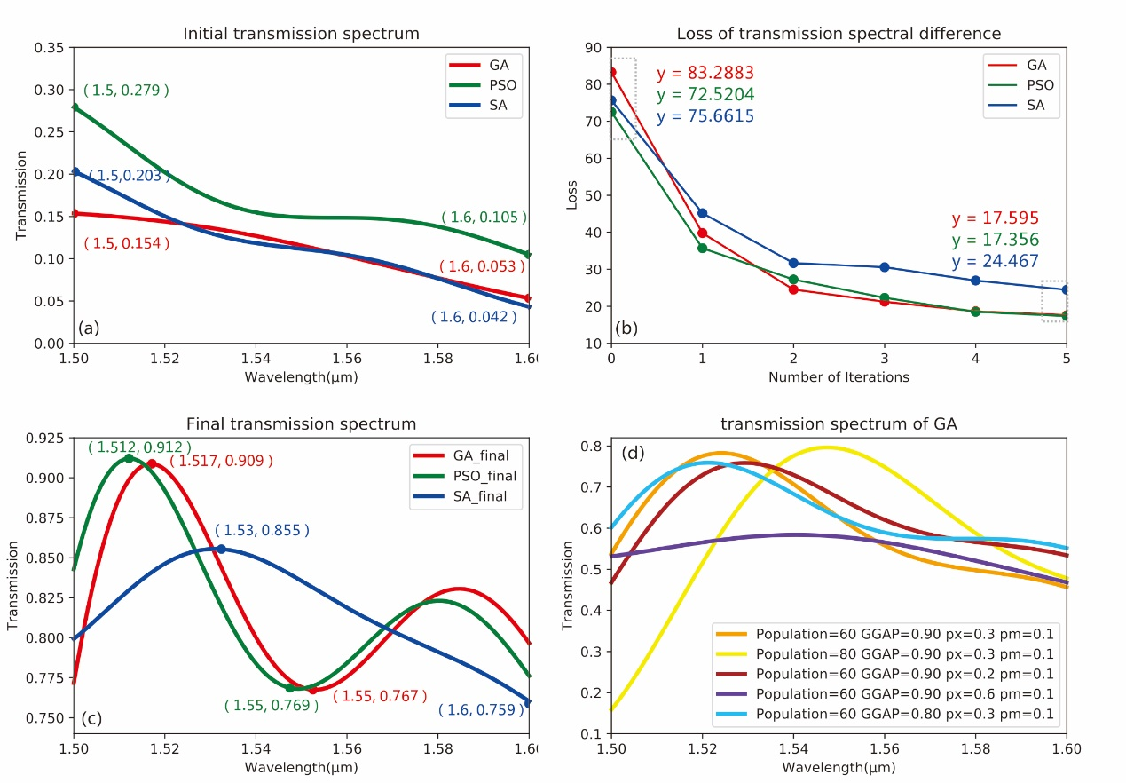
Fig. 3. (a) Initial transmission spectral values that have not been optimized by the GA, PSO, and SA. (b) The attenuation values of the transmission spectra obtained by three algorithms respectively. (c) The final transmission spectrum curve obtained by three algorithms optimization (d) The transmission spectrum curve obtained by GA under different parameters
Next, we use genetic algorithm (GA) to optimize the PSC structure of 40*40 pixels. In the simulation, we set the population size to 100, the maximum genetic algebra to 50, the generation gap selection ratio GGAP=0.8, the probability of crossover occurrence PX=0.3, and the probability of mutation occurrence PM=0.001. We connect MODE to MATLAB and use the Sheffield Toolbox to implement genetic algorithms for selection, crossover and mutation. Being same with the two algorithms mentioned above, we select 100 detection points in the waveguide structure, the ideal transmittance is 100%, and the transmittance of each individual in the population is subtracted from the target transmittance to obtain the difference, then we get the absolute value, which is used as the basis for the objective function. We used the genetic algorithm to traverse the structure five times. The difference between the transmission spectrum and the target transmission spectrum obtained after each traversal is as follows: 83.2883 (the initial value without optimization of the algorithm, just for comparison), 39.7735, 24.5314, 21.2399, 18.65604, 17.59502. The PSC structure optimized by the GA has a transmittance of more than 75% in the wavelength range from 1500 nm to 1600 nm. It means that using GA implemented by the above parameters, a relatively good transmittance effect can be achieved.It is worth noting that when we choose the genetic algorithm for optimization, we do not get the transmission spectrum as high as 75% from the beginning. We first set the parameters as follows: population size to 60, maximum genetic algebra to 50, generation gap selection ratio GGAP=0.9, probability of crossover occurrence PX=0.3, probability of mutation occurrence PM=0.01, and after five traversals, the obtained transmission spectrum can only reach about 50%. We modify population to 80, other parameters remain unchanged, and the variance of obtained transmission spectrum is very large, which ranges from 10% to 80%. Then we change the crossover probability to px=0.2, other parameters remain unchanged, after five traversal, the value of the transmission spectrum is above 45%. We change the crossover probability to px=0.6 again, and the other parameters remain unchanged. After five traversals, the value of the transmission spectrum is above 47%. Finally, we change the value of the GGAP to 0.8, and other parameters are unchanged, then the transmittance we get is above 55%. It can be seen that it is difficult to increase the transmittance of the structure by changing the parameters in the genetic algorithm. The parameters we set at the beginning can achieve maximum transmission efficiency among all.
Finally, we use the simulated annealing algorithm to design the structure of the 40*40 pixel mode converter. We set the maximum temperature to 2000 and the lowest temperature to 1e⁻¹⁸. The new individual structure matrix is generated based on the previous individual structure matrix and has a certain random probability to change. It is worth noting that this probability is related to temperature changes. It isn’t difficult to understand, because as the temperature decreases, it tends to be stable, and the probability of change should also become smaller. We select 100 detection points in the waveguide structure, calculate the difference between the transmission spectrum of the structure obtained and the target transmission spectrum after each iteration. According to the SA algorithm, there is a certain probability accept a value that is worse than the previous result. We set the acceptance tolerance to rand(0.5,1). After five times of traversal, the difference between the target and the transmission spectrum after each traversal is: 75.6615 (initial value for comparison), 45.1666, 31.6836, 30.5698, 26.967, 24.467, the spectrum transmission of the finally optimized structure is above 65%.
A non-linear search algorithm is used to design the structure of PSC, which we call 'direct-binary search' (DBS) algorithm. For the plasmonics-si mode converter, it is a 40 *40 pixel square structure that is split into 1600 points, each point being '0' or '1'. Since the area of ​​the PSC structure is 1um*1um, the footprint of each pixel is 0.025um*0.025um. Firstly, the values of `0' and `1' are randomly assigned to 1600 points in the structure just like two-dimensional code, and as the initial value, the first iteration is performed to obtain the transmission transmittance. When the second iteration is performed, the value of the pixel position of the first row and the second column is changed first. The rule of change is: if the original value is '0', it will be changed to '1'; if the original value is '1' , then changed to '0', which is the exchange of '0' and '1'. The new structural parameters after the change are simulated to obtain a new value of the transmittance. The value of the old transmittance (ie, the value of the transmission spectrum obtained in the first iteration) is compared with the value of the new transmittance, and if the value of the new transmittance is higher than the value of the old transmittance, the changes in the values of `0' and `1' of the first row and the second column of pixels is saved; if the value of the new transmittance is lower than the value of the old transmittance, the value of the pixel of the first row and the second column is not changed, that is, the original value of the position is retained. According to this rule, the same algorithm iteration is performed on the position of the pixels in the first row and the third column. Since there are a total of 1600 pixels, 1600 iterations are required to complete one traversal. In our work, we firstly consider the case of input as non-polarized light. We use the DBS algorithm to optimize PSC structure of 20*20, 30*30, 40*40 pixels respectively. And for each specification, the PSC structure is traversed five times, each traversal includes 1600 iterations, so for the structure of 20*20 pixels, there is a total of 5*400 = 2000 iterations; for the structure of 30*30 pixels, a total of 5 *900 = 4500 iterations; for the 40*40 pixel structure, it includes 5*1600, which is 8000 iterations. We take 100 points at the waveguide structure, and the ideal value of each point is 1, that is, in the ideal case, the transmission spectrum has 100% transmittance. We calculate the difference between the transmittance of each point and the target value. And accumulating the difference of 100 points, the smaller the difference is, the higher transmittance of the PSC structure obtained.
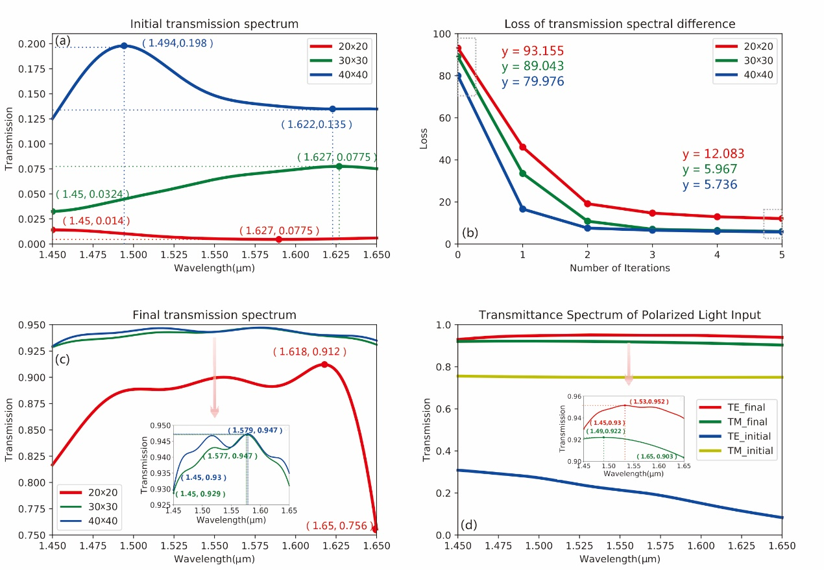
Fig. 3. (a) The initial transmission spectrum curve. (b) The attenuation value of the transmission spectrum after each traversal. (c) The final transmission spectrum obtained after five traversals. (c-1) Final transmission spectrum values for 30x30 and 40x40 structures. (d) The curve of the initial transmission spectrum and the final transmission spectrum when the input is the TE mode and the TM mode, respectively. (d-1) The value of the final transmission spectrum after optimization by the DBS algorithm when the input light is in TE mode and TM mode.
When the DBS algorithm is not optimized, the structure of the PSC is randomly assigned, which can be regard as the initial value. The transmittance of the structure simulated in this situation is below 1.4%. As shown in Figure 2 (a), the initial values of the transmission spectrum of 20*20 (red), 30*30 (green) and 40*40 (blue) pixels are obtained before optimization by the DBS algorithm. We performed five iterations for each structure. After each traversal, the difference between the transmission spectrum and the target transmission spectrum, which we call the attenuation value, becomes smaller. As shown in Fig. 2(b), there is the transmission spectrum and the target difference of the three structures. The attenuation values ​​of the first two transmission spectrum are relatively high, and the latter three are relatively low. For the final target difference, the structures of 20*20, 30*30, and 40*40 pixels are 12.0828, 5.9672, and 5.7362, respectively. It can be seen that the DBS algorithm has a faster convergence rate and can quickly achieve the desired result. As shown in Fig. 2(c), the abscissa in the figure is the wavelength of light, which ranges from 1450 nm to 1650 nm, and the ordinate is the value of the transmittance of the two-dimensional code structure of three different densities after five traversals by the DBS algorithm. It can be seen that the structure effect of 40*40 pixels is the best. In the range of 20nm bandwidth, the transmittance can reach more than 93%, and the structure effect of 20*20 pixels is relatively poor, but the transmission spectrum can still reach above 75%.
Then we consider the case of which the input is polarized. We use MODE to simulate a 40*40 pixel mode converter. Firstly, the TE mode polarized light is input to the si waveguide, and the initial value is randomly assigned to PSC structure. Before the structure is optimized with the DBS algorithm, the initial transmittance is only 1.2%. We put 100 detection points, obtaining the transmission spectrum value, then get the sum of the differences from the target transmission spectrum,which is 77.061. It can be seen that the transmittance of this structure is very low, and light can hardly be transmitted through this structure. The DBS algorithm is used to optimize the PSC structure. After a total of four traversals, the sum of the difference between the transmission spectrum and the target transmission spectrum after each traversal is as follows: 77.061 (this is the value when the algorithm is not optimized, just for comparison), 20.5834, 8.2586, 5.8343, 5.3309. The same as the input case of unpolarized, the convergence speed is faster in the first two optimizations, and slower in the last two optimizations. After 4 traversals, the transmittance of the PSC structure can reach 93% or more, and it can be seen that the transmittance is high. Secondly, the polarized light of the TM mode is input to the Si waveguide on the left side, and the same optimization method is used to perform the traversal five times. The initial value of the PSC structure is randomly assigned, and the initial transmittance is 74.9%. The sum of the difference between the transmission spectrum and the target transmission spectrum after each traversal is as follows: 21.1017 (this is the value not optimized by the algorithm, just for comparison), 10.2226, 8.836, 8.652, 8.4743, 8.3184, the transmittance of the structure optimized by the algorithm reaches more than 90%, which shows that the DBS algorithm has a good optimization effect. As shown in Fig. 2(d), the abscissa is the efficiency of the transmission spectrum in TE/TM mode after the algorithm is optimized. It can be seen that for polarized light, the PSC we designed can also ensure wide bandwidth and high efficiency transmission.
- Conclusion
In this article, we propose a novel method using ANNs to achieve spectrum prediction, inverse design and performance optimization for the PWCCSs. The FR and PIT effects originated from the mode coupling in the PWCCSs are explained theoretically and taken as the example to verify the effectiveness of ANNs. The uncertain parameters in the theoretical models are fitted by using the ANNs effectively. In order to ensure good accuracy and reduce the training time, we use the GA to design the network architectures and select the suitable hyper-parameters for ANNs. It is important to note that the transmission spectrum predicted by ANNs are approximate to the FDTD simulated results with high precision. More importantly, the ANNs have been successfully employed in solving the inverse design and performance optimization problems for the PWCCSs. Obviously, we construct a novel model-driven analysis method for the PWCCSs which are expected to have significant applications in the design, analysis and optimization for optical devices.

Funding. National Natural Science Foundation of China (Grant No. 61625104, No. 61431003); China Postdoctoral Science Foundation (Grant No. 2017M610826, No. 2018T110074); National Key Research and Development program (Grant No.2016YFA0301300); The Beijing Municipal Science & Technology Commission (Grant No. Z181100008918011); The Fundamental Research Funds for the Central Universities (No. 2018XKJC02).
references

