Wideband and polarization-independent silicon waveguide to plasmonic waveguide mode converter based on optimization algorithms
Tian Zhang¹, Zunwei Liu¹, Yihang Dan¹, Shuai Yu¹, Xu Han², Jian Dai¹, Yue Zhou¹, Kun Xu^{1*}
¹State Key Laboratory of Information Photonics and Optical Communications, Beijing University of Posts and Telecommunications, Beijing 100876, China
²Huawei Technologies Co., Ltd, Shenzhen 518129, Guangdong, China

*xukun@bupt.edu.cn
Abstract: The dynamically tunable plasmon induced absorption (PIA) effect is demonstrated in a graphene-assisted metallodielectric grating structure. Two methods are employed to achieve the tunable PIA effect in the mid-infrared region: one is based on controlling the Fermi level of graphene by adjusting the gate voltage, the other is related to varying the refractive index of interlayer.

Our calculated results reveal that high tunability in amplitude and bandwidth of the PIA effect can be achieved by using the above-mentioned methods. Compared with previous results, our scheme is much easier to fabricate and has significant applications in modulators, absorbers and sensors.

1. Introduction
Surface plasmon polaritons (SPPs) is the electromagnetic wave which can transmit on the interface between metal and dielectric [1-3]. Due to breaking the diffraction limit, SPPs have applied in many photonic devices with compact dimension, such as filters [4], beam splitters [5-6], reflectors [6-7], switches [8-9], modulators [10], absorbers [11-12], sensors [13-14] and logic gates [15]. In order to construct plamonic circuits, integrated plasmonic mode converter (PMC), which converts the TE/TM mode in silicon waveguide to the SPPs mode in plasmonic waveguide, has attracted widespread attention because it’s a fundamental device in the optical interconnection system [16-25]. In recent years, many plasmonic waveguide structures, such as metallic slot waveguide and metal-dielectric-metal (MDM) waveguide, have been used to design various PMCs to adapt different integrated environment [16-25]. For these proposed PMCs, conversion efficiency and bandwidth are two important metrics which characterize the device performance. For example, it has been demonstrated that the conversion efficiency and 1 dB bandwidth of the mode converter proposed earlier can reach to 85% and 30-50 nm, respectively [16]. And a directional PMC has been designed to achieve polarization-invariant coupling with relatively high conversion efficiency. To increase the conversion efficiency, the straight plasmonic waveguide in the PMCs is replaced by a slot-taper structure to gradually squeeze the mode in the silicon waveguide into the slot waveguide [17]. In addition to the adjustment of device structure, some traditional optimization algorithms (OA), such as genetic algorithm (GA), have been used to search for the appropriate structure parameters of the taper [25]. Here, the optimization abilities of the OA are limited because it only optimizes for the specific structure rather than relatively complete space. Until now, there are few PMCs have high conversion efficiency and wide bandwidth at the same time.

What’s more, there are few works have mentioned that the coupling efficiency of the designed coupler is independent of the polarization mode of the transmitted light.
Until now, optimization algorithms have been used in a plenty of works to design chip structures[1-7]. The first one is evolutionary algorithms[19-24],such as on-chip broadband polarization rotator designed by genetic algorithm[19], compact power splitters designed ab initio using binary particle swarm optimization in a 2D mesh for a standard foundry silicon photonic platform[20]. What's more, binary search algorithm has been used to design polarization beam splitter[21], polarizer coupler[22], polarization rotator[23], which can achieve relatively high conversion rate. By use of the simulated annealing algorithm, the work[24] designed fiber-to-waveguide coupling structure and optimize parameters to get to obtain maximum coupling efficiency. The second one is using topology optimization algorithm to design optical devices[25-27], such as polarization rotator based on multilevel shape optimization[25]. The third one is Modeling algorithm, for example using artificial neural networks (ANNs)[28] to achieve spectrum prediction, parameter fitting, inverse design and performance optimization for the plasmonic waveguide coupled with cavities structure (PWCCS).
Motivated by the above fundamental studies, in this article, a graphene-assisted metallodielectric grating (GMG) structure is proposed to realize the dynamically tunable PIA effect in the mid-infrared region. The constructive interference of the bright and dark modes induces the PIA effect in the transmission spectrum of the GMG structure, where the hybrid mode in the GCDWL structure acts as the bright mode, and the SPPs mode on graphene excited by the underneath metal grating acts as the dark mode. Our calculated results reveal that the amplitude and bandwidth of the PIA effect can be significantly tuned by varying the Fermi level of the graphene layer. As a comparison, the other two methods which have been reported for tuning the operating window are implemented in our research, namely, altering the thickness and the permittivity of the dielectric waveguide in the GMG structure. In addition, at oblique incidence, we also observe that the suppression of the absorption peak is accompanied with the higher reflection and lower transmission by increasing the incident angles, showing potential applications in optical modulator, absorber, switching and so on.

2. Evolutionary and search algorithms
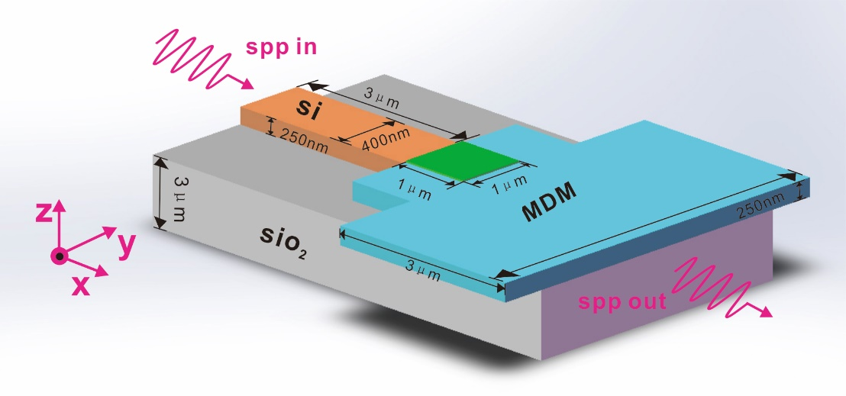
Fig.1 Structure schematic of the proposed GMG structure.
We designed a high-efficiency polarization-independent wideband mode converter, and the bandwidth of the device ranges from 1450nm to 1650nm. As shown in Figure 1, the mode converter is a square two-dimensional code structure with a footprint of only 1*1um²(green), which is composed of 40*40 pixels, each pixel representing one point with a total of 1600 points. The Si waveguide (orange) on the left side is an input waveguide having a length of 3μm, a width of 400nm, and a height of 250nm; the right MDM waveguide(blue) is an output waveguide having a length of 3μm, a width of 3μm, and a height of 250 nm; the thickness silica substrate (grey) is 3um. The coupling efficiency of the dielectric-plasma slot waveguide mode converter is studied and optimized by the 2.5-dimensional finite-difference time-domain simulation MODE method. The coupling efficiency of the mode converter is defined as the ratio of the power coupled to the plasma waveguide mode to the input power in the silicon waveguide. The transmission loss of the plasmonic waveguide is calculated by placing several monitors on the Si waveguide and the MDM waveguide and then fitting these transmissions.
A non-linear search algorithm is used to design the structure of PSC, which we call 'direct-binary search' (DBS) algorithm. For the plasmonics-si mode converter, it is a 40 *40 pixel square structure that is split into 1600 points, each point being '0' or '1'. Since the area of ​​the PSC structure is 1um*1um, the footprint of each pixel is 0.025um*0.025um. Firstly, the values of `0' and `1' are randomly assigned to 1600 points in the structure just like two-dimensional code, and as the initial value, the first iteration is performed to obtain the transmission transmittance. When the second iteration is performed, the value of the pixel position of the first row and the second column is changed first. The rule of change is: if the original value is '0', it will be changed to '1'; if the original value is '1' , then changed to '0', which is the exchange of '0' and '1'. The new structural parameters after the change are simulated to obtain a new value of the transmittance. The value of the old transmittance (ie, the value of the transmission spectrum obtained in the first iteration) is compared with the value of the new transmittance, and if the value of the new transmittance is higher than the value of the old transmittance, the changes in the values of `0' and `1' of the first row and the second column of pixels is saved; if the value of the new transmittance is lower than the value of the old transmittance, the value of the pixel of the first row and the second column is not changed, that is, the original value of the position is retained. According to this rule, the same algorithm iteration is performed on the position of the pixels in the first row and the third column. Since there are a total of 1600 pixels, 1600 iterations are required to complete one traversal.
In our work, we firstly consider the case of input as non-polarized light. We use the DBS algorithm to optimize PSC structure of 20*20, 30*30, 40*40 pixels respectively. And for each specification, the PSC structure is traversed five times, each traversal includes 1600 iterations, so for the structure of 20*20 pixels, there is a total of 5*400 = 2000 iterations; for the structure of 30*30 pixels, a total of 5 *900 = 4500 iterations; for the 40*40 pixel structure, it includes 5*1600, which is 8000 iterations.
We take 100 points at the waveguide structure, and the ideal value of each point is 1, that is, in the ideal case, the transmission spectrum has 100% transmittance. We calculate the difference between the transmittance of each point and the target value. And accumulating the difference of 100 points, the smaller the difference is, the higher transmittance of the PSC structure obtained.
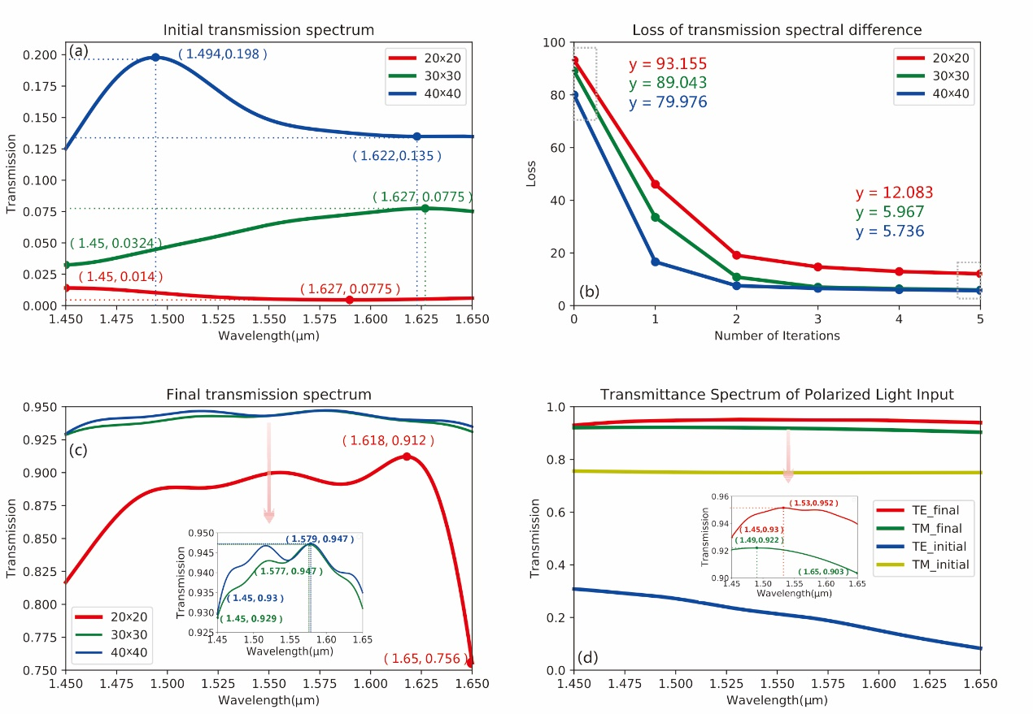
Fig.2 (a) The initial transmission spectrum curve. (b) The attenuation value of the transmission spectrum after each traversal. (c) The final transmission spectrum obtained after five traversals. (c-1) Final transmission spectrum values for 30x30 and 40x40 structures. (d) The curve of the initial transmission spectrum and the final transmission spectrum when the input is the TE mode and the TM mode, respectively. (d-1) The value of the final transmission spectrum after optimization by the DBS algorithm when the input light is in TE mode and TM mode.
When the DBS algorithm is not optimized, the structure of the PSC is randomly assigned, which can be regard as the initial value. The transmittance of the structure simulated in this situation is below 1.4%. As shown in Figure 2 (a), the initial values of the transmission spectrum of 20*20 (red), 30*30 (green) and 40*40 (blue) pixels are obtained before optimization by the DBS algorithm. We performed five iterations for each structure. After each traversal, the difference between the transmission spectrum and the target transmission spectrum, which we call the attenuation value, becomes smaller. As shown in Fig. 2(b), there is the transmission spectrum and the target difference of the three structures. The attenuation values ​​of the first two transmission spectrum are relatively high, and the latter three are relatively low. For the final target difference, the structures of 20*20, 30*30, and 40*40 pixels are 12.0828, 5.9672, and 5.7362, respectively. It can be seen that the DBS algorithm has a faster convergence rate and can quickly achieve the desired result. As shown in Fig. 2(c), the abscissa in the figure is the wavelength of light, which ranges from 1450 nm to 1650 nm, and the ordinate is the value of the transmittance of the two-dimensional code structure of three different densities after five traversals by the DBS algorithm. It can be seen that the structure effect of 40*40 pixels is the best. In the range of 20nm bandwidth, the transmittance can reach more than 93%, and the structure effect of 20*20 pixels is relatively poor, but the transmission spectrum can still reach above 75%.
Then we consider the case of which the input is polarized. We use MODE to simulate a 40*40 pixel mode converter. Firstly, the TE mode polarized light is input to the si waveguide, and the initial value is randomly assigned to PSC structure. Before the structure is optimized with the DBS algorithm, the initial transmittance is only 1.2%. We put 100 detection points, obtaining the transmission spectrum value, then get the sum of the differences from the target transmission spectrum,which is 77.061. It can be seen that the transmittance of this structure is very low, and light can hardly be transmitted through this structure. The DBS algorithm is used to optimize the PSC structure. After a total of four traversals, the sum of the difference between the transmission spectrum and the target transmission spectrum after each traversal is as follows: 77.061 (this is the value when the algorithm is not optimized, just for comparison ), 20.5834, 8.2586, 5.8343, 5.3309. The same as the input case of unpolarized, the convergence speed is faster in the first two optimizations, and slower in the last two optimizations. After 4 traversals, the transmittance of the PSC structure can reach 93% or more, and it can be seen that the transmittance is high. Secondly, the polarized light of the TM mode is input to the Si waveguide on the left side, and the same optimization method is used to perform the traversal five times. The initial value of the PSC structure is randomly assigned, and the initial transmittance is 74.9%. The sum of the difference between the transmission spectrum and the target transmission spectrum after each traversal is as follows: 21.1017 (this is the value not optimized by the algorithm, just for comparison), 10.2226, 8.836, 8.652, 8.4743, 8.3184, the transmittance of the structure optimized by the algorithm reaches more than 90%, which shows that the DBS algorithm has a good optimization effect. As shown in Fig. 2(d), the abscissa is the efficiency of the transmission spectrum in TE/TM mode after the algorithm is optimized. It can be seen that for polarized light, the PSC we designed can also ensure wide bandwidth and high efficiency transmission.
As shown in Fig. 3(a), there are the initial transmission curves of the transmission spectra for different wavelengths before the optimization of GA (red), PSO (green), and SA (blue) algorithms. Figure 3(b) shows the attenuation of the transmission spectrum obtained after each iteration of every algorithm. Fig. 3(c) is a plot of the transmission spectrum of the final structure obtained after five iterations, and Fig. 3(d) is the final transmission spectrum value obtained by five iterations by changing the different parameters using GA.
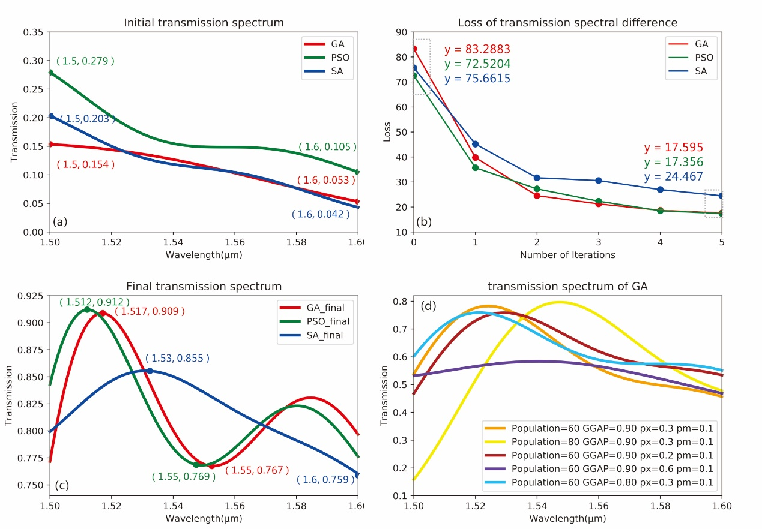
Fig.3 (a) Initial transmission spectral values that have not been optimized by the GA, PSO, and SA. (b) The attenuation values of the transmission spectra obtained by three algorithms respectively. (c) The final transmission spectrum curve obtained by three algorithms optimization (d) The transmission spectrum curve obtained by GA under different parameters
We also used particle swarm optimization (PSO), genetic algorithm (GA) and simulated annealing (SA) algorithm to design the 40*40 pixel code structure. We use particle swarm algorithm firstly. The population size we set is 50, and the maximum genetic algebra is 200 generations, which means that it takes 200 iterations in one traverse. Similar to the DBS algorithm, we set 100 detection points at the waveguide structure, and the ideal value of each point is 1. Calculate the absolute value of the difference between the transmission spectrum of each particle and the target transmission spectrum, set the individual with the smallest difference in transmission spectrum to the global optimum, set the maximum flight speed to 1, the minimum flight speed to -1, and the learning factor c1= c2 to 1.49445. Before particle swarm optimization, the transmittance of the PSC structure is only 10.5%. Then we use the algorithm to optimize the structure, the wavelength range is 1500nm-1600nm. After five traversal, the transmittance can reach more than 75%. The difference between the transmission spectrum obtained by each traversal and the target transmission spectrum is as follows: 72.5204 (the initial value which is not optimized by the algorithm, just for comparison), 35.691, 27.2439, 22.3112, 18.493, 17.3556. According to the simulation results. The effect of the particle swarm algorithm is worse than that of the DBS algorithm, both in terms of bandwidth and transmission efficiency.

Next, we use genetic algorithm (GA) to optimize the PSC structure of 40*40 pixels. In the simulation, we set the population size to 100, the maximum genetic algebra to 50, the generation gap selection ratio GGAP=0.8, the probability of crossover occurrence PX=0.3, and the probability of mutation occurrence PM=0.001. We connect MODE to MATLAB and use the Sheffield Toolbox to implement genetic algorithms for selection, crossover and mutation. Being same with the two algorithms mentioned above, we select 100 detection points in the waveguide structure, the ideal transmittance is 100%, and the transmittance of each individual in the population is subtracted from the target transmittance to obtain the difference, then we get the absolute value, which is used as the basis for the objective function.

We used the genetic algorithm to traverse the structure five times. The difference between the transmission spectrum and the target transmission spectrum obtained after each traversal is as follows: 83.2883 (the initial value without optimization of the algorithm, just for comparison), 39.7735, 24.5314, 21.2399, 18.65604, 17.59502. The PSC structure optimized by the GA has a transmittance of more than 75% in the wavelength range from 1500 nm to 1600 nm. It means that using GA implemented by the above parameters, a relatively good transmittance effect can be achieved.

It is worth noting that when we choose the genetic algorithm for optimization, we do not get the transmission spectrum as high as 75% from the beginning. We first set the parameters as follows: population size to 60, maximum genetic algebra to 50, generation gap selection ratio GGAP=0.9, probability of crossover occurrence PX=0.3, probability of mutation occurrence PM=0.01, and after five traversals, the obtained transmission spectrum can only reach about 50%. We modify population to 80, other parameters remain unchanged, and the variance of obtained transmission spectrum is very large, which ranges from 10% to 80%. Then we change the crossover probability to px=0.2, other parameters remain unchanged, after five traversal, the value of the transmission spectrum is above 45%. We change the crossover probability to px=0.6 again, and the other parameters remain unchanged. After five traversals, the value of the transmission spectrum is above 47%. Finally, we change the value of the GGAP to 0.8, and other parameters are unchanged, then the transmittance we get is above 55%. It can be seen that it is difficult to increase the transmittance of the structure by changing the parameters in the genetic algorithm. The parameters we set at the beginning can achieve maximum transmission efficiency among all.

Finally, we use the simulated annealing algorithm to design the structure of the 40*40 pixel mode converter. We set the maximum temperature to 2000 and the lowest temperature to 1e⁻¹⁸. The new individual structure matrix is generated based on the previous individual structure matrix and has a certain random probability to change. It is worth noting that this probability is related to temperature changes. It isn’t difficult to understand, because as the temperature decreases, it tends to be stable, and the probability of change should also become smaller. We select 100 detection points in the waveguide structure, calculate the difference between the transmission spectrum of the structure obtained and the target transmission spectrum after each iteration. According to the SA algorithm, there is a certain probability accept a value that is worse than the previous result. We set the acceptance tolerance to rand(0.5,1). After five times of traversal, the difference between the target and the transmission spectrum after each traversal is: 75.6615 (initial value for comparison), 45.1666, 31.6836, 30.5698, 26.967, 24.467, the spectrum transmission of the finally optimized structure is above 65%.

3. Topology Optimazation
Moreover, electrical tuning of the PIA effect can be achieved by controlling the Fermi levels of the graphene layers, and the evolutions of the transmission, reflection and absorption spectrums as a function of Fermi level and wavelength are calculated and shown in Fig.4 (b)-(d), respectively. It is obvious that high tuning range can be achieved with a small change in the Fermi levels of the graphene layers. We can observe that as the Fermi level increases, the transmission dip in Fig.4 (b), the reflection peak in Fig.4 (c) and the absorption peak in Fig.4 (d) are blue-shifted, correspondingly. The red dotted lines in Fig.4 (b)-(d) illustrate the change regulation of the resonant wavelength. One can see that the transmission peak of optical channel A is suppressed and that of optical channel B becomes prominent when the Fermi level is increased from 0.79 eV to 0.83 eV in Fig.4 (b). In addition, the bandwidth of optical channel A drops and that of optical channel B is enlarged simultaneously. In Fig.4 (c), the increase of the Fermi levels of graphene can lead to the transition of the reflection spectrum from PIT effect to Fano resonance. We attribute this phenomenon to the resonant wavelength of plasmonic mode on the graphene is sensitive to the change of Fermi levels and hence the symmetry of the PIT effect is broken. What’s more, in Fig.4 (d), the absorption peak is strongly dependent on the Fermi level of the graphene, enabling the flexible selectivity of operating spectral position. It provides a promising solution to obtain a tunable optical absorber in the mid-infrared region. Obviously, it is feasible to dynamically control the spectral positions of the optical channels by varying the gate voltage rather than altering the period and width of gold grating in the fabrication process.
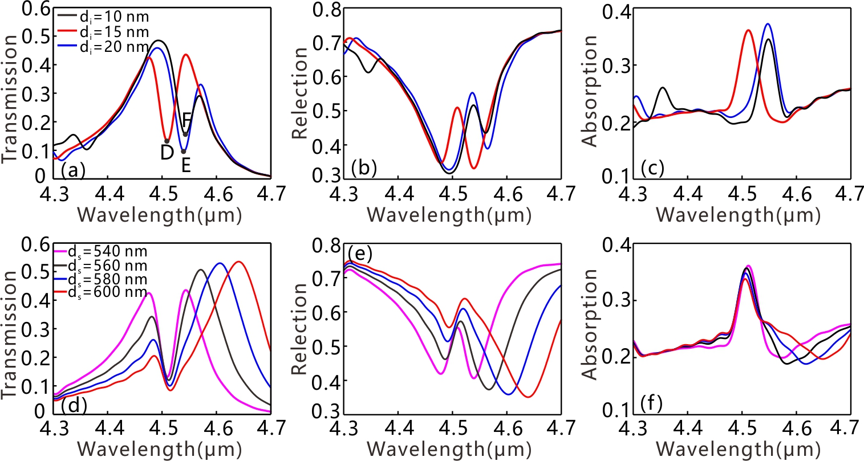
Fig.5 Calculated transmission, reflection and absorption spectrums of the GMG structure for different thickness of the interlayer (a-c) and the SiN_{x} dielectric layer (d-f).
Calculated transmission, reflection and absorption spectrum of the GMG structure for different thicknesses of the interlayer are exhibited in Fig.5 (a)-(c), respectively. It is easy to expect that the PIA, PIT effect and the absorption peak are nonexistent when the thickness of the interlayer is thin. The reason for this is that the guided-mode resonance is not excited on the graphene. In the simulated results shown in Fig.5 (a)-(c), as the thicknesses of the interlayer increases from 10 to 20 nm, the excitation wavelength of guided-mode resonance is varied and the PIT-like optical feature in (b) becomes asymmetry. According to Eq. (4), we can attribute this phenomenon to that the resonant dips (D, E and F in Fig.5 (a)) caused by the guided-mode resonance on graphene are different order. Moreover, Fig.5 (d)-(f) illustrate the simulated transmission, reflection and absorption spectrums of the GMG structure for different thicknesses of the SiN_{x} dielectric layer, respectively. It is seen that the transmission peak of the optical channel has an overall red-shift as the thicknesses of the SiN_{x} dielectric layer increases. The reason for this phenomenon can be explained by the dispersion equations of the GCDWL structure supported by ref. . Besides, it is rather remarkable that the excitation wavelength of the guided-mode resonance is independent of the increase of the SiN_{x} dielectric layer. Thus, the absorption peaks shown in Fig.5 (f) are stable when the thickness of the SiN_{x} waveguide layer increases from 540 nm to 600 nm.
Next let us proceed to consider the nonlinear response of the GMG structure based on the Kerr effect. It's worth nothing that other nonlinear responses are not taken into consideration here, such as third harmonic generation and two photon absorption effect . According to Eqs.(1)-(5), the resonant wavelength of the plasmonic mode on the graphene depends on the Fermi level and the refractive index of the material upon the gold grating. As a result, we can control the resonant wavelength of the guide-mode resonance on the graphene by changing the Fermi level or the dielectric constant of interlayer. Here, the interlayer is assumed as Au:SiO₂ due to its giant Kerr coefficient and ultra-fast response time [27, 31]. And the wavelength of pump light and the Fermi level of graphene are taken to be 550 nm and 0.81 eV, respectively. In the visible range, graphene has a relatively low optical absorption coefficient ~2.3% and a thin thickness ~0.34 nm, thus the pump light normally incident on the GMG structure can transmit the graphene and the nonlinear effect of the graphene is not excited. Besides, the damage of graphene caused by femtosecond pulse or continuous wave laser also should be taken into account. It has been demonstrated that the damage threshold of graphene for femtosecond pulse laser and continuous wave laser is about 2.7 TW/cm² and 1 MW/cm², respectively . The range of the pump intensity in our simulations is about 0~10 MW/cm² and it can be supported by the molecular lasers .
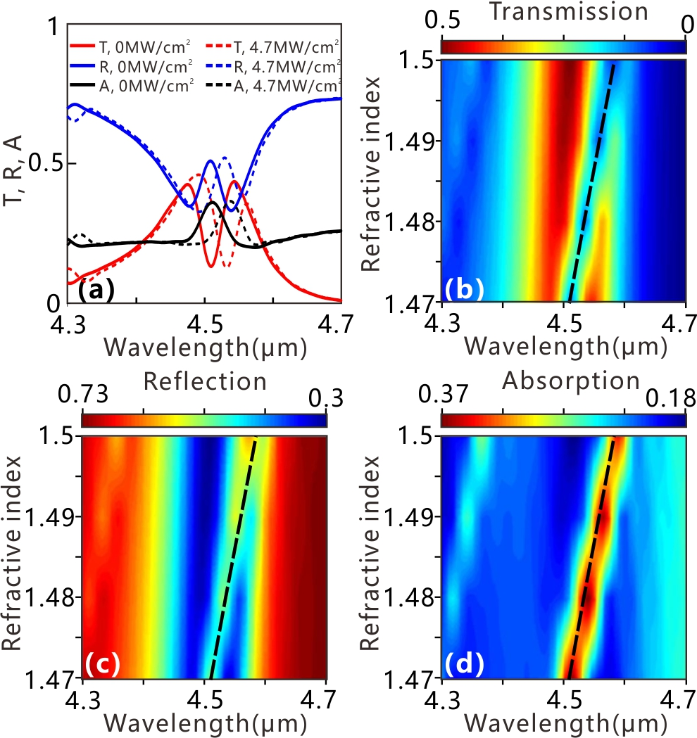
Fig.6 (a) Calculated transmission, reflection and absorption spectrum of the GMG structure for different pump intensities under the condition of normal incidence. Evolution of the transmission (b), reflection (c) and absorption (d) spectrums versus the refractive index of the interlayer and wavelength.
Fig.6 (a) shows the simulated transmission, reflection and absorption spectrum of the GMG structure with different pump intensities (0 and 4.7 MW/cm²). It is obvious that the tunable feature of the operating window can be obtained by increasing the intensity of the pump light. The resonant wavelength of the guide-mode resonance on the graphene is red-shifted as the pump intensity increases from 0 to 4.7 MW/cm². It is attributed to the guided mode resonance excited on the graphene layers is sensitive to the refractive index of the interlayer. In addition, the evolutions of the transmission, reflection and absorption spectrums versus the refractive index of the Au:SiO₂ interlayer and wavelength are shown in Fig.6 (b)-(d), respectively. It's important to note that the dashed lines in Fig.6 (b)-(d) are theoretically resonant wavelengths corresponding to the guided mode resonance based on Eqs. (1)-(5). As show in Fig.6 (b), it is interesting to notice that the optical channel on the left becomes more prominent and the optical channel on the right is suppressed gradually as the pump intensity increases. From Fig.6 (c), the reflectance located at 4.5 μm is reduced from 0.5 to 0.35 when the pump intensity increases from 0 to 9.5 MW/cm², and the symmetry of the PIT effect is broken. In addition, as shown in Fig.6 (d), the increase of the pump intensity leads to the red-shifted of the absorption peak and has a slight impact on the bandwidth of the peak. It can be also found that the theoretically calculated results are in good agreement with the simulated results shown in Fig.6 (b)-(d). Moreover, notice that the response time of the electric tuning method electrical tuning method reaches the microsecond level approximately . While the response time of the tuning method by using the pump light depends on the nonlinear material adopted. It has been demonstrated the response time of the order of picosecond level can be obtained in a similar switching structure . However, the damage of graphene caused by femtosecond pulse and the higher energy consumption should be taken into consideration for the pump light tuning method.
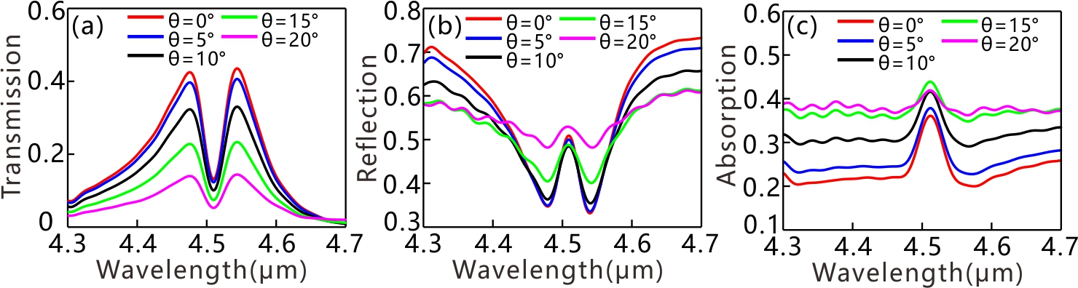
Fig.7 (a-c) Calculated transmission, reflection and absorption spectrums of the GMG structure for different incident angles.
Finally, we also investigate the influence of oblique incident light on the transmission, reflection and absorption spectrum. In order to avoid the influence of electric tuning method and pump light tuning method, the Fermi level of the graphene layers and the pump intensity are fixed as 0.81 eV and 0 MW/cm², respectively. In our simulations, the incident angles range is from 0º to 25º with a step of 5º and the Bloch boundary is employed in x direction. Fig.7 (a)-(c) show the simulated transmission, reflection and absorption spectrums of the GMG structure with different incident angles. It can be found that the increase of the incident angles not only results in the decrease of the transmission of the optical channels but also leads the enhancement of the reflectance. In addition, the suppression of the absorption peak can be observed in Fig.7 (c) as the increase of the incident angles. It means that the guide mode resonance excited on graphene layers becomes more difficult due to the increase of the incident angles. In summary at oblique incidence, we observe that the suppression of the absorption peak is accompanied with the higher reflection and the lower transmission. Certainly, it paves a new way towards the realization of dynamically tunable filter and absorber in the mid-infrared region based on our proposed GMG structure.

4． Conclusions
In conclusion, in this article, the dynamically tunable PIA effect is proposed and investigated in the GMG structure containing nonlinear Kerr medium. Our calculated results reveal that the amplitude and bandwidth of the PIA effect can be tuned by controlling the Fermi level of the graphene or altering the refractive index of the interlayer based on the Kerr effect. Moreover, it can be observed that the suppression of the absorption peak is accompanied with the higher reflection and the lower transmission by increasing the incident angles. Compared with previous results, our proposed GMG scheme is much easier to fabricate and the PIT effect has important applications in filters, modulators, absorbers and sensors in the mid-infrared region.

Funding
This work was supported by National Natural Science Foundation of China (Grant No. 61625104 and No. 61431003), China Postdoctoral Science Foundation (Grant No. 2017M610826) and National key research and development program (2016YFA0301300).

References and links

