Efficient silicon waveguide to plasmonic waveguide mode converter and power splitter based on optimization algorithms
Tian Zhang¹, Zunwei Liu¹, Shuai Yu¹, Yihang Dan¹, Xu Han², Jian Dai¹, and Kun Xu^{1,*}
¹State Key Laboratory of Information Photonics and Optical Communications, Beijing University of Posts and Telecommunications, Beijing 100876, P.R. China
²2012 Lab, Huawei Technologies Co., Ltd, Beijing 100876, P.R. China
*Corresponding author: xukun@bupt.edu.cn

Received XX XXXX 2020; revised XX XXXX 2020; accepted XX XXXX 2020; posted XX XXXX 2020; published XX XXXX 2020

We propose a novel mode converter based on the embedded coding metamaterials to effectively convert the TE mode in a silicon waveguide to the surface plasmon polaritons (SPPs) mode in a plasmonic waveguide with high conversion efficiency and wide bandwidth. In order to improve the performance metrics, some optimization methods (genetic algorithm, particle swarm optimization, multi-traversal direct-binary search and simulated annealing) are applied in the design of coding metamaterials. The simulation results exhibit the converter can perform effective conversion, and the conversion efficiency and bandwidth reach more than 0.93 and 200 nm, respectively. Moreover, a novel plasmonic power splitter with various splitting ratios and directions is proposed based on the embedded coding metamaterials. In comparison to the previous works, we not only propose a high-performance mode converter and a flexible power splitter but also introduce an efficient algorithm for inverse design of coding metamaterials.

I. INTRODUCTION
Surface plasmon polaritons (SPPs) are special electromagnetic wave which can transmit on the interface between metal and dielectric [1-2]. Owing to breaking the diffraction limit, SPPs have been used to realize many photonics devices with compact dimension, such as plasmonic filters [3], splitters [4], switches [5], modulators [6], absorbers [7], sensors [8], logic gates [9] and so on. In order to construct plasmonic circuits, plasmonic mode converter (PMC), which converts the TE/TM mode in a silicon waveguide to the SPPs mode in a plasmonic waveguide, has been an active research topic because it’s a fundamental photonics device in the optical interconnection system [10-24]. Recently, a great deal of plasmonic waveguide structures, for example metallic slot waveguides and metal- dielectric-metal (MDM) waveguides, have been used to design various PMCs for adapting to different integrated environments [10]. For these PMCs, conversion efficiency and bandwidth are two critical performance metrics. For example, it had been proven that the conversion efficiency of an early proposed PMC which included a silicon waveguide butt coupled to a MDM waveguide could reach 70% [11]. In order to improve the conversion efficiency, the direct connection between the traditional straight silicon waveguide and MDM waveguide was specially designed and replaced with multi- section tapers [11], rectangular gaps [12, 13], asymmetric junctions [14], symmetrically corrugated tapers [15], partially corrugated tapers [16], hybrid silicon-gold tapers [17], taper-funnel structures [18] and short curved tapers [19]. Above structures improved the mode matching between the silicon waveguide and the MDM waveguide by gradually squeezing the TE/TM mode from a silicon waveguide to the MDM waveguide, leading to the maximum coupling (transmission) efficiency of the PMCs could reach 70% [11], 88% [12], 92% [13], 72% [15] and 98% [16] based on 2D numerical simulations. In order to avoid the simulation error of 2D simulations, 3D numerical simulations were employed to verify the conversion results [14, 17, 19]. In addition to the vertically oriented coupling, a PMC based on horizontally oriented coupling was present to achieve a high conversion efficiency of 85% and a wide bandwidth of 200 nm [20]. Moreover, the PMCs were demonstrated by using focused ion beam experimentally, and the corresponding maximum coupling (transmission) efficiency could reach 35% [21], 43% [22] and 53% [23]. Besides, an analytical model based on the boundary conditions and mode matching technique was proposed to theoretically explain the transmission characteristics of PMCs [24]. It should be noted that the above PMCs only supported the function of mode conversion. Recently, a plasmonic power splitter (PPS) had been proposed with less transmission losses [25]. Nevertheless, there were few integrated waveguide structure simultaneously having the functions of plasmonic mode conversion and plasmonic power split. It has been demonstrated that the coding metamaterials, which consist of two types of unit cells, can provide a controllable and flexible platform by using a field-programmable gate array [26]. It is expected to improve the performance of the PMC and PPS if there exist a general framework, which can realize multiple functions and avoid repetitive design works.
In addition to the ingenious design of device structure, some optimization algorithms had been used to find the appropriate structure parameters of the PMC. For instance, a silicon-gold taper was optimized to achieve a higher conversion efficiency of 93.3% at 1550 nm [17]. However, the optimization abilities were limited because it only optimized for a specific taper structure rather than a relatively complete optimization space.

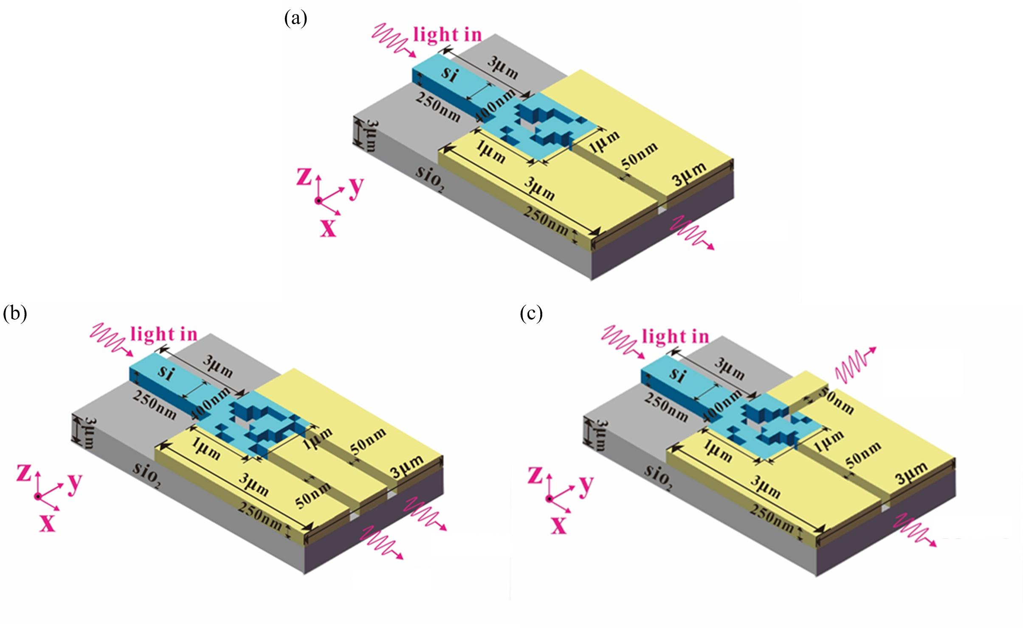
Fig.1 (a) Structure schematic of the proposed PMC. (b) Structure schematic of the proposed PPS, which can achieve the power split in same direction. (c) Structure schematic of the proposed PPS, which can achieve the power split in different direction.

It’s expected to further improve the conversion efficiency and bandwidth by designing an ingenious device structure and selecting an effective optimization algorithm. In general, the inverse design and performance optimization of the photonics devices can be solved by using three methods: gradient based methods, gradient free methods and model based methods [27-28]. As a representative method of the gradient based methods, adjoint variable method optimizes for the linear and nonlinear optical devices, but it needs physical background to derive the gradient of objective function [29]. Obviously, it increases the difficulty in the application of gradient based methods. Apart from the gradient based methods, model based methods, such as artificial neural networks and random forest, are also used to inversely design the photonics devices [30-33]. However, in order to train the model whose inputs are physical parameters and outputs are electromagnetic responses, it requires a lot of time to generate the training instances and test instances [32]. In comparison to the gradient based methods and model based methods, the gradient free methods, which depends on search strategy and evolutionary strategy, are simple and effective [34]. Genetic algorithm (GA) and particle swarm optimization (PSO) are representative evolutionary algorithms which are inspired by the biological evolution and natural selection [35-36]. Recently, we used GA and PSO to determine the hyper-parameters and weights of the optical neural networks [37]. A hierarchical evolutionary algorithm was established to solve the large-pixelated and complex inverse meta-optics design [38]. Although the evolutionary algorithms have advantages in the simplicity and effectiveness, they fall into local optimum easily and demand significant computing time because they need to control a population consisting of individuals [39]. In addition, simulated annealing (SA) and direct-binary search (DBS) are traditional search algorithms, which require less time to converge [40-41]. B. Shen had demonstrated a mode converting polarization beam -splitter which could convert TM mode to TE mode based on coding metamaterials and DBS. [41]. A polarization rotator which could rotate the polarization state from TE (TM) mode to TM (TE) mode was fabricated with a coupling length of 5 µm [42]. A mode exchange device that converted TE₀ and TE₁ was designed by using DBS and coding metamaterials [43]. However, it should be noted that the finite traversal times (only once) limit the optimization ability of the DBS. And there are few reports about the inverse design and performance optimization of the PPS.
In this paper, we propose a novel mode converter based on the embedded coding metamaterials. And several optimization algorithms are used to design the coding metamaterials to improve the performance metrics of PMC. Compared with the PMC optimized by GA, PSO and SA, the simulated results show that the PMC optimized by multi-traversal DBS (MDBS) can simultaneously achieve a high conversion efficiency (> 0.93) and a wide bandwidth (>200 nm). Moreover, a novel PPS with various splitting ratios and directions is proposed based on the embedded coding metamaterials. The simulated results show that the PPS optimized by MDBS can have the functions of plasmonic mode conversion and plasmonic power split simultaneously. Obviously, we propose efficient PMC and PPS based on embedded coding metamaterials and inverse design, which are expected to be applied in the integrated plasmonic circuits.

II. Device design and simulation results
As shown in Fig.1(a), we propose a PMC which consists of a silicon waveguide, silicon-based coding metamaterials (SCMs) and a plasmonic MDM waveguide. All waveguides and SCMs are placed on a silica substrate with the thickness of 3 μm. Here, the SCMs whose footprint is 1×1 μm² and composition is M×N square pixels are embedded into the metal (Au). Each pixel in the SCMs can be selectively filled by silicon or air, corresponding to the logical “1” or “0” state, respectively. Obviously, the SCMs provide a relatively broad optimization space in comparison to the specific device structure in [14]. The length, width and height of the input silicon waveguide which transmits the TE mode polarized light are 3 μm, 0.4 μm and 0.25 μm, respectively. The TE modes in silicon waveguide are converted to the plasmonic modes by the SCMs. After that, the plasmonic modes are coupled into the MDM waveguide whose length and width are 2 μm and 0.05 μm, respectively. In our numerical simulation, the transmission spectrum of the PMC is calculated by the 2.5-dimensional finite-difference time-domain (FDTD) method (adopting Lumerical MODE Solutions). The metal (Au) in the simulation is modeled by the Drude model with (ε∞, ω_{p}, γ_{p}) = (3.7, 9.1 eV, 0.018 eV) [16]. We define the conversion efficiency of PMC as the ratio of the power converted into the MDM waveguide and the output power of the silicon waveguide. Here, the power converted into the plasmonic waveguide is calculated by placing several monitors in the plasmonic waveguide.
First of all, we use two evolutionary algorithms (GA and PSO) and one search algorithm (SA) to design and optimize the PMC when the silicon waveguide is inputted by the TE polarized light. As typical gradient free methods, GA and PSO have been applied in optimizing for various photonics devices due to their simplicity and effectiveness [15]. The algorithmic details of GA are outlined as follows: (i) randomly generating an initial population consisted of N=50 individuals. Here, each individual in the initial population is the SCMs whose pixels are randomly initialized as “1” or “0” state. (ii) For all N SCMs, the transmission spectra are calculated by using the FDTD method. The difference between the simulated transmission spectrum and the targeted transmission spectrum (all the transmittances in the wavelength range 1.5 μm ~1.6 μm are 1) is defined as the optimization objective (fitness) for GA. The differences of the transmittances at all the wavelengths are summed to evaluate the difference between the optimized transmission spectrum and the targeted transmission spectrum. (iii) Trying to generate a new population by using the selection, crossover and mutation procedures. In the selection process, two parent individuals are selected from previous generation based on the roulette-wheel selection with a gap selection ratio 0.8 [16]. Here, the SCMs with smaller difference are selected with higher probability. In the crossover process, the selected SCMs cross over to generate new SCMs based on the uniform crossover method with a crossover probability 0.3. In the mutation process, each pixel in the SCMs has 5% probability to flip from 0 (1) to 1 (0). (iv) The newly generated SCMs are evaluated to determine the GA whether to stop or not. If the genetic generation reaches 100 or the difference remains unchanged for more than 5 times, then GA stops, otherwise, proceeds to Step (ii). In comparison to GA, PSO is also an evolutionary algorithm which is suitable for the decimal rather than binary number [20]. For PSO, the individuals (SCMs) in a population depend on the globally optimal individual and historically optimal record for each individual to search for optimal solution [20]. It should be noticed that the discrete binary PSO (DBPSO) rather than the standard PSO is used to optimize the SCMs. In the DBPSO, the calculation method for the velocity is the same as the standard PSO. But the velocity of the standard PSO directly affects the position of particle, while that of the DBPSO is converted to a flip probability based on the sigmoid function [21]. Then, this flip probability
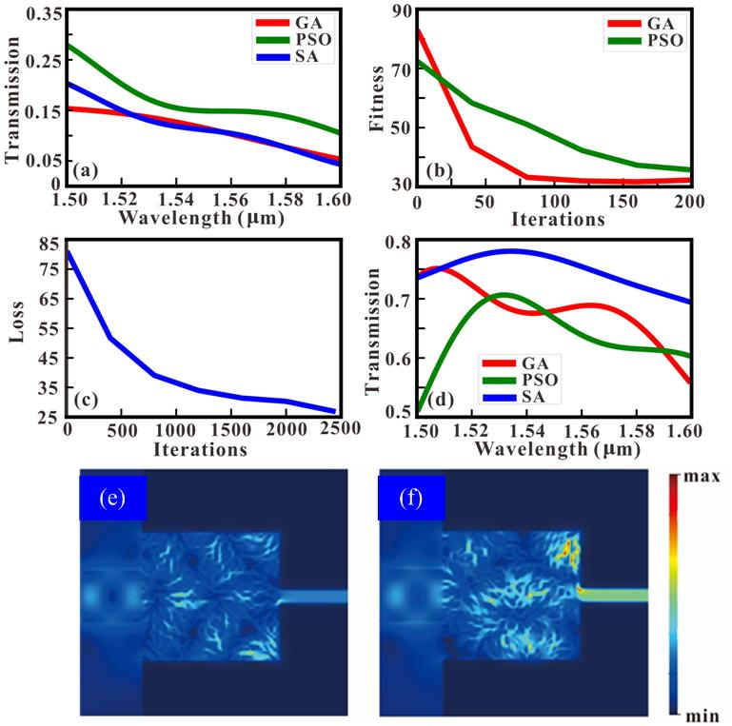
Fig.2 (a) The transmission spectra of the PMCs whose SCMs are randomly initialized for GA, DBPSO and SA. (b) The variations of the differences for GA and DBPSO in different iterations. (c) The variations of the differences for SA in different iterations. (d) The simulated transmission spectra after GA, DBPSO and SA optimizations. The magnetic field distributions of the SCMs before (e) and after (f) the GA optimization.
determines whether the pixels in SCMs are changed or not. The speed range, inertia weight and acceleration constants of the DBPSO in this article are set as -1~1, 1, and c₁=c₂=1.49, respectively. Moreover, SA is a typical search algorithm which imitates the physical annealing in the quenching whose molecules tend to a stable state as temperature decreases [19]. At the initial stage, SA searches for the solution in a broad optimization space by accepting a worse solution with a certain probability. It can alleviate the local optima problem to some extent [19]. As the temperature decreases, the solution changes in a small range to speed up the convergence. Here, in each iteration, SCMs are randomly generated and simulated by using the FDTD method. The objective function (difference) is evaluated to determine the newly generated SCMs whether to accept or not according to the Metropolis criterion [22]. Here, the maximum and minimum of the temperature for the SA are set as 2000 and 1e⁻¹⁸, respectively.
We use GA, DBPSO and SA to optimize the PMC when the SCMs are composed of 40×40 pixels, and the simulated results are shown in Fig. 2. The transmission spectra of the PMCs whose SCMs are randomly initialized for GA, DBPSO and SA are exhibited in Fig. 2(a). Before the optimization, we observe that the transmittances in the wavelength range 1.50 μm ~1.60 μm are very low and the maximum of the transmittances is lower than 0.30, indicating the PMC is ineffective. In order to improve the conversion efficiency, GA, DBPSO and SA are applied in the optimization for the PMCs, and the variation of differences for different iterations are shown in Fig. 2(b) and Fig. 2(c). It can be found that the differences of GA, DBPSO and SA decrease from 83.2, 72.5, and 75.6 to 32.3, 35.7 and 27, respectively. While in the last iteration, the average absolute deviation for each wavelength in the transmission spectrum are 32.3/100=0.323 (GA), 35.7/100=0.357 (DBPSO) and 27/ 100=0.27 (SA). Obviously, we can come to a conclusion that all optimization algorithms are convergent and effective because the differences have sharp declines and the optimized transmission spectra are close to the targeted transmission spectrum. This conclusion can be confirmed by the calculated transmission spectra before and after the optimization. In Fig. 2(d), all the transmittances in the optimized transmission spectra for GA, DBPSO and SA reach more than 50%, and the maximum transmittances for GA, DBPSO and SA are 0.75, 0.71 and 0.78 respectively. In order to vividly illustrate the optimization results of the PMC, Fig. 2(e) and Fig. 2(f) shows the magnetic field distributions of the SCMs before and after the GA optimization, respectively. It can be found that before the GA optimization, the TE mode in silicon waveguide is hardly coupled into the SCMs so the magnetic field in the MDM waveguide is weak. By contrast, after the optimization of GA, the TE mode in silicon waveguide can convert to the SPPs mode in the MDM waveguide, leading to the relatively strong magnetic field and high transmittance in the MDM waveguide. Here, we only take the example of the magnetic field distributions of the SCMs for the GA optimization. And the magnetic field distributions for other optimization methods (DBPSO and SA) are similar so they are not exhibited in this article.
We also consider the influences of parameter setting on the optimization results for the GA and DBPSO, and the results are shown in Fig. 3. In Fig. 3(a), The variations of the differences for different population size (PS), crossover probability (CP) and mutation probability (MP) of GA are calculated based on the FDTD method. It can be found that the fitness decreases from 33.7 to 33.0 when the PS increases from 60 to 100, indicating that the larger the PS is, the better the optimization result is. It’s easy to explain that the large PS can enhance the global searching ability of GA [16]. However, a large PS can lead to high computational cost. Thus, we should strive for a balance between the computational cost and optimization effects, that is, combine them with each other. In addition, the increase of MP may result in the performance degradation of the PMC because a large MP can cause instability and reduce the convergence speed of the GA. Fig. 3(b) exhibits the optimized transmission spectra for different parameter setting of the GA. We can find that a large MP and a small PS can reduce the optimization effects of the PMC. Similarly, Fig. 3(c) exhibits the variations of the differences for different velocity range (V_{min} ~V_{max}) and inertia weight (w) of the DBPSO. It can be found that the difference decreases from 55.9 to 35.7 when the inertia weight increases from 0.8 to 1. We find there is no linear correlation between the velocity range and the difference. In general, the inertia weight and velocity range of the DBPSO affect the attenuation speed and search scope in each iteration. They both have influence on the convergence speed. Here, the decrease of inertia weight reduces the optimization effect of the DBPSO because of the rapid attenuation speed. After the optimization, the simulated transmission spectra (Fig. 3(d)) for different parameters also confirm this conclusion. In order to achieve rapid convergence, the variable inertia weight for different iterations can be employed in the DBPSO. And the velocity range should be configured in a reasonable range to control the relationship between the convergence speed and search scope.
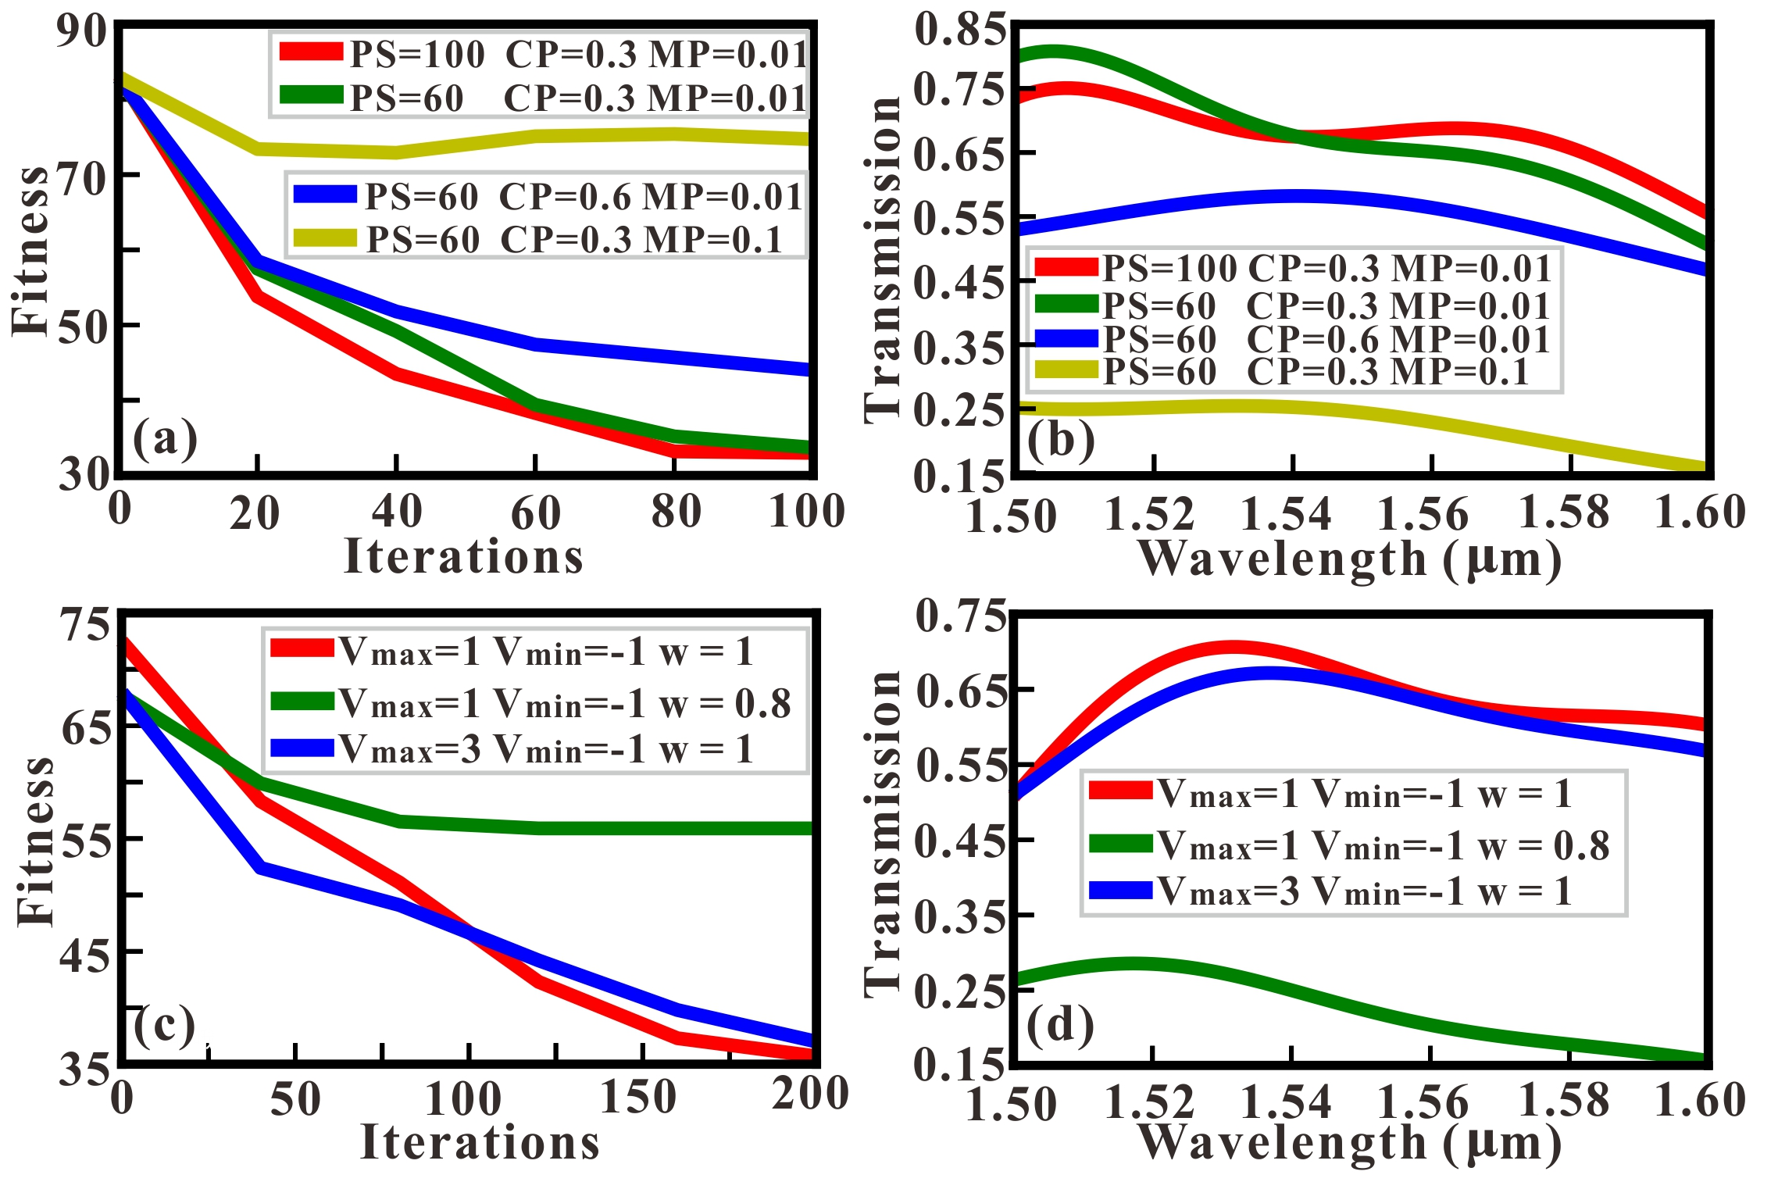
Fig.3 (a) The variations of the fitness (difference) for the GA with different optimization parameters. (b) After the optimization, the transmission spectra for different parameters of GA. (c) The variations of the fitness (difference) for DBPSO with different optimization parameters. (d) After the optimization, the simulated transmission spectra for different optimization parameters of DBPSO.
Next, a non-linear search algorithm, DBS, is used to design the distribution of SCMs. The algorism principle of the DBS is similar to the SA. They are common in searching for the optimal target by changing the single pixel in the MCMs. The difference is the search process of SA is random, while that of the DBS is sequential. The algorithmic details of DBS are outlined as follows: (i) the states “1” or “0” in the SCMs are randomly assigned for a specific PMC. Then, the transmission spectrum of the PMC is calculated by using the FDTD method. (ii) The state of the pixel which locates on some position flips from 0 (1) to 1 (0). Here, if the previous state is '0', it will be changed to '1' and vice versa. In this article, the change of the pixel is executed sequentially and row-wise. It means that if all pixels in the first row are executed, the pixels in the second row will be executed sequentially. Then, the PMC included the newly generated SCMs is simulated by using the 2.5D FDTD method. After that, the sum of the transmittances in the newly generated transmission spectrum is compared with that in the previous transmission spectrum. If the sum of the newly generated transmittances is higher than the sum of the previous transmittances, the newly generated SCMs will be accepted. And the state of this pixel will not change if the sum of the newly generated transmittances is smaller than that of previous transmittances. (iii) The condition of DBS is evaluated to determine the method whether to stop or not. In the traditional DBS, if the algorithm traverses all pixels in the SCMs once, then it stops, otherwise, proceeds to Step (ii). In order to further improve the searching ability, we propose a multi- traversal DBS (MDBS) to traverse the SCMs several times in succession. The reason for this is that when the previous pixel in the MCMs is being selected to be fixed to state “0” or “1”, other pixels are in a certain state. After the first traversal, the distribution of the MCMs may have changed and some of the pixel states have been reversed. Therefore, if the state of the previous pixel is reversed again, the simulated transmission spectrum of the new MCMs may be better. And this MDBS algorithm don’t degrade the performance of the PPWS in the multiple traversal. In this article, if the traversal times of the MDBS reaches maximum or the loss remains unchanged for more than 10 times, then MDBS stops.
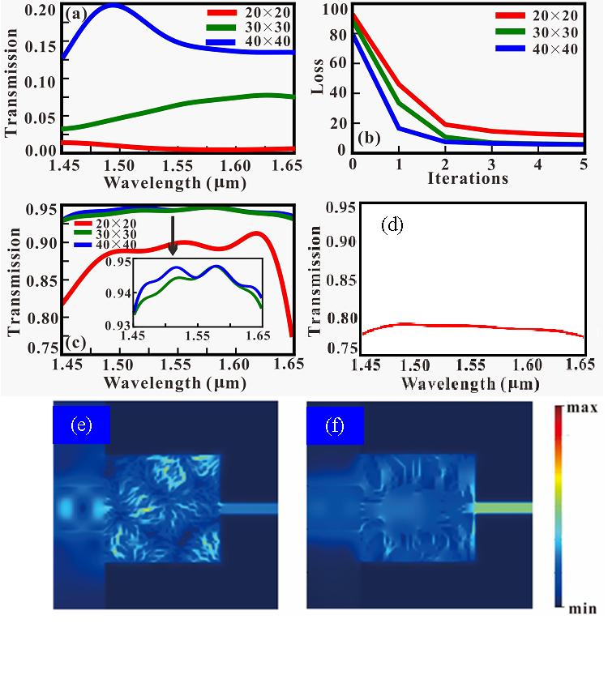
Fig.4 (a) The transmission spectra of the PMCs whose SCMs are randomly initialized. (b) The variations of the differences for different traversal times in the MDBS. (c) The optimized transmission spectra of the PMCs for the SCMs with different densities after the fifth traversal in MDBS. (d) The optimized transmission spectra of the PMC based on 2.5D FDTD simulation (dash line) and 3D FDTD simulation (solid line). The magnetic field distributions of the SCMs before (e) and after (f) the MDBS optimization.
Fig. 4 exhibits the optimization results for the PMC by using the MDBS. Here, we consider three different densities (20×20, 30×30 and 40×40) for the SCMs. The transmission spectra of the PMCs whose SCMs are randomly initialized in the first iteration for three different densities are shown in Fig. 4(a). It can be found the maximums of the transmittances for three densities are lower than 0.20, indicating the PMC is ineffective when the SCMs are randomly initialized. We use the MDBS to optimize the SCMs with 5 times complete traversals. And the optimization objective (the difference between the optimized transmission spectrum and targeted transmission spectrum) for different traversal times is shown in Fig. 4(b). It can be found that the optimization objectives have sharp declines from the beginning, indicating that the DBS is effective for the inverse design of the PMC. And the optimization results are close to those of GA, DBPSO and SA after the first traversal. In order to further reduce the difference, the MDBS is used to traverse the SCMs for 4 times repeatedly. Surprisingly, the differences are further reduced for all SCMs with different densities. After the fifth traversal, the average absolute deviation for each wavelength in the transmission spectra are 5.73/100≈0.057, 5.79/100≈0.06 and 12.08/100≈0.12 for the SCMs with 40×40, 30×30 and 20×20, respectively. Obviously, the transmission spectra of the PMCs optimized by the MDBS are closer to the targeted transmission spectrum than the transmission spectra optimized by the GA, DBPSO and SA. After the fifth traversal, it can be found in Fig. 4(c) that the optimized transmission spectra for 40×40 and 30×30 SCMs are smooth and leveling out at around 0.94 in a wide bandwidth 200 nm, which is beneficial to the realization of wideband and efficient PMC. In order to vividly illustrate the optimization results of the PMC, Fig. 4(e) and Fig. 4(f) shows the magnetic field distributions of the SCMs and MDM waveguide before and after the MDBS optimization, respectively. It can be found that in Fig. 4(e) that the TE mode in silicon waveguide is confined in the SCMs and hardly coupled into the MDM waveguide. Thus, the magnetic field in the MDM waveguide is weak. By contrast, in Fig. 4(f), the magnetic field in the MDM waveguide is relatively strong after the optimization of SCMs based on the MDBS. It means that the TE mode in silicon waveguide is converted to the SPPs mode in the MDM waveguide.
It should be noted that we only consider the conversion of the TE mode in silicon waveguide. In the ideal case the SCMs can be also optimized by using the optimization algorithms to achieve a polarization-invariant PMC with wide bandwidth and high conversion efficiency simultaneously. But there are few reports about the mode conversion between the TM mode in a silicon waveguide and the SPPs mode in a MDM waveguide because the mismatch of the mode. Still, we can utilize the SCMs to convert the polarization state from TM mode to TE mode [42]. After that, the TE mode can be coupled into the plasmonic waveguide by using the SCMs in series. Although the theory is feasible, it will lead to a long coupling length, large dimensions of devices and complex optimization space, which is difficult to design inversely because of high computational cost. Therefore, we don’t use the optimization algorithms to design a PMC that can convert the TM mode in the silicon waveguide in this paper. For the optimized PMC, we also consider the influence of simulation dimension on the transmittance characteristics. Generally speaking, the PMC is usually simulated by 2D FDTD method or 2D finite element method (FEM) because the complexity of the 2D simulation is relatively low. In addition, we use the optimization algorithms to iteratively search for the optimal distribution of the SCMs. The optimization algorithms even require thousands of steps to converge. If the PMC is calculated by the 3D simulation, the optimization process is time-consuming and even not feasible. Actually, lightweight evolutionary algorithms, such as micro genetic algorithm [44-45], micro particle swarm optimization [46] and micro differential algorithm [47], are proposed to reduce optimization time by maintaining a small population. Although the above lightweight algorithms are effective in the design of complex nanostructures, the optimization effects are limited. Therefore, in this article, the optimization of the PMC is based on the 2.5D simulation, which has been demonstrated effective in the electromagnetic simulation of optical devices [48]. Here, we only calculate the 3D simulation for the PMC optimized by the MDBS to confirm the effectiveness of the mode conversion. Fig. 4(d) show the optimized transmission spectra of the PMC based on the 2.5D FDTD simulation (red line) and the 3D FDTD simulation (black line). Here, the thickness of the substrate is set as 3μm. It can be observed that the transmittances in the transmission spectrum for the 3D FDTD simulation are significantly lower than those for the 2.5D FDTD simulation. The reason for this is attributed to the height of the metal film is only 250 nm, which is much thinner than the infinite case in the 2.5D FDTD simulation. Moreover, the out of plane loss occurred in the 3D FDTD simulation should be considered, which is different from the 2.5D FDTD simulation [49]. Although the transmittances calculated by the 3D simulation are decreased, the minimum transmittances are greater than 0.60, which are moderate in some representative PMCs.
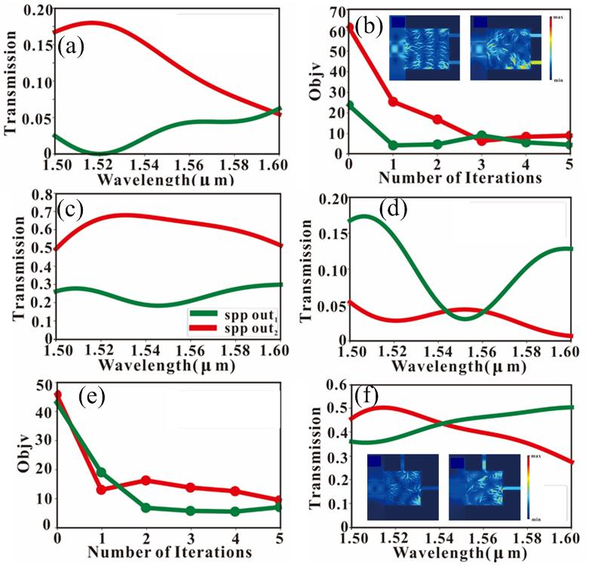
Fig.5 (a) Before the MDBS optimization, the transmission spectra of the upper MDM waveguide (red line) and lower MDM waveguide (green line) in the PPS, which achieve the power split in same direction. (b) The variations of the differences for different traversal times in the MDBS. (c) After the MDBS optimization, the transmission spectra of the upper MDM waveguide (red line) and lower MDM waveguide (green line) in the PPS, which achieve the power split in same direction. (d) Before the MDBS optimization, the transmission spectra of the upper MDM waveguide (red line) and right MDM waveguide (green line) in the PPS, which achieve the power split in different direction. (e) The variations of the differences for different traversal times in the MDBS. (f) After the MDBS optimization, the transmission spectra of the upper MDM waveguide (red line) and lower MDM waveguide (green line) in the PPS, which achieve the power split in different direction.
Finally, we propose two novel PPSs based on the SCMs to achieve the effective power split in same (different) direction. Fig. 1(b) shows the structure schematic of the proposed PPS, which can achieve the effective power split in same direction. In comparison to the PMC shown in Fig. 1(a), the proposed PPS includes two MDM waveguides that are connected to the SCMs in same direction. Here, the targeted power split ratio of the PPS is set as 6:4, which means that 60% (40%) of the TE mode in silicon waveguide is coupled into the upper (lower) plasmonic waveguide. We use the MDBS to optimize for the SCMs, and the traversal times of the MDBS is set as 5. The difference between the simulated transmission spectrum and the targeted transmission spectrum (all the transmittances in the wavelength range 1.5 μm ~1.6 μm are 0.6 (0.4)) is defined as the optimization objective for the upper (lower) plasmonic waveguide. And the above calculated differences for the upper MDM waveguide and lower MDM waveguide are added to comprehensively evaluate the optimization effect. The PPS in the 2.5D FDTD simulation includes 40×40 SCMs. Before the MDBS optimization, Fig. 5(a) shows the transmission spectra of the upper plasmonic waveguide (red solid line) and lower plasmonic waveguide (green solid line) in the PPS. It can be observed that before the MDBS optimization of SCMs, the transmittances in the transmission spectra for two plasmonic waveguide are small, indicating that TM mode can hardly be converted to the SPPs mode in the plasmonic waveguide and the power split ratio is far from the expected target. Fig. 5(b) shows the variations of the differences for different traversal times in the MDBS. We can find that optimization objectives (differences) have sharp declines after the first traversal, indicating that the MDBS is effective for the inverse design of the PPS. As the number of iterations increases, the differences for two plasmonic waveguide are decreased to a relatively low level, indicating that the optimized transmission spectra are gradually close to the targeted transmission spectra. Fig. 5(c) shows the transmission spectra of the upper MDM waveguide and lower MDM waveguide after the fifth traversal in MDBS optimization. In comparison to the simulation results in Fig. 5(a), the gap between the transmission spectra of the upper MDM waveguide and lower MDM waveguide is obvious. And the average of the transmittances in the wavelength range for the upper MDM waveguide is about 0.498, while that for the lower MDM waveguide is 0.327. In Fig. 5(b), the magnetic field distributions of the SCMs and MDM waveguide also confirm the effectiveness of the PPS. We can clearly find that the magnetic field distributions in the lower MDM waveguide is stronger than those of the upper MDM waveguide. Here, although the targeted power split ratio of the optimized PPS is not strict 6:4 because of the transmission loss, it is close to 5:3, which indicates the optimized PPS is effective.
In addition to the PPS that can achieve the effective power split in same direction, we also propose a PPS that can obtain the power split in different direction. As shown in Fig. 1(c), the MDM waveguides are connected to the SCMs in different direction. Here, the SCMs in the PPS are optimized for the "equal-ratio" power split, that is, the targeted power split ratio of the PPS is set as 1:1. It indicates that 50% (50%) of the TE mode in the silicon waveguide is coupled into the upper (right) plasmonic waveguide. For the targeted transmission spectrums of the upper and lower MDM waveguide, all transmittances in the wavelength range 1.5 μm ~1.6 μm are 0.5. Similarly, the difference between the simulated transmission spectrum and targeted transmission spectrum is regarded as the optimization objective in the MDBS. Fig. 5(d) shows the transmission spectra of the upper MDM waveguide (red line) and lower MDM waveguide (green line) in the PPS before the MDBS optimization. Obviously, the transmittances in two simulated transmission spectra are lower than 0.20, which indicates the conversion efficiency of the PMC is low and the power split ratio of the PPS is arbitrary. It can be found in Fig. 5(e), the objective targets for two MDM waveguide are decreased as the number of traversals increases from 1 to 5. It means that with the increase of iterative number, the simulated transmission spectra are gradually close to the targeted transmission spectra. As shown in Fig. 5(f), after the MDBS optimization, the average of the transmittances for the upper MDM waveguide and right MDM waveguide are 0.436 and 0.413, respectively. The power split effects can be demonstrated by the magnetic field distributions in Fig. 5(f). Apparently, our proposed PPS not only converts the TE mode in a silicon waveguide to the SPPs mode in a plasmonic waveguide, but also achieve the power split in different direction. It should be noticed that this multifunctional plasmonic device is seldom mentioned in the traditional PMCs [10-24] and PPSs [50-52]. All in all, we propose a programmable framework to achieve the flexible PPSs. The power split ratio and splitting direction of the PPSs can be flexibly controlled by this programmable framework based on the optimization of the SCMs.

CONCLUSION
In conclusion, we propose a novel PMC to effectively perform the mode conversion between the TE mode in a silicon waveguide and the SPPs mode in a plasmonic waveguide. And several different optimization algorithms, such as GA, DBPSO, SA and MDBS, are applied in the design of the SCMs in the PMC to improve the performance metrics. The 2.5D FDTD simulated results demonstrate that the PMC optimized by MDBS can perform high performance mode conversion, and the conversion efficiency and bandwidth reach more than 0.93 and 200 nm, respectively. Moreover, a novel PPS with various splitting ratios and flexible directions is proposed based on the SCMs. In comparison to the previous articles, our proposed PMC designed by the optimization algorithms has superiority in conversion efficiency and bandwidth. And we not only propose a high-performance PMC and a flexible PPS but also introduce an efficient algorithm for inverse design of coding metamaterials

Funding. National Natural Science Foundation of China (61705015, 61625104, 61431003, 61821001); Beijing Municipal Science and Technology Commission (Z181100008918011); Fundamental Research Funds for the Central Universities (2019RC15, 2018XKJC02); National Key Research and Development program (2019YFB1803504, 2018YFB2201803, 2016YFA0301300).

Disclosures. The authors declare no conflicts of interest.

References
[1] D.K. Gramotnev and S.I. Bozhevolnyi, "Plasmonics beyond the diffraction limit," Nat. Photonics 4, 83-91 (2010).
[2] T. Zhang, L. Chen, and X. Li, "Graphene-based tunable broadband hyperlens for far-field subdiffraction imaging at mid-infrared frequencies," Opt. Express 21, 20888-20899 (2013).
[3] H. Li and te al, "Investigation of the graphene based planar plasmonic filters," Appl. Phys. Lett. 103, 211104 (2013).
[4] T. Zhang, X. Yin, L. Chen, X. Chen, "Ultra-compact polarization beam splitter utilizing a graphene-based asymmetrical directional coupler," Opt. Lett. 41(2), 356-359 (2016).
[5] W. Chang and et al, "A plasmonic fano switch," Nano Lett. 12(9), 4977-4982 (2012).
[6] A. Melikyan and et al, "High-speed plasmonic phase modulators," Nat. Photonics 8, 229-233 (2014)..
[7] X. Xiong and et al, "Broadband plasmonic absorber for photonic integrated circuits," IEEE Photon. Techno. Lett. 26(17), 1726-1729 (2014).
[8] D. Rodrigo and et al, "Mid-infrared plasmonic biosensing with graphene," Science 349(6244), 165-168 (2015).
[9] T. Zhang and et al, "Plasmon induced absorption in a graphene-based nanoribbon waveguide system and its applications in logic gate and sensor," J. Phys. D: Appl. Phys. 51, 055103 (2018).
[10] Y. Fang and M. Sun, "Nanoplasmonic waveguides: towards applications in integrated nanophotonic circuits," Light-Sci Appl. 4, e294 (2015).
[11] G. Veronis and et al, "Theoretical investigation of compact couplers between dielectric slab waveguides and two-dimensional metal-dielectric-metal plasmonic waveguides," Opt. Express, 15(3), 1211 (2007).
[12] R.A. Wahsheh and et al, "Nanoplasmonic couplers and splitters," Opt. Express, 17(21), 19033 (2009).
[13] K.S.R. Atia and et al, "Compact and efficient 2D and 3D designs for photonic-to-plasmonic coupler," J. OPT. SOC. AM. B., 36(6), 1402-1407 (2019).
[14] S.Y. Lee and et al, "Highly efficient plasmonic interconnector based on the asymmetric junction between metaldielectric-metal and dielectric slab waveguides," Opt. Express, 19(10), 9562-9574 (2011).
[15] R. Thomas and et al, "Silicon based plasmonic coupler," Opt. Express, 20(19), 21520 (2012).
[16] Y. Liu and et al, "Plasmonic coupler for silicon-based micro-slabs to plasominc nano-gap waveguide mode coversion enhancement," Journal of Lightwave Technology, 31(11), 1708-1712 (2013).
[17] C. Chen and et al, "Design of highly efficient hybrid Si-Au taper for dielectric strip waveguide to plasmonic slot waveguide mode converter," Journal of Lightwave Technology, 33(2), 535-540 (2015).
[18] B. Zhu and H. Tsang, "High coupling efficiency silicon waveguide to metal–insulator–metal waveguide mode converter," Journal of Lightwave Technology, 34(10), 2467-2472 (2016).
[19] V. Patel and et al, "Efficient coupling from dielectric to hybrid plasmonic waveguide using curved taper," IEEE Photonics Technology Letters, 31(4), 323-326 (2019).
[20] A. Melikyan and et al, "Photonic-to-plasmonic mode converter," Opt. Lett., 39(12), 3488 (2014).
[21] J. Tian and et al, "Broadband high-efficiency surface-plasmon-polariton coupler with silicon-metal interface," Applied Physics Letters, 95, 013504 (2009).
[22] R. Yang and et al, "Efficient light coupling between dielectric slot waveguide and plasmonic slot waveguide," Optics Letters, 35(5), 649-651 (2010).
[23] R.A. Wahsheh and et al, "Experimental and theoretical investigations of an air-slot coupler between dielectric and plasmonic waveguides," Opt. Express, 24(8), 8237-8242 (2016).
[24] M.B. Heydari and et al, "Novel analytical model for nano-coupler between metal–insulator–metal plasmonic and dielectric slab waveguides," Optical and Quantum Electronics, 50, 432 (2018).
[25] M.A. Ayad and et al, "Submicron 1xN ultra wideband MIM plasmonic power splitters," Journal of Lightwave Technology, 32(9), 1814-1820 (2014).
[26] T. Cui, M. Qi, X. Wan, et al. Coding metamaterials, digital metamaterials and programmable metamaterials[J]. Light Science & Applications, 2014, 3(10):e218..
[27] S. Molesky and et al, "Inverse design in nanophotonics," Nat. Photonics 12, 659-670 (2018).
[28] K. Yao, R. Unni, and Y. Zheng, "Intelligent nanophotonics: merging photonics and artificial intelligence at the nanoscale," Nanophotonics 8(3), 339-966 (2019).
[29] T. W. Hughes and et al, "Adjoint method and inverse design for nonlinear nanophotonic devices," ACS Photonics, 2018, 5:4781-4787.
[30] J. Peurifoy, Y. Shen, L. Jing, Y. Yang, F. Canorenteria, B. Delacy, et al., "Nanophotonic particle simulation and inverse design using artificial neural networks," Sci. Adv., 2018, 4:eaar4206.
[31] Z. Liu, D. Zhu, S. P. Rodrigues, K.-T. Lee, and W. Cai, "Generative model for the inverse design of metasurfaces," Nano Lett., 2018, 18:6570-6576.
[32] T. Zhang, J. Wang, Q. Liu, J. Zhou, J. Dai, X. Han, Y. Zhou, K. Xu, "Efficient spectrum prediction and inverse design for plasmonic waveguide systems based on artificial neural networks," Photonics Research 7(3), 368-380 (2019).
[33] T. Zhang, Q. Liu, Y. Dan, S. Yu, X. Han, J. Dai, K. Xu. Machine learning and evolutionary algorithm studies of graphene metamaterials for optimized plasmon-induced transparency. Optics Express, 2020, https://doi.org/10.1364/OE.389231.
[34] N.N. Estakhri, and et al., "Inverse-designed metastructures that solve equations," Science 363, 1333-1338 (2019).
[35] H. Cui, X. Sun, and Z. Yu, "Genetic-algorithm-optimized wideband on-chip polarization rotator with an ultrasmall footprint," Opt. Lett. 42, 3093 (2017).
[36] J. C. Mak, C. Sideris, J. Jeong, A. Hajimiri, and J. K. Poon, "Binary particle swarm optimized 2×2 power splitters in a standard foundry silicon photonic platform," Opt. Lett. 41, 3868 (2016).
[37] T. Zhang, J. Wang, Y. Dan, Y. Lanqiu, J. Dai, X. Han and K. Xu, " Efficient training and design of photonic neural network through neuroevolution," Opt. Express 27(26), 37150-37163 (2019).
[38] Z. Jin, and et al., "Complex Inverse Design of Meta-optics by Segmented Hierarchical Evolutionary Algorithm," ACS Nano 13(1), 821-829 (2019).
[39] Y. Xing, D. Spina, A. Li, T. Dhaene, and W. Bogaerts, "Stochastic collocation for device-level variability analysis in integrated photonics," Photon. Res. 4, 93-100 (2016).
[40] V. Liu, and et al, "Design methodology for compact photonic-crystal-based wavelength division multiplexers," Opt. Lett., 2011, 36(4), 591-593.
[41] B. Shen, and et al, "An integrated-nanophotonics polarization beamsplitter with 2.4 × 2.4 μm² footprint," Nat. Photonics, 2015, 9:378-382.
[42] A. Majumder, and et al, "Ultra-compact polarization rotation in integrated silicon photonics using digital metamaterials," Opt. Express, 2017, 25(17):19721-19731.
[43] H. Jia, and et al, "Inverse-design and demonstration of ultra-compact silicon meta-structure mode exchange device," ACS Photonics, 2018, 5(5): 1833-1838.
[44] P. Fu, S. Lo, P. Tsai, K. Lee, P. Wei. (2018). Optimization for gold nanostructure-based surface plasmon biosensors using a microgenetic algorithm. ACS Photonics, 5(6), 2320-2327.
[45] Z. Li, D. Rosenmann, D.A. Czaplewski, X. Yang, J. Gao. Strong circular dichroism in chiral plasmonic metasurfaces optimized by micro-genetic algorithm. Opt. Express, 2019, 27(20), 28313-28323.
[46] K. Parsopoulos. Parallel cooperative micro-particle swarm optimization: A master–slave model. Applied Soft Computing, 2012, 12(17), 3552-3579.
[47] H. Salehinejad, S. Rahnamayan, H. Tizhoosh. Micro-differential evolution: Diversity enhancement and a comparative study. Applied Soft Computing, 2017, 52, 812-833.
[48] Z. Jiang, S. Liu, and R. Malekian, "Analysis of a whole-space transient electromagnetic field in 2.5-dimensional FDTD geoelectric modeling," IEEE Access, 2017, 5: 18707-18714.
[49] B. Yun, G. Hu, R. Zhang and Y. Cui, "Design of a compact and high sensitive refractive index sensor base on metal-insulator-metal plasmonic Bragg grating," Optics Express, 2014, 22(23): 28662-28670.
[50] M. Ayad, M. Swillam. Mid-Infrared Plasmonic Power Splitters. IEEE Photonics Technology Letters, 2016, 28(21): 2431-2434.
[51] Y. Guo, L. Yan, W. Pan, and et al. A plasmonic splitter based on slot cavity. Optics Express, 2011, 19(15): 13831-13838.
[52] Y. Ye, Y. Xie, T. Song, and et al. Design of a novel plasmonic splitter with variable transmissions and selectable channels. IEEE Transactions on Nanotechnology, 2019, 18:617-625.

