We greatly appreciate the referee for raising many helpful questions and providing insightful suggestions. Here, we reply the questions as follows:
Response to reviewer one
The authors used different inverse design methods to optimize the mode converter between a silicon dielectric waveguide and a plasmonic waveguide. Although it is not a new idea to leverage inverse designs for dielectric photonic devices, it is still quite interesting to see how they perform in designing the converters between a dielectric mode and a plasmonic mode. Actually, the authors have shown quite impressive results in terms of the conversion efficiency and bandwidth. The manuscript can be accepted provided the concerns below are appropriately addressed:
(1) As far as I know, the metal slot can only support a TE mode i.e., the electric field is perpendicular to the vertical slot. Then, how does the mode converter convert the TM mode in the silicon waveguide to the TE mode in the plasmonic waveguide? The authors should show the light propagation images in the finally optimized converter structure, including both the TE input case and the TM input case.
Answer:
Thanks very much for raising this critical question and we really appreciate this. If the ONNs can be trained by using neuroevolution, it not only provides a novel learning method for the ONNs but also is expected to improve the training efficiency for traditional deep reinforcement learning (DRL). In general, reinforcement learning uses an autonomous agent to learn its behavioral policy based on the feedback from interactive environment. And deep learning enables RL to accomplish some complex decision-making problems that are previously intractable, i.e., high dimensional image processing [S1]. The artificial neural networks (ANNs) are treated equivalently to the decision-making policy in the DRL which is mainly solved with three methods: value functions, policy search and actor-critic approaches. However, the training process of the deep ANNs in the DRL is time consuming based on the traditional SGD training strategies. Recently, it has been demonstrated that neuroevolution performs competitively with the learning algorithms in the DRL, such as policy search and deep Q-network [S2]. And on a subset of Atari games, neuroevolution even outperforms the best training algorithms in DRT on the training speed because of its parallelism. Obviously, thanks to the superior training speed of the ONNs and the parallelism of neuroevolution, it’s expect to improve the training efficiency when the ANNs in the DRL are replaced by the ONNs and the SGD learning algorithms are substituted by the evolutionary algorithms. We have use neuroevolution to train the ONNs which are applied in the cart pole games. And the calculated results exhibit that the ONNs which are trained by using neuroevolution can get 325 points (full score is 500). The reason for this relatively low score is attributed to the complex network architecture of the ONNs are difficult to train by using current simulation platform and learning methods. And we will solve this convergence problem in the succeeding work by designing more flexible simulation platform and selecting more efficient learning algorithms. Bearing these points in mind, we have added some explanations, please see the last paragraph on Page 10 in our revision.
Reference:
[S1] K. Arulkumaran, and et al, "Deep reinforcement learning a brief survey," IEEE Signal processig magazine, 2017, 34(6):26-38.
[S2] F. P. Such, V. Madhavan, E. Conti, J. Lehman, K. O. Stanley, and J. Clune, "Deep neuroevolution: Genetic algorithms are a competitive alternative for training deep neural networks for reinforcement learning," arXiv preprint arXiv:1712.06567 (2017).
(2) Besides, the authors should also simulate the final converter structure with a 3D FDTD model to further verify the optimal results.
Answer:
We are thankful to the reviewer for pointing out this issue. In the training process of the ANNs, the training data set is usually randomly divided into several groups. And these groups are inputted into the ANNs model step by step to increase the iteration times. This method has been demonstrated to be effective for the improvement of the accuracy. Generally speaking, the group is named as batch and the size of the batch is called as batchsize. Here, a training process (one forward pass and one backward pass) of the batch is called as iteration, while that for all the training instances is called as epoch. In our manuscript, we use two evolutionary algorithms, genetic algorithm and particle swarm optimization, to train the optical neural networks (ONNs). No matter genetic algorithm or particle swarm optimization, they require an population to search for the optimal solution. And the previous population evolves to reproduce next generation of population. In each generation, all training instances are inputted into the ONNs and transfer from the input layer to output layer. As a result, for the training of ONNs, the epoch and generation are identical to describe the traverse times of all training instances.
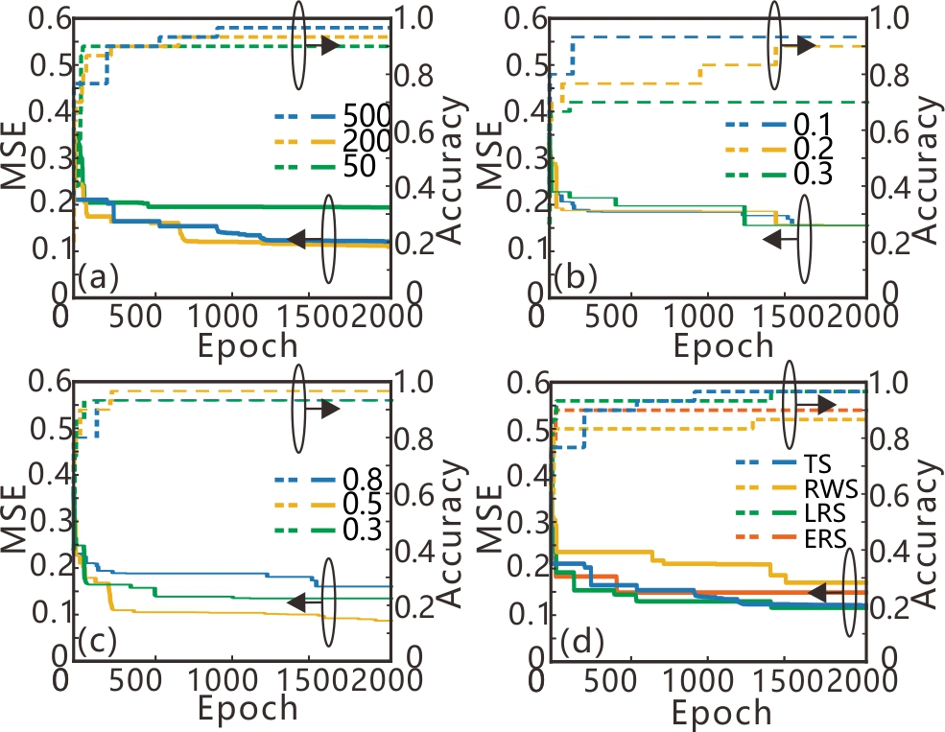
Fig. S1 The MSEs and classification accuracies of the trained ONNs with different population sizes (a), mutation probabilities (b), crossover probabilities (c) and selection operators (d) of the GA.
Bearing these points in mind, we have added some discussions about the optimization parameters, please see the second paragraph on Page 8 and last paragraph on Page 9 in our revision.
(3) What is the ‘targeted transmission spectrum’? How did you evaluate the difference between the optimized transmission spectrum and the targeted transmission spectrum? by summing all the differences of the values at all the wavelengths? The authors should clarify this.
Answer:
We are grateful to the reviewer for the valuable suggestions. In order to improve the conversion efficiency, all the transmittances in a specific wavelength range of the targeted transmission spectrum are set to 1. The difference between the simulated transmission spectrum and the targeted transmission spectrum is defined as the optimization objective (fitness) for the optimization algorithms. Here, the differences of the transmittances at all the wavelengths are summed to evaluate the difference between the optimized transmission spectrum and the targeted transmission spectrum.
Bearing these points in mind, we have added some descriptions about the optimization objective, please see the second paragraph on Page 2 in our revision.
(4) In Fig. 1, the slot width should be 50nm.
Answer:
We are grateful to the reviewer for the valuable suggestions. The width of the MDM waveguide labelled in Figure 1 has been revised as 50 nm. Please see Figure 1 on Page 2 in our revision.
(5) It is better to use ‘spectra’ instead of ‘spectrums’.
Answer:
We are grateful to the reviewer for the valuable suggestions. We have revised ‘spectrums’ as ‘spectra’ in our revision.
(6) Many other gramma errors and typos. Below are only a few of them:
a) SPPs are plural.
b) adapting to
c) And there were few polarization-invariant PMC having……
d) To control the population consisting of
……
Answer:
We are grateful to the reviewer for the valuable suggestions. We have revised the above grammar mistakes in our revision. Moreover, we have carefully checked the whole manuscript and revised other mistakes about spelling and grammar.

Response to reviewer two:
Authors propose using non-gradient based optimization algorithms (genetic and particle swarm) in order to train optical neural networks. They claim these algorithms have comparable performance to gradient based algorithms (i.e small mean squared error) that are often used in the literature. Authors also claim these algorithms are “efficient”.
(1) The width of the MDM waveguide labeled in figure 2 (500nm) is different from that described in the text (0.05um=50nm). Please correct it.
Answer:
We are thankful to the reviewer for pointing out this issue. The width of the MDM waveguide labelled in Figure 1 has been revised as 50 nm. Please see Figure 1 on Page 2 in our revision.
(2) The authors only presented the transmission spectrums of the proposed device using FDTD method, while the mechanism of the mode conversion through the PMC is not explained. The operating principle of the device related to such transmission spectrums should described in detail.
Answer:
Thanks very much for raising this critical question and we really appreciate this. The specific case of direct coupling between the dielectric slab waveguide and MDM waveguide has been investigated in many articles. The first study on the modal properties for compact couplers of the dielectric slab waveguide and plasmonic waveguide was done in [S1]. They reported 70% transmission efficiency at the optical communication wavelength for the proposed coupler based on 2D FDTD simulation. Also, the authors introduced a coupler consisting of multisection taper in this paper [S1]. Novel compact couplers and splitters based on an air-gap were investigated in [S2]. In this work, the authors showed that plasmonic couplers could be designed with a coupling efficiency of 88% (2D FDTD simulation). And a high efficiency plasmonic coupler composed of a tapered silicon strip waveguide and a MDM waveguide is experimentally demonstrated [S3]. Based on the 3D FDTD simulation, the maximum coupling efficiency is about 84%.

Veronis and Fan (2007). based on. A plasmonic interconnector based on an asymmetric junction between MDM waveguide and dielectric slab waveguide with approach 88.5% coupling efficiency was proposed and studied in [S3]. In order to demonstrate this similarity between the 2D and 3D cases, they carried out a 3D FDTD simulation for the interconnection and found the coupling efficiency decreased to 77.6%. In order to achieve more precise mode matching between the silicon slabs and plasmonic waveguides, Liu et al. found that the corrugated structure is a good choice for mode coupling enhancement [S4]. High transmission efficiencies up to 98% can be demonstrated based on 2D FDTD simulation.

In Lima et al. (2017), a directional coupler has been investigated with an
efcient power conversion.

Reference:
[S1] G. Veronis, S. Fan. Theoretical investigation of compact couplers between dielectric slab waveguides and two-dimensional metal-dielectric-metal plasmonic waveguides. Opt. Express, 2007, 15(3):1211–1221.
[S2] R.A. Wahsheh, et al. Nanoplasmonic couplers and splitters. Opt. Express, 2009, 17(21): 19033–19040.
[S3] J. Tian, et al. Broadband high-efficiency surface-plasmon-polariton coupler with silicon-metal interface. Applied Physics Letters, 2009, 95(1): 013504-013504-3.

[S3] S.-Y. Lee, et al. Highly efcient plasmonic interconnector based on the asymmetric junction between metal–dielectric–metal and dielectric slab waveguides. Opt. Express, 2011, 19(10), 9562–9574.
[S4] Y. Liu, et al. Plasmonic Coupler for Silicon-Based Micro-Slabs to Plasominc Nano-Gap Waveguide Mode Coversion Enhancement. Journal of Lightwave Technology, 2013, 31(11), 1708-1712.

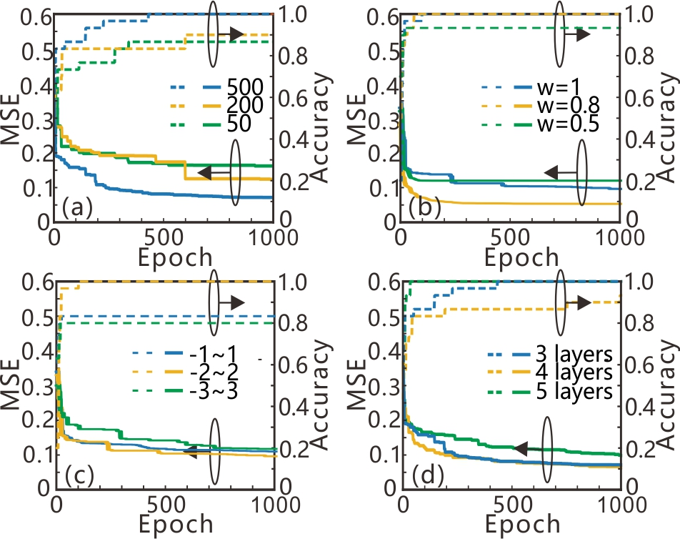
Fig. S2 The MSEs and classification accuracies of the trained ONNs for different population sizes (a), inertia weight (b), velocity ranges (c) of the PSO and the number of the layers in the ONNs (f).
Bearing these points in mind, we have added some discussions about the optimization parameters, please see the second paragraph on Page 8 and last paragraph on Page 9 in our revision.
(3) To better illustrate the transmission characteristics of the proposed PMC, an added figure about simulated field evolutions for the input TE and TM modes along the propagation distance is strongly recommended.
Answer:
We are grateful to the reviewer for the valuable suggestions. In 2017, Shen et al. propose a new architecture for the optical neural networks (ONNs) which can offer an enhancement in computational speed and power efficiency. In order to test and verify the practical performance of their proposal, they use the ONNs to accomplish a vowel recognition problem experimentally. However, the weights in the ONNs are generally mapped from the pre-trained results on a digital computer. In order to self-learn the weights in the ONNs, they propose an alternative approach to directly obtain the gradient of weights based on the forward propagation and ﬁnite difference method [S1]. It should be noted that this learning method directly use forward propagation rather than backward propagation to calculate the gradient of the weights because of the superior speed and low power consumption in the forward propagation. This training method sequentially perturbs each weight of the ONNs by considering the influence of phase shift δθ=10⁻³rad on the objective function. Therefore, T.W. Hughes et al. believe this training method is a brute force method which is inefficient for large systems [S2]. In our manuscript, the ‘brute force method’ refers in particular to the learning method proposed by Shen et al in ref.[S1].
In order to avoid misleading readers, this sentence has been revised, please see the first sentence in paragraph 2 on Page 2 in the revised manuscript.
Reference:
[S1] Y. Shen, N. C. Harris, S. Skirlo, M. Prabhu, T. Baehr-Jones, M. Hochberg, X. Sun, S. Zhao, H. Larochelle, D. Englund, and M. Soljačić, "Deep learning with coherent nanophotonic circuits," Nat. Photonics 11(7), 441-446 (2017).
[S2] T. W. Hughes, M. Minkov, Y. Shi, and S. Fan, "Training of photonic neural networks through in situ backpropagation and gradient measurement," Optica 5(7), 864-871 (2018).
4) There are a few grammatical mistakes, for instance, the first sentence of the text, “Surface plasmon polaritons (SPPs) is a special electromagnetic wave which…” should be corrected into “Surface plasmon polaritons (SPPs) are special electromagnetic wave which…”. Please proof-read the entire manuscript and correct any remaining errors.
Answer:
We are grateful to the reviewer for the valuable suggestions. We have revised this sentence as “Surface plasmon polaritons (SPPs) are special electromagnetic wave which…”. Please see the first line in the Introduction section in our revision. Moreover, we have carefully checked the whole manuscript and revised other mistakes about spelling and grammar.

