Abstract—In this article, we propose a programmable plasmonic waveguide system (PPWS) to achieve several different functions based on metal coding metamaterials (MCMs) and inverse design technology. There is no need to spend much time on considering the shape of resonators because the MCMs in the PPWS are reprogrammable. In order to demonstrate the effectiveness of the PPWS, we utilize it to achieve several filtering functions, including bandstop filter and bandpass filter. The simulation results exhibit that the performance of filters is improved based on genetic algorithm, particle swarm optimization, multi- traversal direct-binary search and simulated annealing, and the bandwidth and quality factor of the narrow-band filter can reach 6.5 nm and 200.5, respectively. In addition to the simple filtering functions, some relatively complex transmission characteristics can also be obtained by using the PPWS, such as plasmon-induced transparency (PIT) -like effects. In comparison to the previous works, our proposed PPWS not only provides a general framework for obtaining an effective, flexible and compact plasmonic devices but also shows the applications of inverse design on photonic devices.
Programmable Multifunctional Plasmonic Waveguide System based on Coding Metamaterials and Inverse Design
Yihang Dan, Tian Zhang, Xu Han, Jian Dai, and Kun Xu
Index Terms—Plasmonic devices, inverse design, optimization.

I. INTRODUCTION
Surface plasmon polaritons (SPPs) are especial electromagnetic waves which occur and propagate at the interface of metal and dielectric and they carry energy and information overcoming the diffraction limit [1]. The appearance of SPPs provides a new way to manipulate light at the nanoscale so it is considered to be the most potential way to realize highly integrated optical system in the future [2]. Since SPPs are discovered, researchers have studied different ways to excite SPPs, such as grating excitation [3], prism coupling [4,5], waveguide mode coupling [6], end-fire coupling [7] and local excitation [8]. The transmission of SPPs usually depends on special waveguide systems, for example metal-dielectric-metal (MDM) waveguide [9], insulator-metal-insulator waveguide [10], hybrid
Manuscript received XXX, 2020; revised XXX, 2020; accepted XXX, 2020. This work was supported by the National Natural Science Foundation of China under Grants 61625104 and 61431003, the Beijing Municipal Science & Technology Commission under Grants Z181100008918011, the Ministry of Science and Technology of China under Grants 2016YFA0301300, the Fundamental Research Funds for the Central Universities under Grants 2019RC15 and 2018XKJC02.
Y. Dan, T. Zhang, J. Dai, K. Xu are with State Key Laboratory of Information Photonics and Optical Communications, Beijing University of Posts and Telecommunications, Beijing 100876, P.R. China (e-mail: ztian@bupt.edu.cn).
X. Han is with Huawei Technologies Co., Ltd, Shenzhen 518129, Guangdong, China
Color versions of one or more figures in this paper are available online at http://ieeexplore.ieee. org.
waveguide [11] and so on. Due to their compact footprint and easy integration, MDM waveguide systems have been widely applied in plasmonic filters [12, 13], splitters [14, 15], optical switches [16, 17], modulators [17, 18], absorbers [19], sensors [20], couplers [21, 22], logic gates [23] and so on. However, in order to realize different functions, researchers often spend much time on searching for and designing for the nano-resonators with different shapes [24-26]. For example, plasmon-induced transparency (PIT) effect [27, 28], which has applications in refractive index sensor and slow light, is a hot spot in the field of SPPs. In order to achieve the PIT effect in the transmission spectrum, various structures of waveguide systems with different resonators have been proposed, such as ring resonators [29], stub resonators [30], T-shaped resonators [31], U-shaped resonators [32], rectangular resonators [33], side-coupled multiple resonators [34-37] and so on. Obviously, it’s cumbersome to construct different resonators for a special purpose. It is expected to improve the design efficiency of photonics devices if there exist a general framework, which can realize multiple functions and avoid repetitive design works. It has been demonstrated that the coding metamaterials, which consist of two types of unit cells, can provide a flexible and controllable platform by using a field-programmable gate array [38]. The coding metamaterials are effectively designed to achieve high- performance and easily integrated photonics devices based on the inverse design technology [39-42]. However, it should be noted that the above waveguide systems generally include dielectric coding metamaterials. There are few plasmonic waveguide system having programmable metal coding metamaterials (MCMs) to obtain multi -function in a general framework.
The inverse design technology based on optimization algorithms, have been used to search for the appropriate distributions and structure parameter of the MCMs. In general, there are three main ways to implement the inverse design of photonics devices: gradient based methods, gradient free methods and model-based methods[43]. As a representative method of the gradient based methods, adjoint variable method (AVM) can optimize for the linear and nonlinear optical devices, but it needs physical background to derive the gradient of objective function [43]. Model based methods, such as artificial neural networks (ANNs) and random forests, are also used for the inverse design of photonics devices [44, 45]. However, a lot of original data and labels are required to train the model which constructs the physical relationship between the structure parameters and corresponding optical responses. The optimization performance is highly dependent on the effect of pre-training model [39]. In comparison to the model-based methods, the gradient free methods, including search strategy and evolution strategy, are simple and effective as they directly search for the optimal solution by iteration and evolution strategies [40]. Genetic algorithm (GA) and particle swarm optimization (PSO) are two representative evolution algorithms, which are inspired by the genetic inheritance and group cooperation [41, 42]. Although GA and PSO have been widely applied in the optimization and design of photonic device, they are easy to fall into local optimal solution because the global search abilities are relatively weak [42-47]. Moreover, simulated annealing (SA) and direct-binary search (DBS) are traditional search algorithms which require less time to converge [48, 49]. However, these two algorithms also easily fall into local optimal solution and they are sensitive to the initial states and optimization parameter setting. And the finite traversal times (only once) limit the optimization ability of the DBS.
In this paper, we propose a programmable plasmonic waveguide system (PPWS) based on MCMs and inverse design to obtain several different functions. Four optimization algorithms, including GA, PSO, SA and DBS, are used to design for the MCMs in the PPWS to realize multiple optical filtering functions, such as narrowband bandstop filter (NBSF), broadband bandstop filter (BBSF), narrowband bandpass filter (NBPF) and broadband bandpass filter (BBPF). The numerical simulation results exhibit that the performance of filters is improved based on the inverse design and weighting operation. For instance, the bandwidth and Q value of the optimized NBSF can reach 6.5 nm and 200.5, respectively. In addition, some relatively complex transmission characteristics can also be obtained by using the PPWS, for example single plasmon- induced transparency (PIT)-like effect, double PIT-like effects and wavelength-tunable PIT-like effects.

II. Device design and simulation results
As shown in Fig. 1, our proposed PPWS consists of a MDM waveguide and MCMs. The MDM waveguide and MCMs are placed on a SiO₂ substrate. Here, the MCMs whose footprint is 400×400 nm² and composition is M×N square pixels are placed on one side of the MDM waveguide. Each pixel in the MCMs can be selectively filled by Ag or air, corresponding to the logical state “0” or “1”, respectively. Obviously, MCMs provide a relatively broad programming space which is expected to realize different functions based on the inverse design technology. In the PPWS, the length and width of the waveguide, which transmits the transverse magnetic (TM) mode polarized light are 620 nm and 100 nm respectively. The TM mode in the MDM waveguide can be coupled into the MCMs partially and then be coupled back into the MDM waveguide. The excited modes in the MCMs will have impact on the transmission characteristics in the transmission spectrum. In our numerical simulations, the transmission spectrums are calculated by using the 2-dimensional finite- difference time-domain (FDTD) method (adopting Lumerical MODE Solutions). The metal (Ag) in the FDTD simulation is modeled by the Drude model with (ε∞, ω_{p}, γ_{p}) = (3.7, 1.37× 10¹⁶Hz, 2.7×10¹³Hz) [S3]. All the transmission spectrums in our simulation are calculated from 800 nm to 1700 nm in the near infrared region. And the transmission loss of the PPWS is calculated by placing several monitors in the waveguide. It should be noted that the MDM waveguide system is usually simulated by using 2D FDTD simulation because of the less simulation time and high accuracy [S1-S3]. Although the 3D FDTD simulations are more close to the practical devices, their time consumption is relatively high.

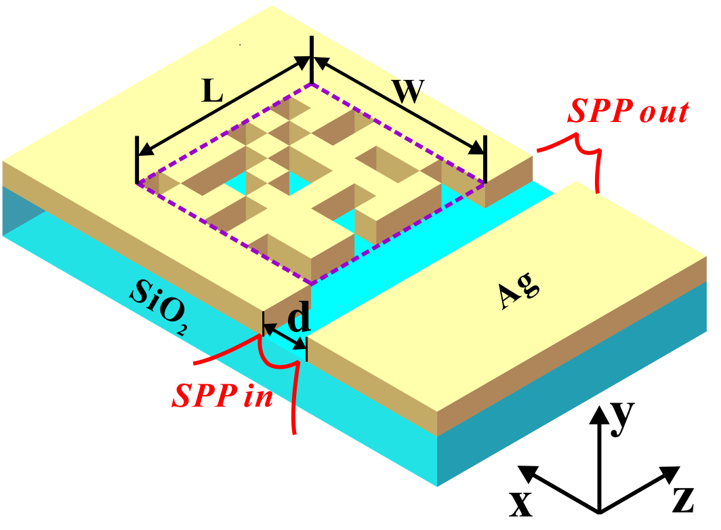
Fig.1 Structure schematic of the proposed PPWS.
As mentioned above, the PPWS provides a relatively broad programming space (MCMs) to support different functions. In practice, the MCMs can be dynamically controlled by using a field-programmable gate array [38]. Here, we randomly select several MCMs to exhibit the transmission characteristics of the PPWS, and the simulation results are shown in Fig. 2. In this simulation, the MCMs whose composition is 8×8 square pixels reveal that the PPWS has a programming space with 2⁶⁴ distributions although some distributions are senseless and repetitive. From Fig. 2(a) to Fig. 2(d), it can be observed that those transmission spectrums are expected to achieve multi- functional filtering, which is a fundamental and important unit in the integrated plasmonic circuits. And these transmission spectrums are simulated for the MCMs randomly selected from all possible distribution. It indicates that the performance metrics of the PPWS can be further improved based on the inverse design or optimization algorithms.
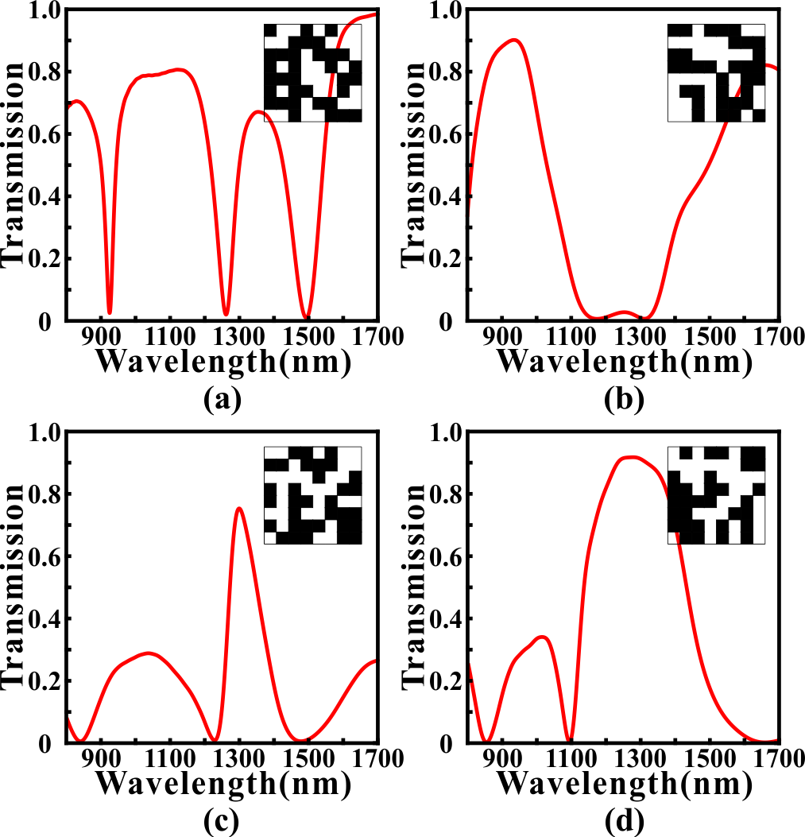
Fig. 2. The simulated transmission spectrums for the MCMs with different distributions. (a) The transmission spectrum that is expected to be used as a NBSF. (b) The transmission spectrum that is expected to be used as a BBSF. (c) The transmission spectrum that is expected to be used as a NBPF. (d) The transmission spectrum that is expected to be used as a BBPF.

Multifunctional photonics devices
- Multifunctional Filter
In section II, we have preliminary proved that the PPWS has potential as a multifunctional filter. It is expected to further improve the performance metrics of the filtering based on the inverse design technology. For example, we want to design a NBSF whose central wavelength and 3dB bandwidth are 1300 nm and 20 nm, respectively. From the beginning, we randomly generate a number of MCMs whose transmission spectrums are simulated by using the 2D FDTD simulation. Then, the MCMs are optimized by using the GA, PSO, SA and DBS to achieve better performance, such as a narrower bandwidth. GA is a highly parallel and adaptive optimization algorithm, which encodes the solutions as genes to achieve evolutionary optimization. Because of the complexity of gene coding, the binary coding, which is suitable for the MCMs, is often used as a simplified substitution [S1]. The algorithmic details of the GA used here are outlined as follows: (i) randomly generating an initial population consisted of N=50 individuals. Here, each individual in the initial population represents a distribution of MCMs whose pixels are randomly initialized as “1” or “0” state. It should be noted that N is an important parameter of the population which has influence on the convergence speed and optimization results. (ii) For all N MCMs, the transmission spectrums are calculated by using the 2D FDTD simulation. The Euclidean distance between the simulated transmission spectrum and the targeted transmission spectrum is defined as the optimization objective function (loss) for the GA. And it can determines whether one individual should be eliminated or not in the evolution. (iii)Trying to generate a new population by using the selection, crossover and mutation procedures. In the selection process, two parent individuals are selected from previous generation based on the roulette-wheel selection with gap selection ratio 0.9 [39]. In the crossover process, the selected MCMs cross over to generate a new MCMs based on the uniform crossover method with a crossover probability of 0.3. In the mutation process, each pixel in the MCMs has 3% probability to flip from 0 (1) to 1 (0). (iv) The newly generated ACMs are evaluated to determine the GA whether to stop or not. If the genetic generation reaches to 100 or the value of optimization objective function remains unchanged for more than 30 times, then GA stops, otherwise, proceeds to Step (ii).
In comparison to GA, PSO is an evolution algorithm based on group cooperation, which is inspired from the foraging behavior of birds [S1]. The solution (we call it “particle”) of the optimization problem is a “bird” in the search space. All particles have a fitness value determined by the optimization objective function which is the same in GA, and each particle has a speed that determines the direction and distance for their flight. It should be noticed that the standard PSO is suitable for the decimal rather than binary so that the discrete binary PSO (DBPSO) rather than the standard PSO is used to optimize the MCMs [S1]. In the DBPSO, the calculation method for the velocity is as same as the standard PSO. But the velocity of the standard PSO directly affects the position of particle, while that of DBPSO is converted to a flip probability based on the sigmoid function [50]. Then, this flip probability determines whether the pixels in the MCMs are changed or not. It should be noted that the speed range, inertia weight and acceleration constants of the DBPSO in the optimization are set as -1~1, 1, and c₁=c₂=1.49, respectively.
SA is a typical search algorithm which imitates the physical annealing in the quenching based on Monte Carlo iterative solution strategy [51]. At the initial stage, SA searches for the solution in a broad optimization space by accepting a worse solution with a certain probability. It can effectively alleviate the local optima problem in the GA and PSO to some extent [52]. As the temperature decreases, the solution changes in a small range to speed up the convergence of SA. Here, in each iteration, the MCMs are randomly generated and simulated by the 2D FDTD simulation. The objective function is evaluated to determine the newly generated MCMs whether to accept or not with an acceptance probability determined by the Metropolis criterion [53]. Here, the maximum and minimum of the temperature for the SA are set as 2000 and 1e-18, respectively. And the iteration times of the SA depends on the decrease rate (0.98) of temperature. In addition, DBS is a nonlinear search algorithm based on the binary tree whose left subtree and right subtree are constructed with state “0” and “1” respectively [S1]. From the beginning, each pixel is traversed in turn, and the branch with the smaller value of optimization objective function is selected and then fixed each time [S1]. It should be noticed that the optimal solution will only approach to the direction of convergence in this selection process, so there will be no oscillation and rebound for the value of optimization objective function. In this article, we propose a novel method to further improve the searching ability of the DBS. After traversing all pixels once, we start the traversal again. The reason for this is that when the first pixel in the MCMs is being selected to be fixed to state “0” or “1”, other pixels are in a certain state. After the first traversal, the distribution of the MCMs may have changed and some of the pixel states have been reversed. Thus, if the state of the first pixel is reversed again, the simulated transmission spectrum of the new MCMs may be better. Moreover, this multi-traversal direct-binary search (MDBS) algorithm can ensure that the performance of the PPWS will not degrade in the multiple traversal. In this article, if the traversal times of the MDBS reaches maximum or the value of loss remains unchanged for more than 10 times, then MDBS stops.
We use GA, DBPSO, SA and MDBS to optimize for the MCMs in the PPWS to achieve a NBSF for demonstrating the availability and effectiveness of optimization algorithms. Here, the MCMs in the PPWS are composed of 8×8 pixels. The targeted central wavelength of the NBSF is set as 1300 nm and the targeted full width at half maximum (FWHM) of the transmission dip is set as 20 nm. Here, the line shape of the targeted transmission spectrum is set as gate function [S1]. The targeted transmission spectrums (green dash lines) and optimized transmission spectrums (red solid lines) are shown in Fig. 3. It can be found that the transmission spectrums have a notable improvement after optimizing with four optimization methods since the optimized transmission spectrums are very close to the targeted transmission spectrums comparing with the initial transmission spectrums (blue dash line). Here, the initial transmission spectrums of the DBS and GA are calculated for the first random distributions of the MCMs, while those of the GA and DBPSO are the best individuals in
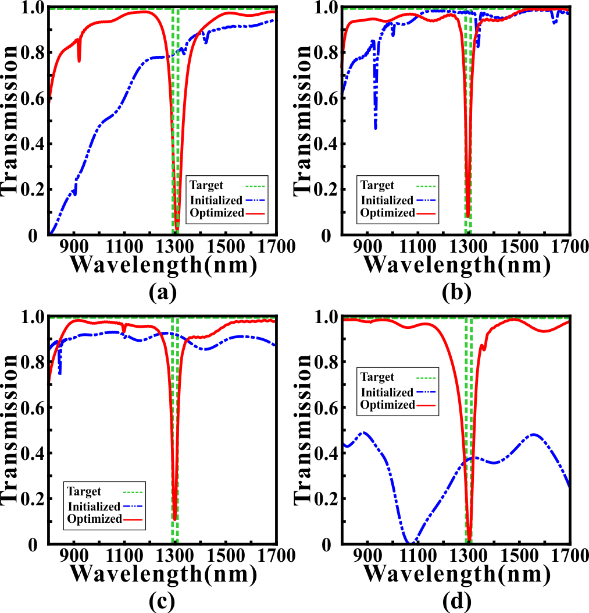
Fig. 3. The initial transmission spectrums (blue dash lines) and optimized transmission spectrum (red solid lines) for GA (a), DBPSO (b), SA (c) and MDBS (d). The green dotted lines in (a), (b), (c) and (d) are the targeted transmission spectrums.
the first iteration. After the optimization, we can find that the minimum transmittances of the transmission dips are reduced to 0.0208, 0.0812, 0.1045 and 0.0184 for GA, DBPSO, SA and MDBS, respectively. And the central wavelengths (FWHMs) of the optimized NBSF are 1307.0 nm (7.5 nm), 1299.5 nm (7.5 nm), 1299.0 nm (10.5 nm) and 1303.0 nm (6.5 nm) for GA, DBPSO, SA and MDBS, respectively. Correspondingly, the Q -factors of the optimized NBSF can reach 174.27, 173.67, 123.71 and 200.46, respectively. Obviously, all optimization algorithms are convergent and effective because the optimized transmission spectrums are close to the targeted transmission spectrums. Even so, there exist slight performance differences of the fluctuation degree in the sideband of the optimized transmission spectrums. The max fluctuations of the sideband in the transmission spectrums optimized by the GA, DBPSO, SA and MDBS are 2.28 dB, 1.32 dB, 1.48 dB and 0.64 dB, respectively. Though SA has the minimum transmittances and FWHM, which indicates it performs well in this simulation, it is unstable in the optimization process. GA, by contrast, can get gratifying performance because it only executes once or twice, which is more stable than others.
After the optimization with GA, the distributions of the MCMs and the magnetic field distributions of the transmission characteristics for NBSF are shown in Fig. 4. The parameter setting of NBSF is same as Fig. 3. It can be found that for the transmission dip at wavelengths 1100 nm and 1500 nm, the SPPs are slightly coupled into MCMs through the pixels that are marked with red boxes. Obviously, it doesn't form a stable resonant mode so that SPPs pass through the MDM waveguide with low loss. For the transmission peak at 1300nm, the SPPs are coupled into the MCMs to form a strong resonant mode in the purple zone. When the SPPs in the MCMs are coupled back into the MDM waveguide, the phase is opposite with the . As a result nnsmission di transmissio

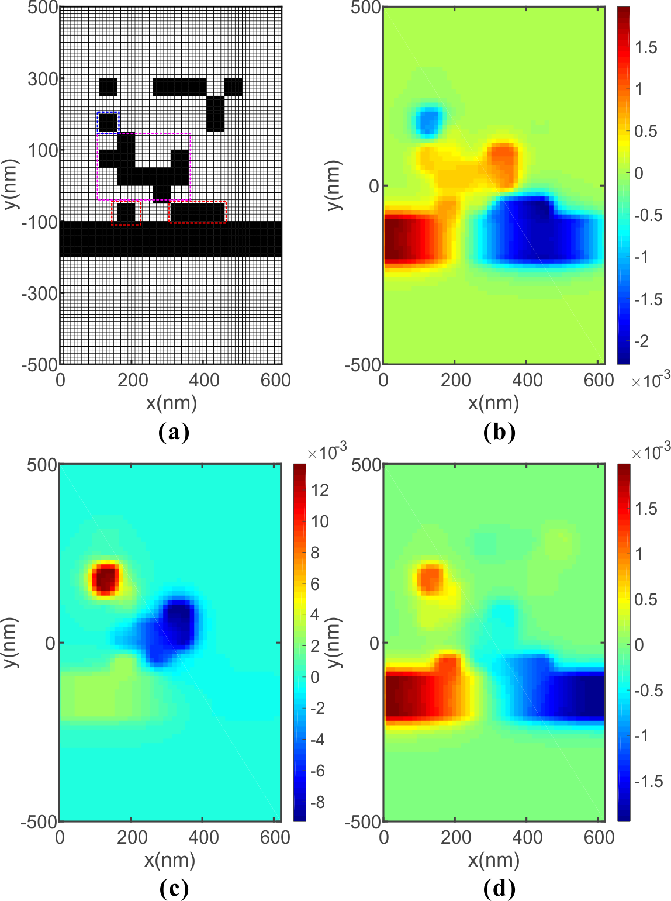
Fig. 4. (a) The distribution of the MCMs for the optimized NBSF. Distributions of the real part of the magnetic field H_{z} at 1100 nm (b), 1300 nm (c), and 1500 nm (d).
original SPPs. Thus, an obvious transmission dip emerges in transmission spectrum.

Then, we use GA to optimize for other three types of filters (BBSF, BBPF and NBPF), and corresponding simulation results are shown in Fig. 5. By contrast, the optimized results for the NBSF are shown in Fig. 5(a). Fig. 5(b) shows the optimized transmission spectrum for the BBSF, which has a wide band stopband from 1100 nm to 1500 nm. It can be found that the transmittances are less than 0.01 in the stopband and higher than 0.8 in the passband, indicating this BBSF can achieve promising filtering effects. In comparison to the NBSF, the stopband of the BBSF is not enough smooth. The reason for this phenomenon is attributed to the optimized MCMs have redundant pixels, which may lead to the deterioration of performance in the stopband. In addition, Fig. 5(c) shows the optimized transmission spectrum for the BPSF that has a broad passband from 1100 nm to 1500 nm. Here, the maximum transmittance and FWHM of the BPSF reach 0.9718 and 423 nm, respectively. ,And the maimum fluctuation degree in the sideband of the BPSF is only 0.14 dB, which indicates that the passband is very flat. Moreover, we design a NBPF whose 3 dB bandwidth is 133.5 nm, and it’s optimized transmission spectrum is shown in Fig. 5(cd). It can e observed that the maximum transmittance of the transmission peak can reach 0.8668 at 1296.5 nm. Obviously, the bandwidth and sideband inhibition of the NBPF can’t be optimized as well as the NBSF. The reason for this phenomenon is related to the loss of the MCMs. In other words, the function of the MCMs is to inhibit the transmission of specific wavelengths so that the NBSF have better performance than NBPF and can be achieved by simpler method. Stated thus, the PPWS is demonstrated to realize multiple optical filtering functions with the remarkable results. We don’t make lots of efforts to consider the shape of the resonator.
Fig. 5(d),

Fig. 5. The transmission spectrums optimized by GA for (a) BBSF, (b) BBPF (c) NBPF and (d) NBSF. The green dotted line is the targeted transmission spectrum. Red solid line is the optimized transmission spectrum.
Next, two key elements which have significant influence on the optimal performance of filtering functions are discussed. Firstly, it's clear that the similarity between the simulated transmission spectrum and targeted transmission spectrum determines the performance of optimization. Here, we propose a simple but effective method named weighting operation to calculate the similarity to improve the performance metrics. As above mentioned, the Euclidean distances between the simulated transmission spectrums and targeted transmission spectrums are regarded as the optimization objective function (loss). Based on this, we use the weighting factor to calculate the Euclidean distance. The details are outlined as follows: (i) dividing the wavelength range of the transmission spectrums into two parts of wavelenh the importance. (ii) One part is called "The central wavelength range (TCWR)", which relates to the wavelength range of stopband or passband we focused on. The other is called ''The else wavelength range (TEWR), which has slight impactinfluenc performance metri. (iii) In each iteration, the loss is calculated by the following formula:

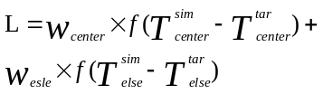 (1)
where w_{center} is the weighting factor of TCWR, w_{els} is the weighting factor of TEWR. f is the function of calculating Euclidean distance. Tsim center and Ttar center represent the simulated simulated transtransmission spectrum and targeted transmission spectrum in TCWR. While Tsim elsec an Ttar celsente re tsimulated transmission spectrum and targeted transmission spectrum in the TEWR.
In order to analyze the influence of the weighting operation, we use GA to optimize for the MCMs in the PPWS to achieve a NBSF. Here, the MCMs are composed of 8×8 pixels. The targeted central wavelength of the NBSF is set as 1300 nm and the FWHM of the transmission dip is set as 20 nm. TCWR includes the wavelength range from 1290 nm to 1310nm, and
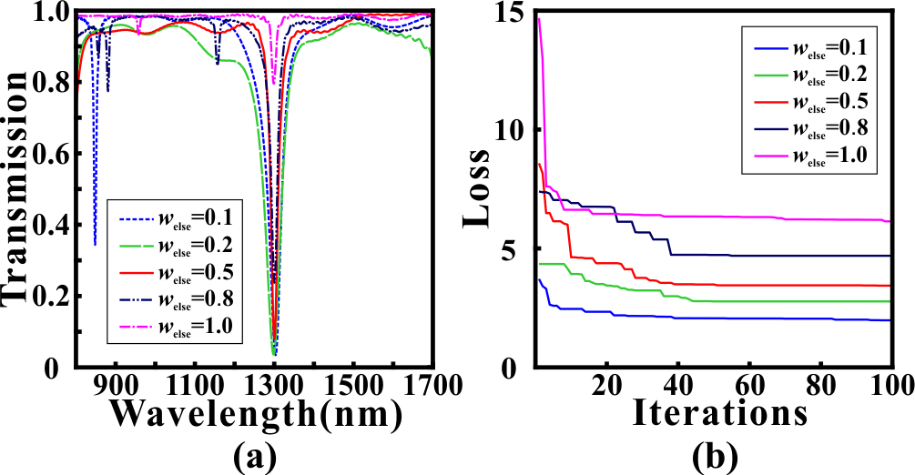
Fig. 6. (a) The optimized transmission spectrums of the NBSF forwitfferent weighting factors w_{else}weightihe variation of loss values for different weighting factors w_{else}with different weighting _{r} is set to 1.
ission dip is set as 20 nm h range from 1290 nm to 131 andtof wavel rangR. The optimized
Ttransmission spectrums with ffferent weighting factors w_{else} of TEWR settinown in Fig. 6(a).

After the optimization, we find that the loss values of different weighting factors w_{else} have a significant decline from Fig. 6(b). The loss values decreases from 3.72 to 1.98 with a 46.77% decline (w_{else}=0.1), 4.35 to 2.77 with a 36.32% decline (w_{else}=0.2), 8.58 to 3.44 with a 59.91% decline (w_{else}=0.5), 7.39 to 4.69 with a 36.54% decline (w_{else}=0.8) and 14.69 to 6.14 with a 58.20% decline (w_{else} =1.0), respectively. And the loss value has continuously decline with weighting factor w_{else} reducing, indicating that the weighting facto has a significant influence on the optimization effects. In Fig. 6(a), it can be found that the minimum transmittance at transmission dip is only 0.7968 when w_{else}=1.0, which is still large to filter even if the loss value has a steep and quick decline in Fig. 6(b). As weighting factor w_{else} decreases, the minimum transmittance at transmission dip reduces to 0.2389, 0.0812, 0.0376 and 0.0360, respectively. However, it can be observed that the sideband has more violent fluctuations when w_{else} decreases from 1.0 to 0.1. Besides, the 3dB bandwidths are 14.5 nm, 7.5 nm, 10.5 nm and 8 nm for w_{else}=0.1, w_{else}=0.2, w_{else}=0.5 and w_{else}=0.8, respectively. As w_{else} decreases, the fluctuations of TEWR become more and more weaksmecause the contribution of TEWR becomes weakersm At the same time, the significance of TCWR is amplified equivalently so a small transmittance at transmission dip can be achieved when w_{else} is decreased. In this article, we use a weighting factor of w_{else}= 0.5, which guarantees a balance between bandwidth, minimum transmittance and fluctuations of sideband. Obvious, it is better to adjust the weighting factor according to the specific application and optimization results of the PPWS.
The other key element for the optimization of the PPWS is the density of pixels in the . ObviouslyAs we proersity of the MCMsermines the practical functions and performance of the PMPWS Mathematically, the permutation and combination of the MCMs grows exntially as the density of pixels in MCMsdensity of the MCMs is increaseds. I noted thatimization algorithms e used in this paper are suitable for global optimization tasknot infinitely. Therefore, it is necessary to choose an appropriate density of pixs in the MCMs, which can not only ensure the diversity of MCMs but also main the efficiency of the optimization algorithms. In order to analyze the impactnfluence of density on the optimization effect, we use all four algorithms ize for a NBSF with four different densities. Th targeted cl wavelength of the NBSF is set as 1300 nm and the FWHM of the transmission dip is set as 20 nm. The optimized
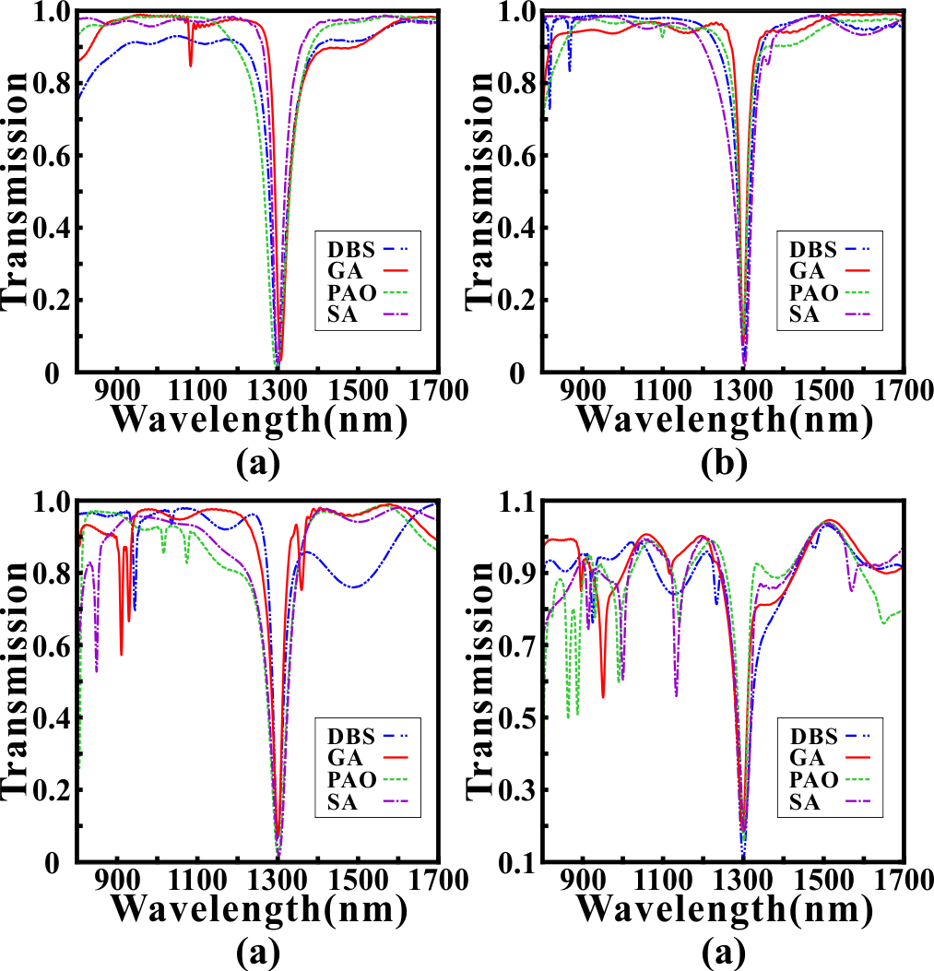
Fig. 7. The optimized transmission spectrums of the NBSF with the MCMs whose densities are (a) 5×5 pixels (b) 8×8 pixels (c) 10×10 pixels (d) 20×20 pixels. Blue lines, red lines, green lines and purple lines are the transmission spectrums optimized by DBS, GA, PSO, and SA, respectively.
NBSF is set as 1300 nm and the FWHM of the transmission dip is seed transmission spectrue Ns areof 5×5 pixels, 8×8ppixed 2ls are edshownn Fig. 7(- (d), respectively. And tThe important performance metrics of the optimized transmission spectrums withfor frent dnsities are shownexhibitem Table I to Table IV. Here, T_{min} and L_{c} are the minimunsmittance and the central wavelength of transmission dip. It can be found thatIn general, the pewidth have remarkable declines as the density of MCMncrases. It can be found thatAnd the minimum transmittance aor 20×20 pixels perform the worst in comparison to other densities. It cannot be neglected that the And the fluctuations in the sideband for 20×20 pixels are extremely vint,h may restricthe applications of filtering function. The"Theso t"Thethe cen

reason for this phenomenon is related to the simple filtering function can be realized by using low-density MCMs (8×8 pixels) and high-density MCMs (20×20 pixels) is so redundant that the filtering performance is degraded. In addition, it should be noted that the FDTD simulation oor high-density MCMs will takes more time to converge be the computational complexity of the high-density MCMs is increased. Obviously, it's not the denser the MCMs are, the better for theformance of filtering function is. The choice of density for the MCMs depends o the practical requirements. Moreover, it can be found that the performance differences between 5×5 pixels, 8×8 pixels and 10×10 pixels are not obvious. In comparison to 5×5 pixels and 10×10 pixels, the inhibition of the sideband for 8×8 pixels performs better becausein it’s smooersmoothness. ndwidth and minimum transmittance of transmission dip for 5×5 pixels are more competitive, but the offset of central wavelength is relatively large, which limits the precise filtering. Considering the diversity of MCMs and computatiiciency, we select the MCMs with 8×8 pixels to achieve most of the functionality in this article.

Table I
Performance of 5×5 pixels
Methods | L_{c} (nm) | T_{min} | 3dB bandwidth(nm)
MDBS | 1300.5 | 0.0124 | 6
SA | 1299 | 0.0267 | 6.5
DBPSO | 1296.5 | 0.0071 | 6
GA | 1307 | 0.0330 | 7
Table II
Performance of 8×8 pixels
Methods | L_{c} (nm) | T_{min} | 3dB bandwidth(nm)
MDBS | 1302.5 | 0.0441 | 7.5
SA | 1303 | 0.0184 | 6.5
DBPSO | 1299 | 0.1045 | 10.5
GA | 1299.5 | 0.0812 | 7.5
Table III
Performance of 10×10 pixels
Methods | L_{c} (nm) | T_{min} | 3dB bandwidth(nm)
MDBS | 1299.5 | 0.0657 | 9.5
SA | 1302.5 | 0.0185 | 8
DBPSO | 1302 | 0.0206 | 8.5
GA | 1299.5 | 0.0737 | 10
Table IV
Performance of 20×20 pixels
Methods | L_{c} (nm) | T_{min} | 3dB bandwidth(nm)
MDBS | 1299.5 | 0.1091 | 16
SA | 1301.5 | 0.1822 | 23
DBPSO | 1301 | 0.1588 | 13
GA | 1297.5 | 0.1860 | 19
- PIT-like effect
In the previous section, we show that the PPWS can achieve a variety of filtering functions, but these functions are relatively simple. Actually, the PPWS can be programmed to realize advanced functions because of the diversity of MCMs. In addition, this programmable waveguide system can also be used to achieve wavelength-tunable optical devices based on optimization algorithms and the MCMs. Here, we use the GA, whose comprehensive performance is the best in the previous section, to optimize for the MCMs to achieve the PIT-like effect in the transmission spectrum. The optical characteristics of the PIT-like effect includes a transmission peak located between two transmission dips
, which has great applications in optical switches, optical data storage and slow light [27, 28]. In this FDTD simulation, the MCMs are composed of 8×8 pixels. The targeted FWHM of the transmission peak is set as 20 nm, while the targeted FWHM of the transmission dip is set as 200 nm. tee ransmission spectrums optimized forth single PIT- like effect are shown in Fig. 8. Obviously, it can be observed that a single PIT-like effect whose center wavelength is at 1297 nm shown in Fig. 8(a) (The targeted central wavelength of the transmission peak is set as 1300 nm). The transmittance of the transmission peak reaches 0.7115, while the transmittances of the transmission dips are 0.0084 (1251 nm) and 0.0086 (1333 nm), respectively. As a critical parameter to evaluate the performance of the PIT-like effect, the Q-factor, is calculated by the following formula:
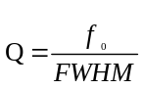 (2)
where f₀ is the center wavelength of in the single PIT-likefect, and FWHM is the full width at half maximum. After the GA optimization, the FWHM in Fig. 8(a) is 35.5 nm so that the Q-factor reaches 36.54. In fact, the Q-factor is lower in the metallic systems due to the ohmic damping [54]. Obviously,
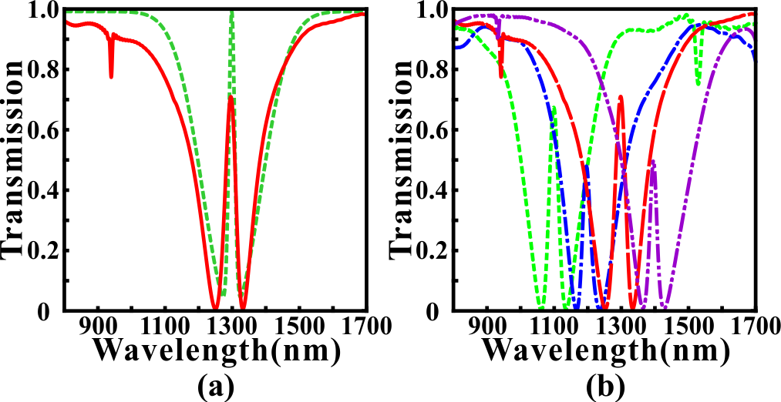
Fig. 8. (a) The transmission spectrum optimized for a single PIT-like effect. The green dotted line is the targeted transmission spectrum. Red solid line is the optimized transmission spectrum. (b) Wavelength-tunable PIT-like effects with different central wavelength 1100 nm, 1200 nm, 1300 nm and 1400 nm.

ohmibusl no need t analyze the complex coupling mechanism in a metallic resonator to achieve a single PIT-like effect. InsteadIn our simulte just focus on using efficient optimization algorithms and reasonable physical conditions to obtain the targeted optical characteristics.
In addition to the PIT-like effect at specific wavelength, the wavelength-tunable PIT-like effect are expected to be applied in highly integrated optical circuits due to their flexibility [S1]. For example, it has been demonstrated that the tunable PIT- effect can be applied in optical modulators, switches, sensors, slow light and so on [S1]. Here, we use the PPWS to achieve wavelength-tunable PIT-like effect based on the optimization of MCMs. Fig. 8(b) shows the wavelength-tunable PIT-like effect with different central wavelength. In the optimization process, we only need to adjust the central position of the targeted PIT-like effect and keep other parameters the samfde. The enter (targeted) wavelengths of the tunable PIT-like effects are 1098 nm (1100 nm), 1195 nm (1200 nm) and 1395 nm (1400 nm), respectively. The maximum deviation between the center wavelength and targeted wavelength is only 5 nm. The corresponding FWHMs (Q-factors) of the tunable PIT- like effects are 31.5 nm (34.86), 27 nm (44.26) and 24 nm (58.13), respectively. And the extinction ratios between the transmission peak and two transmission dips are 19.27 dB (left) and 19.19 dB (right) for the PIT-like effect at 1098 nm, 20.52 dB (left) and 18.93 dB (right) for the PIT-like effect at 1195 nm, 16.55 dB (left) and 18.22 dB (right) for the PIT-like effect at 1395 nm, respectively. Obviously, the 2D FDTD simulationed resul show that the tunable PIT-like effect can be obtained in the wavelength range from 1100 nm to 1400 nm, which provescan trate the PPWS has great tunabilitrty and controllability based on inverse design.
For the PIT-like effect, the distribution of the MCMs and corresponding electromagnetic field distributions are shown in Fig. 9. Based on the magnetic field distributions, we provide a qualitative explanation for the single PIT-like effect. It can be found that SPPs is confined in the regions which are marked by the yellow rectangular box and red rectangular box, leading to the transmission dips at 1251 nm and 1333 nm, respectively.
nm. When wavelength increases to 1297 nm, SPPs who is coupled into yellow zone and blue zone through the red zone forms a ent mode. And the phase is same when SPPs is coupled back into the strip waveguide so there is a transmission peak. For the transmission peak at 1297 nm, SPPs are coupled into yellow zone through the red zone forms a resonant mode. And the phase is same when SPPs is coupled back into the strip waveguide so there is a transmission peak. Here, it’s difficult to use the bright-dark mode coupling mechanism or doublet of dressed states to explain the PIT-like effect [S1].As wavelength increasing to 1333nm, the resonant mode becomes opposite compared with the mode at 1297nm. When SPPs is coupled back int

Fig. 9 (a) The distribution of the MCMs for the PIT-like effect whose center wavelength is at 1297nm. The field distribution of the real part of the magnetic field Hz at (b) 1251 nm, (c) 1297 nm, (d) 1333 nm.

Finally, we add the complexity of the targeted transmission spectrum to achieve the double PIT-like effect. The simulated transmission spectrums are shown in Fig. 10. Fig. 10(a) shows an ideal double PIT-like effect with high transmittanceo-whose transmittances of peaks reach 0.7502 (left channel) and 0.7684 (right channel). By contrast, Fig. 10(b) shows a double PIT- like effect with low transmittances of the transmission peaks. Here, Bue optimization and matching effects of sideband in Fig. 10(b) ise better than those in Fig. 10(ab) It should be noted that the sampling points in wavelength range are equidistant in our simulation. Hot the critical wavelength range that determines the optimization performance is relatively small. Although we use the weighting operation to eliminate the effluence from sideband, there still are problems to be solved to make the simulation results match the targeted spectrums perfectly. Even so, it can be observed that the potential applications of the PPWS to achieve more complex functions from Fig.9 and Fig. 10.
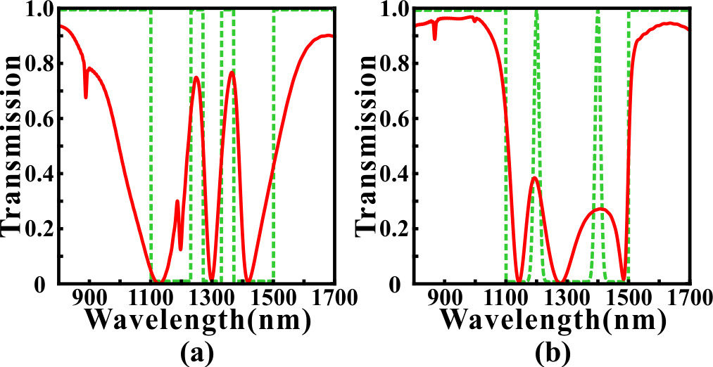
Fig. 10 (a) The simulated transmission spectrum of the double PIT-like effect with high transmittance. The targeted PIT windowscenter wave set ast 1250 nm and 1350nm. The targetd FWHMs of PIT transmission peaks are both m. (b) The simulated transmission spectrum of the double PIT-like effect with low transmittanceThe simulated transmission spectrum oased on gauss function. Th center wi are he targeted FWHMs of PIT transmission peaks are both 20 nm. Theed lines isare the tarted transmission spectrums. Red solid line is optimized transmission spectrum.

CONCLUSION
In conclusion, we propose a PPWS based on MCMs and inverse design. Several optimization algorithms, such as GA, SA, MDBS and DBPSO are applied in the design of the MCMs to achieve different functions. At t wighting operation we prmproves theperfoization effects. The FDTD simulationed relts demonstrate that the optimized PPWS can not only obtainachiele functions (such as filters),multialso achieve more complex transmission characteristics (for example the PIT- like effect, double PIT-like effects and wavelength-tunable PIT-like effects)functengthTough the perfect matching between the targeted transmission spectrums and optimzed transmission spectrums is still ifficult to realizeachiwever, Ttls indicate that the PPWS combined with inverse design technreat potential to design realtifunctional plasmonic devices with low cost and high efficiency. There is no need to spend much time on considering the shape of resonators because the MCMs in the PPWS are reprogrammable. In comparison to the previous works, our proposed PPWS not only provides a general framework for obtaining an effective, flexible and compact plasmonic devices but also shows the applications of inverse design on photonic devices. Meanwhile
References
[1] D.K. Gramotnev and S.I. Bozhevolnyi, "Plasmonics beyond the diffraction limit," Nat. Photonics 4, 83-91 (2010).
[2] T. Zhang, L. Chen, and X. Li, "Graphene-based tunable broadband hyperlens for far-field subdiffraction imaging at mid-infrared frequencies," Opt. Express 21, 20888-20899 (2013).
[3] Hooper I R, Sambles J R. Dispersion of surface plasmon polaritons on short-pitch metal gratings[J]. Physical Review B, 2002, 65(16): 165432.
[4] Otto A. Excitation of nonradiative surface plasma waves in silver by the method of frustrated total reflection[J]. Zeitschrift für Physik, 1968, 216(4): 398-410.
[5] Kretschmann E, Raether H. Notizen: Radiative Decay of Non Radiative Surface Plasmons Excited by Light[J]. Zeitschrift für Naturforschung A, 1968, 23(12): 2135-2136.
[6] 暂缺
[7] G. I. Stegeman, R. F. Wallis, and A. A. Maradudin, "Excitation of surface polaritons by end-fire coupling," Opt. Lett. 8, 386-388 (1983).
[8] D. Rodrigo and et al, "Mid-infrared plasmonic biosensing with graphene," Science 349(6244), 165-168 (2015).
[9] Kocabaş Ş E, Veronis G, Miller D A B, et al. Modal analysis and coupling in metal-insulator-metal waveguides[J]. Physical Review B, 2009, 79(3): 035120.
[10] Du B, Yang Y, Zhang Y, et al. Plasmonic grating based on insulator–metal–insulator structure at telecom wavelengths[J]. IEEE Photonics Technology Letters, 2018, 30(19): 1691-1694.
[11] Lu H, Gan X, Mao D, et al. Graphene-supported manipulation of surface plasmon polaritons in metallic nanowaveguides[J]. Photonics Research, 2017, 5(3): 162-167.
[12] Yun B, Hu G, Cui Y. Theoretical analysis of a nanoscale plasmonic filter based on a rectangular metal–insulator–metal waveguide[J]. Journal of Physics D: Applied Physics, 2010, 43(38): 385102.
[13] Zhang Z, Shi F, Chen Y. Tunable multichannel plasmonic filter based on coupling-induced mode splitting[J]. Plasmonics, 2015, 10(1): 139-144.
[14] Kwon M S, Shin J S, Lee J H. Metal–insulator–silicon–insulator–metal waveguide splitters with large-arm separation[J]. Journal of Lightwave Technology, 2015, 33(18): 3843-3849.
[15] Longkun Yang, Pan Li, and Zhipeng Li, "Plasmonic polarization beam splitting based on single silver nanowire," Opt. Express 27, 3851-3860 (2019).
[16] Gómez-Díaz J S, Perruisseau-Carrier J. Graphene-based plasmonic switches at near infrared frequencies[J]. Optics express, 2013, 21(13): 15490-15504.
[17] Emboras A, Hoessbacher C, Haffner C, et al. Electrically controlled plasmonic switches and modulators[J]. IEEE Journal of Selected Topics in Quantum Electronics, 2014, 21(4): 276-283.
[18] Hössbacher C, Josten A, Bäuerle B, et al. Plasmonic modulator with> 170 GHz bandwidth demonstrated at 100 GBd NRZ[J]. Optics Express, 2017, 25(3): 1762-1768.
[19] Zhang B, Zhao Y, Hao Q, et al. Polarization-independent dual-band infrared perfect absorber based on a metal-dielectric-metal elliptical nanodisk array[J]. Optics express, 2011, 19(16): 15221-15228.
[20] Lu H, Liu X, Mao D, et al. Plasmonic nanosensor based on Fano resonance in waveguide-coupled resonators[J]. Optics letters, 2012, 37(18): 3780-3782.
[21] Yang R, Wahsheh R A, Lu Z, et al. Efficient light coupling between dielectric slot waveguide and plasmonic slot waveguide[J]. Optics letters, 2010, 35(5): 649-651.
[22] Patel V, Sharma P, Kumar V D. Efficient coupling from dielectric to hybrid plasmonic waveguide using curved taper[J]. IEEE Photonics Technology Letters, 2019, 31(4): 323-326.
[23] Liu Z, Ding L, Yi J, et al. Design of a multi-bits input optical logic device with high intensity contrast based on plasmonic waveguides structure[J]. Optics Communications, 2019, 430: 112-118.
[24] Zhang H, Shen D, Zhang Y. Circular split-ring core resonators used in nanoscale metal–insulator–metal band-stop filters[J]. Laser Physics Letters, 2014, 11(11): 115902.
[25] Liu X, Tian J, Yang R. Surface plasmon polariton based metal-insulator-metal filter including two face-to-face concentric semi-rings with different radii[J]. Journal of Optical Technology, 2017, 84(9): 588-592.
[26] Lai W, Wen K, Lin J, et al. Plasmonic filter and sensor based on a subwavelength end-coupled hexagonal resonator[J]. Applied optics, 2018, 57(22): 6369-6374.
[27] Han Z, Bozhevolnyi S I. Plasmon-induced transparency with detuned ultracompact Fabry-Perot resonators in integrated plasmonic devices[J]. Optics Express, 2011, 19(4): 3251-3257.
[28] Wang G, Lu H, Liu X. Dispersionless slow light in MIM waveguide based on a plasmonic analogue of electromagnetically induced transparency[J]. Optics express, 2012, 20(19): 20902-20907.
[29] Zhan S, Li H, Cao G, et al. Slow light based on plasmon-induced transparency in dual-ring resonator-coupled MDM waveguide system[J]. Journal of Physics D: Applied Physics, 2014, 47(20): 205101.
[30] Chen J, Wang C, Zhang R, et al. Multiple plasmon-induced transparencies in coupled-resonator systems[J]. Optics letters, 2012, 37(24): 5133-5135.
[31] Lu H, Liu X, Mao D, et al. Induced transparency in nanoscale plasmonic resonator systems[J]. Optics letters, 2011, 36(16): 3233-3235.
[32] Zhan S, Kong D, Cao G, et al. Analogy of plasmon induced transparency in detuned U-resonators coupling to MDM plasmonic waveguide[J]. Solid state communications, 2013, 174: 50-54.
[33] Han X , Wang T , Li M , et al. Ultrafast and Low-power Dynamically Tunable Plasmon Induced Transparencies in Compact Aperture-Coupled Rectangular Resonators[J]. Journal of Lightwave Technology, 2015, 33(14):1-1.
[34] Guo J. Plasmon-induced transparency in metal–insulator–metal waveguide side-coupled with multiple cavities[J]. Applied optics, 2014, 53(8): 1604-1609.
[35] Liu H, Ren G, Gao Y, et al. Tunable subwavelength terahertz plasmon-induced transparency in the InSb slot waveguide side-coupled with two stub resonators[J]. Applied Optics, 2015, 54(13): 3918-3924.
[36] Yu D M, Zhai X, Wang L L, et al. Plasmon-induced transparency in a surface plasmon polariton waveguide with a right-angled slot and rectangle cavity[J]. Plasmonics, 2016, 11(4): 1151-1155.
[37] Lu H, Liu X, Mao D. Plasmonic analog of electromagnetically induced transparency in multi-nanoresonator-coupled waveguide systems[J]. Physical Review A, 2012, 85(5): 053803.
[38] Cui T J , Qi M Q , Wan X , et al. Coding metamaterials, digital metamaterials and programmable metamaterials[J]. Light Science & Applications, 2014, 3(10):e218.
[38] Molesky S, Lin Z, Piggott A Y, et al. Inverse design in nanophotonics[J]. Nature Photonics, 2018, 12(11): 659-670.
[39] T. Zhang and et al, "Efficient spectrum prediction and inverse design for
plasmonic waveguide systems based on artificial neural networks," Photonics
Research 7(3), 368-380 (2019).
[40] T. W. Hughes and et al, "Adjoint method and inverse design for nonlinear
nanophotonic devices," ACS Photonics 5, 4781-4787 (2018).
[41] Zhang T, Liu Q, Dan Y, et al. Inverse design and optimization of graphene metamaterial for multi-peak plasmon induced transparency based on machine learning and evolutionary algorithms[J]. arXiv preprint arXiv:1908.01354, 2019.
[42] Skaar J, Risvik K M. A genetic algorithm for the inverse problem in synthesis of fiber gratings[J]. Journal of lightwave technology, 1998, 16(10): 1928.
[43] Kern D J, Werner D H. A genetic algorithm approach to the design of ultra-thin electromagnetic bandgap absorbers[J]. Microwave and Optical Technology Letters, 2003, 38(1): 61-64.
[44] Chen P Y, Chen C H, Wang H, et al. Synthesis design of artificial magnetic metamaterials using a genetic algorithm[J]. Optics express, 2008, 16(17): 12806-12818.
[45] Shokooh-Saremi M, Magnusson R. Particle swarm optimization and its application to the design of diffraction grating filters[J]. Optics letters, 2007, 32(8): 894-896.
[46] Forestiere C, Donelli M, Walsh G F, et al. Particle-swarm optimization of broadband nanoplasmonic arrays[J]. Optics letters, 2010, 35(2): 133-135.
[47] Lu Q, Wei W, Yan X, et al. Particle swarm optimized ultra-compact polarization beam splitter on silicon-on-insulator[J]. Photonics and Nanostructures-Fundamentals and Applications, 2018, 32: 19-23.
[48] Kim W J, O'Brien J D. Optimization of a two-dimensional photonic-crystal waveguide branch by simulated annealing and the finite-element method[J]. JOSA B, 2004, 21(2): 289-295.
[49] Shen B, Wang P, Polson R, et al. An integrated-nanophotonics polarization beamsplitter with 2.4× 2.4 μm 2 footprint[J]. Nature Photonics, 2015, 9(6): 378-382.
[50] L. Chuang and et al, "Improved binary PSO for feature selection using
gene expression data," Comput. Biol. Chem. 32(1), 29-38 (2008).
[51]
[52]
[53]
[54] Hu J, Lang T, Hong Z, et al. Comparison of electromagnetically induced transparency performance in metallic and all-dielectric metamaterials[J]. Journal of Lightwave Technology, 2018, 36(11): 2083-2093.

