Abstract—We propose a novel programmable plasmonic structure (PPS) which uses coding metamaterials coupling with metal–insulator–metal (MIM) waveguide to design five types of photonic devices with high performance which is common but important in photonic systems. And several optimization methods (genetic algorithm, particle swarm optimization, multi-traversal direct-binary search and simulated annealing) are applied in designing and optimizing the PPS to improve the performance metrics. Compared with the others, genetic algorithm can optimize all kinds of devices to the greatest extent which proves the efficiency of evolutionary algorithm. All types of photonic devices can perform nanoscale wavelength tunability which is potential and advantageous in highly integrated optical circuits.
Multifunctional and Programmable Plasmonic Waveguide System based on Inverse Design and Coding Metamaterials
Yihang Dan, Tian Zhang, Xu Han, Jian Dai, and Kun Xu
Index Terms—Inverse design, optimization, photonic devices.

I. INTRODUCTION
Surface plasmon polaritons (SPPs) is a kind of especial electromagnetic wave that can carry energy and information overcoming the diffraction limit[1]. The appearance of SPPs provides a new way to manipulate light and is considered to be the most potential way to realize highly integrated optical system in the future [2]. Since SPPs has been proposed, it can be achieved specific applications by forming specific coupling effects with ingenious design. Recently, SPPs can be used to implement filter [3], splitter [4], switch [5], Modulator [6], absorber [7], sensor [8], logic gate [9] and so on. Meanwhile, SPPs is an effective method to realize PIT-like effect, PIT-like effect can be applied in refractive index sensor [10] and slow light [11]. Slow light is the key technology to realize controllable optical delay and all-optical cache, which can be applied to ultrafast optical signal processing, optical data storage and microwave photonics. In addition to the ingenious design of device structure, some optimization algorithms had been used to search for the appropriate structure parameters of the SPPs [12,13,14]. We noticed that those plasmonic devices can only realize a single function based on various geometry and coupling methods. But
Manuscript received XXX, 2020; revised XXX, 2020; accepted XXX, 2020. This work was supported by the National Natural Science Foundation of China under Grants 61625104 and 61431003, the Beijing Municipal Science & Technology Commission under Grants Z181100008918011, the Ministry of Science and Technology of China under Grants 2016YFA0301300, the Fundamental Research Funds for the Central Universities under Grants 2019RC15 and 2018XKJC02.
Y. Dan, T. Zhang, J. Dai, K. Xu are with State Key Laboratory of Information Photonics and Optical Communications, Beijing University of Posts and Telecommunications, Beijing 100876, P.R. China (e-mail: ztian@bupt.edu.cn).
X. Han is with Huawei Technologies Co., Ltd, Shenzhen 518129, Guangdong, China
Color versions of one or more figures in this paper are available online at http://ieeexplore.ieee. org.
different types of devices would be used in the integrated optical circuits which could be a wavelength division multiplexing (WDM) system simultaneously so it requires that the devices are tunable in wavelength. It’s cumbersome and inefficient to design a structure for each requirement. Up to now, there is not a kind of SPPs waveguide structure which is multifunctional and programmable. We hope that we can realize multiple functions by only simple adjustment. It is difficult for us to design such a general structure theoretically, so we need to use the idea of inverse design. First of all, we need to construct a structure with complex solution space to ensure that it has different properties and can achieve different functions. Then, we need effective methods to search and optimize the optimal solutions in the solution space.
In general, there are three ways to inverse design and optimize photonic devices: gradient based method, gradient free method and model-based method [12,13,14]. As a representative method of the gradient based methods, adjoint variable method (AVM) can optimize for the linear and nonlinear optical devices, but it needs physical background to derive the gradient of objective function [15]. Model based methods such as artificial neural networks and random forests are used for inverse design [16,17]. However, a lot of original data and labels are necessary to train the model to remember the relationship between the electromagnetic response and the physical input parameters, which consumes too much time and the optimization performance is very dependent on the effect of pre-training. Compared with the model-based method, the gradient free method based on search strategy or evolution strategy is simple and effective, which do not need to know the internal relationship between input and output in advance but directly search for the optimal solution by iteration and evolution.
In this paper, we propose a novel programmable plasmonic structure (PPS) based on coding metamaterials. And several modified optimization algorithms are used to design the coding metamaterials to realize five types of high performance plasmonic devices. At the same time, we further improve the performance of the plasmonic device by introducing weighted operation. Compared with each type of plasmonic device, the simulated results show that we have comparable or higher performance metrics with smaller footprint. Moreover, each type of device is tunable which is advantageous in highly integrated optical circuits.

II. Device design and simulation results
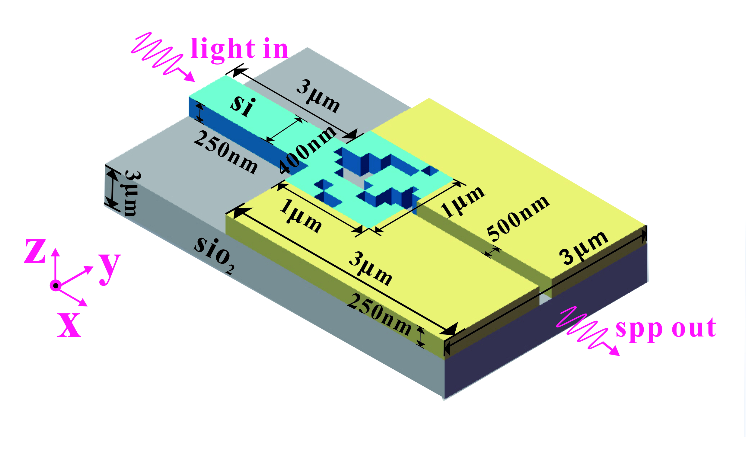
Figure.1 Schematic of the PPS.
As shown in Fig. 1, we propose a programmable plasmonic structure which consists of a strip insulator (air) waveguide and Au-based coding metamaterials (ACM). All waveguides are placed in an Au substrate to form the metal–insulator–metal (MIM) waveguide structure which supports surface plasmon mode. Here, the ACM whose footprint is 400×400 nm² and composition is M×N square pixels are placed parallel with the strip waveguide. Each pixel in the ACM can be selectively filled by Au or air, corresponding to the logical “0” or “1” state, respectively. Obviously, the ACM provides a relatively broad optimization space which can realize different types of photonic devices. The length and width of the input insulator waveguide which transmits the TM/TE mode polarized light are 620 nm, 300 nm respectively. The TM/TE mode in the insulator waveguide can be coupled into the ACM partially and then be coupled back into the insulator waveguide. The mode coupled back will interfere with the original mode causing a specific transmission spectrum. In our simulation, the transmission spectrum of the PPS is calculated by the 2-dimensional finite-difference time-domain (FDTD) method (adopting Lumerical MODE Solutions). The metal in the FDTD simulation is modeled by the Drude model with (ε∞, ωp, γp) = (3.7, 9.1 eV, 0.018 eV) [18]. It should be noticed that the transmission loss of the MIM waveguide is calculated by placing several monitors in the waveguide. All the transmission spectrums in our simulation are calculated from 800nm to 1700nm which is in the near infrared region.
As we mentioned, the PPS must have a relatively broad optimization space to support various types of photonic devices. Figure. 2 shows that our PPS has various possibilities for transmission spectrum. In this simulation, our ACM whose composition is 8×8 square pixels means that the PPS has a optimization space with 2⁶⁴ possibilities which is enough to achieve several types of photonic devices. We noticed that those transmission spectrums reveal that the PPS can be designed as four types of filters which are important and basic in integrated optical circuits from Fig. 2(a) to (d). But these spectrums are generated with random PPS structure which means the performance metrics can be improved and optimized.
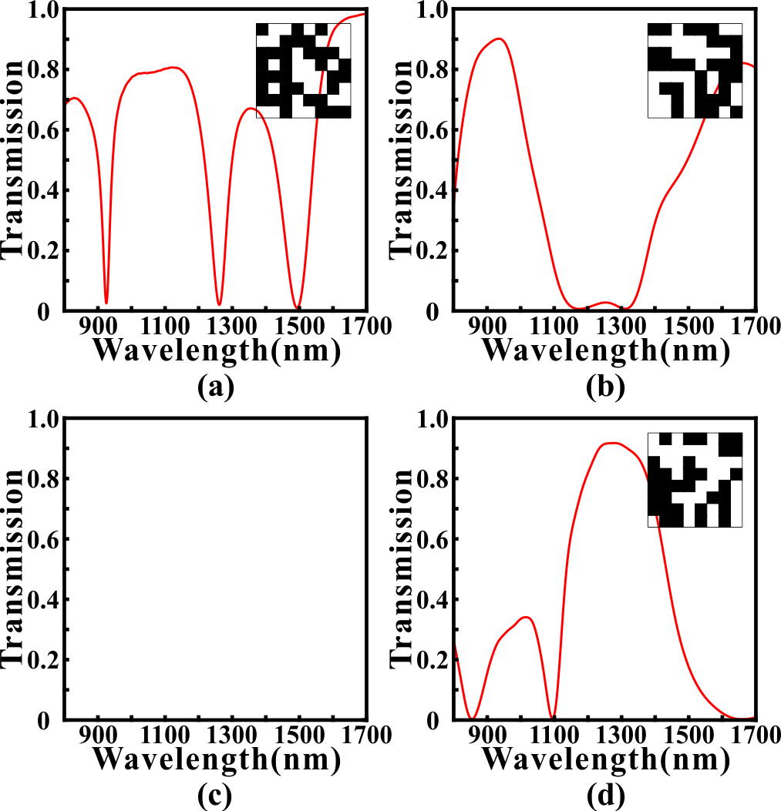
Fig. 2. The random calculated results with different ACM distributions. (a) Transmission spectrum which resembles narrowband bandstop filter (NBSF). (b) Transmission spectrum which resembles broadband bandstop filter (BBSF). (c) Transmission spectrum which resembles narrowband bandpass filter (NBPF). (d) Transmission spectrum which resembles broadband bandpass filter (BBPF).

Multifunctional photonics devices
- Multifunctional Filter
In section II, we have proved that PPS have a relatively broad optimization space as our requirement. Based on this, we expect to improve and optimize specific types of transmission spectrums which have basic embryonic forms. For example, we want to design a NBSF in 1300nm center wavelength with 20nm 3dB bandwidth but we do not know how to pick up the corresponding distribution for ACM. A simple and effective way is to use the global search algorithms. There are several common global search algorithms for inverse design and optimizing photonic devices. In fact, they perform well in this situation.
GA and PSO are two typical gradient free methods which are inspired by the biological evolution and natural selection. They have been applied in optimizing various photonics devices due to their simplicity and effectiveness [19]. It’s apparent that our core task is designing and optimizing the pixels’ distribution in our ACM which is considered as binary number 0 or 1. GA is a highly parallel, random and adaptive optimization algorithm based on the theory of evolution which encodes problems into genes to achieve evolution and convergence. Because of the complexity of gene coding, we often use binary coding as a simplification which is suitable with our structure in ACM. The algorithmic details of GA we used are outlined as follows: (i) randomly generating an initial population consisted of N=50 individuals. Here, each individual in the initial population represents a distribution of ACM whose pixels are randomly initialized as “1” or “0” state. And N is the scale parameter of the population which is important for the convergence speed and performance. (ii) For all N ACMs, the transmission spectrums are calculated by using the FDTD method. The Euclidean distance between simulated transmission spectrum and target transmission spectrum is defined as the optimization objective function(loss) for GA which determines whether an individual is eliminated or not in the evolution. (iii)Trying to generate a new population by using the selection, crossover and mutation procedures. In the selection process, two parent individuals are selected from previous generation based on the roulette-wheel selection with gap selection ratio 0.9 [20]. In the crossover process, the selected ACMs cross over to generate a new ACM based on the uniform crossover method with a crossover probability of 0.3. In the mutation process, each pixel in the ACM has 3% probability to flip from 0 (1) to 1 (0). (iv) The newly generated ACMs are evaluated to determine the GA whether to stop or not. If the genetic generation reaches to 100 or the value of optimization objective function remains unchanged for more than 30 times, then GA stops, otherwise, proceeds to Step (ii).
Compared with GA, PSO is a random search algorithm based on group cooperation, which is developed from foraging behavior of birds. In PSO, each solution of the optimization problem is a “bird” in the search space while we call it “particle”. All particles have a fitness value determined by the optimization objective function which is same in GA, and each particle has a speed that determines the direction and distance for their flight. It should be noticed that the standard PSO is suitable for the decimal rather than binary number so that the discrete binary PSO (DBPSO) rather than the standard PSO is used to optimize the ACM. In the DBPSO, the calculation method for the velocity is as same as the standard PSO. But the velocity of the standard PSO directly affects the position of particle, while that of DBPSO is converted to a flip probability based on the sigmoid function [21]. Then, this flip probability determines whether the pixels in ACMs are changed or not. The speed range, inertia weight and acceleration constants of the DBPSO in this article are set as -1~1, 1, and c1=c2=1.49, respectively.
SA is a typical search algorithm which imitates the physical annealing in the quenching based on Monte Carlo iterative solution strategy [22]. At the initial stage, SA searches for the solution in a broad optimization space by accepting a worse solution with a certain probability. It can alleviate the local optima problem to some extent [23]. As the temperature decreases, the solution changes in a small range to speed up the convergence of SA. Here, in each iteration, ACM is randomly generated by GA tool’s mutation process and simulated by using the FDTD method. The objective function (Euclidean distance) is evaluated to determine the newly generated ACM whether to accept with an acceptance probability determined by the Metropolis criterion [24]. Here, the maximum and minimum of the temperature for the SA are set as 2000 and 1e-18, respectively. It should be noticed that the iteration times depends on the rate of temperature’s decrease which is used with 0.98 in our simulation. Direct-Binary search algorithm is a nonlinear search algorithm based on the binary tree whose left subtree and right subtree are constructed with state “0” and “1” respectively. After the start of the search, each pixel is traversed in turn, and the branch with the smaller value of optimization objective function is selected and then fixed each time. It should be noticed that the optimal solution we got will only approach to the direction of convergence in this selection process, so there will be no oscillation and rebound for the value of optimization objective function. Here, we proposed a novel method to further improve the search extent and performance. After traversing all pixels once, we start the traversal again. The reason for this is that when the first pixel in ACM is being selected to be fixed to state “0” or “1”, other pixels are in a certain state. After the first traversal, the distribution of ACM may have changed and some of the pixel states have been reversed. Therefore, if the state of the first pixel is reversed again, the calculated transmission spectrum of the new structure may be better. Moreover, our algorithm ensures that the performance will not degrade in multiple traversal. This improved algorithm is called multi-traversal DBS (MDBS). It should be noticed in this article that if the traversal times reaches 50 or the value of optimization objective function remains unchanged for more than 10 times, then MDBS stops.
We use GA, DBPSO, SA and MDBS to optimize the ACM to realize NBSF to prove their availability and effectiveness. Here, the ACM is composed of 8×8 pixels. The target central wavelength of BSF is 1300nm and the target full width at half maximum (FWHM) in transmission spectrum is 20nm. And the linetype of target spectrum is Gauss function. In some situations, the gate function also is used. The calculated results are shown in Fig. 3.
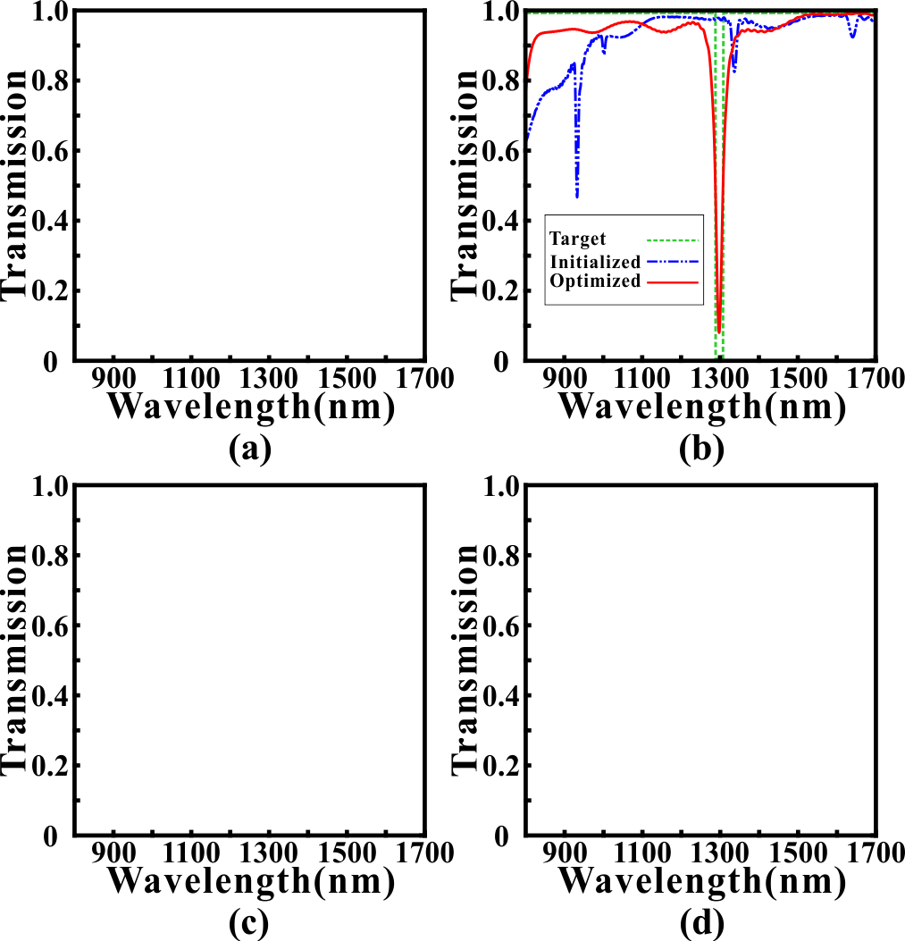
Fig. 3. (a) The simulated transmission spectrum after MDBS optimization. (b) The simulated transmission spectrum after GA optimization. (c) The simulated transmission spectrum after DBPSO optimization. (d) The simulated transmission spectrum after SA optimization. Green dotted line is the target spectrum. Blue solid line is the randomly initialized spectrum. Red solid line is the optimization spectrum.
It can be found that the transmission spectrums after the four methods' optimization have a notable improvement because the optimized transmission spectrums are very close to the targeted transmission spectrum comparing with the randomly initialized spectrum. The minimum transmittances in stopband are reduced to 0.0256, 0.1592, 0.0922 and 0.1029, respectively. And the central wavelengths and FWHMs for BSF are 1300nm, 1300.5nm, 1302nm and 1295nm, and 7.5nm, 12nm, 9nm and 9.5nm, respectively. Moreover, the extinction ratios between stopband and passband are 15.5dB, 7.8dB, 10.1dB and 9.6dB, respectively. Obviously, we can confirm that the optimization methods are efficient and robust in our design task and the ACM in PPS has strong plasticity to realize specific functions. It should be noticed that all optimization algorithms are convergent (effective) but the GA can inhibit the fluctuation in sideband better and use less time. Usually, GA can get quite good performance only after once or twice execution and the results have more similar performance. Here, we give the field distributions of the NBSF which corresponds to MDBS's optimization as a demonstration in Fig. 4. We find that the performance of transmission spectrum corresponds well with the electromagnetic field distributions and structure of ACM, which shows that our methods play a substantial role in design process.
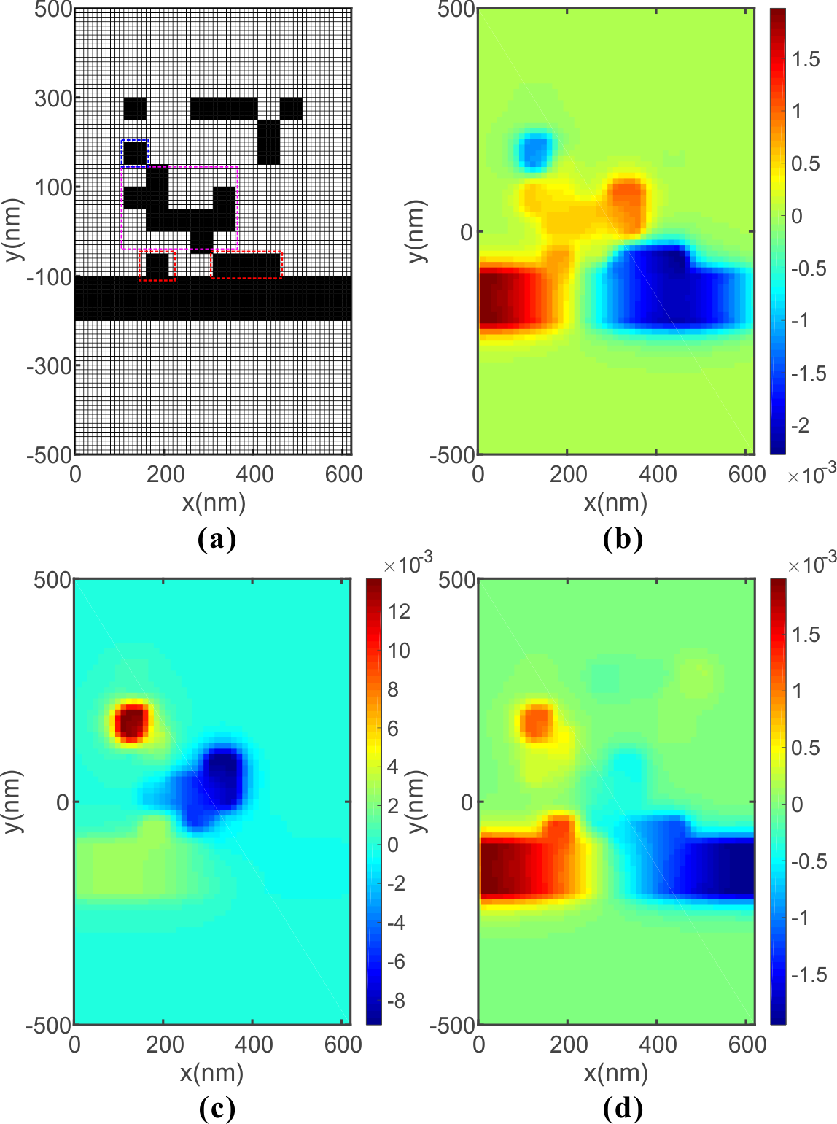
Fig. 4. (a) The distribution of ACM and PPS for NBSF, (b) Distribution of the real part of the magnetic field H_{z} at 1100nm, (c) Distribution of the real part of the magnetic field H_{z} at 1300nm (d) Distribution of the real part of the magnetic field H_{z} at 1500nm.
First, we notice that the SPPs only can coupled into ACM through the pixels which are directly connected with the strip waveguide. In this situation, the pixels are framed with red lines. At the short wavelength of the stopband of 1100nm, SPPs leaks into ACM marginally and does not form a stable resonance mode so SPPs passes through with little loss. As the wavelength increases to 1300nm, SPPs starts a unique resonance mode in ACM. Here, this resonant cavity is not regular which consists of an independent pixel cavity and a L-shaped cavity. When the SPPs in the resonator is coupled back into the strip waveguide, the phase is opposite so we get destructive interference and high loss transmission .As the wavelength continues to increase, the resonance mode is destroyed so it is restored to low loss transmission.
Next, we use GA to design other three types of filters, BBSF, BBPF and NBPF as a demonstration because of GA's higher efficiency. The calculated results are shown in Fig. 5.
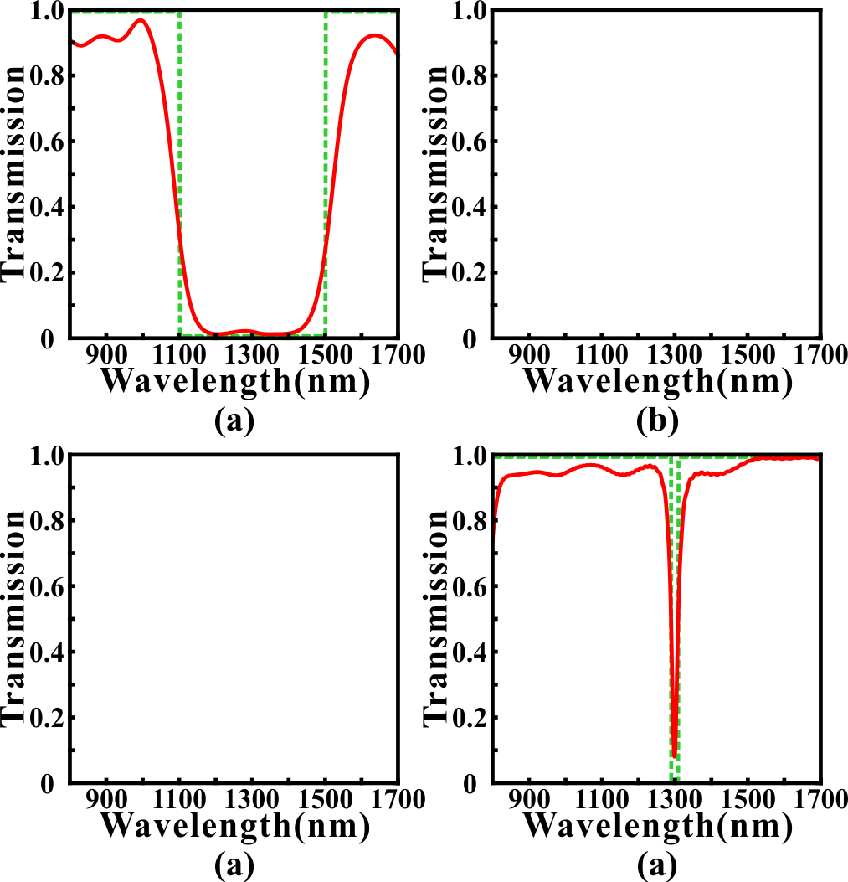
Fig. 5. The simulated transmission spectrums for (a) BBSF (b) BBPF (c) NBPF after GA optimization. (d) The contrast result in NBSF.
Fig. 4(a) shows the optimized transmission spectrum for BBSF which have a broad stopband from 1100nm to 1500nm. The transmittance is less than 0.2 in the stopband and higher than 0.8 in the sideband. Compared with the NBSF, the stopband is not smooth, we think one of the reason is that our ACM is not a symmetric structure after optimization. Fig. 4. (b) shows the optimized transmission spectrum for BPSF. The transmittances exceed 0.7 mostly from 1100nm to 1500nm and the transmittances in stopband is less than 0.3 mostly. In addition, we got a NBPF whose 3dB bandwidth is 166.5nm in Fig. 4(c). The max transmittance reaches 0.9007 in 1297nm which has a 3nm deviation from 1300nm and the transmittances are less than 0.2 mostly in stopband. Obviously, the bandwidth in NBPF can not be controlled as small as NBSF and the sideband inhibition performs worse in band pass filter. The reason is that the strip insulator (air) waveguide supports a surface plasmon polaritons mode from 800nm to 1700nm with wholly low loss if we don't add the ACM with it. In other words, the function of ACM is to inhibit the transmissivity for partial specific wavelength so the BSF can be achieved simpler and have better performance than BPF.
Next, we will discuss two issues that run through the optimization task. Firstly, it's clear that an important factor determining the final optimization performance is to narrow the gap between the simulation spectrum and the target spectrum as much as possible. Here, we proposed a simple but effective method named weighting operation to improve the performance metrics.
As we proposed, we use the Euclidean distance between the simulated spectrums and the target spectrums as the optimization objective function (loss). Here, we use a weighting factor to weight the Euclidean distance. The details are outlined as follows: (i) dividing the transmission spectrums into two parts according to importance. (ii) One part is called "center" which represents the waveband of stopband and passband or the waveband we focused on. The other part is called ''else'' which has no significant impact on our target performance metrics. (iii) In each iteration, we calculate the optimization objective function by the following formula:
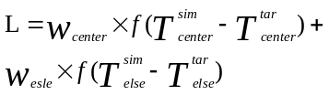 (2)
where the w_{center} is the weighting factor for "center" and the w_{else} is for "else". The function f represents calculating Euclidean distance. And the Tsim center represents the simulated transmittances in "center" waveband. The rest is similar as well.
For example, we use GA method to design and optimize a NBSF with 20nm bandwidth in 1300nm central wavelength. Here, the ACM is composed of 8×8 pixels. The "center" is the waveband form 1290nm to 1310nm, and the rest of the waveband belongs to "else". In Fig. 5, we compared the optimized results for this design with several sets of different weight settings.
In Fig. 5(b), we observe that the loss value in each setting has an obvious convergence. The loss decreases from 3.05 to 2.21 with 27.54% decline when w_{else} = 0.1, 5.39 to 2.37 with 56.23% decline when w_{else} = 0.2, 7.57 to 3.34 with 55.88% decline when w_{else} = 0.5 and 12.56 to 5.45 with 56.61% decline when w_{else} = 1.0. Because of the weighting factor and waveband distribution, the loss value with smaller factor is always less. However, it can be found that the minimum transmittance is only 0.5770 in w_{else} = 1.0 which still is large to achieve a filtering well even it has a steep and quick convergence in loss value. With w_{else} diminishing, it can be found that the minimum transmittance decreases to 0.1299, 0.0955 and 0.0248, respectively. On the other hand, we notice that the sideband has more violent fluctuations when w_{else} decreases. And if we take 0 as the reference value of the minimum transmittance of BSF, we can find that the bandwidth becomes wider as w_{else} decreases. The reason for this phenomenon is the contribution of the waveband in "else" becomes weak to loss value as w_{else} decreases so the influence of the fluctuations in "else" waveband is "smoothed" in the process of evolution. At the same time, the significance of the "center" waveband is amplified equivalently so we get smaller minimum transmittance. In this paper, we usually use a weighting factor of w_{else} = 0.5 which is balanced between bandwidth and minimum transmittance in most cases.
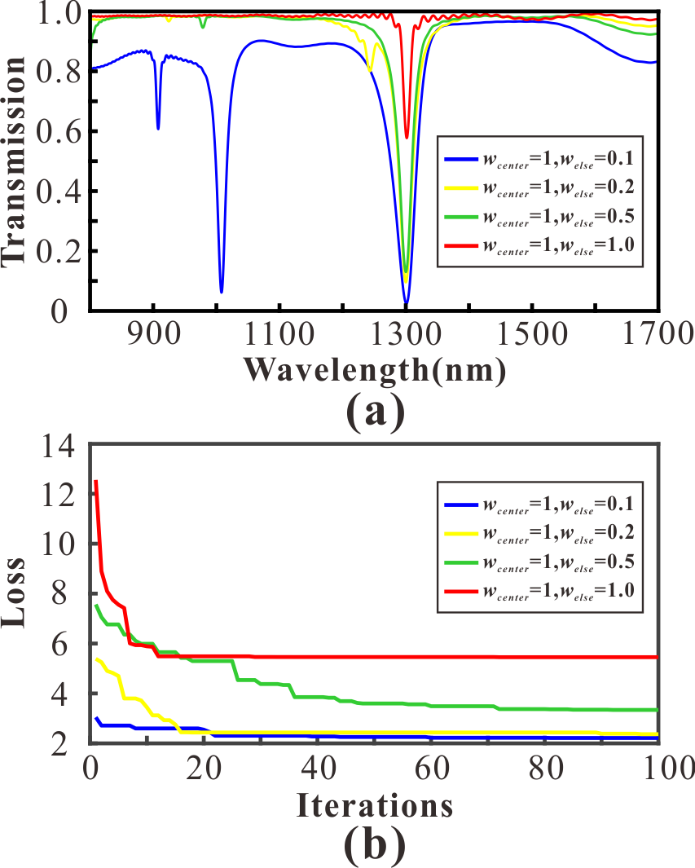
Fig. 5. (a) The optimized transmission spectrums for NBSF in different weight settings (b) The variation of loss values in different weight settings.
Then, another important factor is the density of pixels in the ACM. We emphasize that the diversity of the transmission spectrums of the ACM determines the functions which can be realized. Theoretically, the possibilities of the permutation and combination of ACM grow exponentially as the density of pixels increasing. Although the methods we used in this paper is suitable for global optimization task but not infinitely. Therefore, it is necessary to choose an appropriate density of ACM which can not only ensure the diversity of functions, but also improve the efficiency of the algorithms. Here, we use all four methods to optimize a NBSF with 20nm bandwidth in 1300nm central wavelength. In Fig. 6, we exhibit the optimized results in four different densities 5×5, 8×8, 10×10 and 20×20, respectively.
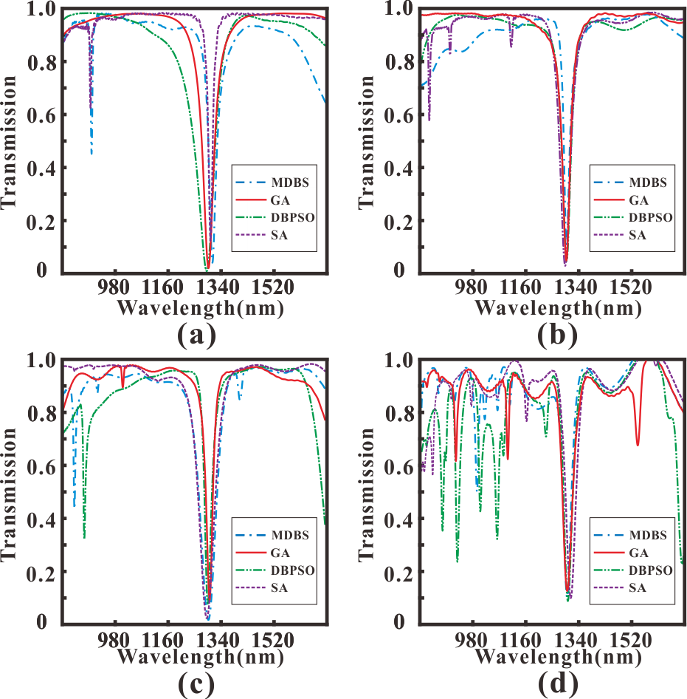
Fig. 6. The optimized results for NBSF in four different algorithms with (a) 5×5 pixels (b) 8×8 pixels (c) 10×10 pixels (d) 20×20 pixels.
The performance metrics in four densities are shown in Table I to Table IV. Here, L_{c} is the center wavelength. T_{min} is the minimum transmittance at L_{c}. And 3dB bandwidth is bandwidth which increases by 3dB from T_{min}. It can be found that the center wavelength offset, minimum transmittance and 3dB bandwidth in 20×20 pixels perform inferiority comparing with others. In addition, the fluctuations in sideband are violent in all four methods which restricts the using band of filter. The reason is that the higher the pixel density is, the more irregular the structure is. In other words, simple transmission spectrums depend on regular symmetric structures which are difficult and unpredictable to organize in 20×20 pixels. Moreover, one single simulation will spend several times than others because of the complexity increasing. In other cases, the difference of performance metrics is not obvious. Compared with 5×5 pixels and 10×10 pixels, the sideband inhibition is better and the metrics have an equilibrium after four methods' optimization in 8×8 pixels. Although 3dB bandwidth and minimum transmittance are more competitive in 5×5 pixels but center wavelength offset is large which limits the precision of tunability. Therefore, we choose 8×8 pixels to achieve most optimization tasks considering diversity and computational efficiency which perform well in this paper.
Table I
Performance parameter in 5×5 pixels
Methods | L_{c}(nm) | T_{min} | 3dB bandwidth(nm)
MDBS | 1311 | 0.0358 | 6.5
SA | 1305 | 0.1199 | 8
DBPSO | 1291.5 | 0.0037 | 5
GA | 1297.5 | 0.0150 | 6.5
Table II
Performance parameter in 8×8 pixels
Methods | L_{c}(nm) | T_{min} | 3dB bandwidth(nm)
MDBS | 1300.5 | 0.1055 | 9.5
SA | 1296 | 0.0245 | 7.5
DBPSO | 1300.5 | 0.0432 | 8.5
GA | 1300 | 0.0443 | 8
Table III
Performance parameter in 10×10 pixels
Methods | L_{c}(nm) | T_{min} | 3dB bandwidth(nm)
MDBS | 1299 | 0.0143 | 9
SA | 1293.5 | 0.0212 | 10.5
DBPSO | 1297 | 0.0762 | 9.5
GA | 1303.5 | 0.0903 | 9.5
Table IV
Performance parameter in 20×20 pixels
Methods | L_{c}(nm) | T_{min} | 3dB bandwidth(nm)
MDBS | 1299.5 | 0.0974 | 12.5
SA | 1312.5 | 0.0970 | 15.5
DBPSO | 1302 | 0.0856 | 12.5
GA | 1300 | 0.1238 | 18

- PIT effect
Next, we use GA to achieve PIT-like effect in our PPS which has great applications in ultrafast optical signal processing, optical data storage and microwave photonics. Here, the ACM is composed of 8×8 pixels and the target full width at half maxima (FWHM) of the transmission peak in stopband is 20nm. Fig. 8 shows the calculated results after optimization. In Fig. 8(a), we got a PIT-like peak in 1297nm. The peak value is 0.7115 and the valley values are 0.0084 and 0.0086, respectively. The Q-factor which is an important parameter to evaluate the performance of the PIT-like effect is calculated by the following formula:
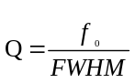 (1)
where the f₀ is the frequency of maximum transmission at the PIT window, and the FWHM is the full width at half maximum. In this optimization, the FWHM is 35.5nm and the Q-factor reaches 36.54 in near infrared waveband. However, the Q-factor is lower in the metallic systems due to ohmic damping[Comparison of Electromagnetically Induced Transparency Performance in Metallic and All-dielectric Metamaterials]. What's more, we do not need any energy to consider the PIT coupling relation which is difficult and incomprehensible in inverse design. We can spend more time to improve the performance by using more powerful constraint conditions or efficient algorithms which are easier.
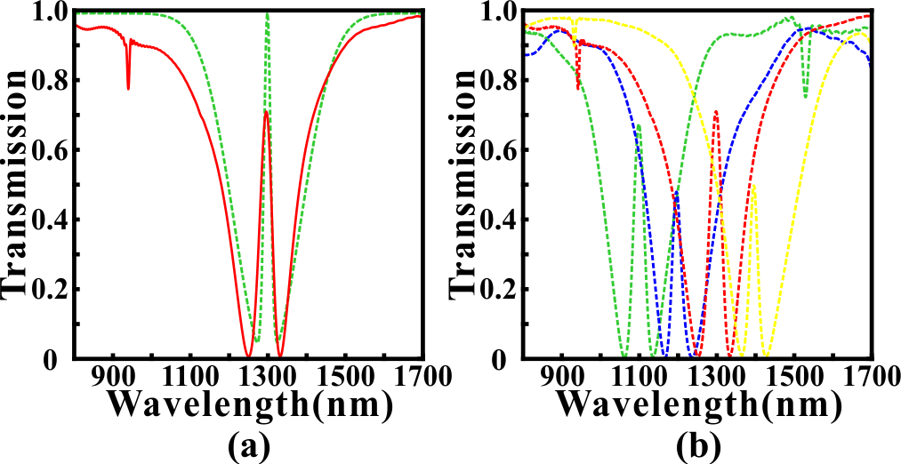
Fig. 8. (a) The simulated PIT-like transmission spectrum in 1300nm (b) Tunable PIT-like effect for different center wavelength
As we mentioned, one of the most competitive advantages of PPS is tunability. The Fig. 8(b) shows the tunable PIT-like effect with different center wavelengths only by adjusting the target function before optimization. It can be found that the PIT peaks are 1098nm, 1195nm and 1395nm, respectively. The maximum deviation is only 5nm. Then the corresponding FWHMs and Q-factors are 31.5nm, 27nm and 24nm, respectively and 34.86, 44.26 and 58.13, respectively. Lastly, the extinction ratio is 19.27dB and 19.19dB for 1098nm, 20.52dB and 18.93dB for 1195nm, 16.55dB and 18.22dB for 1395nm. Obviously, the optimization performances are well-matched for all PIT peaks which proves that our optimization methods and structure have strong universality and plasticity. Actually, we can get arbitrary PIT peaks in this wave band from 900nm to 1600nm and the tunability is adaptive for all types of device in this article.
Then we

CONCLUSION
In conclusion, we propose a novel PMC to effectively perform the mode conversion between the TE/TM mode in a silicon waveguide and the SPPs mode in a plasmonic waveguide. And several different optimization algorithms, such as GA, DBPSO, SA and DBS, are applied in the design of the SCM in the PMC to improve the performance metrics. The FDTD simulated results demonstrate that the PMC optimized by MDBS can perform polarization-invariant conversion, and the conversion efficiency and bandwidth reach more than 0.93 and 200 nm, respectively. Compared with previous articles, our proposed PMC designed by the optimization algorithms has superiority in conversion efficiency and bandwidth.
References
[1] D.K. Gramotnev and S.I. Bozhevolnyi, "Plasmonics beyond the diffraction limit," Nat. Photonics 4, 83-91 (2010).
[2] T. Zhang, L. Chen, and X. Li, "Graphene-based tunable broadband hyperlens for far-field subdiffraction imaging at mid-infrared frequencies," Opt. Express 21, 20888-20899 (2013).
[3] H. Li and te al, "Investigation of the graphene based planar plasmonic filters," Appl. Phys. Lett. 103, 211104 (2013).
[4] T. Zhang, X. Yin, L. Chen, X. Chen, "Ultra-compact polarization beam splitter utilizing a graphene-based asymmetrical directional coupler," Opt. Lett. 41(2), 356-359 (2016).
[5] W. Chang and et al, "A plasmonic fano switch," Nano Lett. 12(9), 4977-4982 (2012).
[6] A. Melikyan and et al, "High-speed plasmonic phase modulators," Nat. Photonics 8, 229-233 (2014)..
[7] X. Xiong and et al, "Broadband plasmonic absorber for photonic integrated circuits," IEEE Photon. Techno. Lett. 26(17), 1726-1729 (2014).
[8] D. Rodrigo and et al, "Mid-infrared plasmonic biosensing with graphene," Science 349(6244), 165-168 (2015).
[9] T. Zhang and et al, "Plasmon induced absorption in a graphene-based nanoribbon waveguide system and its applications in logic gate and sensor," J. Phys. D: Appl. Phys. 51, 055103 (2018).
[10] Y. Fang and M. Sun, "Nanoplasmonic waveguides: towards applications in integrated nanophotonic circuits," Light-Sci Appl. 4, e294 (2015).
[11] A. Melikyan and et al, "Photonic-to-plasmonic mode converter," Opt. Lett., 39(12), 3488 (2014).
[12] J. Lin and et al, "Polarization-controlled tunable directional coupling of surface plasmon polaritons," Science, 340(6130), 331-334 (2013).
[13] B. Zhu and H. Tsang, "High coupling efficiency silicon waveguide to metal–insulator–metal waveguide mode converter," Journal of Lightwave Technology, 34(10), 2467-2472 (2016).
[14] C. Chen and et al, "Design of highly efficient hybrid Si-Au taper for dielectric strip waveguide to plasmonic slot waveguide mode converter," Journal of Lightwave Technology, 33(2), 535-540 (2015).
[15] S. Molesky and et al, "Inverse design in nanophotonics," Nat. Photonics 12, 659-670 (2018).
[16] T. Zhang and et al, "Efficient spectrum prediction and inverse design for plasmonic waveguide systems based on artificial neural networks," Photonics Research 7(3), 368-380 (2019).
[17] T. W. Hughes and et al, "Adjoint method and inverse design for nonlinear nanophotonic devices," ACS Photonics 5, 4781-4787 (2018).
[18] T. Zhang and et al, "Inverse design and optimization of graphene metamaterial for multi-peak plasmon induced transparency based on machine learning and evolutionary algorithms," arXiv:1908.01354 (2019).
[19] B. Shen and et al, "An integrated-nanophotonics polarization beamsplitter with 2.4 × 2.4 μm² footprint," Nat. Photonics 9, 378-382 (2015).
[20] T. Zhang and et al, "Efficient training and design of photonic neural network through neuroevolution," arXiv:1908.08012 (2019).
[21] L. Chuang and et al, "Improved binary PSO for feature selection using gene expression data," Comput. Biol. Chem. 32(1), 29-38 (2008).
[22] S. Kirkpatrick and et al, "Optimization by Simulated Annealing," Science 220(4598), 671-680 (1983).

