Abstract—We propose a programmable multifunctional plasmonic waveguide system (PMPWS) based on coding metamaterials and inverse design. Several types of plasmonic devices are realized using the common architecture which avoids designing different structures of resonator for each requirement. Based on genetic algorithm (GA), particle swarm optimization (PSO), multi-traversal direct-binary search (MDBS) and simulated annealing (SA), the narrowband filters optimized can reach only 7.5nm bandwidth and 173.33 quality factor. Apart from the simple filtering functions, the architecture can also realize relatively complex transmission spectrums such as plasmon-induced transparency (PIT), wavelength tunable PIT and dual PIT. The PMPWS we proposed not only has quality plasticity and expansibility but also has compact footprint with 400×400 nm² which is advantageous for integration so it is expected to applied in highly integrated optical circuits.
Multifunctional and Programmable Plasmonic Waveguide System based on Inverse Design and Coding Metamaterials
Yihang Dan, Tian Zhang, Xu Han, Jian Dai, and Kun Xu
Index Terms—Inverse design, plasmonic, photonic devices.

I. INTRODUCTION
Surface plasmon polaritons (SPMPWS) is a kind of especial electromagnetic wave which occurs and propagates at the interface of metal and dielectric and it carries energy and information overcoming the diffraction limit [1]. The appearance of SPMPWS provides a new way to manipulate light at the nanoscale so it is considered to be the most potential way to realize highly integrated optical system in the future [2]. Since SPMPWS has been discovered, researchers have studied different ways to excite SPMPWS like grating excitation [3], prism coupling [4,5], waveguide mode coupling [6], end-fire coupling [7] and local excitation [8]. Their transmission depends on special waveguide systems like metal-insulator-metal (MIM) waveguide [9], insulator-metal-insulator waveguide (IMI) [10], metamaterial [11] and so on. Due to their compact footprint for integration, SPMPWS waveguide systems have been widely studied and used to realize filter [12, 13], splitter [14,15], switch [16,17], modulator [17,18], absorber [19], sensor [20], coupler [21,22], logic device [23] and so on. However, researchers spend much time searching and designing specific resonators or waveguide structures to realize different functions and improve performance [24-26]. For example, plasmon-induced transparency (PIT) has become a hot spot in SPMPWS field owing to its applications in refractive index sensor and slow light which is the key technology to realize controllable optical delay and all-optical cache, which can be applied to ultrafast optical signal processing, optical data storage and microwave photonics [27,28]. In order to realize PIT, various structures of waveguide systems have been proposed like dual ring resonator [29], series of stub resonator [30], T-shaped resonator [31], U-shaped resonator [32], ring-resonators [33], side-coupled with multiple cavities [34-37] and so on. In fact, it’s cumbersome and inefficient to construct different structures for each requirement. We hope that there is an elastic programmable system which can realize multiple functions in one same framework for reducing repetitive works. As a general architecture, artificial neural networks (ANNs) have been widely used in many fields because of the potential adjustability of networks and the support from algorithms. Here, we can get some inspiration from ANNs. First of all, we construct a reconfigurable waveguide system with complex solution spaces to ensure the variety to achieve multiple functions. Then, effective algorithms are used to search the optimal solution in the solution spaces for each requirement. Here, the method named inverse design is suitable for this task.
In general, there are three methods for inverse design and photonic devices optimization: gradient based method, gradient free method and model-based method [38,39]. As a representative method of the gradient based methods, adjoint variable method (AVM) can optimize the linear and nonlinear optical devices, but it needs physical background to derive the gradient of objective function [40]. Model based methods such as ANNs and random forests are also used for inverse design [39,41]. However, a lot of original datas and labels are necessary to train the model to remember the physical relationship between the output electromagnetic responses and the input parameters which consumes too much time. And the optimization performance is highly dependent on the effect of pre-training. Compared with the model-based method, the gradient free method based on search strategy or evolution strategy is simple and effective, which do not need to know the internal relationship between input and output in advance but directly search for the optimal solution by iteration and evolution. Genetic algorithm (GA) and particle swarm optimization (PSO) are two typical evolution algorithms which have good global search ability inspired by genetic inheritance and group cooperation. They have been widely used to optimize and design photonic device [42-47], However, their local search ability is relatively poor so it is easy to fall into local optimal solution. And simulated annealing (SA) and direct-binary search (DBS) are typical search algorithms which are fast to converse [48,49]. But these two algorithms are sensitive to initial state and parameters, so it is difficult to obtain the optimal solution one time.
In this paper, we propose a novel programmable multifunctional plasmonic waveguide system (PMPWS) based on coding metamaterials. Then, four improved gradient free algorithms are used to configure the coding metamaterials of PMPWS to realize multiple plasmonic devices. Meanwhile, we further improve the optimization performance of these plasmonic devices by introducing weighting operation. Especially, the narrowband filters we optimized can reach only 7.5nm bandwidth and 173.33 quality factor. Moreover, each type of plasmonic device is wavelength tunable which is advantageous in highly integrated optical circuits.

II. Device design and simulation results
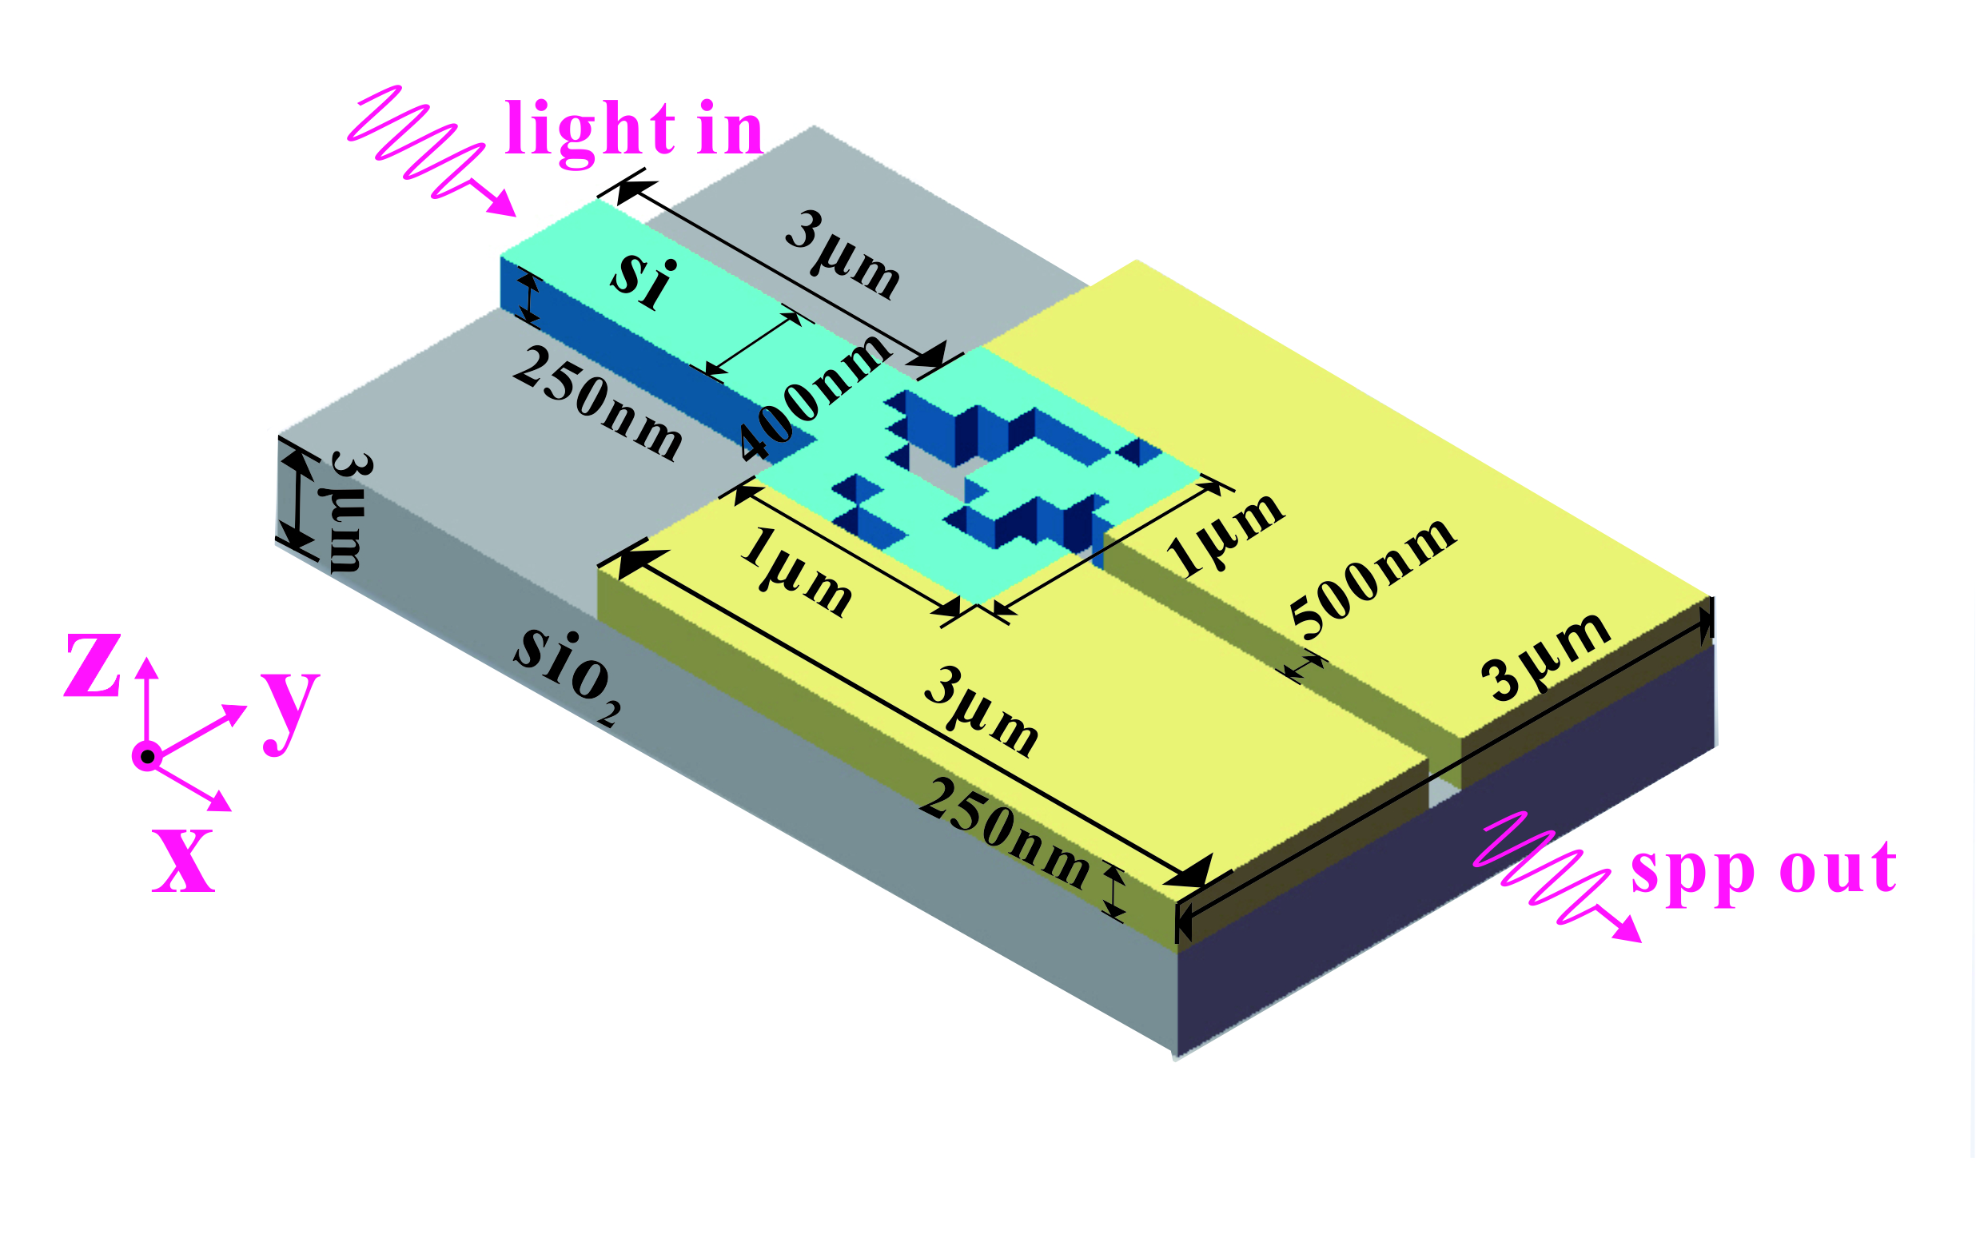
Figure.1 Schematic of the PMPWS.
As shown in Fig. 1, we propose a novel programmable multifunctional plasmonic waveguide system (PMPWS) which consists of a strip insulator (air) waveguide and Ag-based coding metamaterials (ACM). All waveguides are placed in an Ag substrate forming the MIM waveguide system which supports PMPWS. Here, the ACM whose footprint is 400×400 nm² and composition is M×N square pixels are placed parallel with the strip waveguide. Each pixel in the ACM can be selectively filled by Ag or air, corresponding to the logical “0” or “1” state, respectively. Obviously, the ACM provides a relatively broad programming space which can realize different types of photonic devices. The length and width of the input strip waveguide which transmits the TM mode polarized light are 620 nm, 100 nm respectively. The TM mode in the strip waveguide can be coupled into the ACM partially and then be coupled back into the strip waveguide. The mode coupled back will interfere with the original mode causing absorption peaks or transmission peaks in spectrums. In our simulations, the transmission spectrums are calculated by the 2-dimensional finite-difference time-domain (FDTD) method (adopting Lumerical MODE Solutions). The metal in the FDTD simulation is modeled by the Drude model with (ε∞, ω_{p}, γ_{p}) = (3.7, 1.37×10¹⁶Hz, 2.7×10¹³Hz) [xx]. It should be noticed that the transmission loss of the PMPWS is calculated by placing several monitors in the simulation space. All the transmission spectrums in our simulation are calculated from 800nm to 1700nm which is in the near infrared region.
As we mentioned, the PMPWS must have a relatively broad programming space to support various photonic devices. Several different kinds of transmission spectrums are shown in Figure. 2. In this simulation, our ACM whose composition is 8×8 square pixels reveals that the PMPWS has a programming space with 2⁶⁴ distributions although some distributions are useless and repetitive. We noticed that those transmission spectrums can be designed as four types of filters which are basic but important in integrated optical circuits from Fig. 2(a) to (d). Meanwhile, these spectrums are calculated with random ACM distributions which means the performance metrics can be improved and optimized.
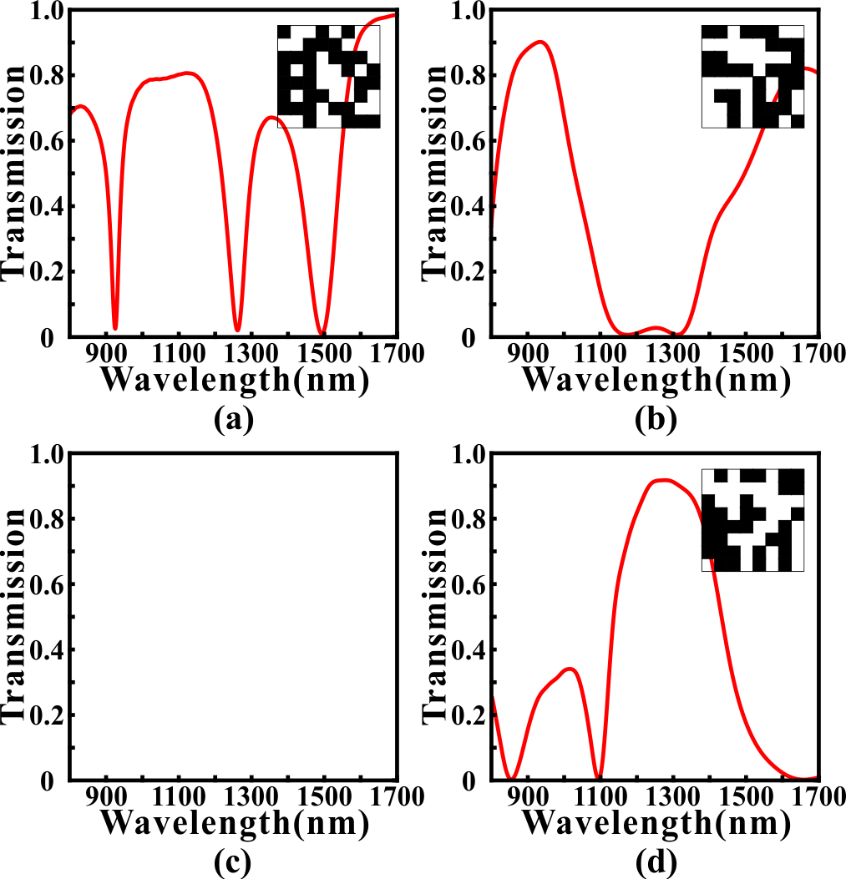
Fig. 2. The calculated results with random different ACM distributions. (a) Transmission spectrum which resembles narrowband bandstop filter (NBSF). (b) Transmission spectrum which resembles broadband bandstop filter (BBSF). (c) Transmission spectrum which resembles narrowband bandpass filter (NBPF). (d) Transmission spectrum which resembles broadband bandpass filter (BBPF).

Multifunctional photonics devices
- Multifunctional Filter
In section II, we proved that PMPWS has potential as our requirement to design multifunctional plasmonic devices. Based on this, we expect to improve and optimize these transmission spectrums which have basic embryonic forms to realize high performances. For example, we need to design a NBSF at 1300nm center wavelength with 20nm 3dB bandwidth but we don't know how to pick up the corresponding embryonic distribution of ACM. Here, a simple and effective way is using the global search algorithms. There are several common global search algorithms for inverse design and optimizing photonic devices. In fact, they perform well in this situation.
GA and PSO are two typical gradient free methods which are inspired by the biological evolution and natural selection. They have been applied in optimizing various photonics devices due to their simplicity and effectiveness [xx]. It’s apparent that our core task is designing and optimizing the distribution of ACM which is considered as binary number 0 or 1. GA is a highly parallel, random and adaptive optimization algorithm based on the theory of evolution which encodes problems into genes to achieve evolution and convergence. Because of the complexity of gene coding, we often use binary coding as a simplification which is suitable for ACM. The algorithmic details of GA we used are outlined as follows: (i) randomly generating an initial population consisted of N=50 individuals. Here, each individual in the initial population represents a distribution of ACM whose pixels are randomly initialized as “1” or “0” state. And N is the scale parameter of the population which is key factor for the convergence speed and optimization performance. (ii) For all N ACMs, the transmission spectrums are calculated by using the FDTD method. The Euclidean distance between simulated transmission spectrum and target transmission spectrum is defined as the optimization objective function (loss) for GA which determines whether one individual is eliminated or not in the evolution. (iii)Trying to generate a new population by using the selection, crossover and mutation procedures. In the selection process, two parent individuals are selected from previous generation based on the roulette-wheel selection with gap selection ratio 0.9 [20]. In the crossover process, the selected ACMs cross over to generate a new ACM based on the uniform crossover method with a crossover probability of 0.3. In the mutation process, each pixel in the ACM has 3% probability to flip from 0 (1) to 1 (0). (iv) The newly generated ACMs are evaluated to determine the GA whether to stop or not. If the genetic generation reaches to 100 or the value of optimization objective function remains unchanged for more than 30 times, then GA stops, otherwise, proceeds to Step (ii).
Compared with GA, PSO is a random search algorithm based on group cooperation, which is developed from foraging behavior of birds. In PSO, each solution of the optimization problem is a “bird” in the search space while we call it “particle”. All particles have a fitness value determined by the optimization objective function which is same in GA, and each particle has a speed that determines the direction and distance for their flight. It should be noticed that the standard PSO is suitable for the decimal rather than binary number so that the discrete binary PSO (DBPSO) rather than the standard PSO is used to optimize the ACM. In the DBPSO, the calculation method for the velocity is as same as the standard PSO. But the velocity of the standard PSO directly affects the position of particle, while that of DBPSO is converted to a flip probability based on the sigmoid function [21]. Then, this flip probability determines whether the pixels in ACMs are changed or not. The speed range, inertia weight and acceleration constants of the DBPSO in this article are set as -1~1, 1, and c1=c2=1.49, respectively.
SA is a typical search algorithm which imitates the physical annealing in the quenching based on Monte Carlo iterative solution strategy [22]. At the initial stage, SA searches for the solution in a broad optimization space by accepting a worse solution with a certain probability. It can alleviate the local optima problem to some extent [23]. As the temperature decreases, the solution changes in a small range to speed up the convergence of SA. Here, in each iteration, ACM is randomly generated by GA tool’s mutation process and simulated by using the FDTD method. The objective function (Euclidean distance) is evaluated to determine the newly generated ACM whether to accept with an acceptance probability determined by the Metropolis criterion [24]. Here, the maximum and minimum of the temperature for the SA are set as 2000 and 1e-18, respectively. It should be noticed that the iteration times depends on the rate of temperature’s decrease which is used with 0.98 in our simulation. Direct-Binary search algorithm is a nonlinear search algorithm based on the binary tree whose left subtree and right subtree are constructed with state “0” and “1” respectively. After the start of the search, each pixel is traversed in turn, and the branch with the smaller value of optimization objective function is selected and then fixed each time. It should be noticed that the optimal solution we got will only approach to the direction of convergence in this selection process, so there will be no oscillation and rebound for the value of optimization objective function. Here, we proposed a novel method to further improve the search extent and performance. After traversing all pixels once, we start the traversal again. The reason for this is that when the first pixel in ACM is being selected to be fixed to state “0” or “1”, other pixels are in a certain state. After the first traversal, the distribution of ACM may have changed and some of the pixel states have been reversed. Therefore, if the state of the first pixel is reversed again, the calculated transmission spectrum of the new structure may be better. Moreover, our algorithm ensures that the performance will not degrade in multiple traversal. This improved algorithm is called multi-traversal DBS (MDBS). It should be noticed in this article that if the traversal times reaches 50 or the value of optimization objective function remains unchanged for more than 10 times, then MDBS stops.
We use GA, DBPSO, SA and MDBS optimizing the ACM to realize NBSF for testing their availability and effectiveness. Here, the ACM is composed of 8×8 pixels. The target central wavelength of BSF is 1300nm and the target full width at half maximum (FWHM) of absorption peak is 20nm. And the linetype of target spectrum is Gate function. In some situations, the Gauss function is also used according to the performance of optimization. The calculated results are shown in Fig. 3.
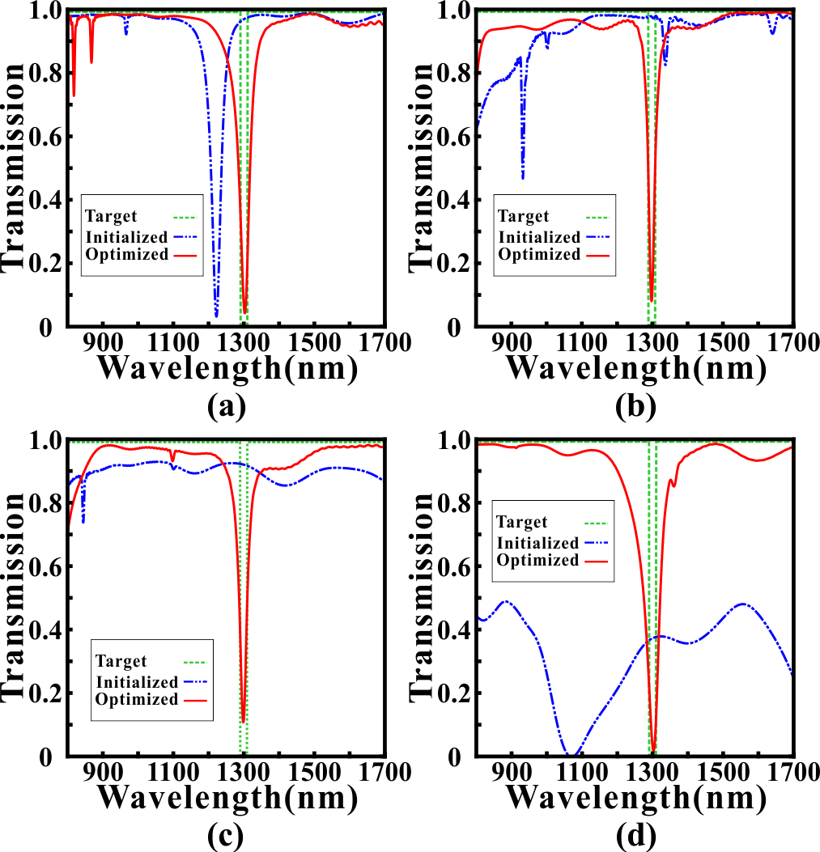
Fig. 3. (a) The simulated transmission spectrum after MDBS optimization. (b) The simulated transmission spectrum after GA optimization. (c) The simulated transmission spectrum after DBPSO optimization. (d) The simulated transmission spectrum after SA optimization. Green dotted line is the target spectrum. Blue solid line is the randomly initialized spectrum. Red solid line is the optimization spectrum.
It can be found that the transmission spectrums after the four methods' optimization have a notable improvement because the optimized transmission spectrums are very close to the targeted transmission spectrum comparing with the randomly initialized spectrum. The minimum transmittances in stopband are reduced to 0.0256, 0.1592, 0.0922 and 0.1029, respectively. And the central wavelengths and FWHMs for BSF are 1300nm, 1300.5nm, 1302nm and 1295nm, and 7.5nm, 12nm, 9nm and 9.5nm, respectively. Moreover, the extinction ratios between stopband and passband are 15.5dB, 7.8dB, 10.1dB and 9.6dB, respectively. Obviously, we can confirm that the optimization methods are efficient and robust in our design task and the ACM in PMPWS has strong plasticity to realize specific functions. It should be noticed that all optimization algorithms are convergent (effective) but the GA can inhibit the fluctuation in sideband better and use less time. Usually, GA can get quite good performance only after once or twice execution and the results have more similar performance. Here, we give the field distributions of the NBSF which corresponds to MDBS's optimization as a demonstration in Fig. 4. We find that the performance of transmission spectrum corresponds well with the electromagnetic field distributions and structure of ACM, which shows that our methods play a substantial role in design process.
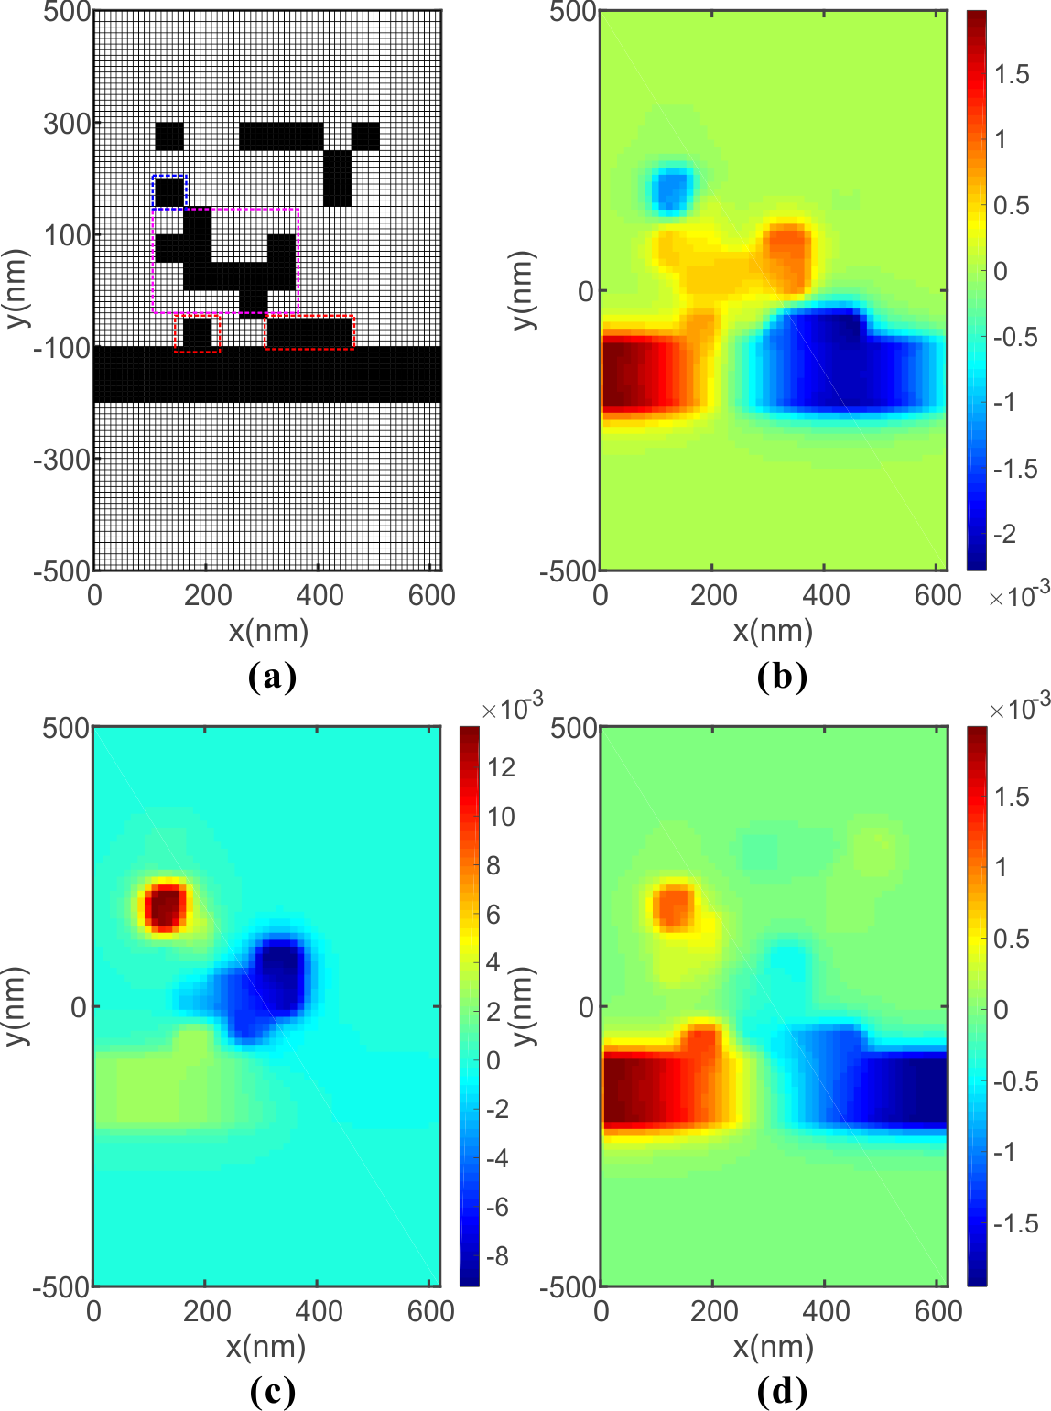
Fig. 4. (a) The distribution of ACM and PMPWS for NBSF, (b) Distribution of the real part of the magnetic field H_{z} at 1100nm, (c) Distribution of the real part of the magnetic field H_{z} at 1300nm (d) Distribution of the real part of the magnetic field H_{z} at 1500nm.
First, we notice that the SPMPWS only can coupled into ACM through the pixels which are directly connected with the strip waveguide. In this situation, the pixels are framed with red lines. At the short wavelength of the stopband of 1100nm, SPMPWS leaks into ACM marginally and does not form a stable resonance mode so SPMPWS passes through with little loss. As the wavelength increases to 1300nm, SPMPWS starts a unique resonance mode in ACM. Here, this resonant cavity is not regular which consists of an independent pixel cavity and a L-shaped cavity. When the SPMPWS in the resonator is coupled back into the strip waveguide, the phase is opposite so we get destructive interference and high loss transmission .As the wavelength continues to increase, the resonance mode is destroyed so it is restored to low loss transmission.
Next, we use GA to design other three types of filters, BBSF, BBPF and NBPF as a demonstration because of GA's higher efficiency. The calculated results are shown in Fig. 5.
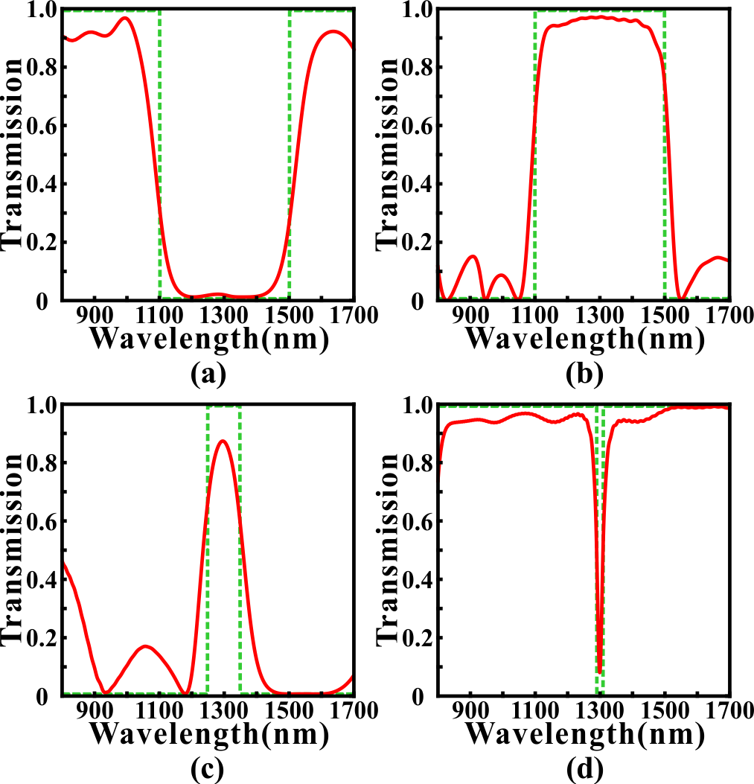
Fig. 5. The simulated transmission spectrums for (a) BBSF (b) BBPF (c) NBPF after GA optimization. (d) The contrast result in NBSF.
Fig. 4(a) shows the optimized transmission spectrum for BBSF which have a broad stopband from 1100nm to 1500nm. The transmittance is less than 0.2 in the stopband and higher than 0.8 in the sideband. Compared with the NBSF, the stopband is not smooth, we think one of the reason is that our ACM is not a symmetric structure after optimization. Fig. 4. (b) shows the optimized transmission spectrum for BPSF. The transmittances exceed 0.7 mostly from 1100nm to 1500nm and the transmittances in stopband is less than 0.3 mostly. In addition, we got a NBPF whose 3dB bandwidth is 166.5nm in Fig. 4(c). The max transmittance reaches 0.9007 in 1297nm which has a 3nm deviation from 1300nm and the transmittances are less than 0.2 mostly in stopband. Obviously, the bandwidth in NBPF can not be controlled as small as NBSF and the sideband inhibition performs worse in band pass filter. The reason is that the strip insulator (air) waveguide supports a surface plasmon polaritons mode from 800nm to 1700nm with wholly low loss if we don't add the ACM with it. In other words, the function of ACM is to inhibit the transmissivity for partial specific wavelength so the BSF can be achieved simpler and have better performance than BPF.
Next, we will discuss two issues that run through the optimization task. Firstly, it's clear that an important factor determining the final optimization performance is to narrow the gap between the simulation spectrum and the target spectrum as much as possible. Here, we proposed a simple but effective method named weighting operation to improve the performance metrics.
As we proposed, we use the Euclidean distance between the simulated spectrums and the target spectrums as the optimization objective function (loss). Here, we use a weighting factor to weight the Euclidean distance. The details are outlined as follows: (i) dividing the transmission spectrums into two parts according to importance. (ii) One part is called "center" which represents the waveband of stopband and passband or the waveband we focused on. The other part is called ''else'' which has no significant impact on our target performance metrics. (iii) In each iteration, we calculate the optimization objective function by the following formula:
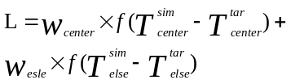 (2)
where the w_{center} is the weighting factor for "center" and the w_{else} is for "else". The function f represents calculating Euclidean distance. And the Tsim center represents the simulated transmittances in "center" waveband. The rest is similar as well.
For example, we use GA method to design and optimize a NBSF with 20nm bandwidth in 1300nm central wavelength. Here, the ACM is composed of 8×8 pixels. The "center" is the waveband form 1290nm to 1310nm, and the rest of the waveband belongs to "else". In Fig. 5, we compared the optimized results for this design with several sets of different weight settings.
In Fig. 5(b), we observe that the loss value in each setting has an obvious convergence. The loss decreases from 3.05 to 2.21 with 27.54% decline when w_{else} = 0.1, 5.39 to 2.37 with 56.23% decline when w_{else} = 0.2, 7.57 to 3.34 with 55.88% decline when w_{else} = 0.5 and 12.56 to 5.45 with 56.61% decline when w_{else} = 1.0. Because of the weighting factor and waveband distribution, the loss value with smaller factor is always less. However, it can be found that the minimum transmittance is only 0.5770 in w_{else} = 1.0 which still is large to achieve a filtering well even it has a steep and quick convergence in loss value. With w_{else} diminishing, it can be found that the minimum transmittance decreases to 0.1299, 0.0955 and 0.0248, respectively. On the other hand, we notice that the sideband has more violent fluctuations when w_{else} decreases. And if we take 0 as the reference value of the minimum transmittance of BSF, we can find that the bandwidth becomes wider as w_{else} decreases. The reason for this phenomenon is the contribution of the waveband in "else" becomes weak to loss value as w_{else} decreases so the influence of the fluctuations in "else" waveband is "smoothed" in the process of evolution. At the same time, the significance of the "center" waveband is amplified equivalently so we get smaller minimum transmittance. In this paper, we usually use a weighting factor of w_{else} = 0.5 which is balanced between bandwidth and minimum transmittance in most cases.
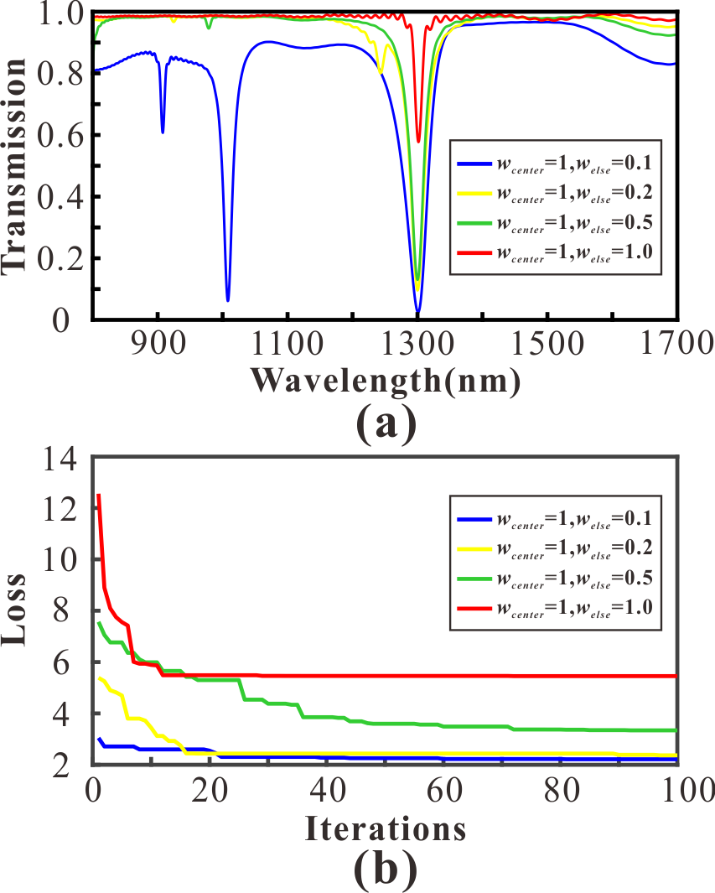
Fig. 5. (a) The optimized transmission spectrums for NBSF in different weight settings (b) The variation of loss values in different weight settings.
Then, another important factor is the density of pixels in the ACM. We emphasize that the diversity of the transmission spectrums of the ACM determines the functions which can be realized. Theoretically, the possibilities of the permutation and combination of ACM grow exponentially as the density of pixels increasing. Although the methods we used in this paper is suitable for global optimization task but not infinitely. Therefore, it is necessary to choose an appropriate density of ACM which can not only ensure the diversity of functions, but also improve the efficiency of the algorithms. Here, we use all four methods to optimize a NBSF with 20nm bandwidth in 1300nm central wavelength. In Fig. 6, we exhibit the optimized results in four different densities 5×5, 8×8, 10×10 and 20×20, respectively.
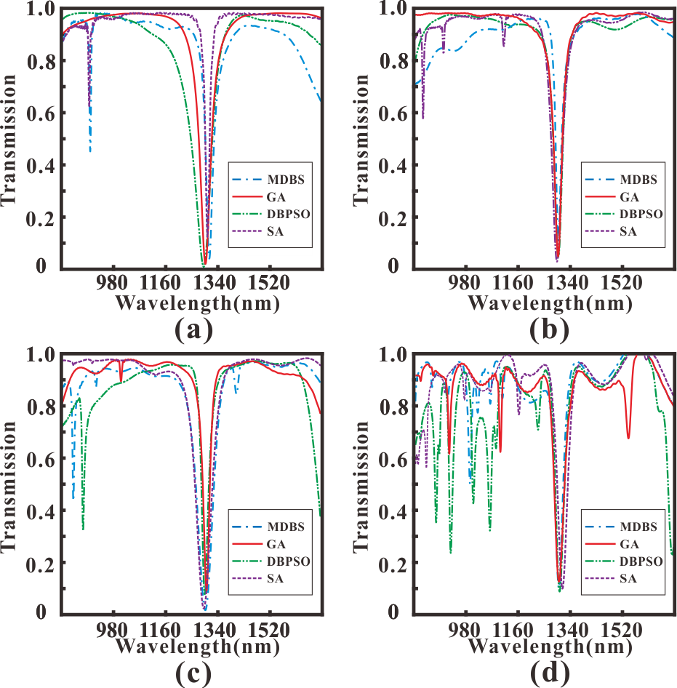
Fig. 6. The optimized results for NBSF in four different algorithms with (a) 5×5 pixels (b) 8×8 pixels (c) 10×10 pixels (d) 20×20 pixels.
The performance metrics in four densities are shown in Table I to Table IV. Here, L_{c} is the center wavelength. T_{min} is the minimum transmittance at L_{c}. And 3dB bandwidth is bandwidth which increases by 3dB from T_{min}. It can be found that the center wavelength offset, minimum transmittance and 3dB bandwidth in 20×20 pixels perform inferiority comparing with others. In addition, the fluctuations in sideband are violent in all four methods which restricts the using band of filter. The reason is that the higher the pixel density is, the more irregular the structure is. In other words, simple transmission spectrums depend on regular symmetric structures which are difficult and unpredictable to organize in 20×20 pixels. Moreover, one single simulation will spend several times than others because of the complexity increasing. In other cases, the difference of performance metrics is not obvious. Compared with 5×5 pixels and 10×10 pixels, the sideband inhibition is better and the metrics have an equilibrium after four methods' optimization in 8×8 pixels. Although 3dB bandwidth and minimum transmittance are more competitive in 5×5 pixels but center wavelength offset is large which limits the precision of tunability. Therefore, we choose 8×8 pixels to achieve most optimization tasks considering diversity and computational efficiency which perform well in this paper.
Table I
Performance parameter in 5×5 pixels
Methods | L_{c}(nm) | T_{min} | 3dB bandwidth(nm)
MDBS | 1311 | 0.0358 | 6.5
SA | 1305 | 0.1199 | 8
DBPSO | 1291.5 | 0.0037 | 5
GA | 1297.5 | 0.0150 | 6.5
Table II
Performance parameter in 8×8 pixels
Methods | L_{c}(nm) | T_{min} | 3dB bandwidth(nm)
MDBS | 1300.5 | 0.1055 | 9.5
SA | 1296 | 0.0245 | 7.5
DBPSO | 1300.5 | 0.0432 | 8.5
GA | 1300 | 0.0443 | 8
Table III
Performance parameter in 10×10 pixels
Methods | L_{c}(nm) | T_{min} | 3dB bandwidth(nm)
MDBS | 1299 | 0.0143 | 9
SA | 1293.5 | 0.0212 | 10.5
DBPSO | 1297 | 0.0762 | 9.5
GA | 1303.5 | 0.0903 | 9.5
Table IV
Performance parameter in 20×20 pixels
Methods | L_{c}(nm) | T_{min} | 3dB bandwidth(nm)
MDBS | 1299.5 | 0.0974 | 12.5
SA | 1312.5 | 0.0970 | 15.5
DBPSO | 1302 | 0.0856 | 12.5
GA | 1300 | 0.1238 | 18

- PIT effect
Next, we use GA to achieve PIT-like effect in our PMPWS which has great applications in ultrafast optical signal processing, optical data storage and microwave photonics. Here, the ACM is composed of 8×8 pixels and the target full width at half maxima (FWHM) of the transmission peak in stopband is 20nm. Fig. 8 shows the calculated results after optimization. In Fig. 8(a), we got a PIT-like peak in 1297nm. The peak value is 0.7115 and the valley values are 0.0084 and 0.0086, respectively. The Q-factor which is an important parameter to evaluate the performance of the PIT-like effect is calculated by the following formula:
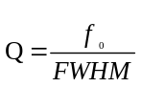 (1)
where the f₀ is the frequency of maximum transmission at the PIT window, and the FWHM is the full width at half maximum. In this optimization, the FWHM is 35.5nm and the Q-factor reaches 36.54 in near infrared waveband. However, the Q-factor is lower in the metallic systems due to ohmic damping[Comparison of Electromagnetically Induced Transparency Performance in Metallic and All-dielectric Metamaterials]. What's more, we do not need any energy to consider the PIT coupling relation which is difficult and incomprehensible in inverse design. We can spend more time to improve the performance by using more powerful constraint conditions or efficient algorithms which are easier.
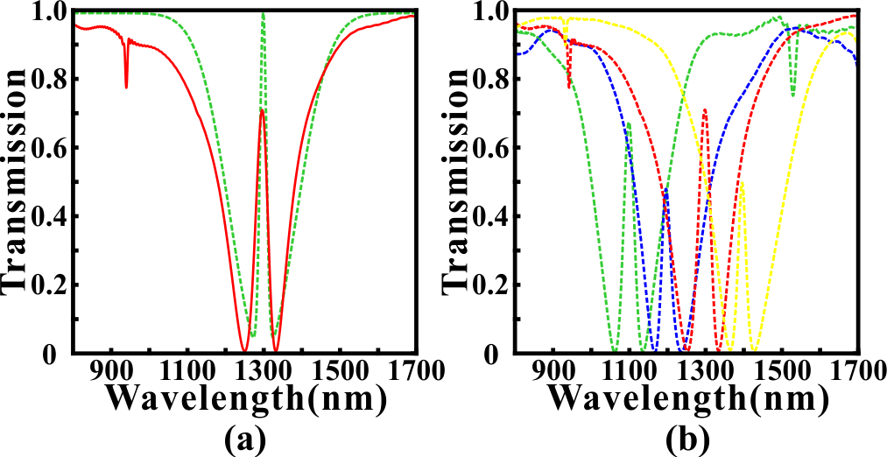
Fig. 8. (a) The simulated PIT-like transmission spectrum in 1300nm (b) Tunable PIT-like effect for different center wavelength
As we mentioned, one of the most competitive advantages of PMPWS is tunability. The Fig. 8(b) shows the tunable PIT-like effect with different center wavelengths only by adjusting the target function before optimization. It can be found that the PIT peaks are 1098nm, 1195nm and 1395nm, respectively. The maximum deviation is only 5nm. Then the corresponding FWHMs and Q-factors are 31.5nm, 27nm and 24nm, respectively and 34.86, 44.26 and 58.13, respectively. Lastly, the extinction ratio is 19.27dB and 19.19dB for 1098nm, 20.52dB and 18.93dB for 1195nm, 16.55dB and 18.22dB for 1395nm. Obviously, the optimization performances are well-matched for all PIT peaks which proves that our optimization methods and structure have strong universality and plasticity. Actually, we can get arbitrary PIT peaks in this wave band from 900nm to 1600nm and the tunability is adaptive for all types of device in this article.
Then we

CONCLUSION
In conclusion, we propose a novel PMC to effectively perform the mode conversion between the TE/TM mode in a silicon waveguide and the SPMPWS mode in a plasmonic waveguide. And several different optimization algorithms, such as GA, DBPSO, SA and DBS, are applied in the design of the SCM in the PMC to improve the performance metrics. The FDTD simulated results demonstrate that the PMC optimized by MDBS can perform polarization-invariant conversion, and the conversion efficiency and bandwidth reach more than 0.93 and 200 nm, respectively. Compared with previous articles, our proposed PMC designed by the optimization algorithms has superiority in conversion efficiency and bandwidth.
References
[1] D.K. Gramotnev and S.I. Bozhevolnyi, "Plasmonics beyond the diffraction limit," Nat. Photonics 4, 83-91 (2010).
[2] T. Zhang, L. Chen, and X. Li, "Graphene-based tunable broadband hyperlens for far-field subdiffraction imaging at mid-infrared frequencies," Opt. Express 21, 20888-20899 (2013).
[3] Hooper I R, Sambles J R. Dispersion of surface plasmon polaritons on short-pitch metal gratings[J]. Physical Review B, 2002, 65(16): 165432.
[4] Otto A. Excitation of nonradiative surface plasma waves in silver by the method of frustrated total reflection[J]. Zeitschrift für Physik, 1968, 216(4): 398-410.
[5] Kretschmann E, Raether H. Notizen: Radiative Decay of Non Radiative Surface Plasmons Excited by Light[J]. Zeitschrift für Naturforschung A, 1968, 23(12): 2135-2136.
[6] 暂缺
[7] G. I. Stegeman, R. F. Wallis, and A. A. Maradudin, "Excitation of surface polaritons by end-fire coupling," Opt. Lett. 8, 386-388 (1983).
[8] D. Rodrigo and et al, "Mid-infrared plasmonic biosensing with graphene," Science 349(6244), 165-168 (2015).
[9] Kocabaş Ş E, Veronis G, Miller D A B, et al. Modal analysis and coupling in metal-insulator-metal waveguides[J]. Physical Review B, 2009, 79(3): 035120.
[10] Du B, Yang Y, Zhang Y, et al. Plasmonic grating based on insulator–metal–insulator structure at telecom wavelengths[J]. IEEE Photonics Technology Letters, 2018, 30(19): 1691-1694.
[11] Lu H, Gan X, Mao D, et al. Graphene-supported manipulation of surface plasmon polaritons in metallic nanowaveguides[J]. Photonics Research, 2017, 5(3): 162-167.
[12] Yun B, Hu G, Cui Y. Theoretical analysis of a nanoscale plasmonic filter based on a rectangular metal–insulator–metal waveguide[J]. Journal of Physics D: Applied Physics, 2010, 43(38): 385102.
[13] Zhang Z, Shi F, Chen Y. Tunable multichannel plasmonic filter based on coupling-induced mode splitting[J]. Plasmonics, 2015, 10(1): 139-144.
[14] Kwon M S, Shin J S, Lee J H. Metal–insulator–silicon–insulator–metal waveguide splitters with large-arm separation[J]. Journal of Lightwave Technology, 2015, 33(18): 3843-3849.
[15] Longkun Yang, Pan Li, and Zhipeng Li, "Plasmonic polarization beam splitting based on single silver nanowire," Opt. Express 27, 3851-3860 (2019).
[16] Gómez-Díaz J S, Perruisseau-Carrier J. Graphene-based plasmonic switches at near infrared frequencies[J]. Optics express, 2013, 21(13): 15490-15504.
[17] Emboras A, Hoessbacher C, Haffner C, et al. Electrically controlled plasmonic switches and modulators[J]. IEEE Journal of Selected Topics in Quantum Electronics, 2014, 21(4): 276-283.
[18] Hössbacher C, Josten A, Bäuerle B, et al. Plasmonic modulator with> 170 GHz bandwidth demonstrated at 100 GBd NRZ[J]. Optics Express, 2017, 25(3): 1762-1768.
[19] Zhang B, Zhao Y, Hao Q, et al. Polarization-independent dual-band infrared perfect absorber based on a metal-dielectric-metal elliptical nanodisk array[J]. Optics express, 2011, 19(16): 15221-15228.
[20] Lu H, Liu X, Mao D, et al. Plasmonic nanosensor based on Fano resonance in waveguide-coupled resonators[J]. Optics letters, 2012, 37(18): 3780-3782.
[21] Yang R, Wahsheh R A, Lu Z, et al. Efficient light coupling between dielectric slot waveguide and plasmonic slot waveguide[J]. Optics letters, 2010, 35(5): 649-651.
[22] Patel V, Sharma P, Kumar V D. Efficient coupling from dielectric to hybrid plasmonic waveguide using curved taper[J]. IEEE Photonics Technology Letters, 2019, 31(4): 323-326.
[23] Liu Z, Ding L, Yi J, et al. Design of a multi-bits input optical logic device with high intensity contrast based on plasmonic waveguides structure[J]. Optics Communications, 2019, 430: 112-118.
[24] Zhang H, Shen D, Zhang Y. Circular split-ring core resonators used in nanoscale metal–insulator–metal band-stop filters[J]. Laser Physics Letters, 2014, 11(11): 115902.
[25] Liu X, Tian J, Yang R. Surface plasmon polariton based metal-insulator-metal filter including two face-to-face concentric semi-rings with different radii[J]. Journal of Optical Technology, 2017, 84(9): 588-592.
[26] Lai W, Wen K, Lin J, et al. Plasmonic filter and sensor based on a subwavelength end-coupled hexagonal resonator[J]. Applied optics, 2018, 57(22): 6369-6374.
[27] Han Z, Bozhevolnyi S I. Plasmon-induced transparency with detuned ultracompact Fabry-Perot resonators in integrated plasmonic devices[J]. Optics Express, 2011, 19(4): 3251-3257.
[28] Wang G, Lu H, Liu X. Dispersionless slow light in MIM waveguide based on a plasmonic analogue of electromagnetically induced transparency[J]. Optics express, 2012, 20(19): 20902-20907.
[29] Zhan S, Li H, Cao G, et al. Slow light based on plasmon-induced transparency in dual-ring resonator-coupled MDM waveguide system[J]. Journal of Physics D: Applied Physics, 2014, 47(20): 205101.
[30] Chen J, Wang C, Zhang R, et al. Multiple plasmon-induced transparencies in coupled-resonator systems[J]. Optics letters, 2012, 37(24): 5133-5135.
[31] Lu H, Liu X, Mao D, et al. Induced transparency in nanoscale plasmonic resonator systems[J]. Optics letters, 2011, 36(16): 3233-3235.
[32] Zhan S, Kong D, Cao G, et al. Analogy of plasmon induced transparency in detuned U-resonators coupling to MDM plasmonic waveguide[J]. Solid state communications, 2013, 174: 50-54.
[33] Zhan S, Li H, Cao G, et al. Theoretical analysis of plasmon-induced transparency in ring-resonators coupled channel drop filter systems[J]. Plasmonics, 2014, 9(6): 1431-1437.
[34] Guo J. Plasmon-induced transparency in metal–insulator–metal waveguide side-coupled with multiple cavities[J]. Applied optics, 2014, 53(8): 1604-1609.
[35] Liu H, Ren G, Gao Y, et al. Tunable subwavelength terahertz plasmon-induced transparency in the InSb slot waveguide side-coupled with two stub resonators[J]. Applied Optics, 2015, 54(13): 3918-3924.
[36] Yu D M, Zhai X, Wang L L, et al. Plasmon-induced transparency in a surface plasmon polariton waveguide with a right-angled slot and rectangle cavity[J]. Plasmonics, 2016, 11(4): 1151-1155.
[37] Lu H, Liu X, Mao D. Plasmonic analog of electromagnetically induced transparency in multi-nanoresonator-coupled waveguide systems[J]. Physical Review A, 2012, 85(5): 053803.
[38] Molesky S, Lin Z, Piggott A Y, et al. Inverse design in nanophotonics[J]. Nature Photonics, 2018, 12(11): 659-670.
[39] T. Zhang and et al, "Efficient spectrum prediction and inverse design for
plasmonic waveguide systems based on artificial neural networks," Photonics
Research 7(3), 368-380 (2019).
[40] T. W. Hughes and et al, "Adjoint method and inverse design for nonlinear
nanophotonic devices," ACS Photonics 5, 4781-4787 (2018).
[41] Zhang T, Liu Q, Dan Y, et al. Inverse design and optimization of graphene metamaterial for multi-peak plasmon induced transparency based on machine learning and evolutionary algorithms[J]. arXiv preprint arXiv:1908.01354, 2019.
[42] Skaar J, Risvik K M. A genetic algorithm for the inverse problem in synthesis of fiber gratings[J]. Journal of lightwave technology, 1998, 16(10): 1928.
[43] Kern D J, Werner D H. A genetic algorithm approach to the design of ultra-thin electromagnetic bandgap absorbers[J]. Microwave and Optical Technology Letters, 2003, 38(1): 61-64.
[44] Chen P Y, Chen C H, Wang H, et al. Synthesis design of artificial magnetic metamaterials using a genetic algorithm[J]. Optics express, 2008, 16(17): 12806-12818.
[45] Shokooh-Saremi M, Magnusson R. Particle swarm optimization and its application to the design of diffraction grating filters[J]. Optics letters, 2007, 32(8): 894-896.
[46] Forestiere C, Donelli M, Walsh G F, et al. Particle-swarm optimization of broadband nanoplasmonic arrays[J]. Optics letters, 2010, 35(2): 133-135.
[47] Lu Q, Wei W, Yan X, et al. Particle swarm optimized ultra-compact polarization beam splitter on silicon-on-insulator[J]. Photonics and Nanostructures-Fundamentals and Applications, 2018, 32: 19-23.
[48] Kim W J, O'Brien J D. Optimization of a two-dimensional photonic-crystal waveguide branch by simulated annealing and the finite-element method[J]. JOSA B, 2004, 21(2): 289-295.
[49] Shen B, Wang P, Polson R, et al. An integrated-nanophotonics polarization beamsplitter with 2.4× 2.4 μm 2 footprint[J]. Nature Photonics, 2015, 9(6): 378-382.

