Abstract—In this article, we propose a programmable plasmonic waveguide system (PMPWS) to achieve several different functions based on metal coding metamaterials (MCMs) and inverse design technology. There is no need to spend much time on considering the shape of resonators because the MCMs in the PMPWS are reprogrammable. In order to demonstrate the effectiveness of the PMPWS, we use it to achieve several filtering functions, including bandstop filter and bandpass filter. The simulation results exhibit that the performance of filters is improved based on genetic algorithm, particle swarm optimization, multi- traversal direct-binary search and simulated annealing, and the bandwidth and quality factor of the narrow-band filter can reach 6.5 nm and 200.5, respectively. In addition to the simple filtering functions, some relatively complex transmission characteristics can also be obtained by using the PMPWS, such as plasmon-induced transparency (PIT) -like effects. In comparison to the previous works, our proposed PMPWS not only provides a general framework for obtaining an effective, flexible and compact plasmonic devices but also shows the applications of inverse design on photonic devices.
Programmable Multifunctional Plasmonic Waveguide System based on Coding Metamaterials and Inverse Design
Yihang Dan, Tian Zhang, Xu Han, Jian Dai, and Kun Xu
Index Terms—Plasmonic devices, inverse design, optimization.

I. INTRODUCTION
Surface plasmon polaritons (SPPs) are especial electromagnetic waves which occur and propagate at the interface of metal and dielectric and they carry energy and information overcoming the diffraction limit [1]. The appearance of SPPs provides a new way to manipulate light at the nanoscale so it is considered to be the most potential way to realize highly integrated optical system in the future [2]. Since SPPs are discovered, researchers have studied different ways to excite SPPs, such as grating excitation [3], prism coupling [4,5], waveguide mode coupling [6], end-fire coupling [7] and local excitation [8]. The transmission of SPPs usually depends on special waveguide systems, for example metal-dielectric-metal (MDM) waveguide [9], insulator-metal-insulator waveguide [10], hybrid

Manuscript received XXX, 2020; revised XXX, 2020; accepted XXX, 2020. This work was supported by the National Natural Science Foundation of China under Grants 61625104 and 61431003, the Beijing Municipal Science & Technology Commission under Grants Z181100008918011, the Ministry of Science and Technology of China under Grants 2016YFA0301300, the Fundamental Research Funds for the Central Universities under Grants 2019RC15 and 2018XKJC02.
Y. Dan, T. Zhang, J. Dai, K. Xu are with State Key Laboratory of Information Photonics and Optical Communications, Beijing University of Posts and Telecommunications, Beijing 100876, P.R. China (e-mail: ztian@bupt.edu.cn).
X. Han is with Huawei Technologies Co., Ltd, Shenzhen 518129, Guangdong, China
Color versions of one or more figures in this paper are available online at http://ieeexplore.ieee. org.
waveguide [11] and so on. Due to their compact footprint and easy integration, MDM waveguide systems have been widely applied in plasmonic filters [12,13], splitters [14,15], optical switches [16,17], modulators [17,18], absorbers [19], sensors [20], couplers [21,22], logic gates [23] and so on. However, in order to realize different functions, researchers often spend much time on searching for and designing for the nano-resonators with different shapes [24-26]. For example, plasmon-induced transparency (PIT) effect [27,28], which has applications in refractive index sensor and slow light, has become a hot spot in the field of SPPs. In order to achieve the PIT effect in the transmission spectrum, various structures of waveguide systems with different resonators have been proposed, such as ring resonators [29], stub resonators [30], T-shaped resonators [31], U- shaped resonators [32], rectangular resonators [33], side-coupled multiple resonators [34-37] and so on. Obvious, it’s cumbersome to construct different resonators for a special purpose. It is expected to improve the design efficiency of photonics devices if there exist a general framework which can realize multiple functions and avoid repetitive design works. It has been demonstrated that the coding metamaterials, which consist of two types of unit cells, can provide a flexible and controllable platform by using a field-programmable gate array [S1]. The coding metamaterials are effectively designed to achieve high-performance and easily integrated photonics devices based on inverse design technology [S2-S5]. However, it should be noted that the above waveguide systems generally include dielectric coding metamaterials. There are few plasmonic devices having multi –function in a general framework based on strong programmability of metal coding metamaterials (MCMs).
The inverse design technology based on optimization algorithms, had been used to find the appropriate distributions and structure parameter of the MCMs. In general, there are three kinds of algorithms for the inverse design of photonic devices: gradient based methods, gradient free methods and model-based methods [38,39]. As a representative method of the gradient based methods, adjoint variable method (AVM) can optimize for the linear and nonlinear optical devices, but it needs physical background to derive the gradient of objective function [40]. Model based methods, such as artificial neural networks (ANNs) and random forests, are also used for the inverse design of photonics devices [39,41]. However, a lot of original data and labels are required to train the model which constructs the physical relationship between the structure parameters and electromagnetic responses. The optimization performance is highly dependent on the effect of pre-training model [S2]. In comparison to the model-based methods, the gradient free methods, including search strategy and evolution strategy, are simple and effective because they directly search for the optimal solution by iteration and evolution strategies [S3]. Genetic algorithm (GA) and particle swarm optimization (PSO) are two typical evolution algorithms, which have good global search ability inspired by genetic inheritance and group cooperation [S4,S5]. Although GA and PSO have been widely applied in the optimization and design of photonic device [42- 47], they are easy to fall into local optimal solution because the global search abilities are relatively poor. Moreover, simulated annealing (SA) and direct-binary search (DBS) are traditional search algorithms which require less time to converge [48,49]. However, the these two algorithms also easily fall into local optimal solution and they are sensitive to the initial states and optimization parameters. And the finite traversal times (only once) limit the optimization ability of the DBS.

In this paper, we propose a programmable multifunctional plasmonic waveguide system (PMPWS) to achieve several different functions based on MCMs and inverse design. Four optimization algorithms, including GA, PSO, SA and DBS, are used to design for the MCMs in the PMPWS to realize multiple filtering functions, such as narrowband bandstop filter (NBSF), broadband bandstop filter (BBSF), narrowband bandpass filter (NBPF) and broadband bandpass filter (BBPF). The simulation results exhibit that the performance of filters is improved based on the inverse design and weighting operation. For instance, the bandwidth and Q value of the optimized NBSF can reach 6.5 nm and 200.5, respectively. In addition, some relatively complex transmission characteristics can also be obtained by using the PMPWS, such as single plasmon- induced transparency (PIT)-like effect, double PIT-like effects and tunable PIT-like effects.

II. Device design and simulation results

As shown in Fig. 1, our proposed PMPWS consists of a MDM waveguide and MCMs. The MDM waveguide and MCMs are placed on a SiO₂ substrate. Here, the MCMs whose footprint is 400×400 nm² and composition is M×N square pixels are placed on one side of the MDM waveguide. Each pixel in the MCMs can be selectively filled by Ag or air, corresponding to the logical “0” or “1” state, respectively. Obviously, the MCMs provide a relatively broad programming space which is expected to realize different functions based on the inverse design technology. In the PMPWS, the length and width of the MDM waveguide, which transmits the TM mode polarized light are 620 nm and 100 nm respectively. The TM mode in the MDM waveguide can be coupled into the MCMs partially and then be coupled back into the MDM waveguide. The excited modes in the MCMs will have influence on the transmission characteristics in the transmission spectrum. In our numerical simulations, the transmission spectrums are calculated by the 2-dimensional finite-difference time-domain (FDTD) method (adopting Lumerical MODE Solutions). It should be noted that the MDM waveguide system is usually simulated by using 2D FDTD simulation because of the less simulation time and high accuracy [S1-S3]. The metal (Ag) in the FDTD simulation is modeled by the Drude model with (ε∞, ω_{p}, γ_{p}) = (3.7, 1.37× 10¹⁶Hz, 2.7×10¹³Hz) [S3]. All the transmission spectrums in our simulation are calculated from 800 nm to 1700 nm in the near infrared region. And the transmission loss of the PMPWS is calculated by placing several monitors in the waveguide.

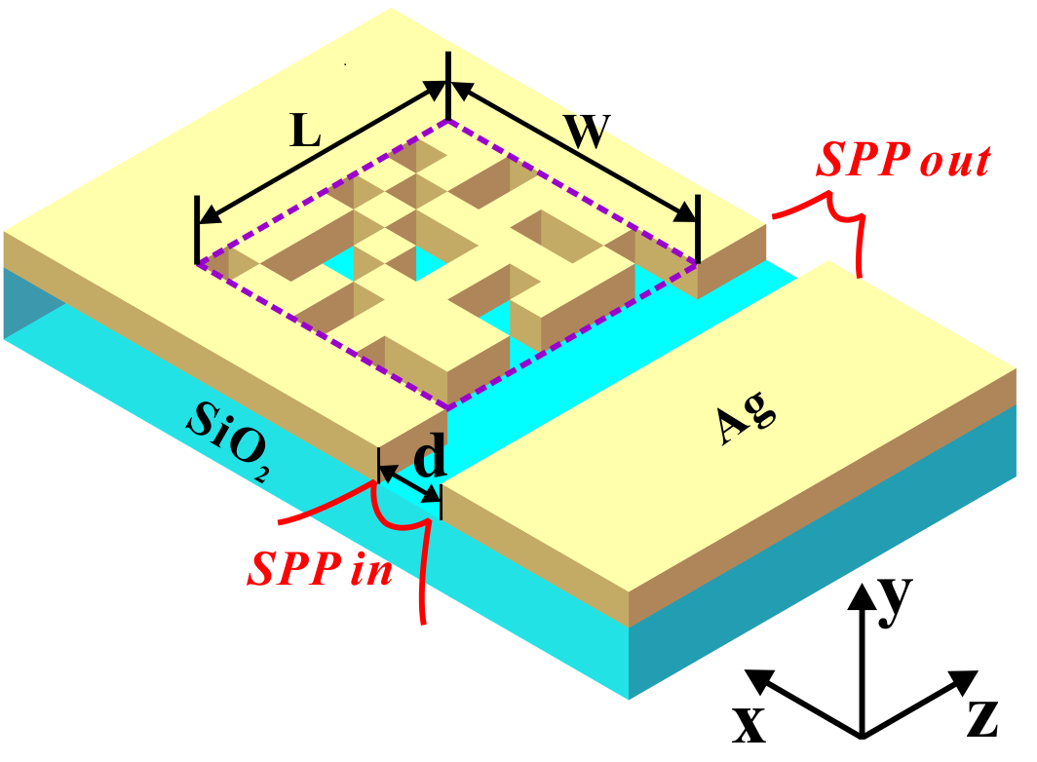
Fig.1 Structure schematic of the proposed PMPWS.
As mentioned above, the PMPWS provides a relatively broad programming space (MCMs) to support different functions. In practice, the MCMs can be controlled by using a field-programmable gate array [S1]. Here, we randomly select several MCMs to exhibit the transmission characteristics of the PMPWS, and the simulation results are shown in Fig. 2. In this simulation, the MCMs whose composition is 8×8 square pixels reveals that the PMPWS has a programming space with 2⁶⁴ distributions although some distributions are senseless and repetitive. From Fig. 2(a) to Fig. 2(d), it can be found that those transmission spectrums are expected to achieve multi- functional filtering, which is a fundamental and important unit in the integrated plasmonic circuits. And these transmission spectrums are simulated for the MCMs randomly selected from all possible distribution. It indicates that the performance metrics of the PMPWS can be further improved based on the inverse design or optimization algorithms.

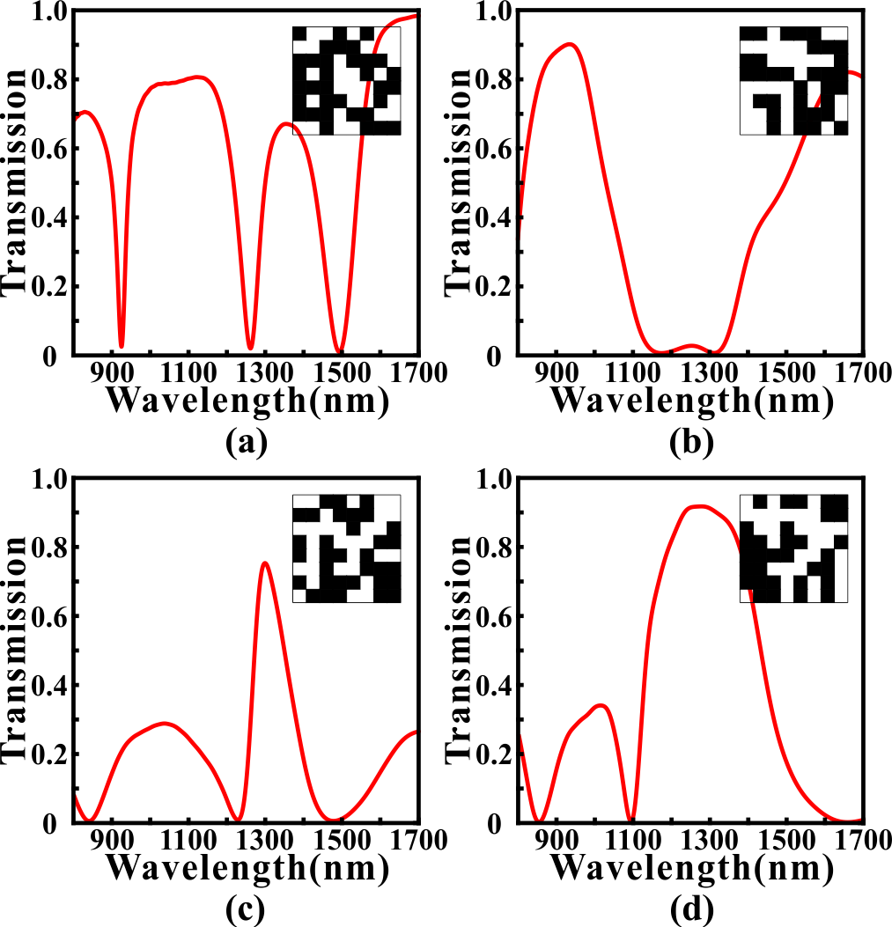
Fig. 2. The simulated transmission spectrums for the MCMs with different distributions. (a) The transmission spectrum that is expected to be used as a NBSF. (b) The transmission spectrum that is expected to be used as a BBSF. (c) The transmission spectrum that is expected to be used as a NBPF. (d) The transmission spectrum that is expected to be used as a BBPF.

Multifunctional photonics devices
- Multifunctional Filter
In section II, we have preliminary proved that the PMPWS has potential as a multifunctional filter. It is expected to further improve the performance metrics of the filtering based on the inverse design technology. For example, we want to design a NBSF whose central wavelength and 3dB bandwidth are 1300 nm and 20 nm, respectively. From the beginning, we randomly generate a number of MCMs whose transmission spectrums are simulated by using the 2D FDTD simulation. Then, the MCMs are optimized by using the GA, PSO, SA and DBS to achieve better performance, such as a narrower bandwidth. GA is a highly parallel and adaptive optimization algorithm which encodes the solutions as genes to achieve evolutionary optimization. Because of the complexity of gene coding, the binary coding, which is suitable for the MCMs, is often used as a simplified substitution [S1].
The algorithmic details of the GA used here are outlined as follows: (i) randomly generating an initial population consisted of N=50 individuals. Here, each individual in the initial population represents a distribution of MCMs whose pixels are randomly initialized as “1” or “0” state. It should be noted that N is an important parameter of the population which has influence on the convergence speed and optimization results. (ii) For all N MCMs, the transmission spectrums are calculated by using the 2D FDTD simulation. The Euclidean distance between the simulated transmission spectrum and the target transmission spectrum is defined as the optimization objective function (loss) for the GA. And it can determines whether one individual should be eliminated or not in the evolution. (iii)Trying to generate a new population by using the selection, crossover and mutation procedures. In the selection process, two parent individuals are selected from previous generation based on the roulette-wheel selection with gap selection ratio 0.9 [39]. In the crossover process, the selected MCMs cross over to generate a new MCMs based on the uniform crossover method with a crossover probability of 0.3. In the mutation process, each pixel in the MCMs has 3% probability to flip from 0 (1) to 1 (0). (iv) The newly generated ACMs are evaluated to determine the GA whether to stop or not. If the genetic generation reaches to 100 or the value of optimization objective function remains unchanged for more than 30 times, then GA stops, otherwise, proceeds to Step (ii).
In comparison to GA, PSO is an evolution algorithm based on group cooperation, which is inspired from the foraging behavior of birds [S1]. In Pachution (we call it “particle”) of the optimization problem is a “bird” in the search space whil particles have a fitness value determined by the optimization objective function which is the same in GA, and each particle has a speed that determines the direction and distance for their flight. It should be noticed that the standard PSO is suitable for the decimal rather than binary numbhat the discrete binary PSO (DBPSO) rather than the standard PSO is used to optimize the MCMs [S1]ACM. the DBPSO, tthe alculation method for the velocity is s same as the standard PSO. But the velocity of the standard PSO directly affects the position of particle, while that of DBPSO is converted to a flip probability based on the sigmoid function [50]. Then, this flip probability determines whether the pixels in the MCMsACMs changed or not. It should be noted that tThe peed range, inertia weight and acceleration constants of the DBPSO in thisoptimizationarti set as -1~1, 1, and c₁=c₂=1.49, respectively.
SA is a typical search algorithm which imitates the physical annealing in the quenching based on Monte Carlo iterative solution strategy [51]. At the initial stage, SA searches for the solution in a broad optimization space by accepting a worse solution with a certain probability. It can effectively alleviate the local optima problem in the GA and PSO to some extent [52]. As the temperature decreases, the solution changes in a small range to speed up the convergence of SA. Here, in each iteration, the MCMs are randomly generated and simulated by the 2D FDTD simulation. The objective function is evaluated to determine the newly generated MCMs whether to accept with an acceptance probability determined by the Metropolis criterion or not [53]. Here, the maximum and minimum of the temperature for the SA are set as 2000 and 1e-18, respectively. And the iteration times of the SA depends on the rate (0.98) of temperature’s decrease. In addition, DBS is a nonlinear search algorithm based on the binary tree whose left subtree and right subtree are constructed with state “0” and “1” respectively [S1]. From the beginning, each pixel is traversed in turn, and the branch with the smaller value of optimization objective function is selected and then fixed each time [S1]. It should be noticed that the optimal solution will only approach to the direction of convergence in this selection process, so there will be no oscillation and rebound for the value of optimization objective function. In this article, we proposed a novel method to further improve the searching ability of the DBS. After traversing all pixels once, we start the traversal again. The reason for this is that when the first pixel in the MCMs is being selected to be fixed to state “0” or “1”, other pixels are in a certain state. After the first traversal, the distribution of the MCMs may have changed and some of the pixel states have been reversed. Thus, if the state of the first pixel is reversed again, the simulated transmission spectrum of the new MCMs may be better. Moreover, this multi-traversal direct-binary search (MDBS) algorithm can ensure that the performance of the PMPWS will not degrade in the multiple traversal. In this article, if the traversal times of the MDBS reaches maximum or the value of loss remains unchanged for more than 10 times, then MDBS stops.
We use GA, DBPSO, SA and MDBS to optimize foring the MCMs in the PMPWSACM to achieve arealize NBSF for demonstrating thetesting their availability and effectiveness of optimization algorithms. Here, Here, tthe ACMMCMs in the PMPWS areis composed of 8×8 pixels. TThe targeted central wavelength of the NBSF is set as 1300 nm and the targeted full width at half maximum (FWHM) of the absorption dippeak is set as 20 nm. It should be noted that the line shape of the targeted transmission spectrum is set as Gate function [S1]. The targeted transmission spectrums (green dash lines) and optimized transmission spectrums (red solid lines) are shown in Fig. 3. It can be found that the transmission spectrums have a notable improvement after optimizing with four methods since the optimized transmission spectrums are very close to the targeted transmission spectrums comparing with the initial transmission spectrums (blue dash line). Here, the initial transmission spectrums of the DBS and GA are calculated for the first random distributions of the MCMs, while those of the GA and DBPSO are the best individuals in
And the linetype of target spectrum is Gate ftion. In some situations,e Gauss functiono used according to the performanctimizathe calculated results are shown in Fig. 3.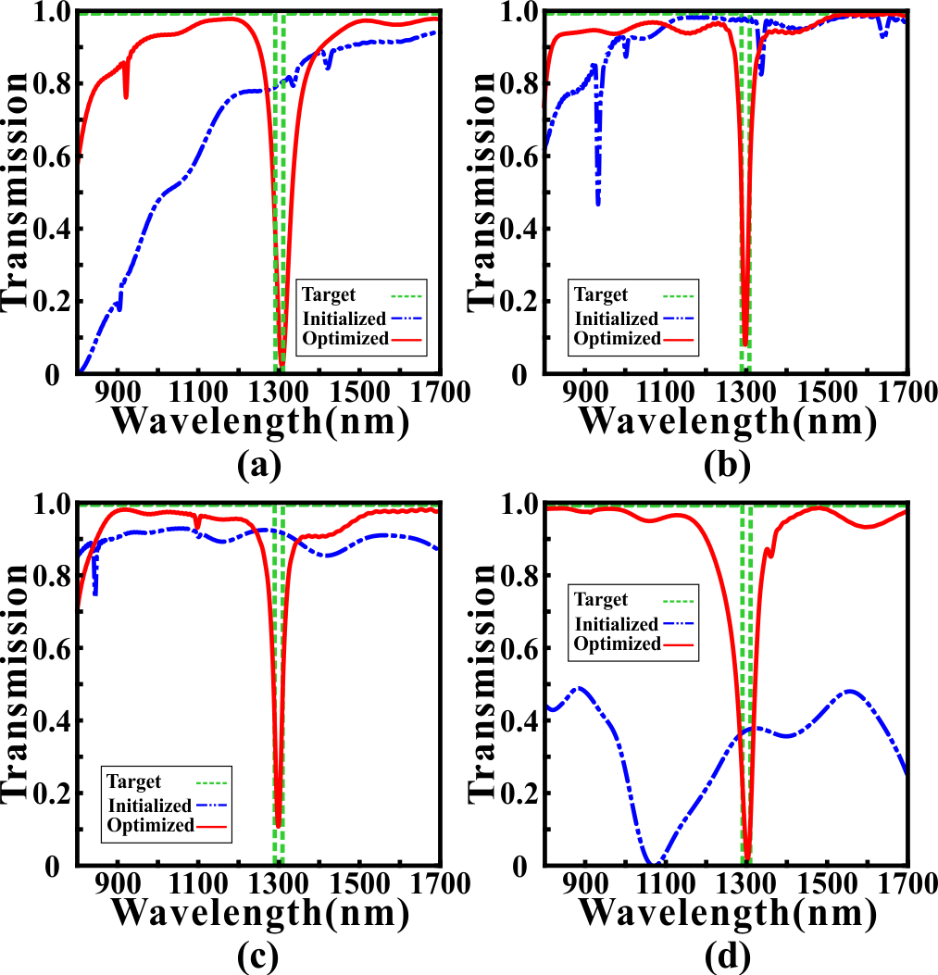
Fig. 3. The initial transmission spectrums (blue dash lines) and optimized transmission spectrum (red solid lines) for GA (a), DBPSO (b), SA (c) and MDBS (d). The green dotted line(c) and (d) are the targeted transmission spectrums.
the first iteration. After the optimization, we can find that the minimum transmittances of the absorption dips are reduced to 0.0208, 0.0812, 0.1045 and 0.0184 for GA, DBPSO, SA and MDBS, respectively. And the central wavelengths (FWHMs) of the optimized NBSF are 1307.0 nm (7.5 nm), 1299.5 nm (7.5 nm), 1299.0 nm (10.5 nm) and 1303.0 nm (6.5 nm) for GA, DBPSO, SA and MDBS, respectively. Correspondingly, the Q-factors of the optimized NBSF can reach to 174.27, 173.67, 123.71 and 200.46, respectively. Obviously, all optimization algorithms are convergent and effective because the optimized transmission spectrums are close to the targeted transmission spectrums. Even so, there exist slight performance differences of the fluctuation degree in the sideband of the optimized transmission spectrums. The max fluctuations of the sideband in the transmission spectrums optimized by the GA, DBPSO, SA and MDBS are 2.28 dB, 1.32 dB, 1.48 dB and 0.64 dB, respectively. Though SA has the minimum transmittances and FWHM, which indicating it performs well in this simulation, it is unstable in the optimization process. GA, by contrast, can get gratifying performance because it only executes once or twice, which is more stable than others.

After the GA optimization, the field distributions of the NBSF are shown in Fig. 4. It shows that the transmission spectrum has great cross reference with the electromagnetic field distributions and ACM distribution, which reveals that our methods play a substantial role in design process. First, we notice that the SPPs mainly can be coupled into ACM through the pixels which are directly connected with the strip waveguide. In this situation, these pixels are framed with red lines. At the short wavelength of the stopband which is 1100nm, SPPs leaks into ACM marginally and doesn't form a the wavelength increasing to 1300nm, SPPs starts a unique stable resonant mode so SPPs passes through with low loss. As

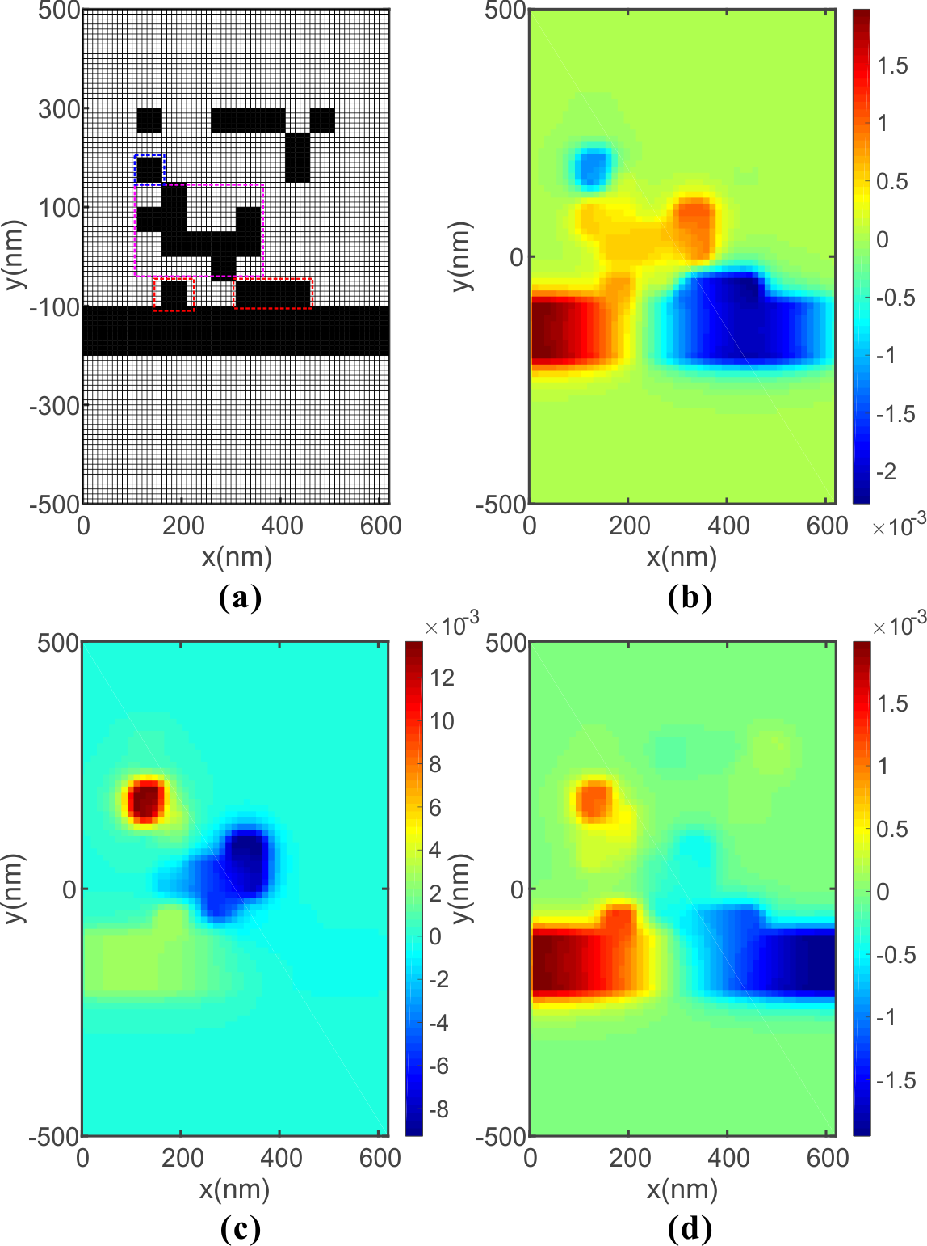
Fig. 4. (a) The distribution of ACM and PMPWS for NBSF, (b) Distribution of the real part of the magnetic field H_{z} at 1100nm, (c) Distribution of the real part of the magnetic field H_{z} at 1300nm (d) Distribution of the real part of the magnetic field H_{z} at 1500nm.
resonant mode in ACM. Here, this resonator is not regular which consists of an independent pixel cavity and the L-shaped cavity. When the SPPs in the resonator is coupled back into the strip waveguide, the phase is opposite so we get destructive interference and high loss transmission. When the wavelength continues to increase, the resonant mode is destroyed so it is restored to low loss transmission. Then, we use GA to design other three types of filters, BBSF, BBPF and NBPF as a demonstration because of GA's higher efficiency.
Fig. 5(a) shows the optimized transmission spectrum for the BBSF, which has a broad stopband from 1100 nm to 1500 nm. It can be found that the transmittances are less than 0.01 in the stopband and higher than 0.8 in the passband. Compared with the NBSF, the stopband of the BBSF is not enough smooth. The reason for this phenomenon is related to the optimized MCMs have redundant pixels, which may cause deterioration of performance in the stopband. Fig. 5(b) shows the optimized transmission spectrum for the BPSF that has a broad passband from 1100 nm to 1500 nm. The maximum transmittance of the BBSF can reach to 0.9718 at 1305 nm and the FWHM reaches to 423 nm. In addition, the maximum fluctuation degree in the sideband of the BPSF is only 0.14 dB, which indicates the passband is very flat. Moreover, we designed a NBPF whose 3 dB bandwidth is 133.5 nm, and it’s optimized transmission spectrum is shown in Fig. 5(c). It can be observed that the maximum transmittance can reach to 0.8668 at 1296.5 nm. Obviously, the bandwidth and sideband inhibition of the NBPF can’t be optimized as well as the NBSF. The reason for this is related to the loss of the MCMs. In other words, the function of the MCMs is to inhibit the transmission of a specific wavelengths so that the NBSF can be achieved simpler and have better performance than NBPF.

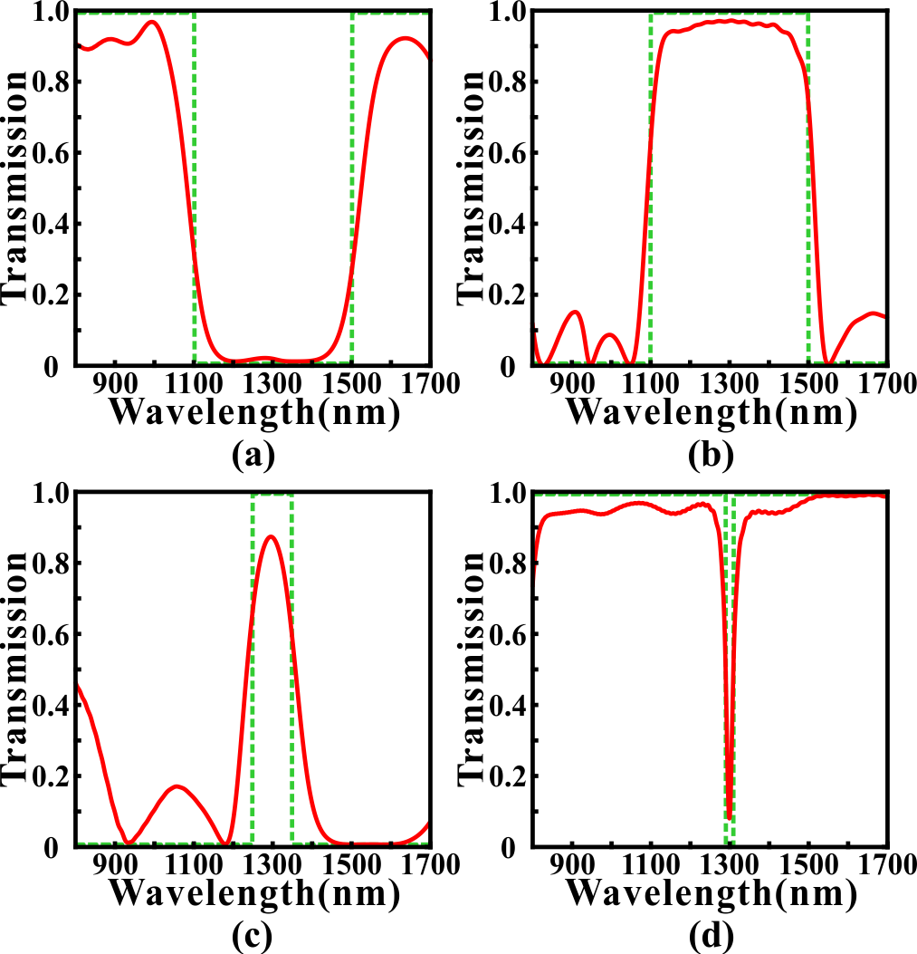
Fig. 5. The transmission spectrums optimized by GA for (a) BBSF (b) BBPF (c) NBPF. (d) The contrast result which is designed for NBSF. The green dotted line is the target transmission spectrum. Red solid line is the optimized transmission spectrum.

Next, we will discuss two issues which run through this optimization task. Firstly, it's clear that an important factor determining the final optimization performance is narrowing the gap between the simulation spectrums and the target spectrums as much as possible. Here, we proposed a simple but effective method named weighting operation to improve the performance metrics.
As we proposed, we consider the Euclidean distance between the simulated spectrums and the target spectrums as the optimization objective function (loss). Here, we add a weighting factor to calculate the Euclidean distance. The details are outlined as follows: (i) dividing the transmission spectrums into two parts according to the importance of wavelength. (ii) One part is called "the central" which represents the waveband of stopband and passband or the waveband we focused on. The other part is called ''the else'' which has no significant impact for our target performance metrics. (iii) In each iteration, we calculate the optimization objective function by the following formula:
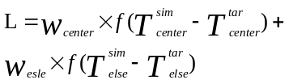 (2)
where the w_{center} is the weighting factor for "the central" and the w_{else} is for "the else". The function f represents calculating Euclidean distance. And the Tsim center represents the simulated transmittances in "the central" waveband. The rest are similar as well.
For example, we use GA to design and optimize a NBSF with 20nm bandwidth in 1300nm central wavelength. Here, the ACM is composed of 8×8 pixels. "The central" is the waveband from 1290nm to 1310nm, and the rest of the waveband belongs to "the else". In Fig. 6, we compared the optimized results with several sets of different weighting settings.
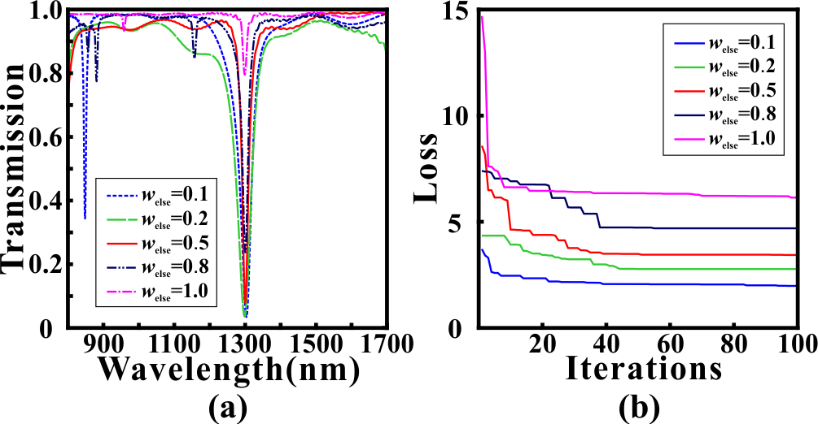
Fig. 6. (a) The optimized transmission spectrums for NBSF in different weighting settings (b) The variation of loss values in different weighting settings. In all settings, w_{center} is set to 1.
In Fig. 6(b), we observe that the loss value in each setting has an obvious convergence. The loss decreases from 3.72 to 1.98 with 46.77% decline when w_{else} = 0.1, 4.35 to 2.77 with 36.32% decline when w_{else} = 0.2, 8.58 to 3.44 with 59.91% decline when w_{else} = 0.5, 7.39 to 4.69 with 36.54% decline when w_{else} = 0.8 and 14.69 to 6.14 with 58.20% decline when w_{else} = 1.0. Because of the weighting factor and distribution of waveband, the loss value with smaller weighting factor is smaller totally. However, it can be found that the minimum transmittance at absorption peak is only 0.7968 when w_{else} = 1.0 which still is large to realize a BSF even if the loss value has a steep and quick convergence in Fig. 6(b). With w_{else} decreasing, the minimum transmittance at absorption peak decreases to 0.2389, 0.0812, 0.0376 and 0.0360, respectively. Meanwhile, we can notice that the sideband has more violent fluctuations when w_{else} decreases from 1.0 to 0.1. The 3dB bandwidth are 14.5nm, 7.5nm, 10.5nm and 8nm from w_{else}=0.8 to w_{else}=0.1. Especially, the minimum transmittance is only -0.9863dB so there is no 3dB bandwidth when w_{else} = 1.0. The patterns of minimum transmittance and 3dB bandwidth are explained as follows: the contribution of "the else" becomes weak for loss value as w_{else} decreasing so that the fluctuations in "the else" are "smoothed" in the evolution process. At the same time, the significance of "the central" is amplified equivalently so we get smaller minimum transmittance at stopband. On the other hand, the smaller minimum transmittance can get smaller 3dB bandwidth because of exponential conversion. In this paper, we usually use a weighting factor of w_{else} = 0.5 which has a balance between bandwidth, minimum transmittance and fluctuations of sideband in most cases. However, it is better to adjust the weighting factor in time according to the specific performance after single optimization.

Then, another important factor of this optimization task is the density of pixels of the ACM. We emphasize that the diversity of the ACM determines the functions which can be realized. Theoretically, the possibilities of the permutation and combination of ACM grow exponentially as the density of pixels increasing. Although the algorithms we used in this paper are suitable for global optimization task but not infinitely. Therefore, it is necessary to choose an appropriate density of ACM which can not only ensure the diversity but also improve the efficiency of the algorithms. Here, we test all four algorithms to optimize a NBSF with 20nm 3dB bandwidth at 1300nm central wavelength with different densities. In Fig. 7, we exhibit the optimized results with densities of 5×5, 8×8, 10×10 and 20×20, respectively.
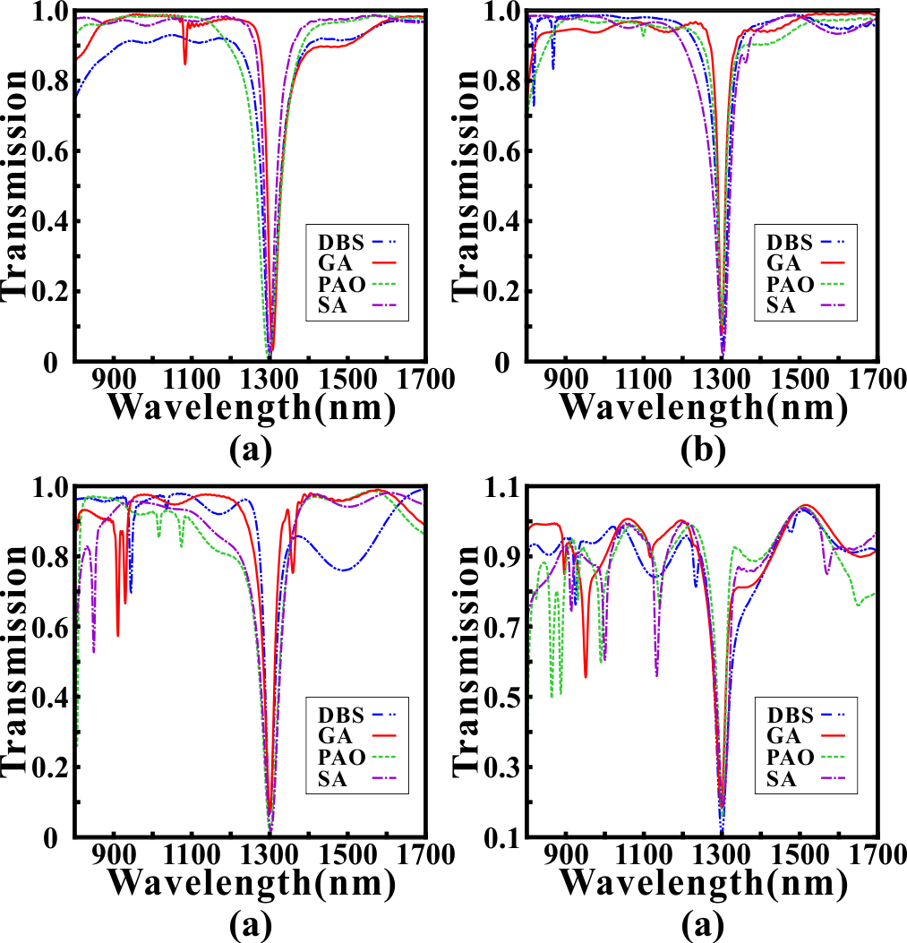
Fig. 7. The optimized results of NBSF with densities of (a) 5×5 pixels (b) 8×8 pixels (c) 10×10 pixels (d) 20×20 pixels.
The performance metrics with four different densities are shown from Table I to Table IV. Here, L_{c} is the central wavelength at absorption peak. T_{min} is the minimum transmittance of the stopband. And 3dB bandwidth is the bandwidth which increases by 3dB from T_{min}. As a whole, the performance metrics have a remarkable descent as densities increasing in all situations. It can be found that the central wavelength offset, minimum transmittance and 3dB bandwidth of 20×20 pixels perform worst compared with others. Meanwhile, the fluctuations in sideband are extremely violent which restricts the using band of filter. It is apparent that simple transmission spectrums can be realized depending on regular symmetric structures which are difficult and unpredictable to organize with 20×20 pixels. In other words, the density of 20×20 pixels is too much redundant for this task. Moreover, one single simulation with this density will spend several times than others because of the complexity of ACM increasing evidently. In other densities, the difference of performance metrics is not obvious. Compared with 5×5 pixels and 10×10 pixels, the sideband inhibition performs better and the metrics have an equilibrium when density is 8×8 pixels. Although 3dB bandwidth and minimum transmittance are more competitive in 5×5 pixels but central wavelength offset is large which limits the precision of tunability. Therefore, we choose 8×8 pixels to finish most optimization tasks and it performs well in this paper considering diversity and computational efficiency.
- PIT effect
In last section, we show that our system can realize a variety of filtering functions, but these functions are relatively simple, and there are many other simpler systems that can achieve. Actually, the advantages of our PMPWS are that it can be programmed to realize more complex functions and the system is tunable of wavelength.
Table I
Performance of 5×5 pixels
Methods | L_{c}(nm) | T_{min} | 3dB bandwidth(nm)
MDBS | 1300.5 | 0.0124 | 6
SA | 1299 | 0.0267 | 6.5
DBPSO | 1296.5 | 0.0071 | 6
GA | 1307 | 0.0330 | 7
Table II
Performance of 8×8 pixels
Methods | L_{c}(nm) | T_{min} | 3dB bandwidth(nm)
MDBS | 1302.5 | 0.0441 | 7.5
SA | 1303 | 0.0184 | 6.5
DBPSO | 1299 | 0.1045 | 10.5
GA | 1299.5 | 0.0812 | 7.5
Table III
Performance of 10×10 pixels
Methods | L_{c}(nm) | T_{min} | 3dB bandwidth(nm)
MDBS | 1299.5 | 0.0657 | 9.5
SA | 1302.5 | 0.0185 | 8
DBPSO | 1302 | 0.0206 | 8.5
GA | 1299.5 | 0.0737 | 10
Table IV
Performance of 20×20 pixels
Methods | L_{c}(nm) | T_{min} | 3dB bandwidth(nm)
MDBS | 1299.5 | 0.1091 | 16
SA | 1301.5 | 0.1822 | 23
DBPSO | 1301 | 0.1588 | 13
GA | 1297.5 | 0.1860 | 19

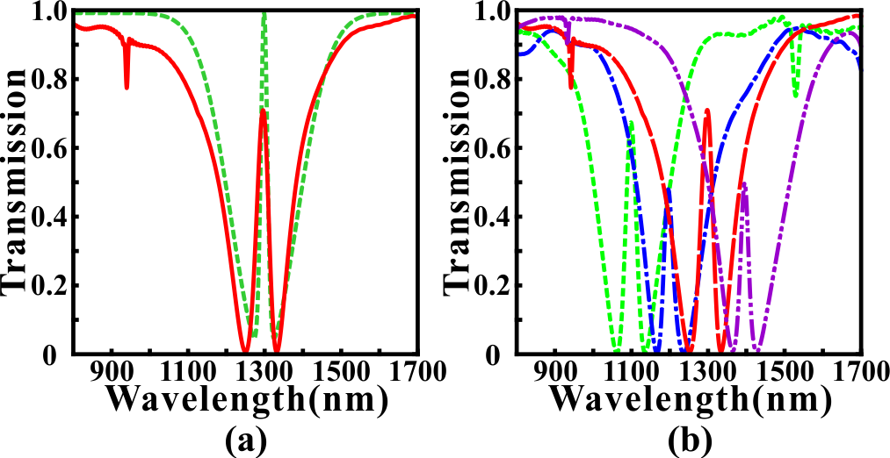
Fig. 8. (a) The simulated PIT transmission spectrum in 1300nm. The green dotted line is the target transmission spectrum. Red solid line is the optimized transmission spectrum. (b) Tunable PIT effect for different central wavelength. The target PIT windows are 1100nm, 1200nm, 1300nm and 1400nm.

Here, we use GA to realize PIT effect in our PMPWS which has great applications in ultrafast optical signal processing, optical data storage and microwave photonics [27,28]. In this simulation, the ACM is composed of 8×8 pixels and the target FWHM of the transmission peak at stopband is 20nm. Fig. 8 shows the calculated results after optimization. In Fig. 8(a), we get a PIT window at 1297nm wavelength. The peak value is 0.7115 and the valley values are 0.0084 and 0.0086, respectively. And the wavelengths of valleys are 1251nm and 1333nm. The Q-factor which is an important parameter to evaluate the performance of the PIT effect is calculated by the following formula:
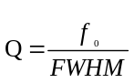 (1)
where the f₀ is the frequency of maximum transmission at the PIT window, and the FWHM is the full width at half maximum. In this optimization, the FWHM is 35.5nm and the Q-factor reaches 36.54 in near infrared waveband. In fact, the Q-factor is lower in the metallic systems due to ohmic damping [54]. What's more, we do not need any energy to consider the coupling relation which is difficult and incomprehensible in PIT design task so researchers can focus on improving the performance using more powerful constraint conditions or efficient algorithms.

As we mentioned, one of the most competitive advantages of PMPWS is tunability. Fig. 8(b) shows the tunable PIT effect with different central wavelengths only by adjusting the target function before optimization. These PIT windows appear at 1098nm, 1195nm and 1395nm, respectively. The maximum deviation is only 5nm. Then the corresponding FWHMs and Q-factors are 31.5nm, 27nm and 24nm, respectively and 34.86, 44.26 and 58.13, respectively. Lastly, the extinction ratio between peaks and valleys is 19.27dB and 19.19dB for 1098nm, 20.52dB and 18.93dB for 1195nm, 16.55dB and 18.22dB for 1395nm. Obviously, the optimization performances are well-matched for all PIT peaks which proves that our optimization methods and structure have strong universality and plasticity. Actually, we can get arbitrary PIT windows in the wave band from 900nm to 1600nm and the tunability is adaptive for all types of device in this paper.
Here, we provide a qualitative explanation of the PIT effect in this simulation based on the field distributions. The results are exhibited in Fig. 9. It can be found that SPPs is bound in the pixel cavity which is framed by the red dotted line so there is a valley at 1251nm in the transmission spectrum. When wavelength increases to 1297nm, SPPs which is coupled into yellow zone and blue zone through the red zone forms a resonant mode. And the phase is same when coupled back into the strip waveguide so generate a transmission peak. As wavelength increasing to 1333nm, the resonant mode becomes opposite compared with the mode at 1297nm. Therefore, it makes the SPPs coupled back restrain the transmission of the SPPs in the strip waveguide.

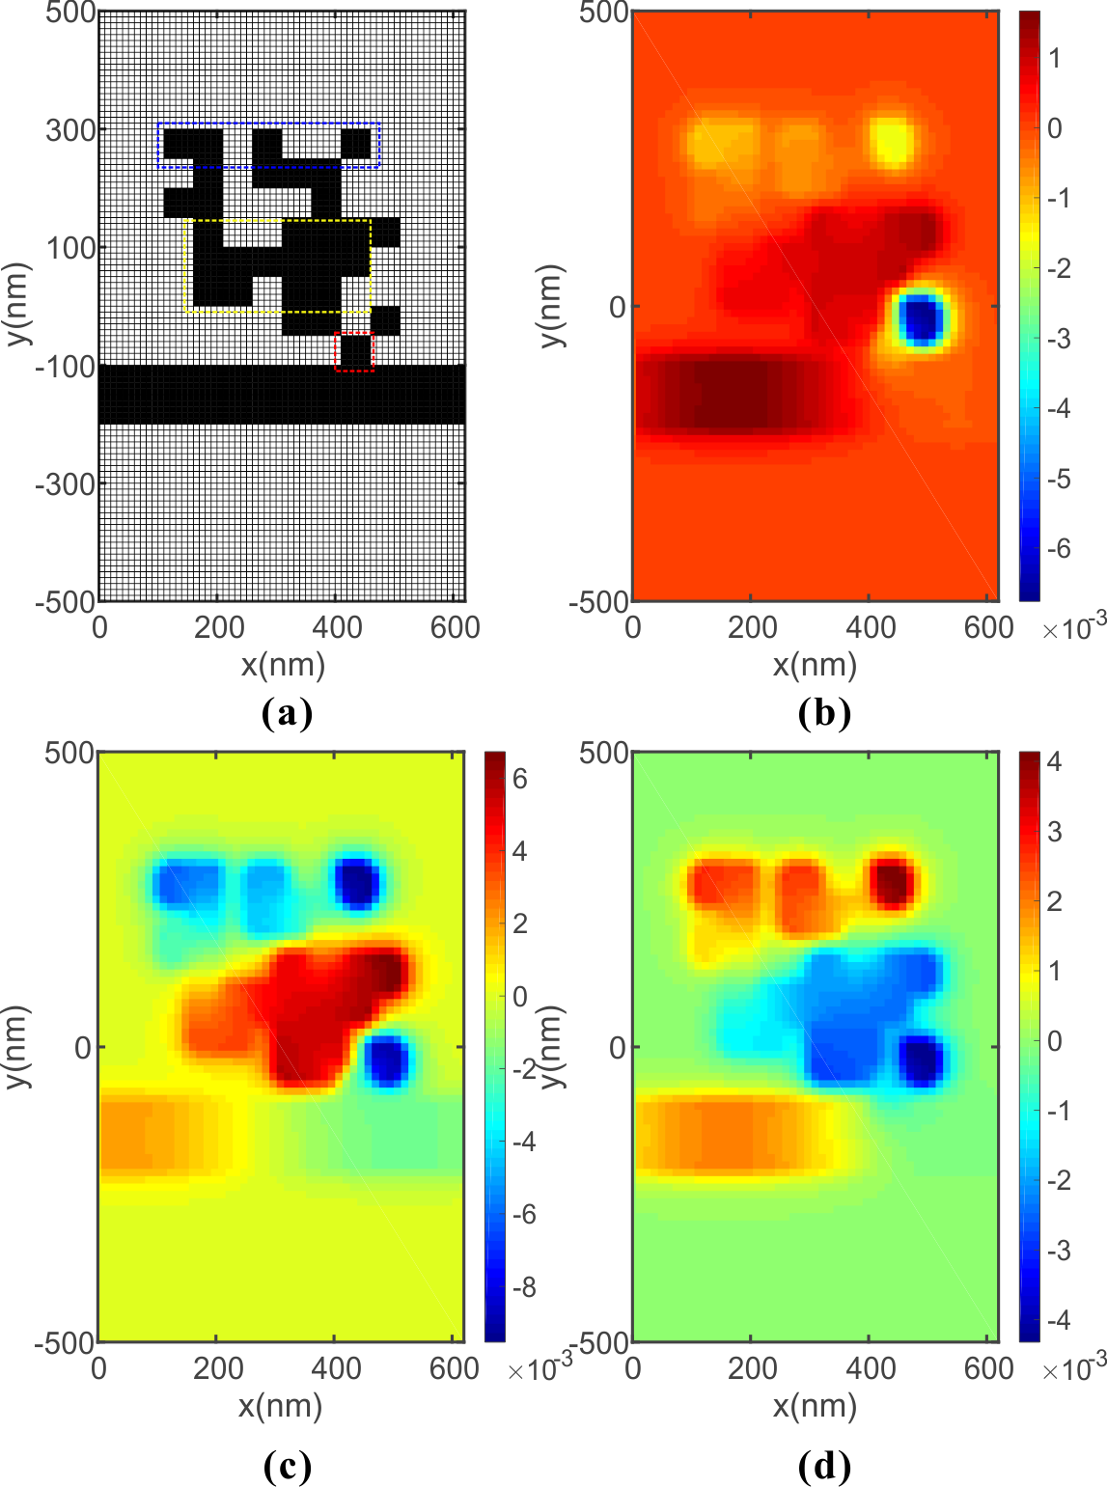
Fig. 9 (a) The distribution of ACM and PMPWS for PIT effect whose window is at 1297nm. The field distribution of the real part of the magnetic field Hz at (b) 1251nm, (c)1297nm, (d) 1333nm.

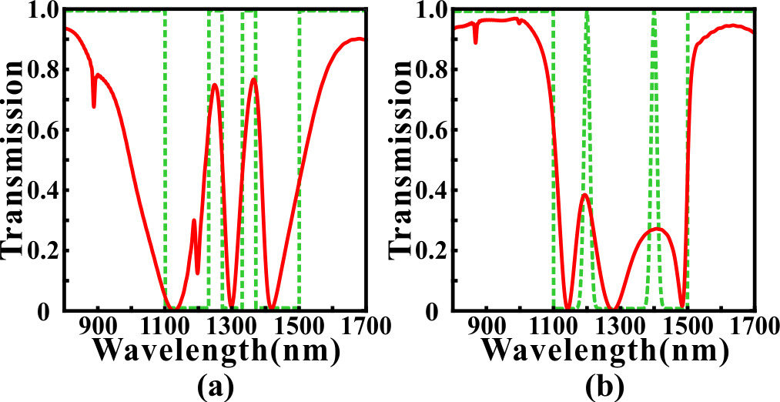
Fig. 10 (a) The simulated results of dual PIT effect based on gate function. The target PIT windows are 1250nm and 1350nm. FWHMs of PIT transmission peaks are both 40nm. (b) The simulated results of dual PIT effect based on gauss function. The target PIT windows are 1200nm and 1400nm. FWHMs of PIT transmission peaks are both 20nm. The green dotted line is the target transmission spectrum. Red solid line is the optimized transmission spectrum.
Lastly, we try to increase the complexity of the target transmission spectrums and expect to achieve dual PIT effect. The calculated results are shown in Fig. 10. Fig. 10(a) shows a more ideal dual PIT window with higher transmissivity of PIT peaks which are 0.7502 and 0.7684. But the optimization and matching of sideband are not as good as Fig. 10(b). It should be noticed that the wavelength is equidistant in our simulation. However, the wavelength range that determines the performance of the optimization effect is a small part which is only a few to a dozen percent of the total data. Although we use the weighting method to eliminate effects from sideband, there are still problems to be solved to make the simulation results match the target spectrums perfectly. But at least, we can notice the potential of this system to achieve more complex functions from Fig.10.

CONCLUSION
In conclusion, we propose a programmable multifunctional plasmonic waveguide system (PMPWS) based on coding metamaterials and inverse design. Then, several optimization algorithms, such as MDBS, SA, GA and DBPSO are applied in the design of the ACM of PMPWS. At the same time, the weighting method we proposed improves the performance metrics. The FDTD simulated results demonstrate that the PMPWS can not only realize simple multi-functional filtering, but also realize more complex PIT effect. Moreover, these plasmonic devices is tunable which is advantageous in highly integrated optical circuits. Although the perfect matching between target spectrums and optimized spectrums is still different to realize. However, these results truly prove that PMPWS combined with algorithms optimization has great potential to design multifunctional plasmonic devices with low cost and high efficiency. Meanwhile, we consider the side coupling in this paper so it is inefficient for bandpass tasks. Other ways of coupling may overcome this problem. In the future, designing more efficient algorithm evaluation mechanisms or coupling methods are worth to focus on.
References
[1] D.K. Gramotnev and S.I. Bozhevolnyi, "Plasmonics beyond the diffraction limit," Nat. Photonics 4, 83-91 (2010).
[2] T. Zhang, L. Chen, and X. Li, "Graphene-based tunable broadband hyperlens for far-field subdiffraction imaging at mid-infrared frequencies," Opt. Express 21, 20888-20899 (2013).
[3] Hooper I R, Sambles J R. Dispersion of surface plasmon polaritons on short-pitch metal gratings[J]. Physical Review B, 2002, 65(16): 165432.
[4] Otto A. Excitation of nonradiative surface plasma waves in silver by the method of frustrated total reflection[J]. Zeitschrift für Physik, 1968, 216(4): 398-410.
[5] Kretschmann E, Raether H. Notizen: Radiative Decay of Non Radiative Surface Plasmons Excited by Light[J]. Zeitschrift für Naturforschung A, 1968, 23(12): 2135-2136.
[6] 暂缺
[7] G. I. Stegeman, R. F. Wallis, and A. A. Maradudin, "Excitation of surface polaritons by end-fire coupling," Opt. Lett. 8, 386-388 (1983).
[8] D. Rodrigo and et al, "Mid-infrared plasmonic biosensing with graphene," Science 349(6244), 165-168 (2015).
[9] Kocabaş Ş E, Veronis G, Miller D A B, et al. Modal analysis and coupling in metal-insulator-metal waveguides[J]. Physical Review B, 2009, 79(3): 035120.
[10] Du B, Yang Y, Zhang Y, et al. Plasmonic grating based on insulator–metal–insulator structure at telecom wavelengths[J]. IEEE Photonics Technology Letters, 2018, 30(19): 1691-1694.
[11] Lu H, Gan X, Mao D, et al. Graphene-supported manipulation of surface plasmon polaritons in metallic nanowaveguides[J]. Photonics Research, 2017, 5(3): 162-167.
[12] Yun B, Hu G, Cui Y. Theoretical analysis of a nanoscale plasmonic filter based on a rectangular metal–insulator–metal waveguide[J]. Journal of Physics D: Applied Physics, 2010, 43(38): 385102.
[13] Zhang Z, Shi F, Chen Y. Tunable multichannel plasmonic filter based on coupling-induced mode splitting[J]. Plasmonics, 2015, 10(1): 139-144.
[14] Kwon M S, Shin J S, Lee J H. Metal–insulator–silicon–insulator–metal waveguide splitters with large-arm separation[J]. Journal of Lightwave Technology, 2015, 33(18): 3843-3849.
[15] Longkun Yang, Pan Li, and Zhipeng Li, "Plasmonic polarization beam splitting based on single silver nanowire," Opt. Express 27, 3851-3860 (2019).
[16] Gómez-Díaz J S, Perruisseau-Carrier J. Graphene-based plasmonic switches at near infrared frequencies[J]. Optics express, 2013, 21(13): 15490-15504.
[17] Emboras A, Hoessbacher C, Haffner C, et al. Electrically controlled plasmonic switches and modulators[J]. IEEE Journal of Selected Topics in Quantum Electronics, 2014, 21(4): 276-283.
[18] Hössbacher C, Josten A, Bäuerle B, et al. Plasmonic modulator with> 170 GHz bandwidth demonstrated at 100 GBd NRZ[J]. Optics Express, 2017, 25(3): 1762-1768.
[19] Zhang B, Zhao Y, Hao Q, et al. Polarization-independent dual-band infrared perfect absorber based on a metal-dielectric-metal elliptical nanodisk array[J]. Optics express, 2011, 19(16): 15221-15228.
[20] Lu H, Liu X, Mao D, et al. Plasmonic nanosensor based on Fano resonance in waveguide-coupled resonators[J]. Optics letters, 2012, 37(18): 3780-3782.
[21] Yang R, Wahsheh R A, Lu Z, et al. Efficient light coupling between dielectric slot waveguide and plasmonic slot waveguide[J]. Optics letters, 2010, 35(5): 649-651.
[22] Patel V, Sharma P, Kumar V D. Efficient coupling from dielectric to hybrid plasmonic waveguide using curved taper[J]. IEEE Photonics Technology Letters, 2019, 31(4): 323-326.
[23] Liu Z, Ding L, Yi J, et al. Design of a multi-bits input optical logic device with high intensity contrast based on plasmonic waveguides structure[J]. Optics Communications, 2019, 430: 112-118.
[24] Zhang H, Shen D, Zhang Y. Circular split-ring core resonators used in nanoscale metal–insulator–metal band-stop filters[J]. Laser Physics Letters, 2014, 11(11): 115902.
[25] Liu X, Tian J, Yang R. Surface plasmon polariton based metal-insulator-metal filter including two face-to-face concentric semi-rings with different radii[J]. Journal of Optical Technology, 2017, 84(9): 588-592.
[26] Lai W, Wen K, Lin J, et al. Plasmonic filter and sensor based on a subwavelength end-coupled hexagonal resonator[J]. Applied optics, 2018, 57(22): 6369-6374.
[27] Han Z, Bozhevolnyi S I. Plasmon-induced transparency with detuned ultracompact Fabry-Perot resonators in integrated plasmonic devices[J]. Optics Express, 2011, 19(4): 3251-3257.
[28] Wang G, Lu H, Liu X. Dispersionless slow light in MIM waveguide based on a plasmonic analogue of electromagnetically induced transparency[J]. Optics express, 2012, 20(19): 20902-20907.
[29] Zhan S, Li H, Cao G, et al. Slow light based on plasmon-induced transparency in dual-ring resonator-coupled MDM waveguide system[J]. Journal of Physics D: Applied Physics, 2014, 47(20): 205101.
[30] Chen J, Wang C, Zhang R, et al. Multiple plasmon-induced transparencies in coupled-resonator systems[J]. Optics letters, 2012, 37(24): 5133-5135.
[31] Lu H, Liu X, Mao D, et al. Induced transparency in nanoscale plasmonic resonator systems[J]. Optics letters, 2011, 36(16): 3233-3235.
[32] Zhan S, Kong D, Cao G, et al. Analogy of plasmon induced transparency in detuned U-resonators coupling to MDM plasmonic waveguide[J]. Solid state communications, 2013, 174: 50-54.
[33] Zhan S, Li H, Cao G, et al. Theoretical analysis of plasmon-induced transparency in ring-resonators coupled channel drop filter systems[J]. Plasmonics, 2014, 9(6): 1431-1437.
[34] Guo J. Plasmon-induced transparency in metal–insulator–metal waveguide side-coupled with multiple cavities[J]. Applied optics, 2014, 53(8): 1604-1609.
[35] Liu H, Ren G, Gao Y, et al. Tunable subwavelength terahertz plasmon-induced transparency in the InSb slot waveguide side-coupled with two stub resonators[J]. Applied Optics, 2015, 54(13): 3918-3924.
[36] Yu D M, Zhai X, Wang L L, et al. Plasmon-induced transparency in a surface plasmon polariton waveguide with a right-angled slot and rectangle cavity[J]. Plasmonics, 2016, 11(4): 1151-1155.
[37] Lu H, Liu X, Mao D. Plasmonic analog of electromagnetically induced transparency in multi-nanoresonator-coupled waveguide systems[J]. Physical Review A, 2012, 85(5): 053803.
[38] Molesky S, Lin Z, Piggott A Y, et al. Inverse design in nanophotonics[J]. Nature Photonics, 2018, 12(11): 659-670.
[39] T. Zhang and et al, "Efficient spectrum prediction and inverse design for
plasmonic waveguide systems based on artificial neural networks," Photonics
Research 7(3), 368-380 (2019).
[40] T. W. Hughes and et al, "Adjoint method and inverse design for nonlinear
nanophotonic devices," ACS Photonics 5, 4781-4787 (2018).
[41] Zhang T, Liu Q, Dan Y, et al. Inverse design and optimization of graphene metamaterial for multi-peak plasmon induced transparency based on machine learning and evolutionary algorithms[J]. arXiv preprint arXiv:1908.01354, 2019.
[42] Skaar J, Risvik K M. A genetic algorithm for the inverse problem in synthesis of fiber gratings[J]. Journal of lightwave technology, 1998, 16(10): 1928.
[43] Kern D J, Werner D H. A genetic algorithm approach to the design of ultra-thin electromagnetic bandgap absorbers[J]. Microwave and Optical Technology Letters, 2003, 38(1): 61-64.
[44] Chen P Y, Chen C H, Wang H, et al. Synthesis design of artificial magnetic metamaterials using a genetic algorithm[J]. Optics express, 2008, 16(17): 12806-12818.
[45] Shokooh-Saremi M, Magnusson R. Particle swarm optimization and its application to the design of diffraction grating filters[J]. Optics letters, 2007, 32(8): 894-896.
[46] Forestiere C, Donelli M, Walsh G F, et al. Particle-swarm optimization of broadband nanoplasmonic arrays[J]. Optics letters, 2010, 35(2): 133-135.
[47] Lu Q, Wei W, Yan X, et al. Particle swarm optimized ultra-compact polarization beam splitter on silicon-on-insulator[J]. Photonics and Nanostructures-Fundamentals and Applications, 2018, 32: 19-23.
[48] Kim W J, O'Brien J D. Optimization of a two-dimensional photonic-crystal waveguide branch by simulated annealing and the finite-element method[J]. JOSA B, 2004, 21(2): 289-295.
[49] Shen B, Wang P, Polson R, et al. An integrated-nanophotonics polarization beamsplitter with 2.4× 2.4 μm 2 footprint[J]. Nature Photonics, 2015, 9(6): 378-382.
[50] L. Chuang and et al, "Improved binary PSO for feature selection using
gene expression data," Comput. Biol. Chem. 32(1), 29-38 (2008).
[51]
[52]
[53]
[54] Hu J, Lang T, Hong Z, et al. Comparison of electromagnetically induced transparency performance in metallic and all-dielectric metamaterials[J]. Journal of Lightwave Technology, 2018, 36(11): 2083-2093.

