Hathaway – Sjostrom 2022
The best-laid plans of mice and men…but the poet didn’t say anything about women. I had the best intentions in the summer of 2021 to write and send this Christmas letter by October 2021 at the latest. So here we are, more than a year later and I’ve decided we need to email our greetings.

Wait! What?
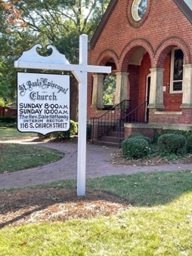
In August 2021 we moved from South Carolina to North Carolina. You may be aware that we’ve had plans for quite a while to retire to the beach, probably to Florida. While this move got us a little closer to the beach, we were still more than 3 hours away. So what’s that about? We answered God’s call. Since our move to the mainland in 2014, Dale had been supplying (substituting) for a number of parishes, including St. Paul’s in Monroe NC since 2017. When their priest passed away (cancer) in May 2021, Dale was asked to be a part-time interim rector. Both of us felt God was calling us to this ministry. Rock Hill is only 40 miles from Monroe, but an hour-long drive on country roads. Taking advantage of a hot housing market, we sold our home in Rock Hill in August 2021 and leased a home in Monroe. We were certain housing prices would drop in 2022 when we planned to move to Florida.

COVID 19
You’ve heard there was a pandemic, right? It certainly impacted us in numerous ways. In March 2020 Mary Pat, who retired from Winthrop University in May 2019, was conducting professional development sessions for a small rural school system; her last session was on March 11. Dale was teaching religion classes at Winthrop, which converted to virtual instruction over spring break; he continued to teach remotely through the 2020-21 school year. As a priest, Dale spent much of 2020 and the beginning of 2021 using a variety of technology (video, zoom, facebook live) to offer religious services to congregations where he supplied. As vaccinations became available, we gradually moved from outdoor services to indoors, with masking and social distancing whenever transmission rates soared. Mary Pat enjoyed growing into the role of pastor’s wife. One aspect of our ministry allowed her to combine her love of people and her enjoyment of cooking: We hosted several small dinner parties for people from St. Paul’s. It was a blessing to serve the people of St. Paul’s, but also at times difficult and exhausting. Dale finally decided he was ready for retirement. (YAY!) As his contract with St. Paul’s came to an end, we began to look for a home in a warmer climate, closer to the ocean.

We avoided Covid 19 and were mostly quite healthy during the pandemic. However, Dale had a cat scan in fall 2021, a routine follow-up to heart issues he’s had for several years. It turned out to be not so routine, and in early November 2021 he had a heart catheterization. They found one artery with a 90% blockage and put in a stent. He’s feeling fine now (surprisingly, he didn’t really feel bad before), attended cardio-rehab for a while, and continues to exercise through bicycling and Nordic walking.

2022 – Another move
This is our last, I promise. We’ve heard that people always say that. But between us we have moved almost 50 times, and we have never before said “this is the last”. So, until the kids have to put us in a home, this is it! In April we bought a house in Highland Lakes, a 55+ community in Palm Harbor, FL, in the Tampa Bay area (actually Clearwater). The purchase was mostly sight unseen, as the housing market did NOT calm down, and there have been a few wrinkles: new roof, repairs to air conditioner, electrical and plumbing issues…and then the refrigerator died – twice! Oh, and it took 6 weeks for our “stuff” to arrive, so we had an eventful summer, staying with cousins and camping out in the living room on air mattresses. But we’re mostly happy with the house and the community, and we love being 3 miles from the gulf. We had a chance to practice hurricane preparation in September, grateful that at the last minute Ian turned south and missed us. We pray for the people of Fort Myers, many of whom lost everything.

Travel 2023
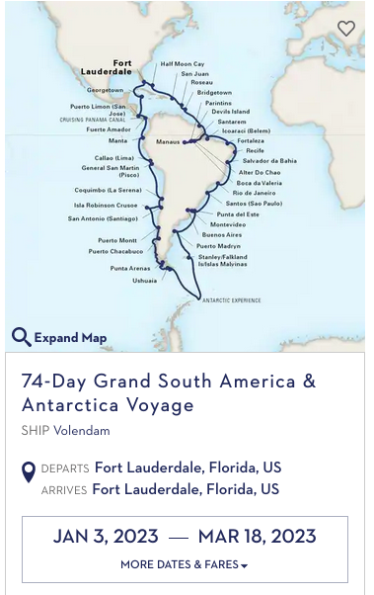
Despite being vaccinated and boosted, we were oh-so-careful during the pandemic and really curtailed our travel. However, we have exciting travel plans for 2023; we’ve booked a 74-day cruise (see map at left). We’re so excited! We’ve never been on a cruise longer than a week, and packing for the equator and Antarctica will be a challenge. We’ll go through the Panama Canal, down the Pacific coast of South America, and spend several days cruising in Antarctica. Then around the cape and up the Atlantic coast, with frequent stops in port cities on both sides of South America. A highlight of the trip (in a trip filled with highlights, including Antarctica!) is a week cruising up the Amazon. Hopefully Antarctica and the Amazon rain forest will still be there, and Covid-19 won’t be.

Please note new (and permanent) address; our phone numbers and email addresses haven’t changed. We would love to hear from you.

Dale Hathaway and Mary Pat Sjostrom
2648 Camille Drive
Palm Harbor FL. 34684

Dale Hathaway Mary Pat Sjostrom
808-780-2573 808-497-1617
dhath12@gmail.com marypat.sjostrom@gmail.com

Sjostrom Family News
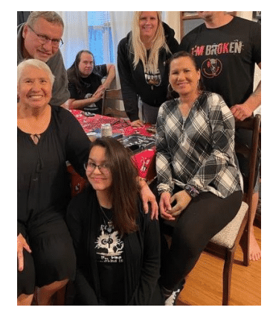
Since Mom’s passing early in 2021, the seven Sjostrom siblings have managed to stay close. Mary Pat’s brother Bob and his wife Brenda moved to Florida last summer, to a lovely community a little over an hour from us. The rest of the family planned to visit at the end of September, and we almost made it, but Hurricane Ian caused a change of plans. So Bob and Brenda and the two of us braved the cold and went to Ohio, where Joe and Tami hosted a second Thanksgiving dinner. I’m sure the Florida trip will be rescheduled next year.

Sean and Joleen live in Rock Hill and continue to stay active in AA. They enjoy Nascar during the season. They hosted Thanksgiving for the second year in a row. Amy and Patch were able to get away from Atlanta for a few days to join us, and we always enjoy seeing Joleen’s mother Jane, brother Ray and daughter Raven. We have so much to be grateful for! We will all meet again in Rock Hill for Sean and Joleen’s wedding in April 2023.

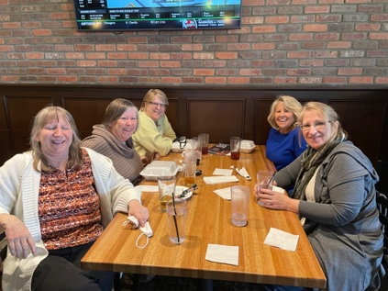
Amy and Patch live in the Atlanta suburbs, where Amy continues her music, playing bass guitar and sometimes cello in several Atlanta-based bands. She made the best of things during the pandemic by developing a series of podcasts on Facebook, interviewing musicians, and writing for Guitar Girl magazine. Since things have opened up, her groups have sometimes played in Charlotte , Asheville, and Myrtle Beach. Pre-pandemic we enjoyed attending. Look for Amy Epperley on Facebook and Instagram.

Hathaway Family News
Dale’s family is scattered across the country, and COVID made it difficult for us to get together. Miriam has done a massively impressive job as a mom of young children during this time of pandemic. River and Will are exceptional however you measure it – though that’s the view of a grandpa. Owen’s children are doing well in a multi-colored variety of approaches to life. Madison graduated from college and is working in Denver. Bella graduated from high school early, got a certificate and a job caring for the elderly in a nursing home. She is now working towards her degree and with her it seems the sky’s the limit. Julian has continued to learn his trade and is employed in his beloved mountains, providing time for mountain activities. We really enjoyed a visit from him last month. Lydia is teaching elementary school in South Bend; we’ve been able to visit her a couple of times.

Dale’s brother David has made a happy shift in his life; he met and became engaged to Laura, who was a neighbor of their mother in Las Cruces, NM. David and Laura will be married in January 2023, and have bought a lovely home in Albuquerque. Bill and Karla are still in Arizona, though both of them feel a tug to relocate. Santa Fe? Denver? For the time being they remain nestled in their home in the forest outside of Flagstaff.

