pacific-cruise-itinerary-with-graphic

## Pacific Cruise 2025

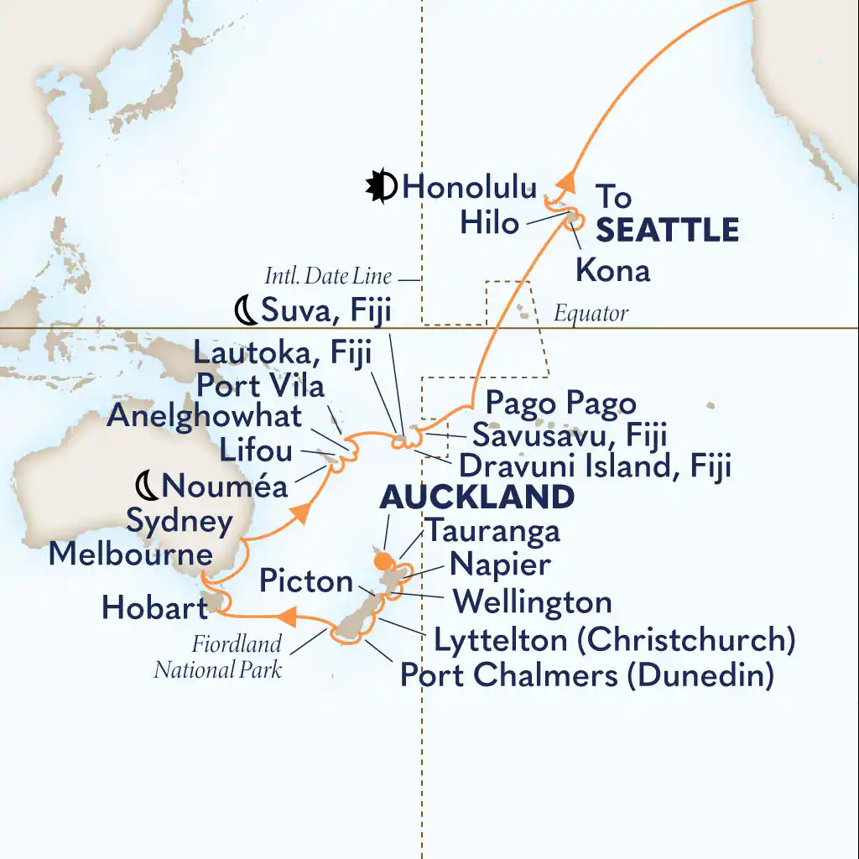

* March 4 Fly to Honolulu
* Mar 16, 2025 at 5pm Auckland, New Zealand
* March 16 Departs 5pm DAY 1 - AUCKLAND, NEW ZEALAND
* March 17 In Port - 8am to 5pm DAY 2 - TAURANGA (ROTORUA), NEW ZEALAND
* March 18 - NAPIER, NEW ZEALAND March 18 In Port - 12am to 6pm
* March 19 In Port - 10am to 6pm DAY 4 - WELLINGTON, NEW ZEALAND
* March 20 In Port - 8am to 5pm DAY 5 - PICTON, NEW ZEALAND
* March 21 In Port - 8am to 5pm DAY 6 - LYTTELTON (CHRISTCHURCH), NEW ZEALAND
* March 22 In Port - 7am to 6pm DAY 7 - PORT CHALMERS (DUNEDIN), NEW ZEALAND
* March 23 DAY 8 - CRUISING FIORDLAND NATL PARK
* March 24 DAY 9 - AT SEA
* March 25 DAY 10 - AT SEA
* March 26 In Port - 8am to 5pm DAY 11 - HOBART, TASMANIA, AUSTRALIA
* March 27 DAY 12 - AT SEA
* March 28 In Port - 8am to 5pm DAY 13 - MELBOURNE, AUSTRALIA
* March 29 DAY 14 - AT SEA
* March 30 SYDNEY, AUSTRALIA
* March 30 In Port - 7am to 6:45pm PLANNED ACTIVITIES:
* March 31 DAY 16 - AT SEA
* April 1 DAY 17 - AT SEA
* April 2 In Port - 8am to 10pm DAY 18 - NOUMEA, NEW CALEDONIA
* April 3 In Port - 8am to 5pm DAY 19 - EASO, LIFOU, NEW CALEDONIA
* April 4 In Port - 8am to 5pm DAY 20 - MYSTERY ISLAND, VANUATU
* April 5 In Port - 8am to 5pm DAY 21 - PORT VILA, VANUATU
* April 6 DAY 22 - AT SEA
* April 7 In Port - 8am to 5pm DAY 23 - LAUTOKA, FIJI
* April 8 In Port - 8am to 11pm
* April 9 In Port - 8am to 5pm DAY 25 - DRAVUNI ISLAND, FIJI
* April 10 In Port - 8am to 4pm DAY 26 - SAVUSAVU, VANUA LEVI, FIJI
* April 11 In Port - 9am to 5pm DAY 27 - PAGO PAGO, TUTUILA, AMERICAN SAMOA
* April 12 DAY 28 - AT SEA
* April 13 DAY 29 - CROSSING THE EQUATOR
* April 14 DAY 30 - AT SEA
* April 15 DAY 31 - AT SEA
* April 16 DAY 32 - AT SEA
* April 17 In Port - 8am to 9pm DAY 33 - KONA, HAWAII, US
* April 18 In Port - 8am to 5pm DAY 34 - HILO, HAWAII, US
* April 19 Arrives - 7am DAY 35 - HONOLULU, HAWAII, US
* April 20 Departs 5pm DAY 36 - HONOLULU, HAWAII, US
* April 21 DAY 37 - AT SEA
* April 22 DAY 38 - AT SEA
* April 23 DAY 39 - AT SEA
* April 24 DAY 40 - AT SEA
* April 25 DAY 41 - AT SEA
* April 26 In Port - 8am to 11pm DAY 42 - VICTORIA, BRITISH COLUMBIA, CANADA
* Apr 27, 2025 at 7am Seattle, Washington, US
* Return to Florida