1. All the parameters of APIs calls must use POST and using no direct URI parameters.
2. You can do it using several pages or one page only, but be aware that unless logged successfully the JavaScript code for the rest of the app should not be available in the source code on the login screen.
3. The design should be very clean, here are what the other pages will look like:

<https://willig.apliko.fr/client/?c=d&i=41&d=D200203025&k=GF45CS7NSK>

As you can see, it’s just black, grey and green buttons. It’s exactly what I want.

You can forget the header and footer. Just ready a dummy template file for both of them and I will do it myself. They will be added to all the pages.

1. It must be responsive. The main target is a desktop browser, but it should be easily viewable on mobile phone as well.
2. On the Hompage, there is a list at the top:

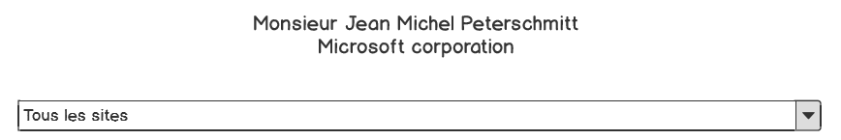

This list has the same function on all the pages. It serves as an address filter. When it’s on ‘Tous les sites’ (which mean ALL THE ADDRESS), it will display the information of all the addresses, but when we select a specific address, it will display the information of this selected one only.

1. The "address" is formatted using: **[street] + ", " + [city]**
2. The date format: "**DD-MM-YYYY**"
3. The time is in 24 hour format: **21:20**
4. All other data comes preformatted