Dale Hendricks
300-343-872
Student Name: _______________________________ID: ____________
Jesse Hett
300-129-611
Student Name: _______________________________ID: ____________
Jordan Newman
300-203-135
Student Name: _______________________________ID: ____________
Jake Jason Yatco
300-347-620
Student Name: _______________________________ID: ____________

Lab 4: Implementing GRASP Principles in JAVA

Part 1. USE CASE DIAGRAM

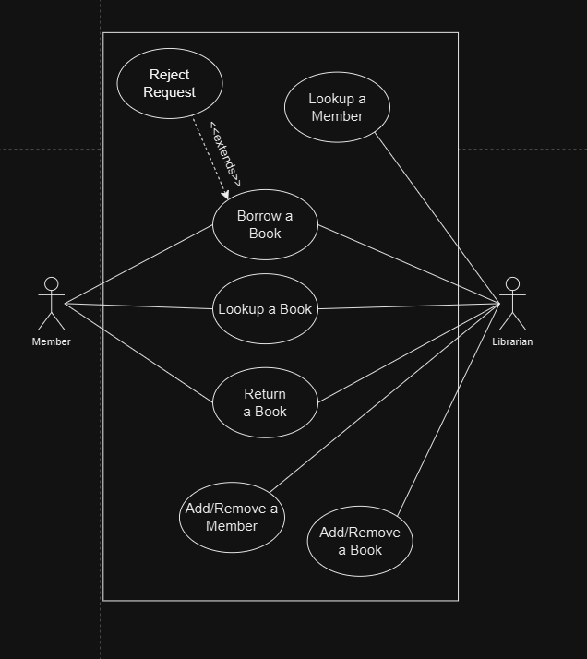
Part 2. CLASS DIAGRAM

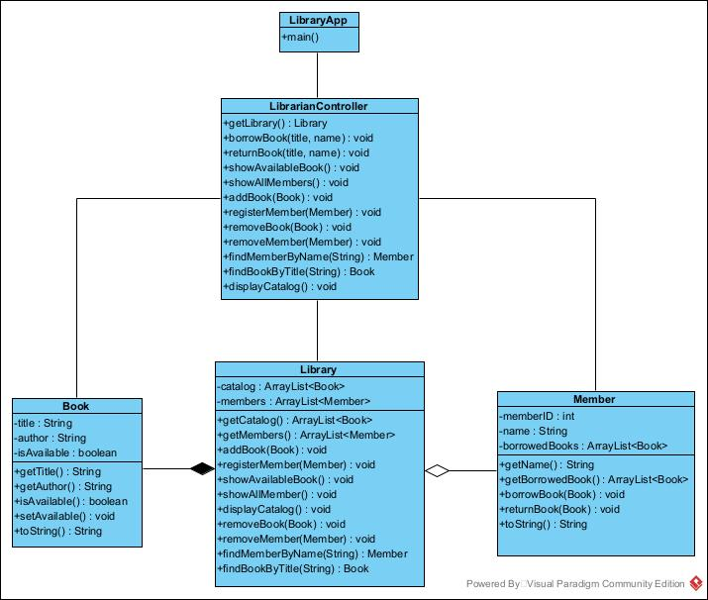

Summary of Relationships:
- Library and Member: Aggregation (Members can exist independently)
- Library and Book: Composition (Books are part of the Library)
- LibrarianController and Library: Association (Controller interacts with Library)
- LibrarianController and Book: Association (Controller interacts with Books)
- LibrarianController and Member: Association (Controller interacts with Members)
Part 3. GRASP PRINCIPLES APPLIED

1. Information Expert:
- Book Class – The Book knows if it’s available or not and can update that status by itself.
- Member Class – The Member keeps track of the books they have borrowed and manages that list.

2. Creator:
- Library Class – The Library is responsible for creating and managing Book and Member object. It has methods to add new books and register new members.

3. Controller:
- LibrarianController Class – This class acts like a manager which takes user request like borrowing a book and coordinates the actions by talking to the Library, Member and Book classes.

4. Low Coupling: The classes interact with each other through methods instead of directly changing each other’s internal attributes. This way, a class can be changed without messing up other classes.

5. High Cohesion:
Each Classes has a clear purpose
  - Book deals with book-related tasks
  - Member manages member-related tasks
  - Library oversees everything, including books and members
  - LibrarianController handles user action without getting involved in the details of books or members

