- Computational fluid dynamics (CFD) is a branch of fluid mechanics that uses numerical analysis and data structures to analyze and solve problems that involve fluid flows
- We are interested in predicting the evolution of properties such as velocity, pressure, temperature, density and viscosity
- Computers are used to perform the calculations required to simulate the free-stream flow of the fluid, and the interaction of the fluid (liquids and gases) with surfaces defined by boundary conditions
- To do so we define a mathematical model of the physical process (Navier Stockes equations) and we use numerical analysis methods to approximate a solution over a discrete grid.
- Navier-Stockes challenges :
  - Navier-Stokes equations are not well understood from a mathematical point of view. One of the famous seven problems of mathematics is related to proving the existence of smooth solutions in 3 dimensional space (smooth solutions are have continuous derivatives of every order)
  - turbulence : turbulence is the time dependent chaotic behavior observed in many fluid flows. Properly simulating turbulence requires a very fine mesh with is computationaly impractical.

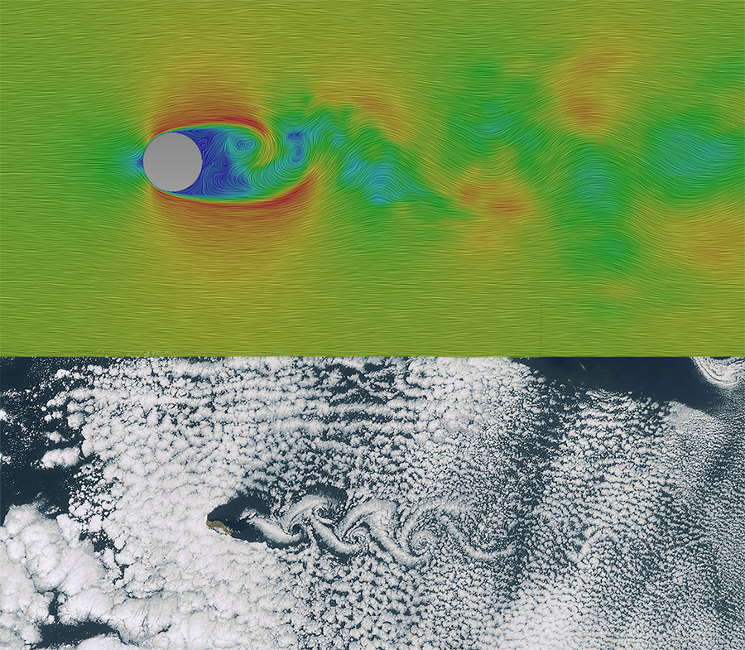
- Our idea : simulate on a coarse grid which has low computational cost and then use CNN’s to upsample our simulation to a higher resolution. It might be the case that there is enough information in the low resolution simulation for a ML model to upscale to a higher resolution.

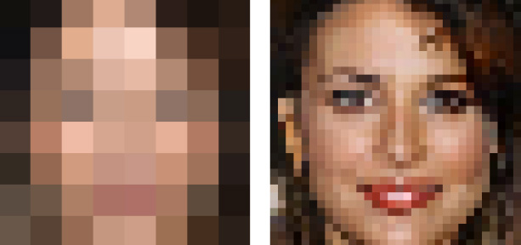
- Challenges :
  - avoid learning the data : we need to generate data that’s diverse enough and find appropriate regularization methods
  - Properties we can play with :
    - size of the grid
    - Reynolds Number (describes the degree of turbulent flow). We are especially interested in determining if it possible to upscale simulations for fluid with high reynolds number
  - find an appropriate model.
  - It might be the case that there is nothing to learn.
- Practical challenges :
  - The library we are using is in C++, the documentation is extremely poor to say the least and it takes a lot of time to generate data.
  - 99% of my time has been spent generating data, and finding ways to feed to our models.
  - It is actually relatively easy to build a model using Tensorflow/Keras/PyTorch.
  - It’s probable that generating enough data and training a large enough model will require using many processors in parallel.

