Mark | /

Team name: | A6
Homework number: | Homework 6
Due date: | 26/10/25
Contribution | NO | Partial | Full
Diego Alexander Suarez Mejia |  |  | x
Mohanesh Ravi |  |  | x
Luis Rubianes |  |  | x
Rodrigo Barrero |  |  | x
Pedro Augusto Cardoso Campos |  |  | x
Notes: none

Project name
Not done | Partially done  (major problems) | Partially done  (minor problems) | Completed
 |  |  | x
Introduction
This report describes the procedure and results of Homework 6, which assesses the knowledge acquired during the laboratory session on UART and ADC.
The assignment consisted of:
- Acquire LDR resistance value every ms and to send its average value to a remote terminal every 1s. Then convert the resistance value to a lux level and send that to the remote terminal.
Procedure:
For this project, we’ve used the ADC to read the value LDR resistance (PIN IN_PA0) and then used the USART connectivity to transmit the value to the PC.
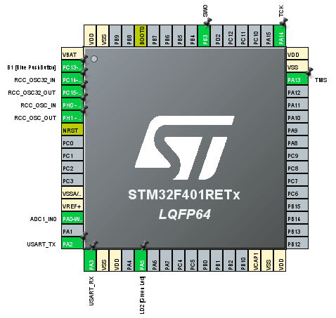
Figure 1. Pinout configuration

The first step was to check that the USART connectivity was properly enabled (through pins PA2 and PA3) and configured. Figure 2. shows the parameters.

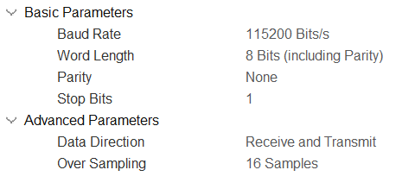
Figure 2. USART2 Parameter Settings

The next step was to configure the ADC to receive the LDR signals, for this we used the IN0, which is connected to the LDR resistance.
For this channel, we’ve done the following configurations. Enable DMA in circular mode and Half Word for the memory. A Word is composed of co bits, for this case, 16 bits is enough for the resistance value, therefore it is more efficient to use a half word, reducing the possibility of finding an error due to the second half of the word that does not contain information.
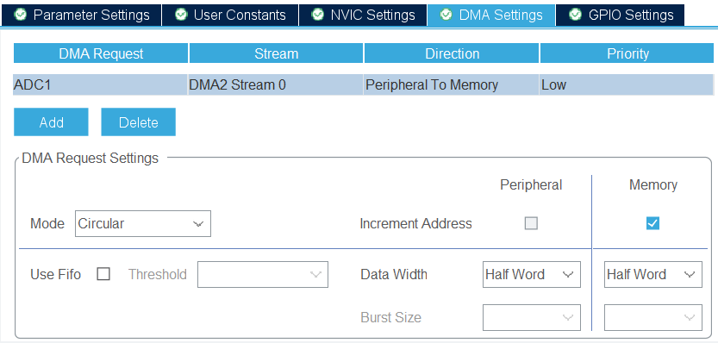
Figure 2. ADC DMA Settings

We enabled the ADC global interrupt.
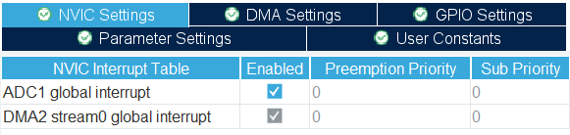
The following parameters were modified
Figure 2. Interrupt Table
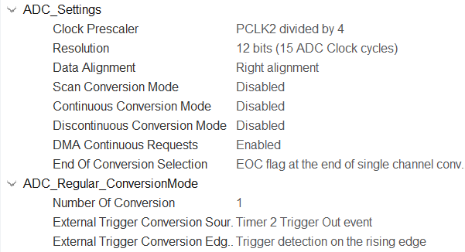
Figure 2. ADCParameter Settings
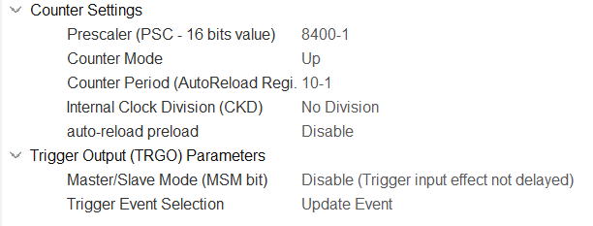
Figure 2. Timer Parameter Settings

.
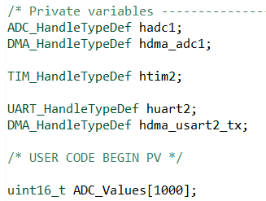
Figure 3. Declaration of variables

Figure 4. Initialization of timer and ADC

Lastly, we need to implement the HAL_ADC_HalfCpltCallback function. In this callback, we iterate through the meaningful values stored in the buffer, calculate their average, and then use that average to determine the corresponding resistance and lux levels.

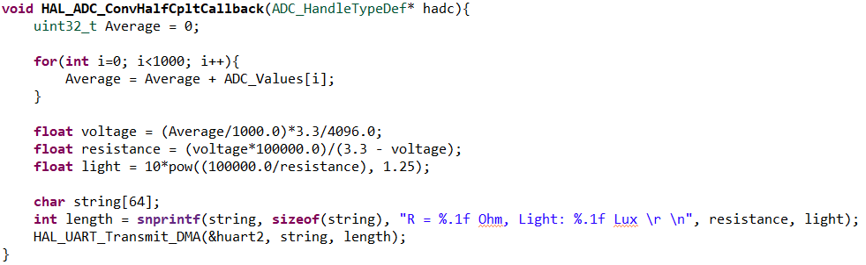
Figure 5. ADC Callback function

Professor comments:

