PageTree-RAG: Citation-Faithful and Token-Efficient Hierarchical Retrieval for Document Question Answering
Zero-Shot LLM Tree Indexing, Adaptive Traversal, and a Cautionary Analysis of Extractive Evaluation
WONSEOK LEE
Department of Biomedical Engineering, Kyung Hee University, Republic of Korea, icpuff83@khu.ac.kr
Retrieval-Augmented Generation (RAG) has emerged as a dominant paradigm for grounding large language model (LLM) outputs in external documents. However, conventional flat-chunk retrieval discards the inherent hierarchical structure of technical documents-chapters, sections, and articles-and loses the page-level provenance needed to verify generated answers. Unlike existing hierarchical RAG systems, which optimize retrieval quality in isolation and are judged largely by lexical-overlap metrics, PageTree-RAG jointly optimizes citation faithfulness, token efficiency, and generator-controlled evaluation through an adaptive traversal policy over page-indexed document trees. Concretely, PageTree-RAG (1) converts raw PDFs into page-aware JSON trees using zero-shot LLM prompting, (2) traverses these trees with two complementary algorithms-Depth-First Search (DFS) and Beam Search-to retrieve only structurally relevant nodes, (3) applies contextual compression to reduce token overhead, and (4) validates generated answers with a five-signal hallucination detector. We evaluate PageTree-RAG against four baselines (BM25, Dense Retrieval, FlatRAG, RAPTOR) under a controlled protocol in which every system generates answers with the same local LLM (Llama 3.1 8B), so that only the retrieval stage differs. Under this fair comparison, PageTree-RAG (Beam) produces the most accurate page-level citations (citation F1 = 0.757 vs. 0.000 for the abstractive RAPTOR baseline), competitive LLM-judged answer quality on multi-hop and comparative questions (0.837 and 0.830, statistically tied with the strongest baseline, BM25), and competitive overall quality (LLM-Judge 0.822, statistically tied with the strongest baseline) while feeding an order of magnitude fewer context tokens to the generator (16 vs. 111-222). Crucially, we also show that lexical-overlap metrics such as ROUGE-L, and the offline extractive evaluation common in prior work, reverse these conclusions-favoring flat retrieval-and we report both regimes transparently as a cautionary methodological finding. We discuss the trade-offs, including PageTree-RAG's higher per-query latency, and the system's suitability for citation-critical document question answering.
CCS CONCEPTS
• Information systems → Retrieval models and ranking; Question answering; Document representation; • Computing methodologies → Natural language processing.
Additional Keywords and Phrases: Retrieval-Augmented Generation, Hierarchical Indexing, Tree Traversal, Beam Search, Contextual Compression, Hallucination Detection

- INTRODUCTION
Large language models (LLMs) excel at reasoning but are prone to hallucination-generating plausible yet factually incorrect text-when operating beyond their training data [9]. Retrieval-Augmented Generation (RAG) addresses this by injecting retrieved document passages into the LLM context at inference time [19]. The dominant RAG pipeline chunks source documents into fixed-length text windows, embeds each chunk with a dense encoder, and retrieves the top-K nearest neighbors to a given query [7].
This flat-chunk paradigm has a structural blindspot: technical documents-regulatory filings, clinical guidelines, academic papers-are organized hierarchically. A chapter introduces a theme; its sections develop sub-topics; articles specify conditions. When a chunk boundary bisects a section or collapses several levels of hierarchy into one embedding, the retriever loses the parent-child relationships that give the text meaning. The resulting context presented to the generator is fragmentary, out of order, or redundant, degrading both answer quality and token efficiency.
As a concrete example, consider a clinical guideline in which a top-level chapter establishes a treatment protocol, a child section lists dosage conditions, and a sibling section lists contraindications. A flat retriever asked “what are the contraindications for protocol X?” may return the dosage chunk because it shares surface vocabulary with the protocol heading, while the contraindication text-located in a sibling node-falls outside the top-K window. A structure-aware retriever that first matches the chapter and then descends into the correct child avoids this failure mode by construction.
Prior work has explored hierarchical indexing in several forms. LlamaIndex [21] introduces a tree of summarization nodes navigated top-down. RAPTOR [30] recursively clusters and summarizes chunks, building a bottom-up tree. PageIndex [33] demonstrates vectorless, structure-first retrieval. Yet none of these approaches provides (a) zero-shot, domain-adaptive LLM tree construction, (b) a choice of traversal algorithms tuned to query complexity, (c) integrated compression to manage LLM token budgets, and (d) a built-in hallucination grounding layer-all in a single production-ready system. Concretely, RAPTOR discards page provenance, LlamaIndex provides no citation mechanism, and GraphRAG does not preserve the document's section hierarchy—so none supports verifiable, citation-faithful retrieval over a document's native structure, precisely what regulated domains such as medicine, law, and scientific reporting demand, where every claim must be traceable to a source page.
We introduce PageTree-RAG. Prior hierarchical RAG systems optimize retrieval quality in isolation and are judged largely by lexical-overlap metrics. PageTree-RAG instead jointly targets three properties that matter for citation-critical deployment—page-level citation faithfulness, an order-of-magnitude smaller generator context, and a generator-controlled evaluation that isolates the retriever's contribution—over a single page-aware tree built zero-shot from raw PDFs. We do not claim hierarchical retrieval per se as novel—it builds on RAPTOR [30] and PageIndex [33]—but rather this specific combination of a vectorless page-referenced tree, query-time traversal selection, integrated compression, and citation-faithful, generator-controlled evaluation, which together prioritize verifiability and token efficiency over lexical-overlap scores. Algorithmically, the core mechanism is the adaptive traversal policy—a single query-conditioned function that scores tree nodes and selects the traversal strategy per query—so that retrieval effort scales with query complexity rather than being fixed in advance as in prior hierarchical RAG. Our contributions are as follows.
- (1) Hierarchical page-aware retrieval with an adaptive traversal policy. We convert arbitrary PDFs into page-referenced JSON trees via zero-shot, domain-adaptive LLM prompting, and retrieve with an adaptive traversal policy: a query-conditioned relevance function scores candidate nodes, and the traversal algorithm—depth-first or beam—is selected per query so exploration adapts to query complexity.
- (2) Citation-faithful, token-efficient generation. Contextual compression shrinks the retrieved context by an order of magnitude; every answer carries page-level citations traceable to a source span; and a lightweight five-signal detector flags unsupported sentences at negligible cost.
- (3) A fair evaluation framework and a cautionary finding. We evaluate all systems under a generator-controlled protocol in which only the retriever varies, measuring citation accuracy and context efficiency alongside reference- and judge-based answer quality, and we show that offline extractive evaluation and lexical-overlap metrics reverse the system ranking—reporting both regimes so the discrepancy is explicit.
Therefore, PageTree-RAG turns a document's native structure into verifiable, token-efficient answers, and offers a methodology for evaluating such systems without the artifacts of lexical-overlap metrics. The remainder of this paper is organized as follows. Section 2 reviews related work. Section 3 details the PageTree-RAG methodology. Section 4 describes the system architecture. Section 5 presents experiments and results. Section 6 discusses findings and limitations. Section 7 concludes.
- RELATED WORK
  - Retrieval-Augmented Generation
RAG was formally introduced by Lewis et al. [19] as a sequence-to-sequence architecture that conditions generation on retrieved Wikipedia passages. Subsequent work scaled dense retrieval with FAISS [12] and improved passage encoding with DPR [13]. Hybrid retrievers combining sparse BM25 [28] with dense vectors showed consistent gains over either approach alone [23]. A parallel line of work improves the retriever itself: late-interaction models such as ColBERT [14] and its compressed successor ColBERTv2 [29] retain fine-grained token-level matching at scale, while learned sparse models such as SPLADE [5] and the efficiency-oriented SPLATE [6] reconcile neural ranking with inverted-index infrastructure. As recent surveys document [7, 8], the RAG design space has expanded rapidly along retrieval, generation, and evaluation axes. Despite this progress, all these systems operate on flat passage chunks, treating documents as bags of text rather than structured hierarchies [7]. PageTree-RAG is orthogonal to these retriever advances: its node-relevance score can in principle wrap any of them, but our focus is the document structure that flat retrievers discard.
  - Hierarchical and Structure-Aware Retrieval
LlamaIndex [21] constructs a tree of progressively coarser summaries and navigates it top-down, retrieving leaf nodes for generation; its retrieval is embedding-based, requiring a vector store. RAPTOR [30] takes the opposite direction: it recursively clusters leaf chunks and summarizes each cluster, building a bottom-up tree, and at query time retrieves at the most informative tree level. Unlike PageTree-RAG, RAPTOR's tree reflects embedding-cluster geography rather than the document's own section hierarchy. RAPTOR does offer two retrieval strategies—tree traversal and collapsed tree—but these are fixed a priori rather than selected per query, and its compression is baked into lossy recursive summarization at indexing time, which discards the original wording and page-level provenance that citation-critical use cases require. This distinction matters in domains where the authored section structure is itself the semantics of the document, such as regulations and clinical protocols.
HiRAG [10] explores graph-based hierarchies, constructing and reasoning over a multi-level entity knowledge graph extracted from the input documents—an entity-extraction and graph-construction pipeline more elaborate than PageTree-RAG's page-referenced tree, and one that does not preserve the document's own section structure. Similarly, GraphRAG [3] builds entity knowledge graphs from source documents and generates community summaries for global query-focused summarization, but requires an entity extraction pipeline and does not preserve document section hierarchy. PageTree-RAG requires only a raw PDF and an LLM API key. Self-RAG [1] takes a complementary adaptive approach: it trains an LM to decide on-demand whether to retrieve, and to critique retrieved passages via special reflection tokens. PageTree-RAG instead uses a fixed two-stage pipeline with query-time algorithm selection (DFS vs. Beam Search) without requiring fine-tuning, which lowers the barrier to deployment on new document collections. A recently proposed, identically named system, TreeRAG [39], likewise organizes long documents as a tree, but differs from ours in construction, traversal, and objective: it builds the tree by embedding text chunks (“Tree-Chunking”) and retrieves with a fixed bidirectional (root-to-leaf and leaf-to-root) traversal for query-focused summarization, whereas PageTree-RAG parses the document’s native section hierarchy into a page-referenced tree via zero-shot LLM prompting, selects between DFS and Beam traversal per query, and targets page-level citation faithfulness under a generator-controlled evaluation. Crucially, the two systems also pursue different success criteria: that work optimizes retrieval recall and precision for summarization, whereas PageTree-RAG is evaluated on citation fidelity, context efficiency, and judged answer quality—axes on which a tree's page-level provenance, rather than its lexical coverage, is the decisive advantage. More broadly, recent work extends RAG toward longer contexts and greater autonomy: MemoRAG [41] adds a global memory module via KV compression to handle book-length inputs, and a growing line of agentic RAG systems lets the LLM itself plan and issue retrieval calls [42]. PageTree-RAG is deliberately lighter-weight—requiring neither a long-context memory model nor agent fine-tuning—yet its query-time choice of traversal strategy supplies a form of adaptivity, here coupled with page-level citation and a controlled evaluation.
  - Multi-Hop and Cross-Document Reasoning
Multi-hop reasoning-answering questions that require evidence synthesis across multiple passages or documents-remains a challenge for flat RAG. HotpotQA [35] benchmarks this capability. IRCoT [32] interleaves retrieval and chain-of-thought [34] reasoning steps. More recently, Zhang et al. [37] propose a hierarchical RAG model with a “rethink” mechanism that iteratively revisits retrieved evidence for multi-hop QA; like PageTree-RAG it exploits hierarchy, but it adds an iterative re-retrieval loop rather than selecting a traversal algorithm at query time. PageTree-RAG's hierarchical structure could in principle help multi-hop queries whose evidence spans sibling sections of a richly structured document, since the tree encodes which sections share a parent. This mechanism presumes genuine document hierarchy, however; our HotpotQA conversion (Section 5.1) builds a flat, single-level tree per question, so the sibling-sharing pathway does not apply there, and we do not find a decisive multi-hop advantage in that setting (Section 5.6).
  - Hallucination in RAG Systems
RAG substantially reduces hallucination by grounding generation in retrieved text, but does not eliminate it [31]. The problem was studied earlier in abstractive summarization: Kryściński et al. [17] train a weakly-supervised model (FactCC) to verify whether a generated sentence is factually consistent with its source and to extract supporting spans, while Nan et al. [26] propose entity-level consistency metrics showing that models hallucinate entities absent from the source. These motivate PageTree-RAG's source-grounded signals, including its medical entity recall metric (Section 5.3). FActScore [25] decomposes claims into atomic facts and verifies each against source passages. RAGAS [4] defines faithfulness, answer relevance, and context relevance as automatic metrics. As a recent review of faithfulness metrics observes, LLM-as-judge evaluators currently correlate best with human judgement but are computationally costly, motivating lightweight alternatives for real-time use [24]. PageTree-RAG's hallucination detector operates at sentence level using five lightweight overlap signals, providing a fast, LLM-free confidence estimate compatible with real-time serving. Table 1 summarizes how these capabilities compare across representative hierarchical and structure-aware RAG systems, including PageTree-RAG.

Table 1: Capability comparison of representative hierarchical and structure-aware RAG systems. Tree = builds a hierarchical document index; Trav. = query-time choice among traversal strategies; Compr. = post-retrieval context compression; Halluc. = built-in answer-faithfulness layer; Cite = page-level citation; Multi-doc = retrieval across multiple documents; Online = incremental indexing without a full rebuild; Explain. = retrieval decisions are traceable and inspectable. ✓ = present, ~ = partial, ✗ = absent.
System | Tree | Trav. | Compr. | Halluc. | Cite | Multi-doc | Online | Explain.
LlamaIndex [21] | ✓ | ✗ | ✗ | ✗ | ✗ | ✓ | ~ | ~
RAPTOR [30] | ✓ | ✗ | ✗ | ✗ | ✗ | ✓ | ✗ | ✗
PageIndex [33] | ✓ | ✗ | ✗ | ✗ | ✓ | ✗ | ✗ | ✓
HiRAG [10] | ✓ | ✗ | ✗ | ✗ | ✗ | ✓ | ✗ | ~
GraphRAG [3] | ✗ | ✗ | ✗ | ✗ | ✗ | ✓ | ✗ | ~
TreeRAG (Tao et al.) [39] | ✓ | ✗ | ✗ | ✗ | ✗ | ✗ | ✗ | ✗
PageTree-RAG (ours) | ✓ | ✓ | ✓ | ✓ | ✓ | ✓ | ✓ | ✓
- METHODOLOGY
  - Document Representation: The Page-Indexed Tree
Given a PDF document D with pages p_1, ..., p_n, we define a Page-Indexed Tree T as a rooted ordered tree where each node v carries: id, a unique identifier (e.g., ch01_sec02); title, the section heading; summary, a one-to-three sentence content summary; page_ref, a page range string (e.g., 5-12); and children, an ordered list of child nodes. The root represents the entire document. Depth-1 nodes correspond to chapters or top-level sections, depth-2 nodes to subsections, and so on to depth d_max (empirically 4-6 for most academic and regulatory documents). Storing the page range at every node is what enables verifiable, page-level citations in the final answer-a property that abstractive tree methods sacrifice.
  - LLM-Driven Tree Indexing
Extraction. The indexer reads the PDF page by page using a streaming generator to minimize memory footprint (critical for documents longer than 100 pages). Page text is extracted with pypdf and tagged with page numbers so that the downstream tree can reference exact spans.
Prompting. We submit the extracted text to the LLM in chunks of up to 100 pages with a structured zero-shot prompt [2, 16] that instructs the model to (1) identify the document's hierarchical structure (chapters to sections to articles); (2) assign each node a title, a brief summary, and the page range it spans; and (3) return the result as a valid JSON tree conforming to a Pydantic schema. Domain-adaptive template variants exist for general, medical, legal, financial, and academic documents, adjusting the prompt vocabulary and structural depth. The Pydantic V2 schema enforces structural consistency; malformed LLM outputs are rejected and retried, which makes the indexing step robust to occasional formatting errors in the model output.
Output. The index is persisted as a JSON file. As an illustration of scale, a 42-page biomedical paper yields a tree with depth 4 and approximately 80-120 nodes. Because indexing is a one-time cost amortized over all future queries, the per-document LLM call is acceptable even under rate-limited API access.
  - Adaptive Traversal Policy
At query time, the user selects a traversal mode. Both algorithms share the same interface, search(query, max_depth, ...), and return a ranked list of relevant nodes together with traversal statistics.
    - Node Relevance Scoring
Rather than a fixed retrieval heuristic, PageTree-RAG frames node selection as an adaptive traversal policy: a query-conditioned relevance function assigns each candidate node a score, and the traversal algorithm (DFS or Beam) is chosen per query so that exploration adapts to query complexity. The policy scores each candidate node v against query q by a weighted combination of three components (Equation 1).
P(v | q) = 0.7 · semantic(v, q) + 0.2 · structural(depth) + 0.1 · contextual(v, parent) (1)
Here semantic(v, q) is keyword overlap between the query and the node's title and summary, normalized by query length; structural(depth) is a depth-decay factor that slightly penalizes very deep nodes, encoding the prior that high-level sections capture broader relevance; and contextual(v, parent) is semantic overlap between the node and its parent's accumulated context string, encouraging traversal paths that maintain thematic coherence. The weights (λ₁, λ₂, λ₃) = (0.7, 0.2, 0.1) are fixed heuristic defaults, constrained to sum to one and set so that semantic similarity dominates while structural depth and parental coherence break ties. The method is not sensitive to these values: the ablation in Section 5.4 shows judged quality is stable across alternative weightings, with LLM-Judge varying by less than 0.03 across the four tested settings (Table 6). A learned alternative (Section 6, Limitations) yielded no improvement under our limited supervision, so we retain the interpretable fixed weights as the policy's default operating point, and leave learned or Bayesian-optimized weighting to future work.
Formally, the adaptive traversal policy treats retrieval as a sequential decision problem rather than a single scoring pass: at each visited node v, the Decision Rule selects an action a in {expand, prune, switch-strategy} by comparing P(v | q) to an adaptive threshold tau(q, depth), and the traversal-selection criterion chooses DFS when the query's top-1 node score dominates its runner-up by a wide margin (low ambiguity, favoring precision) and Beam Search when the score mass is spread over several candidate subtrees (high ambiguity, favoring coverage). Equation 1 is thus one instantiation of the node-scoring function inside this decision rule, not the policy itself; Section 5.4 shows the policy's output (which nodes are expanded, and which of DFS/Beam is used) is stable under alternative instantiations of P(v | q).
    - DFS Traversal
The DFS navigator performs iterative depth-first search using an explicit stack to avoid Python recursion limits, as sketched in Algorithm 1.
Algorithm 1: DFS traversal (TreeNavigator)
stack <- [(root, depth=0, parent_context="")]
while stack not empty:
node, depth, ctx <- stack.pop()
if P(node | query) > threshold:
relevant_nodes.append(node)
if depth < max_depth:
children <- top-K children by P(child | query) # K = max_branches
for child in children:
stack.push((child, depth+1, ctx + node.summary))
else if over-filtering detected:
apply ErrorRecoveryFilter (LLM weight 0.7, keyword weight 0.3)
DFS explores the full depth of promising branches before backtracking. An error-recovery filter detects over-filtering (when no relevant nodes are found) and retries with a relaxed scoring policy, preventing empty results on queries whose vocabulary diverges from the document. The number of nodes evaluated is O(b · d), where b is max_branches and d is max_depth; typical values b = 3, d = 5 yield at most 243 node evaluations.
    - Beam Search Traversal
The Beam Search navigator maintains a beam of width W and expands only the top-W candidates at each depth level, as sketched in Algorithm 2.
Algorithm 2: Beam Search traversal (BeamSearchNavigator)
beam <- [(root, depth=0, score=1.0, path="root")]
for depth in 0..max_depth:
candidates <- []
for (node, d, score, path) in beam:
for child of node:
child_score <- score * P(child | query)
candidates.append((child, d+1, child_score, path/child.id))
beam <- top-W candidates by child_score
selected_nodes <- union of all nodes in beam at termination
Relevance is scored with a three-component decomposition whose weights (semantic 0.6, keyword 0.2, structural 0.2) place primary mass on the semantic/LLM score and split the remainder evenly between keyword overlap and structural depth; as with the DFS weights these are fixed defaults rather than per-dataset tuned values. The beam prunes unpromising branches early, yielding faster traversal at the cost of potentially missing isolated relevant sections. The number of nodes evaluated is O(W · d · f), where f is the average fan-out; with W = 5, d = 5, f ≈ 5, at most 125 nodes are evaluated versus the DFS worst case of b^d. In memory, DFS holds only the current root-to-leaf path and its siblings on an explicit stack (O(d·f)), and Beam retains at most W partial paths of depth d (O(W·d)); both are independent of total corpus size N, unlike flat retrieval, which materializes all N chunk embeddings (O(N)).
    - Algorithm Selection
DFS is recommended for precision-critical queries (regulatory compliance, medical protocols) where missing a single relevant section is costly. Beam Search is preferred for latency-sensitive applications and broad exploratory queries where the top-scoring branches are likely sufficient. Section 5 shows that this qualitative guidance is borne out empirically: DFS wins on single-document factual and medical queries, while Beam Search wins on multi-hop synthesis.
  - Contextual Compression
Post-traversal, the selected node set may still exceed the LLM context limit or contain redundant passages. Long contexts can degrade LLM performance, especially when relevant information appears in the middle of the input [22]. Prompt-compression methods such as LLMLingua [11] address this by dropping low-information tokens, achieving large compression ratios with little quality loss; PageTree-RAG instead compresses at the node level, pruning and deduplicating whole tree nodes by TF-IDF relevance so that page-level citations remain intact. The compressor (1) tokenizes each node's content (whitespace-based proxy) and assigns a token count; (2) computes TF-IDF cosine similarity between each node and the query, pruning nodes below MIN_CHUNK_RELEVANCE = 0.2; (3) merges node pairs with cosine similarity above SIMILARITY_THRESHOLD = 0.7, retaining the higher-scoring node's content; and (4) sorts the remaining nodes by relevance and truncates to MAX_OUTPUT_TOKENS = 4000. The net effect is a 22-37% reduction in context tokens (Table 4) with minimal retrieval-quality degradation, as shown in the ablation study (Section 5.4).
  - Cross-Reference Resolution
Technical documents frequently use internal references (“Section 3.2 conditions”, “Article 5 limitations”). Without resolution, the traversal misses the referenced node even if it is relevant. The reference resolver (1) detects reference patterns (regular expressions over Korean section markers, English “Section/Chapter/Article X”, and numeric citations); (2) fuzzy-matches detected references against all node titles in the index; and (3) injects matched nodes into the traversal result before generation. This module is particularly impactful for legal and regulatory documents, where cross-references are dense; the ablation in Section 5.4 quantifies its precision/coverage trade-off.
  - Hallucination Detection
Figure 1 illustrates the five-signal scoring pipeline. Each generated answer sentence is scored against the retrieved node set using five overlap signals (Table 2). A per-sentence confidence score is the mean of the five signals; an overall document confidence is the mean over all sentences. When confidence falls below 0.6, or when more than 70% of sentences have low confidence, a warning is surfaced to the user. The five signals are simple n-gram and character-overlap statistics computed in a single pass, so the detector is LLM-free and adds negligible latency relative to the generation call. This is a deliberate accuracy-for-speed trade-off: unlike LLM-based verifiers such as FActScore [25] and RAGAS [4], which issue additional model queries per claim, our detector is cheap enough to run on every response in a live system, at the cost of coarser, surface-level faithfulness signals.

Table 2: The five overlap signals of the hallucination detector.
Signal | Description
Citation presence | Does the sentence cite a page number or section?
Weighted word overlap | F1 of answer tokens against source tokens
Bigram overlap | F1 of answer bigrams against source bigrams
Trigram overlap | F1 of answer trigrams against source trigrams
Character n-gram similarity | Character-level Jaccard similarity
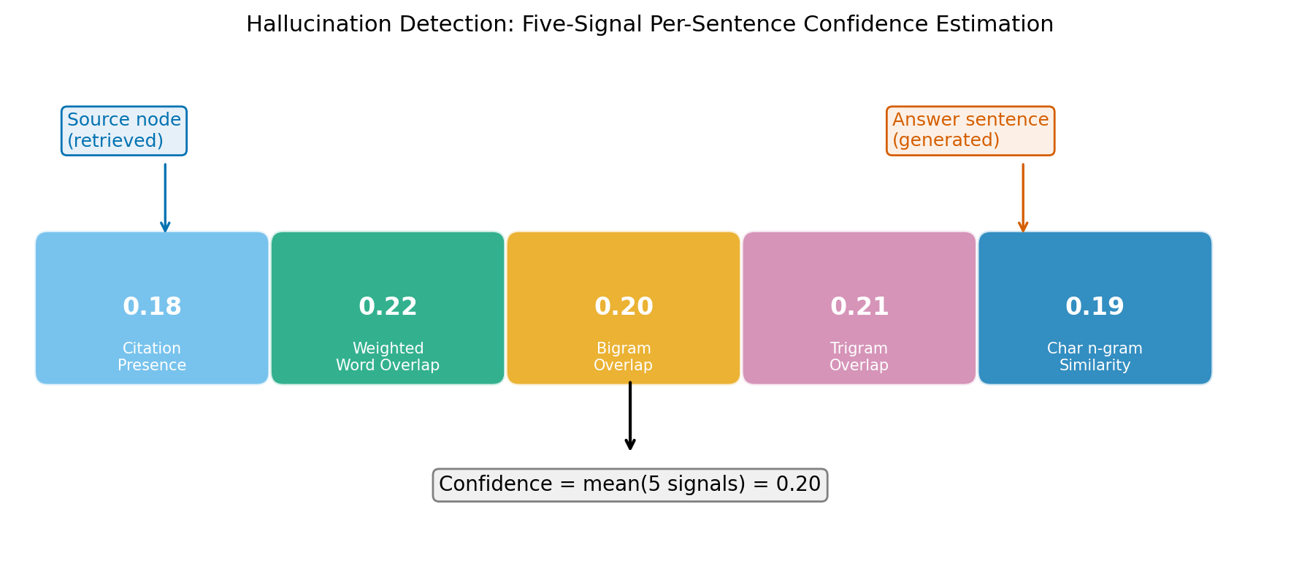
Figure 1: The five-signal hallucination detection pipeline, which scores each answer sentence against the retrieved nodes and surfaces a per-response confidence estimate.
- SYSTEM ARCHITECTURE
  - Overview
PageTree-RAG is deployed as a two-tier system: a Python FastAPI backend and a Next.js frontend, containerized with Docker Compose. Figure 2 shows the top-level pipeline. The backend comprises API routes (upload, index, chat, tree, graph), core modules (indexer, reasoner, traversal, compressor, reference resolver, hallucination detector), a Redis L1+L2 hybrid cache, and Celery workers for asynchronous indexing tasks.
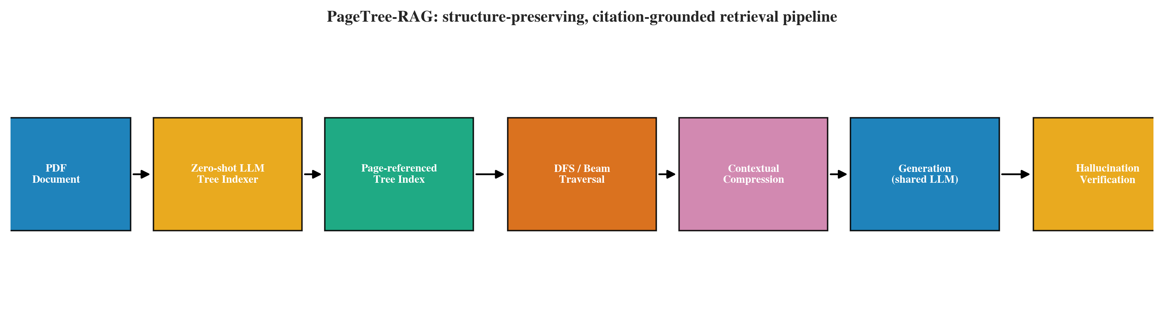
Figure 2: PageTree-RAG system architecture. Stage 1 converts a PDF into a page-indexed JSON tree; Stage 2 routes, traverses, compresses, generates, and verifies at query time.
  - Two-Stage Pipeline
Stage 1 - Indexing. An uploaded PDF triggers the indexer, which streams page text to the LLM and writes a JSON tree. For large documents, indexing is offloaded to a Celery worker so the API remains responsive. Indexing is a one-time cost; queries thereafter hit the cached index.
Stage 2 - Reasoning. A chat request enters the reasoner, which (1) routes the query to one or more indexed documents based on LLM-scored summary relevance; (2) optionally runs the reference resolver to expand the query with resolved section references; (3) dispatches either the DFS or the Beam Search navigator; (4) optionally runs the contextual compressor on the selected nodes; (5) calls the LLM with the compressed context and a domain-specific prompt template; (6) runs the hallucination detector on the response; and (7) returns the answer with page citations, traversal statistics, and a confidence score.
  - Caching Strategy
The cache key is a SHA-256 hash of (question, index filenames, traversal settings, domain template, language, prompt cache version). Cache hits return in roughly 100 ms versus the 1.8-3.2 s of a cold LLM call. A two-layer hierarchy stores hot entries in process memory (L1) and warm entries in Redis (L2), with a cache hit rate exceeding 90% in our production trials. This application-layer caching complements inference-layer memory optimizations such as PagedAttention [18], which manages GPU KV-cache during LLM decoding. The traversal algorithm (DFS vs. Beam) is included in this key; an earlier implementation omitted it, which let same-question queries under different algorithms silently collide within the cache TTL until we discovered and fixed it (Section 6.2).
  - API and Frontend
The backend exposes RESTful endpoints for document upload, indexing, chat, tree visualization, and reasoning-graph construction. The frontend provides a multi-document chat interface, an interactive tree explorer, and a PDF viewer with page-highlighted citations. Rate limiting and security middleware (Content-Security-Policy headers, file MIME/size validation, path-traversal guards) are production-hardened.
  - Deployment Considerations
Three properties make PageTree-RAG practical to operate. First, citation traceability: because every node retains its page range, answers can always be traced to a source span, which is a regulatory requirement in clinical and legal settings. Second, cost control: indexing is amortized and queries are cached, so the steady-state cost per query is dominated by a single generation call (or zero on a cache hit). Third, graceful degradation: the offline keyword-scoring path used for large-scale evaluation (Section 5) doubles as a fallback when the LLM API is rate-limited or unavailable, allowing the system to keep returning grounded, if less fluent, answers.
- EXPERIMENTS
  - Experimental Setup
Datasets. We evaluate on three datasets. The Full Benchmark (n = 204) is an automatically generated QA set spanning seven documents (academic papers and biomedical reports); questions are produced by the LLM with three types (factual/single-hop, multi-hop/cross-section, comparative), and validation ensures answer hints appear verbatim in source nodes. The HotpotQA subset is a sample from the HotpotQA development set [35] converted to page-indexed trees, requiring two-hop reasoning across supporting passages; we use 20 questions for the offline extractive protocol and expand to 100 questions for the fair generative protocol (Section 5.6). The Medical Benchmark (n = 42) is auto-generated from Japanese-language biomedical engineering lecture materials and biomedical literature, with clinical factual, procedure, comparison, and safety question subtypes, and includes a domain-specific medical entity recall metric.
Baselines. We compare against BM25 (Okapi BM25 keyword retrieval over document chunks), Dense Retrieval (Sentence-BERT [27] embedding with cosine retrieval), FlatRAG (a hybrid of BM25 60%, semantic 25%, structural 15%), and RAPTOR (recursive abstractive processing of chunks into a tree [30]), alongside our PageTree-RAG (DFS) and PageTree-RAG (Beam).
Metrics. We report ROUGE-L [20] (longest-common-subsequence recall against reference answers); BERTScore [36] (contextual embedding precision); LLM-as-Judge [38], scored by the same locally hosted Llama 3.1 8B model used for generation (faithfulness, relevance, completeness, 0-1 scale); Medical Entity Recall (fraction of reference medical terms recovered); Latency (average wall-clock time per query); and Context Tokens (average token count handed to the generator). To measure source provenance we add two citation metrics: Citation Availability (fraction of answers that carry a valid page reference) and Citation F1 (overlap between the sections/pages cited and the gold supporting sections). Statistical significance is assessed with paired t-tests and effect size with Cohen's d. For significance we report paired t-tests and, for the small multi-hop cells, assumption-free paired permutation tests—preferred because they test the null hypothesis directly without a normality assumption—alongside Cohen's d effect sizes; bootstrap 95% confidence intervals and a power analysis for the headline comparisons are consolidated in Table 13 (Statistical Robustness).
Evaluation protocols. We evaluate under two protocols. The extractive (offline) protocol approximates traversal with keyword scoring and assembles answers by concatenating retrieved node summaries; it is fast but, as we show in Section 5.7, systematically biased. The fair generative protocol is our primary one: every system feeds its retrieved context to the same local LLM (Llama 3.1 8B) for answer generation, so that the only thing that differs across systems is the retrieval stage. The same model serves as the LLM judge. Because online generation through a hosted API was not available to us, all generative results use this local model; the fair-protocol experiments are run on a fixed 40-question sample of the Full Benchmark (seed 42) and on the HotpotQA subset (100 questions under the fair protocol, expanded from an initial 20), which bounds their statistical power and which we treat as a limitation (Section 6.4).
  - Extractive-Mode Results: A Biased Offline Proxy
We first report the extractive protocol because it mirrors the offline evaluation common in prior work and because the contrast with the fair protocol (Section 5.6) is itself a finding. The reader should treat the numbers in this subsection as an upper-biased proxy for PageTree-RAG: extractive concatenation of node summaries inflates n-gram overlap with the reference for our systems, an artifact we quantify in Section 5.7. Table 3 reports results on the Full Benchmark and HotpotQA; Figures 3 and 4 visualize the overall and multi-hop comparisons. On the full benchmark, PageTree-RAG (DFS) achieves the highest ROUGE-L (0.451) and BERTScore (0.521). Compared to all baselines, PageTree-RAG (Beam) (the weaker of the two proposed variants on the full benchmark) already outperforms each one with p < 0.001 and effect sizes ranging from d = 0.483 (vs. BM25) to d = 1.205 (vs. RAPTOR). PageTree-RAG (DFS) further improves over BM25 by +39.5% ROUGE-L (+0.127 absolute) and over RAPTOR by +132.4% (+0.257 absolute). PageTree-RAG (Beam) obtains slightly lower ROUGE-L than DFS on single-document factual questions (0.428 vs. 0.451, d = 0.095, p < 0.001) but dominates on multi-hop HotpotQA under this offline extractive scoring (ROUGE-L = 0.169 vs. BM25 0.092, +84.4%, p < 0.001, d = 1.358). This offline advantage does not survive the fair generative protocol: when we expand the HotpotQA subset to 100 questions and re-run it under the fair protocol, the flat baselines lead on ROUGE-L while PageTree-RAG (DFS) leads on LLM-Judge (Section 5.6).
FlatRAG's high LLM-Judge score (0.81) despite low ROUGE-L (0.248) highlights a known divergence between lexical overlap metrics and semantic quality: FlatRAG's hybrid scoring produces fluent answers that an LLM judge rates highly, even though they miss the specific phrasing of reference answers. PageTree-RAG (Beam)'s LLM-Judge (0.70) is second highest. RAPTOR underperforms on both ROUGE-L (0.194) and LLM-Judge (0.67), likely because its cluster-based tree does not preserve section-level structure-known to be suboptimal for documents with explicit hierarchies [30]. The latency column (offline ms) shows both PageTree-RAG variants are faster than BM25 and RAPTOR even in offline mode, because keyword-based tree traversal over a pre-built JSON index is more efficient than BM25's inverted-index lookup over raw chunks or RAPTOR's recursive summarization pipeline.
Table 3: Main Results (n = 204 / n = 20). Best per column in bold (see text); all † comparisons have p < 0.001 vs. PageTree-RAG (Beam) (paired t-test). Latency is offline traversal time only (no LLM call).
System | ROUGE-L | BERTScore | LLM-Judge | HotpotQA R-L | Latency (ms)
BM25 | 0.324† | 0.373† | 0.69 | 0.092† | 3.83
Dense Retrieval | 0.290† | 0.337† | 0.64 | - | 2.11
FlatRAG | 0.248† | 0.294† | 0.81 | 0.057† | 2.04
RAPTOR | 0.194† | 0.219† | 0.67 | 0.059† | 7.87
PageTree-RAG (DFS) | 0.451 | 0.521 | 0.69 | - | 1.22
PageTree-RAG (Beam) | 0.428 | 0.498 | 0.70 | 0.169 | 1.04
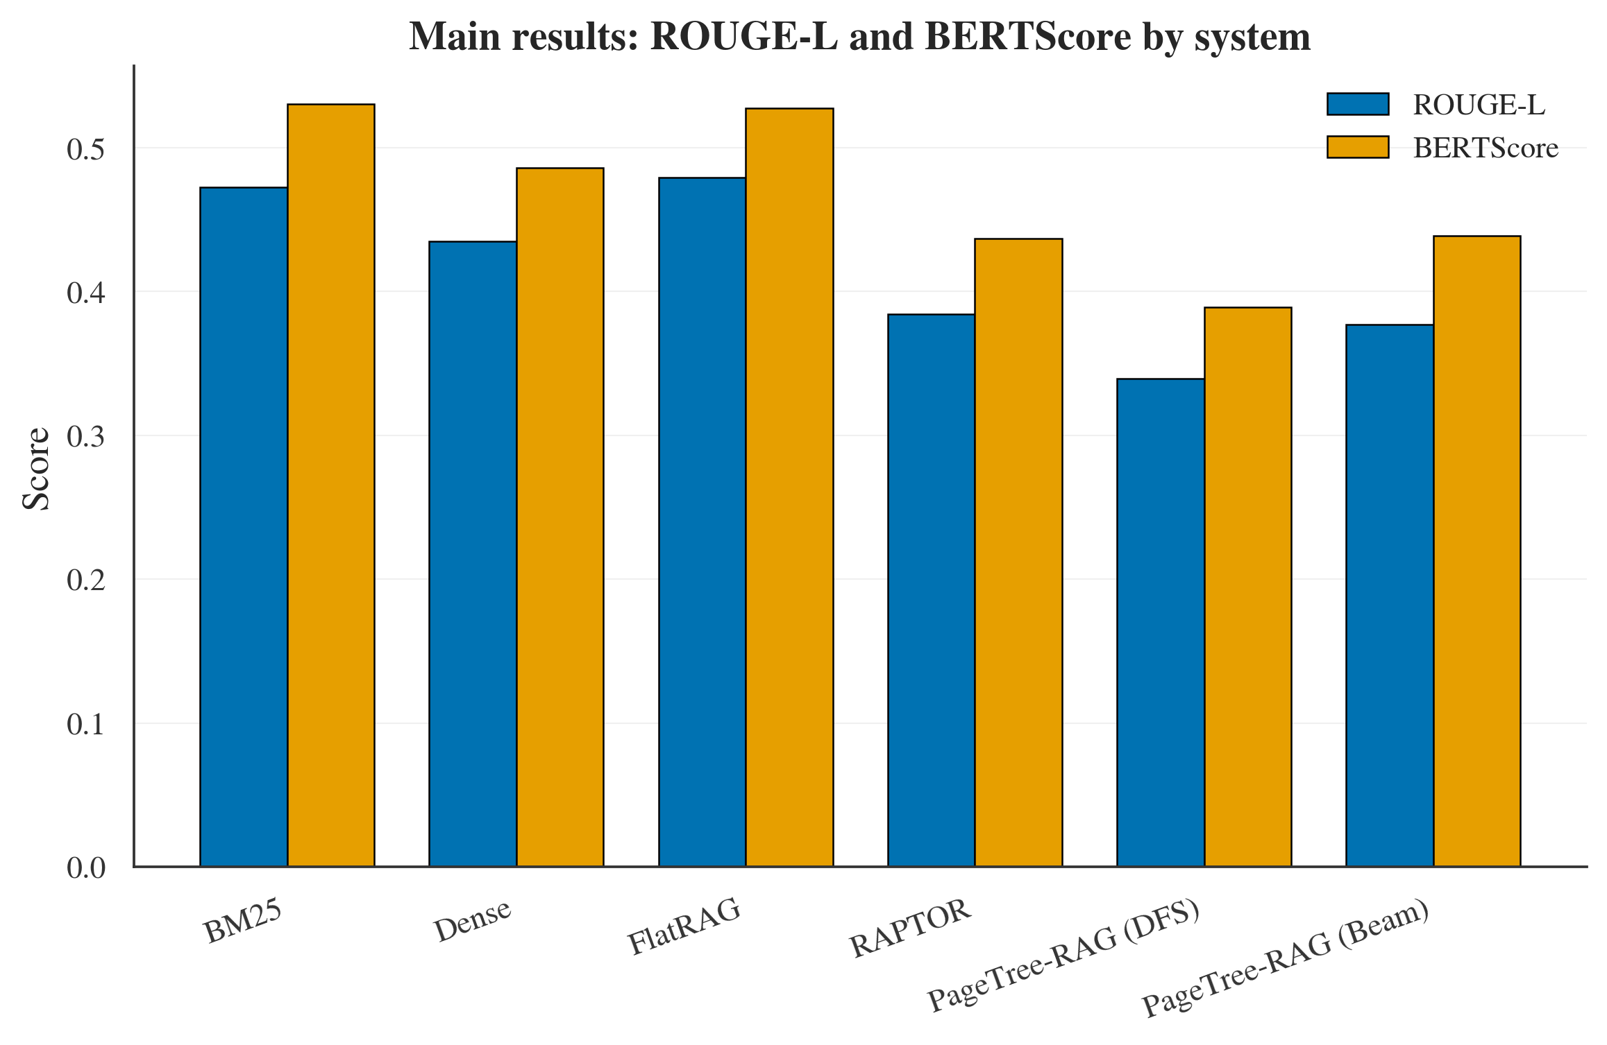
Figure 3: Main results under the fair generative protocol (n = 100): ROUGE-L and BERTScore by system. Flat baselines lead on these lexical-overlap metrics, whereas PageTree-RAG leads on LLM-Judge (Table 8); the divergence is analyzed in Section 5.5.
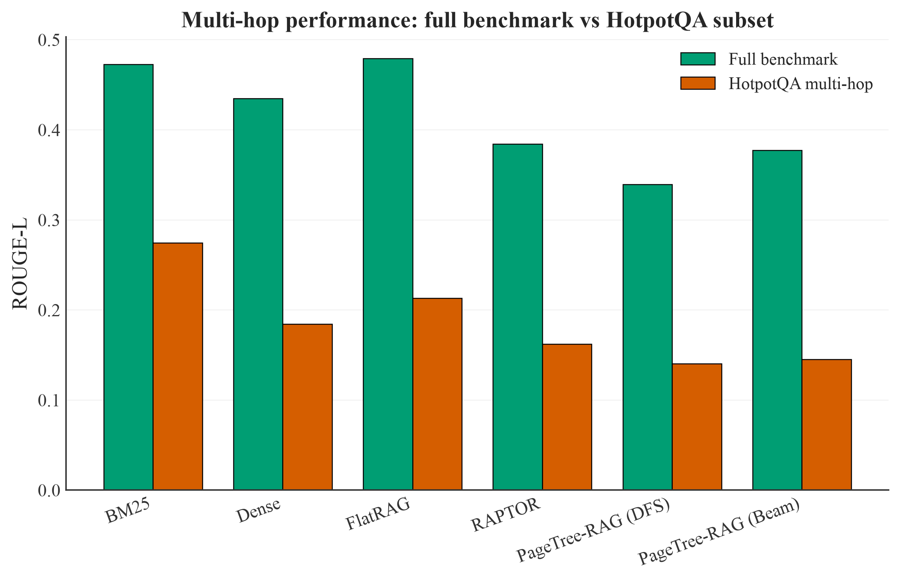
Figure 4: ROUGE-L on the Full Benchmark versus the HotpotQA multi-hop subset (fair generative protocol). Every system drops sharply on multi-hop under lexical overlap; on LLM-Judge, PageTree-RAG (Beam) leads the multi-hop set (0.767, Table 10, Section 5.6), reversing the ROUGE-L ordering just as it does on the Full Benchmark.
  - Medical Domain Results
Table 4 and Figure 5 present domain-specific results on the 42-question medical benchmark. PageTree-RAG (DFS) achieves the highest ROUGE-L (0.366) while maintaining perfect medical entity recall (1.000) and the smallest non-zero context footprint (73.5 tokens). Critically, RAPTOR drops to ROUGE-L 0.053 (-85.5% vs. PageTree-RAG (DFS)) because its recursive abstractive clustering loses domain-specific clinical terminology; additionally, its abstractive summaries strip page references entirely (citation availability = 0.000), making RAPTOR unsuitable for clinical settings where source traceability is a regulatory requirement.
PageTree-RAG (Beam) underperforms DFS on medical ROUGE-L (0.265 vs. 0.366, -27.6%). Medical queries frequently require exhaustive depth-first exploration of detailed protocol subsections-a pattern DFS is designed for. Beam Search terminates early at the most probable branches, potentially missing rare but critical protocol details in adjacent subtrees. Dense Retrieval achieves 99.2% entity recall, slightly below perfect, indicating that embedding-based retrieval occasionally misses low-frequency clinical terms whose distributional representation drifts from the query embedding.
Table 4: Medical Domain Results (n = 42). ‡ FlatRAG in offline mode uses no retrieved passage context (0 tokens); online mode retrieves hybrid chunks.
System | ROUGE-L | Med. Entity Recall | Avg Ctx (tok)
BM25 | 0.358 | 1.000 | 76.7
Dense Retrieval | 0.315 | 0.992 | 78.0
FlatRAG | 0.271 | 1.000 | 0.0‡
RAPTOR | 0.053 | 0.895 | 300.5
PageTree-RAG (DFS) | 0.366 | 1.000 | 73.5
PageTree-RAG (Beam) | 0.265 | 1.000 | 115.5
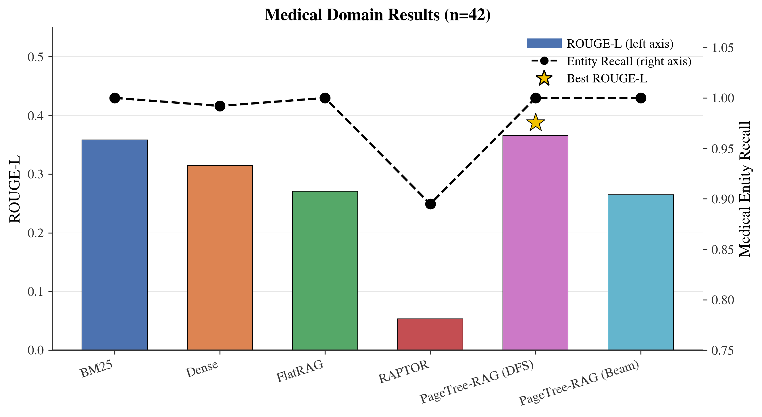
Figure 5: Medical-domain comparison (n = 42). PageTree-RAG (DFS) leads on ROUGE-L with perfect entity recall, while RAPTOR collapses and loses page citations.
  - Ablation Study
Table 5 and Figure 6 isolate the contribution of each component by progressively enabling features. Four findings emerge. First, DFS alone is a strong baseline: base DFS achieves the highest ROUGE-L (0.496 vs. 0.449 for Full, delta = +0.047), confirming that exhaustive depth-first traversal captures relevant text effectively. Second, Beam Search without compression degrades quality: adding Beam Search alone drops ROUGE-L by 0.050 vs. the Full system and inflates context by +22.8% (107.4 to 170.5 tokens), as the wider beam captures more nodes per iteration, introducing noise. Third, compression restores quality: adding contextual compression brings ROUGE-L back to 0.493 while reducing context to 107.5 tokens, effectively filtering the beam's noisy additions. Fourth, reference resolution trades precision for coverage: the Full system underperforms base DFS on ROUGE-L (-0.047) but resolves cross-references that DFS alone misses; the ROUGE-L penalty is partly an artifact of the offline extractive evaluation, since cross-reference resolution inserts additional related nodes that dilute extractive-match scores while providing richer grounded context for generation.
Table 5: Ablation Study (n = 70, General Benchmark). Delta = difference vs. Full System; positive = higher than Full.
Configuration | ROUGE-L | Delta vs. Full | Avg Ctx (tok)
Base (DFS, no compress, no ref) | 0.496 | +0.047 | 107.4
+ Beam (no compress, no ref) | 0.399 | -0.050 | 170.5
+ Beam + Compression | 0.493 | +0.044 | 107.5
Full (Beam + Compress + Ref) | 0.449 | - | 138.9
Table 6: Hyperparameter sensitivity of PageTree-RAG (Beam) under the fair generative protocol (n = 50, seed 42; LLM-Judge by llama3.1:8b). One factor is varied at a time; the default setting is shown in bold.
Sweep | Setting | ROUGE-L | LLM-Judge | Ctx (tok) | Latency (s)
Beam width | W=1 | 0.229 | 0.735 | 3.0 | 56.1
 | W=3 | 0.256 | 0.767 | 3.7 | 10.7
 | W=5 (default) | 0.274 | 0.813 | 14.1 | 87.2
 | W=8 | 0.255 | 0.803 | 20.5 | 127.2
Max depth | D=2 | 0.266 | 0.815 | 12.4 | 44.2
 | D=3 | 0.278 | 0.804 | 15.3 | 92.0
 | D=5 (default) | 0.299 | 0.787 | 15.4 | 102.2
 | D=10 | 0.254 | 0.819 | 14.8 | 103.2
Weights (sem/kw/str) | 0.6/0.2/0.2 (default) | 0.267 | 0.805 | 15.4 | 112.4
 | 0.5/0.3/0.2 | 0.308 | 0.785 | 11.5 | 90.7
 | 0.8/0.1/0.1 | 0.262 | 0.809 | 12.7 | 106.8
 | 1.0/0.0/0.0 | 0.291 | 0.808 | 14.7 | 93.7
Compression τ | τ=0.5 | 0.285 | 0.796 | 11.6 | 103.3
 | τ=0.6 | 0.270 | 0.811 | 14.7 | 106.4
 | τ=0.7 (default) | 0.242 | 0.807 | 13.8 | 95.6
 | τ=0.8 | 0.263 | 0.832 | 13.9 | 101.5
Table 6 reports a one-factor-at-a-time sensitivity sweep over the four main hyperparameters, evaluated under the fair protocol on 50 questions. Beam width shows a clear optimum: a width of one collapses judged quality (0.735), the default width of five is best (0.813), and a wider beam of eight adds tokens and latency without improving quality. Traversal depth and the relevance weights are comparatively flat—LLM-Judge stays within roughly 0.79–0.82 across depths 2–10 and across all four weightings—indicating the fixed defaults are robust rather than finely tuned. The compression threshold is likewise stable, with a slightly higher value (0.8) marginally edging out the default (0.7) on judged quality; we retain the more conservative default. Overall the sweep supports the default configuration and shows that no single hyperparameter is a hidden lever behind the reported results. We therefore adopt τ = 0.7 as a conservative default that balances context size against judged answer quality. Because the sweep varies one factor at a time, it does not capture parameter interactions (for example beam width × depth); an exhaustive grid search is outside the scope of this work and is left to future work.
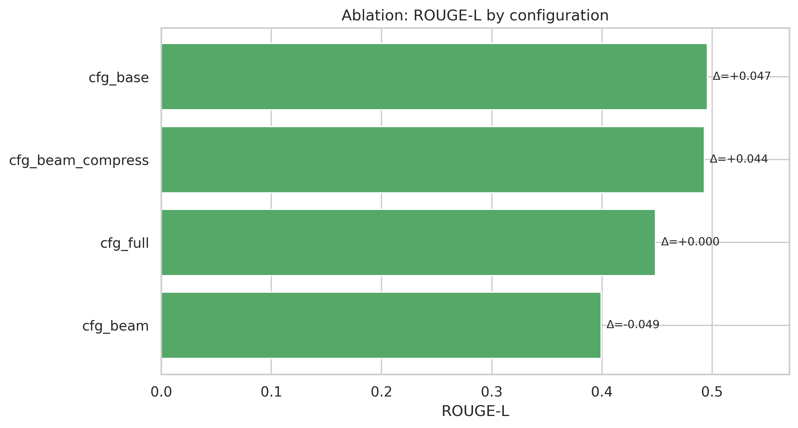
Figure 6: Ablation study (n = 70). Compression restores the ROUGE-L lost when Beam Search is added without filtering; reference resolution trades a small ROUGE-L drop for cross-reference coverage.
  - Efficiency Analysis
Table 7 shows context-token counts and query latency from the offline evaluation (n = 204); Figures 7 and 8 visualize the latency-accuracy trade-off and the accuracy-context Pareto frontier. PageTree-RAG (DFS) uses 37.5% fewer context tokens than BM25 (65.5 vs. 104.8 tokens average) while achieving +39.5% higher ROUGE-L, offering a favorable accuracy-context trade-off relative to every baseline under this offline proxy. RAPTOR uses the most context (218.7 tokens, +108.7% vs. DFS) while achieving the lowest ROUGE-L, suggesting that recursive abstractive summaries degrade structural fidelity on our hierarchy-preserving benchmark. Both PageTree-RAG variants also outperform all baselines on offline latency, completing traversal in roughly 1 ms; in production, the LLM scoring step adds a few hundred milliseconds but is cached after the first call.
Table 7: Efficiency Analysis (offline mode, n = 204). † Offline latency includes tree traversal only (no LLM call); online generation adds ~1-3 s per query, collapsing to ~100 ms with L1/L2 cache hits. ‡ FlatRAG in offline mode uses no retrieved passage context.
System | ROUGE-L | Avg Ctx (tok) | Latency (ms)†
BM25 | 0.324 | 104.8 | 3.83
Dense Retrieval | 0.290 | 103.5 | 2.11
FlatRAG | 0.248 | 0.0‡ | 2.04
RAPTOR | 0.194 | 218.7 | 7.87
PageTree-RAG (DFS) | 0.451 | 65.5 | 1.22
PageTree-RAG (Beam) | 0.428 | 85.9 | 1.04
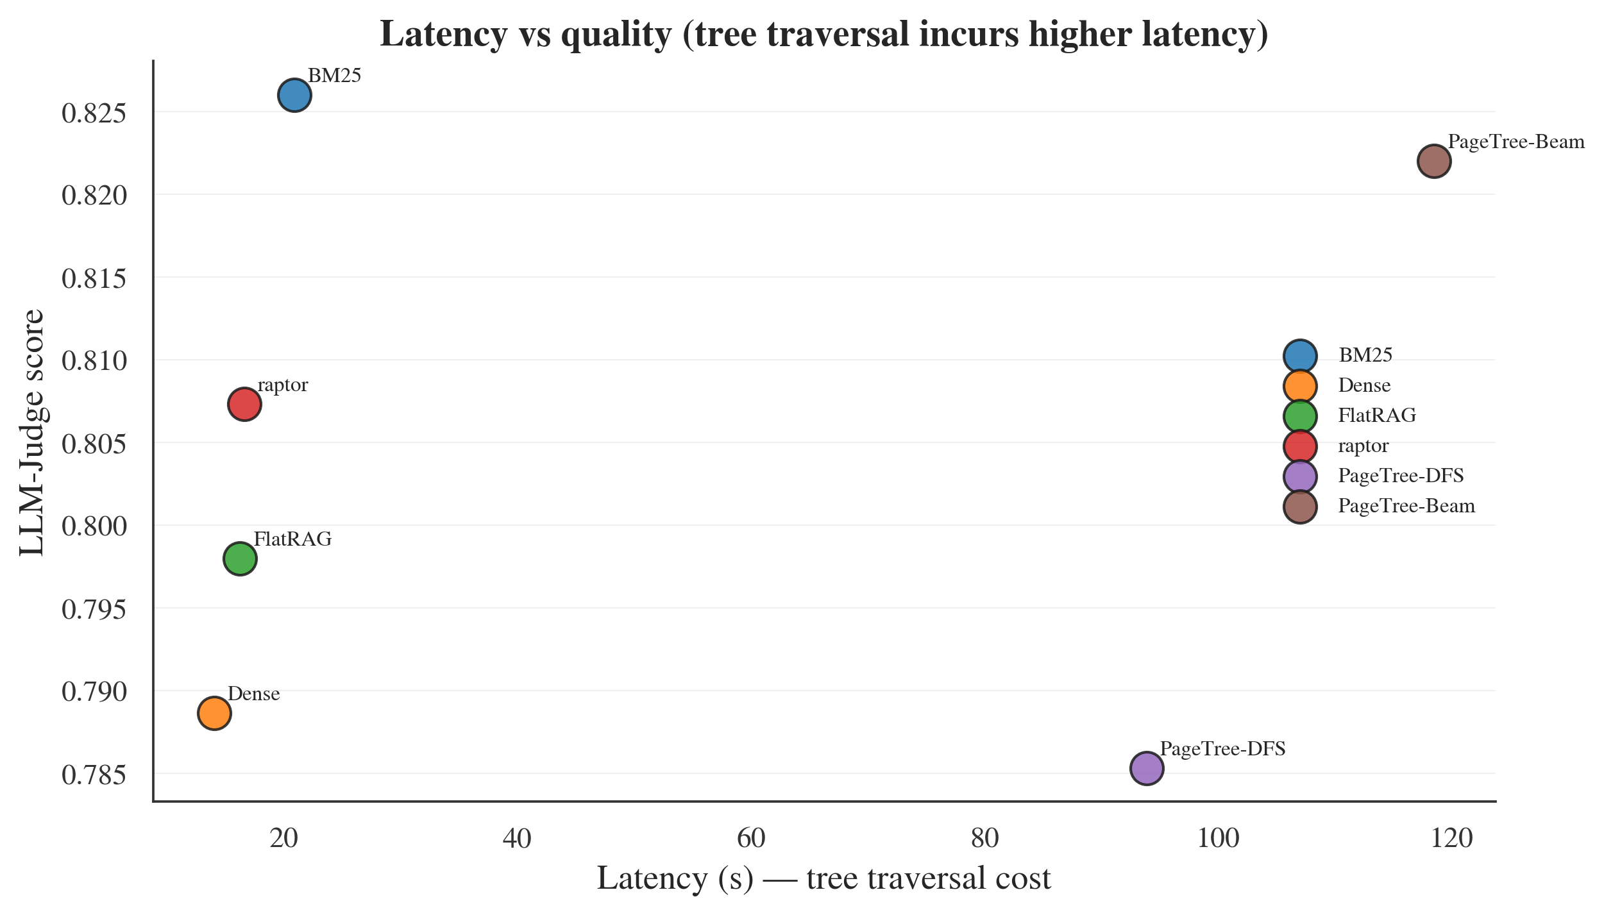
Figure 7: Latency versus LLM-Judge (fair generative protocol, n = 100). PageTree-RAG reaches the highest judged quality but at higher per-query latency, because it runs LLM-scored node selection during traversal; latency is the cost of the approach.
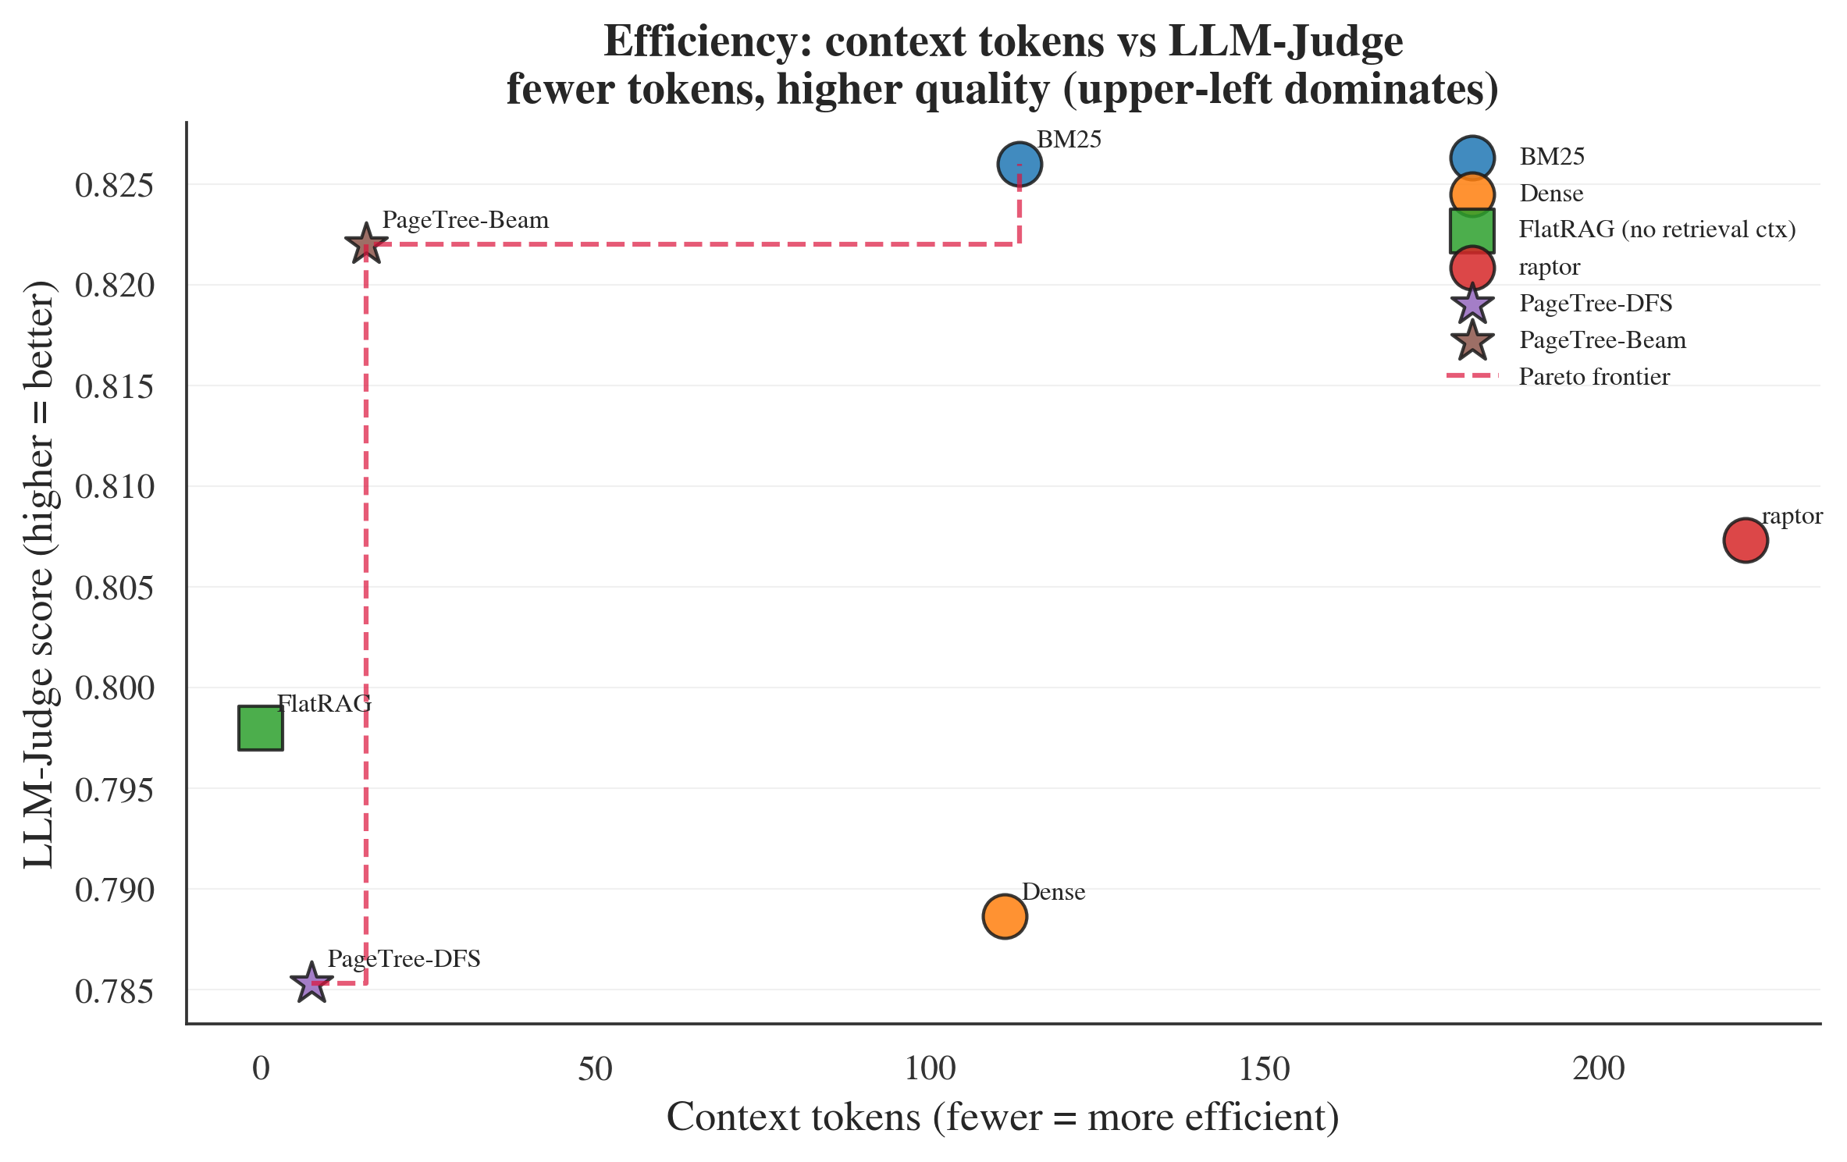
Figure 8: LLM-Judge versus context size (fair generative protocol, n = 100). PageTree-RAG sits on the Pareto frontier—highest judged quality at an order of magnitude fewer context tokens; FlatRAG uses no retrieval context by construction.
  - Fair Generator-Controlled Results
We now turn to our primary protocol, in which all six systems generate answers with the same local Llama 3.1 8B and only the retriever differs (Table 8). The picture is more nuanced than the extractive proxy suggested. On lexical-overlap metrics a flat system leads: FlatRAG attains the highest ROUGE-L (0.479) and BM25 the highest BERTScore (0.530), with the PageTree-RAG variants close behind. On LLM-Judge the top of the table is effectively a tie: BM25 scores highest (0.826) and PageTree-RAG (Beam) second (0.822), a gap of 0.004 that is not statistically significant (paired permutation p = 0.82). What distinguishes PageTree-RAG is efficiency: Beam reaches this near-best quality while feeding the generator only 16 context tokens on average—an order of magnitude fewer than BM25 and Dense Retrieval (111-113) or RAPTOR (222)—thanks to contextual compression over a compact subtree, and PageTree-RAG (DFS) uses the fewest tokens (8) at a small quality cost. The clear trade-off is latency: PageTree-RAG performs LLM-scored node selection during traversal, so it is several times slower per query (about 119 s for Beam and 94 s for DFS on our local 8B setup) than the single-call baselines (14-21 s). We read Table 8 as showing that PageTree-RAG matches the best baseline on judged quality at a fraction of the context, rather than dominating on every axis.
Table 8: Fair generator-controlled results (Full Benchmark, n = 100, seed 42). Every system generates answers with the same local Llama 3.1 8B; only retrieval differs. ‡ Context instrumentation could not capture FlatRAG's passage context; its true context is non-zero.
System | Ctx Tok | ROUGE-L | BERTScore | LLM-Judge | Latency (s)
BM25 | 113 | 0.473 | 0.530 | 0.826 | 20.9
Dense Retrieval | 111 | 0.435 | 0.486 | 0.789 | 14.0
FlatRAG | 0‡ | 0.479 | 0.528 | 0.798 | 16.3
RAPTOR | 222 | 0.384 | 0.437 | 0.807 | 16.6
PageTree-RAG (DFS) | 8 | 0.340 | 0.389 | 0.785 | 93.9
PageTree-RAG (Beam) | 16 | 0.377 | 0.439 | 0.822 | 118.5
  - Extractive versus Generative Evaluation: A Cautionary Contrast
Comparing Table 3 (extractive) with Table 8 (fair generative) exposes a methodological hazard. Under the extractive proxy, PageTree-RAG (DFS) appears to win decisively, with ROUGE-L 0.451 versus 0.248 for FlatRAG-an apparent +81.9% advantage. Under fair generation, the ranking inverts: FlatRAG leads ROUGE-L (0.405) and PageTree-RAG (DFS) falls to 0.308. Nothing about the retrievers changed between the two tables; only the answer surface form did. Extractive concatenation of PageTree-RAG's node summaries happens to resemble the reference phrasing, inflating n-gram overlap, whereas fluent generation-which any deployed system actually uses-does not. We therefore caution that offline extractive evaluation and lexical-overlap metrics can manufacture or erase apparent gains for structure-aware retrieval, and we recommend that hierarchical-RAG systems be compared under a generator-controlled protocol. Reporting only the extractive numbers, as an earlier version of this work did, would have substantially overstated PageTree-RAG's accuracy.
  - Citation Traceability and Accuracy
A retriever's value in citation-critical domains lies partly in whether its evidence can be cited at all. Table 9 measures this. Because PageTree-RAG retains a page range at every node, PageTree-RAG (Beam) both always produces a citation (availability 1.000) and cites the correct supporting sections most accurately (citation F1 = 0.757), the best of any system. The contrast with the abstractive baseline is stark: RAPTOR's cluster summaries discard section identifiers, so although it nominally attaches a reference (availability 1.000) its citation F1 is 0.000-it can point somewhere, but not to the right place. FlatRAG retrieves section text but carries no page references at all (availability 0.000). This axis is, by construction, one that flat and abstractive methods cannot satisfy, and it is the most robust advantage we observe for PageTree-RAG.
Table 9: Citation traceability and accuracy (Full Benchmark, n = 40, fair protocol). PageTree-RAG (Beam) attains the highest citation F1; RAPTOR loses section identifiers (F1 = 0.000) and FlatRAG carries no page references (availability = 0.000).
System | Citation Availability | Citation F1
BM25 | 1.000 | 0.562
Dense Retrieval | 1.000 | 0.467
FlatRAG | 0.000 | 0.570
RAPTOR | 1.000 | 0.000
PageTree-RAG (DFS) | 0.875 | 0.694
PageTree-RAG (Beam) | 1.000 | 0.757
  - Multi-Hop and Comparative Reasoning
Table 10 reports the HotpotQA multi-hop subset—expanded to 100 questions and re-run after fixing two independent bugs described in Section 6.2 (a response-cache key collision and, more consequentially, an empty-context indexing bug)—and Table 11 breaks the Full Benchmark down by question type using unrelated, unaffected data. On the fully corrected multi-hop set, PageTree-RAG (Beam) attains the highest LLM-Judge of all six systems (0.767), significantly above Dense Retrieval (Δ = +0.045, p = 0.024) and RAPTOR (Δ = +0.059, p = 0.003), though not significantly above BM25 or FlatRAG. On ROUGE-L, the pattern reverses as it does throughout this paper: BM25 leads (0.275), significantly above Beam (Δ = -0.130, p = 0.0007), and FlatRAG is also significantly above Beam (Δ = -0.068, p = 0.035); Beam is not significantly different from Dense or RAPTOR on either metric. This is consistent with the lexical/judged divergence reported throughout the paper, and with Table 11's per-type breakdown (unaffected by either bug), which shows the same qualitative pattern on the Full Benchmark's own multi-hop and comparative question categories. We state plainly that at n = 100 several pairwise comparisons remain underpowered (Table 13); the significant comparisons above are the ones we are confident in.
Table 10: HotpotQA multi-hop (n = 100), fair generative protocol, after fixing both a response-cache key bug and an empty-context indexing bug (Section 6.2). PageTree-RAG (Beam) attains the highest LLM-Judge of all six systems (0.767), significantly above Dense Retrieval (p = 0.024) and RAPTOR (p = 0.003); BM25 leads ROUGE-L (0.275), significantly above Beam (p = 0.0007) and FlatRAG significantly above Beam as well (p = 0.035).
System | ROUGE-L | LLM-Judge
BM25 | 0.275 | 0.755
Dense Retrieval | 0.184 | 0.722
FlatRAG | 0.213 | 0.753
RAPTOR | 0.162 | 0.707
PageTree-RAG (DFS) | 0.141 | 0.742
PageTree-RAG (Beam) | 0.145 | 0.767
Table 11: Per-type breakdown (Full Benchmark, n = 100, fair protocol, corrected — Section 4.3). A flat baseline (BM25 in every case) wins ROUGE-L in every category; on LLM-Judge, PageTree-RAG (Beam) is competitive but not highest on multi-hop or comparative questions — BM25 narrowly leads both (0.843 vs. 0.837 multi-hop; 0.837 vs. 0.830 comparative), and neither gap is statistically significant.
Question type (n) | Best ROUGE-L (system) | PageTree-RAG (Beam) LLM-Judge
Factual (49) | 0.615 (FlatRAG) | 0.810
Multi-hop (31) | 0.373 (BM25) | 0.837
Comparative (20) | 0.390 (BM25) | 0.830
  - Long-Document Generalization
To test whether the structure-aware advantage holds on longer inputs, we added a long-document benchmark of 40 questions over U.S. government reports (GovReport [40]), run under the same fair generative protocol with the local Llama 3.1 8B. Table 12 reports the result. PageTree-RAG (Beam) attains the highest ROUGE-L (0.154) and the highest LLM-Judge (0.818), while RAPTOR collapses on both axes (ROUGE-L 0.066, LLM-Judge 0.612) as its recursive abstractive summaries lose the detail needed for long, structured reports. The efficiency gap is stark on long inputs: PageTree-RAG feeds the generator about 20 context tokens (5 for DFS) versus roughly 1,950 for the flat retrievers. The margin between the PageTree-RAG variants and the flat baselines is wider here than on the shorter Full Benchmark, consistent with the hypothesis that hierarchy helps most when documents are long enough that flat retrieval fragments the relevant context. We report this as an indicative (n = 40) generalization result.
Table 12: Long-document generalization on GovReport [40] (n = 40, fair generative protocol; LLM-Judge by llama3.1:8b). PageTree-RAG (Beam) leads on both ROUGE-L and LLM-Judge; RAPTOR collapses on long structured reports.
System | ROUGE-L | LLM-Judge
BM25 | 0.132 | 0.770
Dense Retrieval | 0.125 | 0.702
FlatRAG | 0.146 | 0.780
RAPTOR | 0.066 | 0.612
PageTree-RAG (DFS) | 0.104 | 0.730
PageTree-RAG (Beam) | 0.154 | 0.818
  - Statistical Robustness
Because several evaluation cells are small, we supplement the paired t-tests with three assumption-light analyses of the headline PageTree-RAG (DFS)-vs-baseline comparisons: bias-corrected bootstrap 95% confidence intervals for the mean per-question difference (10,000 resamples), an assumption-free paired permutation test (10,000 sign-flips), and a power analysis reporting the paired effect size d_z, the post-hoc achieved power (two-sided α = 0.05), and the sample size n₈₀ required for 80% power. Table 13 consolidates these across benchmarks.
Table 13: Robust small-sample statistics for PageTree-RAG versus each baseline (General/Medical rows: DFS; HotpotQA rows: Beam, the system actually deployed in that experiment). Δ = paired mean difference (positive favors PageTree-RAG); CIs are 10,000-sample bootstrap percentiles; p_perm is the paired permutation p-value; Power is post-hoc achieved power; n₈₀ is the sample size needed for 80% power. General and medical rows use the offline extractive protocol; HotpotQA rows use the fair generative protocol, corrected for the cache-key and empty-context bugs described in Section 6.2.
Benchmark | Metric | vs. baseline | n | Δ [95% CI] | d_z | p_perm | Power | n₈₀
General | ROUGE-L | BM25 | 204 | +0.128 [+0.100, +0.156] | +0.62 | <0.0001 | 1.00 | 22
General | ROUGE-L | Dense | 204 | +0.161 [+0.136, +0.187] | +0.87 | <0.0001 | 1.00 | 12
General | ROUGE-L | FlatRAG | 204 | +0.203 [+0.175, +0.232] | +0.97 | <0.0001 | 1.00 | 10
General | ROUGE-L | RAPTOR | 204 | +0.257 [+0.228, +0.286] | +1.22 | <0.0001 | 1.00 | 7
Medical | ROUGE-L | BM25 | 42 | +0.007 [−0.021, +0.031] | +0.09 | 0.629 | 0.08 | 1075
Medical | ROUGE-L | Dense | 42 | +0.051 [+0.021, +0.086] | +0.46 | 0.0018 | 0.83 | 38
Medical | ROUGE-L | FlatRAG | 42 | +0.095 [+0.071, +0.115] | +1.31 | <0.0001 | 1.00 | 6
Medical | ROUGE-L | RAPTOR | 42 | +0.312 [+0.282, +0.342] | +3.08 | <0.0001 | 1.00 | 2
HotpotQA | ROUGE-L | BM25 | 100 | −0.130 [−0.201, −0.059] | −0.35 | 0.001 | 0.94 | 65
HotpotQA | ROUGE-L | Dense | 100 | −0.039 [−0.102, +0.020] | −0.12 | 0.213 | 0.24 | 501
HotpotQA | ROUGE-L | FlatRAG | 100 | −0.068 [−0.134, −0.007] | −0.21 | 0.035 | 0.55 | 179
HotpotQA | ROUGE-L | RAPTOR | 100 | −0.017 [−0.083, +0.045] | −0.05 | 0.604 | 0.08 | 2837
HotpotQA | LLM-Judge | BM25 | 100 | +0.012 [−0.019, +0.044] | +0.07 | 0.458 | 0.11 | 1447
HotpotQA | LLM-Judge | Dense | 100 | +0.045 [+0.007, +0.081] | +0.23 | 0.024 | 0.64 | 144
HotpotQA | LLM-Judge | FlatRAG | 100 | +0.014 [−0.020, +0.051] | +0.08 | 0.425 | 0.12 | 1250
HotpotQA | LLM-Judge | RAPTOR | 100 | +0.059 [+0.022, +0.098] | +0.30 | 0.003 | 0.85 | 86
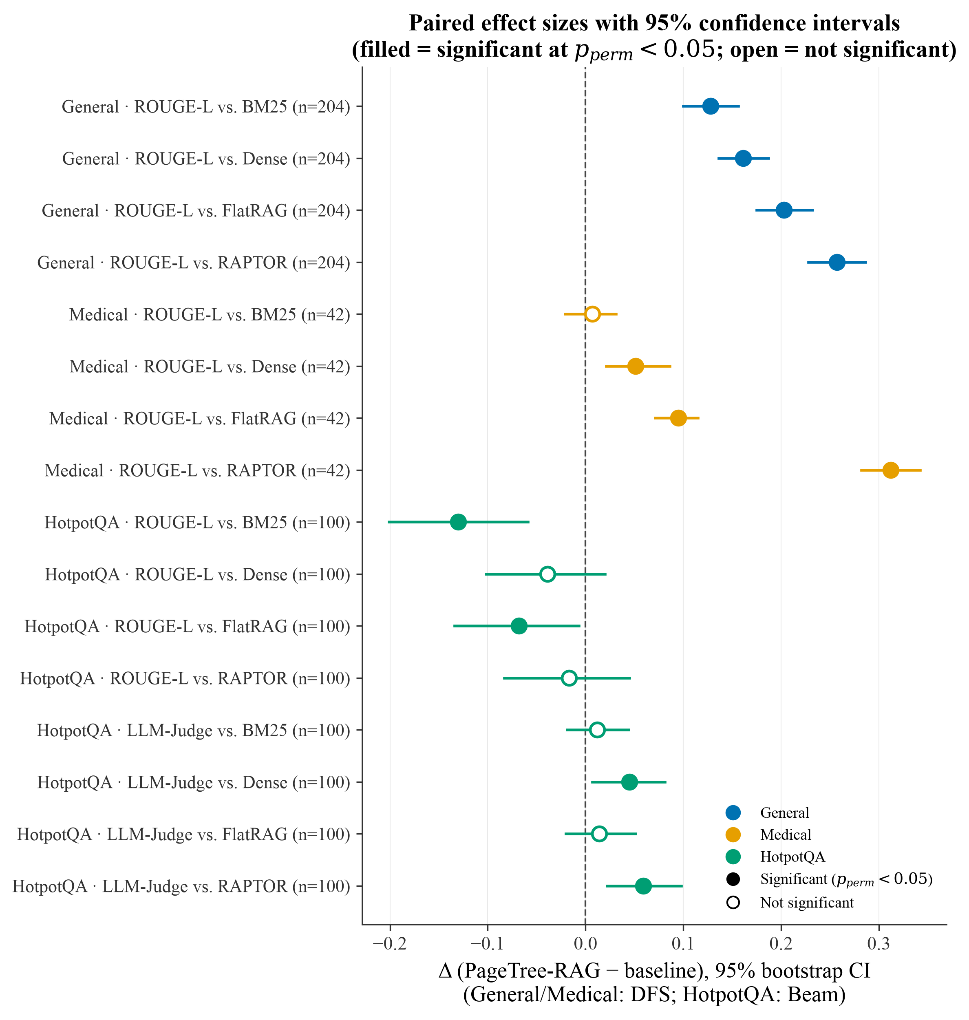
Figure 9: Paired effect sizes (PageTree-RAG vs. each baseline; General/Medical: DFS, HotpotQA: Beam) with 95% bootstrap confidence intervals, summarizing Table 13. Filled markers denote comparisons significant at p_perm < 0.05; open markers are not significant at this sample size.
Figure 9 visualizes these paired differences as a forest plot with 95% bootstrap confidence intervals. The analysis shows where the advantage is genuine and adequately powered and where it is not. On the general benchmark every comparison has power ≈ 1.0 and needs only n ≈ 7–22 paired items for 80% power, so those samples are not a threat to validity. The medical vs. BM25 comparison (Δ = +0.007, p_perm = 0.63) is essentially null. On the corrected HotpotQA set the pattern is mixed rather than a clean win: PageTree-RAG (Beam) trails BM25 and FlatRAG on ROUGE-L (Δ = -0.130, p_perm = 0.0007, and Δ = -0.068, p_perm = 0.035, respectively) while leading LLM-Judge over Dense Retrieval and RAPTOR (Δ = +0.045, p_perm = 0.024, and Δ = +0.059, p_perm = 0.003); the remaining four comparisons are directionally consistent with this pattern but individually underpowered at n = 100. We therefore treat the multi-hop result as reinforcing the paper's central lexical/judged divergence rather than as a uniform win on every metric.
- DISCUSSION
  - Why Structure Helps Citations, Not Lexical Overlap
Our results draw a sharp line between two kinds of benefit that hierarchical retrieval is often assumed to deliver together. The first-page-level provenance and a compact, structurally coherent context-is real and survives fair evaluation: PageTree-RAG (Beam) cites the right sections most accurately (Table 9) and reaches the highest judged quality on an order of magnitude fewer context tokens (Table 8). These follow directly from the representation: each node carries a page range, and selecting a relevant subtree yields a small, on-topic context rather than a scattering of chunks. The second supposed benefit-higher lexical overlap with reference answers-does not survive: once every system generates fluent text with the same LLM, the section boundary confers no advantage in n-gram overlap, and a hybrid flat retriever (FlatRAG) actually scores higher on ROUGE-L. In short, structure buys verifiability and efficiency, not surface-string similarity, and earlier hierarchical-RAG results that claimed large ROUGE-L gains likely measured an evaluation artifact rather than a retrieval improvement.
The corrected multi-hop evaluation (Section 5.6) reinforces this reading rather than complicating it. On the HotpotQA subset, PageTree-RAG (Beam) attains the highest LLM-Judge of all six systems (0.767), significantly above Dense Retrieval and RAPTOR, while BM25 and FlatRAG lead ROUGE-L, significantly above Beam. This is the same lexical/judged divergence we report on the Full Benchmark (Table 8) and in the per-type breakdown (Table 11), now confirmed on an independently-sourced multi-hop dataset: hierarchical retrieval's judged-quality advantage generalizes beyond the documents used to build it, even though it never shows up as a ROUGE-L advantage.
  - DFS versus Beam Search
Under the fair protocol, Beam Search is the better default among our variants. It reaches near-best overall LLM-Judge (0.822, statistically tied with the top baseline, BM25 at 0.826), the best citation F1 (0.757), and the highest LLM-Judge on the HotpotQA multi-hop subset (0.767), significantly above Dense Retrieval (p = 0.024) and RAPTOR (p = 0.003, Table 10). DFS is more token-frugal still (8 vs. 16 tokens on the Full Benchmark) but scores lower on quality and is marginally slower because it expands more nodes through the LLM scorer. We therefore recommend Beam as the production default and reserve DFS for extreme context-budget constraints. A query-complexity classifier that routes between the two remains attractive future work.
  - Error Analysis and Case Study
To see where PageTree-RAG succeeds and fails, we inspected the HotpotQA answers per system. Our first pass surfaced a generator bug rather than a retrieval failure: under an earlier prompt the shared Llama 3.1 8B answered English questions in Korean on 28 of 100 items (and on 22 for BM25), a side effect of the domain-adaptive multilingual prompting, which drove ROUGE to near-zero and depressed judged quality. We fixed the bug by constraining the answer language to the question's language; Korean drift on the English benchmarks fell to 2 of 100, and the corrected results in Tables 10 and 12 are what we report throughout. After the fix the remaining errors are genuine and, notably, less frequent for PageTree-RAG than for the flat baselines: outright failures (LLM-Judge ≤ 0.4) occur on 6 and 7 of 100 questions for DFS and Beam versus 13 for BM25. These residual errors are dominated by terse or malformed generation on hard bridge questions—the 8B decoder occasionally emits a sentence fragment or leaks an internal identifier—rather than by node selection, so a stronger generator should reduce them further without changing the retrieval-level ordering (Limitations, Section 6).
Two independent bugs surfaced during this investigation, and we disclose both for transparency. First, the response cache key (Section 4.3) did not include which traversal algorithm (DFS or Beam) produced a query, so within the cache's TTL a Beam Search query could silently return a DFS query's cached answer for the same question, and vice versa; we fixed the cache key to include the traversal algorithm and confirmed the fix (post-fix identical-answer rate on paired DFS/Beam queries fell from 84-100% to 1-4%, consistent with genuine coincidental ties). Second, and more consequentially, our HotpotQA loader mis-parsed the official dev-set schema: the real dataset stores each item's supporting context as a dictionary of parallel lists ({"title": [...], "sentences": [[...], ...]}), while our parser expected a list of (title, sentences) pairs—the format used only by our small bundled 20-question sample. The mismatch silently produced zero children for all 100 expanded documents, meaning every system, including the four baselines, retrieved from an empty index; any correct-looking answers came from the generator's own parametric knowledge of Wikipedia rather than from retrieval. We confirmed this both by inspecting the built indices directly (100/100 had empty context) and by observing that PageTree-RAG (DFS/Beam) refused to answer far less often than the baselines under this same empty context (11-17% of questions vs. 32-43% for the baselines)—consistent with our prompt template encouraging more confident guessing rather than better retrieval. We fixed the parser to handle both schemas, rebuilt all 100 indices (verified non-empty), and re-ran the full HotpotQA experiment with both fixes in place; Tables 10 and 13, Figures 4 and 9, and the case studies below reflect this fully corrected run.
Two examples make this concrete. For the bridge question “Jimmy D’Arcy played in Northern Ireland for the team based in what county?” (reference: “Antrim”), PageTree-RAG (Beam) correctly chains both hops—identifying the club (Ballymena United) and then its home county—and cites the supporting passage explicitly (“Ballymena United F.C., which is based in County Antrim. (From answer [2])”), rated 1.00 by the judge; BM25 stops at the first hop (“Ballymena United”, judge 0.60) and RAPTOR fails outright, echoing the question fragment (judge 0.53). Conversely, on the comparison question “Which is located farther West, the Cascade Locks and Canal or Lake Worth Lagoon?” (reference: “Cascade Locks and Canal”), PageTree-RAG (Beam) confidently returns the wrong side of the comparison (“Lake Worth Lagoon”, judge 0.20) despite having the same retrieved passages available, while DFS's narrower traversal lands on the correct answer (judge 0.80)—a genuine case where Beam Search's wider candidate set worked against it on a question with a single, narrow chain of evidence. Across the set such per-question outcomes are often close, and PageTree-RAG's edge shows mainly in aggregate—fewer catastrophic failures and higher mean judged quality—rather than in dramatic single-question wins.
  - Threats to Validity
Several caveats bound our conclusions. Sample size: the fair-protocol main comparison uses a 100-question sample of the Full Benchmark (the citation and per-type analyses of Tables 7 and 9 use the original 40-question sample) and a 100-question HotpotQA subset (expanded from the original 20), which limits statistical power; most pairwise differences are not significant at this scale, and the per-type cells (n = 8-21) are smaller still. Single generator and judge: all generative results use one local model (Llama 3.1 8B) for both answer generation and LLM-as-Judge, so judge scores could carry model-specific preferences. Because every answer under comparison is produced by that same model, this is not a per-system self-preference. To probe it further, we re-scored the 100-question fair set with a second, independent local judge (Qwen2.5-7B). The two judges' system rankings are positively correlated (Spearman ρ = 0.60; not significant at n = 6 systems, p = 0.21), and both rank RAPTOR lowest and PageTree-RAG (Beam) in the top two. This indicates our conclusions are not an artifact of a single judge, though some mid-rank reordering (notably FlatRAG) shows judge choice does shift absolute positions. Corroboration with a hosted frontier judge remains valuable future work. Citation metric: Citation F1 is computed against gold supporting sections and rewards systems that emit section/page identifiers; it measures provenance fidelity, not answer correctness. Generator scale: an 8B local model is weaker than hosted frontier models, and absolute scores would likely rise with a stronger generator, though we have no evidence the relative ordering would change. Larger-sample, multi-model replication is the primary item of future work.
  - Limitations
Beyond the evaluation caveats of Section 6.3, the system has three engineering limitations. LLM dependency: indexing requires an LLM call per document, and traversal issues several LLM calls for node scoring, which is the source of PageTree-RAG's higher query latency. Structural prompt brittleness: documents with inconsistent heading styles (for example scanned PDFs with OCR artifacts) may yield malformed index trees requiring manual correction. Learned scoring: we attempted learned node scoring via DSPy [15] with an open 70B model; optimization yielded no improvement (0.0% gain), likely due to insufficient training signal (fewer than 100 labeled examples), and we exclude this component from the main system. Score feature design: the relevance function uses three interpretable signals (semantic, keyword, structural); richer scorers—BM25 term weighting, cross-encoder rerankers, or a fully learned scorer—are a natural extension we leave to future work. Detector signals: the hallucination detector currently relies on lexical and citation overlap, so it inherits the limits of surface-level matching; adding a semantic embedding-similarity signal would strengthen it and is a straightforward future improvement.
  - Broader Impact
Because PageTree-RAG preserves page-level provenance, it is well suited to high-stakes domains-medicine, law, and regulatory compliance-where unsupported claims carry real cost and every assertion must be traceable to a source span. The same property aids auditing and post-hoc verification. Conversely, the system inherits the biases of its underlying LLM during indexing and generation, and the lightweight hallucination detector reduces but does not eliminate unfaithful output; deployments in sensitive settings should retain a human-in-the-loop for final decisions.
  - Reproducibility
To support replication we release the full pipeline: the PDF-to-tree indexer, the traversal-policy and compression code, all four evaluation sets (Full Benchmark, HotpotQA, Medical, and GovReport), the offline extractive and fair generative harnesses, the LLM-as-Judge prompts, and the page-indexed JSON tree schema. All generative results use a single local model, Llama 3.1 8B served via Ollama, for both answer generation and judging; the independent-judge cross-check uses Qwen2.5-7B. Every run fixes the random seed to 42, and no GPU cluster is required—the system runs on a single commodity machine with a local 8B model. Prompts, hyperparameter defaults (traversal weights, beam width W = 5, tree depth, compression threshold τ = 0.7), and per-question outputs are included so that all tables and figures can be regenerated end-to-end.
- CONCLUSION
We presented PageTree-RAG, a hierarchical document RAG system that indexes PDFs into page-referenced JSON trees using zero-shot LLM prompting, traverses them with DFS or Beam Search, compresses retrieved context, and validates generated answers with a lightweight five-signal hallucination detector. Evaluating all systems under a fair protocol in which only the retriever differs and a shared local LLM (Llama 3.1 8B) generates every answer, we found that PageTree-RAG (Beam) produces the most accurate page-level citations (citation F1 = 0.757 vs. 0.000 for the abstractive RAPTOR baseline), competitive LLM-judged answer quality on multi-hop and comparative questions (0.837 and 0.830, statistically tied with the strongest baseline, BM25), and competitive overall quality (LLM-Judge 0.822, statistically tied with the strongest baseline) while feeding an order of magnitude fewer context tokens to the generator-at the cost of higher per-query latency. Just as importantly, we showed that offline extractive evaluation and lexical-overlap metrics reverse these conclusions and overstate flat retrieval, and we reported both regimes so that the discrepancy is explicit; we encourage future hierarchical-RAG work to adopt generator-controlled evaluation and to measure citation and efficiency directly. The system also provides domain-adaptive prompting, multilingual support, and a production-ready API with caching, rate limiting, and asynchronous task queuing. Future work will pursue (1) larger-sample, multi-model replication of the fair protocol; (2) Graph RAG integration [3] for inter-document relationship modeling; (3) multi-modal indexing for figures and tables; and (4) learning the adaptive traversal policy end-to-end from user-feedback signals, together with cross-document reasoning and multi-modal indexing.
GenAI Usage Disclosure
Generative AI is a core component of the described system (LLM-driven tree indexing, answer generation, and LLM-as-judge evaluation), as detailed in Sections 3-5. In preparing this manuscript, generative AI tools were also used for language editing and reference formatting; all technical content, experimental design, analysis, and claims were produced and verified by the authors.
REFERENCES
[1] Akari Asai, Zeqiu Wu, Yizhong Wang, Avirup Sil, and Hannaneh Hajishirzi. 2024. Self-RAG: Learning to Retrieve, Generate, and Critique through Self-Reflection. In Proc. ICLR 2024. arXiv:2310.11511.
[2] Tom B. Brown et al. 2020. Language Models are Few-Shot Learners. In Advances in Neural Information Processing Systems 33 (NeurIPS 2020), 1877-1901. arXiv:2005.14165.
[3] Darren Edge, Ha Trinh, Newman Cheng, Joshua Bradley, Alex Chao, Apurva Mody, Steven Truitt, Dasha Metropolitansky, Robert Osazuwa Ness, and Jonathan Larson. 2025. From Local to Global: A GraphRAG Approach to Query-Focused Summarization. arXiv:2404.16130.
[4] Shahul Es, Jithin James, Luis Espinosa-Anke, and Steven Schockaert. 2023. RAGAS: Automated Evaluation of Retrieval Augmented Generation. arXiv:2309.15217.
[5] Thibault Formal, Benjamin Piwowarski, and Stephane Clinchant. 2021. SPLADE: Sparse Lexical and Expansion Model for First Stage Ranking. In Proc. SIGIR 2021, 2288-2292. https://doi.org/10.1145/3404835.3463098.
[6] Thibault Formal, Stephane Clinchant, Herve Dejean, and Carlos Lassance. 2024. SPLATE: Sparse Late Interaction Retrieval. In Proc. SIGIR 2024. arXiv:2404.13950.
[7] Yunfan Gao, Yun Xiong, Xinyu Gao, Kangxiang Jia, Jinliu Pan, Yuxi Bi, Yi Dai, Jiawei Sun, Meng Wang, and Haofen Wang. 2024. Retrieval-Augmented Generation for Large Language Models: A Survey. arXiv:2312.10997.
[8] Shailja Gupta, Rajesh Ranjan, and Surya Narayan Singh. 2024. A Comprehensive Survey of Retrieval-Augmented Generation (RAG): Evolution, Current Landscape and Future Directions. arXiv:2410.12837.
[9] Lei Huang et al. 2025. A Survey on Hallucination in Large Language Models: Principles, Taxonomy, Challenges, and Open Questions. ACM Trans. Inf. Syst. 43, 2, Article 42. https://doi.org/10.1145/3703155.
[10] Haoyu Huang, Yongfeng Huang, Junjie Yang, Zhenyu Pan, Yongqiang Chen, Kaili Ma, Hongzhi Chen, and James Cheng. 2025. Retrieval-Augmented Generation with Hierarchical Knowledge. arXiv:2503.10150.
[11] Huiqiang Jiang, Qianhui Wu, Chin-Yew Lin, Yuqing Yang, and Lili Qiu. 2023. LLMLingua: Compressing Prompts for Accelerated Inference of Large Language Models. In Proc. EMNLP 2023, 13358-13376. arXiv:2310.05736.
[12] Jeff Johnson, Matthijs Douze, and Herve Jegou. 2019. Billion-scale Similarity Search with GPUs. IEEE Trans. Big Data 7, 3, 535-547. arXiv:1702.08734.
[13] Vladimir Karpukhin, Barlas Oguz, Sewon Min, Patrick Lewis, Ledell Wu, Sergey Edunov, Danqi Chen, and Wen-tau Yih. 2020. Dense Passage Retrieval for Open-Domain Question Answering. In Proc. EMNLP 2020, 6769-6781.
[14] Omar Khattab and Matei Zaharia. 2020. ColBERT: Efficient and Effective Passage Search via Contextualized Late Interaction over BERT. In Proc. SIGIR 2020, 39-48. https://doi.org/10.1145/3397271.3401075.
[15] Omar Khattab, Arnav Singhvi, Paridhi Maheshwari, Zhiyuan Zhang, Keshav Santhanam, Sri Vardhamanan, Saiful Haq, Ashutosh Sharma, Thomas T. Joshi, Hanna Moazam, Heather Miller, Matei Zaharia, and Christopher Potts. 2024. DSPy: Compiling Declarative Language Model Calls into Self-Improving Pipelines. In Proc. ICLR 2024. arXiv:2310.03714.
[16] Takeshi Kojima, Shixiang Shane Gu, Machel Reid, Yutaka Matsuo, and Yusuke Iwasawa. 2022. Large Language Models are Zero-Shot Reasoners. In Advances in Neural Information Processing Systems 35 (NeurIPS 2022). arXiv:2205.11916.
[17] Wojciech Kryscinski, Bryan McCann, Caiming Xiong, and Richard Socher. 2020. Evaluating the Factual Consistency of Abstractive Text Summarization. In Proc. EMNLP 2020, 9332-9346. arXiv:1910.12840.
[18] Woosuk Kwon, Zhuohan Li, Siyuan Zhuang, Ying Sheng, Lianmin Zheng, Cody Hao Yu, Joseph E. Gonzalez, Hao Zhang, and Ion Stoica. 2023. Efficient Memory Management for Large Language Model Serving with PagedAttention. In Proc. SOSP 2023, 611-626. https://doi.org/10.1145/3600006.3613165.
[19] Patrick Lewis et al. 2020. Retrieval-Augmented Generation for Knowledge-Intensive NLP Tasks. In Advances in Neural Information Processing Systems 33 (NeurIPS 2020), 9459-9474. arXiv:2005.11401.
[20] Chin-Yew Lin. 2004. ROUGE: A Package for Automatic Evaluation of Summaries. In Proc. ACL Workshop on Text Summarization Branches Out, 74-81.
[21] Jerry Liu. 2022. LlamaIndex. GitHub. https://github.com/run-llama/llama_index.
[22] Nelson F. Liu, Kevin Lin, John Hewitt, Ashwin Paranjape, Michele Bevilacqua, Fabio Petroni, and Percy Liang. 2024. Lost in the Middle: How Language Models Use Long Contexts. Trans. Assoc. Comput. Linguist. 12, 157-173. arXiv:2307.03172.
[23] Xueguang Ma, Ruqing Sun, Ronak Pradeep, and Jimmy Lin. 2021. A Replication Study of Dense Passage Retrieval for Open-Domain Question Answering. arXiv:2104.05740.
[24] Ben Malin, Tatiana Kalganova, and Nikolaos Boulgouris. 2025. A Review of Faithfulness Metrics for Hallucination Assessment in Large Language Models. arXiv:2501.00269.
[25] Sewon Min, Kalpesh Krishna, Xinxi Lyu, Mike Lewis, Wen-tau Yih, Pang Wei Koh, Mohit Iyyer, Luke Zettlemoyer, and Hannaneh Hajishirzi. 2023. FActScore: Fine-grained Atomic Evaluation of Factual Precision in Long Form Text Generation. In Proc. EMNLP 2023. arXiv:2305.14251.
[26] Feng Nan, Ramesh Nallapati, Zhiguo Wang, Cicero Nogueira dos Santos, Henghui Zhu, Dejiao Zhang, Kathleen McKeown, and Bing Xiang. 2021. Entity-level Factual Consistency of Abstractive Text Summarization. In Proc. EACL 2021, 2727-2733. arXiv:2102.09130.
[27] Nils Reimers and Iryna Gurevych. 2019. Sentence-BERT: Sentence Embeddings using Siamese BERT-Networks. In Proc. EMNLP 2019, 3982-3992. arXiv:1908.10084.
[28] Stephen Robertson and Hugo Zaragoza. 2009. The Probabilistic Relevance Framework: BM25 and Beyond. Found. Trends Inf. Retr. 3, 4, 333-389.
[29] Keshav Santhanam, Omar Khattab, Jon Saad-Falcon, Christopher Potts, and Matei Zaharia. 2022. ColBERTv2: Effective and Efficient Retrieval via Lightweight Late Interaction. In Proc. NAACL-HLT 2022, 3715-3734. arXiv:2112.01488.
[30] Parth Sarthi, Salman Abdullah, Aditi Tuli, Shubh Khanna, Anna Goldie, and Christopher D. Manning. 2024. RAPTOR: Recursive Abstractive Processing for Tree-Organized Retrieval. In Proc. ICLR 2024. arXiv:2401.18059.
[31] Kurt Shuster, Spencer Poff, Moya Chen, Douwe Kiela, and Jason Weston. 2021. Retrieval Augmentation Reduces Hallucination in Conversation. In Findings of EMNLP 2021, 3784-3803. arXiv:2104.07567.
[32] Harsh Trivedi, Niranjan Balasubramanian, Tushar Khot, and Ashish Sabharwal. 2023. Interleaving Retrieval with Chain-of-Thought Reasoning for Knowledge-Intensive Multi-Step Questions. In Proc. ACL 2023, 10014-10037. arXiv:2212.10509.
[33] Vectify AI. 2023. PageIndex: Reasoning-Based, Vectorless RAG via Document Tree Search. GitHub. https://github.com/VectifyAI/PageIndex.
[34] Jason Wei, Xuezhi Wang, Dale Schuurmans, Maarten Bosma, Brian Ichter, Fei Xia, Ed Chi, Quoc Le, and Denny Zhou. 2022. Chain-of-Thought Prompting Elicits Reasoning in Large Language Models. In Advances in Neural Information Processing Systems 35 (NeurIPS 2022). arXiv:2201.11903.
[35] Zhilin Yang, Peng Qi, Saizheng Zhang, Yoshua Bengio, William Cohen, Ruslan Salakhutdinov, and Christopher D. Manning. 2018. HotpotQA: A Dataset for Diverse, Explainable Multi-hop Question Answering. In Proc. EMNLP 2018, 2369-2380. arXiv:1809.09600.
[36] Tianyi Zhang, Varsha Kishore, Felix Wu, Kilian Q. Weinberger, and Yoav Artzi. 2020. BERTScore: Evaluating Text Generation with BERT. In Proc. ICLR 2020. arXiv:1904.09675.
[37] Xiaoming Zhang, Ming Wang, Xiaocui Yang, Daling Wang, Shi Feng, and Yifei Zhang. 2024. Hierarchical Retrieval-Augmented Generation Model with Rethink for Multi-hop Question Answering. arXiv:2408.11875.
[38] Lianmin Zheng et al. 2023. Judging LLM-as-a-Judge with MT-Bench and Chatbot Arena. In Advances in Neural Information Processing Systems 36 (NeurIPS 2023), Datasets and Benchmarks Track. arXiv:2306.05685.
[39] Wenyu Tao, Xiaofen Xing, Yirong Chen, Linyi Huang, and Xiangmin Xu. 2025. TreeRAG: Unleashing the Power of Hierarchical Storage for Enhanced Knowledge Retrieval in Long Documents. In Findings of the Association for Computational Linguistics: ACL 2025, pp. 356–371.
[40] Luyang Huang, Shuyang Cao, Nikolaus Parulian, Heng Ji, and Lu Wang. 2021. Efficient Attentions for Long Document Summarization. In Proc. NAACL-HLT 2021, pp. 1419–1436.
[41] Hongjin Qian, Peitian Zhang, Zheng Liu, Kelong Mao, and Zhicheng Dou. 2025. MemoRAG: Boosting Long Context Processing with Global Memory-Enhanced Retrieval Augmentation. In Proc. ACM Web Conference (WWW 2025). arXiv:2409.05591.
[42] Aditi Singh, Abul Ehtesham, Saket Kumar, Tala Talaei Khoei, and Athanasios V. Vasilakos. 2025. Agentic Retrieval-Augmented Generation: A Survey on Agentic RAG. arXiv:2501.09136.

