**RestClient for Unity 🤘**

This **HTTP/REST** Client is based on Promises to avoid the [Callback Hell](http://callbackhell.com/) ☠️ and the [Pyramid of doom](https://en.wikipedia.org/wiki/Pyramid_of_doom_(programming))💩 working with **Coroutines** in **Unity** 🎮, example:

var api = "https://jsonplaceholder.typicode.com";

RestClient.GetArray<Post>(api + "/posts", (err, res) => {

RestClient.GetArray<Todo>(api + "/todos", (errTodos, resTodos) => {

RestClient.GetArray<User>(api + "/users", (errUsers, resUsers) => {

//Missing validations to catch errors!

});

});

});

But working with **Promises** we can improve our code, yay! 👏

RestClient.GetArray<Post>(api + "/posts").Then(response => {

EditorUtility.DisplayDialog("Success", JsonHelper.ArrayToJson<Post>(response, true), "Ok");

return RestClient.GetArray<Todo>(api + "/todos");

}).Then(response => {

EditorUtility.DisplayDialog("Success", JsonHelper.ArrayToJson<Todo>(response, true), "Ok");

return RestClient.GetArray<User>(api + "/users");

}).Then(response => {

EditorUtility.DisplayDialog("Success", JsonHelper.ArrayToJson<User>(response, true), "Ok");

}).Catch(err => EditorUtility.DisplayDialog ("Error", err.Message, "Ok"));

**Features**🎮

* Works out of the box 🎉
* Supports **HTTPS/SSL**
* Built on top of **UnityWebRequest** system
* Includes JSON serialization with **JsonUtility** (Other tools are supported!)
* Get **Arrays** Supported
* Default **HTTP** Methods **(GET, POST, PUT, DELETE, HEAD)**
* Generic **REQUEST** method to create any http request
* Based on **Promises** for a better asynchronous programming
* Handle HTTP exceptions in a better way
* Retry HTTP requests easily
* Open Source 🦄

## Supported platforms 📱 🖥

The [UnityWebRequest](https://docs.unity3d.com/Manual/UnityWebRequest.html) system supports most Unity platforms:

* All versions of the Editor and Standalone players
* WebGL
* Mobile platforms: iOS, Android
* Universal Windows Platform
* PS4 and PSVita
* XboxOne
* HoloLens
* Nintendo Switch

**Demo ⏯**

Do you want to see this beautiful package in action? Download the demo [here](https://minhaskamal.github.io/DownGit/%23/home?url=https://github.com/proyecto26/RestClient/tree/master/demo)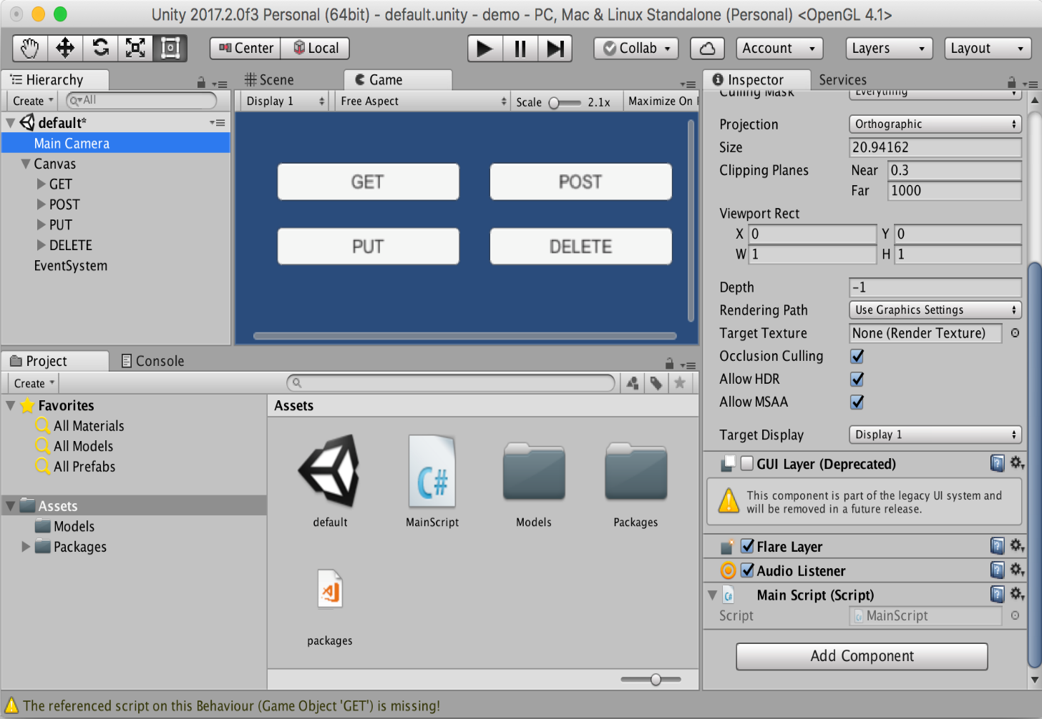

**Installation**👨**‍**💻

**Unity package**

Download and install the **.unitypackage** file of the latest release published [here](https://github.com/proyecto26/RestClient/releases).

**Nuget package**

Other option is downloading this package from **NuGet** with **Visual Studio** or using the **nuget-cli**, a [NuGet.config](https://github.com/proyecto26/RestClient/blob/master/demo/NuGet.config) file is required at the root of your **Unity Project**, for example:

<?xml version="1.0" encoding="utf-8"?>

<configuration>

<config>

<add key="repositoryPath" value="./Assets/Packages" />

</config>

</configuration>

The package to search for is [Proyecto26.RestClient](https://www.nuget.org/packages/Proyecto26.RestClient/).

**Getting Started**📚

The default methods **(GET, POST, PUT, DELETE, HEAD)** are:

RestClient.Get("https://jsonplaceholder.typicode.com/posts/1").Then(res => {

EditorUtility.DisplayDialog("Response", res.Text, "Ok");

});

RestClient.Post("https://jsonplaceholder.typicode.com/posts", newPost).Then(res => {

EditorUtility.DisplayDialog("Status", res.StatusCode.ToString(), "Ok");

});

RestClient.Put("https://jsonplaceholder.typicode.com/posts/1", updatedPost).Then(res => {

EditorUtility.DisplayDialog("Status", res.StatusCode.ToString(), "Ok");

});

RestClient.Delete("https://jsonplaceholder.typicode.com/posts/1").Then(res => {

EditorUtility.DisplayDialog("Status", res.StatusCode.ToString(), "Ok");

});

RestClient.Head("https://jsonplaceholder.typicode.com/posts").Then(res => {

EditorUtility.DisplayDialog("Status", res.StatusCode.ToString(), "Ok");

});

### Handling during scene transition

ExecuteOnMainThread.RunOnMainThread.Enqueue(() => {

//Any API call using RestClient

});

### Generic Request Method

And we have a generic method to create any type of request:

RestClient.Request(new RequestHelper {

Uri = "https://jsonplaceholder.typicode.com/post",

Method = "POST",

Timeout = 10,

Params = new Dictionary<string, string> {

{ "param1", “Query string param..." }

},

Headers = new Dictionary<string, string> {

{ "Authorization", "Bearer JWT_token..." }

},

Body = newPhoto, //Serialize object using JsonUtility by default

BodyString = SerializeObject(newPhoto), //Use it instead of 'Body' to serialize using other tools

BodyRaw = CompressToRawData(newPhoto), //Use it instead of 'Body' to send raw data directly

FormData = new WWWForm(), //Send files, etc with POST requests

SimpleForm = new Dictionary<string, string> {}, //Content-Type: application/x-www-form-urlencoded

FormSections = new List<IMultipartFormSection>() {}, //Content-Type: multipart/form-data

CertificateHandler = new CustomCertificateHandler(),

UploadHandler = new UploadHandlerRaw(bytes), //Send bytes directly if it's required

DownloadHandler = new DownloadHandlerFile(destPah), //Download large files

ContentType = "application/json", //JSON is used by default

Retries = 3, //Number of retries

RetrySecondsDelay = 2, //Seconds of delay to make a retry  
 RetryCallbackOnlyOnNetworkErrors = true, //Invoke RetryCallback only when the retry is provoked by a network error

RetryCallback = (err, retries) => {}, //See the error before retrying the request

ProgressCallback = (percent) => {}, //Reports progress of the request from 0 to 1

EnableDebug = true, //See logs of the requests for debug mode

IgnoreHttpException = true, //Prevent to catch http exceptions

ChunkedTransfer = false,

UseHttpContinue = true,

RedirectLimit = 32,

DefaultContentType = false, //Disable JSON content type by default

ParseResponseBody = false //Don't encode and parse downloaded data as JSON

}).Then(response => {

//Get resources via downloadHandler to get more control!

Texture texture = ((DownloadHandlerTexture)response.Request.downloadHandler).texture;

AudioClip audioClip = ((DownloadHandlerAudioClip)response.Request.downloadHandler).audioClip;

AssetBundle assetBundle = ((DownloadHandlerAssetBundle)response.Request.downloadHandler).assetBundle;

EditorUtility.DisplayDialog("Status", response.StatusCode.ToString(), "Ok");

}).Catch(err => {

var error = err as RequestException;

EditorUtility.DisplayDialog("Error Response", error.Response, "Ok");

});

* Example downloading an audio file:

var fileUrl = "https://bit.ly/2ZUpqTc";

var fileType = AudioType.OGGVORBIS;

RestClient.Get(new RequestHelper {

Uri = fileUrl,

DownloadHandler = new DownloadHandlerAudioClip(fileUrl, fileType),

}).Then(res => {

AudioSource audio = GetComponent<AudioSource>();

audio.clip = ((DownloadHandlerAudioClip)res.Request.downloadHandler).audioClip;

audio.Play();

});

With all the methods we have the possibility to indicate the type of response, in the following example we're going to create a class and the **HTTP** requests to load **JSON** data easily:

[Serializable]

public class User

{

public int id;

public string name;

public string username;

public string email;

public string phone;

public string website;

}

* **GET JSON**

var usersRoute = "https://jsonplaceholder.typicode.com/users";

RestClient.Get<User>(usersRoute + "/1").Then(firstUser => {

EditorUtility.DisplayDialog("JSON", JsonUtility.ToJson(firstUser, true), "Ok");

});

* **GET Array (JsonHelper is an extension to manage arrays)**

RestClient.GetArray<User>(usersRoute).Then(users => {

EditorUtility.DisplayDialog("Array", JsonHelper.ArrayToJsonString<User>(users, true), "Ok");

});

Also, we can create different classes for custom responses:

[Serializable]

public class CustomResponse

{

public int id;

}

* **POST**

RestClient.Post<CustomResponse>(usersRoute, newUser).Then(customResponse => {

EditorUtility.DisplayDialog("JSON", JsonUtility.ToJson(customResponse, true), "Ok");

});

* **PUT**

RestClient.Put<CustomResponse>(usersRoute + "/1", updatedUser).Then(customResponse => {

EditorUtility.DisplayDialog("JSON", JsonUtility.ToJson(customResponse, true), "Ok");

});

**Custom HTTP Headers, Params and Options**💥

**HTTP Headers**, such as Authorization, can be set in the **DefaultRequestHeaders** object for all requests

RestClient.DefaultRequestHeaders["Authorization"] = "Bearer ...";

**Query string params** can be set in the **DefaultRequestParams** object for all requests

RestClient.DefaultRequestParams["param1"] = “Query string value...";

Also we can add specific options and override default headers and params for a request

var currentRequest = new RequestHelper {

Uri = "https://jsonplaceholder.typicode.com/photos",

Headers = new Dictionary<string, string> {

{ "Authorization", "Other token..." }

},

Params = new Dictionary<string, string> {

{ "param1", "Other value..." }

}

};

RestClient.GetArray<Photo>(currentRequest).Then(response => {

EditorUtility.DisplayDialog("Header", currentRequest.GetHeader("Authorization"), "Ok");

});

And we can know the status of the request and cancel it!

currentRequest.UploadProgress; //The progress by uploading data to the server

currentRequest.UploadedBytes; //The number of bytes of body data the system has uploaded

currentRequest.DownloadProgress; //The progress by downloading data from the server

currentRequest.DownloadedBytes; //The number of bytes of body data the system has downloaded

currentRequest.Abort(); //Abort the request manually

Later we can clean the default headers and params for all requests

RestClient.CleanDefaultHeaders();

RestClient.CleanDefaultParams();

**Code example**

* Unity as Client

[Serializable]

public class ServerResponse {

public string id;

public string date; //DateTime is not supported by JsonUtility

}

[Serializable]

public class User {

public string firstName;

public string lastName;

}

RestClient.Post<ServerResponse>("www.api.com/endpoint", new User {

firstName = "Juan David",

lastName = "Nicholls Cardona"

}).Then(response => {

EditorUtility.DisplayDialog("ID: ", response.id, "Ok");

EditorUtility.DisplayDialog("Date: ", response.date, "Ok");

});

* NodeJS as Backend (Using [Express](http://expressjs.com/es/starter/hello-world.html))

router.post('/', function(req, res) {

console.log(req.body.firstName)

res.json({

id: 123,

date: new Date()

})

});

**Collaborators**🥇

| **jdnichollsc** | **jdnichollsc** | https://avatars3.githubusercontent.com/u/25492923?s=460&v=4 |
| --- | --- | --- |
| [Juan Nicholls](mailto:jdnichollsc@hotmail.com) | [Diego Ossa](mailto:diegoossa@gmail.com) | [Nasdull](mailto:nasdull@hotmail.com) |

**Credits**👍

* **C-Sharp-Promise:** [Promises library for C# for management of asynchronous operations.](https://github.com/Real-Serious-Games/C-Sharp-Promise)
* **MyAPI:** [A template to create awesome APIs easily ⚡️](https://github.com/proyecto26/MyAPI)

**Supporting**🍻

I believe in Unicorns 🦄 Support [me](http://www.paypal.me/jdnichollsc/2), if you do too.

**Happy coding**💯

Made with ❤️