|  |  |  |
| --- | --- | --- |
| **Winter 2019 School**  *Advanced Analysis of Atmosphere-Surface Interactions and Feedbacks (ATMDP-003)*  March 4 – 15, 2019  Hyytiälä, Finland  **Course information** | **logo** |  |

**Overview of the daily programme**

|  |  |
| --- | --- |
| 7:00-8:30 Breakfast (Sun until 9:00)  8:30 Morning session begins  11:15 Lunch  12:00 Afternoon session I begins  13:30 Coffee | 14:00 Afternoon session II begins  16:30 Dinner  17:30 Evening session begins  Evening Sauna (not every day)  Sports session (every 2nd day)  Evening Evening meal/snack |
|  |  |

**The door codes**

3721* A-building, B-building

2862* Institute

**Accommodation and keys**

The accommodation list is on the A-building lobby. The students’ rooms are in the A-building, assistants have their rooms in the A- and B-buildings, and lecturers’ rooms are mainly in the B- and C-buildings. The room doors are open upon arrival, one key in the door lock, another at the desk in the room. **Don’t lock yourself out of your room**, especially during nights and weekend, when the spare keys are not readily available! Opening the door will cost you 20€. Please fill in the accommodation form, found on the desk of your room.

The silence is in effect in A-building between 23:00 and 7:00, please don’t make noise then!

Don’t forget to leave the keys in the room in the end of the course!

**Computer class and internet**

The computer class in the institute with 13 workstations in the institute can **only** be used between **7:00 and 22:30**. Being there at night results in an alarm (and costs you 50€), so keep out! There are additional computers in the A-building computer class and three workstations in the reference library that can be used at all times. There is also a wireless network (hupnet/eduroam) in the institute and accommodation buildings. Students and staff members of Finnish universities can log on workstations and in hupnet using their personal account, students and staff members of European universities can also authenticate through eduroam. Others should use the guest account: that will be given at the course.

**Social and outdoor programme**

**Tuesday, Mar 5:** Visit to SMEAR II station. We will stay outside most of the time, dress accordingly, proper shoes will keep your feet dry and warm.

**Saturday, Mar 9**:Excursion. Evening free.

**Sunday, Mar 10:** Breakfast until 9:00 and free time until afternoon

**Thursday, Mar 14:** Course dinner and party.

**Sauna**

There are two saunas (big and small sauna). The sauna schedule will be provided on a daily basis.

**Laundry**

There is a washing machine on the 2nd floor of A-building. Make a booking on the list you can find in the room, wash your clothes, and dry them up in the drying room. One wash is 3€, to be paid in the end of the course.

**Meals**

Breakfast, lunch, afternoon coffee and dinner are served in the A-building canteen (1st floor). The evening meal is served in the A-building cabinet next to the canteen. Please lift up the chairs after you have eaten, and return the dishes to the return point. It is forbidden to take food out of the canteen.

**Extra drinks (charged in the end of the course)**

Beer/lemonade 1.50 €; Cider 2.60 €

Mark your drinks on the list next to the refrigerator, and pay your drinks by Thursday, March 14, 15:30 in the station office.

**Hyytiälä on the map of Finland**

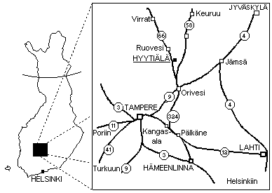

**Hyytiälä Forestry Field Station map**

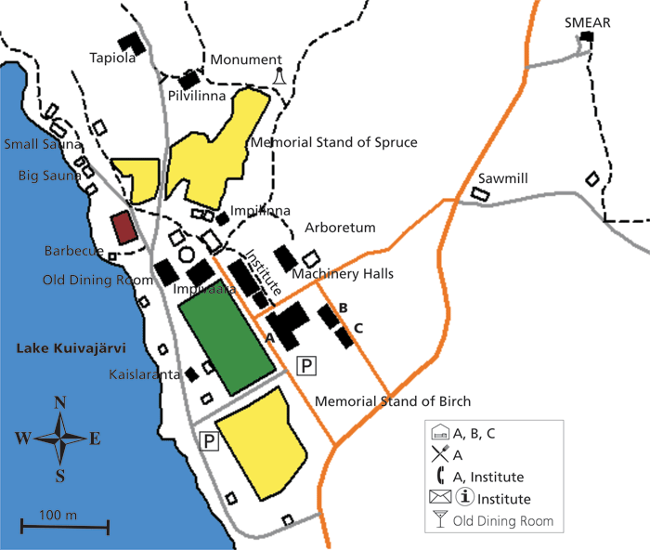

Lectures and group presentations: auditorium (institute)

Group work: computer room (institute), meeting room (institute), library (institute), seminar room (A-building)

Accommodation: students A-building, teachers and assistants mainly B- and C-buildings

Meals: A-building

Computer classes: Institute, A-building

Sauna: big sauna by the lake, small sauna by the lake

In case of practical questions during the course, contact

Lubna Dada ([lubna.dada@helsinki.fi](mailto:lubna.dada@helsinki.fi), tel. +358 50 4488568)

Tuomo Nieminen ([tuomo.nieminen@helsinki.fi](mailto:tuomo.nieminen@helsinki.fi); tel. +358 40 8196166)

Qiaozhi Zha ([qiaozhi.zha@helsinki.fi](mailto:qiaozhi.zha@helsinki.fi), tel. +358 45 6983000)