MINOR PROJECT – 6
Leave Management System
Appsmith, PostgreSQL, Docker and AWS EC2 Deployment
Student Dalia Mahata
Project Leave Management System
Tools Used Appsmith, PostgreSQL, Docker, AWS EC2
Submission Date 28 September 2026

Abstract
This report presents the design and implementation of a Leave Management System using Appsmith as the application interface, PostgreSQL for data storage, Docker for containerized deployment, and AWS EC2 as the cloud hosting environment. The system provides a leave request form, status tracking, search and filtering, and administrative approval or rejection of leave requests. Database records were verified through a PostgreSQL query, while the Docker containers and EC2 instance were verified as running.

1. Introduction
Managing employee leave requests through manual methods can make tracking, approval and record maintenance difficult. The Leave Management System provides a centralized interface in which employee leave information can be entered and stored in a PostgreSQL database. The application displays the stored requests in a table and provides controls for searching, approving and rejecting requests. The completed application is deployed using Docker containers and hosted on an AWS EC2 instance.

2. Objectives
- Create a web-based interface for submitting employee leave requests.
- Store leave request information in a PostgreSQL database.
- Display leave requests with employee details, dates, reason and current status.
- Provide Pending, Approved and Rejected status tracking.
- Provide search/filter functionality for leave records.
- Provide administrative Approve and Reject actions.
- Deploy the application and database using Docker containers.
- Host and verify the deployed system on AWS EC2.

3. Project Configuration
Component | Configuration
Application | Appsmith — Leave Management System
Database | PostgreSQL — leave_requests table
Application Container | Appsmith container
Database Container | PostgreSQL container
Application Port | 80 mapped to the application container
Deployment | Docker on AWS EC2
Main Functions | Submit Leave Request, Search, Approve, Reject, Status Tracking
Verified Data | Employee name, email, leave type, start date, end date, reason, status

4. Application Interface and Leave Request Evidence
The application provides the main Leave Management System interface. The form contains fields for employee name, employee email, leave type, start date, end date and reason for leave. A Submit Leave Request button sends the request for processing. The page also displays the current leave status, search input, status counters and the leave records table.
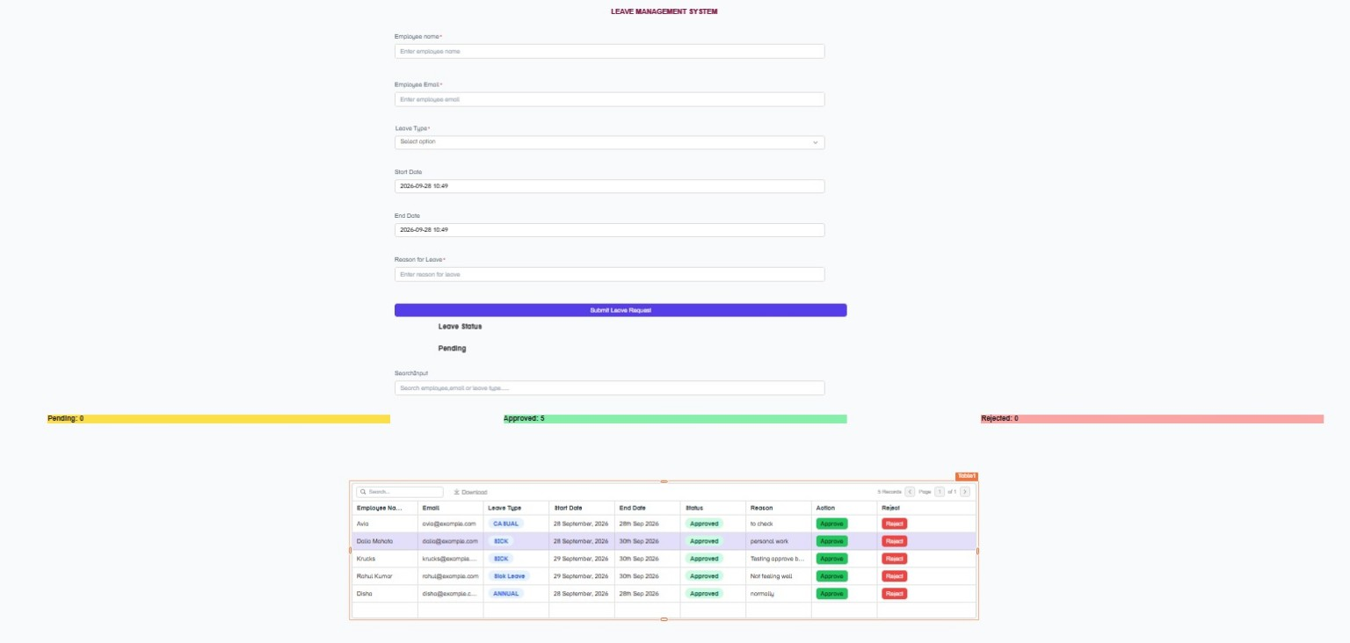
Figure 1: Leave Management System interface with request form, status, search, counters and records table.
The interface provides a single place for entering a request and reviewing the stored leave records. The table includes employee details, leave type, dates, status, reason and action controls.

5. Leave Submission and Pending Status
A new leave request can be entered by providing the employee information, selecting a leave type, specifying the dates and entering the reason. After submission, the request is displayed with Pending status until it is processed by the administrator.
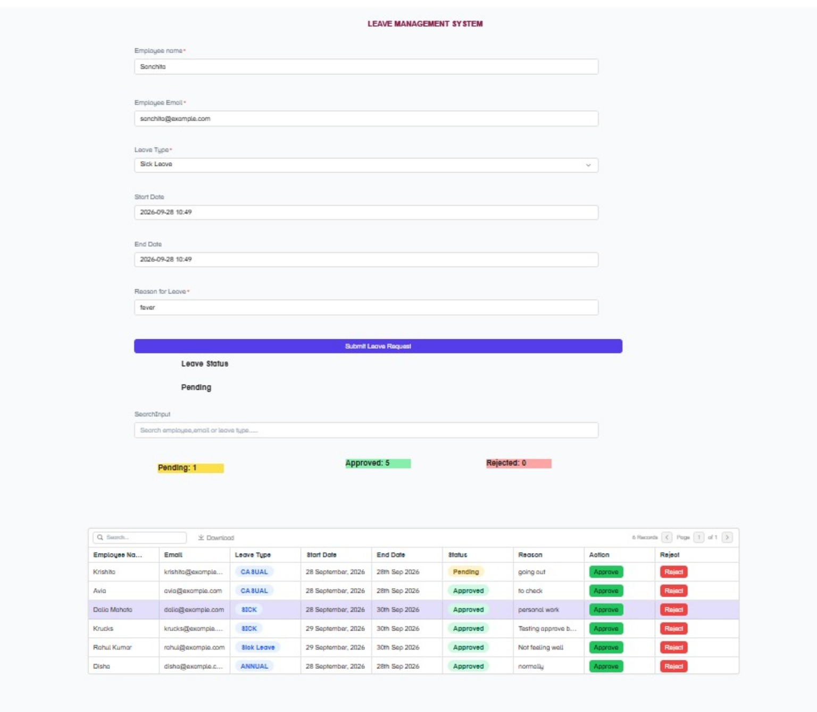
Figure 2: Leave request entered in the form and displayed with Pending status.
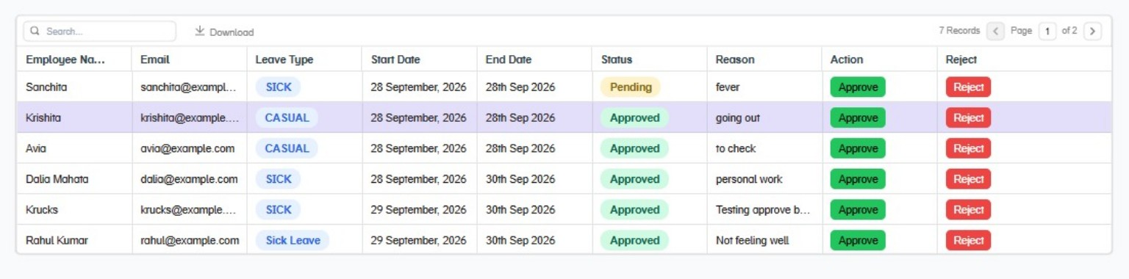
Figure 3: Leave records table showing employee information, leave type, dates and status.

6. Search and Filtering Evidence
The application includes a search field that can be used to locate leave records by employee information or leave type. The filtered result allows the administrator to inspect the matching request without manually reviewing every record.
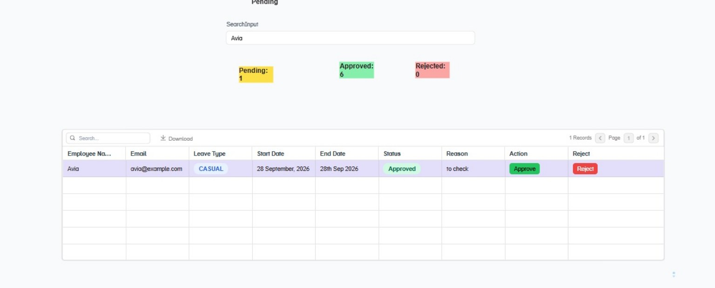
Figure 4: Search/filter operation displaying the matching leave record.
The evidence demonstrates that the dashboard can narrow the displayed records according to the entered search term while retaining the status summary.

7. Approval and Rejection Workflow
Each leave record contains Approve and Reject controls. Processing a request changes the status stored for that record. The screenshots demonstrate approved and rejected states in the leave table, allowing the administrator to track the outcome of each request.
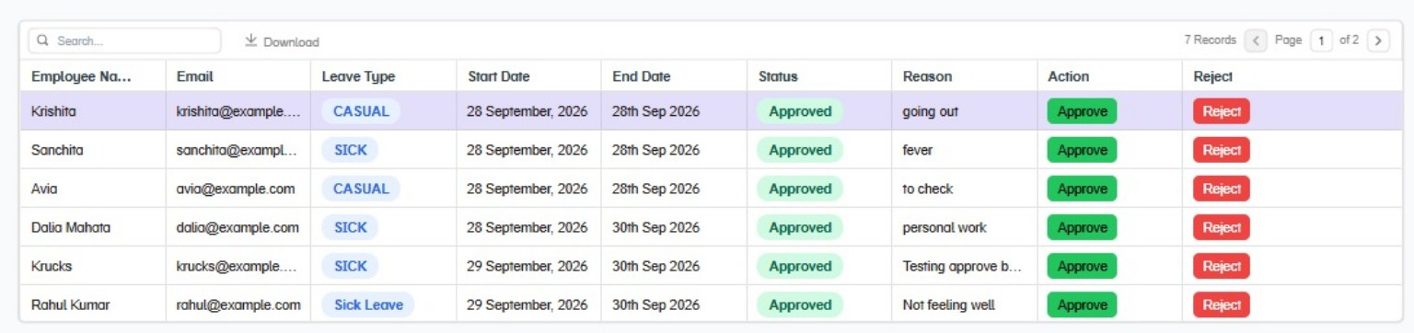
Figure 5: Leave records showing the available Approve and Reject actions and processed statuses.
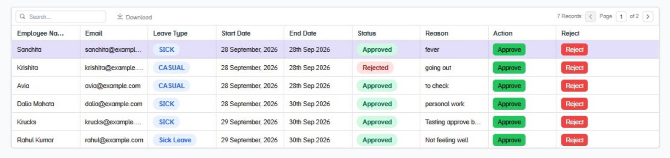
Figure 6: Updated leave table showing a rejected request together with approved requests.

8. Database Verification
The Leave Management System stores its records in PostgreSQL. The database evidence shows a SELECT query executed against the leave_requests table. The result contains the stored employee name, employee email, leave type, start date, end date, reason and status fields.
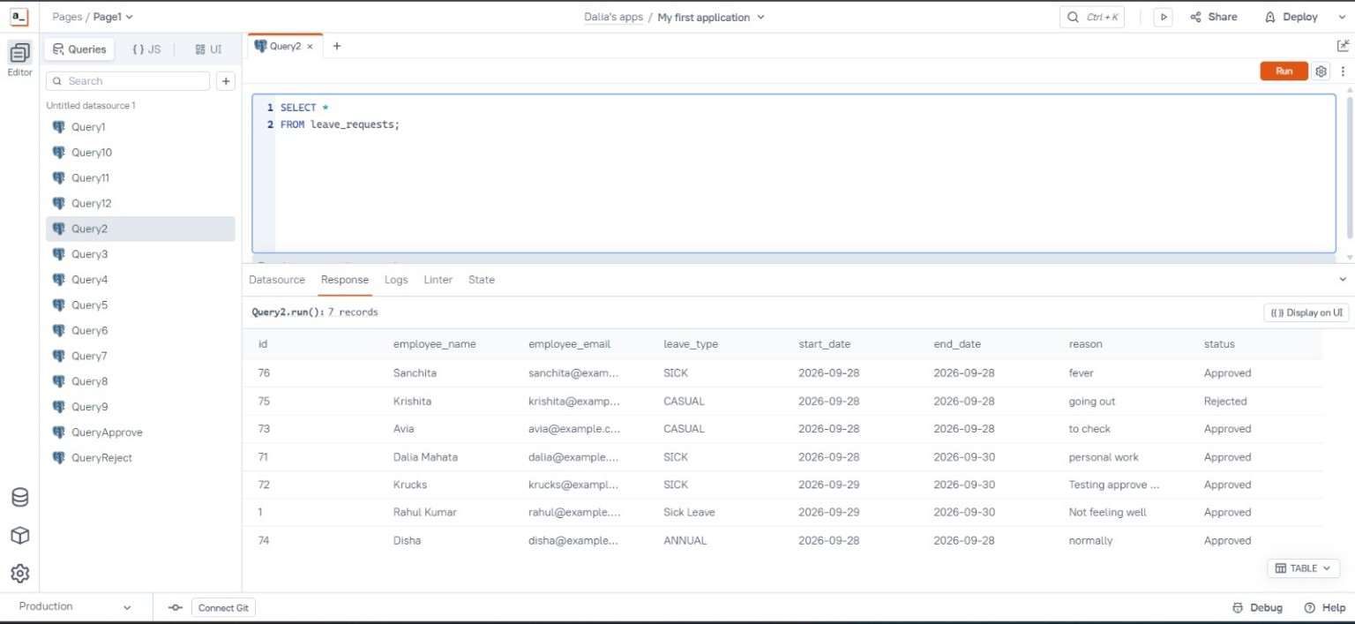
Figure 7: PostgreSQL leave_requests table queried to verify stored application records.
The database result confirms that the records displayed by the application are persisted in the PostgreSQL backend.

9. AWS EC2 Deployment Verification
The completed application was deployed on an AWS EC2 instance. The EC2 console evidence shows the instance in the Running state and identifies the deployed Leave Management System environment.
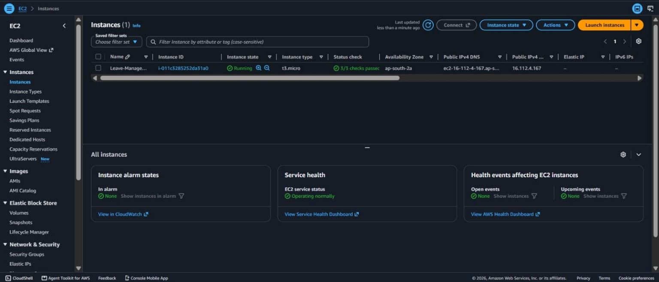
Figure 8: AWS EC2 instance running for the Leave Management System deployment.
The running EC2 instance provides the cloud environment used to host the containerized application.

10. Docker Container Verification
Docker is used to run the application and PostgreSQL services as separate containers. The terminal evidence shows the Appsmith application container and PostgreSQL database container running on the EC2 host. The application container exposes the web service through port 80.
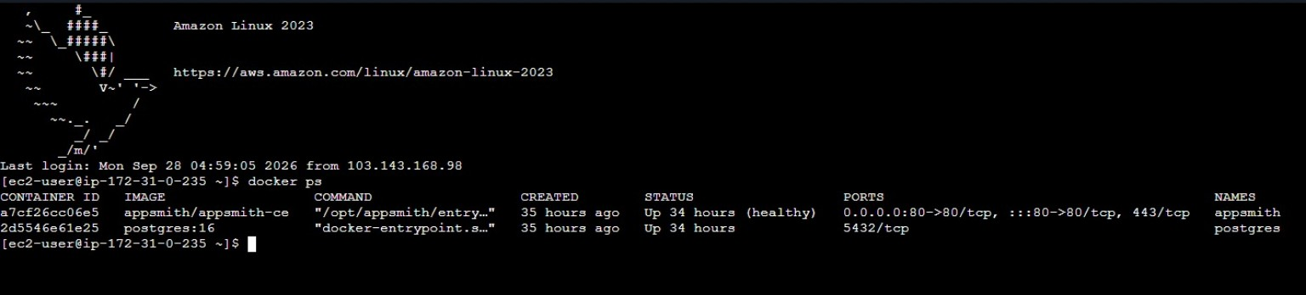
Figure 9: Running Docker containers for Appsmith and PostgreSQL on the EC2 instance.
The container status verifies that the application and database services required by the project are active in the deployment environment.

11. Validation Summary
The Leave Management System was validated from the user interface through the database and deployment environment:
- Leave request form verified with employee, email, leave type, date and reason fields.
- Submitted request verified with Pending status.
- Approved and Rejected statuses verified in the leave records table.
- Pending, Approved and Rejected counters displayed on the dashboard.
- Search/filter operation verified using an employee record.
- PostgreSQL leave_requests table verified using a SELECT query.
- Appsmith and PostgreSQL Docker containers verified as running.
- AWS EC2 instance verified in the Running state.

12. Conclusion
This project successfully demonstrates a centralized Leave Management System using Appsmith, PostgreSQL, Docker and AWS EC2. The system supports leave submission, database storage, status tracking, searching, approval and rejection. PostgreSQL verification confirms persistent storage, while Docker and EC2 verification confirms the cloud deployment environment. The evidence demonstrates an end-to-end workflow from leave request entry to database storage and administrative processing.

13. References
- Appsmith documentation
- PostgreSQL documentation
- Docker documentation
- Amazon EC2 documentation
— End of Report —

