

Dr. Amani A Salama

SYSTEM ANALYSIS AND DESIGN

Team Member

-Eng. Dalia Mostafa

-Eng. Hesham Qutb

-Eng. Hadeer Abdel Nasser

**Pharmaceutical Company**

* **business description.**
* **Business Name**
* **(BIO PHARMA)** Pharmaceutical Company , owned and operated by Dr. Sameh Mahmoud.
* **Company goal**
* Rising prices of medicines are putting them beyond the reach of many people, even in rich countries. In less-developed countries, millions of individuals do not have access to essential drugs. Drug development is failing to address the major health needs of these countries. The prices of patented medicines usually far exceed the marginal costs of their production; the industry maintains that high prices and patent protection are necessary to compensate for high development costs of innovative products**.**

**-** These problems are represented in the fact that there are many types of medicines that do not exist in the market due to the difficulty of importing these types and the lack of alternatives for them at a reduced price, and among the services provided by the company.

* + Providing alternatives to medicines that are not available in the market.
* Easy and multiple payment methods .
* Ease of dealing with hospitals and pharmacies with the.
* company- Save time, effort and money.
* Providing a lot of services to many pharmacies during the 24 hours.

**Target customer**

customers in the company is divided into several categories :#

Hospitals-

Pharmacies -

- outpatients

Doctors -

medical institutions –

# There is also a website that provides the company's services to anyone for the purpose of saving time and effort.

**The company's Location #**

- ( BIO PHARM ) is headquartered in Cairo, Illinois and opened operations in April 2019.

**# product or services**

- The company provides some medicines that do not exist, as the company provides alternatives to these items, such as:

- amphetamine mix ( Adderall XR)

- altrofloxacin

- alpidem

- alsetron

- bendazac

-bithionol

-dantron

-difemerine

-cianidanol

-cinepazid

-cloforex

-dimazole

-etretinatre

**- Hospitals** ..by providing some drugs, water solutions, injections and sterilization tools.

- **Pharmacies** .. provide medicines and some medical equipment.

- **Patients** ..provided with some medicines that have no alternatives in pharmacies, and this is what the site offers.

**Normalization –**

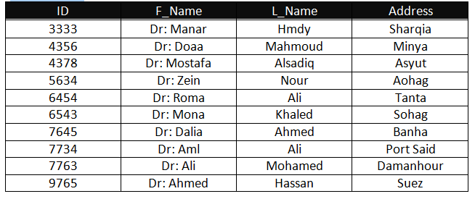**Doctors :**

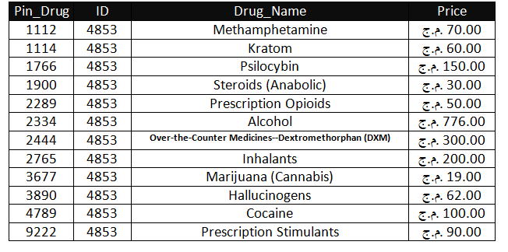**Drugs :**

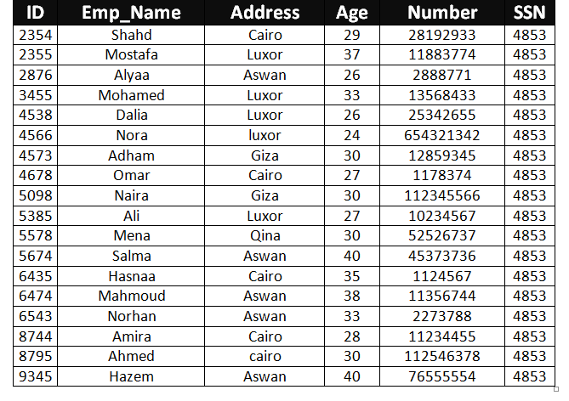**Employees :**

**Hospitals :**

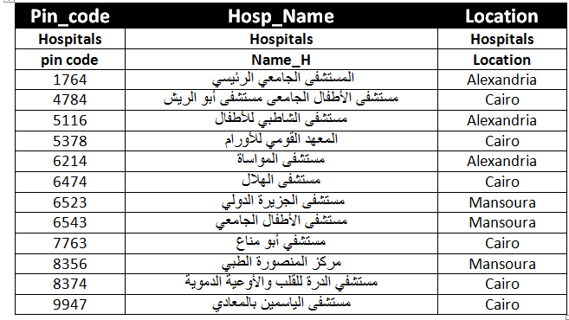

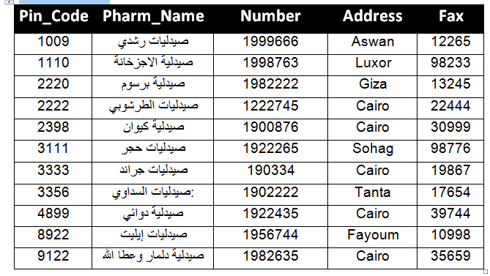**Pharmacy :**

**Patients :**

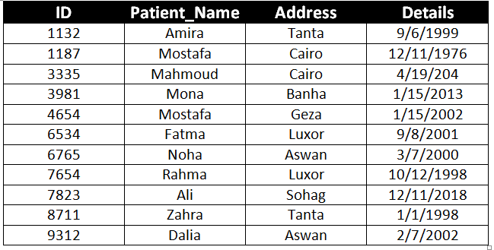

**Pharmaceutical Company :**

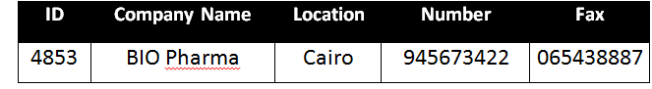

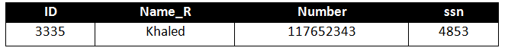**Medical Representative :**

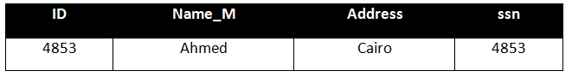**Manager :**

**Importes :**

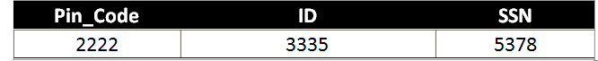

**Data flow diagram**

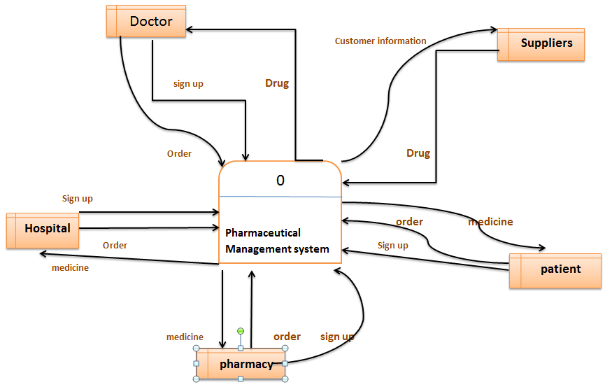**Context - level diagram:**

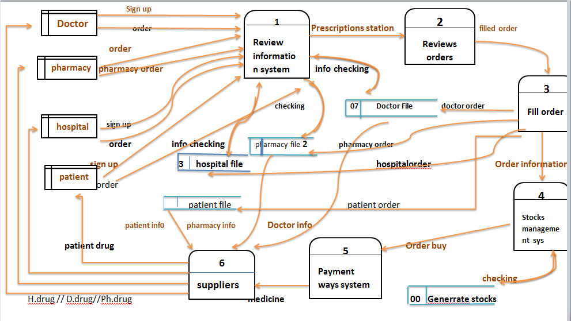**Zero Diagram level-**