Biobank and Biospecimen Management System
Written Report
Student name: Dalia salah othman
Student ID: 221091944
Selected topic: Biobank and Biospecimen Management System

1. Problem Statement, Scope, Assumptions, and Business Rules
Biobanks must manage biospecimens from donor consent through collection, aliquoting, storage, and research testing. The database must preserve donor privacy, prevent invalid references, record sample storage, and support researchers requesting aliquots. This project implements a MySQL database for a biobank and biospecimen management system using anonymized academic sample records.

Scope
The system stores donors, consent records, sample types, storage locations, biospecimens, aliquots, researchers, test requests, and request–aliquot assignments. It supports two analytical views, a trigger for aliquot depletion, and a stored procedure for donor history. No user interface is included; the base project is database-only.

Assumptions and rules
- Each donor may have multiple consent records and biospecimens.
- Every biospecimen belongs to one donor and one sample type.
- Every aliquot belongs to one biospecimen and one storage location.
- A researcher may submit many test requests.
- A test request may use many aliquots and an aliquot may be assigned to many requests; request_aliquots resolves this M:N relationship.
- Donor and researcher emails and sample-type names are unique.
- When an aliquot volume becomes zero or negative during an update, it is normalized to zero and marked Used by the trigger.
- Deleting a donor removes dependent consents and biospecimens; deleting a biospecimen removes dependent aliquots; request assignments are deleted with their request.

2. Entities, Attributes, Identifiers, and Key Decisions
Entity | Key attributes | Key decision
donors | donor_id PK; first_name; last_name; gender; date_of_birth; blood_type; email UNIQUE; created_at | Email is required and unique; demographic fields use controlled ENUM values.
consents | consent_id PK; donor_id FK; consent_type; status; signed_date | Consent is separated from donor so consent history can be retained.
sample_types | sample_type_id PK; type_name UNIQUE; description; storage_temp_celsius | Lookup entity prevents repeated sample-type descriptions and temperatures.
storage_locations | location_id PK; freezer_name; shelf_number; box_number; capacity | Represents physical storage coordinates and capacity.
biospecimens | specimen_id PK; donor_id FK; sample_type_id FK; collection_date; initial_volume_ml; status | Connects donor, sample type, collection event, and specimen lifecycle.
aliquots | aliquot_id PK; specimen_id FK; location_id FK; volume_ul; concentration_ng_ul; status | Tracks portions of a specimen and their storage location.
researchers | researcher_id PK; full_name; institution; email UNIQUE; phone | Researcher email is unique and requests reference the researcher.
test_requests | request_id PK; researcher_id FK; request_date; status; purpose | Stores the research need and approval lifecycle.
request_aliquots | request_id + aliquot_id composite PK; assigned_date | Associative table resolving the request–aliquot M:N relationship.

3. ER Diagram, Cardinality Ratios, and Participation Constraints
The supplied ERD is included below. It shows nine base tables, two views, the request_aliquots associative entity, and crow’s-foot relationship notation. The views shown are view_researcher_request_summary and view_available_aliquots_detail.
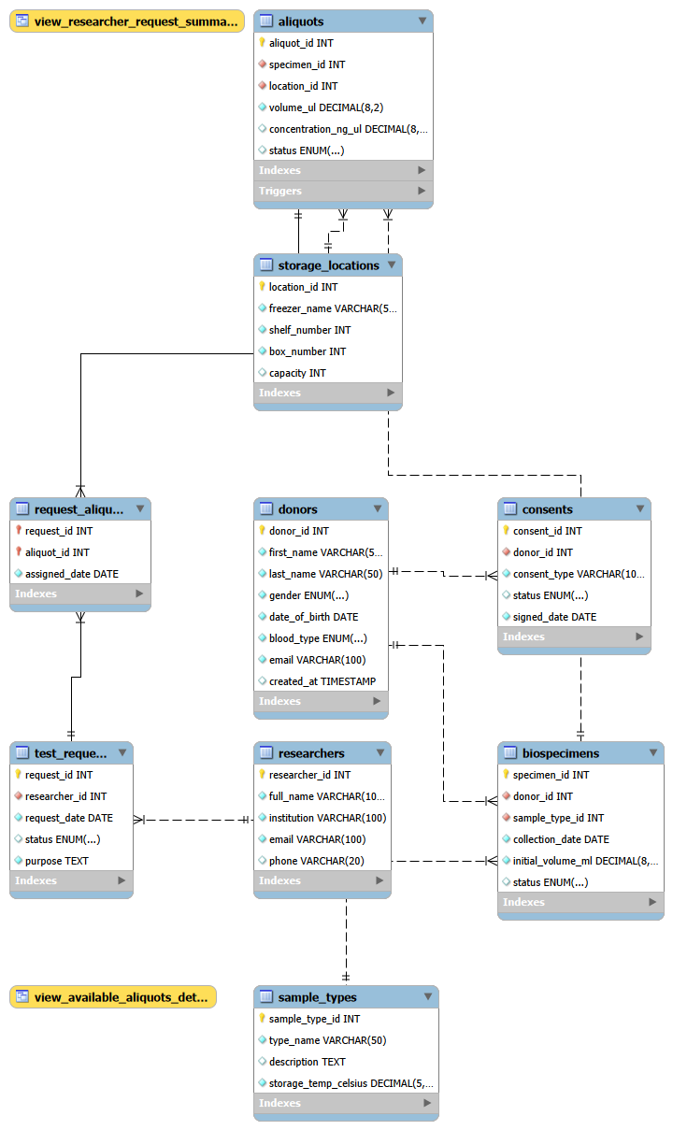
Figure 1. Supplied BiobankDB ERD.
Relationship | Cardinality | Participation
donors—consents | 1:N | Each consent must reference one donor because donor_id is NOT NULL; a donor may have zero or many consents.
donors—biospecimens | 1:N | Each biospecimen must reference one donor; a donor may have zero or many biospecimens.
sample_types—biospecimens | 1:N | Each biospecimen must reference one sample type; a sample type may be used by zero or many biospecimens.
biospecimens—aliquots | 1:N | Each aliquot must reference one specimen; a specimen may have zero or many aliquots.
storage_locations—aliquots | 1:N | Each aliquot must reference one location; a location may contain zero or many aliquots.
researchers—test_requests | 1:N | Each request must reference one researcher; a researcher may submit zero or many requests.
test_requests—request_aliquots | 1:N | Each assignment references one request; a request may have zero or many assigned aliquots.
aliquots—request_aliquots | 1:N | Each assignment references one aliquot; an aliquot may appear in zero or many request assignments. Together these implement M:N.

4. Relational Schema and Constraints
The exact schema is defined in create_tables.sql. The design includes primary keys, foreign keys, UNIQUE constraints, ENUM domains, NOT NULL constraints, DEFAULT values, cascading actions, and performance indexes.
Table | Primary key | Foreign keys | Unique / other constraints
donors | donor_id | None | email UNIQUE NOT NULL; ENUM gender and blood_type; created_at DEFAULT CURRENT_TIMESTAMP
consents | consent_id | donor_id → donors CASCADE | status ENUM DEFAULT Active; required consent_type and signed_date
sample_types | sample_type_id | None | type_name UNIQUE NOT NULL; storage temperature NOT NULL
storage_locations | location_id | None | freezer, shelf, box required; capacity DEFAULT 100
biospecimens | specimen_id | donor_id → donors CASCADE; sample_type_id → sample_types | collection and initial volume required; status ENUM DEFAULT Available
aliquots | aliquot_id | specimen_id → biospecimens CASCADE; location_id → storage_locations | volume and status required/defaulted; index on status
researchers | researcher_id | None | email UNIQUE NOT NULL; full_name and institution required
test_requests | request_id | researcher_id → researchers | status ENUM DEFAULT Pending; purpose required
request_aliquots | request_id + aliquot_id | request_id → test_requests CASCADE; aliquot_id → aliquots | composite PK; assigned_date required

CREATE TABLE request_aliquots (
request_id INT NOT NULL, aliquot_id INT NOT NULL, assigned_date DATE NOT NULL,
PRIMARY KEY (request_id, aliquot_id),
FOREIGN KEY (request_id) REFERENCES test_requests(request_id) ON DELETE CASCADE,
FOREIGN KEY (aliquot_id) REFERENCES aliquots(aliquot_id)
);
Indexes are explicitly created on donors(email), biospecimens(collection_date), and aliquots(status). These support common lookup, date-filtering, and status-filtering operations.

5. Normalization to Third Normal Form
Form | Application
1NF | All fields are atomic. Repeated aliquots for a specimen are rows, not repeated columns; repeated request assignments are rows in request_aliquots.
2NF | Single-key tables have no partial dependencies. In request_aliquots, assigned_date depends on the full composite key (request_id, aliquot_id).
3NF | Donor, sample-type, storage, researcher, and request facts are separated. Non-key attributes depend on their own table key and not on another non-key attribute.

The decomposition reduces anomalies: a storage temperature is changed in sample_types once, a donor email in donors once, and a storage coordinate in storage_locations once.

6. Implementation Details and Selected SQL Code
The scripts target MySQL 8.0+ and run in order: create_tables.sql, load_data.sql, views.sql, triggers_procedures.sql, queries.sql, and testing.sql. The first script drops and recreates BiobankDB for clean repeatable testing.
CREATE INDEX idx_donor_email ON donors(email);
CREATE INDEX idx_specimen_collection ON biospecimens(collection_date);
CREATE INDEX idx_aliquot_status ON aliquots(status);
CREATE TRIGGER trg_check_aliquot_volume
BEFORE UPDATE ON aliquots
FOR EACH ROW
BEGIN
IF NEW.volume_ul <= 0 THEN SET NEW.status = 'Used'; SET NEW.volume_ul = 0; END IF;
END
CALL sp_GetDonorFullHistory(1);
INSERT INTO storage_locations (freezer_name, shelf_number, box_number, capacity)
VALUES ('Freezer Delta', 1, 401, 75);

7. Sample Data and Screenshots of Successful Execution
The load-data script contains four sample types, ten donors, ten consents, ten storage locations, ten biospecimens, ten aliquots, ten researchers, ten test requests, and ten request_aliquots assignments. The data is meaningful: donors have consent statuses, specimens have sample types and collection dates, aliquots have volume and concentration, requests have approval statuses, and assignments link requests to aliquots.

Evidence | Required action
S1 | Run load_data.sql and show row counts for the main tables.
S2 | Show view_available_aliquots_detail output.
S3 | Show view_researcher_request_summary output.
S1 — show table biospecimens
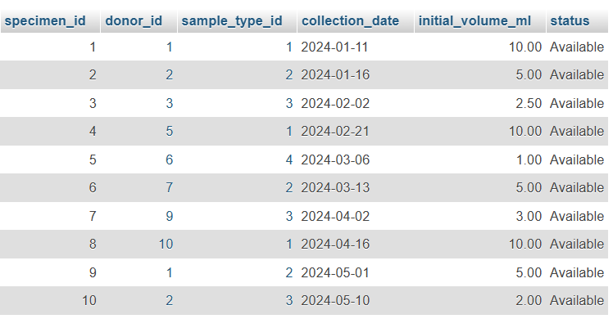
S2 —
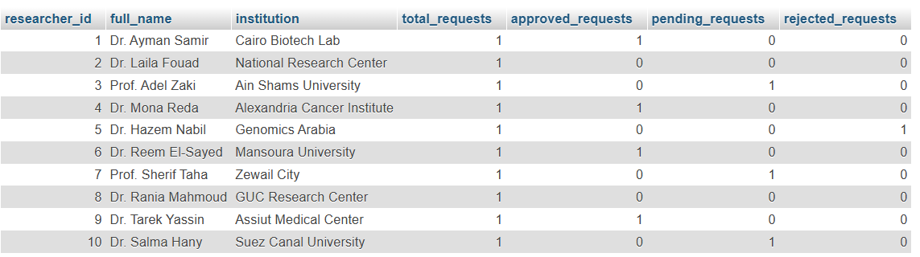
S3
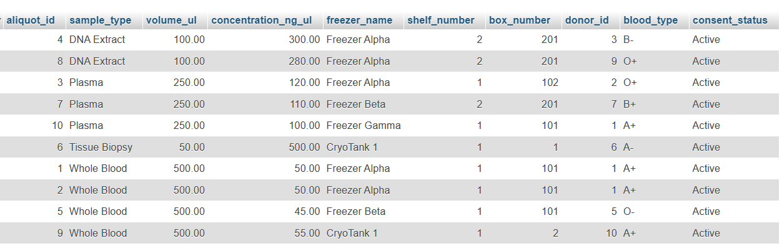

8. Views, Trigger, and Stored Procedure
Object | Purpose
view_available_aliquots_detail | Returns aliquots with sample type, storage, donor blood type, and consent status where the aliquot is In Storage and consent is Active.
view_researcher_request_summary | LEFT JOINs researchers to requests and counts total, approved, pending, and rejected requests for each researcher.
trg_check_aliquot_volume | BEFORE UPDATE trigger. When new volume is zero or negative, it sets volume to zero and status to Used.
sp_GetDonorFullHistory | Returns two result sets: donor/consent information, then biospecimen and aliquot history with sample type and storage freezer.

9. Test Cases, Results, Limitations, and Conclusion
Test | Expected result | Evidence
T1 data coverage | Main tables contain the loaded sample records and request_aliquots demonstrates M:N. | S1
T2 available view | Only in-storage aliquots with active consent appear. | S2
T3 researcher summary | Every researcher appears, including researchers with zero requests; counts are grouped correctly. | S3

Limitations
- The database uses anonymized academic records, not real donor data.
- Storage capacity is recorded but there is no automatic capacity check against the number of aliquots.
- The trigger handles updates to aliquot volume but does not prevent an invalid negative volume during the initial INSERT unless an additional validation rule is added.
- The project has no authentication, audit trail, freezer monitoring, or user interface.
- Execution screenshots, student names, IDs, GitHub URL, and presentation video link must be added by the student before final submission.

Conclusion
The BiobankDB design meets the core database complexity requirements with nine meaningful tables, a many-to-many associative table, normalized relations, explicit keys and constraints, two views, a trigger, a stored procedure, meaningful sample data, and varied SQL operations. The remaining submission work is to execute the scripts, capture genuine screenshots, complete personal details, publish the repository, and commit the presentation and video evidence.

