A Hybrid Network Intrusion Detection System  
Diateam: SCAD@COPS

Lisa MALIPHOL

July 2015

* Introduction
  + Project background
  + Problem definition
  + Paper organization
* SCADA Systems
  + Terms
    - ICS
    - SCADA
    - PLC
    - RTU
    - HMI
  + Traffic characterization
* Protocols
  + TCP
  + MODBUS/TCP
* Common Attacks on SCADA
  + Command Injection
  + Response Injection
  + Denial of Service
* Intrusion Detection Systems
  + Host IDS
  + Network IDS
    - Signature-based
    - Anomaly-based
* Techniques of Network Intrusion Detection
  + Statistical
  + Machine Learning
  + Data Mining
* Tools
  + Wireshark
  + TShark
  + UNIX unitilites - sed, awk, bash, etc.
  + R
  + C++
  + SQLite3
  + MongoDB/MySQL
* Data Source
* Exploratory Data Analysis
* Statistical Measures/Features
* Architecture
  + Process (Figure 1)
    - Step 1: Data Acquisition During Normal Activity - From the IDS appliance, sniff the network traffic, extract and store data in a database.
    - Step 2: Statistical Analysis
      * 2.1 - Process data - Perform any transformation, filtering and data cleansing necessary.
      * 2.2 - Calculate and determine statistical measures.
      * 2.3 - Configure appliance with statistical parameters.
    - Step 3: Detection Mode - Appliance is set to detection mode.
  + Technical Architecture (Figure 2)

Figure 1 - Process  
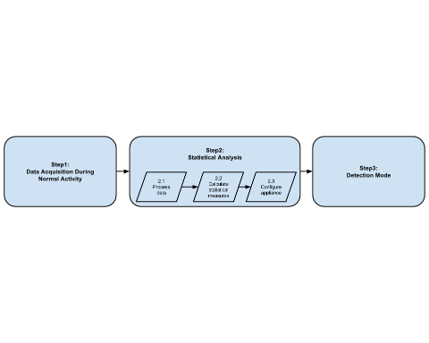

Figure 2 - Technical Architecture  
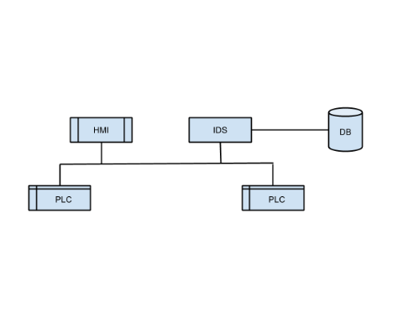

* Implementation
* Testing/Evaluation
* Conclusion/Future Work
* Bibliography
* Appendices