Homework assignment 02

Due 2026-Sept-24
Answer the following questions about algorithms, recursion and abstract data types (linked list, binary tree, stack and queue), with particular emphasis on linked lists and binary trees.
The marks for each question are shown in brackets [ ]. Total marks: 100.
Write your answers in the answer boxes. For all programming questions, write Python code.

Question 1 - Linked lists and arrays (25 marks)
A linked list is stored in two parallel 1D arrays. startPointer holds the index of the first node and heapStartPointer holds the index of the first free node. A null pointer is -1.
DECLARE myLinkedList : ARRAY[0:7] OF INTEGER
DECLARE myLinkedListPointers : ARRAY[0:7] OF INTEGER
CONSTANT nullPointer = -1

Index | myLinkedList | myLinkedListPointers
0 | 12 | 2
1 | | 4
2 | 35 | 5
3 | | 6
4 | | 3
5 | 47 | 7
6 | | -1
7 | 61 | -1

startPointer = 0 heapStartPointer = 1

(a) State the value of startPointer and explain how the program can tell which node is the last one in the list. [4]
0
The node which has value in myLinkedList but the corresponding value in myLinkedListPointers are -1.

(b) Complete the trace table to show how the value 47 is found. [6]
Iteration | itemPointer | myLinkedList[itemPointer] | Found? | Next pointer
1 | 0 | 12 | NO | 2
2 | 2 | 35 | NO | 5
3 | 5 | 47 | Yes | 7

(c) A new value is to be added to the END of the list. State the two pointer values that must be changed, and say what each is changed to. [4]
startPointer remained same since the new value is added to the end of the list(it might be temporarily changed when iterating)
heapStartPointer points to the next free node in the list, which value is 4 in this case

(d) Explain what happens to heapStartPointer when a node is taken from the free list (heap). [4]
heapStartPointer points to the next free node in the list, which value is 4 in this case??

(e) State two advantages of using a linked list rather than an array to store data. [4]
1linked list can make use of memory space that is not continuous
2better extensibility, it doensn’t have a pre-defined size initially and append and delete are generally more convenient

(f) State one disadvantage of a linked list compared with an array. [3]
Lower speed of accessing element compared to array.

Question 2 - Linked list pseudocode (35 marks)
The linked list in Question 1 is used again. The variables startPointer, heapStartPointer and nullPointer are global, and the two arrays are named myLinkedList and myLinkedListPointers.
(a) Write pseudocode for the function countNodes() that returns the number of nodes currently stored in the list. [8]
FUNCTION countNodes() RETURNS INTEGER
DECLARE Count,Temp : INTEGER
Count <- 0
Temp <- startPointer
WHILE Temp<>-1
Count<-Count+1
Temp<-myLinkedListPointers[Temp]
ENDWHILE
RETURN Count
ENDFUNCTION

(b) Write pseudocode for the function findMax() that returns the largest value stored in the list, or -1 if the list is empty. [10]
FUNCTION findMax() RETURNS INTEGER
DECLARE Maximum,Temp : INTEGER
Maximum <- -100
Temp <- startPointer
WHILE Temp<>-1
IF myLinkedList[Temp]>Maximum THEN
Maximum<-myLinkedList[Temp]
ENDIF
Temp<-myLinkedListPointers[Temp]
ENDWHILE
RETURN Maximum
ENDFUNCTION

(c) Write pseudocode for the procedure insertAtEnd(itemAdd) that adds itemAdd as the last node in the list. It must check whether the list is full. [12]
PROCEDURE insertAtEnd(itemAdd:INTEGER)
DECLARE Temp: INTEGER
IF countNodes()=0 THEN
OUTPUT "Invalid"
ELSE
Temp<-startPointer
WHILE myLinkedListPointers[Temp]<>-1
Temp<- myLinkedListPointers
ENDWHILE
myLinkedListPointers[Temp]<-heapStartPointer
myLinkedList[heapStartPointer]<-itemAdd
myLinkedListPointers[heapStartPointer]<- -1
heapStartPointer<-myLinkedListPointers[heapStartPointer]
ENDIF
ENDPROCEDURE

(d) Explain why insertAtEnd() must traverse the list, whereas inserting at the start of the list does not. [5]
Write your answer here.
Because insertAtEnd has to first find the position of the last node. However, since the startPointer is known, no traversing is required when just inserting at the start of list.

Question 3 - Binary tree (25 marks)
(a) The following values are inserted, in this order, into an initially empty binary search tree: 50, 30, 70, 20, 40, 60, 80. Draw the resulting binary search tree in the box below. [8]
Draw or type your tree here.
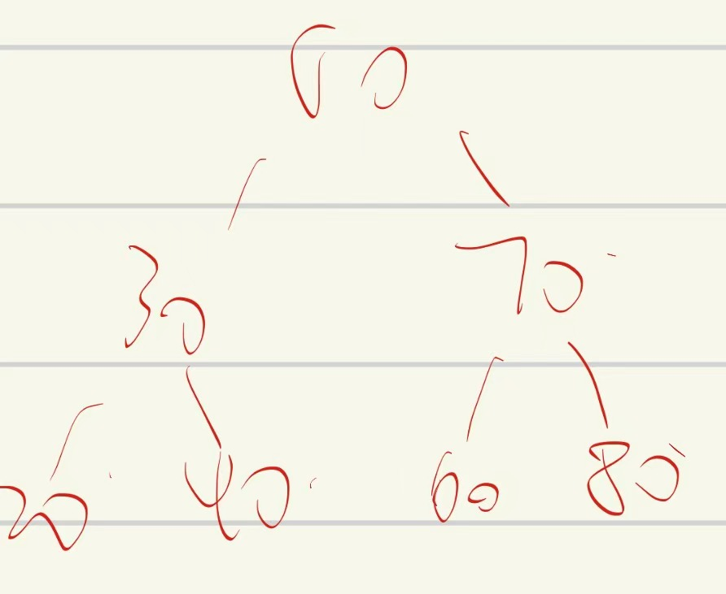

(b) For the tree you have drawn, state the value of the root node, name all of the leaf nodes, and state the level of the node 60. [6]
Root node:50
Leaf:20 40 60 80
Level:3

(c) State the height (depth) of the tree. [3]
Write your answer here.
2

(d) Explain how the value 40 is found in the tree, naming each node that is visited. [5]
Write your answer here.
- >30->40
Start:compare 50 and 40, 40 is smaller, go to the left node
Then:compare 30 and 40, 40 is bigger, go to the right node
40=40, so return

(e) The values 10, 20, 30, 40 and 50 are inserted in that order into a new binary search tree. Explain why searching this tree would be less efficient than searching the tree in part (a). [3]
Write your answer here.
It will form
10
20
30...
Which has a much high depth and thus time complexity is about O(n) in that case.

Question 4 - Stack programming (15 marks)
(a) A stack is used to check whether a string of brackets is balanced. A string is balanced if every "(" has a matching ")" in the correct order. Write program code for the function is_balanced(text) that returns True if text is balanced and False otherwise. You must use a Python list as a stack. [10]
def is_balanced(Str):
global stack
Top=0
for i in Str:
if i=='(':
stack[Top]=i
Top=Top+1
elif i==')':
if Top==0:
return False
Top=Top-1
if Top==0:
return True
return False

(b) Test your program with the three strings "(())", "(()" and "()()" and paste a screenshot of your output in the box below. [5]
Copy and paste your screenshot here.

