Insert your name, centre number and candidate number into the header above.
Save this evidence document as evidence_ followed by your centre number_ candidate number. For example: evidence_ zz999_9999.doc
Screenshots or program listings must be copied into appropriate cells in the following tables.
Examiners must be able to read the contents including any screenshots without the use of a magnifying glass. Answers that are not readable or missing will not be awarded any marks.
Save this evidence document at regular intervals, for example every 10 minutes.
Question 1
Part 1(a)(i)
{Copy and paste program code listing for question 1(a)(i) here}
class Bird:
def __init__(self,dis,spe):
self.__DistancePerHour=dis #real
self.__Species=spe #string
self.__XPosition=500.0 #real
self.__YPosition=500.0 #real

Part 1(a)(ii)
{Copy and paste program code listing for question 1(a)(ii) here}
def GetSpecies(self):
return self.__Species

Part 1(a)(iii)
{Copy and paste program code listing for question 1(a)(iii) here}
def Move(self,DoT,time):
Dis=(float(self.__DistancePerHour)/60)*time
sign=[0,0]*100
sign[6]=[1,0]
sign[3]=[-1,0]
sign[5]=[0,1]
sign[7]=[0,-1]
self.__XPosition+=ord(DoT)*sign[1]
self.__YPosition+=ord(DoT)*sign[0]

Part 1(a)(iv)
{Copy and paste program code listing for question 1(a)(iv) here}
def Move(self,DoT,time):
Dis=(float(self.__DistancePerHour)/60)*time
sign=[0,0]*100
sign[6]=[1,0]
sign[3]=[-1,0]
sign[5]=[0,1]
sign[7]=[0,-1]
Index=ord(DoT)%8
self.__XPosition+=sign[Index][1]*Dis
self.__YPosition+=sign[Index][0]*Dis

Part 1(b)
{Copy and paste program code listing for question 1(b) here}
BirdA=Bird(71.0,"Cockatiel")
BirdB=Bird(56.0,"Macaw")

Part 1(c)(i)
{Copy and paste program code listing for question 1(c)(i) here}
print(BirdA.GetPosition())
print(BirdB.GetPosition())
N=input("Enter the bird selected:")
D=input("Enter the distance selected:")
T=int(input("Enter the time:"))
if N==BirdA.GetSpecies():
BirdA.Move(D,T)
print(BirdA.GetPosition())
else:
BirdB.Move(D,T)
print(BirdB.GetPosition())

Part 1(c)(ii)
{Copy and paste screenshot(s) for question 1(c)(ii) here}
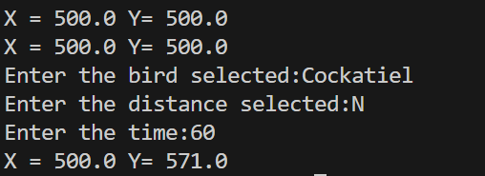
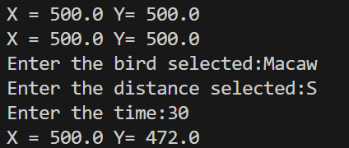
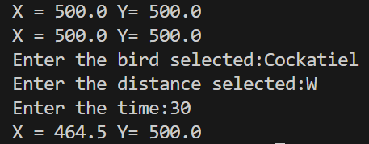
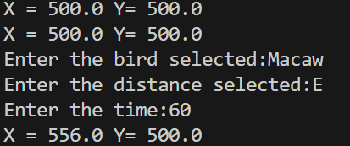

Question 2
Part 2(a)
{Copy and paste program code listing for question 2(a) here}
import random
def Judge():
global Array123
if len(Array123)==len(set(Array123)):
return True
return False
Array123=[0]*20
while True:
for i in range(20):
Array123[i]=random.randint(0,100)
if Judge():
break

Part 2(b)
{Copy and paste program code listing for question 2(b) here}

def PrintArray(Array1):
print(Array1,end=" ")
return

Part 2(c)
{Copy and paste program code listing for question 2(c) here}
def BubbleSort(Array1):
for i in range(len(Array1)-1):
Flag=False
for j in range(i+1,len(Array1)):
if Array1[i]>Array1[j]:
Array1[i],Array1[j]=Array1[j],Array1[i]
Flag=True
if Flag==False:
break
return Array1

Part 2(d)(i)
{Copy and paste program code listing for question 2(d)(i) here}

PrintArray(Array123)
Array123=BubbleSort(Array123)
print("Sorted")
print("")
PrintArray(Array123)
print("")

Part 2(d)(ii)
{Copy and paste screenshot(s) for question 2(d)(ii) here}

Part 2(e)
{Copy and paste program code listing for question 2(e) here}

def RecursiveBinarySearch(a,left,right,Searched):
if left>right:
return -1
mid=(left+right)//2
if a[mid]==Searched:
return mid
if a[mid]<Searched:
return(RecursiveBinarySearch(a,mid+1,right,Searched))
else:
return(RecursiveBinarySearch(a,left,mid-1,Searched))

Part 2(f)(i)
{Copy and paste program code listing for question 2(f)(i) here}
Array123=[0]*20
while True:
for i in range(20):
Array123[i]=random.randint(0,100)
if Judge():
break
PrintArray(Array123)
Array123=BubbleSort(Array123)
print("Sorted")
print("")
PrintArray(Array123)
print("")
a=int(input("Please enter an integer"))
t=RecursiveBinarySearch(Array123,0,19,a)
if t==-1:
print("Not found")
else:
print(f"Found at position: {t}")

Part 2(f)(ii)
{Copy and paste screenshot(s) for question 2(f)(ii) here}
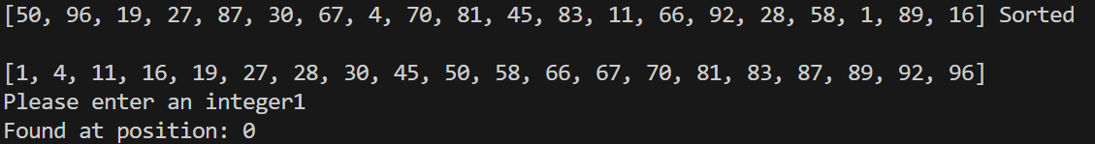

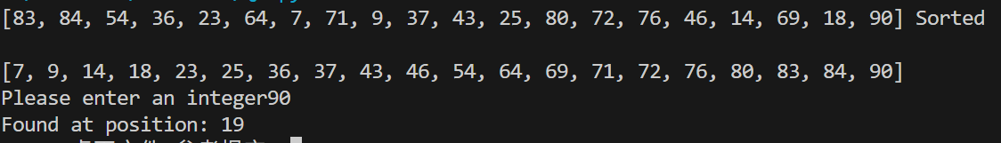

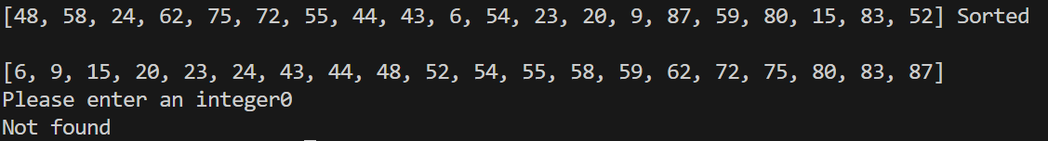

Question 3
Part 3(a)
{Copy and paste program code listing for question 3(a) here}
TreeArray=[]
for i in range(50):
TreeArray.append([-1,-1,-1])
RootPointer=-1
FreeNode=0

Part 3(b)
{Copy and paste program code listing for question 3(b) here}

def AddNode(Parameter):
global TreeArray,FreeNode,RootPointer
if FreeNode==50:
print("The tree is full")
TreeArray[FreeNode][1]=Parameter
if RootPointer==-1:
TreeArray[0][1]=Parameter
RootPointer+=1
FreeNode+=1
return
Start=RootPointer
while Start!=-1:
if Parameter>TreeArray[Start][1]:
if TreeArray[Start][2]==-1:
TreeArray[Start][2]=FreeNode
FreeNode=FreeNode+1
return
else:
Start=TreeArray[Start][2]
else:
if TreeArray[Start][0]==-1:
TreeArray[Start][0]=FreeNode
FreeNode=FreeNode+1
return
else:
Start=TreeArray[Start][0]

Part 3(c)
{Copy and paste program code listing for question 3(c) here}
TreeArray=[]
for i in range(50):
TreeArray.append([-1,-1,-1])
RootPointer=-1
FreeNode=0
FileHandler=open("TreeData.txt","r")
NewLine=FileHandler.readline().strip()
while NewLine!="":
AddNode(int(NewLine))
NewLine=FileHandler.readline().strip()
FileHandler.close()

Part 3(d)
{Copy and paste program code listing for question 3(d) here}
def WriteAllToFile():
global TreeArray
FileHandler=open("Tree.txt","w")
for i in range(50):
Line=f"{TreeArray[i][0]}, {TreeArray[i][1]}, {TreeArray[i][2]}"
FileHandler.write(Line+"\n")
FileHandler.close()

Part 3(e)(i)
{Copy and paste program code listing for question 3(e)(i) here}
WriteAllToFile()

Part 3(e)(ii)
{Copy and paste screenshot(s) for question 3(e)(ii) here}


