Classwork 20261030

2026-Oct-30
Answer the following questions about binary floating-point representation and file handling.
The marks for each question are shown in brackets [ ]. Total marks: 100.
Write your answers in the answer boxes. For all programming questions, write Python code.
The text file QueueData.txt is provided with this paper.

Question 1 - Floating-point representation (18 marks)
Numbers are stored in a computer system using binary floating-point representation with:
12 bits for the mantissa
4 bits for the exponent
two's complement form for both the mantissa and the exponent.

(a) Write the normalised floating-point representation of the following positive binary number using this system. [6]
0.0000001011011011
Mantissa | Exponent
0.1011011011 | 1010

(b) Calculate the normalised binary floating-point representation of -58.625 in this system. [12]
Show your working.
Mantissa | Exponent
1000101011 | 0110

Working:

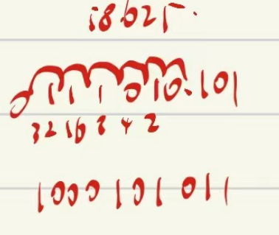

Question 2 - File reading and a linear queue (82 marks)
A program reads data from a text file and stores it in a queue. The linear queue Queue is stored as a 1D array of up to 50 elements. The queue has the following pointers:
HeadPointer - this stores the index of the first element in the queue, initialised to -1
TailPointer - this stores the index of the last element in the queue, initialised to -1

(a) Queue is a global array of 50 integers with all elements initialised to -1 in the main program.
The two pointers are declared as global variables and initialised to -1.
Write program code to declare and initialise Queue, HeadPointer and TailPointer. [9]
Copy and paste your code here.
#main
Queue=[-1]*50
HeadPointer=-1 #global
TailPointer=-1 #global

(b) The function Enqueue():
takes an integer parameter to store in the next position in the queue
returns FALSE if the queue is full and the parameter cannot be stored in the queue
returns TRUE if the parameter is stored in the queue
updates the pointers where appropriate.
Write program code for Enqueue(). [19]
Copy and paste your code here.
def Enqueue(Parameter):
global Queue, HeadPointer, TailPointer
if TailPointer==49:
return False
else:
TailPointer=TailPointer+1
Queue[TailPointer]=Parameter
return True

(c) The function Dequeue():
returns the next item in the queue, if the queue is not empty
returns -1 if the queue is empty
updates the pointers where appropriate.
Write program code for Dequeue(). [16]
Copy and paste your code here.
def Dequeue():
global Queue, HeadPointer, TailPointer
if HeadPointer>=TailPointer:
return -1
else:
HeadPointer=HeadPointer+1
Num=Queue[HeadPointer]
return Num

(d) The text file QueueData.txt stores positive integers. Each integer is on a new line in the file.
The procedure CreateQueue():
opens the file QueueData.txt
reads in each line from the text file and uses Enqueue() to insert each line into the queue
outputs "Queue full" if any item cannot be inserted into the queue
uses exception handling when opening and reading from the text file.
The procedure needs to work for a file that contains an unknown number of lines.
Write program code for CreateQueue(). [19]
Copy and paste your code here.
def CreateQueue():
try:
FileHandler=open("QueueData.txt","r")
Line=FileHandler.readline().strip()
while Line!="":
T=Enqueue(int(Line))
if T==False:
print("Queue full")
Line=""
else:
Line=FileHandler.readline().strip()
FileHandler.close()
except FileNotFoundError:
print("No such file")

(e) (i) The main program needs extending to call CreateQueue(). The main program then adds together all of the integers stored in the queue, using Dequeue() to access each integer. The total is then output.
Write program code to extend the main program. [16]
Copy and paste your code here.
#main
Queue=[-1]*50
HeadPointer=-1 #global
TailPointer=-1 #global
CreateQueue()
print(Queue)
Total=0
while True:
T=Dequeue()
if T==-1:
print(Total)
break
else:
Total=Total+T

(ii) Test your program.
Take a screenshot of the output(s) and paste it into the box below. [3]

