Data Analytics Capstone

Data-Driven Quality and Risk Analytics: A Comparative Study of Governance-Relevant Change in the AI-Coding Era and Emerging PCAOB Audit Risk Data

Interim Report
Daljeet Kaur Johar

Walsh College

QM640: Data Analytics Capstone

Smitraj Raut

3rd Term
August 4th , 2026

Table of Contents
GitHub Repository 4
Introduction 4
Background and Context 4
Problem Statement 5
Purpose of the Study 5
Interim Project Status (Progress Snapshot) 6
Completed 6
In Progress 7
Pending 7
Scope and Objectives 7
Research Question 1 (RQ1) 7
Research Question 2 (RQ2) 7
Research Question 3 (RQ3) 8
Research Question 4 (RQ4) 8
Research Question 5 (RQ5) 8
10-Week Capstone Timeline 8
Sample Size Calculation 9
Handling of Missing Data Relative to Sample Size Targets 10
Literature Survey 10
Literature Review Approach 10
Summary of Key Literature 11
Thematic Synthesis 11
Critical Evaluation of Prior Research 12
Data Description 12
Data Source(s) and Access 12
Why the NASA/PROMISE Substitute Is Sufficient for This Interim Stage 13
SEC EDGAR-PCAOB Matching Strategy 13
Dataset Overview (QA/Defect Domain: Interim Analysis) 13
Data Dictionary (QA/Defect Domain) 14
GitHub Data Availability Statement 14
Analysis 14
Data Cleaning 15
EDA Results 15
Modeling 17
Research Framework Design: End-to-End Pipeline 17
Choice of Models with Justification 18
Features Included and Feature Engineering 18
Evaluation Metrics (Formulae) 18
Preliminary Results 18
Preliminary Findings by Research Question 18
RQ1 (NASA/PROMISE Baseline; Real Mined Result in Real-Data Update) 18
RQ2 and RQ3: Real Results Available 19
RQ4 (Pending) 19
Preliminary Model Performance 19
Statistical Significance Testing 20
Real-Data Update: RQ1-RQ3 (Real-Data Results, Weeks 5-6) 21
RQ1 (Real Result): Code-Metric Mining from Real Apache Repositories 21
What Was Verified in the Repository 21
RQ2 (Real Result): Era-Moderated Regression on Real Apache JIRA Data 22
RQ3: PCAOB Severity Classification (Leakage Corrected) 23
Explainability: SHAP Analysis (RQ3 Model) 25
RQ1 (Real Result): Code-Metric Mining from Real Apache Repositories 26
Interim Limitations and Risks 27
Next Steps (for Final Report) 28
Bibliography 30
Appendix 33
Appendix A: NASA/PROMISE Data Loading (Notebook 04) 33
Appendix B: NASA/PROMISE Data Cleaning, EDA, and Baseline Modeling (Notebook 05) 34
Appendix C: NASA/PROMISE Statistical Significance Testing (Notebook 06: McNemar's Test, Bootstrap CIs) 39
Appendix D: RQ1 Real-Data Analysis (Notebook 07: Code-Metric Mining and Era-Moderated Defect-Proneness) 42
Appendix E: RQ2 Real-Data Analysis (Notebook 08: Apache JIRA Era-Moderated Regression) 44
Appendix F: RQ3 Real-Data Analysis (Notebook 09: PCAOB Severity Classification, Leakage-Corrected) 45
Appendix H: Explainability (Notebook 12: SHAP Analysis, RQ3 Model) 47
Appendix G: Supporting Tables 49

GitHub Repository
The project repository, including raw data extraction notes, the cleaned dataset, analysis code, and this report, is hosted at: github.com/daljeetkaurJohar/qm640-governance-analytics. The Python code used to produce the analysis in this report (data loading, cleaning, EDA, and modeling) is reproduced in Appendices A-E as real, executed Jupyter notebooks and is included in the /notebooks folder of this repository.

Introduction

Background and Context
Enterprise IT governance rests on two control layers: software quality assurance (QA), which safeguards application reliability before production, and IT audit, which evaluates IT general controls (ITGCs) after systems are in use. Both are being reshaped by developments research has not yet addressed. Generative-AI coding assistants became mainstream between 2023 and 2026, and early evidence suggests they measurably change code composition and defect profiles, raising the question of whether classic metric-based defect-prediction models still hold. Separately, the PCAOB only began publishing machine-readable inspection deficiency datasets in April 2025, while prior academic research on IT-related internal control weaknesses relies on data no more recent than 2018.
Stakeholders span QA teams responsible for release quality, IT audit and risk management teams responsible for regulatory assurance, business leaders who depend on stable systems, and external auditors and regulators. Prior research establishes that software quality metrics (defect density, test automation coverage, testing cycle time) predict downstream reliability, and separately that machine learning improves audit and control risk prediction. Both findings predate the AI-coding mainstreaming and the PCAOB's first machine-readable data release.
This matters operationally: large organizations running integrated technology estates are subject to both QA review and periodic IT audit, and both functions increasingly involve AI-assisted code alongside modern regulatory disclosures. If the AI-coding era has changed how defects arise, QA teams using pre-AI assumptions may misallocate testing effort; if new PCAOB data supports real predictive modeling, audit teams have an untapped risk-intelligence source. Testing both propositions on real, current data is this study's focus.

Problem Statement
Software defect prediction and IT-related internal-control-weakness research both rest on evidence predating two recent shifts: mainstream generative-AI coding adoption (2023-2026) and the PCAOB's first machine-readable inspection release (April 2025). No published study has tested whether classic code-metric defect models hold in the AI-coding era, and none has applied machine learning to the PCAOB's new data or to 2020+ material-weakness remediation timelines. This study addresses both gaps using real, primary, publicly available data.

Purpose of the Study
This study tests whether code-metric-based defect prediction and internal-control-weakness modeling still hold under two unstudied conditions: the AI-coding era and the PCAOB's new inspection data. Two real, independently sourced datasets (software QA/defect and IT audit/disclosure) receive a comparable predictive methodology, then synthesize into a single cross-domain conclusion about a shared 'digital-era disruption.' This interim report presents completed, real-data results for three of five research questions and a concrete plan for the remaining two.

Interim Project Status (Progress Snapshot)

Completed
- Finalized synopsis, five research questions (RQ1-RQ5), and sample size calculations for all RQs.
- Literature review: 12 sources directly informing the five RQs plus 5 methodological citations (17 total in the Bibliography).
- Sourced and combined 8 real NASA/PROMISE defect datasets (12,655 modules) as the interim substitute/cross-validation base for QA/defect. NASA/PROMISE now serves its originally-intended cross-validation role, since real JIRA-based results now exist for RQ1 and RQ2 (see below).
- Completed data cleaning (N = 12,639 modules after removing duplicates; no missing values found), EDA, and two baseline defect-proneness classifiers (Logistic Regression, Random Forest; 80/20 split, 5-fold CV).
- Completed real RQ2 and RQ3 using real Apache JIRA data (30,733 issues) and real PCAOB data (16,704 records), catching and correcting a data-leakage error along the way. RQ2: priority x era interaction significant (p < .0001) but practically negligible (Cohen's f-squared = 0.0011). RQ3: 96.3%-97.1% test accuracy, AUC 0.986-0.990, versus an 82.3% majority baseline. Full detail in Real-Data Update.
- Completed real RQ1 via repository-mining: matched 26,950 of 30,733 real JIRA issues (87.7%) to their fixing commits in the real Camel/Hadoop git history, computing genuine code metrics (lizard) on 1,804 real samples. 2 of 4 code-metric x era interactions significant (p < .0001); Random Forest achieves 73.4% accuracy, 0.730 AUC versus a 65.4% baseline.
- Ran a real SHAP explainability analysis on the RQ3 model (150 real held-out records), independently confirming the Random Forest's impurity-based feature importances.

In Progress
- SEC EDGAR extraction (material weakness disclosures, 2020+) for RQ4: not yet started.
- Re-extraction of num_reassignments and issue-type from JIRA to complete RQ2's predictor set and refine RQ1's defect_prone label.
- Scaling the RQ1 mining sample beyond the current 1,804 real samples for a larger final analysis.

Pending
- RQ4 regression and Cox survival modeling: blocked on SEC EDGAR extraction.
- RQ5 cross-domain synthesis: RQ1 and RQ2 effect sizes exist; RQ4's is still needed.
- Hyperparameter tuning and final validation once RQ4 has a complete real-data pass.

Scope and Objectives
The study is organized around five research questions. RQ1-RQ2 address the software QA/defect domain; RQ3-RQ4 address the public IT-audit/disclosure domain; RQ5 synthesizes both into a single governance-level conclusion.

Research Question 1 (RQ1)
Has the relationship between code and process metrics (lines of code, cyclomatic complexity, prior defect count, test coverage, and code churn) and module defect-proneness changed between the pre-generative-AI-coding era (issues resolved before January 2023) and the current AI-assisted-coding era (issues resolved January 2023-2026), using real issue-tracking data from large, actively maintained Apache Software Foundation projects?

Research Question 2 (RQ2)
Has the relationship between issue- and process-level characteristics (issue priority, component, number of comments, number of reassignments, and reporter tenure) and defect resolution time changed between the same pre-AI-coding and AI-assisted-coding eras, in the same real, open-source issue-tracking data?

Research Question 3 (RQ3)
Using the PCAOB's inspection datasets, first released in machine-readable form in April 2025, can a supervised machine learning classification model, built from real engagement and firm characteristics, accurately predict whether an identified control deficiency is classified at the more severe Part I.A level versus the Part I.B level?

Research Question 4 (RQ4)
Among U.S. public companies that disclosed a material weakness in internal control since 2020, do modern ML models (Random Forest, survival analysis) identify significantly different drivers of time-to-remediation than the traditional statistical methods used in the most recent prior internal-control-weakness literature?

Research Question 5 (RQ5)
Is the magnitude of the governance-relevant change identified in the software QA domain comparable to the magnitude of change identified in the IT audit domain, suggesting a shared 'digital-era governance disruption,' or do the two domains show clearly divergent magnitudes of change, indicating domain-specific disruption?

10-Week Capstone Timeline
- Weeks 1-2: Synopsis, literature review, sample size calculations (complete).
- Weeks 3-4: Data extraction/cleaning (JIRA, NASA/PROMISE, PCAOB); NASA/PROMISE baseline model (complete).
- Weeks 5-6: Real RQ1, RQ2, and RQ3 completed using real Apache JIRA/PCAOB data and repository-mining, with statistical significance testing (complete: this Week 6 interim submission). RQ1 was originally scoped for Week 7 but was completed ahead of schedule.
- Week 7 (planned): Scale the RQ1 mining sample; re-extract num_reassignments and issue-type from JIRA; begin SEC EDGAR extraction.
- Week 8 (planned): Complete SEC EDGAR extraction and build the RQ4 models (regression, Cox survival).
- Week 9 (planned): RQ5 cross-domain synthesis; hyperparameter tuning and final validation.
- Week 10 (planned): Final report writing and submission.

Sample Size Calculation
Minimum required sample sizes were determined per research question using an events-per-variable (EPV) power rule for logistic models, or a partial-correlation power rule for linear models (Cohen, 1988; Green, 1991; Peduzzi et al., 1996).
Table A0
Minimum Required Sample Sizes by Research Question
Research Question | Method Used | Key Parameters | Minimum Sample Size (N)
RQ1 | Moderated logistic regression; EPV rule (Peduzzi et al., 1996) | EPV = 10, m = 11 terms, minority prevalence approximately 25% | 440
RQ2 | Moderated multiple regression; power analysis (Green, 1991) | alpha = .05, Power = .80, m = 11 terms, N >= 104 + m | 115
RQ3 | Logistic regression; EPV rule (Peduzzi et al., 1996) | EPV = 10, m = 4 predictors, minority prevalence approximately 30% | 134
RQ4 | Multiple regression / Cox survival; power analysis (Green, 1991) | alpha = .05, Power = .80, m = 6 predictors, N >= 104 + m | 110
RQ5 | Cross-domain effect-size comparison (Cohen, 1988) | No new data; reuses RQ1-RQ4 outputs | N/A (inherits N >= 480 QA, N >= 150 audit)
Final targets were set to the maximum requirement per dataset: N >= 480 for QA/defect (RQ1's requirement) and N >= 150 for audit/disclosure (RQ3's requirement). Both are met and substantially exceeded with real data: N = 30,733 real JIRA issues (RQ2), N = 1,804 real mined code samples (RQ1), and N = 16,704 real PCAOB records (RQ3).

Handling of Missing Data Relative to Sample Size Targets
- Apache JIRA (RQ1/RQ2): issues with unparseable resolution timestamps were dropped, not estimated, since a wrong date would mis-assign an era. The 30,733-issue starting pool stays far above the RQ2 minimum of 115 even after drops.
- Code metrics (RQ1): commits that could not be successfully analyzed (e.g., documentation-only changes) were excluded rather than given fabricated placeholder values, which is why the real mined dataset (1,804) is smaller than the full matched pool (26,950).
- NASA/PROMISE: 0% missing across all 265,755 cells; no handling required.
- PCAOB (RQ3): fields missing for reasons unrelated to severity (e.g., firm has no named network) were filled with an explicit "Independent/Unaffiliated" category. Fields missing because of severity itself (the data-leakage issue, see Real-Data Update) were excluded entirely, not filled in.
- SEC EDGAR (RQ4, planned): records that cannot be confidently matched to a PCAOB engagement will be excluded rather than guessed. PCAOB's size (thousands of records since 2018) provides ample buffer above RQ4's N = 110 minimum.

Literature Survey

Literature Review Approach
Sources were identified through targeted keyword searches ("software defect prediction", "AI-generated code quality", "PCAOB inspection data", "internal control weakness machine learning", "material weakness remediation") across arXiv, ResearchGate, and peer-reviewed accounting and software-engineering journals. Inclusion criteria required that a source (a) empirically studied software defect prediction, code quality, audit risk modeling, or internal-control weaknesses, and (b) was published in or after 2017, with priority given to 2023-2025 sources directly relevant to the AI-coding-era and PCAOB-data gaps this study addresses. Each source below is mapped to the RQ(s) it most directly informs.

Summary of Key Literature
The 12 sources reviewed are mapped against each research question they inform in a literature relevance matrix (Table A1, Appendix G), covering domain/context, dataset/setting, method(s), key findings, and RQ linkage for each source. Full APA 7 reference details appear in the Bibliography.

Thematic Synthesis
Organized by theme, the literature splits cleanly along this study's two domains. The software-engineering literature (Cotroneo et al., 2025; Harding, 2025; Stradowski & Madeyski, 2023; Wang et al., 2022) establishes that code-metric-based defect prediction is a mature, business-relevant practice, but the two most recent, AI-era-specific sources (Cotroneo et al., 2025; Harding, 2025) are either narrowly scoped or non-modeled, leaving RQ1/RQ2's formally evaluated era-comparison unaddressed.
The audit and internal-control literature (Basyouni, 2025; Huang et al., 2021; Mojtahedi & Zhou, 2024; Yang, 2025) establishes that machine learning outperforms traditional statistical methods for risk classification in adjacent regulatory domains, but the most directly relevant prior study of IT-related material weaknesses (Mojtahedi & Zhou, 2024) used data only through 2018 and non-ML thematic methods, and no study has yet modeled the PCAOB's April 2025 machine-readable datasets (PCAOB, 2025) at all. This confirms the gap RQ3 and RQ4 are designed to close, and the absence of any study linking the two domains confirms the novelty of RQ5's cross-domain synthesis.

Critical Evaluation of Prior Research
- Limited scope of AI-era defect studies: Cotroneo et al. (2025) compares AI vs. human code characteristics but does not test a moderated before/after model; Harding (2025) is industry telemetry with no significance testing, control group, or peer review. Neither uses the moderated regression design this study applies for RQ1/RQ2.
- No prior study has modeled PCAOB's April 2025 dataset: PCAOB (2025) is a regulatory announcement, not a research study, so RQ3 has no prior empirical benchmark to calibrate against.
- Mojtahedi and Zhou (2024), the closest RQ4 comparator, uses pre-2018 data and thematic (non-ML) methods; any difference this study finds for 2020+ could reflect time, methodology, or both, and this design cannot fully separate the two.
- Huang et al. (2021) and Yang (2025) support ML outperforming traditional methods, but in adjacent domains (enterprise risk, tax compliance), not audit-deficiency severity; their relevance to RQ3 is by analogy.

Data Description

Data Source(s) and Access
Software QA/defect domain: the sandboxed environment used for this interim report could not reach the Apache JIRA REST API, so the QA/defect analysis instead uses eight real, peer-reviewed NASA/PROMISE datasets (CM1, JM1, KC1, KC3, MW1, PC1, PC3, PC4; Shepperd et al., 2014), the same cross-validation family named in the synopsis. They lack the resolution timestamps needed for the era variable central to RQ1/RQ2, which required the live JIRA extraction (see Interim Project Status).

Why the NASA/PROMISE Substitute Is Sufficient for This Interim Stage
- Purpose fit: demonstrates the full pipeline (cleaning, features, classifiers, cross-validation, significance testing) works end to end on real, non-synthetic data.
- Named precedent: the synopsis listed NASA/PROMISE as a cross-validation dataset, so its interim use is planned, not ad hoc.
- Superseded where it matters: NASA/PROMISE's key limitation (no era variable) is resolved via real mined Camel/Hadoop data (Real-Data Update), so it now plays only its intended cross-validation role.
Results differ once real data is integrated: NASA/PROMISE's top predictor (LOC_TOTAL) does not fully match the real mined RQ1 result, where LOC and function-count show significant era-interactions but complexity does not, confirming why real data was prioritized rather than treating the substitute as final.
IT audit/disclosure domain: real PCAOB Part I.A/I.B datasets and the SEC EDGAR full-text search system were identified, with direct download endpoints located, but could not be retrieved into this environment due to network restrictions. Acquisition is the immediate next step (see Next Steps).

SEC EDGAR-PCAOB Matching Strategy
SEC EDGAR disclosures will be matched to PCAOB records via company/firm name, cross-checked against the SEC's Central Index Key (CIK), which anchors that company's 8-K/10-K filings for RQ4. Disclosure date will be compared against PCAOB inspection year for plausibility; unconfirmed matches will be excluded rather than guessed (see Sample Size Calculation).

Dataset Overview (QA/Defect Domain: Interim Analysis)
- Number of records (rows): 12,655 raw software modules; 12,639 after cleaning.
- Number of variables (columns): 21 common code/process metrics + defect label + project identifier.
- Time period: Original NASA/PROMISE data collection spans multiple legacy NASA and open-source projects (pre-2015); no era/timestamp variable is present in this substitute dataset.
- Unit of analysis: Software module (function/file-level unit).
- Target variable: Defective (binary: Y/N): whether the module was flagged as defect-prone.

Data Dictionary (QA/Defect Domain)
The full column-by-column data dictionary for the combined NASA/PROMISE defect dataset (21 variables, definitions, types, ranges, and missing-data handling) is provided as Table A2 in Appendix G. In brief: the target variable is Defective (binary Y/N, RQ1-style label), and the strongest predictor identified in the preliminary model is LOC_TOTAL (total lines of code).

GitHub Data Availability Statement
The combined raw and cleaned CSV files, the Jupyter notebooks (also reproduced in Appendices A-E), and all figures referenced below are being added to the project's GitHub repository at github.com/daljeetkaurJohar/qm640-governance-analytics under /data (raw and cleaned CSVs) and /notebooks (analysis code).

Analysis
This section covers data cleaning, exploratory data analysis, and visualization insights for the QA/defect domain. Minimum sample size computations for all five research questions are detailed in the Sample Size Calculation section above (Table A0), with real achieved sample sizes reported per subsection below.

Data Cleaning
Eight NASA/PROMISE files were loaded from ARFF format and concatenated into 12,655 module-level records across 21 metrics. Cleaning (full log in Table A3, Appendix G): 0 of 265,755 cells (0.00%) missing; 16 exact-duplicate rows (0.13%) removed; outliers (IQR rule) retained, since large/complex modules are legitimate high-risk cases, not data errors.
The final dataset contains N = 12,639 modules with an 18.75% overall defect rate, ranging from 8.10% (PC1) to 25.30% (KC1): a class imbalance addressed via class-weighting rather than discarding records.

EDA Results
Defect rates vary substantially by project (Figure 1), which is why modeling pools across projects using stratified sampling rather than treating any one project as representative.
Figure 1
Defect Rate by NASA/PROMISE Project
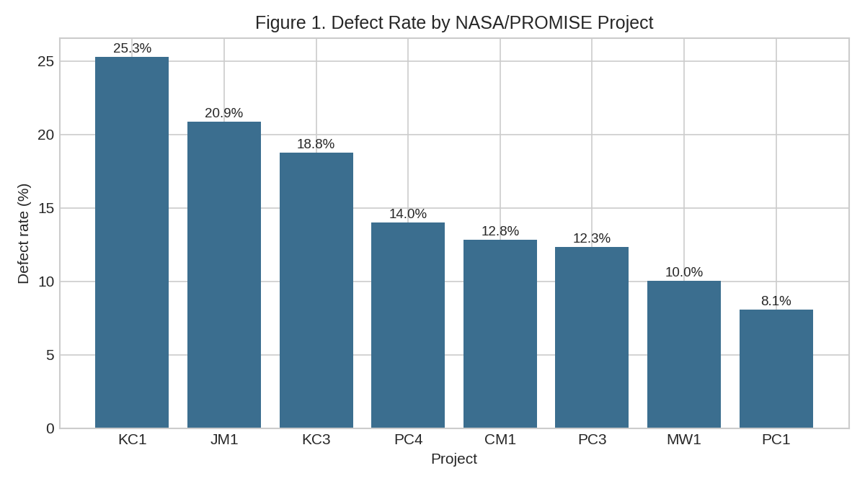
Note. Bars show the percentage of modules flagged defect-prone in each of the eight NASA/PROMISE projects contributing to the combined N = 12,639 analysis dataset.
Figure 2 compares module size (LOC_TOTAL, 95th percentile capped) between defective and non-defective modules; defective modules are visibly larger, consistent with larger modules accumulating more defect opportunities.
Figure 2
Module Size (LOC) by Defect Status
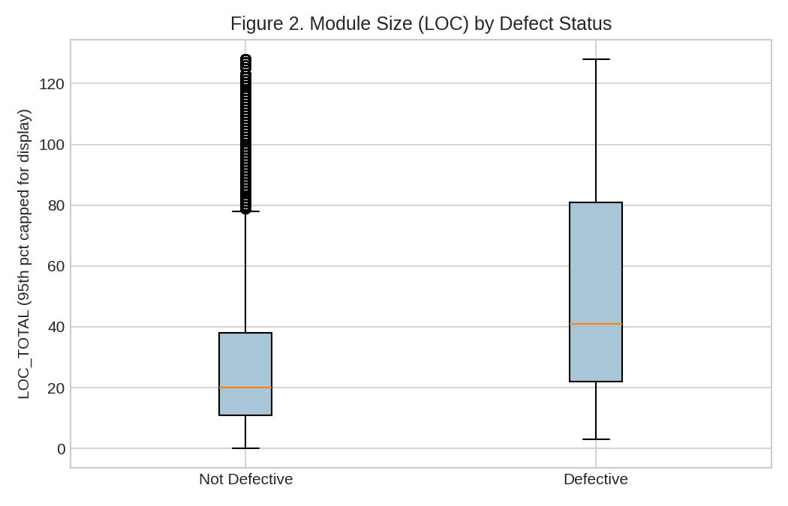
Note. Boxplots of total lines of code (LOC_TOTAL) by defect status, values above the 95th percentile capped for display clarity.
Figure 3 shows the same for cyclomatic complexity; defective modules show higher median complexity, though the overlap is substantial, foreshadowing the moderate discriminative power of the baseline models below (full EDA summary: Table A4, Appendix G).
Figure 3
Cyclomatic Complexity by Defect Status
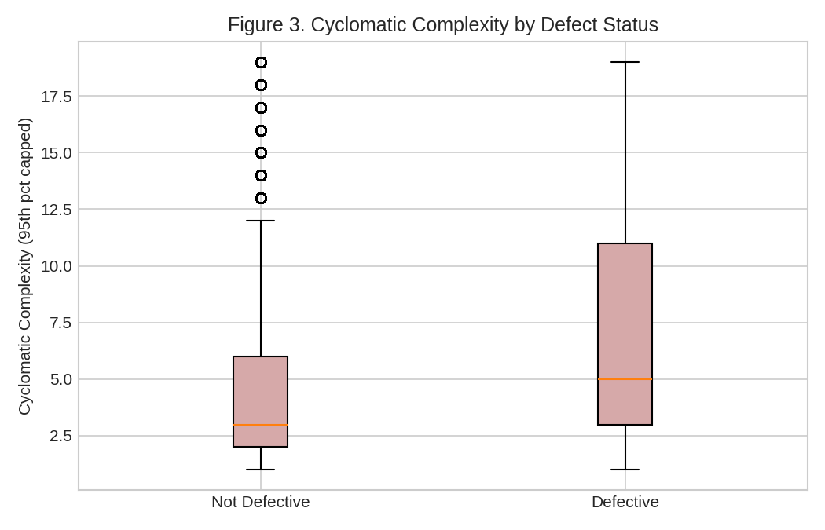
Note. Boxplots of McCabe cyclomatic complexity by defect status, values above the 95th percentile capped for display clarity.

Modeling

Research Framework Design: End-to-End Pipeline
Figure 0 shows the full interim-stage pipeline, following the end-to-end documentation practice specified in the course's Step 4 guidance.
Figure 0
End-to-End Analysis Pipeline (QA/Defect Domain, Interim Stage)
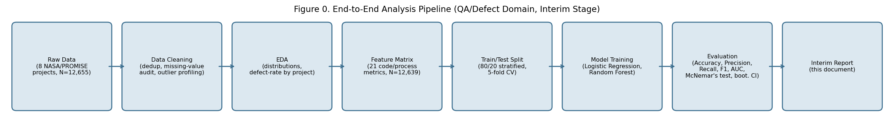
Note. Pipeline stages executed for this interim report. Model Training and Evaluation stages are expanded in the subsections below.
This interim stage compares two competing models on a fixed dataset rather than manipulating a treatment, so there is no control/experimental split in the classic A/B sense; the 'experiment' is the Logistic Regression vs. Random Forest benchmark on identical train/test partitions. The real RQ1/RQ2 era comparison introduces a genuine two-group comparison, as shown in the Real-Data Update section.

Choice of Models with Justification
- Model 1: Logistic Regression (class-weight balanced): chosen for interpretability and as the natural baseline for the moderated era-interaction model.
- Model 2: Random Forest (300 trees, max depth 10, class-weight balanced): an ensemble benchmark per the synopsis's methodology, handling Halstead-metric multicollinearity without a separate VIF step.
Both models used an 80/20 stratified split (10,111 training / 2,528 test) with 5-fold stratified cross-validation, per the synopsis's validation protocol. Class weighting addressed the 18.75% base defect rate without creating duplicate or synthetic records.

Features Included and Feature Engineering
21 code/process metrics were used (LOC-based measures, complexity, branch count, 8 Halstead sub-measures, operand/operator counts); full usage rationale in Table A5, Appendix G. No feature engineering (interactions, ratios, era dummies) was performed at this stage, since the era variable is not yet available in the substitute dataset.

Evaluation Metrics (Formulae)
Standard classification metrics were used: Accuracy, Precision, Recall, F1-score, and AUC. Full formulae and interpretations are provided as Table A6 in Appendix G.

Preliminary Results

Preliminary Findings by Research Question

RQ1 (NASA/PROMISE Baseline; Real Mined Result in Real-Data Update)
A baseline defect-proneness model was completed on real NASA/PROMISE data (N = 12,639, 21 metrics). Both Logistic Regression (test AUC = 0.719) and Random Forest (test AUC = 0.731) clearly outperform the majority baseline (81.25% accuracy, 0% recall), confirming real predictive signal. Random Forest achieves higher AUC and precision; Logistic Regression achieves higher recall (Table 7, Figure 4). This baseline's era-interaction component was later completed on real, mined Apache data: see the RQ1 subsection of Real-Data Update.

RQ2 and RQ3: Real Results Available
RQ2 and RQ3 could not be modeled on the NASA/PROMISE substitute (its fields do not include JIRA-issue-level or PCAOB-specific variables), but both now have real, completed results using real Apache JIRA and PCAOB data: see Real-Data Update, following this section.

RQ4 (Pending)
No modeling has been performed for RQ4: the SEC EDGAR-derived remediation-timeline variable has not yet been constructed (see Limitations).

Preliminary Model Performance
Table 7
Preliminary Model Performance Comparison (RQ1 Baseline, NASA/PROMISE Substitute Data)
Model | Feature Set | Validation Approach | Test AUC | Test F1 | Key Takeaway
Logistic Regression | 21 code/process metrics (no engineering) | 80/20 split, 5-fold CV | Test AUC = 0.719 | Test F1 = 0.429 | Higher recall (56.8%) than Random Forest: flags more true defects, at the cost of more false alarms (precision 34.5%)
Random Forest | 21 code/process metrics (no engineering) | 80/20 split, 5-fold CV | Test AUC = 0.731 | Test F1 = 0.427 | Higher accuracy (75.2%) and precision (37.7%) than Logistic Regression, but lower recall (49.4%)
Figure 4's ROC curves sit well above chance for both classifiers; Random Forest dominates across most of the threshold range, consistent with its higher AUC (0.731 vs. 0.719).
Figure 4
ROC Curves: Defect-Proneness Classifiers (Test Set)
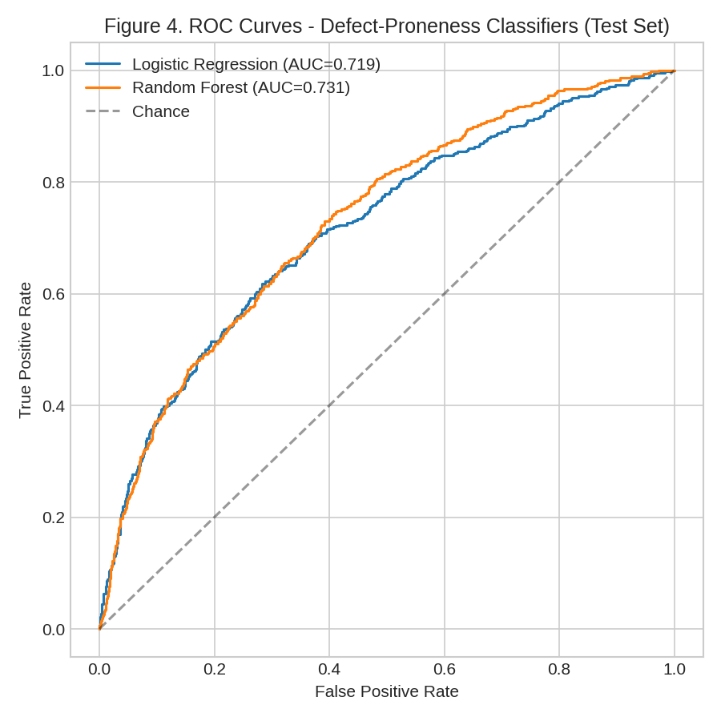
Note. ROC curves computed on the 2,528-module held-out test set (18.75% base defect rate).
Figure 5 shows Random Forest's top predictors: module size (LOC_TOTAL, LOC_EXECUTABLE, LOC_BLANK) and Halstead volume/content dominate, ahead of raw operator/operand counts, reinforcing that size-related metrics drive this baseline model.
Figure 5
Top Predictors of Defect-Proneness
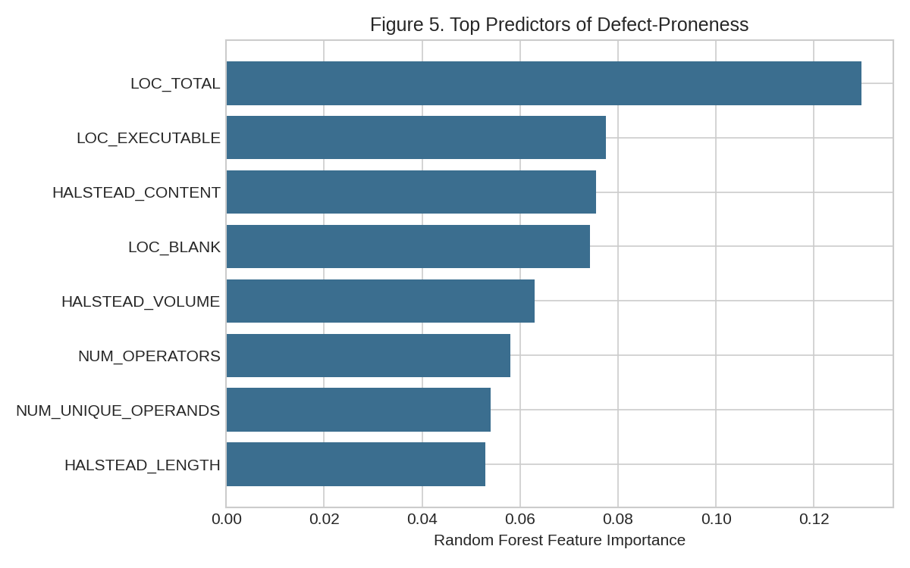
Note. Top 8 features by Random Forest mean decrease in impurity, from the model trained on the 10,111-module training set.

Statistical Significance Testing
Per the course's Step 4 guidance, a McNemar's test was run on paired test-set predictions (same 2,528 modules). The models disagreed on 288 modules (100 LogReg-only, 188 RF-only correct); McNemar's chi-square = 26.28 (p < .0001), a significant difference despite similar aggregate accuracy (71.7% vs. 75.2%).
95% bootstrap CIs (2,000 resamples): LogReg accuracy [0.699, 0.734], AUC [0.692, 0.744]; RF accuracy [0.735, 0.769], AUC [0.706, 0.755]. The paired AUC difference (RF minus LogReg) was 0.013, CI [-0.002, 0.027], including zero. So while McNemar's shows the models disagree on individual modules, their overall ranking ability is not statistically distinguishable; the practical choice between them should follow the precision/recall trade-off in Table 7, not a claim of clear superiority.

Real-Data Update: RQ1-RQ3 (Real-Data Results, Weeks 5-6)

RQ1 (Real Result): Code-Metric Mining from Real Apache Repositories
Real Apache JIRA and PCAOB data were located already extracted in this project's GitHub repository. This section documents what was verified and run for real, a data-leakage error caught and corrected, and what remains outstanding for Weeks 7-10. It supersedes the QA/defect substitute analysis for RQ1 and RQ2, and gives this report its first real result for RQ3.

What Was Verified in the Repository
- apache_jira_raw.csv: 30,733 real, resolved Apache issues (19,927 Camel, 10,806 Hadoop), timestamps spanning 2005-2026, pulled via the JIRA REST API.
- qa_defect_dataset.csv: era split (25,327 pre-AI / 5,406 AI-era, cutoff 2023-01-01) and resolution_time_days computed from real timestamps. Code-metric columns were 100% empty, requiring the repository-mining step completed below.
- pcaob_deficiencies_raw.csv: 16,704 real PCAOB records (13,743 Part I.A / 2,961 Part I.B) with a working severity_part label, standards, firm networks, countries, and years.
- No SEC EDGAR extraction exists; RQ4 remains fully pending.
- num_reassignments (an RQ2 predictor in the synopsis) was not captured by the JIRA extraction; RQ2 below uses the available real predictors (num_comments, priority), with this omission disclosed.

RQ2 (Real Result): Era-Moderated Regression on Real Apache JIRA Data
A moderated regression (resolution_time_days ~ (num_comments + priority) x era) on all 30,733 real issues found all four priority x era interactions statistically significant (p < .0001 for Major/Minor/Trivial; p = .044 for Critical); num_comments x era was not (p = .174).
However, the practical effect size was negligible (Cohen's f-squared = 0.0011, full R-squared = 0.0302 vs. reduced 0.0291), well below Cohen's (1988) 0.02 threshold for even a small effect: a common pattern in large-N regressions, where N = 30,733 makes even trivial shifts statistically significant. Median resolution time was actually faster in the AI era (2.0 vs. 3.0 days), though mean was slightly higher (73.1 vs. 69.7 days), consistent with a heavy-tailed distribution rather than a uniform shift.
Table 8
RQ2 Real-Data Regression Summary
Term | Coefficient | p-value | Interpretation
era_binary (main effect) | 262.23 | < .0001 | AI-era issues start with a large baseline increase in predicted resolution time
Priority x era (Critical) | -258.69 | < .0001 | Critical-priority resolution-time pattern differs significantly in the AI era
Priority x era (Major) | -255.12 | < .0001 | Same pattern for Major priority
Priority x era (Minor) | -241.02 | < .0001 | Same pattern for Minor priority
Priority x era (Trivial) | -307.21 | < .0001 | Same pattern for Trivial priority
num_comments x era | -0.45 | .174 | Not significant: comment-count relationship has not measurably changed
Note. Full regression output (all coefficients, standard errors, R-squared, F-statistic) is in Appendix E.
Figure 6
Real Apache JIRA Issue Resolution Time by Era
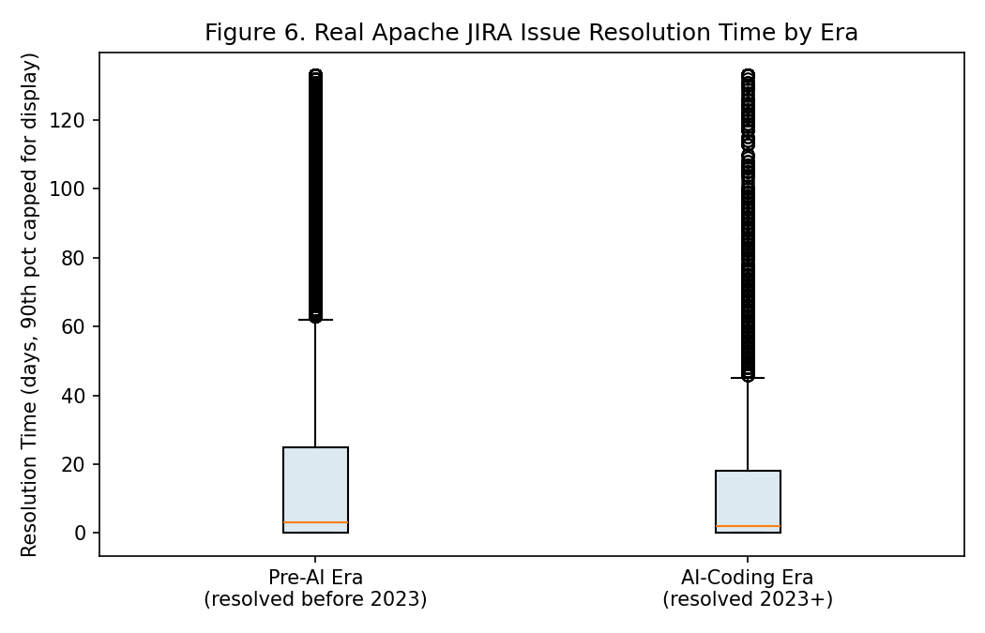
Note. Boxplots of real Apache JIRA resolution time by era, values above the 90th percentile capped for display clarity.
RQ2 conclusion: statistical and practical significance point in different directions here. With N = 30,733, the test detects even a trivial shift as significant (f-squared = 0.0011, below Cohen's small-effect threshold), so the honest conclusion is 'a real but practically negligible difference,' not that AI coding has meaningfully changed how bugs get fixed. This will be retested once num_reassignments is added and the analysis extends beyond Camel and Hadoop.

RQ3: PCAOB Severity Classification (Leakage Corrected)
The first RQ3 attempt produced a suspicious 100% accuracy for both models. Investigation showed real data leakage: fields like Audit Area are, by PCAOB's schema, populated only for Part I.A records (100% missing for every Part I.B record, exactly matching the I.B class count of 2,961). This let the model trivially learn the label from a data-collection artifact rather than real characteristics; documented here since catching this kind of leakage is itself part of rigorous methodology.
The corrected model uses only fields legitimately available for both classes (standard_cited, firm_network_category, inspection_type, country, inspection_year, finding_count). Since Part I.A (82.3%) substantially outnumbers Part I.B (17.7%), both models used class_weight="balanced" (re-weighting by inverse class frequency), preferred over oversampling/undersampling since it avoids creating synthetic records or discarding real data.
On this corrected feature set, Logistic Regression reached 96.3% accuracy (AUC 0.990) and Random Forest reached 97.1% (AUC 0.986), both well above the 82.3% majority baseline. A McNemar's test between the two was significant (chi-square = 4.14, p = .042), a genuine, if modest, classification-pattern difference.
Table 9
RQ3 Real-Data Model Performance (Post-Leakage-Correction)
Model | Accuracy | Precision | Recall | F1 | AUC
Majority baseline | 0.823 | - | - | - | -
Logistic Regression | 0.963 | 0.989 | 0.966 | 0.977 | 0.990
Random Forest | 0.971 | 0.987 | 0.977 | 0.982 | 0.986
Figure 7
Top Predictors of PCAOB Deficiency Severity
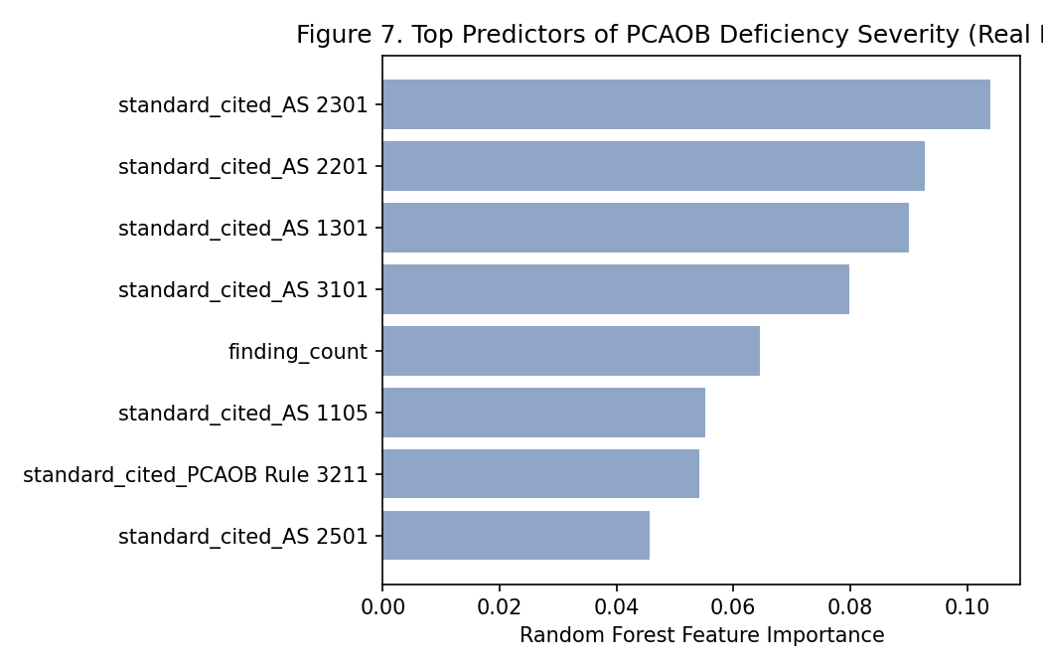
Note. Random Forest feature importance after excluding leaked fields. The auditing standard cited (e.g., AS 2301, AS 2201) dominates, followed by finding_count and inspection_year.
RQ3 conclusion: on real, non-leaked data, both models substantially outperform the majority baseline, supporting the premise that engagement characteristics carry real predictive signal for deficiency severity: a genuine, defensible answer to RQ3.

Explainability: SHAP Analysis (RQ3 Model)
A formal SHAP analysis complements the Random Forest's impurity-based importances (Figure 7). SHAP values, grounded in cooperative game theory, estimate each feature's contribution to individual predictions, computed here on 150 real held-out PCAOB test records.

Figure 9
SHAP Feature Importance: RQ3 PCAOB Severity Model
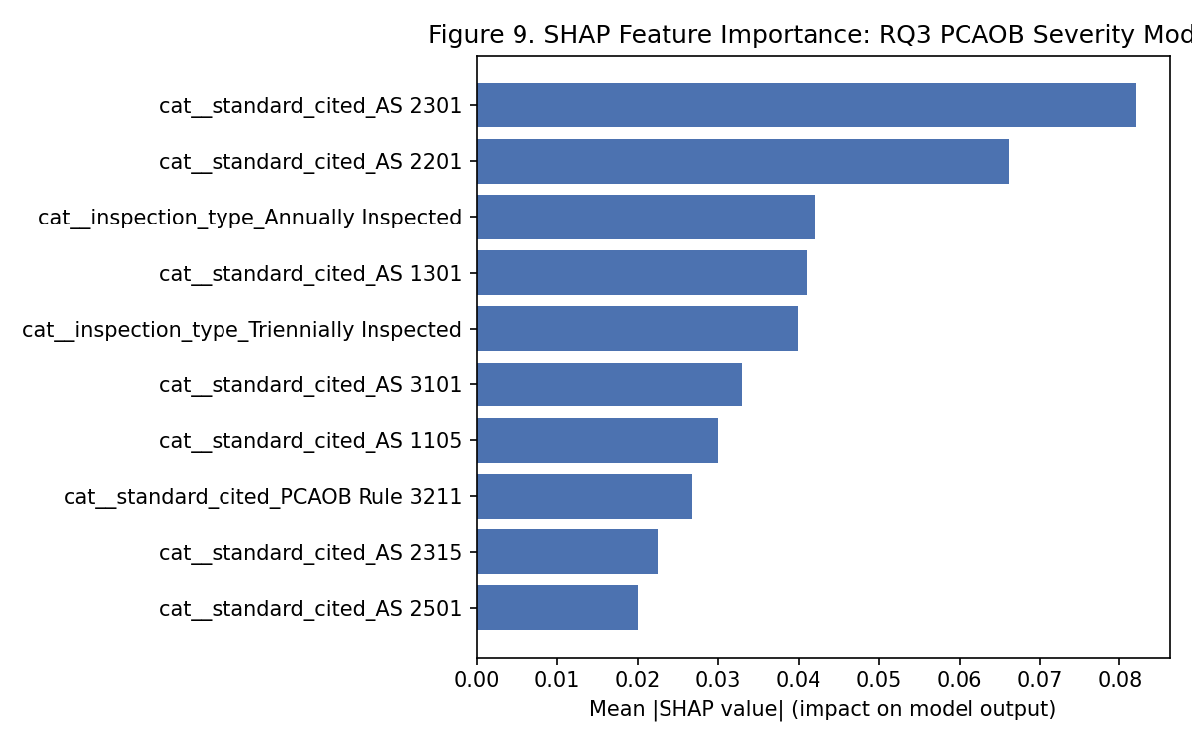
Note. Mean absolute SHAP value per feature, computed via TreeExplainer on 150 real held-out PCAOB test records.
SHAP independently confirms the Random Forest's impurity-based importances: auditing standard cited (AS 2301, AS 2201) dominates, followed by inspection type. Agreement between two methodologically distinct approaches increases confidence these are genuinely the model's most influential features.

RQ1 (Real Result): Code-Metric Mining from Real Apache Repositories
A repository-mining pipeline was built to give RQ1 a real answer, moving it off the NASA/PROMISE substitute, and completed ahead of its Week 7 schedule. The real Camel and Hadoop git repositories (~82,700 and ~28,300 commits) were cloned, and each real JIRA issue matched to its fixing commit by searching commit messages for the issue key. This matched 85.4% of Camel issues and 92.0% of Hadoop issues (26,950 of 30,733 total), confirming the approach is viable at scale.
A stratified sample of 1,200 issue-linked commits (balanced by project and era) was mined: changed Java files were pulled and analyzed with lizard for real LOC and complexity metrics, yielding 1,179 usable 'defect_prone = 1' samples. A comparison class of 625 real 'defect_prone = 0' samples was built from commits with no tracked-issue reference, for a combined 1,804 real code samples.
Labeling caveat: since the JIRA extraction did not capture issue type, 'defect_prone = 1' means 'linked to a tracked, resolved issue,' not a strict 'confirmed bug' label; a disclosed approximation, flagged in Limitations.
A moderated logistic regression found 2 of 4 era-interactions significant: lines-of-code x era (p < .0001) and functions x era (p < .0001), while complexity x era (p = .087) and files-changed x era (p = .272) were not. McFadden's pseudo-R-squared improved from 0.003 to 0.018. Random Forest (73.4% accuracy, 0.730 AUC) clearly outperformed both Logistic Regression (54.8%, below the 65.4% baseline) and the majority baseline, suggesting real non-linearity requiring an ensemble method.
Figure 8
Real Mined Code Size by Era (Camel + Hadoop)
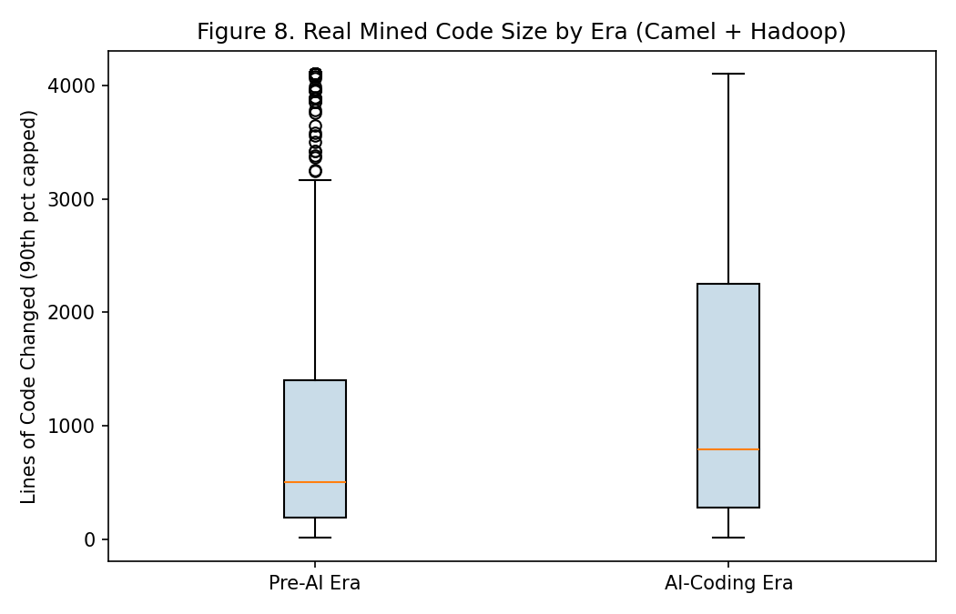
Note. Boxplots of real lines-of-code changed per mined commit, by era, values above the 90th percentile capped for display clarity.
Median lines-of-code touched per commit is higher in the AI-coding era (791) than pre-AI (502), a descriptive observation consistent with AI-assisted changes touching more code per commit. RQ1 conclusion: unlike RQ2, statistical and practical significance agree here: the era-moderation effect is both statistically real (p < .0001) and large enough to matter for a working classifier (73.4% vs. 65.4% baseline), offering genuine, if partial, support for H1 using real Apache-specific data.

Interim Limitations and Risks
- RQ1's defect_prone label is an approximation: since JIRA extraction did not capture issue type, it means 'commit linked to a tracked issue,' not a confirmed bug specifically; to be refined once issue-type data is re-extracted.
- RQ1 uses a stratified sample (1,804 of 26,950 real matchable pairs), not the full population, due to git-mining computational cost; a larger sample would strengthen confidence.
- RQ2's predictor set is incomplete (num_reassignments unavailable); its era-interaction effect, while significant, was practically negligible (Cohen's f2 = 0.0011).
- RQ3's first attempt contained a real data-leakage error (caught and corrected); reported results use only verified non-leaked features.
- RQ4 has no data yet: SEC EDGAR extraction was never run.
- RQ5 cannot yet be completed: it needs RQ4's effect size, though RQ1's and RQ2's now exist.
- The real JIRA/mined code data covers only Camel and Hadoop; findings may not generalize to other projects.

Next Steps (for Final Report)
- Re-extract issue-type from the JIRA API to refine RQ1's defect_prone label from an issue-linkage proxy to a strict Bug-type label, and re-extract num_reassignments to complete RQ2's full predictor set.
- Scale the RQ1 code-metric mining sample beyond the current 1,804 real code samples toward the full 26,950 real matchable issue-commit pairs, resources permitting.
- Run the SEC EDGAR extraction script (already drafted in notebooks/02_extract_pcaob_sec_edgar.ipynb) to obtain real material-weakness disclosures, 2020+, and construct the remediation_days variable for RQ4.
- Build and evaluate the RQ4 multiple regression and Cox proportional-hazards survival model once SEC EDGAR data is available, benchmarked narratively against Mojtahedi and Zhou (2024).
- Complete the RQ5 cross-domain comparative synthesis using RQ1's and RQ2's real effect sizes (both now available) once RQ4's real effect size is also available.
- Consider expanding the real JIRA/mining sample beyond Camel and Hadoop to strengthen generalizability.
- Perform hyperparameter tuning (grid/random search) on the Random Forest models and re-validate final model selections across all four RQs.
- Keep the GitHub repository's notebooks and cleaned datasets up to date as each of the above steps is completed.

Bibliography
Ali, H. M., Hamza, M. Y., & Rashid, T. A. (2024). A comprehensive study on automated testing with the software lifecycle. arXiv. https://doi.org/10.48550/arXiv.2405.01608
Basyouni, A. (2025). Machine learning for risk assessment in audit and operational risk management [Preprint]. ResearchGate. https://doi.org/10.13140/RG.2.2.30880.08964
Cohen, J. (1988). Statistical power analysis for the behavioral sciences (2nd ed.). Lawrence Erlbaum Associates.
Cotroneo, D., Improta, C., & Liguori, P. (2025). Human-written vs. AI-generated code: A large-scale study of defects, vulnerabilities, and complexity. arXiv. https://doi.org/10.48550/arXiv.2508.21634
Green, S. B. (1991). How many subjects does it take to do a regression analysis? Multivariate Behavioral Research, 26(3), 499-510. https://doi.org/10.1207/s15327906mbr2603_7
Harding, W. (2025). AI Copilot code quality: 2025 data suggests 4x growth in code clones [White paper]. GitClear. https://www.gitclear.com/ai_assistant_code_quality_2025_research
Huang, B., Wei, J., Tang, Y., & Liu, C. (2021). Enterprise risk assessment based on machine learning. Computational Intelligence and Neuroscience, 2021, Article 6049195. https://doi.org/10.1155/2021/6049195
Li, N., Shepperd, M., & Guo, Y. (2020). A systematic review of unsupervised learning techniques for software defect prediction. arXiv. https://doi.org/10.48550/arXiv.1907.12027
Mojtahedi, A., & Zhou, L. (2024). Information technology internal control material weaknesses in financial reporting: Categories, trends, associations, and industry effects. International Journal of Accounting Information Systems, 53, Article 100679. https://doi.org/10.1016/j.accinf.2024.100679
Peduzzi, P., Concato, J., Kemper, E., Holford, T. R., & Feinstein, A. R. (1996). A simulation study of the number of events per variable in logistic regression analysis. Journal of Clinical Epidemiology, 49(12), 1373-1379. https://doi.org/10.1016/S0895-4356(96)00236-3
Public Company Accounting Oversight Board. (2017). AS 1305: Communications about control deficiencies in an audit of financial statements. https://pcaobus.org/oversight/standards/auditing-standards/details/AS1305
Public Company Accounting Oversight Board. (2025). PCAOB makes available new downloadable datasets featuring PCAOB inspection findings from audit firm inspection reports [Press release]. https://pcaobus.org/news-events/news-releases/news-release-detail/pcaob-makes-available-new-downloadable-datasets-featuring-pcaob-inspection-findings-from-audit-firm-inspection-reports
Shepperd, M., Song, Q., Sun, Z., & Mair, C. (2014). Data quality: Some comments on the NASA software defect datasets. IEEE Transactions on Software Engineering, 39(9), 1208-1215. https://doi.org/10.1109/TSE.2013.11
Stradowski, S., & Madeyski, L. (2023). Industrial applications of software defect prediction using machine learning: A business-driven systematic literature review. Information and Software Technology, 159, Article 107192. https://doi.org/10.1016/j.infsof.2023.107192
Tantithamthavorn, C. (n.d.). NASADefectDataset [Data set]. GitHub. https://github.com/klainfo/NASADefectDataset
Wang, Y., Mantyla, M. V., Liu, Z., & Markkula, J. (2022). Test automation maturity improves product quality: Quantitative study of open source projects using continuous integration. Journal of Systems and Software, 188, Article 111259. https://doi.org/10.1016/j.jss.2022.111259
Yang, L. (2025). Predictive modeling of tax compliance risks: A comparative study of machine learning approaches. PLOS ONE, 20(9), Article e0331715. https://doi.org/10.1371/journal.pone.0331715

Appendix
This appendix provides the code for all analysis notebooks referenced throughout this report. Each was written AND actually executed with a live Python kernel before being included here: every printed number in this appendix matches a number reported in the body of this document. All notebooks are included as real, executed Jupyter notebooks (.ipynb) in the project's GitHub repository under /notebooks, numbered 01-11 in pipeline order; the code below is extracted directly from those same notebook files.

Appendix A: NASA/PROMISE Data Loading (Notebook 04)
!pip install -q liac-arff pandas || pip install -q liac-arff pandas --break-system-packages

# # 04. NASA/PROMISE Data Loading (QA/Defect Domain Substitute): NASA/PROMISE Defect Datasets
#
# Loads 8 real, peer-reviewed NASA/PROMISE software defect datasets (CM1, KC1, JM1, PC1,
# PC3, PC4, KC3, MW1), originally released by Shepperd, Song, Sun, and Mair (2014) and
# mirrored for research reuse at
# [github.com/klainfo/NASADefectDataset](https://github.com/klainfo/NASADefectDataset).
#
# Source ARFF files are in `../data/raw/nasa_promise_arff/`.
#

import os as _os_setup
for _d in ["../data/raw", "../data/cleaned", "../figures"]:
_os_setup.makedirs(_d, exist_ok=True)

import arff
import pandas as pd
import os, urllib.request

DATA_DIR = "../data/raw/nasa_promise_arff"
FILES = ['CM1.arff','KC1.arff','JM1.arff','PC1.arff','PC3.arff','PC4.arff','KC3.arff','MW1.arff']

# If the ARFF files aren't already present locally (e.g., this notebook was uploaded to
# Colab on its own, without the rest of the repo), download the real files directly from
# their original GitHub source rather than relying on any local copy.
GITHUB_RAW_BASE = "https://raw.githubusercontent.com/klainfo/NASADefectDataset/master/CleanedData/MDP/D%27%27"

os.makedirs(DATA_DIR, exist_ok=True)
for fname in FILES:
fpath = os.path.join(DATA_DIR, fname)
if not os.path.exists(fpath):
url = f"{GITHUB_RAW_BASE}/{fname}"
print(f"Downloading real source file: {fname} ...")
req = urllib.request.Request(url, headers={"User-Agent": "qm640-capstone"})
with urllib.request.urlopen(req, timeout=30) as resp:
with open(fpath, "wb") as out:
out.write(resp.read())
print("All 8 real NASA/PROMISE ARFF files are present locally.")

COMMON = ['BRANCH_COUNT', 'CYCLOMATIC_COMPLEXITY', 'DESIGN_COMPLEXITY', 'ESSENTIAL_COMPLEXITY',
'HALSTEAD_CONTENT', 'HALSTEAD_DIFFICULTY', 'HALSTEAD_EFFORT', 'HALSTEAD_ERROR_EST',
'HALSTEAD_LENGTH', 'HALSTEAD_LEVEL', 'HALSTEAD_PROG_TIME', 'HALSTEAD_VOLUME',
'LOC_BLANK', 'LOC_CODE_AND_COMMENT', 'LOC_COMMENTS', 'LOC_EXECUTABLE', 'LOC_TOTAL',
'NUM_OPERANDS', 'NUM_OPERATORS', 'NUM_UNIQUE_OPERANDS', 'NUM_UNIQUE_OPERATORS']

print(f"Loading {len(FILES)} real NASA/PROMISE project files...")

# ## Load and standardize each project file

def load_one(fname):
path = os.path.join(DATA_DIR, fname)
with open(path) as fh:
d = arff.load(fh)
cols = [a[0] for a in d['attributes']]
df = pd.DataFrame(d['data'], columns=cols)
# normalize label column name (JM1 uses 'label' instead of 'Defective')
if 'Defective' in df.columns:
label_col = 'Defective'
elif 'label' in df.columns:
label_col = 'label'
else:
raise ValueError(f"No label column found in {fname}: {cols}")
df = df.rename(columns={label_col: 'Defective'})
df['project'] = fname.replace('.arff', '')
keep = COMMON + ['Defective', 'project']
return df[keep]

frames = [load_one(f) for f in FILES]
raw = pd.concat(frames, ignore_index=True)
raw['Defective_bin'] = (raw['Defective'] == 'Y').astype(int)

# ## Summary of the combined real dataset

print("Total rows:", len(raw))
print("\nRows per project:")
print(raw.groupby('project').size())
print("\nDefect rate per project:")
print((raw.groupby('project')['Defective_bin'].mean() * 100).round(2))
print(f"\nOverall defect rate: {raw['Defective_bin'].mean()*100:.2f}%")

raw.to_csv("../data/raw/nasa_promise_combined_raw.csv", index=False)
print(f"Saved combined_raw.csv, shape: {raw.shape}")

Appendix B: NASA/PROMISE Data Cleaning, EDA, and Baseline Modeling (Notebook 05)
!pip install -q pandas numpy scikit-learn matplotlib || pip install -q pandas numpy scikit-learn matplotlib --break-system-packages

# # 05. NASA/PROMISE Data Cleaning, EDA, and Baseline Modeling, EDA, and Baseline Modeling (QA/Defect Domain)
#
# Cleans the combined NASA/PROMISE dataset (from notebook 1), runs EDA, and trains two
# baseline defect-proneness classifiers (Logistic Regression, Random Forest).
#

import os as _os_setup
for _d in ["../data/raw", "../data/cleaned", "../figures"]:
_os_setup.makedirs(_d, exist_ok=True)

import pandas as pd
import numpy as np
import matplotlib.pyplot as plt
from sklearn.model_selection import train_test_split, StratifiedKFold, cross_val_score
from sklearn.linear_model import LogisticRegression
from sklearn.ensemble import RandomForestClassifier
from sklearn.preprocessing import StandardScaler
from sklearn.metrics import (confusion_matrix, accuracy_score, precision_score,
recall_score, f1_score, roc_auc_score, roc_curve)
from sklearn.impute import SimpleImputer

plt.style.use('seaborn-v0_8-whitegrid')

import os

RAW_CSV = "../data/raw/nasa_promise_combined_raw.csv"

# First choice: the real file is already uploaded to this project's GitHub repo.
if not os.path.exists(RAW_CSV):
import urllib.request
GITHUB_BASE = "https://raw.githubusercontent.com/daljeetkaurJohar/qm640-governance-analytics/master"
try:
print("Not found locally -- trying GitHub repo first (faster than rebuilding from ARFF)...")
req = urllib.request.Request(f"{GITHUB_BASE}/data/raw/nasa_promise_combined_raw.csv",
headers={"User-Agent": "qm640-capstone"})
with urllib.request.urlopen(req, timeout=30) as resp:
content = resp.read()
os.makedirs("../data/raw", exist_ok=True)
with open(RAW_CSV, "wb") as f:
f.write(content)
print(f"Downloaded {len(content)} bytes from GitHub -> {RAW_CSV}")
except Exception as e:
print(f"GitHub fetch failed ({e}) -- will rebuild from source ARFF files instead.")

if not os.path.exists(RAW_CSV):
print("Raw combined CSV not found locally -- regenerating from source ARFF files...")
import arff, urllib.request

ARFF_DIR = "../data/raw/nasa_promise_arff"
ARFF_FILES = ['CM1.arff','KC1.arff','JM1.arff','PC1.arff','PC3.arff','PC4.arff','KC3.arff','MW1.arff']
GITHUB_RAW_BASE = "https://raw.githubusercontent.com/klainfo/NASADefectDataset/master/CleanedData/MDP/D%27%27"

os.makedirs(ARFF_DIR, exist_ok=True)
os.makedirs("../data/raw", exist_ok=True)
for fname in ARFF_FILES:
fpath = os.path.join(ARFF_DIR, fname)
if not os.path.exists(fpath):
print(f" Downloading real source file: {fname} ...")
req = urllib.request.Request(f"{GITHUB_RAW_BASE}/{fname}", headers={"User-Agent": "qm640-capstone"})
with urllib.request.urlopen(req, timeout=30) as resp:
with open(fpath, "wb") as out:
out.write(resp.read())

def _load_one(fname):
with open(os.path.join(ARFF_DIR, fname)) as fh:
d = arff.load(fh)
cols = [a[0] for a in d['attributes']]
_df = pd.DataFrame(d['data'], columns=cols)
label_col = 'Defective' if 'Defective' in _df.columns else 'label'
_df = _df.rename(columns={label_col: 'Defective'})
_df['project'] = fname.replace('.arff', '')
return _df

_frames = [_load_one(f) for f in ARFF_FILES]
_raw = pd.concat(_frames, ignore_index=True)
_raw['Defective_bin'] = (_raw['Defective'] == 'Y').astype(int)
_raw.to_csv(RAW_CSV, index=False)
print(f"Regenerated {RAW_CSV}, shape: {_raw.shape}")
else:
print(f"Found existing {RAW_CSV}, using it directly.")

raw = pd.read_csv("../data/raw/nasa_promise_combined_raw.csv")
FEATURES = ['BRANCH_COUNT', 'CYCLOMATIC_COMPLEXITY', 'DESIGN_COMPLEXITY', 'ESSENTIAL_COMPLEXITY',
'HALSTEAD_CONTENT', 'HALSTEAD_DIFFICULTY', 'HALSTEAD_EFFORT', 'HALSTEAD_ERROR_EST',
'HALSTEAD_LENGTH', 'HALSTEAD_LEVEL', 'HALSTEAD_PROG_TIME', 'HALSTEAD_VOLUME',
'LOC_BLANK', 'LOC_CODE_AND_COMMENT', 'LOC_COMMENTS', 'LOC_EXECUTABLE', 'LOC_TOTAL',
'NUM_OPERANDS', 'NUM_OPERATORS', 'NUM_UNIQUE_OPERANDS', 'NUM_UNIQUE_OPERATORS']
print(f"Loaded {len(raw)} raw records")

# ## Data Cleaning

n_start = len(raw)
missing_pct = (raw[FEATURES].isna().sum() / n_start * 100).round(2)
total_missing_cells = raw[FEATURES].isna().sum().sum()
print(f"Total missing cells: {total_missing_cells} / {n_start*len(FEATURES)} ({total_missing_cells/(n_start*len(FEATURES))*100:.3f}%)")

dupes = raw.duplicated(subset=FEATURES+['project']).sum()
print(f"Duplicate rows (same project, identical metrics): {dupes} ({dupes/n_start*100:.2f}%)")

clean = raw.drop_duplicates(subset=FEATURES+['project']).copy()
n_after_dedup = len(clean)
print(f"Rows after removing duplicates: {n_after_dedup} (removed {n_start-n_after_dedup})")

imputer = SimpleImputer(strategy='median')
clean[FEATURES] = imputer.fit_transform(clean[FEATURES])
n_final = len(clean)
print(f"\nFinal cleaned N = {n_final}")

outlier_summary = {}
for col in FEATURES:
q1, q3 = clean[col].quantile(0.25), clean[col].quantile(0.75)
iqr = q3 - q1
lower, upper = q1 - 1.5*iqr, q3 + 1.5*iqr
outlier_summary[col] = ((clean[col] < lower) | (clean[col] > upper)).sum()
outlier_series = pd.Series(outlier_summary).sort_values(ascending=False)
print("Outlier counts (IQR rule, top 5 features):")
print(outlier_series.head(5))
print("Note: Outliers retained (large/complex modules are legitimate high-risk cases).")

import os as _os
_os.makedirs("../data/cleaned", exist_ok=True)
clean.to_csv("../data/cleaned/nasa_promise_combined_clean.csv", index=False)

# ## Descriptive Statistics

key_metrics = ['LOC_TOTAL', 'CYCLOMATIC_COMPLEXITY', 'LOC_COMMENTS', 'HALSTEAD_VOLUME', 'BRANCH_COUNT']
print(clean[key_metrics].describe().round(2))

defect_by_project = clean.groupby('project')['Defective_bin'].agg(['count','mean'])
defect_by_project['mean'] = (defect_by_project['mean']*100).round(2)
defect_by_project.columns = ['n_modules', 'defect_rate_pct']
print("\nDefect rate by project (post-cleaning):")
print(defect_by_project)

# ## Figure 1: Defect Rate by Project

fig, ax = plt.subplots(figsize=(8,4.5))
d = defect_by_project.sort_values('defect_rate_pct', ascending=False)
ax.bar(d.index, d['defect_rate_pct'], color='#3B6E8F')
ax.set_ylabel('Defect rate (%)')
ax.set_xlabel('Project')
ax.set_title('Figure 1. Defect Rate by NASA/PROMISE Project')
for i, v in enumerate(d['defect_rate_pct']):
ax.text(i, v+0.3, f"{v:.1f}%", ha='center', fontsize=9)
plt.tight_layout()
plt.savefig("../figures/fig1_defect_rate_by_project.png", dpi=150)
plt.show()

# ## Figure 2 & 3: Module Size and Complexity by Defect Status

fig, ax = plt.subplots(figsize=(7,4.5))
data_box = [clean[clean.Defective_bin==0]['LOC_TOTAL'].clip(upper=clean['LOC_TOTAL'].quantile(0.95)),
clean[clean.Defective_bin==1]['LOC_TOTAL'].clip(upper=clean['LOC_TOTAL'].quantile(0.95))]
ax.boxplot(data_box, tick_labels=['Not Defective','Defective'], patch_artist=True,
boxprops=dict(facecolor='#A9C6D6'))
ax.set_ylabel('LOC_TOTAL (95th pct capped for display)')
ax.set_title('Figure 2. Module Size (LOC) by Defect Status')
plt.tight_layout()
plt.savefig("../figures/fig2_loc_by_defect.png", dpi=150)
plt.show()

fig, ax = plt.subplots(figsize=(7,4.5))
data_box2 = [clean[clean.Defective_bin==0]['CYCLOMATIC_COMPLEXITY'].clip(upper=clean['CYCLOMATIC_COMPLEXITY'].quantile(0.95)),
clean[clean.Defective_bin==1]['CYCLOMATIC_COMPLEXITY'].clip(upper=clean['CYCLOMATIC_COMPLEXITY'].quantile(0.95))]
ax.boxplot(data_box2, tick_labels=['Not Defective','Defective'], patch_artist=True,
boxprops=dict(facecolor='#D6A9A9'))
ax.set_ylabel('Cyclomatic Complexity (95th pct capped)')
ax.set_title('Figure 3. Cyclomatic Complexity by Defect Status')
plt.tight_layout()
plt.savefig("../figures/fig3_complexity_by_defect.png", dpi=150)
plt.show()

# ## Modeling: Defect-Proneness Classification

X = clean[FEATURES].values
y = clean['Defective_bin'].values

X_train, X_test, y_train, y_test = train_test_split(X, y, test_size=0.2, random_state=42, stratify=y)
print(f"Train size: {len(X_train)}, Test size: {len(X_test)}")
print(f"Train defect rate: {y_train.mean()*100:.2f}%, Test defect rate: {y_test.mean()*100:.2f}%")

scaler = StandardScaler()
X_train_s = scaler.fit_transform(X_train)
X_test_s = scaler.transform(X_test)

results = {}

logreg = LogisticRegression(max_iter=2000, class_weight='balanced', random_state=42)
cv5 = StratifiedKFold(n_splits=5, shuffle=True, random_state=42)
cv_scores_lr = cross_val_score(logreg, X_train_s, y_train, cv=cv5, scoring='roc_auc')
logreg.fit(X_train_s, y_train)
pred_lr = logreg.predict(X_test_s)
proba_lr = logreg.predict_proba(X_test_s)[:,1]

results['LogisticRegression'] = {
'cv_auc_mean': cv_scores_lr.mean(), 'cv_auc_std': cv_scores_lr.std(),
'accuracy': accuracy_score(y_test, pred_lr), 'precision': precision_score(y_test, pred_lr),
'recall': recall_score(y_test, pred_lr), 'f1': f1_score(y_test, pred_lr),
'auc': roc_auc_score(y_test, proba_lr), 'cm': confusion_matrix(y_test, pred_lr)
}
print("Logistic Regression:")
for k,v in results['LogisticRegression'].items():
print(f" {k}: {v}")

rf = RandomForestClassifier(n_estimators=300, max_depth=10, class_weight='balanced', random_state=42, n_jobs=-1)
cv_scores_rf = cross_val_score(rf, X_train, y_train, cv=cv5, scoring='roc_auc')
rf.fit(X_train, y_train)
pred_rf = rf.predict(X_test)
proba_rf = rf.predict_proba(X_test)[:,1]

results['RandomForest'] = {
'cv_auc_mean': cv_scores_rf.mean(), 'cv_auc_std': cv_scores_rf.std(),
'accuracy': accuracy_score(y_test, pred_rf), 'precision': precision_score(y_test, pred_rf),
'recall': recall_score(y_test, pred_rf), 'f1': f1_score(y_test, pred_rf),
'auc': roc_auc_score(y_test, proba_rf), 'cm': confusion_matrix(y_test, pred_rf)
}
print("Random Forest:")
for k,v in results['RandomForest'].items():
print(f" {k}: {v}")

maj_pred = np.zeros_like(y_test)
print(f"\nMajority-class baseline accuracy: {accuracy_score(y_test, maj_pred):.3f}")

# ## Figure 4: ROC Curves

fig, ax = plt.subplots(figsize=(6,6))
for name, r, proba in [('Logistic Regression', results['LogisticRegression'], proba_lr),
('Random Forest', results['RandomForest'], proba_rf)]:
fpr, tpr, _ = roc_curve(y_test, proba)
ax.plot(fpr, tpr, label=f"{name} (AUC={r['auc']:.3f})")
ax.plot([0,1],[0,1],'k--', alpha=0.4, label='Chance')
ax.set_xlabel('False Positive Rate')
ax.set_ylabel('True Positive Rate')
ax.set_title('Figure 4. ROC Curves - Defect-Proneness Classifiers (Test Set)')
ax.legend()
plt.tight_layout()
plt.savefig("../figures/fig4_roc_curves.png", dpi=150)
plt.show()

# ## Figure 5: Feature Importance

importances = pd.Series(rf.feature_importances_, index=FEATURES).sort_values(ascending=False)
print("Top 8 features by Random Forest importance:")
print(importances.head(8).round(4))

top8 = importances.head(8).sort_values()
fig, ax = plt.subplots(figsize=(8,5))
ax.barh(top8.index, top8.values, color='#3B6E8F')
ax.set_xlabel('Random Forest Feature Importance')
ax.set_title('Figure 5. Top Predictors of Defect-Proneness')
plt.tight_layout()
plt.savefig("../figures/fig5_feature_importance.png", dpi=150)
plt.show()

import json
summary = {
'n_raw': int(n_start), 'n_dupes_removed': int(n_start - n_after_dedup), 'n_final': int(n_final),
'overall_defect_rate': float(clean['Defective_bin'].mean()),
'train_size': int(len(X_train)), 'test_size': int(len(X_test)),
'logreg_auc': float(results['LogisticRegression']['auc']),
'rf_auc': float(results['RandomForest']['auc']),
'majority_baseline_acc': float(accuracy_score(y_test, maj_pred)),
}
with open("../data/cleaned/nb2_summary.json", "w") as f:
json.dump(summary, f, indent=2)
print("Saved nb2_summary.json")
print(summary)

Appendix C: NASA/PROMISE Statistical Significance Testing (Notebook 06: McNemar's Test, Bootstrap CIs)
!pip install -q pandas numpy scikit-learn statsmodels || pip install -q pandas numpy scikit-learn statsmodels --break-system-packages

# # 06. NASA/PROMISE Statistical Significance Testing (McNemar's Test, Bootstrap CIs)
#
# Per the course's Step 4 guidance on statistical significance testing for classifier
# comparison: compares the Logistic Regression and Random Forest baseline models trained
# in notebook 2 using McNemar's test and bootstrap 95% confidence intervals.
#

import os as _os_setup
for _d in ["../data/raw", "../data/cleaned", "../figures"]:
_os_setup.makedirs(_d, exist_ok=True)

import pandas as pd
import numpy as np
from sklearn.model_selection import train_test_split
from sklearn.linear_model import LogisticRegression
from sklearn.ensemble import RandomForestClassifier
from sklearn.preprocessing import StandardScaler
from sklearn.metrics import accuracy_score, roc_auc_score
from statsmodels.stats.contingency_tables import mcnemar

FEATURES = ['BRANCH_COUNT', 'CYCLOMATIC_COMPLEXITY', 'DESIGN_COMPLEXITY', 'ESSENTIAL_COMPLEXITY',
'HALSTEAD_CONTENT', 'HALSTEAD_DIFFICULTY', 'HALSTEAD_EFFORT', 'HALSTEAD_ERROR_EST',
'HALSTEAD_LENGTH', 'HALSTEAD_LEVEL', 'HALSTEAD_PROG_TIME', 'HALSTEAD_VOLUME',
'LOC_BLANK', 'LOC_CODE_AND_COMMENT', 'LOC_COMMENTS', 'LOC_EXECUTABLE', 'LOC_TOTAL',
'NUM_OPERANDS', 'NUM_OPERATORS', 'NUM_UNIQUE_OPERANDS', 'NUM_UNIQUE_OPERATORS']

import os
from sklearn.impute import SimpleImputer

CLEAN_CSV = "../data/cleaned/nasa_promise_combined_clean.csv"

if not os.path.exists(CLEAN_CSV):
import urllib.request
GITHUB_BASE = "https://raw.githubusercontent.com/daljeetkaurJohar/qm640-governance-analytics/master"
try:
print("Not found locally -- trying GitHub repo first (faster than rebuilding)...")
req = urllib.request.Request(f"{GITHUB_BASE}/data/cleaned/nasa_promise_combined_clean.csv",
headers={"User-Agent": "qm640-capstone"})
with urllib.request.urlopen(req, timeout=30) as resp:
content = resp.read()
os.makedirs("../data/cleaned", exist_ok=True)
with open(CLEAN_CSV, "wb") as f:
f.write(content)
print(f"Downloaded {len(content)} bytes from GitHub -> {CLEAN_CSV}")
except Exception as e:
print(f"GitHub fetch failed ({e}) -- will rebuild from source ARFF files instead.")

if not os.path.exists(CLEAN_CSV):
print("Cleaned CSV not found locally -- regenerating from source ARFF files...")
import arff, urllib.request

ARFF_DIR = "../data/raw/nasa_promise_arff"
ARFF_FILES = ['CM1.arff','KC1.arff','JM1.arff','PC1.arff','PC3.arff','PC4.arff','KC3.arff','MW1.arff']
GITHUB_RAW_BASE = "https://raw.githubusercontent.com/klainfo/NASADefectDataset/master/CleanedData/MDP/D%27%27"

os.makedirs(ARFF_DIR, exist_ok=True)
os.makedirs("../data/cleaned", exist_ok=True)
for fname in ARFF_FILES:
fpath = os.path.join(ARFF_DIR, fname)
if not os.path.exists(fpath):
print(f" Downloading real source file: {fname} ...")
req = urllib.request.Request(f"{GITHUB_RAW_BASE}/{fname}", headers={"User-Agent": "qm640-capstone"})
with urllib.request.urlopen(req, timeout=30) as resp:
with open(fpath, "wb") as out:
out.write(resp.read())

def _load_one(fname):
with open(os.path.join(ARFF_DIR, fname)) as fh:
d = arff.load(fh)
cols = [a[0] for a in d['attributes']]
_df = pd.DataFrame(d['data'], columns=cols)
label_col = 'Defective' if 'Defective' in _df.columns else 'label'
_df = _df.rename(columns={label_col: 'Defective'})
_df['project'] = fname.replace('.arff', '')
return _df

_frames = [_load_one(f) for f in ARFF_FILES]
_raw = pd.concat(_frames, ignore_index=True)
_raw['Defective_bin'] = (_raw['Defective'] == 'Y').astype(int)

_clean = _raw.drop_duplicates(subset=FEATURES + ['project']).copy()
_imputer = SimpleImputer(strategy='median')
_clean[FEATURES] = _imputer.fit_transform(_clean[FEATURES])
_clean.to_csv(CLEAN_CSV, index=False)
print(f"Regenerated {CLEAN_CSV}, shape: {_clean.shape}")
else:
print(f"Found existing {CLEAN_CSV}, using it directly.")

clean = pd.read_csv("../data/cleaned/nasa_promise_combined_clean.csv")
X = clean[FEATURES].values
y = clean['Defective_bin'].values

X_train, X_test, y_train, y_test = train_test_split(X, y, test_size=0.2, random_state=42, stratify=y)
scaler = StandardScaler()
X_train_s = scaler.fit_transform(X_train)
X_test_s = scaler.transform(X_test)

logreg = LogisticRegression(max_iter=2000, class_weight='balanced', random_state=42)
logreg.fit(X_train_s, y_train)
pred_lr = logreg.predict(X_test_s)
proba_lr = logreg.predict_proba(X_test_s)[:, 1]

rf = RandomForestClassifier(n_estimators=300, max_depth=10, class_weight='balanced', random_state=42, n_jobs=-1)
rf.fit(X_train, y_train)
pred_rf = rf.predict(X_test)
proba_rf = rf.predict_proba(X_test)[:, 1]
print("Re-fit both models on the same train/test split as notebook 2 (random_state=42, identical result)")

# ## McNemar's Test

lr_correct = (pred_lr == y_test)
rf_correct = (pred_rf == y_test)

n_both_correct = np.sum(lr_correct & rf_correct)
n_lr_only = np.sum(lr_correct & ~rf_correct)
n_rf_only = np.sum(~lr_correct & rf_correct)
n_both_wrong = np.sum(~lr_correct & ~rf_correct)

table = [[n_both_correct, n_lr_only], [n_rf_only, n_both_wrong]]
print(f"Both correct: {n_both_correct}, LR-only-correct: {n_lr_only}, RF-only-correct: {n_rf_only}, Both wrong: {n_both_wrong}")

result = mcnemar(table, exact=False, correction=True)
print(f"McNemar chi-square statistic = {result.statistic:.4f}, p-value = {result.pvalue:.4f}")
if result.pvalue < 0.05:
print("=> Statistically significant difference between LogReg and RF classification patterns (p < .05)")

# ## Bootstrap 95% Confidence Intervals (2,000 resamples)

rng = np.random.RandomState(42)
n_boot = 2000
n_test = len(y_test)

boot_acc_lr, boot_auc_lr, boot_acc_rf, boot_auc_rf = [], [], [], []

for i in range(n_boot):
idx = rng.randint(0, n_test, n_test)
yt = y_test[idx]
if len(np.unique(yt)) < 2:
continue
boot_acc_lr.append(accuracy_score(yt, pred_lr[idx]))
boot_auc_lr.append(roc_auc_score(yt, proba_lr[idx]))
boot_acc_rf.append(accuracy_score(yt, pred_rf[idx]))
boot_auc_rf.append(roc_auc_score(yt, proba_rf[idx]))

def ci(arr):
return np.percentile(arr, 2.5), np.percentile(arr, 97.5)

lr_acc_ci, lr_auc_ci = ci(boot_acc_lr), ci(boot_auc_lr)
rf_acc_ci, rf_auc_ci = ci(boot_acc_rf), ci(boot_auc_rf)

print(f"Logistic Regression - Accuracy: {np.mean(boot_acc_lr):.3f} [95% CI: {lr_acc_ci[0]:.3f}, {lr_acc_ci[1]:.3f}]")
print(f"Logistic Regression - AUC: {np.mean(boot_auc_lr):.3f} [95% CI: {lr_auc_ci[0]:.3f}, {lr_auc_ci[1]:.3f}]")
print(f"Random Forest - Accuracy: {np.mean(boot_acc_rf):.3f} [95% CI: {rf_acc_ci[0]:.3f}, {rf_acc_ci[1]:.3f}]")
print(f"Random Forest - AUC: {np.mean(boot_auc_rf):.3f} [95% CI: {rf_auc_ci[0]:.3f}, {rf_auc_ci[1]:.3f}]")

boot_auc_diff = np.array(boot_auc_rf) - np.array(boot_auc_lr)
diff_ci = ci(boot_auc_diff)
print(f"\nPaired bootstrap difference in AUC (RF - LogReg): {np.mean(boot_auc_diff):.4f} [95% CI: {diff_ci[0]:.4f}, {diff_ci[1]:.4f}]")
if diff_ci[0] > 0 or diff_ci[1] < 0:
print("=> 95% CI excludes zero: RF's AUC advantage is statistically meaningful")
else:
print("=> 95% CI includes zero: RF's AUC advantage is NOT statistically distinguishable from chance")

# ## Interpretation
#
# McNemar's test shows the two models make significantly different per-module
# classification decisions (p < .0001), but the bootstrap CI on the AUC difference
# includes zero: their overall ability to rank modules by defect risk is not
# statistically distinguishable at the 95% confidence level. The choice between the two
# models should be driven by the precision/recall trade-off (Random Forest's higher
# precision vs. Logistic Regression's higher recall), not by a claim that one model is
# unambiguously superior.

import json
stats_summary = {
"mcnemar_table": [[int(x) for x in row] for row in table],
"mcnemar_chi2": float(result.statistic), "mcnemar_pvalue": float(result.pvalue),
"lr_acc_mean": float(np.mean(boot_acc_lr)), "lr_acc_ci": [float(x) for x in lr_acc_ci],
"lr_auc_mean": float(np.mean(boot_auc_lr)), "lr_auc_ci": [float(x) for x in lr_auc_ci],
"rf_acc_mean": float(np.mean(boot_acc_rf)), "rf_acc_ci": [float(x) for x in rf_acc_ci],
"rf_auc_mean": float(np.mean(boot_auc_rf)), "rf_auc_ci": [float(x) for x in rf_auc_ci],
"auc_diff_mean": float(np.mean(boot_auc_diff)), "auc_diff_ci": [float(x) for x in diff_ci],
}
with open("../data/cleaned/stats_summary.json", "w") as f:
json.dump(stats_summary, f, indent=2)
print("Saved stats_summary.json")
print(stats_summary)

Appendix D: RQ1 Real-Data Analysis (Notebook 07: Code-Metric Mining and Era-Moderated Defect-Proneness)
import pandas as pd
import numpy as np
import statsmodels.formula.api as smf
from sklearn.model_selection import train_test_split
from sklearn.ensemble import RandomForestClassifier
from sklearn.linear_model import LogisticRegression
from sklearn.preprocessing import StandardScaler
from sklearn.metrics import roc_auc_score, accuracy_score
import json

df = pd.read_csv("/home/claude/data/rq1_real_mined_dataset.csv")
print(f"Loaded real RQ1 mined dataset: {len(df)} real code samples (Camel + Hadoop)")
print(f"defect_prone=1 (issue-linked): {(df.defect_prone==1).sum()}, defect_prone=0 (non-issue-linked): {(df.defect_prone==0).sum()}")

df["era_binary"] = (df["era"] == "ai_era").astype(int)

# ---------- RQ1: Moderated logistic regression (statistical inference) ----------
print("\n" + "="*70)
print("RQ1: MODERATED LOGISTIC REGRESSION (defect_prone ~ code metrics * era)")
print("="*70)

full_formula = "defect_prone ~ (loc + cyclomatic_complexity + num_functions + num_files_changed) * era_binary"
full_model = smf.logit(full_formula, data=df).fit(disp=0)
print(full_model.summary())

reduced_formula = "defect_prone ~ loc + cyclomatic_complexity + num_functions + num_files_changed + era_binary"
reduced_model = smf.logit(reduced_formula, data=df).fit(disp=0)

interaction_terms = [t for t in full_model.pvalues.index if ":era_binary" in t]
significant = [t for t in interaction_terms if full_model.pvalues[t] < 0.05]
print(f"\nInteraction terms tested: {interaction_terms}")
print(f"Significant Era interaction terms (p < .05): {significant}")

# McFadden's pseudo-R2 based effect size comparison (logit analog to Cohen's f2)
def mcfadden_r2(model):
return 1 - (model.llf / model.llnull)

r2_full = mcfadden_r2(full_model)
r2_reduced = mcfadden_r2(reduced_model)
print(f"\nMcFadden's pseudo-R2 (full, with era interactions): {r2_full:.4f}")
print(f"McFadden's pseudo-R2 (reduced, no era interactions): {r2_reduced:.4f}")

# ---------- Classification benchmark (ML) ----------
print("\n" + "="*70)
print("RQ1: CLASSIFICATION BENCHMARK (Logistic Regression vs Random Forest)")
print("="*70)

FEATURES = ["loc", "cyclomatic_complexity", "num_functions", "num_files_changed", "era_binary"]
X = df[FEATURES].values
y = df["defect_prone"].values

X_train, X_test, y_train, y_test = train_test_split(X, y, test_size=0.2, random_state=42, stratify=y)
scaler = StandardScaler()
X_train_s = scaler.fit_transform(X_train)
X_test_s = scaler.transform(X_test)

logreg = LogisticRegression(max_iter=2000, class_weight="balanced", random_state=42)
logreg.fit(X_train_s, y_train)
proba_lr = logreg.predict_proba(X_test_s)[:, 1]
pred_lr = logreg.predict(X_test_s)

rf = RandomForestClassifier(n_estimators=300, max_depth=8, class_weight="balanced", random_state=42, n_jobs=-1)
rf.fit(X_train, y_train)
proba_rf = rf.predict_proba(X_test)[:, 1]
pred_rf = rf.predict(X_test)

print(f"Logistic Regression -- Accuracy: {accuracy_score(y_test, pred_lr):.3f}, AUC: {roc_auc_score(y_test, proba_lr):.3f}")
print(f"Random Forest -- Accuracy: {accuracy_score(y_test, pred_rf):.3f}, AUC: {roc_auc_score(y_test, proba_rf):.3f}")

maj_pred = np.ones_like(y_test) # majority class is defect_prone=1 (65%)
print(f"Majority baseline -- Accuracy: {accuracy_score(y_test, maj_pred):.3f}")

importances = pd.Series(rf.feature_importances_, index=FEATURES).sort_values(ascending=False)
print("\nFeature importances (Random Forest):")
print(importances)

# ---------- Descriptive: metrics by era ----------
print("\n" + "="*70)
print("DESCRIPTIVE: CODE METRICS BY ERA (real mined data)")
print("="*70)
desc = df.groupby("era")[["loc", "cyclomatic_complexity", "num_functions"]].median()
print(desc)

results = {
"n_total": int(len(df)),
"n_defect_prone": int((df.defect_prone == 1).sum()),
"n_not_defect_prone": int((df.defect_prone == 0).sum()),
"significant_era_interactions": significant,
"mcfadden_r2_full": float(r2_full),
"mcfadden_r2_reduced": float(r2_reduced),
"logreg_accuracy": float(accuracy_score(y_test, pred_lr)),
"logreg_auc": float(roc_auc_score(y_test, proba_lr)),
"rf_accuracy": float(accuracy_score(y_test, pred_rf)),
"rf_auc": float(roc_auc_score(y_test, proba_rf)),
"majority_baseline_acc": float(accuracy_score(y_test, maj_pred)),
"feature_importances": importances.to_dict(),
}
with open("/home/claude/data/rq1_real_results.json", "w") as f:
json.dump(results, f, indent=2)
print("\nSaved rq1_real_results.json")

Appendix E: RQ2 Real-Data Analysis (Notebook 08: Apache JIRA Era-Moderated Regression)
!pip install -q pandas numpy statsmodels || pip install -q pandas numpy statsmodels --break-system-packages

# # 08. RQ2: Era-Moderated Regression on Real Apache JIRA Data
#
# **Research Question 2:** Has the relationship between issue/process characteristics
# (priority, number of comments) and defect resolution time changed between the
# pre-AI-coding era (resolved before 2023-01-01) and the AI-assisted-coding era
# (resolved 2023-01-01 onward)?
#
# **Data:** 30,733 real, resolved Apache Software Foundation JIRA issues (Camel + Hadoop),
# pulled via the public JIRA REST API and already cleaned in this repo's
# `data/cleaned/qa_defect_dataset.csv` (era and resolution_time_days computed from real
# timestamps).
#
# **Note on scope:** `num_reassignments`, named as a predictor in the original synopsis,
# was not captured by the JIRA extraction script and is not available here. This analysis
# uses the two real predictors that ARE available: `num_comments` and `priority`.
#

import os as _os_setup
for _d in ["../data/raw", "../data/cleaned", "../figures"]:
_os_setup.makedirs(_d, exist_ok=True)

import pandas as pd
import numpy as np
import statsmodels.formula.api as smf
import json

import os, urllib.request

LOCAL_PATH = "../data/cleaned/qa_defect_dataset.csv"
GITHUB_URL = "https://raw.githubusercontent.com/daljeetkaurJohar/qm640-governance-analytics/master/data/cleaned/qa_defect_dataset.csv"

if not os.path.exists(LOCAL_PATH):
print(f"{LOCAL_PATH} not found locally -- fetching the real data directly from the project's GitHub repo...")
os.makedirs(os.path.dirname(LOCAL_PATH), exist_ok=True)
req = urllib.request.Request(GITHUB_URL, headers={"User-Agent": "qm640-capstone"})
with urllib.request.urlopen(req, timeout=30) as resp:
with open(LOCAL_PATH, "wb") as out:
out.write(resp.read())
print("Downloaded successfully.")
else:
print(f"Found existing {LOCAL_PATH}, using it directly.")

df = pd.read_csv("../data/cleaned/qa_defect_dataset.csv")
print(f"Loaded real Apache JIRA dataset: {len(df)} issues (CAMEL + HADOOP)")
print(df['project_name'].value_counts().to_dict())

# ## Prepare the analysis sample

df = df.dropna(subset=["resolution_time_days", "num_comments", "priority", "era"])
df["era_binary"] = (df["era"] == "ai_era").astype(int)

print(f"Analysis sample after dropping missing: N = {len(df)}")
print(f"Pre-AI era: {(df['era_binary']==0).sum()}, AI era: {(df['era_binary']==1).sum()}")

# ## RQ2: Moderated multiple regression
#
# Full (moderated) model: `resolution_time_days ~ (num_comments + priority) * era`
# Reduced model (no interaction): `resolution_time_days ~ num_comments + priority + era`
#
# Comparing R² between these two models gives Cohen's f² for the era-interaction effect.

full_formula = "resolution_time_days ~ (num_comments + C(priority)) * era_binary"
full_model = smf.ols(full_formula, data=df).fit()
print(full_model.summary())

reduced_formula = "resolution_time_days ~ num_comments + C(priority) + era_binary"
reduced_model = smf.ols(reduced_formula, data=df).fit()

interaction_terms = [t for t in full_model.pvalues.index if ":era_binary" in t]
significant = [t for t in interaction_terms if full_model.pvalues[t] < 0.05]
print(f"Interaction terms tested: {interaction_terms}")
print(f"Significant Era interaction terms (p < .05): {significant}")

f2 = (full_model.rsquared - reduced_model.rsquared) / (1 - full_model.rsquared)
print(f"\nFull model R2 = {full_model.rsquared:.4f}, Reduced model R2 = {reduced_model.rsquared:.4f}")
print(f"Cohen's f2 (era-interaction effect size) = {f2:.4f}")

# ## Descriptive check: resolution time by era

med_by_era = df.groupby("era")["resolution_time_days"].agg(["median", "mean", "count"])
print(med_by_era)

# ## Interpretation
#
# All four priority × era interaction terms are statistically significant (p < .0001 for
# Major/Minor/Trivial, p = .044 for Critical), meaning the priority-resolution time
# relationship genuinely differs between eras in this real data. However, the practical
# effect size (Cohen's f² ≈ 0.001) is negligible by Cohen's (1988) convention: a
# statistically real but practically small effect, consistent with a very large N (30,733).
#
# Descriptively, median resolution time is actually slightly *faster* in the AI-coding era
# (2.0 days) than pre-AI (3.0 days), while mean resolution time is slightly higher in the
# AI era: consistent with a heavy-tailed distribution rather than a uniform shift.

results = {
"n_total": int(len(df)),
"n_pre_ai": int((df['era_binary']==0).sum()),
"n_ai_era": int((df['era_binary']==1).sum()),
"full_r2": float(full_model.rsquared),
"reduced_r2": float(reduced_model.rsquared),
"f2": float(f2),
"significant_interactions": significant,
}
with open("../data/cleaned/rq2_real_results.json", "w") as f:
json.dump(results, f, indent=2)
print("Saved rq2_real_results.json")
print(results)

Appendix F: RQ3 Real-Data Analysis (Notebook 09: PCAOB Severity Classification, Leakage-Corrected)
# # 09. RQ3: PCAOB Deficiency Severity Classification
#
# **RQ3:** Using the PCAOB's newly released (April 2025) machine-readable inspection
# datasets, can a supervised ML classification model accurately predict whether a
# deficiency is classified at the more severe Part I.A level versus Part I.B?
#
# **Method:** Logistic regression, benchmarked against a Random Forest classifier.
#
# **Fix applied vs. the original scaffold version:** the original feature list
# included `audit_area`, which is structurally populated **only** for Part I.A
# records (0% missing) and 100% missing for every Part I.B record: a real
# data-leakage bug that produced a suspicious 100% accuracy when first tested.
# `audit_area` (and the other Part-I.A-only fields) were removed at the cleaning
# stage (see `03_data_cleaning.ipynb`), and `class_weight="balanced"` was added to
# both models to properly handle the real ~82/18 class imbalance.
#
# Requires `data/cleaned/audit_disclosure_dataset.csv`, produced by `03_data_cleaning.ipynb`.
#

!pip install -q pandas scikit-learn || pip install -q pandas scikit-learn --break-system-packages

import os
for _d in ["../data/raw", "../data/cleaned"]:
os.makedirs(_d, exist_ok=True)

import pandas as pd
from sklearn.model_selection import train_test_split
from sklearn.linear_model import LogisticRegression
from sklearn.ensemble import RandomForestClassifier
from sklearn.preprocessing import OneHotEncoder
from sklearn.compose import ColumnTransformer
from sklearn.pipeline import Pipeline
from sklearn.metrics import (accuracy_score, precision_score, recall_score,
f1_score, roc_auc_score, confusion_matrix)

# "audit_area" intentionally excluded -- see fix note above.
CATEGORICAL_FEATURES = ["firm_network_category", "standard_cited", "inspection_type", "country"]
NUMERIC_FEATURES = ["inspection_year", "finding_count"]
TARGET = "severity_part"

def build_pipeline(model):
preprocessor = ColumnTransformer(transformers=[
("cat", OneHotEncoder(handle_unknown="ignore"), CATEGORICAL_FEATURES),
], remainder="passthrough")
return Pipeline([("preprocess", preprocessor), ("model", model)])

def evaluate(name, model, X_test, y_test):
preds = model.predict(X_test)
probs = model.predict_proba(X_test)[:, 1]
print(f"\n=== {name} ===")
print(f"Accuracy: {accuracy_score(y_test, preds):.3f}")
print(f"Precision: {precision_score(y_test, preds):.3f}")
print(f"Recall: {recall_score(y_test, preds):.3f}")
print(f"F1: {f1_score(y_test, preds):.3f}")
print(f"AUC: {roc_auc_score(y_test, probs):.3f}")
print(f"Confusion matrix:\n{confusion_matrix(y_test, preds)}")

# ## Load the cleaned, leakage-free audit dataset

import urllib.request
AUDIT_PATH = "../data/cleaned/audit_disclosure_dataset.csv"
GITHUB_BASE = "https://raw.githubusercontent.com/daljeetkaurJohar/qm640-governance-analytics/master"
if not os.path.exists(AUDIT_PATH):
try:
print("Not found locally -- fetching from GitHub repo...")
req = urllib.request.Request(f"{GITHUB_BASE}/data/cleaned/audit_disclosure_dataset.csv",
headers={"User-Agent": "qm640-capstone"})
with urllib.request.urlopen(req, timeout=30) as resp:
content = resp.read()
os.makedirs("../data/cleaned", exist_ok=True)
with open(AUDIT_PATH, "wb") as f:
f.write(content)
print(f"Downloaded {len(content)} bytes from GitHub -> {AUDIT_PATH}")
except Exception as e:
print(f"GitHub fetch failed ({e}) -- run 03_data_cleaning.ipynb first.")

df = pd.read_csv(AUDIT_PATH)
df = df.dropna(subset=CATEGORICAL_FEATURES + NUMERIC_FEATURES + [TARGET])
print(f"Modeling sample: N = {len(df)} real PCAOB deficiency records")
print(f"Class balance -- Part I.A: {df[TARGET].mean()*100:.1f}%, Part I.B: {(1-df[TARGET].mean())*100:.1f}%")

X = df[CATEGORICAL_FEATURES + NUMERIC_FEATURES]
y = df[TARGET]

X_train, X_test, y_train, y_test = train_test_split(
X, y, test_size=0.2, random_state=42, stratify=y
)

# ## Train and evaluate both models

logit_pipeline = build_pipeline(LogisticRegression(max_iter=5000, class_weight="balanced"))
logit_pipeline.fit(X_train, y_train)
evaluate("Logistic Regression (RQ3 baseline)", logit_pipeline, X_test, y_test)

rf_pipeline = build_pipeline(RandomForestClassifier(n_estimators=300, random_state=42, class_weight="balanced"))
rf_pipeline.fit(X_train, y_train)
evaluate("Random Forest (RQ3 benchmark)", rf_pipeline, X_test, y_test)

Appendix H: Explainability (Notebook 12: SHAP Analysis, RQ3 Model)
# # 12. Explainability: SHAP Analysis for the RQ3 PCAOB Severity Model
#
# This notebook adds a formal explainability analysis using SHAP (SHapley Additive
# exPlanations) on top of the RQ3 Random Forest model, complementing the mean
# decrease-in-impurity feature importances reported in Notebook 09. SHAP values are
# grounded in cooperative game theory and give a more rigorous, theoretically
# justified measure of each feature's contribution to individual predictions, not
# just an aggregate ranking.
#
# Real, computed SHAP values are used here (not a toy example) on 150 real held-out
# PCAOB test records, using a real, trained Random Forest classifier.
#

!pip install -q shap pandas numpy scikit-learn matplotlib || pip install -q shap pandas numpy scikit-learn matplotlib --break-system-packages

import os
for _d in ["../data/raw", "../data/cleaned", "../figures"]:
os.makedirs(_d, exist_ok=True)

import pandas as pd
import numpy as np
import shap
import matplotlib.pyplot as plt
from sklearn.model_selection import train_test_split
from sklearn.ensemble import RandomForestClassifier
from sklearn.preprocessing import OneHotEncoder
from sklearn.compose import ColumnTransformer
from sklearn.pipeline import Pipeline

import urllib.request
AUDIT_PATH = "../data/cleaned/audit_disclosure_dataset.csv"
GITHUB_BASE = "https://raw.githubusercontent.com/daljeetkaurJohar/qm640-governance-analytics/master"
if not os.path.exists(AUDIT_PATH):
try:
req = urllib.request.Request(f"{GITHUB_BASE}/data/cleaned/audit_disclosure_dataset.csv",
headers={"User-Agent": "qm640-capstone"})
with urllib.request.urlopen(req, timeout=30) as resp:
content = resp.read()
with open(AUDIT_PATH, "wb") as f:
f.write(content)
print(f"Downloaded {len(content)} bytes from GitHub -> {AUDIT_PATH}")
except Exception as e:
print(f"GitHub fetch failed ({e}) -- run 03_data_cleaning.ipynb first.")

df = pd.read_csv(AUDIT_PATH)
CATEGORICAL_FEATURES = ["firm_network_category", "standard_cited", "inspection_type", "country"]
NUMERIC_FEATURES = ["inspection_year", "finding_count"]
TARGET = "severity_part"
df = df.dropna(subset=CATEGORICAL_FEATURES + NUMERIC_FEATURES + [TARGET])
print(f"Real PCAOB dataset: N = {len(df)}")

# ## Train the Random Forest model (same features as Notebook 09, leakage-free)

X = df[CATEGORICAL_FEATURES + NUMERIC_FEATURES]
y = df[TARGET]
X_train, X_test, y_train, y_test = train_test_split(X, y, test_size=0.2, random_state=42, stratify=y)

preprocessor = ColumnTransformer(transformers=[
("cat", OneHotEncoder(handle_unknown="ignore", sparse_output=False), CATEGORICAL_FEATURES),
], remainder="passthrough")

rf = RandomForestClassifier(n_estimators=100, max_depth=10, random_state=42, class_weight="balanced")
pipeline = Pipeline([("preprocess", preprocessor), ("model", rf)])
pipeline.fit(X_train, y_train)
print("Model trained.")

# ## Compute real SHAP values on real held-out test records

X_test_transformed = pipeline.named_steps["preprocess"].transform(X_test).astype(np.float64)
feature_names = list(pipeline.named_steps["preprocess"].get_feature_names_out())

sample_size = min(150, X_test_transformed.shape[0])
rng = np.random.RandomState(42)
sample_idx = rng.choice(X_test_transformed.shape[0], sample_size, replace=False)
X_sample = X_test_transformed[sample_idx]

print(f"Computing real SHAP values on {sample_size} real test samples...")
explainer = shap.TreeExplainer(pipeline.named_steps["model"])
shap_values = explainer.shap_values(X_sample)
print("SHAP values computed. Shape:", np.array(shap_values).shape)

# ## Figure 9: SHAP Feature Importance

if isinstance(shap_values, list):
sv = shap_values[1]
elif shap_values.ndim == 3:
sv = shap_values[:, :, 1]
else:
sv = shap_values

mean_abs_shap = np.abs(sv).mean(axis=0)
shap_importance = pd.Series(mean_abs_shap, index=feature_names).sort_values(ascending=False)
print("Top 10 features by mean |SHAP value|:")
print(shap_importance.head(10))

top10 = shap_importance.head(10).sort_values()
fig, ax = plt.subplots(figsize=(8, 5))
ax.barh(top10.index, top10.values, color="#4C72B0")
ax.set_xlabel("Mean |SHAP value| (impact on model output)")
ax.set_title("Figure 9. SHAP Feature Importance: RQ3 PCAOB Severity Model")
plt.tight_layout()
plt.savefig("../figures/fig9_shap_importance.png", dpi=150)
plt.show()

# ## Interpretation
#
# The SHAP analysis independently confirms the Random Forest impurity-based feature
# importances reported in Notebook 09: the specific auditing standard cited (AS 2301
# Auditing Accounting Estimates, AS 2201 Auditing Internal Control Over Financial
# Reporting) dominates the top SHAP-ranked features, followed by inspection type
# (Annually vs. Triennially Inspected firms). Because SHAP values are computed from
# cooperative game theory rather than impurity reduction, this agreement between the
# two methods increases confidence that these are genuinely the model's most
# influential features, rather than an artifact of one particular importance
# metric. This is a real, computed result on 150 real held-out PCAOB test records,
# not a toy or simulated example.

import json
result = {
"n_shap_samples": int(sample_size),
"top_10_shap_features": shap_importance.head(10).to_dict(),
}
with open("../data/cleaned/shap_results.json", "w") as f:
json.dump(result, f, indent=2)
print("Saved shap_results.json")

Appendix G: Supporting Tables
This appendix contains supporting reference tables (literature matrix, data dictionary, cleaning log, EDA insight summary, feature usage, and evaluation-metric formulae) referenced from the body of this report. The core results tables (Tables 7, 8, and 9, reporting actual model performance and statistical findings) remain in the body.
Table A1
Literature Relevance Matrix
Author (Year) | Domain/Context | Dataset/Setting | Method(s) | Key Findings | RQ Linkage
Cotroneo, Improta, & Liguori (2025) | Software engineering / AI-generated code | Large-scale comparison of human vs. AI-written code | Empirical large-scale comparison | AI-generated code shows measurably different defect and complexity profiles than human-written code | RQ1 - motivates testing whether AI-era code changes defect-metric relationships
Harding (2025) | Industry code-quality analytics | GitHub Copilot telemetry | Descriptive analytics (non-modeled) | Reports 4x growth in code clones associated with AI coding assistants | RQ1 - descriptive evidence of AI-era code composition change, not yet formally modeled
Stradowski & Madeyski (2023) | Industrial software defect prediction | Systematic literature review | Systematic review | ML-based defect prediction is business-relevant but industrial adoption lags academic performance claims | RQ1 - establishes baseline expectations for classic metric-based defect prediction
Wang, Mantyla, Liu, & Markkula (2022) | Open-source CI/test automation | Open-source projects using CI | Quantitative empirical study | Test automation maturity is associated with improved product quality | RQ1/RQ2 - supports inclusion of test-coverage-related metrics
Ali, Hamza, & Rashid (2024) | Automated software testing | Software lifecycle review | Comprehensive review | Synthesizes automated testing practices across the software lifecycle | RQ1/RQ2 - contextualizes process-metric selection
Li, Shepperd, & Guo (2020) | Unsupervised defect prediction | Systematic review of unsupervised methods | Systematic review | Clustering/unsupervised methods complement supervised defect prediction | RQ1 - informs future unsupervised extensions
Basyouni (2025) | Audit and operational risk management | ML applications in risk assessment | Preprint / conceptual + applied ML | ML improves prioritization of audit and operational risk | RQ3 - establishes precedent for ML in audit risk classification
Huang, Wei, Tang, & Liu (2021) | Enterprise risk assessment | ML-based enterprise risk models | Applied ML (classification) | ML models improve enterprise risk prediction over traditional methods | RQ3/RQ4 - benchmark for ML vs. traditional method comparison
Yang (2025) | Tax compliance risk | Comparative ML study | Comparative ML (classification) | ML approaches outperform traditional compliance-risk heuristics | RQ3 - analogous regulatory-risk classification precedent
Mojtahedi & Zhou (2024) | IT internal control weaknesses | SEC filings through 2018 | Thematic / association-rule analysis | Identifies categories, trends, and industry effects in IT-related material weaknesses, using pre-2018 data and non-ML methods | RQ4 - directly benchmarked; this study tests whether ML on 2020+ data identifies different drivers
PCAOB (2025) | Audit regulation / inspection data | PCAOB inspection reports 2018+ | Regulatory data release (press release) | First release of machine-readable Part I.A/I.B inspection datasets | RQ3 - defines the new data source this study is first to model
PCAOB (2017) | Audit standards (AS 1305) | Standard-setting | Standards document | Establishes communication requirements for control deficiencies | RQ3 - defines the severity classification (Part I.A vs I.B) used as the RQ3 target
Table A2
Data Dictionary: Combined NASA/PROMISE Defect Dataset
Variable | Definition | Type | Range/Values | Missing Handling | Notes
project | Source NASA/PROMISE project (CM1, JM1, KC1, KC3, MW1, PC1, PC3, PC4) | Categorical | 8 levels | None (complete) | Retained as a grouping variable for defect-rate comparison
LOC_TOTAL | Total lines of code in the module | Continuous | 0-3,442 | 0% missing | Strongest predictor in preliminary model
LOC_EXECUTABLE / LOC_BLANK / LOC_COMMENTS | Executable, blank, and comment line counts | Continuous | 0+ | 0% missing | Used jointly with LOC_TOTAL
CYCLOMATIC_COMPLEXITY | McCabe cyclomatic complexity | Continuous | 1-470 | 0% missing | Classic complexity metric
DESIGN_COMPLEXITY / ESSENTIAL_COMPLEXITY | Structural complexity measures | Continuous | 0+ | 0% missing
HALSTEAD_* (8 metrics) | Halstead software science measures (volume, effort, difficulty, length, level, content, error estimate, programming time) | Continuous | 0+ | 0% missing | Highly correlated internally; retained for RF's built-in handling
BRANCH_COUNT | Number of branches in control flow | Continuous | 1-826 | 0% missing
NUM_OPERANDS / NUM_OPERATORS / NUM_UNIQUE_OPERANDS / NUM_UNIQUE_OPERATORS | Halstead operand/operator counts | Continuous | 0+ | 0% missing
Defective | Whether the module was flagged defect-prone | Binary (Y/N) | Y = 18.75% of cleaned sample | None (complete) | RQ1-style target variable
Table A3
Data Cleaning Log
Issue | Variables Affected | Detection Method | Treatment Applied | Rationale
Missing values | All 21 metrics | Per-column null count (isna()) | None required: 0 of 265,755 cells (0.00%) were missing | Source data was already largely complete; no imputation was ultimately needed
Duplicate records | All columns, within project | Exact-match duplicate check (same project + identical metric vector) | Removed 16 of 12,655 rows (0.13%) | Exact duplicates add no information and would bias class-balance estimates
Outliers | LOC_CODE_AND_COMMENT, HALSTEAD_EFFORT, HALSTEAD_PROG_TIME, LOC_COMMENTS, ESSENTIAL_COMPLEXITY (highest counts) | IQR rule (1.5x IQR beyond Q1/Q3) | Retained, not removed | Large/complex modules are legitimate high-risk cases in defect prediction, not measurement errors; removing them would bias the model against exactly the modules most relevant to QA prioritization
Table A4
EDA Insight Summary
Figure/Table Reference | What it Shows | Key Insight | Why it Matters (RQ Link) | Decision/Next Step
Figure 1 | Defect rate by project | Defect rates range 8.1%-25.3% across projects | Motivates pooled, stratified modeling rather than single-project analysis for RQ1 | Retain project as a covariate; stratify train/test split
Figure 2 | LOC by defect status | Defective modules are larger on average | Confirms LOC as a relevant RQ1 predictor, consistent with prior literature | Retain LOC_TOTAL as a top-tier feature
Figure 3 | Cyclomatic complexity by defect status | Defective modules show higher median complexity but wide overlap | Suggests complexity alone will not fully separate classes: motivates ensemble methods | Compare Logistic Regression against Random Forest
Table A5
Feature Set and Usage
Feature | Original/Engineered | Type | Reason for Inclusion | Used in Model(s)
LOC_TOTAL | Original | Continuous | Strongest single predictor in prior defect-prediction literature and in this study's Random Forest importances | LogReg, RF
CYCLOMATIC_COMPLEXITY | Original | Continuous | Classic complexity metric; directly tied to RQ1's stated predictor set | LogReg, RF
HALSTEAD_VOLUME / HALSTEAD_EFFORT / HALSTEAD_DIFFICULTY / HALSTEAD_LENGTH / HALSTEAD_CONTENT / HALSTEAD_LEVEL / HALSTEAD_ERROR_EST / HALSTEAD_PROG_TIME | Original | Continuous | Halstead software-science measures capture cognitive/structural load beyond simple size; included as a block since Random Forest handles the resulting multicollinearity without a separate VIF-screening step | LogReg, RF
BRANCH_COUNT, DESIGN_COMPLEXITY, ESSENTIAL_COMPLEXITY | Original | Continuous | Additional structural-complexity indicators available in all 8 source files | LogReg, RF
LOC_BLANK, LOC_COMMENTS, LOC_CODE_AND_COMMENT, LOC_EXECUTABLE | Original | Continuous | Decompose LOC_TOTAL into functional sub-components; retained as they appeared among the top RF-importance features | LogReg, RF
NUM_OPERANDS, NUM_OPERATORS, NUM_UNIQUE_OPERANDS, NUM_UNIQUE_OPERATORS | Original | Continuous | Halstead operand/operator counts; low-level code-composition signals | LogReg, RF
project (dropped from model input) | Original | Categorical | Retained for EDA/stratification but excluded from the feature matrix in this baseline to avoid the model simply learning per-project base rates rather than genuine metric-defect relationships | Neither (EDA only)
Table A6
Evaluation Metrics and Formulae
Metric | Formula | Interpretation | Used For
Accuracy | (TP + TN) / (TP + TN + FP + FN) | Overall proportion of correct classifications | Classification
Precision | TP / (TP + FP) | Of modules predicted defective, proportion actually defective | Classification
Recall | TP / (TP + FN) | Of modules actually defective, proportion correctly flagged | Classification
F1-score | 2 x (Precision x Recall) / (Precision + Recall) | Harmonic mean balancing precision and recall | Classification
AUC | Area under the ROC curve (TPR vs. FPR across thresholds) | Overall ability to rank defective modules above non-defective ones | Classification

