Data-Driven Quality and Risk Analytics: A Comparative Study of Governance-Relevant Change in the AI-Coding Era and Emerging PCAOB Audit Risk Data
Synopsis
Daljeet Kaur Johar
Walsh College
QM640: Data Analytics Capstone
Smitraj Raut
3rd Term
July 21, 2026

Data-Driven Quality and Risk Analytics: A Comparative Study of Governance-Relevant Change in the AI-Coding Era and Emerging PCAOB Audit Risk Data
Introduction
Background and Context
Enterprise IT governance in large industrial organizations rests on two control layers that are typically managed as separate functions: software quality assurance (QA), which safeguards the reliability of applications before they reach production, and IT audit, which evaluates the design and operating effectiveness of IT general controls (ITGCs) after systems are in use. Both functions are currently being reshaped by developments that established research has not yet caught up with. On the QA side, generative-AI coding assistants (e.g., GitHub Copilot, ChatGPT-based tools) became mainstream between 2023 and 2026, and early evidence suggests they measurably change the composition and defect profile of code (Cotroneo et al., 2025; Harding, 2025), raising the question of whether classic, metric-based defect-prediction models still behave the same way. On the audit side, the PCAOB only began publishing machine-readable inspection deficiency datasets in April 2025 (PCAOB, 2025), and prior academic research on IT-related internal control weaknesses has relied on data no more recent than 2018 and predominantly pre-2010 samples (Mojtahedi & Zhou, 2024). Both shifts open real, largely unanswered questions rather than settled ones.
The stakeholders in this domain span software engineering and QA teams responsible for release quality, IT audit and risk management teams responsible for regulatory and control assurance (e.g., SOX compliance, cloud security audits), business unit leaders who depend on stable systems for operations, and external auditors and regulators who rely on timely, well-supported control communications (PCAOB, 2017). Academic and industry research has established that software quality metrics, including defect density, test automation coverage, and testing cycle time, are measurable, predictive indicators of downstream software reliability (Stradowski & Madeyski, 2023; Wang et al., 2022), and separately that machine learning can improve the prioritization and prediction of audit and control risk (Basyouni, 2025; Huang et al., 2021; Yang, 2025). However, these established findings were generated before two recent disruptions: the mainstreaming of generative-AI coding tools and the PCAOB's first release of granular, machine-readable inspection data. Neither disruption has yet been examined with a formal, evaluated predictive-modeling study; the closest existing work is either industry-reported code-quality analytics without formal classification evaluation (Harding, 2025) or informal, non-modeled descriptive analysis of the new PCAOB data, leaving open exactly the two questions this study investigates.
This gap has direct operational and business relevance. Organizations such as Tata Steel operate large, integrated technology estates spanning enterprise resource planning and asset-management systems, cloud platforms, and industrial AI/ML applications, all of which are subject to both QA review and periodic IT audit, and both functions are increasingly staffed by teams writing and reviewing AI-assisted code and relying on modern, data-rich regulatory disclosures. If the AI-coding era has changed how defects arise, QA teams using pre-AI-era assumptions may misallocate testing effort; if newly available PCAOB data can support real predictive modeling, audit teams have an untapped source of risk intelligence. Testing both of these propositions directly, on real and current data, is the focus of this study.

Problem Statement
Currently, two of the most established analytic literatures in enterprise IT governance, software defect prediction and IT-related internal-control-weakness research, rest on evidence that predates two significant, recent shifts: the mainstream adoption of generative-AI coding assistants (2023–2026) and the PCAOB's first release of granular, machine-readable inspection datasets (April 2025). No published, formally evaluated predictive-modeling study has yet tested whether classic code-metric-based defect and resolution-time models still hold in the AI-coding era, and no published study has yet applied supervised machine learning to the PCAOB's new datasets or to material-weakness remediation timelines from 2020 onward. The gap this study addresses is this absence of current, formally evaluated predictive modeling in both domains, using only real, primary, publicly available data.
Purpose of the Study
This study aims to test whether two well-established governance analytics practices, code-metric-based defect prediction and internal-control-weakness modeling, still hold under two real, current conditions that have not yet been formally studied: the generative-AI coding era, and the PCAOB's newly released machine-readable inspection data. Because a single proprietary dataset linking one organization's QA telemetry to its own audit findings is not available, and because synthetic or Kaggle-sourced data are excluded under this capstone's data requirements, the study uses two real, independently sourced datasets, applying a comparable predictive methodology to each, and then brings the two halves of the study together into a single, unified cross-domain synthesis rather than two disconnected analyses. Specifically, the study will (a) test whether the relationship between code/process metrics and defect-proneness differs between the pre-AI-coding era and the current AI-assisted-coding era, (b) test whether the relationship between issue/process characteristics and defect resolution time differs across those same two eras, (c) build and evaluate the first formal supervised classification model of PCAOB deficiency severity using the PCAOB's April 2025 machine-readable datasets, (d) test whether modern ML models identify different remediation-time drivers than the traditional statistical methods used in earlier internal-control research (Mojtahedi & Zhou, 2024) when applied to material weaknesses disclosed since 2020, and (e) compare the magnitude of the governance-relevant change found in the software QA domain (a, b) against the magnitude of change found in the IT audit domain (c, d) to test whether both control layers described in the Background are experiencing a comparable “digital-era governance disruption,” or whether the two domains are changing independently of one another. The study blends moderation/interaction analysis (a, b), classification and driver analysis (c, d), and a cross-domain comparative synthesis (e) to produce genuinely current, previously untested findings in both domains and a single, unified governance-level conclusion.
Scope and Objectives
To operationalize the purpose above, the study is organized around five research questions (RQs). RQ1–RQ2 address the software QA/defect domain (framed as a pre-AI-era vs. AI-coding-era comparison); RQ3–RQ4 address the public IT-audit/disclosure domain (framed around the PCAOB's newly available data and a post-2020 extension of prior internal-control research); and RQ5 brings the two domains together into a single, unified cross-domain comparison, so that the study produces one coherent governance-level conclusion rather than two unrelated studies under one title. Each RQ is paired with a proposed statistical or machine-learning methodology, detailed further in the Analytic Approach section below.
Research Question 1 (RQ1)
Has the relationship between code and process metrics (lines of code, cyclomatic complexity, prior defect count, test coverage, and code churn) and module defect-proneness changed between the pre-generative-AI-coding era (issues resolved before January 2023) and the current AI-assisted-coding era (issues resolved January 2023–2026), using real issue-tracking data from large, actively maintained Apache Software Foundation projects?
Research Question 2 (RQ2)
Has the relationship between issue- and process-level characteristics (issue priority, component, number of comments, number of reassignments, and reporter tenure) and defect resolution time changed between the same pre-AI-coding and AI-assisted-coding eras, in the same real, open-source issue-tracking data?
Research Question 3 (RQ3)
Using the PCAOB's inspection datasets, first released in machine-readable form in April 2025, can a supervised machine learning classification model, built from real engagement and firm characteristics (inspection year, firm network category, audit area affected, and PCAOB standard cited), accurately predict whether an identified control deficiency is classified at the more severe Part I.A level versus the Part I.B level, an application not yet addressed by any formally evaluated predictive model in the existing literature?
Research Question 4 (RQ4)
Among U.S. public companies that disclosed a material weakness in internal control since 2020 (via SEC 10-K or Item 4.02 Form 8-K filings), a period not covered by the most recent prior internal-control-weakness research, which analyzed data only through 2018 (Mojtahedi & Zhou, 2024), do modern ML models (Random Forest, survival analysis) identify significantly different drivers of time-to-remediation than the traditional statistical methods used in that earlier literature?
Research Question 5 (RQ5)
Is the magnitude of the governance-relevant change identified in the software QA domain (the Era × metric interaction effects in RQ1/RQ2) comparable to the magnitude of the governance-relevant change identified in the IT audit domain (the difference between this study's 2020+ ML-identified remediation drivers and the drivers reported in Mojtahedi and Zhou's 2024 pre-2018 analysis in RQ4), suggesting both control layers are undergoing a comparable, shared “digital-era governance disruption,” or whether the two domains show clearly divergent magnitudes of change, indicating that governance-relevant disruption is domain-specific rather than a shared, cross-functional phenomenon? This comparative synthesis question has not been addressed by any existing study, since RQ1–RQ4 are each, individually, unaddressed gaps in their own literatures, and no published work has compared the two.
Sample Size Calculation
Use either Power of test or Confidence interval to determine sample size for each research question.
Table 1
Minimum Required Sample Sizes by Research Question
Research Question | Method Used | Key Parameters | Minimum Sample Size (N)
RQ1 | Moderated logistic regression (Era × predictor interactions on defect-proneness) – Events-per-variable rule (Peduzzi et al., 1996) | EPV = 10, total terms m = 11 (5 main effects + era + 5 interactions), assumed minority-class prevalence ≈ 25%, N ≥ (EPV × m) / prevalence | 440
RQ2 | Moderated multiple regression (Era × predictor interactions on resolution time) – Power analysis (Green, 1991) | α = .05, Power = .80, total terms m = 11 (5 main effects + era + 5 interactions), partial-correlation rule N ≥ 104 + m | 115
RQ3 | Logistic regression (Part I.A vs. Part I.B classification) – Events-per-variable rule (Peduzzi et al., 1996) | EPV = 10, predictors m = 4, assumed minority-class (Part I.A) prevalence ≈ 30%, N ≥ (EPV × m) / prevalence | 134
RQ4 | Multiple regression / Cox survival (remediation days, 2020+ sample) – Power analysis (Green, 1991) | α = .05, Power = .80, predictors m = 6, partial-correlation rule N ≥ 104 + m | 110
RQ5 | Cross-domain comparison of standardized effect sizes (Cohen, 1988) between RQ1/RQ2 era-interaction effects and RQ4's driver-set shift relative to Mojtahedi and Zhou (2024) | No new data collection required; reuses model outputs and effect sizes already estimated for RQ1–RQ4 | N/A – inherits N ≥ 480 (QA/defect) and N ≥ 150 (audit/disclosure) from RQ1–RQ4

To ensure adequate statistical power across all analyses, the final sample size for each real dataset needs to be selected as the maximum of the minimum sample sizes obtained for the research questions drawn from that dataset. For the software QA/defect dataset (RQ1–RQ2), RQ1's moderated (interaction) model has the larger requirement, so the study will target N ≥ 480 resolved issues split across the two eras (buffer above the N = 440 minimum), drawn from one or more large, long-running Apache JIRA projects with resolved-issue histories spanning both before and after January 2023. For the audit/disclosure dataset (RQ3–RQ4), RQ3 has the larger requirement, so the study will target N ≥ 150 deficiency/remediation records (buffer above the N = 134 minimum) drawn from PCAOB inspection datasets and matched SEC EDGAR filings from 2020 onward. Both targets are comfortably achievable given the size of the real, publicly available source data (PCAOB alone publishes several thousand deficiency records since 2018, and major Apache projects have thousands of resolved issues spanning both eras).
RQ5 requires no additional data collection: it is a comparative synthesis performed on the effect sizes and model outputs already produced by RQ1–RQ4, so its feasibility is fully inherited from the sample sizes established above.
Data Description
Because Tata Steel's internal QA and IT-audit records are confidential and proprietary, and because this capstone's data requirements exclude both Kaggle-hosted and synthetic/simulated data, the study instead uses two real, primary, publicly available data sources, one per domain, downloaded directly from their original government or academic hosts.
Software QA/defect domain: Real issue- and defect-tracking data will be drawn from the Apache Software Foundation's public JIRA repository (https://issues.apache.org/jira), focusing on one or more large, actively maintained projects (e.g., Apache Camel, Apache Hadoop) with resolved-issue histories spanning both before and after January 2023, accessed via the public JIRA REST API. Each record will be tagged with an era variable (pre-AI-coding: resolved before 2023-01-01; AI-coding era: resolved 2023-01-01 onward) based on its real resolution timestamp; no synthetic labeling or per-commit AI-authorship detection is required, since the era boundary is drawn directly from real, recorded dates. This will be cross-validated against the NASA/PROMISE Software Defect Prediction Repository (https://promise.site.uottawa.ca/SERepository/datasets-page.html ), a curated academic repository of real, previously published open-source and NASA project defect datasets used extensively in peer-reviewed defect-prediction research.
IT audit/disclosure domain: Real audit-deficiency data will be drawn directly from the PCAOB's official downloadable inspection datasets (https://pcaobus.org/oversight/inspections/firm-inspection-reports ), first released in machine-readable form in April 2025 (PCAOB, 2025) and covering Part I.A and Part I.B deficiency records from 2018 onward in CSV, XML, and JSON formats, including deficiency descriptions, cited PCAOB standards, and severity classification. This will be supplemented with real company-disclosure data retrieved through the SEC EDGAR Full-Text Search system (https://www.sec.gov/edgar/search/) , searching Item 4.02 Form 8-K filings and 10-K “material weakness” disclosures filed from 2020 onward, a period not covered by the most recent prior internal-control-weakness research (Mojtahedi & Zhou, 2024), to construct a genuine remediation-timeline variable (date of initial disclosure to the date of a subsequent filing confirming remediation).
No Kaggle-hosted datasets and no synthetically generated records will be used anywhere in the study; every observation will be traceable to its original PCAOB, SEC, Apache Software Foundation, or NASA/PROMISE source record. All extraction scripts, cleaned datasets, and a complete data dictionary will be hosted in a public GitHub repository at https://github.com/daljeetkaurJohar/qm640-governance-analytics (repository created and populated with the initial project scaffold), ensuring the study is fully reproducible from the original public sources, as shown in Figure 1.
Data Dictionary
The GitHub repository will include a /data folder (raw and cleaned datasets in .csv format), a /notebooks folder (data generation, cleaning, and modeling code in Python), a /docs folder (this synopsis, the data dictionary, and the final report), and a top-level README.md describing the folder structure, reproduction steps, and licensing. A tree structure of the repository is shown in Figure 1, with sample screenshots of the cleaned dataset and key summary tables shown in Figures 2 and 3.
Figure 1
GitHub Repository Folder Structure
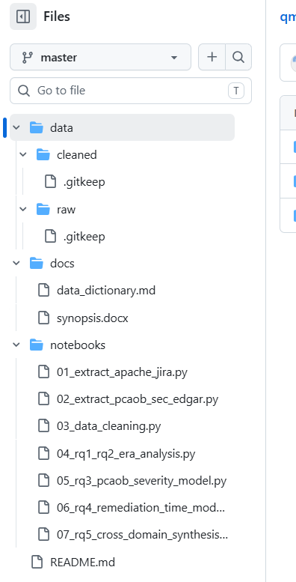

Note. Repository available at github.com/daljeetkaurJohar/qm640-governance-analytics.

Figure 2
Preview of the Cleaned QA/Defect Dataset (First 10 Rows)
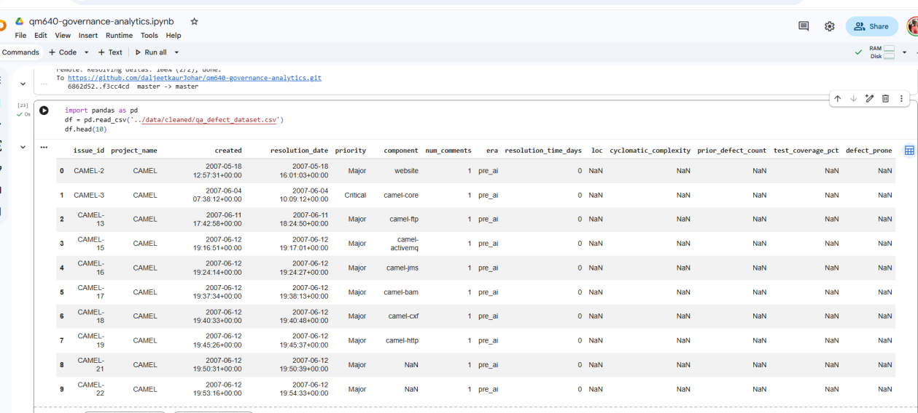
Figure 3
Descriptive Statistics for the Cleaned Datasets
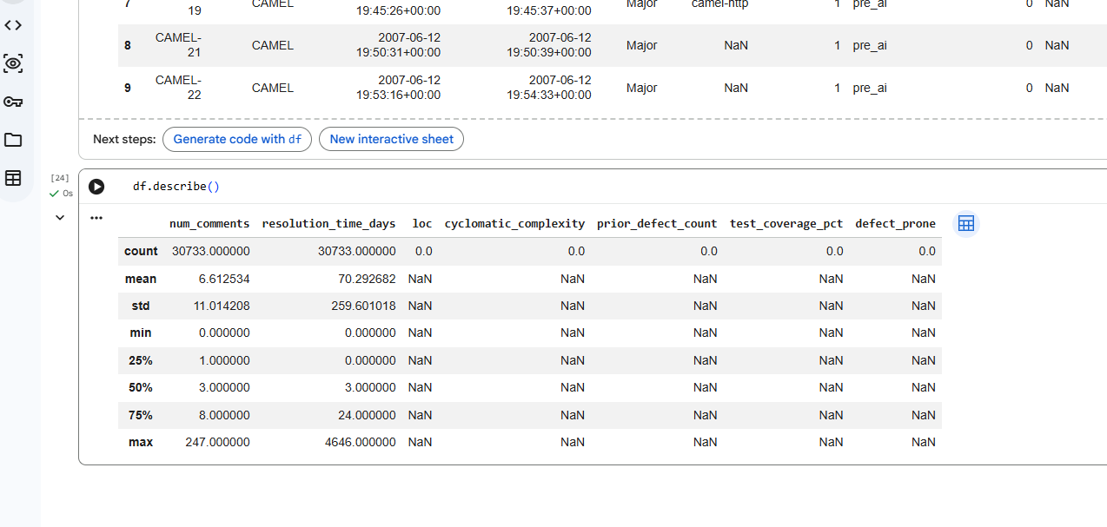
Because the two domains are separate, real datasets rather than a single joined table, two data dictionaries are planned, summarized in Tables 2 and 3 below. The final report will expand each into a complete field-by-field dictionary with data types, units, and value ranges, accompanied by descriptive-statistics tables and screenshots of the cleaned data.
Table 2
Software QA / Defect Dataset (Apache JIRA / NASA-PROMISE) Data Dictionary
Variable | Description | Type / Scale
issue_id | Unique JIRA issue/defect identifier | Categorical (ID)
project_name | Apache project (e.g., CAMEL, HADOOP) | Categorical
loc | Lines of code in the affected module | Continuous
cyclomatic_complexity | McCabe complexity of the affected module | Continuous
prior_defect_count | Number of prior defects logged against the module | Continuous
code_churn | Lines added, modified, or deleted in the module since the prior release (added − deleted lines) | Continuous
test_coverage_pct | % of module covered by automated tests, where available | Continuous (0–100)
priority | JIRA-assigned issue priority | Ordinal
component | Functional component/module of the project | Categorical
num_comments | Number of comments on the issue thread | Continuous
num_reassignments | Number of times the issue was reassigned | Continuous
reporter_tenure | Days between the reporter's first recorded project activity and the date this issue was filed | Continuous
resolution_time_days | Days from issue creation to resolution (RQ2 target) | Continuous
defect_prone | Whether the module was reclassified as defect-prone (RQ1 target) | Binary
era | Pre-AI-coding (resolved before 2023-01-01) vs. AI-coding era (resolved 2023-01-01 onward); serves as the RQ1/RQ2 moderator | Binary

Table 3
IT Audit / Disclosure Dataset (PCAOB / SEC EDGAR) Data Dictionary
Variable | Description | Type / Scale
deficiency_id | PCAOB inspection deficiency record identifier | Categorical (ID)
inspection_year | Year of the PCAOB inspection report | Continuous
firm_network_category | PCAOB firm classification (e.g., Global Network Firm, Non-Affiliate) | Categorical
audit_area | Audit area affected by the deficiency (e.g., revenue, ICFR) | Categorical
standard_cited | PCAOB auditing standard most directly cited | Categorical
severity_part | Part I.A (more severe) vs. Part I.B classification (RQ3 target) | Binary
company_cik | SEC Central Index Key of the related public company (where matched) | Categorical (ID)
industry_sic | SIC industry code of the disclosing company | Categorical
weakness_category | Category of disclosed material weakness (e.g., IT general controls, revenue recognition) | Categorical
disclosure_date | Date material weakness was first disclosed (8-K Item 4.02 / 10-K) | Date
remediation_confirmed_date | Date a subsequent filing confirmed remediation | Date
remediation_days | Days from disclosure to confirmed remediation (RQ4 target) | Continuous

Analytic Approach
Each research question is paired with a corresponding statistical or machine-learning technique, a directional research hypothesis, and a defined set of evaluation metrics, summarized below. RQ1 and RQ2 use moderation (interaction-term) models to test whether predictor–outcome relationships differ by era, rather than simple prediction models, since the research question is about a change in relationship, not the relationship itself. All models will be trained on an 80/20 train-test split with 5-fold cross-validation on the training set, and predictor sets will be screened for multicollinearity (variance inflation factor < 5) before modeling.
Solution to RQ1–RQ5
RQ1 – Moderated logistic regression (interaction terms between an era dummy and each code/process metric), benchmarked against separately trained Random Forest classifiers for each era. H1: at least one Era × metric interaction term is statistically significant, indicating that the predictive relationship between code/process metrics and defect-proneness differs between the pre-AI-coding and AI-assisted-coding eras. Evaluation metrics: statistical significance and sign of each interaction coefficient (Wald test, α = .05); Accuracy, Precision = TP / (TP + FP), Recall = TP / (TP + FN), F1 = 2 × (Precision × Recall) / (Precision + Recall), and AUC computed separately for each era's held-out test set to compare model performance across eras.
RQ2 – Moderated multiple linear regression on resolution_time_days (interaction terms between an era dummy and each issue/process characteristic). H2: at least one Era × characteristic interaction term is statistically significant, indicating that the drivers of defect resolution time differ between the two eras. Model diagnostics will include residual normality (Shapiro-Wilk test) and homoscedasticity (Breusch-Pagan test). Evaluation metrics: significance of interaction coefficients (t-test, α = .05); R² and adjusted R² = 1 − [(1 − R²)(n − 1)/(n − k − 1)]; RMSE = √[Σ(y − ŷ)² / n]; MAE = Σ|y − ŷ| / n, computed separately per era.
RQ3 – Logistic regression, benchmarked against a Random Forest classifier, marking the first formally evaluated supervised model applied to the PCAOB's April 2025 machine-readable inspection datasets. H3: audit area affected, PCAOB standard cited, and firm network category significantly predict whether a deficiency is classified at the more severe Part I.A level, with model performance significantly exceeding a majority-class baseline. Evaluation metrics: Accuracy, Precision = TP / (TP + FP), Recall = TP / (TP + FN), F1 = 2 × (Precision × Recall) / (Precision + Recall), Area Under the ROC Curve (AUC), and odds ratios with 95% confidence intervals.
RQ4 – Multiple linear regression on remediation_days, supplemented by a Cox proportional hazards survival model treating remediation as a time-to-event outcome (with right-censoring for weaknesses still unremedied at data cutoff), applied to material weaknesses disclosed from 2020 onward. H4: the set of statistically significant drivers of remediation time in this 2020+ sample differs from the drivers reported in the most recent prior internal-control-weakness research (Mojtahedi & Zhou, 2024), which analyzed 2014–2018 data using thematic and association-rule methods rather than supervised ML. Evaluation metrics: R²/adjusted R² and RMSE for the regression model; Harrell's concordance index (C-statistic) and hazard ratios with 95% confidence intervals for the survival model, compared narratively against the associations reported in Mojtahedi and Zhou (2024).
RQ5 – Cross-domain comparative synthesis. The standardized effect sizes of the significant Era × metric interaction terms from RQ1/RQ2 (Cohen's f², computed as f² = (R² with interaction terms − R² without interaction terms) / (1 − R² with interaction terms)) will be compared against the standardized effect size of the difference between this study's 2020+ ML-identified remediation-time drivers and the drivers reported in Mojtahedi and Zhou (2024). H5: the two domain-level effect sizes are of comparable magnitude (interpreted using Cohen's, 1988, conventions for small/medium/large effects), supporting a shared “digital-era governance disruption” interpretation; a large discrepancy between the two effect sizes would instead support a domain-specific interpretation. Evaluation: side-by-side comparison of Cohen's f² (or partial R² shift) across both domains, presented in a structured synthesis table, with a qualitative narrative discussing convergence or divergence in light of each domain's specific findings from RQ1–RQ4.
Must have: Evaluation metrics with proper formulae and calculations. The evaluation-metric formulae above (R², RMSE, MAE, Accuracy, Precision, Recall, F1, AUC, concordance index, and hazard ratios) will be applied consistently across all four RQs: two computed on the real Apache JIRA / NASA-PROMISE dataset and two on the real PCAOB / SEC EDGAR dataset, and reported with worked numeric examples using the study's own train/test splits in the final report.
Recommendation and Application
If RQ1/RQ2 confirm that AI-coding-era relationships differ from pre-AI-era ones, QA and engineering leadership gain a concrete, evidence-based reason to update test-prioritization and code-review practices for AI-assisted contributions rather than relying on pre-2023-era assumptions. If RQ3 confirms that PCAOB's new datasets support accurate deficiency-severity prediction, audit and governance teams gain an early, low-cost risk-screening tool built entirely from public regulatory data. If RQ4 identifies remediation-time drivers that differ from the pre-2018 literature, audit committees and internal-audit functions gain updated, current guidance on which weakness characteristics most delay remediation today. Organizations such as Tata Steel that maintain their own linked, proprietary QA and IT-audit telemetry could further apply this study's validated modeling approach internally to build a combined, real-time governance risk-tiering tool.
If RQ5 finds that the two domains show comparable magnitudes of governance-relevant change, this provides organizations like Tata Steel with a single, unified argument for treating software QA and IT audit modernization as one coordinated governance initiative rather than two separate budget lines, since both control layers would be shown to be responding to the same underlying “digital-era” disruption. If instead the two domains diverge, that is equally actionable: it tells governance leadership that QA and audit modernization need domain-specific timelines and resourcing rather than a one-size-fits-all governance response.

Identify the Target User
The primary target users are IT Audit leadership and audit planning teams (for risk-based audit scoping), Enterprise QA and Engineering managers (for targeting automation and defect-prevention investment), and CIO/CTO and Enterprise Risk/Governance committees (for portfolio-level oversight of technology risk). Secondary users include external auditors seeking corroborating evidence of a well-functioning, data-informed internal control environment.

References
Ali, H. M., Hamza, M. Y., & Rashid, T. A. (2024). A comprehensive study on automated testing with the software lifecycle. arXiv. https://doi.org/10.48550/arXiv.2405.01608
Basyouni, A. (2025). Machine learning for risk assessment in audit and operational risk management [Preprint]. ResearchGate. https://doi.org/10.13140/RG.2.2.30880.08964
Cohen, J. (1988). Statistical power analysis for the behavioral sciences (2nd ed.). Lawrence Erlbaum Associates.
Cotroneo, D., Improta, C., & Liguori, P. (2025). Human-written vs. AI-generated code: A large-scale study of defects, vulnerabilities, and complexity. arXiv. https://doi.org/10.48550/arXiv.2508.21634
Green, S. B. (1991). How many subjects does it take to do a regression analysis? Multivariate Behavioral Research, 26(3), 499–510. https://doi.org/10.1207/s15327906mbr2603_7
Harding, W. (2025). AI Copilot code quality: 2025 data suggests 4x growth in code clones [White paper]. GitClear. https://www.gitclear.com/ai_assistant_code_quality_2025_research
Huang, B., Wei, J., Tang, Y., & Liu, C. (2021). Enterprise risk assessment based on machine learning. Computational Intelligence and Neuroscience, 2021, Article 6049195. https://doi.org/10.1155/2021/6049195
Li, N., Shepperd, M., & Guo, Y. (2020). A systematic review of unsupervised learning techniques for software defect prediction. arXiv. https://doi.org/10.48550/arXiv.1907.12027
Mojtahedi, A., & Zhou, L. (2024). Information technology internal control material weaknesses in financial reporting: Categories, trends, associations, and industry effects. International Journal of Accounting Information Systems, 53, Article 100679. https://doi.org/10.1016/j.accinf.2024.100679
Peduzzi, P., Concato, J., Kemper, E., Holford, T. R., & Feinstein, A. R. (1996). A simulation study of the number of events per variable in logistic regression analysis. Journal of Clinical Epidemiology, 49(12), 1373–1379. https://doi.org/10.1016/S0895-4356(96)00236-3
Public Company Accounting Oversight Board. (2017). AS 1305: Communications about control deficiencies in an audit of financial statements. https://pcaobus.org/oversight/standards/auditing-standards/details/AS1305
Public Company Accounting Oversight Board. (2025). PCAOB makes available new downloadable datasets featuring PCAOB inspection findings from audit firm inspection reports [Press release]. https://pcaobus.org/news-events/news-releases/news-release-detail/pcaob-makes-available-new-downloadable-datasets-featuring-pcaob-inspection-findings-from-audit-firm-inspection-reports
Stradowski, S., & Madeyski, L. (2023). Industrial applications of software defect prediction using machine learning: A business-driven systematic literature review. Information and Software Technology, 159, Article 107192. https://doi.org/10.1016/j.infsof.2023.107192
Wang, Y., Mäntylä, M. V., Liu, Z., & Markkula, J. (2022). Test automation maturity improves product quality: Quantitative study of open source projects using continuous integration. Journal of Systems and Software, 188, Article 111259. https://doi.org/10.1016/j.jss.2022.111259
Yang, L. (2025). Predictive modeling of tax compliance risks: A comparative study of machine learning approaches. PLOS ONE, 20(9), Article e0331715. https://doi.org/10.1371/journal.pone.0331715

Appendix
This appendix provides supporting diagrams for the study design, data pipeline, and real-data timeline described in the sections above and referenced throughout the Introduction and Analytic Approach.
Appendix A: Overall Study Design
Figure A1
Overall Study Design
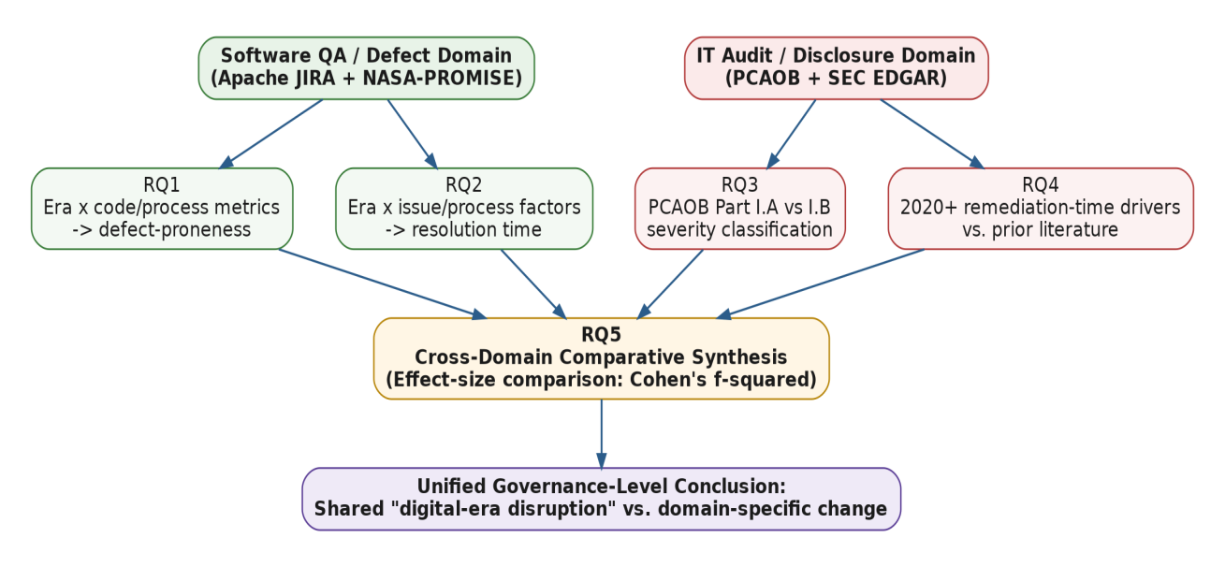

Note. This figure shows the two independent real-data domains (software QA/defect and IT audit/disclosure), their four corresponding research questions (RQ1–RQ4), and the cross-domain synthesis (RQ5) that produces a single, unified governance-level conclusion.

Appendix B: Data Pipeline
Figure A2
Data Pipeline
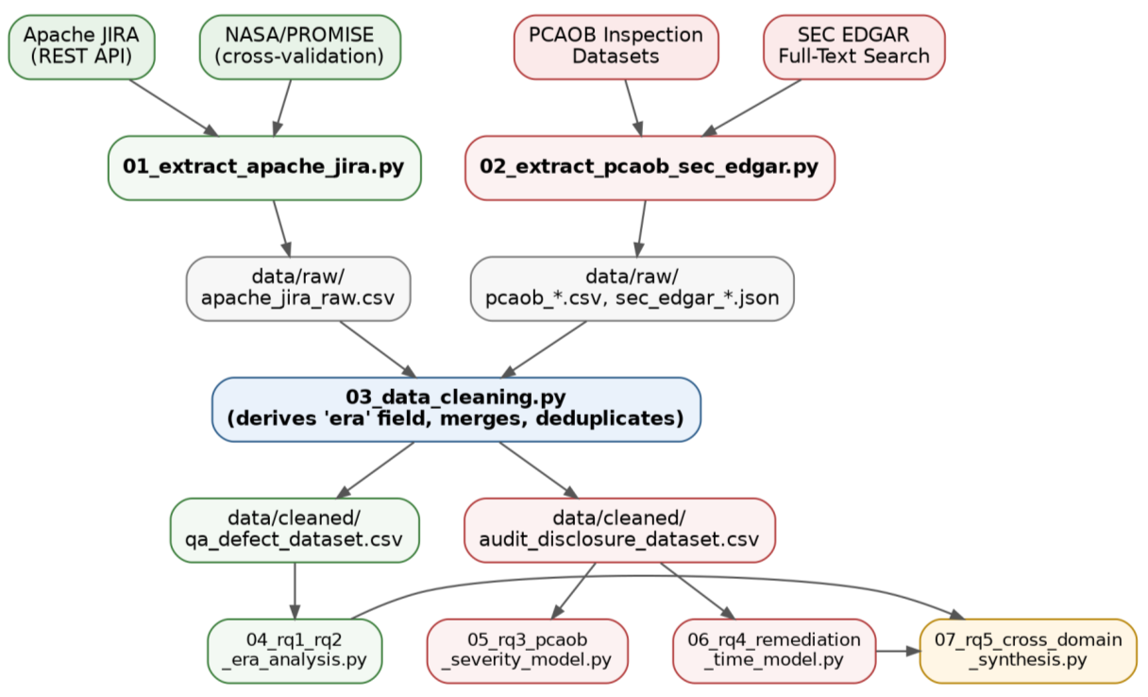

Note. This figure shows the data pipeline from real, publicly available sources (Apache JIRA, NASA/PROMISE, PCAOB, SEC EDGAR) through extraction, cleaning, and the seven analysis notebooks (01–07) corresponding to RQ1–RQ5.

Appendix C: Real-Data Timeline
Figure A3
Real-Data Timeline: Era Boundaries and Data-Window Coverage
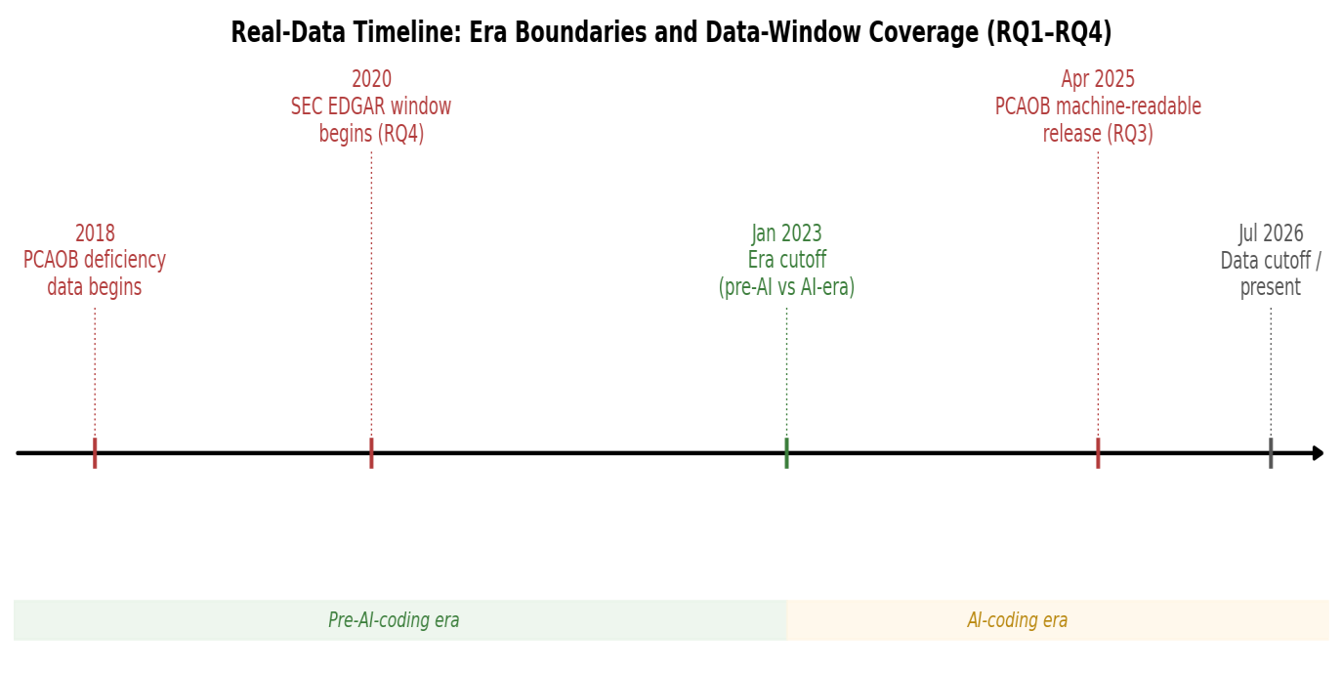

Note. This figure shows the timeline of real data-window boundaries used across the study: the PCAOB's 2018 deficiency-data start, the 2020 SEC EDGAR disclosure window (RQ4), the January 2023 pre-AI/AI-coding era cutoff (RQ1/RQ2), and the PCAOB's April 2025 machine-readable data release (RQ3).

