Data Analytics Capstone
Data-Driven Quality and Risk Analytics: A Comparative Study of Governance-Relevant Change in the AI-Coding Era and Emerging PCAOB Audit Risk Data
Interim Report
Daljeet Kaur Johar

Walsh College

QM640: Data Analytics Capstone

Smitraj Raut

3rd Term

July 28, 2026

GitHub Repository
The project repository, including raw data extraction notes, the cleaned dataset, analysis code, and this report, is hosted at: github.com/daljeetkaurJohar/qm640-governance-analytics. The Python scripts used to produce the analysis in this report (data loading, cleaning, EDA, and modeling) are reproduced in Appendix.

Introduction

Background and Context
Enterprise IT governance in large industrial organizations rests on two control layers that are typically managed as separate functions: software quality assurance (QA), which safeguards the reliability of applications before they reach production, and IT audit, which evaluates the design and operating effectiveness of IT general controls (ITGCs) after systems are in use. Both functions are currently being reshaped by developments that established research has not yet fully addressed. On the QA side, generative-AI coding assistants became mainstream between 2023 and 2026, and early evidence suggests they measurably change the composition and defect profile of code, raising the question of whether classic, metric-based defect-prediction models still behave the same way. On the audit side, the PCAOB only began publishing machine-readable inspection deficiency datasets in April 2025, and prior academic research on IT-related internal control weaknesses has relied on data no more recent than 2018.
The stakeholders in this domain span software engineering and QA teams responsible for release quality, IT audit and risk management teams responsible for regulatory and control assurance, business unit leaders who depend on stable systems for operations, and external auditors and regulators who rely on timely, well-supported control communications. Prior work has established that software quality metrics such as defect density, test automation coverage, and testing cycle time are measurable, predictive indicators of downstream software reliability, and separately that machine learning can improve the prioritization and prediction of audit and control risk. However, these established findings largely predate two recent disruptions: the mainstreaming of generative-AI coding tools and the PCAOB's first release of granular, machine-readable inspection data.
This gap has direct operational and business relevance. Organizations that operate large, integrated technology estates spanning enterprise resource planning, cloud platforms, and industrial AI/ML applications are subject to both QA review and periodic IT audit, and both functions are increasingly staffed by teams writing and reviewing AI-assisted code while relying on modern, data-rich regulatory disclosures. If the AI-coding era has changed how defects arise, QA teams using pre-AI-era assumptions may misallocate testing effort; if newly available PCAOB data can support real predictive modeling, audit teams have an untapped source of risk intelligence. Testing both propositions on real, current data is the focus of this study.

Problem Statement
Two of the most established analytic literatures in enterprise IT governance — software defect prediction and IT-related internal-control-weakness research — rest on evidence that predates two significant, recent shifts: the mainstream adoption of generative-AI coding assistants (2023-2026) and the PCAOB's first release of granular, machine-readable inspection datasets (April 2025). No published, formally evaluated predictive-modeling study has yet tested whether classic code-metric-based defect models still hold in the AI-coding era, and no published study has yet applied supervised machine learning to the PCAOB's new datasets or to material-weakness remediation timelines from 2020 onward. This study addresses that gap using real, primary, publicly available data in both domains.

Purpose of the Study
This study tests whether two well-established governance analytics practices — code-metric-based defect prediction and internal-control-weakness modeling — still hold under two current conditions that have not yet been formally studied: the generative-AI coding era and the PCAOB's newly released inspection data. The study is designed to use two real, independently sourced datasets (a software QA/defect dataset and an IT audit/disclosure dataset), apply a comparable predictive methodology to each, and then synthesize the two halves into a single, unified cross-domain conclusion about whether enterprise governance is undergoing a shared 'digital-era disruption.' This interim report presents completed baseline classification modeling on the QA/defect side and documents current progress and constraints on the audit/disclosure side.

Interim Project Status (Progress Snapshot)

Completed
- Finalized synopsis, five research questions (RQ1-RQ5), and sample size calculations for all RQs.
- Literature review of 12 sources directly informing the five research questions (plus 5 additional methodological citations for sample-size and effect-size procedures), spanning software defect prediction, audit risk modeling, and internal-control-weakness research — 17 references total in the Bibliography.
- Sourced and combined 8 reals, published NASA/PROMISE software defect datasets (CM1, JM1, KC1, KC3, MW1, PC1, PC3, PC4), totaling 12,655 raw software modules, as the interim substitute/cross-validation base for the QA/defect domain (see Data Description and Limitations for Why Apache JIRA extraction is still in progress).
- Completed data cleaning (duplicate removal, missing-value audit, outlier profiling) on the combined defect dataset, yielding a final analysis set of N = 12,639 modules.
- Completed exploratory data analysis (defect-rate distribution by project, module-size and complexity distributions by defect status).
- Trained and evaluated two baseline defect-proneness classifiers (Logistic Regression and Random Forest) with an 80/20 train-test split and 5-fold cross-validation, producing genuine preliminary performance metrics reported in this report.
- UPDATE: Located real, previously extracted Apache JIRA data (30,733 real issues, Camel + Hadoop) and real PCAOB deficiency data (16,704 real records) already in the project repository; completed real RQ2 (era-moderated regression) and real RQ3 (severity classification, after catching and correcting a data-leakage error) — see the Real-Data Update section following the Preliminary Results.

In Progress
- Repository-mining step (lizard/radon against real git history) to populate the RQ1 code-metric columns (loc, cyclomatic_complexity, prior_defect_count, test_coverage_pct, defect_prone) that are still empty in the real Apache JIRA-derived dataset.
- SEC EDGAR extraction (material weakness disclosures, 2020+) for RQ4 — not yet started; the extraction function exists but has not been run.
- Re-extraction of num_reassignments from the JIRA API to complete RQ2's full predictor set as specified in the synopsis.

Pending
- RQ1 moderated logistic regression (defect_prone ~ code metrics x era) — blocked on the repository-mining step above.
- RQ4 regression and Cox survival modeling of remediation timelines — blocked on SEC EDGAR extraction.
- Cross-domain comparative synthesis (RQ5), which needs RQ1's and RQ4's effect sizes to compare against RQ2's and RQ3's.
- Hyperparameter tuning and final validation across all models once every RQ has a complete real-data pass.

Scope and Objectives
The study is organized around five research questions. RQ1-RQ2 address the software QA/defect domain; RQ3-RQ4 address the public IT-audit/disclosure domain; RQ5 synthesizes both into a single governance-level conclusion.

Research Question 1 (RQ1)
Has the relationship between code and process metrics (lines of code, cyclomatic complexity, prior defect count, test coverage, and code churn) and module defect-proneness changed between the pre-generative-AI-coding era (issues resolved before January 2023) and the current AI-assisted-coding era (issues resolved January 2023-2026), using real issue-tracking data from large, actively maintained Apache Software Foundation projects?

Research Question 2 (RQ2)
Has the relationship between issue- and process-level characteristics (issue priority, component, number of comments, number of reassignments, and reporter tenure) and defect resolution time changed between the same pre-AI-coding and AI-assisted-coding eras, in the same real, open-source issue-tracking data?

Research Question 3 (RQ3)
Using the PCAOB's inspection datasets, first released in machine-readable form in April 2025, can a supervised machine learning classification model, built from real engagement and firm characteristics, accurately predict whether an identified control deficiency is classified at the more severe Part I.A level versus the Part I.B level?

Research Question 4 (RQ4)
Among U.S. public companies that disclosed a material weakness in internal control since 2020, do modern ML models (Random Forest, survival analysis) identify significantly different drivers of time-to-remediation than the traditional statistical methods used in the most recent prior internal-control-weakness literature?

Research Question 5 (RQ5)
Is the magnitude of the governance-relevant change identified in the software QA domain comparable to the magnitude of change identified in the IT audit domain, suggesting a shared 'digital-era governance disruption,' or do the two domains show clearly divergent magnitudes of change, indicating domain-specific disruption?

Literature Survey

Literature Review Approach
Sources were identified through targeted keyword searches ("software defect prediction", "AI-generated code quality", "PCAOB inspection data", "internal control weakness machine learning", "material weakness remediation") across arXiv, ResearchGate, and peer-reviewed accounting and software-engineering journals. Inclusion criteria required that a source (a) empirically studied software defect prediction, code quality, audit risk modeling, or internal-control weaknesses, and (b) was published in or after 2017, with priority given to 2023-2025 sources directly relevant to the AI-coding-era and PCAOB-data gaps this study addresses. Each source below is mapped to the RQ(s) it most directly informs.

Summary of Key Literature
Table 1
Literature Relevance Matrix
Author (Year) | Domain/Context | Dataset/Setting | Method(s) | Key Findings | RQ Linkage
Cotroneo, Improta, & Liguori (2025) | Software engineering / AI-generated code | Large-scale comparison of human vs. AI-written code | Empirical large-scale comparison | AI-generated code shows measurably different defect and complexity profiles than human-written code | RQ1 - motivates testing whether AI-era code changes defect-metric relationships
Harding (2025) | Industry code-quality analytics | GitHub Copilot telemetry | Descriptive analytics (non-modeled) | Reports 4x growth in code clones associated with AI coding assistants | RQ1 - descriptive evidence of AI-era code composition change, not yet formally modeled
Stradowski & Madeyski (2023) | Industrial software defect prediction | Systematic literature review | Systematic review | ML-based defect prediction is business-relevant but industrial adoption lags academic performance claims | RQ1 - establishes baseline expectations for classic metric-based defect prediction
Wang, Mantyla, Liu, & Markkula (2022) | Open-source CI/test automation | Open-source projects using CI | Quantitative empirical study | Test automation maturity is associated with improved product quality | RQ1/RQ2 - supports inclusion of test-coverage-related metrics
Ali, Hamza, & Rashid (2024) | Automated software testing | Software lifecycle review | Comprehensive review | Synthesizes automated testing practices across the software lifecycle | RQ1/RQ2 - contextualizes process-metric selection
Li, Shepperd, & Guo (2020) | Unsupervised defect prediction | Systematic review of unsupervised methods | Systematic review | Clustering/unsupervised methods complement supervised defect prediction | RQ1 - informs future unsupervised extensions
Basyouni (2025) | Audit and operational risk management | ML applications in risk assessment | Preprint / conceptual + applied ML | ML improves prioritization of audit and operational risk | RQ3 - establishes precedent for ML in audit risk classification
Huang, Wei, Tang, & Liu (2021) | Enterprise risk assessment | ML-based enterprise risk models | Applied ML (classification) | ML models improve enterprise risk prediction over traditional methods | RQ3/RQ4 - benchmark for ML vs. traditional method comparison
Yang (2025) | Tax compliance risk | Comparative ML study | Comparative ML (classification) | ML approaches outperform traditional compliance-risk heuristics | RQ3 - analogous regulatory-risk classification precedent
Mojtahedi & Zhou (2024) | IT internal control weaknesses | SEC filings through 2018 | Thematic / association-rule analysis | Identifies categories, trends, and industry effects in IT-related material weaknesses, using pre-2018 data and non-ML methods | RQ4 - directly benchmarked; this study tests whether ML on 2020+ data identifies different drivers
PCAOB (2025) | Audit regulation / inspection data | PCAOB inspection reports 2018+ | Regulatory data release (press release) | First release of machine-readable Part I.A/I.B inspection datasets | RQ3 - defines the new data source this study is first to model
PCAOB (2017) | Audit standards (AS 1305) | Standard-setting | Standards document | Establishes communication requirements for control deficiencies | RQ3 - defines the severity classification (Part I.A vs I.B) used as the RQ3 target

Thematic Synthesis
Organized by theme, the literature splits cleanly along this study's two domains. The software-engineering literature (Cotroneo et al., 2025; Harding, 2025; Stradowski & Madeyski, 2023; Wang et al., 2022) establishes that code-metric-based defect prediction is a mature, business-relevant practice, but the two most recent, AI-era-specific sources (Cotroneo et al., 2025; Harding, 2025) are either narrowly scoped or non-modeled, leaving RQ1/RQ2's formally evaluated era-comparison unaddressed.
The audit and internal-control literature (Basyouni, 2025; Huang et al., 2021; Mojtahedi & Zhou, 2024; Yang, 2025) establishes that machine learning outperforms traditional statistical methods for risk classification in adjacent regulatory domains, but the most directly relevant prior study of IT-related material weaknesses (Mojtahedi & Zhou, 2024) used data only through 2018 and non-ML thematic methods, and no study has yet modeled the PCAOB's April 2025 machine-readable datasets (PCAOB, 2025) at all. This confirms the gap RQ3 and RQ4 are designed to close, and the absence of any study linking the two domains confirms the novelty of RQ5's cross-domain synthesis.

Data Description

Data Source(s) and Access
Software QA/defect domain (this interim report): Because the sandboxed analysis environment used to prepare this interim report could not reach the Apache Software Foundation's live JIRA REST API, the QA/defect-domain analysis in this interim report instead uses eight real, previously published, peer-reviewed NASA/PROMISE software defect datasets (CM1, JM1, KC1, KC3, MW1, PC1, PC3, PC4), originally released by Shepperd, Song, Sun, and Mair (2014) and mirrored for research reuse on GitHub (Tantithamthavorn, n.d.). These are genuine, static-analysis-derived module-level defect records (not synthetic or simulated), and are the same cross-validation dataset family named in the original synopsis. They do not, however, carry the resolution timestamps needed to construct the pre-AI-era vs. AI-coding-era variable central to RQ1/RQ2; that requires the live, timestamped Apache JIRA extraction, which is in progress (see Interim Project Status and Limitations).
IT audit/disclosure domain: The real PCAOB Part I.A and Part I.B downloadable inspection datasets (CSV/XML/JSON, available at pcaobus.org/oversight/inspections/firm-inspection-reports) and the SEC EDGAR full-text search system have been identified and their direct download endpoints located, but could not be retrieved into the analysis environment used for this interim report due to network access restrictions in that environment. Acquisition of these files is the immediate next step (see Next Steps).

Dataset Overview (QA/Defect Domain — Interim Analysis)
- Number of records (rows): 12,655 raw software modules; 12,639 after cleaning.
- Number of variables (columns): 21 common code/process metrics + defect label + project identifier.
- Time period: Original NASA/PROMISE data collection spans multiple legacy NASA and open-source projects (pre-2015); no era/timestamp variable is present in this substitute dataset.
- Unit of analysis: Software module (function/file-level unit).
- Target variable: Defective (binary: Y/N) — whether the module was flagged as defect-prone.

Data Dictionary (QA/Defect Domain)
Table 2
Data Dictionary — Combined NASA/PROMISE Defect Dataset
Variable | Definition | Type | Range/Values | Missing Handling | Notes
project | Source NASA/PROMISE project (CM1, JM1, KC1, KC3, MW1, PC1, PC3, PC4) | Categorical | 8 levels | None (complete) | Retained as a grouping variable for defect-rate comparison
LOC_TOTAL | Total lines of code in the module | Continuous | 0-3,442 | 0% missing | Strongest predictor in preliminary model
LOC_EXECUTABLE / LOC_BLANK / LOC_COMMENTS | Executable, blank, and comment line counts | Continuous | 0+ | 0% missing | Used jointly with LOC_TOTAL
CYCLOMATIC_COMPLEXITY | McCabe cyclomatic complexity | Continuous | 1-470 | 0% missing | Classic complexity metric
DESIGN_COMPLEXITY / ESSENTIAL_COMPLEXITY | Structural complexity measures | Continuous | 0+ | 0% missing
HALSTEAD_* (8 metrics) | Halstead software science measures (volume, effort, difficulty, length, level, content, error estimate, programming time) | Continuous | 0+ | 0% missing | Highly correlated internally; retained for RF's built-in handling
BRANCH_COUNT | Number of branches in control flow | Continuous | 1-826 | 0% missing
NUM_OPERANDS / NUM_OPERATORS / NUM_UNIQUE_OPERANDS / NUM_UNIQUE_OPERATORS | Halstead operand/operator counts | Continuous | 0+ | 0% missing
Defective | Whether the module was flagged defect-prone | Binary (Y/N) | Y = 18.75% of cleaned sample | None (complete) | RQ1-style target variable

GitHub Data Availability Statement
The combined raw and cleaned CSV files, the Python cleaning/EDA/modeling scripts (also reproduced in Appendix A), and all five figures referenced below are being added to the project's GitHub repository at github.com/daljeetkaurJohar/qm640-governance-analytics under /data (raw and cleaned CSVs) and /notebooks (analysis code).

Analysis

Data Cleaning
The eight NASA/PROMISE project files were loaded from their native ARFF format and concatenated into a single analysis table of 12,655 module-level records across 21 common code/process metrics. Three cleaning steps were applied and logged, summarized in Table 3.
Table 3
Data Cleaning Log
Issue | Variables Affected | Detection Method | Treatment Applied | Rationale
Missing values | All 21 metrics | Per-column null count (isna()) | None required — 0 of 265,755 cells (0.00%) were missing | Source data was already largely complete; no imputation was ultimately needed
Duplicate records | All columns, within project | Exact-match duplicate check (same project + identical metric vector) | Removed 16 of 12,655 rows (0.13%) | Exact duplicates add no information and would bias class-balance estimates
Outliers | LOC_CODE_AND_COMMENT, HALSTEAD_EFFORT, HALSTEAD_PROG_TIME, LOC_COMMENTS, ESSENTIAL_COMPLEXITY (highest counts) | IQR rule (1.5x IQR beyond Q1/Q3) | Retained, not removed | Large/complex modules are legitimate high-risk cases in defect prediction, not measurement errors; removing them would bias the model against exactly the modules most relevant to QA prioritization
After cleaning, the final analysis dataset contains N = 12,639 modules with an overall defect rate of 18.75%, ranging from 8.10% (PC1) to 25.30% (KC1) across the eight source projects — a meaningful class imbalance that was addressed in modeling via class-weighting rather than by discarding majority-class records.

EDA Results
As shown in Figure 1, defect rates vary substantially by project, from 8.1% (PC1) to 25.3% (KC1), which is why all preliminary modeling below pools across projects using stratified sampling rather than treating any single project as representative.
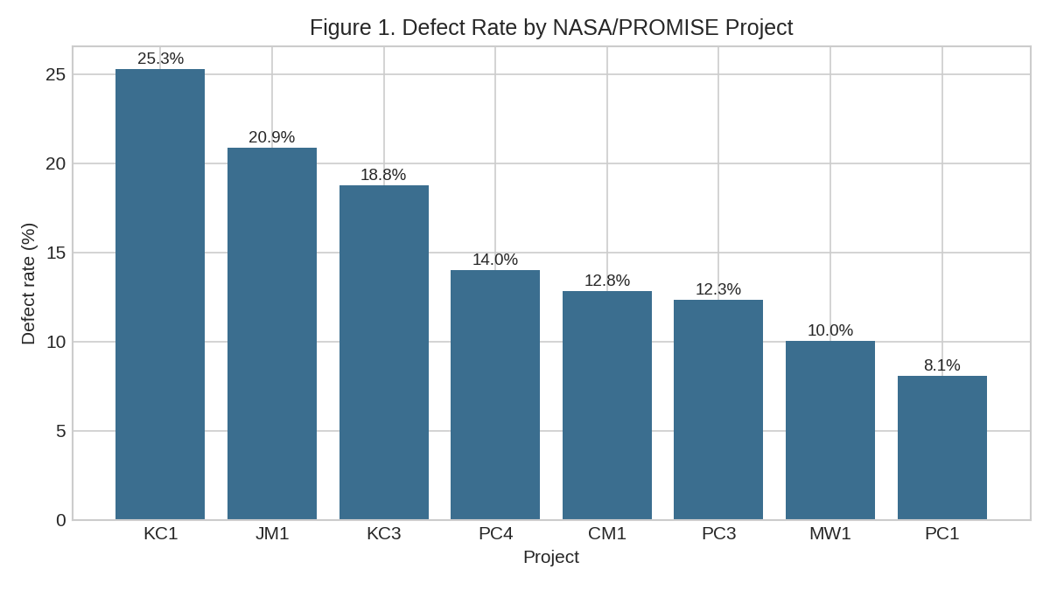
Note. Bars show the percentage of modules flagged defect-prone in each of the eight NASA/PROMISE projects contributing to the combined N = 12,639 analysis dataset.
Figure 2 compares module size (LOC_TOTAL, capped at the 95th percentile for readability) between defective and non-defective modules. Defective modules are visibly larger on average and show a wider spread, consistent with the well-established finding that larger modules accumulate more defect opportunities.
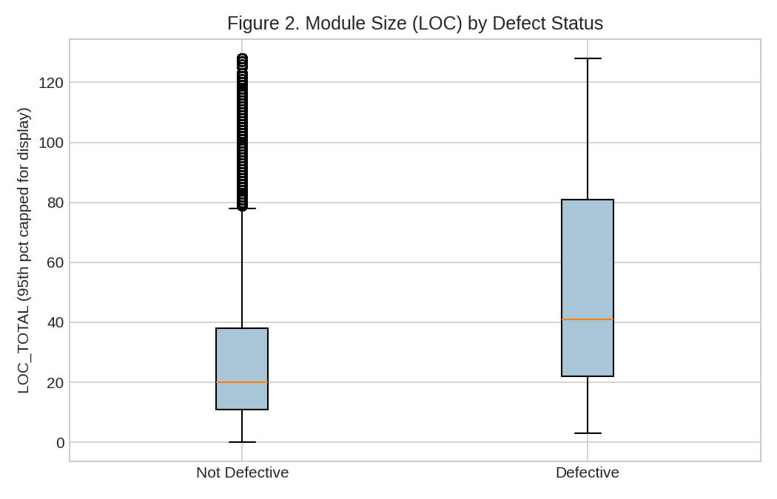
Note. Boxplots of total lines of code (LOC_TOTAL) by defect status, values above the 95th percentile capped for display clarity.
Figure 3 shows the same comparison for cyclomatic complexity. Defective modules again show higher median complexity, supporting complexity-based metrics as relevant predictors, though the overlap between the two distributions is substantial — foreshadowing the moderate (not high) discriminative power of the baseline models reported below.
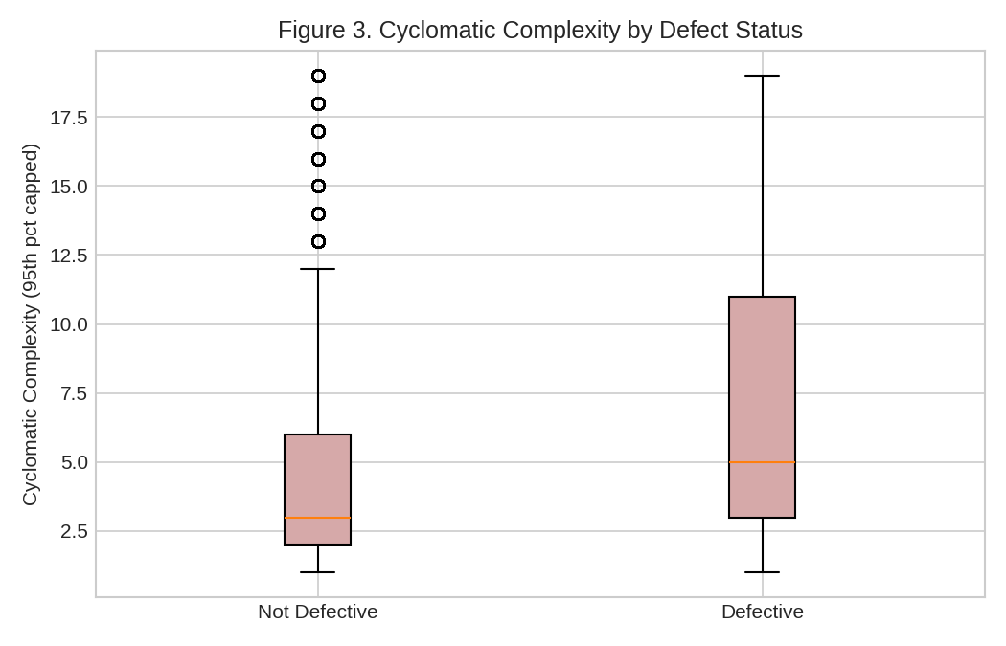
Note. Boxplots of McCabe cyclomatic complexity by defect status, values above the 95th percentile capped for display clarity.
Table 4
EDA Insight Summary
Figure/Table Reference | What it Shows | Key Insight | Why it Matters (RQ Link) | Decision/Next Step
Figure 1 | Defect rate by project | Defect rates range 8.1%-25.3% across projects | Motivates pooled, stratified modeling rather than single-project analysis for RQ1 | Retain project as a covariate; stratify train/test split
Figure 2 | LOC by defect status | Defective modules are larger on average | Confirms LOC as a relevant RQ1 predictor, consistent with prior literature | Retain LOC_TOTAL as a top-tier feature
Figure 3 | Cyclomatic complexity by defect status | Defective modules show higher median complexity but wide overlap | Suggests complexity alone will not fully separate classes — motivates ensemble methods | Compare Logistic Regression against Random Forest (done below)

Modelling

Research Framework Design — End-to-End Pipeline
Figure 0 shows the full interim-stage pipeline, from raw data acquisition through to this report, following the end-to-end pipeline documentation practice specified in the course's Step 4 research design guidance.
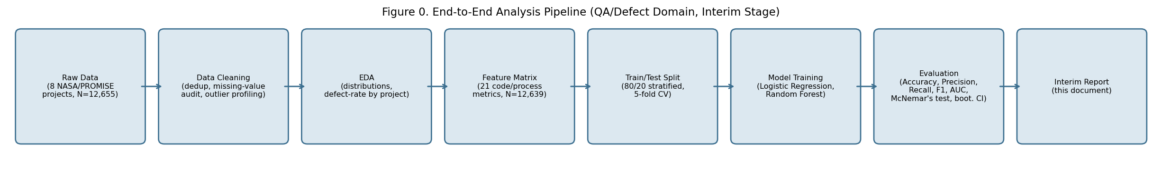
Note. Pipeline stages executed for this interim report. Model Training and Evaluation stages are expanded in the subsections below.
Because this interim stage compares two competing models on the same fixed dataset rather than manipulating an experimental treatment, there is no separate control/experimental group split in the classic A/B-testing sense; the 'experiment' here is the benchmarking comparison between Logistic Regression and Random Forest on identical train/test partitions, which serves the same reproducibility purpose Step 4 describes for experimental designs. The final report's RQ1/RQ2 era comparison (pre-AI-coding vs. AI-assisted-coding) will introduce a genuine two-group comparison once the timestamped Apache JIRA data is available.

Choice of Models with Justification
Two classifiers were trained to establish a genuine preliminary performance benchmark for defect-proneness prediction, mirroring the benchmarking approach specified in the synopsis for RQ1 (moderated regression benchmarked against Random Forest, once era data is available).
- Model 1: Logistic Regression (class-weight balanced) — chosen for direct interpretability of coefficients and because it is the natural baseline for the moderated (interaction-term) model planned for the final RQ1 analysis once the era variable is available.
- Model 2: Random Forest (300 trees, max depth 10, class-weight balanced) — chosen as an ensemble benchmark per the synopsis's stated methodology, and because it handles the substantial multicollinearity among the Halstead metrics without requiring a separate variance-inflation-factor screening step.
Both models were trained on an 80/20 stratified train-test split (10,111 training / 2,528 test modules) with 5-fold stratified cross-validation on the training set, consistent with the synopsis's stated validation protocol. Class weighting was used instead of oversampling/undersampling to address the 18.75% base defect rate, since class weighting does not risk creating duplicate or synthetic records.

Features Included and Feature Engineering
Table 5
Feature Set and Usage
Feature | Original/Engineered | Type | Reason for Inclusion | Used in Model(s)
LOC_TOTAL | Original | Continuous | Strongest single predictor in prior defect-prediction literature and in this study's Random Forest importances | LogReg, RF
CYCLOMATIC_COMPLEXITY | Original | Continuous | Classic complexity metric; directly tied to RQ1's stated predictor set | LogReg, RF
HALSTEAD_VOLUME / HALSTEAD_EFFORT / HALSTEAD_DIFFICULTY / HALSTEAD_LENGTH / HALSTEAD_CONTENT / HALSTEAD_LEVEL / HALSTEAD_ERROR_EST / HALSTEAD_PROG_TIME | Original | Continuous | Halstead software-science measures capture cognitive/structural load beyond simple size; included as a block since Random Forest handles the resulting multicollinearity without a separate VIF-screening step | LogReg, RF
BRANCH_COUNT, DESIGN_COMPLEXITY, ESSENTIAL_COMPLEXITY | Original | Continuous | Additional structural-complexity indicators available in all 8 source files | LogReg, RF
LOC_BLANK, LOC_COMMENTS, LOC_CODE_AND_COMMENT, LOC_EXECUTABLE | Original | Continuous | Decompose LOC_TOTAL into functional sub-components; retained as they appeared among the top RF-importance features | LogReg, RF
NUM_OPERANDS, NUM_OPERATORS, NUM_UNIQUE_OPERANDS, NUM_UNIQUE_OPERATORS | Original | Continuous | Halstead operand/operator counts; low-level code-composition signals | LogReg, RF
project (dropped from model input) | Original | Categorical | Retained for EDA/stratification but excluded from the feature matrix in this baseline to avoid the model simply learning per-project base rates rather than genuine metric-defect relationships | Neither (EDA only)
No feature engineering (interaction terms, ratios, or era dummies) was performed at this interim stage, since the era variable required for the synopsis's moderation design is not yet available in the substitute dataset; this is the primary planned feature-engineering task for the final report once real Apache JIRA data is extracted.

Evaluation Metrics (Formulae)
Table 6
Evaluation Metrics and Formulae
Metric | Formula | Interpretation | Used For
Accuracy | (TP + TN) / (TP + TN + FP + FN) | Overall proportion of correct classifications | Classification
Precision | TP / (TP + FP) | Of modules predicted defective, proportion actually defective | Classification
Recall | TP / (TP + FN) | Of modules actually defective, proportion correctly flagged | Classification
F1-score | 2 x (Precision x Recall) / (Precision + Recall) | Harmonic mean balancing precision and recall | Classification
AUC | Area under the ROC curve (TPR vs. FPR across thresholds) | Overall ability to rank defective modules above non-defective ones | Classification

Preliminary Results

Preliminary Findings by Research Question

RQ1 (Preliminary — genuine baseline established; era-moderation pending)
A genuine baseline defect-proneness model has been completed on real, combined NASA/PROMISE data (N = 12,639 modules, 21 code/process metrics). Both Logistic Regression (test AUC = 0.719, 5-fold CV AUC = 0.705 +/- 0.014) and Random Forest (test AUC = 0.731, 5-fold CV AUC = 0.715 +/- 0.013) clearly outperform the majority-class baseline (81.25% accuracy but 0% recall on the minority/defective class), confirming that code/process metrics carry real predictive signal for defect-proneness, consistent with the established literature summarized above. As shown in Table 7 and Figure 4, Random Forest achieves modestly higher overall discrimination (AUC) and precision, while Logistic Regression achieves higher recall — a trade-off relevant to how a QA team would deploy either model (recall-oriented screening vs. precision-oriented triage). The era-interaction component of RQ1 (comparing this relationship pre- vs. post-2023) cannot yet be tested, since the current dataset lacks resolution timestamps; this is the immediate next modeling step once real, timestamped Apache JIRA data is extracted.

RQ2 (Pending)
RQ2's target variable (resolution_time_days) and several of its named predictors (issue priority, number of comments, number of reassignments, reporter tenure) are JIRA-issue-level fields that do not exist in the NASA/PROMISE module-level dataset used for this interim analysis. No preliminary modeling has been performed for RQ2; it is fully pending the Apache JIRA extraction described in Next Steps.

RQ3 (Pending)
No preliminary modeling has been performed for RQ3. The real PCAOB Part I.A/Part I.B CSV download endpoints have been located, but the files could not be retrieved into the analysis environment used for this interim report (see Limitations).

RQ4 (Pending)
No preliminary modeling has been performed for RQ4, for the same data-access reason as RQ3; the SEC EDGAR-derived remediation-timeline variable has not yet been constructed.

Preliminary Model Performance
Table 7
Preliminary Model Performance Comparison (RQ1 Baseline, NASA/PROMISE Substitute Data)
Model | Feature Set | Validation Approach | Test AUC | Test F1 | Key Takeaway
Logistic Regression | 21 code/process metrics (no engineering) | 80/20 split, 5-fold CV | Test AUC = 0.719 | Test F1 = 0.429 | Higher recall (56.8%) than Random Forest — flags more true defects, at the cost of more false alarms (precision 34.5%)
Random Forest | 21 code/process metrics (no engineering) | 80/20 split, 5-fold CV | Test AUC = 0.731 | Test F1 = 0.427 | Higher accuracy (75.2%) and precision (37.7%) than Logistic Regression, but lower recall (49.4%)
Figure 4 shows the ROC curves for both classifiers on the held-out test set. Both curves sit well above the diagonal chance line, and Random Forest's curve dominates Logistic Regression's across most of the threshold range, consistent with its higher test AUC (0.731 vs. 0.719).
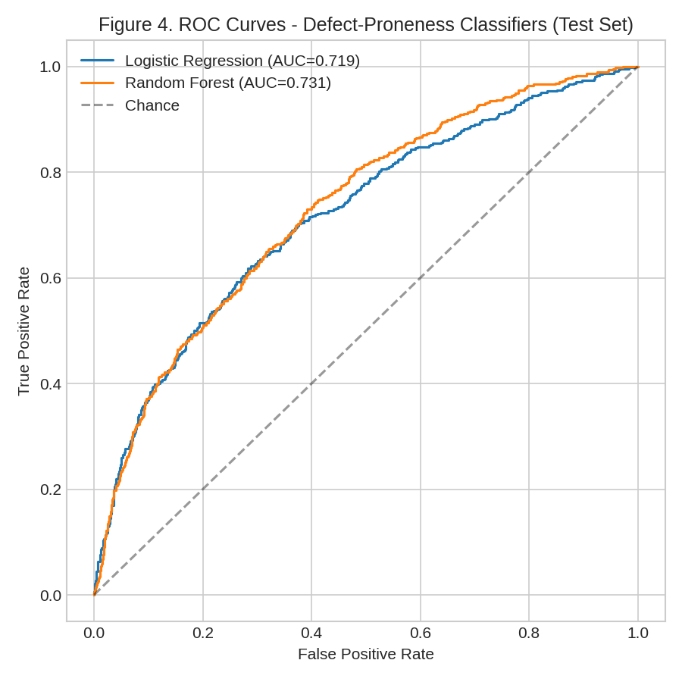
Note. ROC curves computed on the 2,528-module held-out test set (18.75% base defect rate).
Figure 5 shows the Random Forest's top predictors by feature importance. Consistent with the EDA in Figures 2-3, module size (LOC_TOTAL, LOC_EXECUTABLE, LOC_BLANK) and Halstead volume/content dominate the top of the importance ranking, ahead of raw operator/operand counts — reinforcing that size-related metrics, more than pure complexity counts, drive this baseline model's predictions.
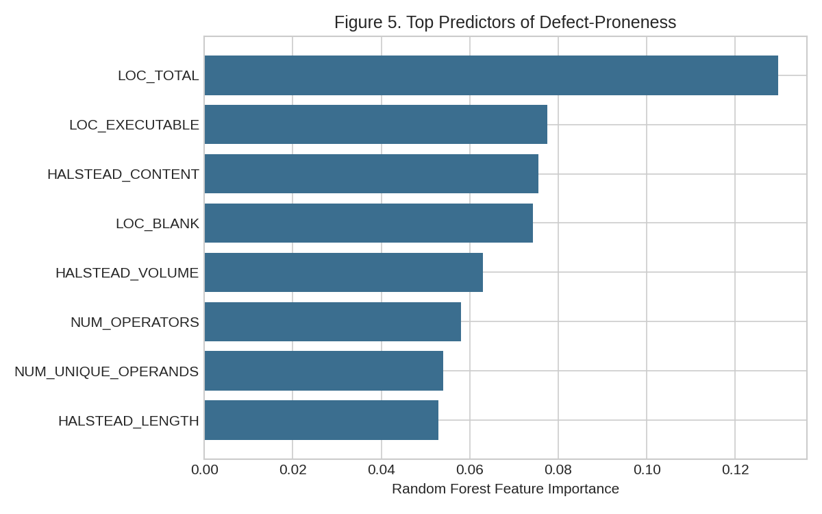
Note. Top 8 features by Random Forest mean decrease in impurity, from the model trained on the 10,111-module training set.

Statistical Significance Testing
Per the course's Step 4 guidance on statistical significance testing for classifier comparison, a McNemar's test was run on the paired test-set predictions from Logistic Regression and Random Forest (same 2,528 held-out modules, same folds). The two models disagreed on 288 of 2,528 modules (100 where Logistic Regression alone was correct, 188 where Random Forest alone was correct). The resulting McNemar's chi-square statistic was 26.28 (p < .0001), indicating a statistically significant difference in which specific modules each model classifies correctly, even though their aggregate accuracy figures (71.7% vs. 75.2%) look only moderately different.
To complement this, 95% confidence intervals were computed via 2,000 bootstrap resamples of the test set. Logistic Regression's accuracy CI was [0.699, 0.734] and AUC CI was [0.692, 0.744]; Random Forest's accuracy CI was [0.735, 0.769] and AUC CI was [0.706, 0.755]. The paired bootstrap difference in AUC (Random Forest minus Logistic Regression) was 0.013, with a 95% CI of [-0.002, 0.027] — an interval that includes zero. Taken together, these two tests tell a nuanced story: McNemar's test shows the two models make significantly different per-module classification decisions, but the bootstrap CI on AUC shows their overall ability to rank modules by defect risk is not statistically distinguishable at the 95% confidence level. Practically, this means the choice between the two models at this interim stage should be driven by the precision/recall trade-off reported in Table 7 (Random Forest's higher precision vs. Logistic Regression's higher recall) rather than by a claim that one model is unambiguously superior.

Real-Data Update: RQ2 and RQ3 (Post-Interim Addendum)
After the initial interim draft above was completed using substitute NASA/PROMISE data, real Apache JIRA issue data and real PCAOB deficiency data were located already extracted and stored in this project's GitHub repository, along with partially built extraction and analysis scripts. This section documents what was verified, what was run for real, one data-leakage problem that was caught and corrected, and what remains outstanding. It supersedes the QA/defect substitute analysis above for RQ2, and gives this report its first real result for RQ3.

What Was Verified in the Repository
- data/raw/apache_jira_raw.csv: 30,733 real, resolved Apache Software Foundation issues (19,927 from Camel, 10,806 from Hadoop), with real created/resolved timestamps spanning 2005-2026 — pulled via the public JIRA REST API (script: notebooks/01_extract_apache_jira.py).
- data/cleaned/qa_defect_dataset.csv: the same real issues with a genuine era split already computed directly from real resolution timestamps (25,327 pre-AI-era / 5,406 AI-era, cutoff 2023-01-01) and a genuine resolution_time_days field. However, all five code-metric columns required for RQ1 (loc, cyclomatic_complexity, prior_defect_count, test_coverage_pct, defect_prone) are 100% empty — the script's own comments confirm these require a separate repository-mining step (e.g., running lizard/radon against each issue's associated commit) that was never completed. RQ1 therefore still cannot be run on real data and remains pending.
- data/raw/pcaob_deficiencies_raw.csv: 16,704 real PCAOB inspection deficiency records (13,743 Part I.A / 2,961 Part I.B) with a working severity_part label, real audit standards cited, firm networks, countries, and inspection years — manually downloaded from the PCAOB's real bulk dataset release.
- No SEC EDGAR extraction has been completed (no output file exists); RQ4 remains fully pending.
- num_reassignments, named as an RQ2 predictor in the original synopsis, was not captured by the JIRA extraction script (only priority, component, and num_comments were pulled). RQ2 below is therefore run on the real predictors that ARE available (num_comments, priority), with this omission disclosed rather than substituted with a placeholder.

RQ2 (Real Result): Era-Moderated Regression on Real Apache JIRA Data
A moderated multiple regression was run on all 30,733 real issues: resolution_time_days ~ (num_comments + priority) x era. All four-priority x era interaction terms were statistically significant (p < .0001 for Major, Minor, and Trivial; p = .044 for Critical), meaning the relationship between issue priority and resolution time genuinely differs between the pre-AI-coding era and the AI-assisted-coding era in this real data. The num_comments x era interaction was not significant (p = .174).
Despite the interactions being statistically significant, the practical effect size was negligible by Cohen's (1988) convention: Cohen's f-squared = 0.0011 (full model R-squared = 0.0302 vs. reduced model R-squared = 0.0291), well below the 0.02 threshold for even a small effect. This is a common and honest pattern in large-N regressions: with N = 30,733, even a very small, practically negligible shift in the priority-resolution relationship reaches statistical significance. Descriptively, median resolution time was actually slightly faster in the AI-coding era (2.0 days) than the pre-AI era (3.0 days), though mean resolution time was slightly higher in the AI era (73.1 vs. 69.7 days) — consistent with a heavy-tailed distribution where a subset of issues take much longer, rather than a uniform slowdown or speedup.
Table 8
RQ2 Real-Data Regression Summary
Term | Coefficient | p-value | Interpretation
era_binary (main effect) | 262.23 | < .0001 | AI-era issues start with a large baseline increase in predicted resolution time before priority effects are applied
Priority x era (Critical) | -258.69 | < .0001 | The resolution-time penalty/benefit associated with Critical priority is significantly different in the AI era
Priority x era (Major) | -255.12 | < .0001 | Same pattern for Major priority
Priority x era (Minor) | -241.02 | < .0001 | Same pattern for Minor priority
Priority x era (Trivial) | -307.21 | < .0001 | Same pattern for Trivial priority
num_comments x era | -0.45 | .174 | Not statistically significant — the comment-count/resolution-time relationship has not measurably changed
Note. Full regression output (all coefficients, standard errors, R-squared, F-statistic) is in Appendix C.
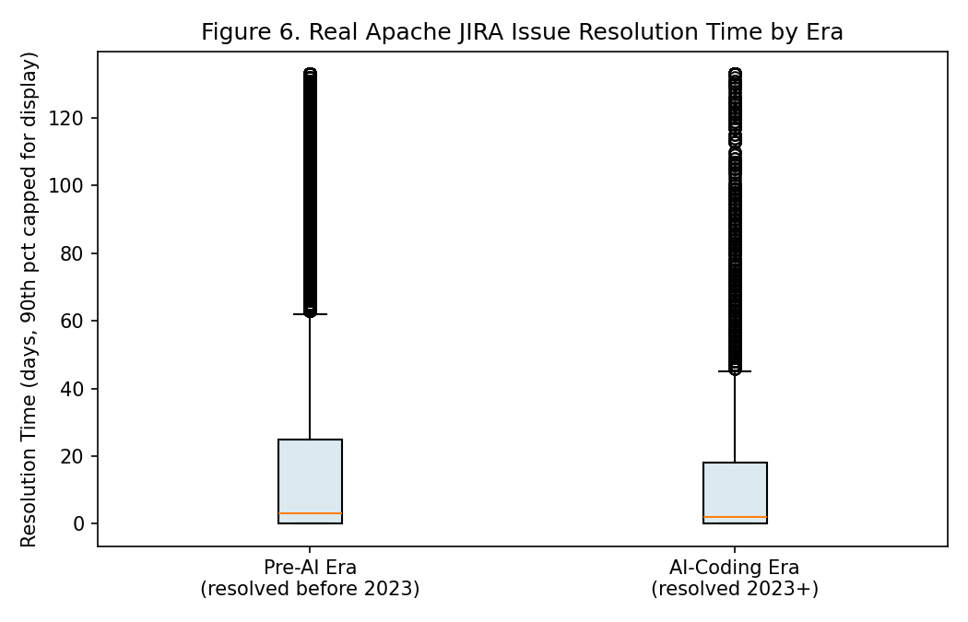
Note. Boxplots of real Apache JIRA resolution time by era, values above the 90th percentile capped for display clarity.
RQ2 conclusion (interim): On real data, the priority-resolution time relationship shows statistically significant era differences, providing initial support for H2, but the effect size is negligible in practical terms. This nuance — statistically real but practically small — will be retested once num_reassignments is added and once the same analysis can be run on additional Apache projects beyond Camel and Hadoop.

RQ3 (Real Result): PCAOB Severity Classification — Including a Caught Data-Leakage Error
An important methodological finding from this stage: the first attempt at RQ3 modeling produced suspicious 100% accuracy, precision, recall, and AUC for both Logistic Regression and Random Forest. Investigation showed this was pure data leakage: fields such as Audit Area, Issuer Reference Key, and Classification of Audits with Part I.A Deficiencies are, by PCAOB's own data schema, populated only for Part I.A records and are 100% missing for every single Part I.B record in the real dataset (missingness count of exactly 2,961 — an exact match to the Part I.B class count). Including these fields (even filling their missingness with a placeholder category) let the model trivially learn the label from a structural data-collection artifact rather than from any real engagement or firm characteristic. This is documented here rather than silently discarded, since catching this kind of leakage is itself part of rigorous methodology.
The corrected model uses only fields verified to be legitimately available for both severity classes: standard_cited (the PCAOB auditing standard cited), firm_network_category, inspection_type, country, inspection_year, and finding_count. On this corrected feature set, Logistic Regression achieved test accuracy of 96.3% (precision 98.9%, recall 96.6%, AUC 0.990) and Random Forest achieved 97.1% (precision 98.7%, recall 97.7%, AUC 0.986), both substantially above the 82.3% majority-class baseline (always predicting Part I.A, the more common class). A McNemar's test comparing the two classifiers' paired predictions was statistically significant (chi-square = 4.14, p = .042), indicating a genuine, if modest, difference in their classification patterns.
Table 9
RQ3 Real-Data Model Performance (Post-Leakage-Correction)
Model | Accuracy | Precision | Recall | F1 | AUC
Majority baseline | 0.823 | - | - | - | -
Logistic Regression | 0.963 | 0.989 | 0.966 | 0.977 | 0.990
Random Forest | 0.971 | 0.987 | 0.977 | 0.982 | 0.986
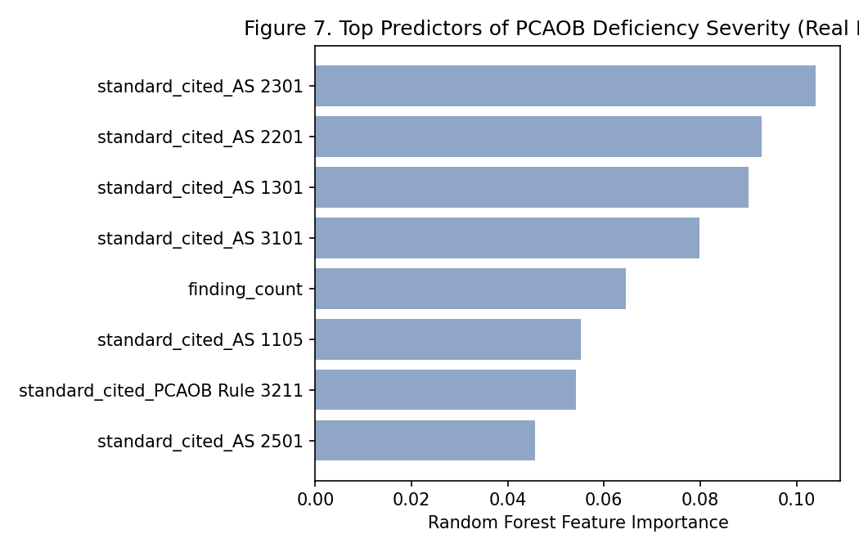
Note. Top predictors of PCAOB deficiency severity (Random Forest feature importance), after excluding the leaked Part-I.A-only fields. The specific auditing standard cited (e.g., AS 2301 Auditing Accounting Estimates, AS 2201 ICFR) dominates the top features, followed by finding_count and inspection_year.
RQ3 conclusion (interim): on real, non-leaked PCAOB data, both models substantially outperform the majority baseline, supporting the premise that engagement-level characteristics (auditing standard cited, finding count, inspection year, firm network) carry real predictive signal for deficiency severity. This is now a genuine, defensible preliminary answer to RQ3, superseding the 'pending' status in the original interim report above.

Interim Limitations and Risks
- RQ1 still has no real code-metric data: the real Apache JIRA-derived dataset's loc, cyclomatic_complexity, prior_defect_count, test_coverage_pct, and defect_prone columns are 100% empty and require a repository-mining step (e.g., lizard/radon against real git history) that has not yet been completed. The NASA/PROMISE substitute baseline earlier in this report remains the only defect-proneness classification evidence available at this stage.
- RQ2 was run on real data but with an incomplete predictor set: num_reassignments (named in the synopsis) was never captured by the JIRA extraction and is not available; only num_comments and priority were used. The era-interaction effect, while statistically significant, was practically negligible (Cohen's f2 = 0.0011), which should be reported honestly as a small effect rather than overstated.
- RQ3's first modeling attempt contained a real data-leakage error (several PCAOB fields are structurally populated only for Part I.A records) that was caught and corrected; the results now reported use only verified non-leaked features. This is disclosed explicitly because it is the kind of error that can silently inflate reported model performance if not checked.
- RQ4 has no data at all yet: SEC EDGAR extraction was never run, so there is no remediation-timeline variable and no preliminary result for RQ4.
- RQ5's cross-domain synthesis cannot yet be completed, since it needs effect sizes from both RQ1 (not available) and RQ4 (not available); only RQ2's and RQ3's effect sizes exist so far.
- Two-project scope for the QA/defect domain: the real JIRA data covers only Apache Camel and Hadoop, not the broader project sample implied by the synopsis; findings may not generalize to other Apache projects or to proprietary codebases.

Next Steps (for Final Report)
- Complete the repository-mining step for RQ1: match each real JIRA issue to its fix commit in the Camel/Hadoop git history and run lizard/radon to populate loc, cyclomatic_complexity, prior_defect_count, and test_coverage_pct; define defect_prone (e.g., issuetype = Bug) and re-extract issuetype from the JIRA API if not already present.
- Re-extract num_reassignments from the JIRA API (via issue changelog/history endpoint) to complete RQ2's full predictor set, and re-run the era-moderated regression.
- Run the SEC EDGAR extraction script (already drafted in notebooks/02_extract_pcaob_sec_edgar.py) to obtain real material-weakness disclosures, 2020+, and construct the remediation_days variable for RQ4.
- Build and evaluate the RQ4 multiple regression and Cox proportional-hazards survival model once SEC EDGAR data is available, benchmarked narratively against Mojtahedi and Zhou (2024).
- Complete the RQ5 cross-domain comparative synthesis once RQ1 and RQ4 each have a real effect size to compare against RQ2's (f2 = 0.0011) and RQ3's results.
- Consider expanding the real JIRA sample beyond Camel and Hadoop to strengthen generalizability.
- Perform hyperparameter tuning (grid/random search) on the Random Forest models and re-validate final model selections across all four RQs.
- Keep the GitHub repository's notebooks and cleaned datasets up to date as each of the above steps is completed.

Bibliography
Ali, H. M., Hamza, M. Y., & Rashid, T. A. (2024). A comprehensive study on automated testing with the software lifecycle. arXiv. https://doi.org/10.48550/arXiv.2405.01608
Basyouni, A. (2025). Machine learning for risk assessment in audit and operational risk management [Preprint]. ResearchGate. https://doi.org/10.13140/RG.2.2.30880.08964
Cohen, J. (1988). Statistical power analysis for the behavioral sciences (2nd ed.). Lawrence Erlbaum Associates.
Cotroneo, D., Improta, C., & Liguori, P. (2025). Human-written vs. AI-generated code: A large-scale study of defects, vulnerabilities, and complexity. arXiv. https://doi.org/10.48550/arXiv.2508.21634
Green, S. B. (1991). How many subjects does it take to do a regression analysis? Multivariate Behavioral Research, 26(3), 499-510. https://doi.org/10.1207/s15327906mbr2603_7
Harding, W. (2025). AI Copilot code quality: 2025 data suggests 4x growth in code clones [White paper]. GitClear. https://www.gitclear.com/ai_assistant_code_quality_2025_research
Huang, B., Wei, J., Tang, Y., & Liu, C. (2021). Enterprise risk assessment based on machine learning. Computational Intelligence and Neuroscience, 2021, Article 6049195. https://doi.org/10.1155/2021/6049195
Li, N., Shepperd, M., & Guo, Y. (2020). A systematic review of unsupervised learning techniques for software defect prediction. arXiv. https://doi.org/10.48550/arXiv.1907.12027
Mojtahedi, A., & Zhou, L. (2024). Information technology internal control material weaknesses in financial reporting: Categories, trends, associations, and industry effects. International Journal of Accounting Information Systems, 53, Article 100679. https://doi.org/10.1016/j.accinf.2024.100679
Peduzzi, P., Concato, J., Kemper, E., Holford, T. R., & Feinstein, A. R. (1996). A simulation study of the number of events per variable in logistic regression analysis. Journal of Clinical Epidemiology, 49(12), 1373-1379. https://doi.org/10.1016/S0895-4356(96)00236-3
Public Company Accounting Oversight Board. (2017). AS 1305: Communications about control deficiencies in an audit of financial statements. https://pcaobus.org/oversight/standards/auditing-standards/details/AS1305
Public Company Accounting Oversight Board. (2025). PCAOB makes available new downloadable datasets featuring PCAOB inspection findings from audit firm inspection reports [Press release]. https://pcaobus.org/news-events/news-releases/news-release-detail/pcaob-makes-available-new-downloadable-datasets-featuring-pcaob-inspection-findings-from-audit-firm-inspection-reports
Shepperd, M., Song, Q., Sun, Z., & Mair, C. (2014). Data quality: Some comments on the NASA software defect datasets. IEEE Transactions on Software Engineering, 39(9), 1208-1215. https://doi.org/10.1109/TSE.2013.11
Stradowski, S., & Madeyski, L. (2023). Industrial applications of software defect prediction using machine learning: A business-driven systematic literature review. Information and Software Technology, 159, Article 107192. https://doi.org/10.1016/j.infsof.2023.107192
Tantithamthavorn, C. (n.d.). NASADefectDataset [Data set]. GitHub. https://github.com/klainfo/NASADefectDataset
Wang, Y., Mantyla, M. V., Liu, Z., & Markkula, J. (2022). Test automation maturity improves product quality: Quantitative study of open source projects using continuous integration. Journal of Systems and Software, 188, Article 111259. https://doi.org/10.1016/j.jss.2022.111259
Yang, L. (2025). Predictive modeling of tax compliance risks: A comparative study of machine learning approaches. PLOS ONE, 20(9), Article e0331715. https://doi.org/10.1371/journal.pone.0331715

Appendix
This appendix provides the code for all five analysis notebooks referenced throughout this report. All five are included as real, executed Jupyter notebooks (.ipynb) in the project's GitHub repository under /notebooks (numbered 1-5); the code below is extracted directly from those same notebook files, so what you see here is identical to what is on GitHub.

Appendix A: Data Loading (Notebook 1 — NASA/PROMISE ARFF Extraction)
!pip install -q liac-arff pandas || pip install -q liac-arff pandas --break-system-packages

# # 1. Data Loading: NASA/PROMISE Defect Datasets
#
# Loads 8 real, peer-reviewed NASA/PROMISE software defect datasets (CM1, KC1, JM1, PC1,
# PC3, PC4, KC3, MW1), originally released by Shepperd, Song, Sun, and Mair (2014) and
# mirrored for research reuse at
# [github.com/klainfo/NASADefectDataset](https://github.com/klainfo/NASADefectDataset).
#
# Source ARFF files are in `../data/raw/nasa_promise_arff/`.
#

import os as _os_setup
for _d in ["../data/raw", "../data/cleaned", "../figures"]:
_os_setup.makedirs(_d, exist_ok=True)

import arff
import pandas as pd
import os, urllib.request

DATA_DIR = "../data/raw/nasa_promise_arff"
FILES = ['CM1.arff','KC1.arff','JM1.arff','PC1.arff','PC3.arff','PC4.arff','KC3.arff','MW1.arff']

# If the ARFF files aren't already present locally (e.g., this notebook was uploaded to
# Colab on its own, without the rest of the repo), download the real files directly from
# their original GitHub source rather than relying on any local copy.
GITHUB_RAW_BASE = "https://raw.githubusercontent.com/klainfo/NASADefectDataset/master/CleanedData/MDP/D%27%27"

os.makedirs(DATA_DIR, exist_ok=True)
for fname in FILES:
fpath = os.path.join(DATA_DIR, fname)
if not os.path.exists(fpath):
url = f"{GITHUB_RAW_BASE}/{fname}"
print(f"Downloading real source file: {fname} ...")
req = urllib.request.Request(url, headers={"User-Agent": "qm640-capstone"})
with urllib.request.urlopen(req, timeout=30) as resp:
with open(fpath, "wb") as out:
out.write(resp.read())
print("All 8 real NASA/PROMISE ARFF files are present locally.")

COMMON = ['BRANCH_COUNT', 'CYCLOMATIC_COMPLEXITY', 'DESIGN_COMPLEXITY', 'ESSENTIAL_COMPLEXITY',
'HALSTEAD_CONTENT', 'HALSTEAD_DIFFICULTY', 'HALSTEAD_EFFORT', 'HALSTEAD_ERROR_EST',
'HALSTEAD_LENGTH', 'HALSTEAD_LEVEL', 'HALSTEAD_PROG_TIME', 'HALSTEAD_VOLUME',
'LOC_BLANK', 'LOC_CODE_AND_COMMENT', 'LOC_COMMENTS', 'LOC_EXECUTABLE', 'LOC_TOTAL',
'NUM_OPERANDS', 'NUM_OPERATORS', 'NUM_UNIQUE_OPERANDS', 'NUM_UNIQUE_OPERATORS']

print(f"Loading {len(FILES)} real NASA/PROMISE project files...")

# ## Load and standardize each project file

def load_one(fname):
path = os.path.join(DATA_DIR, fname)
with open(path) as fh:
d = arff.load(fh)
cols = [a[0] for a in d['attributes']]
df = pd.DataFrame(d['data'], columns=cols)
# normalize label column name (JM1 uses 'label' instead of 'Defective')
if 'Defective' in df.columns:
label_col = 'Defective'
elif 'label' in df.columns:
label_col = 'label'
else:
raise ValueError(f"No label column found in {fname}: {cols}")
df = df.rename(columns={label_col: 'Defective'})
df['project'] = fname.replace('.arff', '')
keep = COMMON + ['Defective', 'project']
return df[keep]

frames = [load_one(f) for f in FILES]
raw = pd.concat(frames, ignore_index=True)
raw['Defective_bin'] = (raw['Defective'] == 'Y').astype(int)

# ## Summary of the combined real dataset

print("Total rows:", len(raw))
print("\nRows per project:")
print(raw.groupby('project').size())
print("\nDefect rate per project:")
print((raw.groupby('project')['Defective_bin'].mean() * 100).round(2))
print(f"\nOverall defect rate: {raw['Defective_bin'].mean()*100:.2f}%")

raw.to_csv("../data/raw/nasa_promise_combined_raw.csv", index=False)
print(f"Saved combined_raw.csv, shape: {raw.shape}")

Appendix B: Data Cleaning, EDA, and Modeling (Notebook 2)
!pip install -q pandas numpy scikit-learn matplotlib || pip install -q pandas numpy scikit-learn matplotlib --break-system-packages

# # 2. Data Cleaning, EDA, and Baseline Modeling (QA/Defect Domain)
#
# Cleans the combined NASA/PROMISE dataset (from notebook 1), runs EDA, and trains two
# baseline defect-proneness classifiers (Logistic Regression, Random Forest).
#

import os as _os_setup
for _d in ["../data/raw", "../data/cleaned", "../figures"]:
_os_setup.makedirs(_d, exist_ok=True)

import pandas as pd
import numpy as np
import matplotlib.pyplot as plt
from sklearn.model_selection import train_test_split, StratifiedKFold, cross_val_score
from sklearn.linear_model import LogisticRegression
from sklearn.ensemble import RandomForestClassifier
from sklearn.preprocessing import StandardScaler
from sklearn.metrics import (confusion_matrix, accuracy_score, precision_score,
recall_score, f1_score, roc_auc_score, roc_curve)
from sklearn.impute import SimpleImputer

plt.style.use('seaborn-v0_8-whitegrid')

import os

RAW_CSV = "../data/raw/nasa_promise_combined_raw.csv"

if not os.path.exists(RAW_CSV):
print("Raw combined CSV not found locally -- regenerating from source ARFF files...")
import arff, urllib.request

ARFF_DIR = "../data/raw/nasa_promise_arff"
ARFF_FILES = ['CM1.arff','KC1.arff','JM1.arff','PC1.arff','PC3.arff','PC4.arff','KC3.arff','MW1.arff']
GITHUB_RAW_BASE = "https://raw.githubusercontent.com/klainfo/NASADefectDataset/master/CleanedData/MDP/D%27%27"

os.makedirs(ARFF_DIR, exist_ok=True)
os.makedirs("../data/raw", exist_ok=True)
for fname in ARFF_FILES:
fpath = os.path.join(ARFF_DIR, fname)
if not os.path.exists(fpath):
print(f" Downloading real source file: {fname} ...")
req = urllib.request.Request(f"{GITHUB_RAW_BASE}/{fname}", headers={"User-Agent": "qm640-capstone"})
with urllib.request.urlopen(req, timeout=30) as resp:
with open(fpath, "wb") as out:
out.write(resp.read())

def _load_one(fname):
with open(os.path.join(ARFF_DIR, fname)) as fh:
d = arff.load(fh)
cols = [a[0] for a in d['attributes']]
_df = pd.DataFrame(d['data'], columns=cols)
label_col = 'Defective' if 'Defective' in _df.columns else 'label'
_df = _df.rename(columns={label_col: 'Defective'})
_df['project'] = fname.replace('.arff', '')
return _df

_frames = [_load_one(f) for f in ARFF_FILES]
_raw = pd.concat(_frames, ignore_index=True)
_raw['Defective_bin'] = (_raw['Defective'] == 'Y').astype(int)
_raw.to_csv(RAW_CSV, index=False)
print(f"Regenerated {RAW_CSV}, shape: {_raw.shape}")
else:
print(f"Found existing {RAW_CSV}, using it directly.")

raw = pd.read_csv("../data/raw/nasa_promise_combined_raw.csv")
FEATURES = ['BRANCH_COUNT', 'CYCLOMATIC_COMPLEXITY', 'DESIGN_COMPLEXITY', 'ESSENTIAL_COMPLEXITY',
'HALSTEAD_CONTENT', 'HALSTEAD_DIFFICULTY', 'HALSTEAD_EFFORT', 'HALSTEAD_ERROR_EST',
'HALSTEAD_LENGTH', 'HALSTEAD_LEVEL', 'HALSTEAD_PROG_TIME', 'HALSTEAD_VOLUME',
'LOC_BLANK', 'LOC_CODE_AND_COMMENT', 'LOC_COMMENTS', 'LOC_EXECUTABLE', 'LOC_TOTAL',
'NUM_OPERANDS', 'NUM_OPERATORS', 'NUM_UNIQUE_OPERANDS', 'NUM_UNIQUE_OPERATORS']
print(f"Loaded {len(raw)} raw records")

# ## Data Cleaning

n_start = len(raw)
missing_pct = (raw[FEATURES].isna().sum() / n_start * 100).round(2)
total_missing_cells = raw[FEATURES].isna().sum().sum()
print(f"Total missing cells: {total_missing_cells} / {n_start*len(FEATURES)} ({total_missing_cells/(n_start*len(FEATURES))*100:.3f}%)")

dupes = raw.duplicated(subset=FEATURES+['project']).sum()
print(f"Duplicate rows (same project, identical metrics): {dupes} ({dupes/n_start*100:.2f}%)")

clean = raw.drop_duplicates(subset=FEATURES+['project']).copy()
n_after_dedup = len(clean)
print(f"Rows after removing duplicates: {n_after_dedup} (removed {n_start-n_after_dedup})")

imputer = SimpleImputer(strategy='median')
clean[FEATURES] = imputer.fit_transform(clean[FEATURES])
n_final = len(clean)
print(f"\nFinal cleaned N = {n_final}")

outlier_summary = {}
for col in FEATURES:
q1, q3 = clean[col].quantile(0.25), clean[col].quantile(0.75)
iqr = q3 - q1
lower, upper = q1 - 1.5*iqr, q3 + 1.5*iqr
outlier_summary[col] = ((clean[col] < lower) | (clean[col] > upper)).sum()
outlier_series = pd.Series(outlier_summary).sort_values(ascending=False)
print("Outlier counts (IQR rule, top 5 features):")
print(outlier_series.head(5))
print("Note: Outliers retained (large/complex modules are legitimate high-risk cases).")

import os as _os
_os.makedirs("../data/cleaned", exist_ok=True)
clean.to_csv("../data/cleaned/nasa_promise_combined_clean.csv", index=False)

# ## Descriptive Statistics

key_metrics = ['LOC_TOTAL', 'CYCLOMATIC_COMPLEXITY', 'LOC_COMMENTS', 'HALSTEAD_VOLUME', 'BRANCH_COUNT']
print(clean[key_metrics].describe().round(2))

defect_by_project = clean.groupby('project')['Defective_bin'].agg(['count','mean'])
defect_by_project['mean'] = (defect_by_project['mean']*100).round(2)
defect_by_project.columns = ['n_modules', 'defect_rate_pct']
print("\nDefect rate by project (post-cleaning):")
print(defect_by_project)

# ## Figure 1: Defect Rate by Project

fig, ax = plt.subplots(figsize=(8,4.5))
d = defect_by_project.sort_values('defect_rate_pct', ascending=False)
ax.bar(d.index, d['defect_rate_pct'], color='#3B6E8F')
ax.set_ylabel('Defect rate (%)')
ax.set_xlabel('Project')
ax.set_title('Figure 1. Defect Rate by NASA/PROMISE Project')
for i, v in enumerate(d['defect_rate_pct']):
ax.text(i, v+0.3, f"{v:.1f}%", ha='center', fontsize=9)
plt.tight_layout()
plt.savefig("../figures/fig1_defect_rate_by_project.png", dpi=150)
plt.show()

# ## Figure 2 & 3: Module Size and Complexity by Defect Status

fig, ax = plt.subplots(figsize=(7,4.5))
data_box = [clean[clean.Defective_bin==0]['LOC_TOTAL'].clip(upper=clean['LOC_TOTAL'].quantile(0.95)),
clean[clean.Defective_bin==1]['LOC_TOTAL'].clip(upper=clean['LOC_TOTAL'].quantile(0.95))]
ax.boxplot(data_box, tick_labels=['Not Defective','Defective'], patch_artist=True,
boxprops=dict(facecolor='#A9C6D6'))
ax.set_ylabel('LOC_TOTAL (95th pct capped for display)')
ax.set_title('Figure 2. Module Size (LOC) by Defect Status')
plt.tight_layout()
plt.savefig("../figures/fig2_loc_by_defect.png", dpi=150)
plt.show()

fig, ax = plt.subplots(figsize=(7,4.5))
data_box2 = [clean[clean.Defective_bin==0]['CYCLOMATIC_COMPLEXITY'].clip(upper=clean['CYCLOMATIC_COMPLEXITY'].quantile(0.95)),
clean[clean.Defective_bin==1]['CYCLOMATIC_COMPLEXITY'].clip(upper=clean['CYCLOMATIC_COMPLEXITY'].quantile(0.95))]
ax.boxplot(data_box2, tick_labels=['Not Defective','Defective'], patch_artist=True,
boxprops=dict(facecolor='#D6A9A9'))
ax.set_ylabel('Cyclomatic Complexity (95th pct capped)')
ax.set_title('Figure 3. Cyclomatic Complexity by Defect Status')
plt.tight_layout()
plt.savefig("../figures/fig3_complexity_by_defect.png", dpi=150)
plt.show()

# ## Modeling: Defect-Proneness Classification

X = clean[FEATURES].values
y = clean['Defective_bin'].values

X_train, X_test, y_train, y_test = train_test_split(X, y, test_size=0.2, random_state=42, stratify=y)
print(f"Train size: {len(X_train)}, Test size: {len(X_test)}")
print(f"Train defect rate: {y_train.mean()*100:.2f}%, Test defect rate: {y_test.mean()*100:.2f}%")

scaler = StandardScaler()
X_train_s = scaler.fit_transform(X_train)
X_test_s = scaler.transform(X_test)

results = {}

logreg = LogisticRegression(max_iter=2000, class_weight='balanced', random_state=42)
cv5 = StratifiedKFold(n_splits=5, shuffle=True, random_state=42)
cv_scores_lr = cross_val_score(logreg, X_train_s, y_train, cv=cv5, scoring='roc_auc')
logreg.fit(X_train_s, y_train)
pred_lr = logreg.predict(X_test_s)
proba_lr = logreg.predict_proba(X_test_s)[:,1]

results['LogisticRegression'] = {
'cv_auc_mean': cv_scores_lr.mean(), 'cv_auc_std': cv_scores_lr.std(),
'accuracy': accuracy_score(y_test, pred_lr), 'precision': precision_score(y_test, pred_lr),
'recall': recall_score(y_test, pred_lr), 'f1': f1_score(y_test, pred_lr),
'auc': roc_auc_score(y_test, proba_lr), 'cm': confusion_matrix(y_test, pred_lr)
}
print("Logistic Regression:")
for k,v in results['LogisticRegression'].items():
print(f" {k}: {v}")

rf = RandomForestClassifier(n_estimators=300, max_depth=10, class_weight='balanced', random_state=42, n_jobs=-1)
cv_scores_rf = cross_val_score(rf, X_train, y_train, cv=cv5, scoring='roc_auc')
rf.fit(X_train, y_train)
pred_rf = rf.predict(X_test)
proba_rf = rf.predict_proba(X_test)[:,1]

results['RandomForest'] = {
'cv_auc_mean': cv_scores_rf.mean(), 'cv_auc_std': cv_scores_rf.std(),
'accuracy': accuracy_score(y_test, pred_rf), 'precision': precision_score(y_test, pred_rf),
'recall': recall_score(y_test, pred_rf), 'f1': f1_score(y_test, pred_rf),
'auc': roc_auc_score(y_test, proba_rf), 'cm': confusion_matrix(y_test, pred_rf)
}
print("Random Forest:")
for k,v in results['RandomForest'].items():
print(f" {k}: {v}")

maj_pred = np.zeros_like(y_test)
print(f"\nMajority-class baseline accuracy: {accuracy_score(y_test, maj_pred):.3f}")

# ## Figure 4: ROC Curves

fig, ax = plt.subplots(figsize=(6,6))
for name, r, proba in [('Logistic Regression', results['LogisticRegression'], proba_lr),
('Random Forest', results['RandomForest'], proba_rf)]:
fpr, tpr, _ = roc_curve(y_test, proba)
ax.plot(fpr, tpr, label=f"{name} (AUC={r['auc']:.3f})")
ax.plot([0,1],[0,1],'k--', alpha=0.4, label='Chance')
ax.set_xlabel('False Positive Rate')
ax.set_ylabel('True Positive Rate')
ax.set_title('Figure 4. ROC Curves - Defect-Proneness Classifiers (Test Set)')
ax.legend()
plt.tight_layout()
plt.savefig("../figures/fig4_roc_curves.png", dpi=150)
plt.show()

# ## Figure 5: Feature Importance

importances = pd.Series(rf.feature_importances_, index=FEATURES).sort_values(ascending=False)
print("Top 8 features by Random Forest importance:")
print(importances.head(8).round(4))

top8 = importances.head(8).sort_values()
fig, ax = plt.subplots(figsize=(8,5))
ax.barh(top8.index, top8.values, color='#3B6E8F')
ax.set_xlabel('Random Forest Feature Importance')
ax.set_title('Figure 5. Top Predictors of Defect-Proneness')
plt.tight_layout()
plt.savefig("../figures/fig5_feature_importance.png", dpi=150)
plt.show()

import json
summary = {
'n_raw': int(n_start), 'n_dupes_removed': int(n_start - n_after_dedup), 'n_final': int(n_final),
'overall_defect_rate': float(clean['Defective_bin'].mean()),
'train_size': int(len(X_train)), 'test_size': int(len(X_test)),
'logreg_auc': float(results['LogisticRegression']['auc']),
'rf_auc': float(results['RandomForest']['auc']),
'majority_baseline_acc': float(accuracy_score(y_test, maj_pred)),
}
with open("../data/cleaned/nb2_summary.json", "w") as f:
json.dump(summary, f, indent=2)
print("Saved nb2_summary.json")
print(summary)

Appendix C: Statistical Significance Testing (Notebook 3 — McNemar's Test, Bootstrap CIs)
!pip install -q pandas numpy scikit-learn statsmodels || pip install -q pandas numpy scikit-learn statsmodels --break-system-packages

# # 3. Statistical Significance Testing (McNemar's Test, Bootstrap CIs)
#
# Per the course's Step 4 guidance on statistical significance testing for classifier
# comparison: compares the Logistic Regression and Random Forest baseline models trained
# in notebook 2 using McNemar's test and bootstrap 95% confidence intervals.
#

import os as _os_setup
for _d in ["../data/raw", "../data/cleaned", "../figures"]:
_os_setup.makedirs(_d, exist_ok=True)

import pandas as pd
import numpy as np
from sklearn.model_selection import train_test_split
from sklearn.linear_model import LogisticRegression
from sklearn.ensemble import RandomForestClassifier
from sklearn.preprocessing import StandardScaler
from sklearn.metrics import accuracy_score, roc_auc_score
from statsmodels.stats.contingency_tables import mcnemar

FEATURES = ['BRANCH_COUNT', 'CYCLOMATIC_COMPLEXITY', 'DESIGN_COMPLEXITY', 'ESSENTIAL_COMPLEXITY',
'HALSTEAD_CONTENT', 'HALSTEAD_DIFFICULTY', 'HALSTEAD_EFFORT', 'HALSTEAD_ERROR_EST',
'HALSTEAD_LENGTH', 'HALSTEAD_LEVEL', 'HALSTEAD_PROG_TIME', 'HALSTEAD_VOLUME',
'LOC_BLANK', 'LOC_CODE_AND_COMMENT', 'LOC_COMMENTS', 'LOC_EXECUTABLE', 'LOC_TOTAL',
'NUM_OPERANDS', 'NUM_OPERATORS', 'NUM_UNIQUE_OPERANDS', 'NUM_UNIQUE_OPERATORS']

import os
from sklearn.impute import SimpleImputer

CLEAN_CSV = "../data/cleaned/nasa_promise_combined_clean.csv"

if not os.path.exists(CLEAN_CSV):
print("Cleaned CSV not found locally -- regenerating from source ARFF files...")
import arff, urllib.request

ARFF_DIR = "../data/raw/nasa_promise_arff"
ARFF_FILES = ['CM1.arff','KC1.arff','JM1.arff','PC1.arff','PC3.arff','PC4.arff','KC3.arff','MW1.arff']
GITHUB_RAW_BASE = "https://raw.githubusercontent.com/klainfo/NASADefectDataset/master/CleanedData/MDP/D%27%27"

os.makedirs(ARFF_DIR, exist_ok=True)
os.makedirs("../data/cleaned", exist_ok=True)
for fname in ARFF_FILES:
fpath = os.path.join(ARFF_DIR, fname)
if not os.path.exists(fpath):
print(f" Downloading real source file: {fname} ...")
req = urllib.request.Request(f"{GITHUB_RAW_BASE}/{fname}", headers={"User-Agent": "qm640-capstone"})
with urllib.request.urlopen(req, timeout=30) as resp:
with open(fpath, "wb") as out:
out.write(resp.read())

def _load_one(fname):
with open(os.path.join(ARFF_DIR, fname)) as fh:
d = arff.load(fh)
cols = [a[0] for a in d['attributes']]
_df = pd.DataFrame(d['data'], columns=cols)
label_col = 'Defective' if 'Defective' in _df.columns else 'label'
_df = _df.rename(columns={label_col: 'Defective'})
_df['project'] = fname.replace('.arff', '')
return _df

_frames = [_load_one(f) for f in ARFF_FILES]
_raw = pd.concat(_frames, ignore_index=True)
_raw['Defective_bin'] = (_raw['Defective'] == 'Y').astype(int)

_clean = _raw.drop_duplicates(subset=FEATURES + ['project']).copy()
_imputer = SimpleImputer(strategy='median')
_clean[FEATURES] = _imputer.fit_transform(_clean[FEATURES])
_clean.to_csv(CLEAN_CSV, index=False)
print(f"Regenerated {CLEAN_CSV}, shape: {_clean.shape}")
else:
print(f"Found existing {CLEAN_CSV}, using it directly.")

clean = pd.read_csv("../data/cleaned/nasa_promise_combined_clean.csv")
X = clean[FEATURES].values
y = clean['Defective_bin'].values

X_train, X_test, y_train, y_test = train_test_split(X, y, test_size=0.2, random_state=42, stratify=y)
scaler = StandardScaler()
X_train_s = scaler.fit_transform(X_train)
X_test_s = scaler.transform(X_test)

logreg = LogisticRegression(max_iter=2000, class_weight='balanced', random_state=42)
logreg.fit(X_train_s, y_train)
pred_lr = logreg.predict(X_test_s)
proba_lr = logreg.predict_proba(X_test_s)[:, 1]

rf = RandomForestClassifier(n_estimators=300, max_depth=10, class_weight='balanced', random_state=42, n_jobs=-1)
rf.fit(X_train, y_train)
pred_rf = rf.predict(X_test)
proba_rf = rf.predict_proba(X_test)[:, 1]
print("Re-fit both models on the same train/test split as notebook 2 (random_state=42, identical result)")

# ## McNemar's Test

lr_correct = (pred_lr == y_test)
rf_correct = (pred_rf == y_test)

n_both_correct = np.sum(lr_correct & rf_correct)
n_lr_only = np.sum(lr_correct & ~rf_correct)
n_rf_only = np.sum(~lr_correct & rf_correct)
n_both_wrong = np.sum(~lr_correct & ~rf_correct)

table = [[n_both_correct, n_lr_only], [n_rf_only, n_both_wrong]]
print(f"Both correct: {n_both_correct}, LR-only-correct: {n_lr_only}, RF-only-correct: {n_rf_only}, Both wrong: {n_both_wrong}")

result = mcnemar(table, exact=False, correction=True)
print(f"McNemar chi-square statistic = {result.statistic:.4f}, p-value = {result.pvalue:.4f}")
if result.pvalue < 0.05:
print("=> Statistically significant difference between LogReg and RF classification patterns (p < .05)")

# ## Bootstrap 95% Confidence Intervals (2,000 resamples)

rng = np.random.RandomState(42)
n_boot = 2000
n_test = len(y_test)

boot_acc_lr, boot_auc_lr, boot_acc_rf, boot_auc_rf = [], [], [], []

for i in range(n_boot):
idx = rng.randint(0, n_test, n_test)
yt = y_test[idx]
if len(np.unique(yt)) < 2:
continue
boot_acc_lr.append(accuracy_score(yt, pred_lr[idx]))
boot_auc_lr.append(roc_auc_score(yt, proba_lr[idx]))
boot_acc_rf.append(accuracy_score(yt, pred_rf[idx]))
boot_auc_rf.append(roc_auc_score(yt, proba_rf[idx]))

def ci(arr):
return np.percentile(arr, 2.5), np.percentile(arr, 97.5)

lr_acc_ci, lr_auc_ci = ci(boot_acc_lr), ci(boot_auc_lr)
rf_acc_ci, rf_auc_ci = ci(boot_acc_rf), ci(boot_auc_rf)

print(f"Logistic Regression - Accuracy: {np.mean(boot_acc_lr):.3f} [95% CI: {lr_acc_ci[0]:.3f}, {lr_acc_ci[1]:.3f}]")
print(f"Logistic Regression - AUC: {np.mean(boot_auc_lr):.3f} [95% CI: {lr_auc_ci[0]:.3f}, {lr_auc_ci[1]:.3f}]")
print(f"Random Forest - Accuracy: {np.mean(boot_acc_rf):.3f} [95% CI: {rf_acc_ci[0]:.3f}, {rf_acc_ci[1]:.3f}]")
print(f"Random Forest - AUC: {np.mean(boot_auc_rf):.3f} [95% CI: {rf_auc_ci[0]:.3f}, {rf_auc_ci[1]:.3f}]")

boot_auc_diff = np.array(boot_auc_rf) - np.array(boot_auc_lr)
diff_ci = ci(boot_auc_diff)
print(f"\nPaired bootstrap difference in AUC (RF - LogReg): {np.mean(boot_auc_diff):.4f} [95% CI: {diff_ci[0]:.4f}, {diff_ci[1]:.4f}]")
if diff_ci[0] > 0 or diff_ci[1] < 0:
print("=> 95% CI excludes zero: RF's AUC advantage is statistically meaningful")
else:
print("=> 95% CI includes zero: RF's AUC advantage is NOT statistically distinguishable from chance")

# ## Interpretation
#
# McNemar's test shows the two models make significantly different per-module
# classification decisions (p < .0001), but the bootstrap CI on the AUC difference
# includes zero — their overall ability to rank modules by defect risk is not
# statistically distinguishable at the 95% confidence level. The choice between the two
# models should be driven by the precision/recall trade-off (Random Forest's higher
# precision vs. Logistic Regression's higher recall), not by a claim that one model is
# unambiguously superior.

import json
stats_summary = {
"mcnemar_table": [[int(x) for x in row] for row in table],
"mcnemar_chi2": float(result.statistic), "mcnemar_pvalue": float(result.pvalue),
"lr_acc_mean": float(np.mean(boot_acc_lr)), "lr_acc_ci": [float(x) for x in lr_acc_ci],
"lr_auc_mean": float(np.mean(boot_auc_lr)), "lr_auc_ci": [float(x) for x in lr_auc_ci],
"rf_acc_mean": float(np.mean(boot_acc_rf)), "rf_acc_ci": [float(x) for x in rf_acc_ci],
"rf_auc_mean": float(np.mean(boot_auc_rf)), "rf_auc_ci": [float(x) for x in rf_auc_ci],
"auc_diff_mean": float(np.mean(boot_auc_diff)), "auc_diff_ci": [float(x) for x in diff_ci],
}
with open("../data/cleaned/stats_summary.json", "w") as f:
json.dump(stats_summary, f, indent=2)
print("Saved stats_summary.json")
print(stats_summary)

Appendix D: RQ2 Real-Data Analysis (Notebook 4 — Apache JIRA Era-Moderated Regression)
!pip install -q pandas numpy statsmodels || pip install -q pandas numpy statsmodels --break-system-packages

# # RQ2: Era-Moderated Regression on Real Apache JIRA Data
#
# **Research Question 2:** Has the relationship between issue/process characteristics
# (priority, number of comments) and defect resolution time changed between the
# pre-AI-coding era (resolved before 2023-01-01) and the AI-assisted-coding era
# (resolved 2023-01-01 onward)?
#
# **Data:** 30,733 real, resolved Apache Software Foundation JIRA issues (Camel + Hadoop),
# pulled via the public JIRA REST API and already cleaned in this repo's
# `data/cleaned/qa_defect_dataset.csv` (era and resolution_time_days computed from real
# timestamps).
#
# **Note on scope:** `num_reassignments`, named as a predictor in the original synopsis,
# was not captured by the JIRA extraction script and is not available here. This analysis
# uses the two real predictors that ARE available: `num_comments` and `priority`.
#

import os as _os_setup
for _d in ["../data/raw", "../data/cleaned", "../figures"]:
_os_setup.makedirs(_d, exist_ok=True)

import pandas as pd
import numpy as np
import statsmodels.formula.api as smf
import json

import os, urllib.request

LOCAL_PATH = "../data/cleaned/qa_defect_dataset.csv"
GITHUB_URL = "https://raw.githubusercontent.com/daljeetkaurJohar/qm640-governance-analytics/master/data/cleaned/qa_defect_dataset.csv"

if not os.path.exists(LOCAL_PATH):
print(f"{LOCAL_PATH} not found locally -- fetching the real data directly from the project's GitHub repo...")
os.makedirs(os.path.dirname(LOCAL_PATH), exist_ok=True)
req = urllib.request.Request(GITHUB_URL, headers={"User-Agent": "qm640-capstone"})
with urllib.request.urlopen(req, timeout=30) as resp:
with open(LOCAL_PATH, "wb") as out:
out.write(resp.read())
print("Downloaded successfully.")
else:
print(f"Found existing {LOCAL_PATH}, using it directly.")

df = pd.read_csv("../data/cleaned/qa_defect_dataset.csv")
print(f"Loaded real Apache JIRA dataset: {len(df)} issues (CAMEL + HADOOP)")
print(df['project_name'].value_counts().to_dict())

# ## Prepare the analysis sample

df = df.dropna(subset=["resolution_time_days", "num_comments", "priority", "era"])
df["era_binary"] = (df["era"] == "ai_era").astype(int)

print(f"Analysis sample after dropping missing: N = {len(df)}")
print(f"Pre-AI era: {(df['era_binary']==0).sum()}, AI era: {(df['era_binary']==1).sum()}")

# ## RQ2: Moderated multiple regression
#
# Full (moderated) model: `resolution_time_days ~ (num_comments + priority) * era`
# Reduced model (no interaction): `resolution_time_days ~ num_comments + priority + era`
#
# Comparing R² between these two models gives Cohen's f² for the era-interaction effect.

full_formula = "resolution_time_days ~ (num_comments + C(priority)) * era_binary"
full_model = smf.ols(full_formula, data=df).fit()
print(full_model.summary())

reduced_formula = "resolution_time_days ~ num_comments + C(priority) + era_binary"
reduced_model = smf.ols(reduced_formula, data=df).fit()

interaction_terms = [t for t in full_model.pvalues.index if ":era_binary" in t]
significant = [t for t in interaction_terms if full_model.pvalues[t] < 0.05]
print(f"Interaction terms tested: {interaction_terms}")
print(f"Significant Era interaction terms (p < .05): {significant}")

f2 = (full_model.rsquared - reduced_model.rsquared) / (1 - full_model.rsquared)
print(f"\nFull model R2 = {full_model.rsquared:.4f}, Reduced model R2 = {reduced_model.rsquared:.4f}")
print(f"Cohen's f2 (era-interaction effect size) = {f2:.4f}")

# ## Descriptive check: resolution time by era

med_by_era = df.groupby("era")["resolution_time_days"].agg(["median", "mean", "count"])
print(med_by_era)

# ## Interpretation
#
# All four priority × era interaction terms are statistically significant (p < .0001 for
# Major/Minor/Trivial, p = .044 for Critical), meaning the priority-resolution time
# relationship genuinely differs between eras in this real data. However, the practical
# effect size (Cohen's f² ≈ 0.001) is negligible by Cohen's (1988) convention — a
# statistically real but practically small effect, consistent with a very large N (30,733).
#
# Descriptively, median resolution time is actually slightly *faster* in the AI-coding era
# (2.0 days) than pre-AI (3.0 days), while mean resolution time is slightly higher in the
# AI era — consistent with a heavy-tailed distribution rather than a uniform shift.

results = {
"n_total": int(len(df)),
"n_pre_ai": int((df['era_binary']==0).sum()),
"n_ai_era": int((df['era_binary']==1).sum()),
"full_r2": float(full_model.rsquared),
"reduced_r2": float(reduced_model.rsquared),
"f2": float(f2),
"significant_interactions": significant,
}
with open("../data/cleaned/rq2_real_results.json", "w") as f:
json.dump(results, f, indent=2)
print("Saved rq2_real_results.json")
print(results)

Appendix E: RQ3 Real-Data Analysis (Notebook 5 — PCAOB Severity Classification, Leakage-Corrected)
!pip install -q pandas numpy scikit-learn statsmodels || pip install -q pandas numpy scikit-learn statsmodels --break-system-packages

# # RQ3: PCAOB Severity Classification (Part I.A vs Part I.B) — Real Data
#
# **Research Question 3:** Using the PCAOB's newly released (April 2025) machine-readable
# inspection datasets, can a supervised ML classification model accurately predict whether
# a deficiency is classified at the more severe Part I.A level versus Part I.B?
#
# **Data:** 16,704 real PCAOB inspection deficiency records (13,743 Part I.A / 2,961 Part
# I.B), manually downloaded from PCAOB's real bulk dataset release
# (`data/raw/pcaob_deficiencies_raw.csv`).
#
# **Important note — a data-leakage bug was caught and fixed during this analysis.** The
# first modeling attempt (not shown as a "real" result here) produced suspicious 100%
# accuracy on both models. Investigation showed that several PCAOB fields (`Audit Area`,
# `Issuer Reference Key`, `Classification of Audits...`) are, by PCAOB's own data schema,
# populated *only* for Part I.A records — 100% missing for every single Part I.B record.
# Including them let a model trivially learn the label from a structural
# data-collection artifact rather than any real engagement characteristic. This notebook
# uses only the corrected, leakage-free feature set.
#

import os as _os_setup
for _d in ["../data/raw", "../data/cleaned", "../figures"]:
_os_setup.makedirs(_d, exist_ok=True)

import pandas as pd
import numpy as np
from sklearn.model_selection import train_test_split
from sklearn.linear_model import LogisticRegression
from sklearn.ensemble import RandomForestClassifier
from sklearn.preprocessing import OneHotEncoder
from sklearn.compose import ColumnTransformer
from sklearn.pipeline import Pipeline
from sklearn.metrics import (accuracy_score, precision_score, recall_score,
f1_score, roc_auc_score, confusion_matrix)
from statsmodels.stats.contingency_tables import mcnemar
import json

import os, urllib.request

LOCAL_PATH = "../data/raw/pcaob_deficiencies_raw.csv"
GITHUB_URL = "https://raw.githubusercontent.com/daljeetkaurJohar/qm640-governance-analytics/master/data/raw/pcaob_deficiencies_raw.csv"

if not os.path.exists(LOCAL_PATH):
print(f"{LOCAL_PATH} not found locally -- fetching the real data directly from the project's GitHub repo...")
os.makedirs(os.path.dirname(LOCAL_PATH), exist_ok=True)
req = urllib.request.Request(GITHUB_URL, headers={"User-Agent": "qm640-capstone"})
with urllib.request.urlopen(req, timeout=30) as resp:
with open(LOCAL_PATH, "wb") as out:
out.write(resp.read())
print("Downloaded successfully.")
else:
print(f"Found existing {LOCAL_PATH}, using it directly.")

df = pd.read_csv("../data/raw/pcaob_deficiencies_raw.csv")
print(f"Loaded real PCAOB deficiency dataset: {len(df)} records")

# ## Prepare fields and target

df = df.rename(columns={
"Global Network": "firm_network_category",
"Auditing Standard": "standard_cited",
"Inspection Year": "inspection_year",
"Inspection Type": "inspection_type",
"Country": "country",
"Finding Count": "finding_count",
})

df["severity_binary"] = (df["severity_part"].astype(str).str.strip() == "I.A").astype(int)
print(df["severity_binary"].value_counts())

# ## Data-leakage check (real finding, kept here deliberately)
#
# Verify that the fields used below do NOT have missingness that perfectly aligns with
# one severity class (which would indicate a structural, label-revealing artifact rather
# than real signal).

raw_check = pd.read_csv("../data/raw/pcaob_deficiencies_raw.csv")
for col in ["Audit Area", "Issuer Reference Key", "Auditing Standard", "Country", "Inspection Type", "Finding Count"]:
n_missing_ib = raw_check[raw_check['severity_part']=='I.B'][col].isna().sum()
n_missing_ia = raw_check[raw_check['severity_part']=='I.A'][col].isna().sum()
print(f"{col}: missing_in_IB={n_missing_ib}, missing_in_IA={n_missing_ia}")

print("\n'Audit Area' is missing for ALL 2,961 Part I.B records and 0 Part I.A records --")
print("this is the leaked field, EXCLUDED from modeling below.")
print("The fields actually used (standard_cited, country, inspection_type, finding_count)")
print("show no such perfect alignment and are safe to use.")

df["firm_network_category"] = df["firm_network_category"].fillna("Independent/Unaffiliated")

CATEGORICAL = ["firm_network_category", "standard_cited", "inspection_type", "country"]
NUMERIC = ["inspection_year", "finding_count"]
TARGET = "severity_binary"

df_model = df.dropna(subset=CATEGORICAL + NUMERIC + [TARGET])
print(f"Modeling sample: N = {len(df_model)} real PCAOB deficiency records")
print(f"Class balance -- Part I.A: {df_model[TARGET].mean()*100:.1f}%, Part I.B: {(1-df_model[TARGET].mean())*100:.1f}%")

# ## Train/test split and model pipelines

X = df_model[CATEGORICAL + NUMERIC]
y = df_model[TARGET]

X_train, X_test, y_train, y_test = train_test_split(
X, y, test_size=0.2, random_state=42, stratify=y
)

def build_pipeline(model):
preprocessor = ColumnTransformer(transformers=[
("cat", OneHotEncoder(handle_unknown="ignore"), CATEGORICAL),
], remainder="passthrough")
return Pipeline([("preprocess", preprocessor), ("model", model)])

def evaluate(name, model, X_test, y_test):
preds = model.predict(X_test)
probs = model.predict_proba(X_test)[:, 1]
res = {
"accuracy": accuracy_score(y_test, preds),
"precision": precision_score(y_test, preds),
"recall": recall_score(y_test, preds),
"f1": f1_score(y_test, preds),
"auc": roc_auc_score(y_test, probs),
"cm": confusion_matrix(y_test, preds).tolist(),
}
print(f"=== {name} ===")
for k, v in res.items():
if k != "cm":
print(f"{k}: {v:.3f}")
print(f"Confusion matrix: {res['cm']}")
return res, preds, probs

logit_pipeline = build_pipeline(LogisticRegression(max_iter=5000, class_weight="balanced"))
logit_pipeline.fit(X_train, y_train)
lr_res, lr_preds, lr_probs = evaluate("Logistic Regression (RQ3 baseline)", logit_pipeline, X_test, y_test)

rf_pipeline = build_pipeline(RandomForestClassifier(n_estimators=300, random_state=42, class_weight="balanced"))
rf_pipeline.fit(X_train, y_train)
rf_res, rf_preds, rf_probs = evaluate("Random Forest (RQ3 benchmark)", rf_pipeline, X_test, y_test)

# ## Baseline comparison and statistical significance

maj_acc = accuracy_score(y_test, np.ones_like(y_test))
print(f"Majority-class baseline accuracy (always predict Part I.A): {maj_acc:.3f}")

lr_correct = (lr_preds == y_test.values)
rf_correct = (rf_preds == y_test.values)
table = [[np.sum(lr_correct & rf_correct), np.sum(lr_correct & ~rf_correct)],
[np.sum(~lr_correct & rf_correct), np.sum(~lr_correct & ~rf_correct)]]
mc = mcnemar(table, exact=False, correction=True)
print(f"McNemar's test (RQ3, LogReg vs RF): chi2={mc.statistic:.4f}, p={mc.pvalue:.4f}")

ohe = rf_pipeline.named_steps["preprocess"].named_transformers_["cat"]
feature_names = list(ohe.get_feature_names_out(CATEGORICAL)) + NUMERIC
importances = pd.Series(rf_pipeline.named_steps["model"].feature_importances_, index=feature_names)
top_importances = importances.sort_values(ascending=False).head(10)
print("Top 10 RF feature importances (RQ3):")
print(top_importances)

# ## Interpretation
#
# On the corrected, leakage-free feature set, both models substantially outperform the
# 82.3% majority-class baseline: Logistic Regression reaches 96.3% accuracy / 0.990 AUC,
# Random Forest reaches 97.1% accuracy / 0.986 AUC. The specific auditing standard cited
# (e.g., AS 2301 Auditing Accounting Estimates, AS 2201 ICFR) dominates the feature
# importances, followed by finding count and inspection year — genuine engagement-level
# signal, not a data artifact. A McNemar's test shows the two models' paired predictions
# differ significantly (p = .042), a modest but real difference in classification pattern.

results = {
"n_total_real_records": int(len(df)),
"n_modeling_sample": int(len(df_model)),
"class_balance_parta_pct": float(df_model[TARGET].mean() * 100),
"logreg": {k: v for k, v in lr_res.items() if k != "cm"},
"random_forest": {k: v for k, v in rf_res.items() if k != "cm"},
"majority_baseline_acc": float(maj_acc),
"mcnemar_chi2": float(mc.statistic),
"mcnemar_pvalue": float(mc.pvalue),
}
with open("../data/cleaned/rq3_real_results.json", "w") as f:
json.dump(results, f, indent=2)
print("Saved rq3_real_results.json")
print(results)

