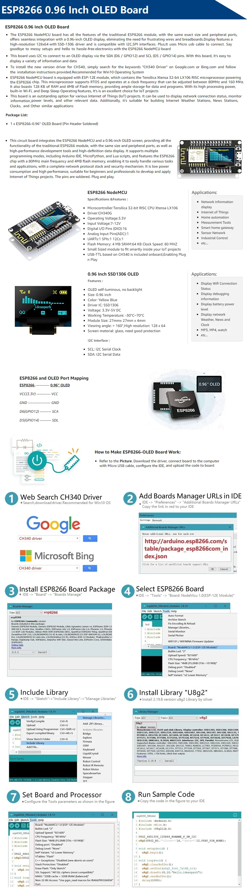

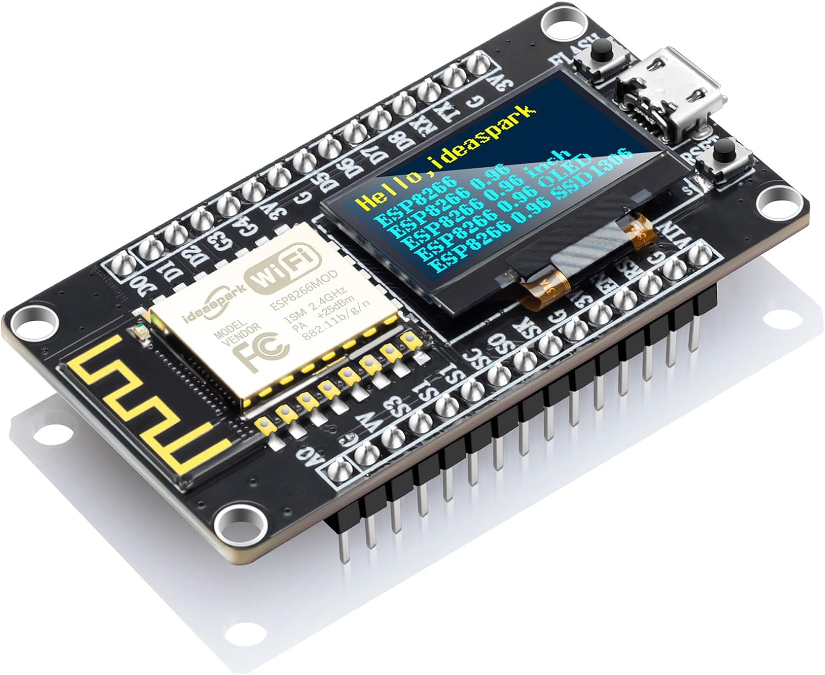
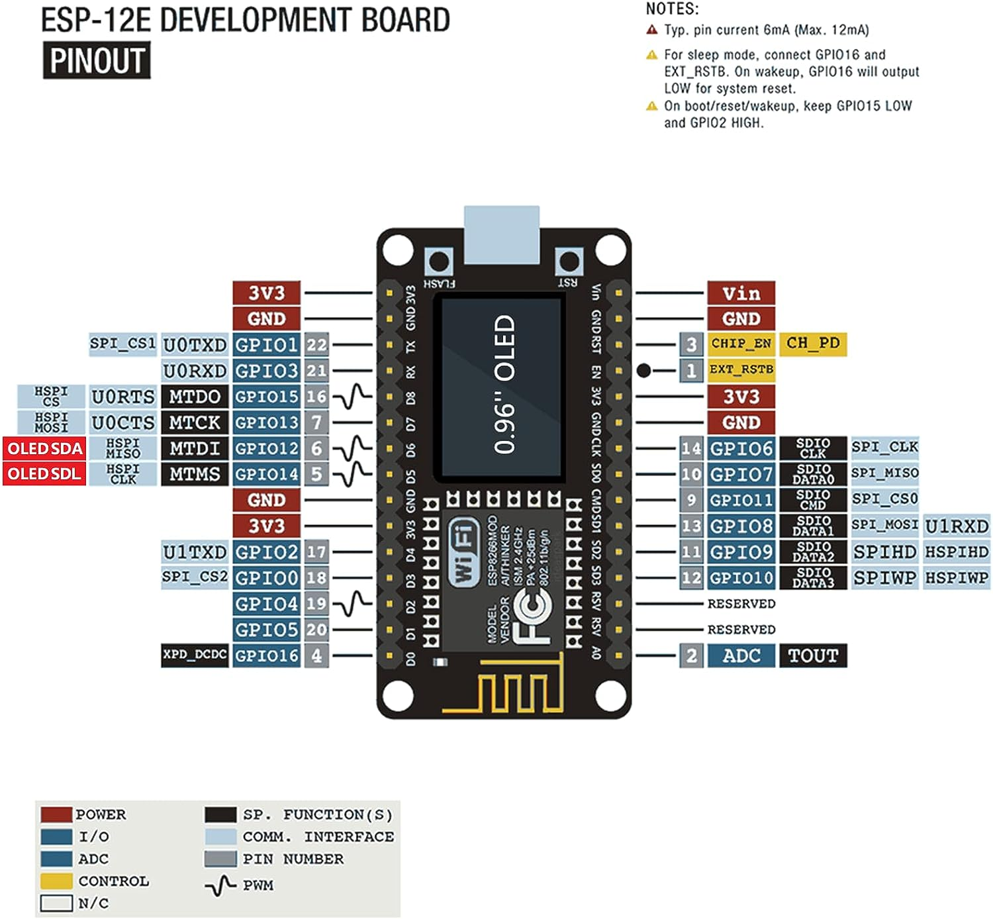
Grey 8266mod pin#
Error? 1&3 labels swapped
Caution, some errors here. Better reference: https://randomnerdtutorials.com/esp8266-pinout-reference-gpios/
Error, D5 is OLED SCL

