Group_by: Josh Dahle, Dallas Dickey, Matthew Fay, Kevin Hastings, Jack Hemer

November 7, 2019

**Impact of Salary Cap on Team Wins in the NFL**

**The situation, its data, and the question to be answered.**

The National Football League (NFL), like other North American professional leagues, has a salary cap. The salary cap is a rule put into place to limit the amount of money that a team can spend on its players’ salaries. One of the main reasons for having a salary cap is to maintain a competitive balance across the league. It does not allow richer teams to buy more high performing players than poorer teams.

The most recent Collective Bargaining Agreement (CBA) formulated by the NFL occurred in 2011. In 2011, the salary cap was $120 million with expected growth each year until the CBA ends in 2020. The NFL also implemented a salary floor which required all teams to spend at least 88.8% of the salary cap in 2011 and 2012, and then an average of 90% between 2013 – 2016 and 2017 – 2020. The salary floor makes it more difficult for teams to purposely field a bad team during a rebuild and forces them to remain competitive.

The data we gathered for our research analysis included the following information from the 2015 – 2018 seasons: team name, total players signed, average age of signed players, active salary cap, dead money, total cap spend, unused cap space, salary spend per position, and overall record. Active cap space refers to the money spent on players actively on the team’s roster. Dead money refers to the money spent on a player no longer with the team.

The reason we chose to collect 4 seasons worth of data (2015 – 2018) is because players that are drafted in the annual NFL Draft sign 4-year contracts. Round 1 draft picks receive a 5th year team option but players drafted in rounds 2 – 7 sign 4-year contracts. Undrafted rookies can sign contracts up to 3 years in length. Using 4 years of data allows us to cover majority of rookies through the entirety of their contracts and demonstrates the change in position distribution per team.

The idea behind our research analysis was to find if there is a correlation of spending salary cap space and total wins. There were three factors that we thought would have the biggest impact on wins over the course of the season. First, salary cap usage on the quarterback. We wanted to evaluate this because quarterbacks are oftentimes the highest paid player on their respective teams. We assumed that teams that more evenly distribute their cap space will win more games. Second, total unused cap space, because we assumed that teams who use most of the salary cap will win more games. Third, average age of players taking up salary cap space. Our assumption was that teams with an average aged roster would win more games because of a good mix of young talent and veteran leadership.

*Salary cap for years we considered in our analysis*

|  |  |
| --- | --- |
| **Year** | **Salary Cap** |
| 2015 | $143.28 million |
| 2016 | $155.27 million |
| 2017 | $167.00 million |
| 2018 | $177.2 million |

**Analysis**

To test our hypothesis and find out if there is a correlation of spending salary cap space and total wins, we first began by plotting a scatter chart of the salary cap and wins. Then to draw more conclusions we included a regression analysis and plotted a regression line to the chart below. The results of the regression analysis were a P-value of .3597 and adjusted R-squared value of -.001222. Based on this there is not a statistically significant between total salary cap spending and wins.

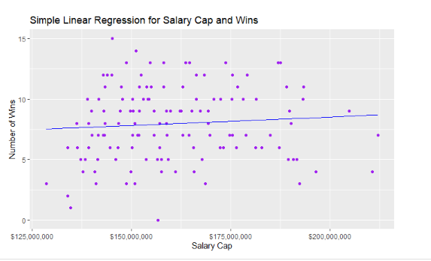

Next we decided to take a sample of the teams with the highest salary cap over the 4 year period to see if we can find any trends in their success during the season. We found a range of wins from 0 to 14 and no specific trending.

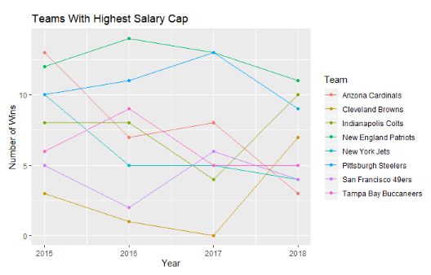

We then reviewed teams that spent the most on dead money to see if we could find any trends in wins.

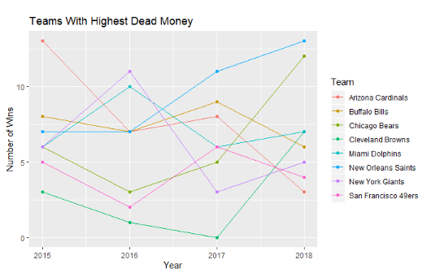

Since the overall salary cap utilization doesn’t appear to have a significant correlation with a team’s wins, we looked at whether an individual position could better explain a team’s performance. Organizations, whether it is the NFL or the company you work for, have a defined budget of dollars they can spend on salaries for their staff. When determining how to allocate salary dollars they weigh several factors such as supply and demand of necessary talent, the organization's performance, and the individual's performance or experience. Ultimately, the organization wants to efficiently spend salary dollars by allocating more on key talent that will best improve the organization's performance.

With this understanding, it makes sense that the NFL would allocate more of their salary cap to positions that result in better performance (measured by number of wins).

The quarterback is usually one of the highest paid and highest profile individual players, so we also expected a correlation between the number of wins a team has and the amount of money paid to their quarterback, but this wasn't supported in the data either.

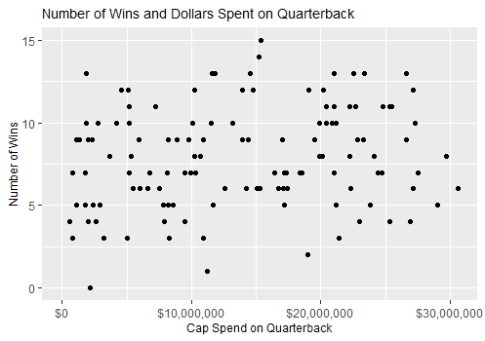

**A summary of getting the data and preparing it for analysis.**

The NFL provides easy access to team salary information and team overall record. We gathered all the team salary data from Spotrac and all the overall record data from NFL. We were able to copy the data from each source into four separate CSV files and then read each file into R. We also combined all 4 years of data into one CSV file so we could analyze all the data at the same time. Because there are only 32 teams, one year of data is small, but combining all 4 years into one file allows us to look at more data at once.

**A summary of the various obstacles you faced during the project and how you overcame them.**

**Documentation of the R function written to assist your analysis.**

**Data Sources**

*Team Salary*

<https://www.spotrac.com/nfl/cap/2018/>

<https://www.spotrac.com/nfl/cap/2017/>

<https://www.spotrac.com/nfl/cap/2016/>

<https://www.spotrac.com/nfl/cap/2015/>

*Positional Breakdown*

<https://www.spotrac.com/nfl/positional/breakdown/2018/>

<https://www.spotrac.com/nfl/positional/breakdown/2017/>

<https://www.spotrac.com/nfl/positional/breakdown/2016/>

<https://www.spotrac.com/nfl/positional/breakdown/2015/>

*Overall Record*

<https://www.nfl.com/standings/league/2018/REG>

<https://www.nfl.com/standings/league/2017/REG>

<https://www.nfl.com/standings/league/2016/REG>

<https://www.nfl.com/standings/league/2015/REG>